SINKing Ecology Robot (SINKER) 902306 Colleen Durkin, Francisco Chavez, Paul Roberts, Rich Henthorn, George Stern, Enoch Nicholson, James McClure, Karen Salamy, Danelle Cline
The SINKER (SINKing Ecology Robot) will measure variability of carbon flux to the seafloor and the ecological source of this variation. The instrument will be moored on the seafloor and initially designed for deployment at the MARS cabled observatory. When sinking particles settle through a vertical collection cylinder, they will be imaged by a set of cameras, and images will be used to identify particle types (e.g., fecal pellet, aggregate, organism) and to calculate their carbon fluxes and sinking speeds.
Engineering Activities
- The SINKER deployment frame was completed early in July 2025 with enough time to be deployed and connected to MARS on our July 15 cruise on the R/V Rachel Carson. The deployment went very smoothly thanks to the efforts of Science, Engineering and Operations (Figs. 1 and 2). An integrated PTZ camera on the SINKER instrument allows remote view of the operation of the sealing and flux camera cleaning mechanism (Fig. 3).
- Since deploying SINKER at MARS on July 15, the instrument has been running continuously, recording images from two sediment flux cameras, and three sinking particle cameras. Through a combination of image compression and selective recording rates on the system, these data can just fit in the available 100 MB/s bandwidth on MARS. On average SINKER produces 700 MB or roughly 275,000 images per day for archive, processing, and analysis on shore.
- In concert with the instrument deployment, Karen Salamy and Danelle Cline have developed a new instrument dashboard to enable real-time visualization of camera images and instrument health monitoring (Figs. 4 and 5).

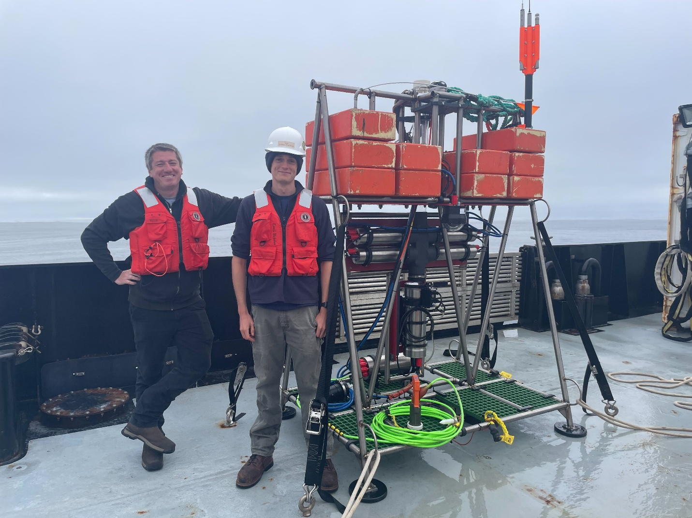
Figure 1: Engineers Paul Roberts and Enoch Nicholson stand next to the SINKER before its maiden deployment at MARS
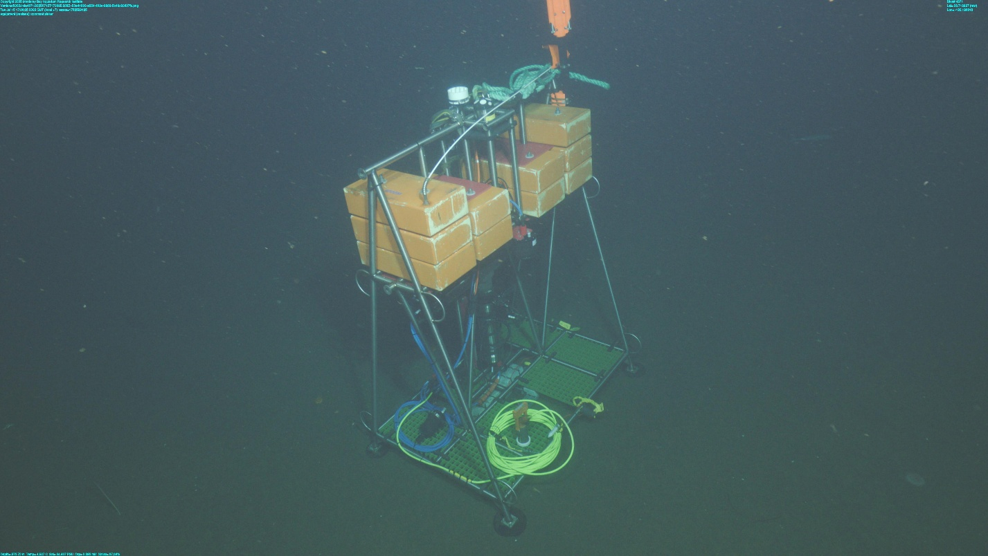
Figure 2: Frame grab of SINKER on the bottom at 880 m near its deployment site at MARS.

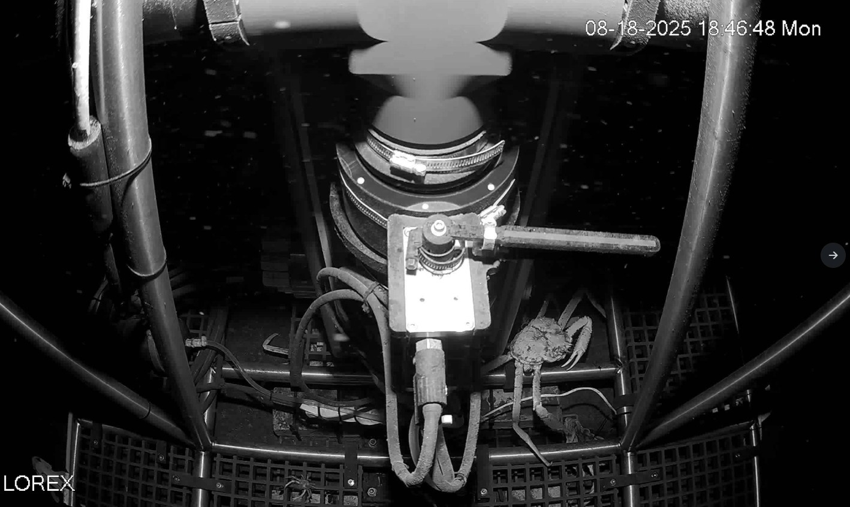
Figure 3: View of the SINKER cleaning and sealing mechanism from the integrated station camera.

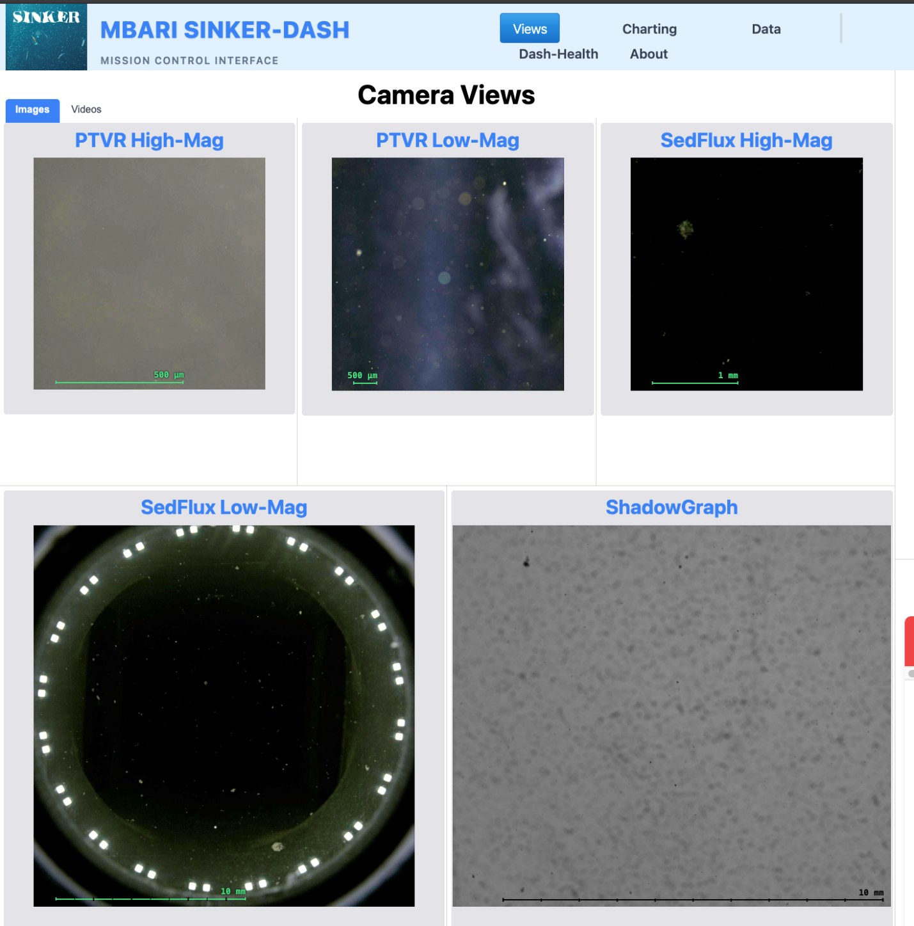
Figure 4: View of all five camera feeds from the SINKER dashboard.

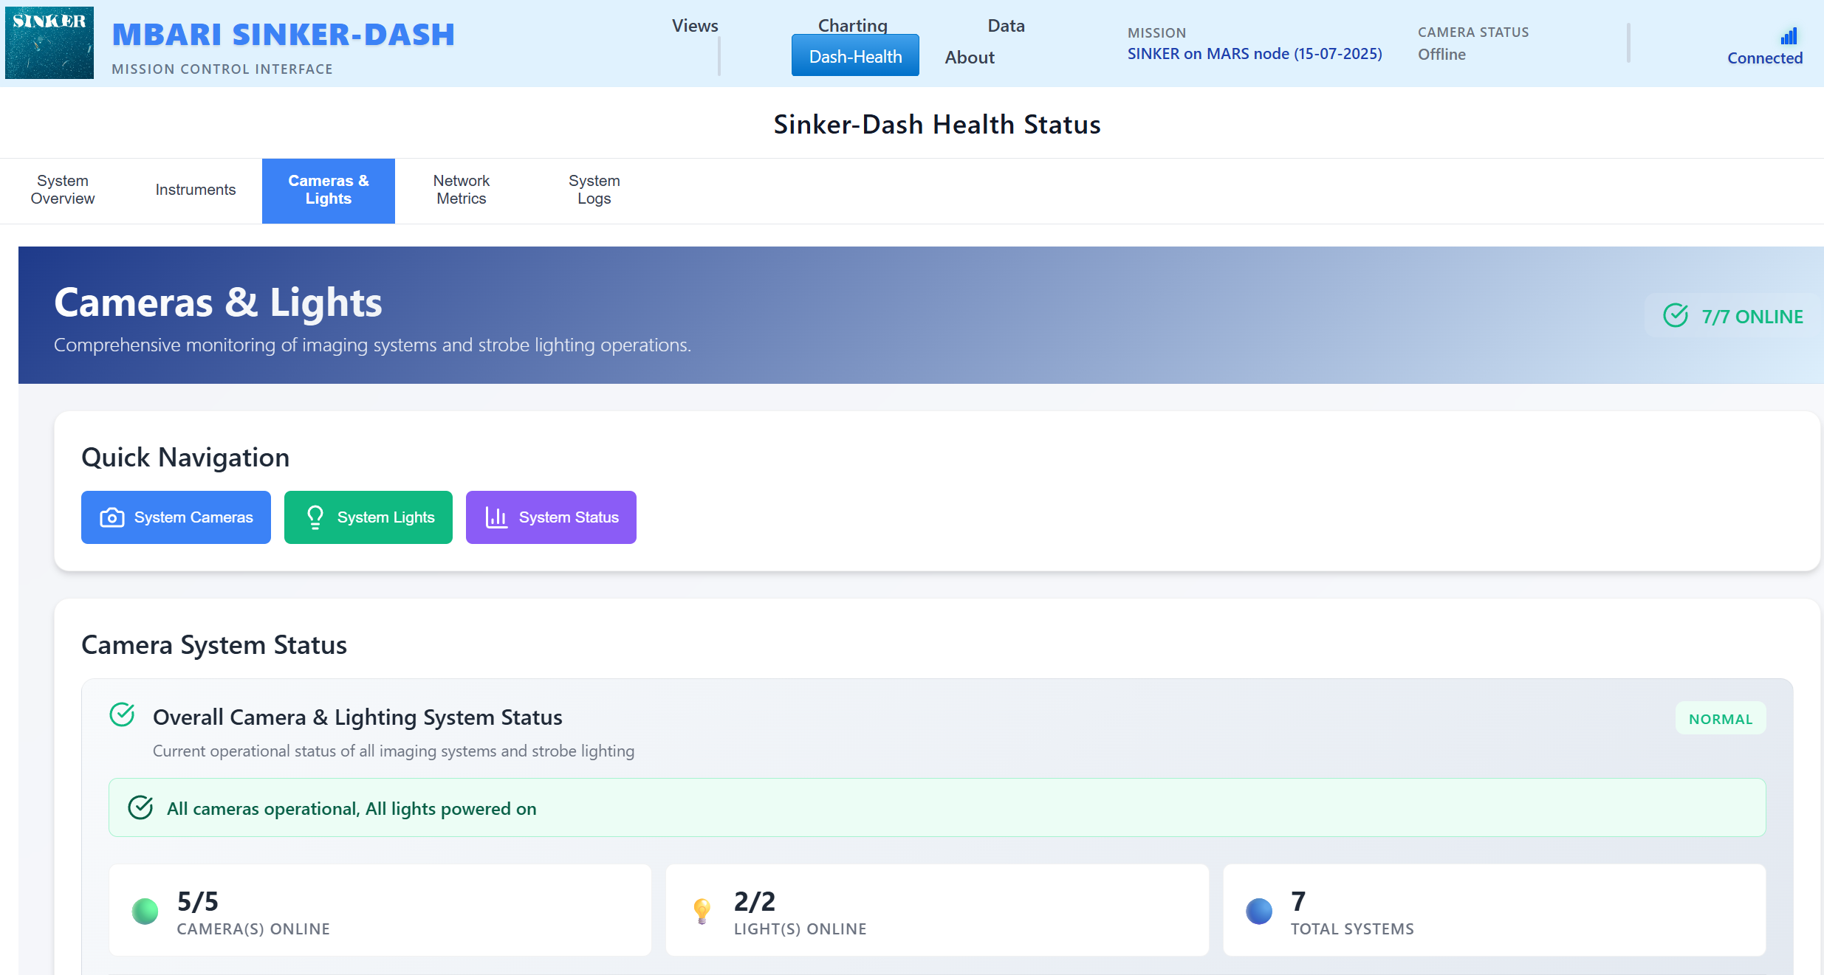
Figure 5: Summary view of the SINKER dash heath status page. Submenus under the “Quick Navigation” heading allow drilling down to individual component health status.

