SINKing Ecology Robot (SINKER) 902306 Colleen Durkin, Francisco Chavez, Paul Roberts, Rich Henthorn, George Stern, Enoch Nicholson, James McClure, Karen Salamy, Danelle Cline
The SINKER (SINKing Ecology Robot) will measure variability of carbon flux to the seafloor and the ecological source of this variation. The instrument will be moored on the seafloor and initially designed for deployment at the MARS cabled observatory. When sinking particles settle through a vertical collection cylinder, they will be imaged by a set of cameras, and images will be used to identify particle types (e.g., fecal pellet, aggregate, organism) and to calculate their carbon fluxes and sinking speeds.
Engineering Activities
- The deployment frame for SINKER was revised based on feedback from the ROV pilots and ship’s crew. The latest design is shown in Figure 1 and fabrication is starting this week. The frame will allow autonomous and cabled deployments of SINKER at MARS during scheduled ship days in July, August, and December 2025.
- The project team supported a highly successful test deployment near MARS (Figure 2) between March 10, 2025 and March 17, 2025. During the deployment SINKER ran autonomously for nearly 6 days, recording images on all five cameras with a 50% duty cycle (one for one our every two hours).
- Data from the March test deployment confirmed that the instrument will be capable of measuring individual particle sinking speeds and also particle flux. Example preliminary data from the deployment are shown in Figs. 3, 4 and 5.
- The project team is starting planning for a SINKER dashboard that will enable operators and engineers to view current status of SINKER when deployed at MARS and send control commands.

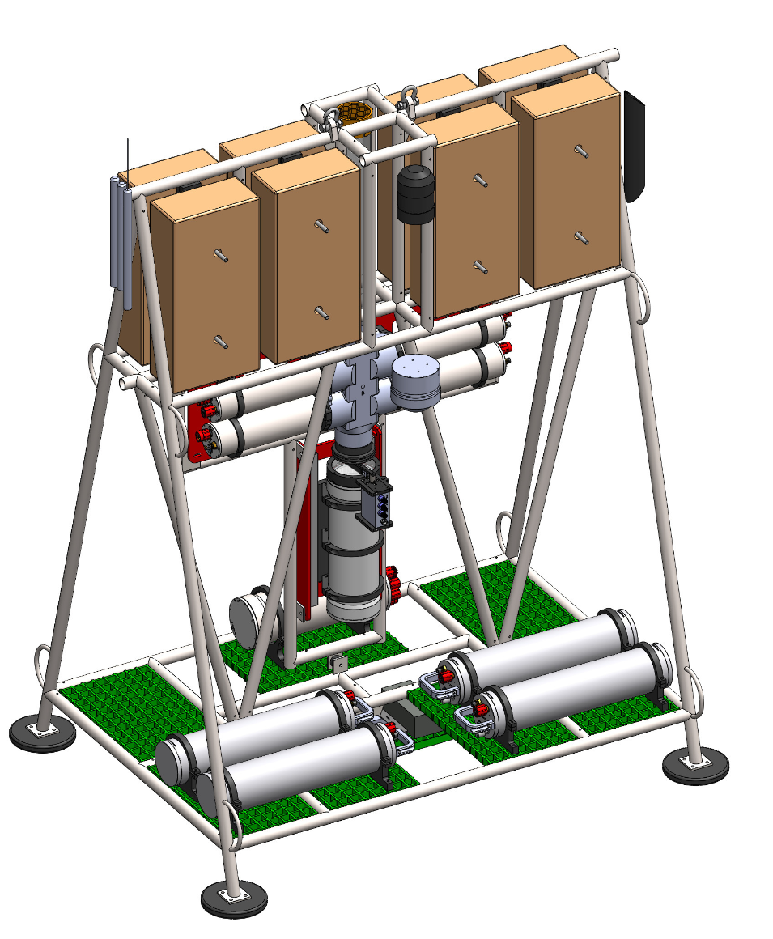
Figure 1: Completed design for the MARS deployment frame. The frame integrates SINKER into an elevator-like welded titanium frame with space for batteries during autonomous deployment or MARS cable during cables deployment.

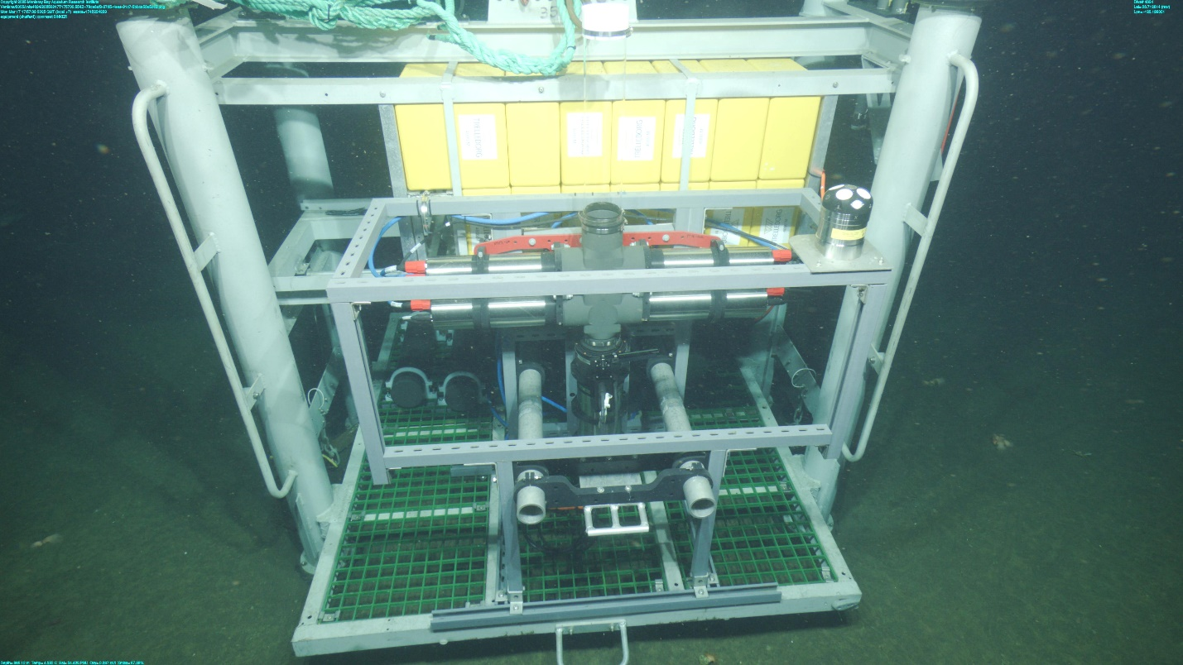
Figure 2: Frame grab of SINKER mounted in the BRS elevator deployed near MARS at 980 m. On the top right of the SINKER frame, a new Nortek ADCP was used to measure the flow environment starting at the top of the sinking column and extending 15 m above the instrument.

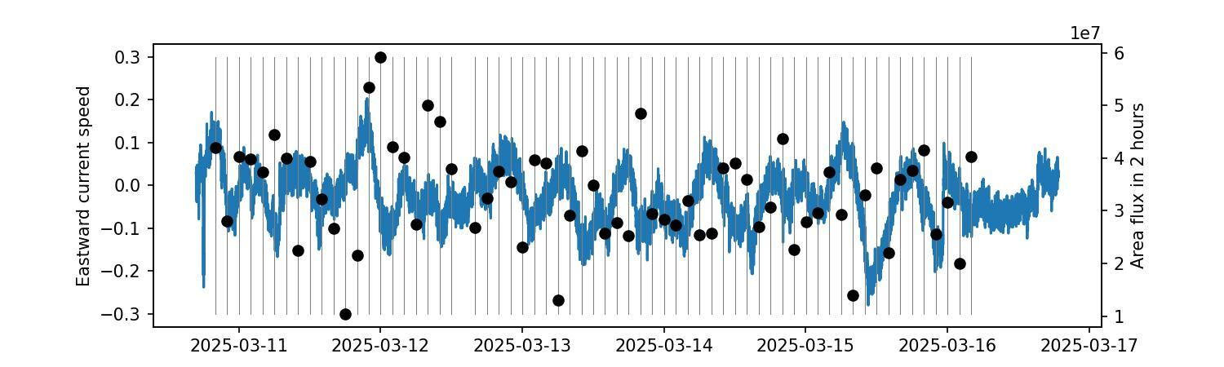
Figure 3: Comparison of measured current velocity (in m/s) from the ADCP (blue) and particle flux during 2-hour intervals (black) estimated from the SINKER low-mag sediment camera. Typical currents were below 12 cm/s, and no significant correlation was found between current speed and flux estimates.

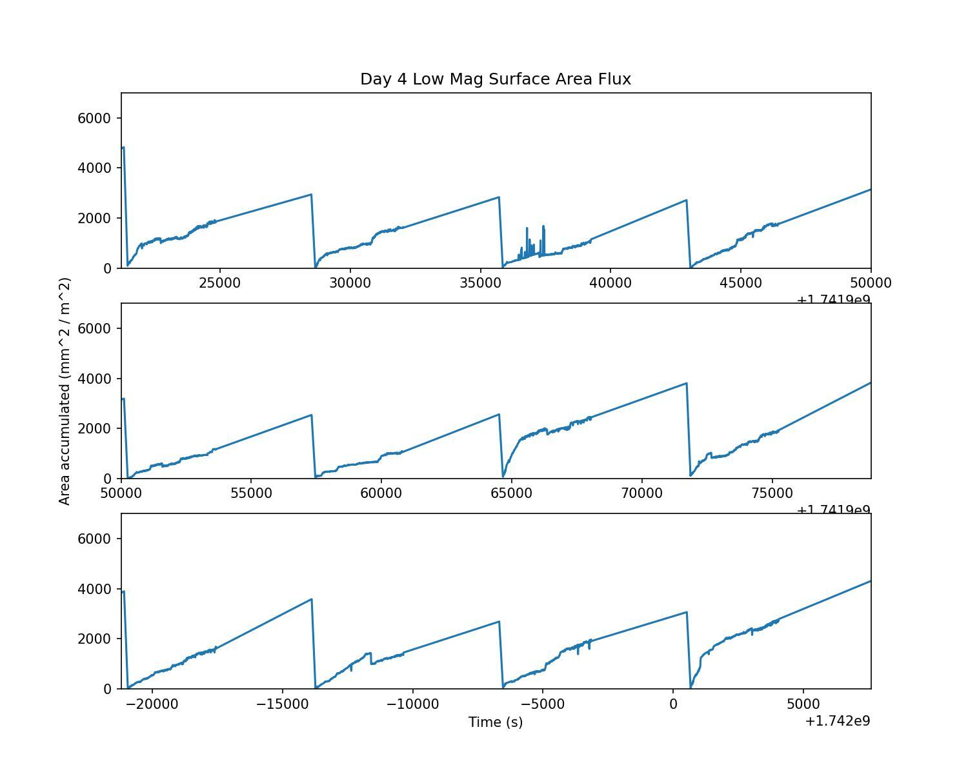
Figure 4: Individual 2-hour accumulation plots from day 4 of the deployment. At the start of each accumulation period, the wiper clears the port surface and resets the background flux estimate to 0. Accumulation is measured at 1 Hz for the first 5 minutes and then 1/10 Hz after for the first hour. At the end of the second hour, total accumulation is estimated for a final image before clearing the port restarts the cycle.

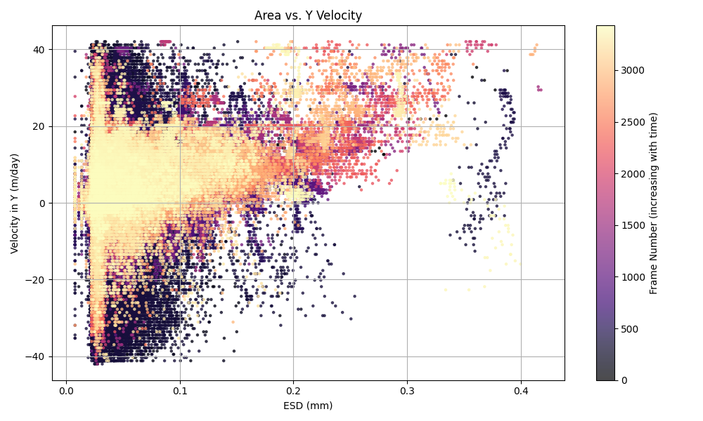
Figure 5: Scatter plot of sinking/rising speed (positive means sinking) as a function of particle size (horizontal) and time (color) during a 1-hour recording period. Smaller particles tend to follow fluid motion are found to be sinking and rising during the earlier part of the recording period due to the column being unsealed for cleaning. After around 15 minutes, the flow settings and the majority of the particles are found to be sinking at rates between 5-40 m/day.

