SINKing Ecology Robot (SINKER) 902306 Colleen Durkin, Francisco Chavez, Paul Roberts, Alana Sherman, Paul McGill, François Cazenave, Rich Henthorn, George Stern, Enoch Nicholson
The SINKER (SINKing Ecology Robot) will measure variability of carbon flux to the seafloor and the ecological source of this variation. The instrument will be moored on the seafloor and initially designed for deployment at the MARS cabled observatory. When sinking particles settle through a vertical collection cylinder, they will be imaged by a set of cameras, and images will be used to identify particle types (e.g., fecal pellet, aggregate, organism) and to calculate their carbon fluxes and sinking speeds.
Engineering Activities
- The project team has completed three SINKER deployments since March 2024. Two deployments in July validated the revised sinking column sealing mechanism and actuator, and the most recent deployment on Oct 9, tested the complete SINKER instrument with all three side-looking cameras and an ROV capable version of the deployment frame (Figure 1).
- The newly developed shadowgraph imaging system enabled quantitative measurements of sinking particle size, and velocity inside of the sinking column (Figure 2).

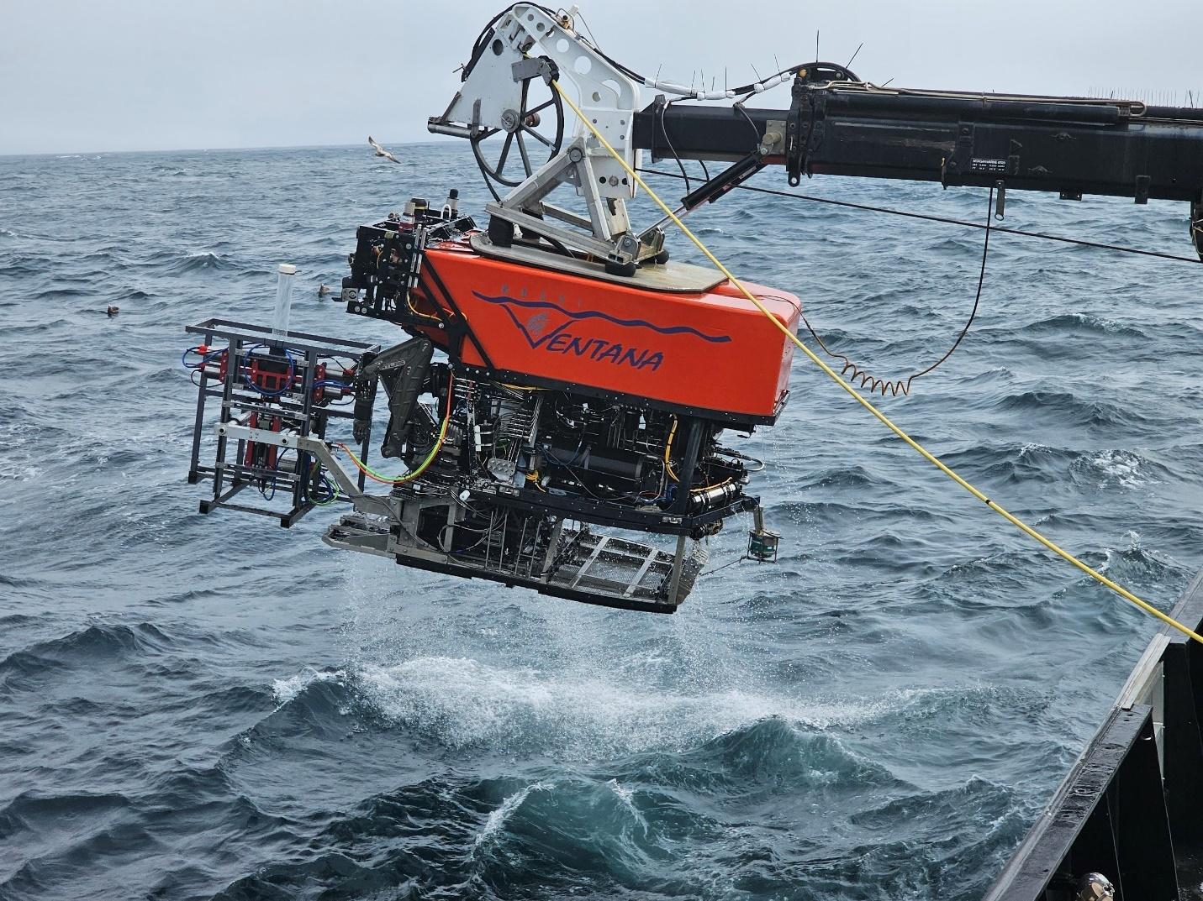
Figure 1: The complete SINKER instrument mounted in the Ventana swing arm during deployment at MARS on October 9, 2024

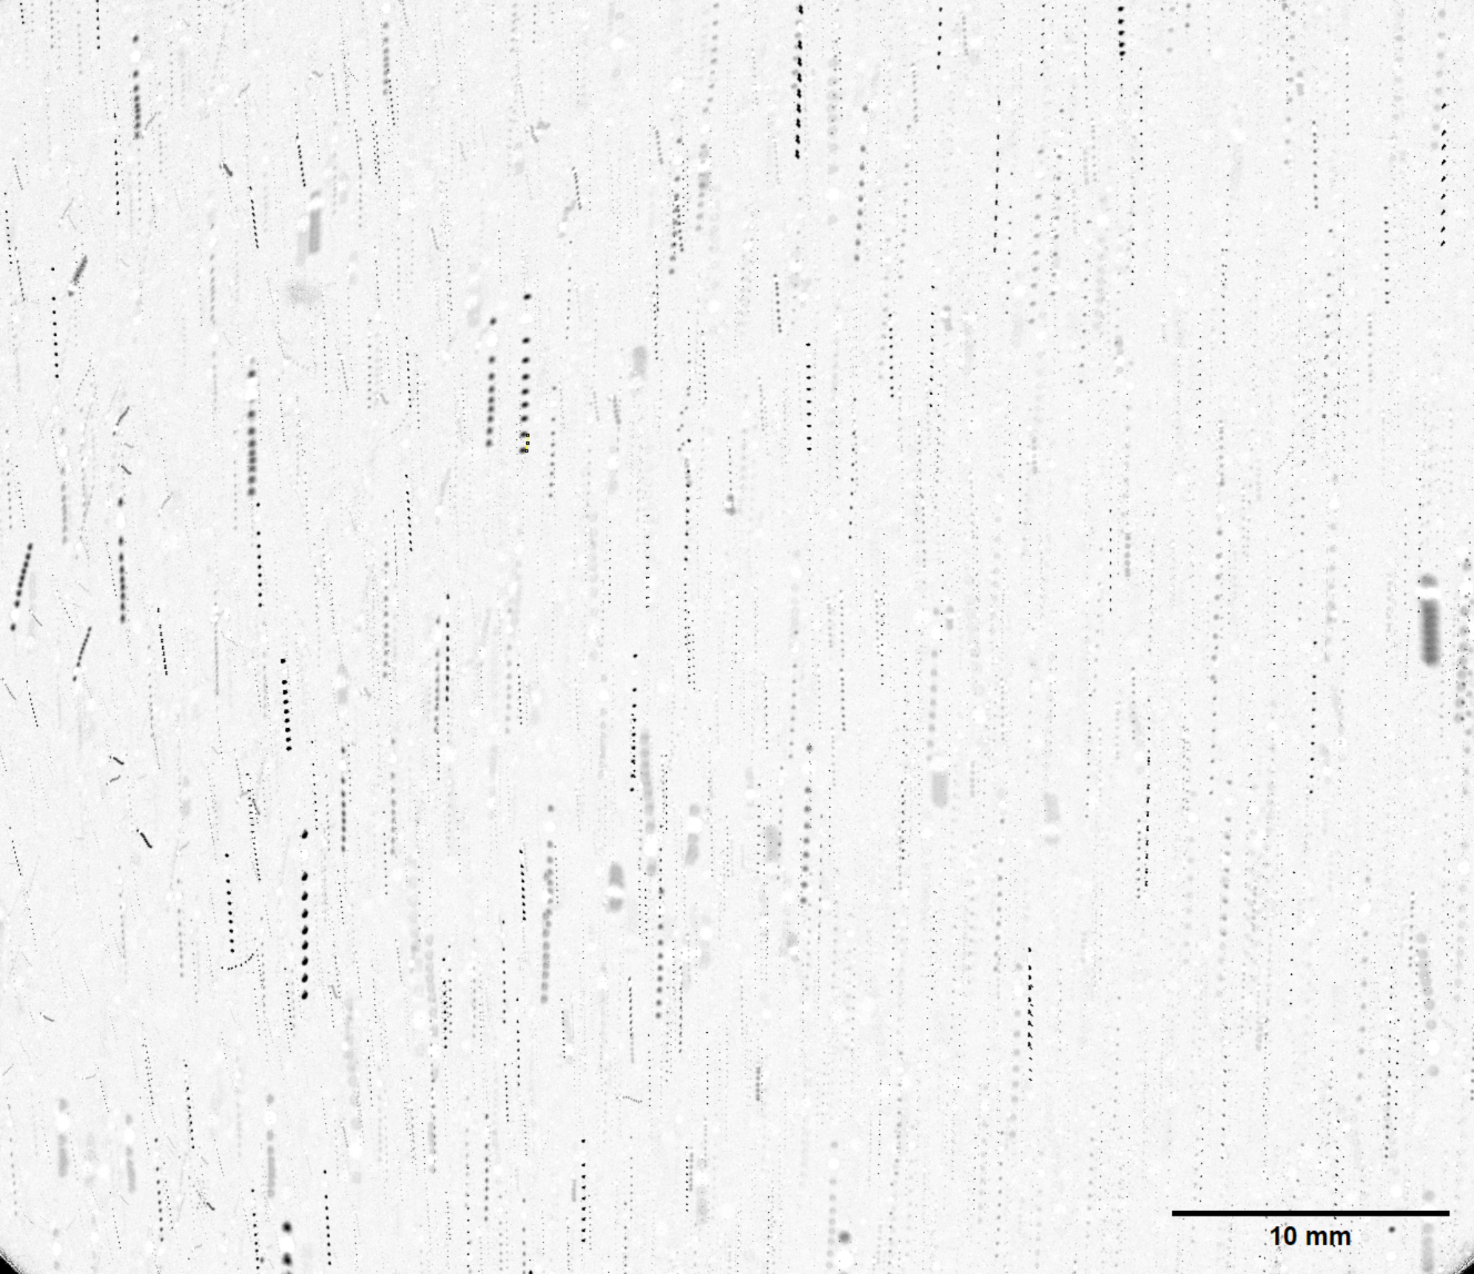
Figure 2: Visualizing sinking particles inside of the sinking column using the shadowgraph modality. A sequence of 10 consecutive frames recorded at 1 Hz is superimposed into one image to show the particle trajectories. The shadowgraph imaging geometry enables quantitative measurements of particle size and velocity due to its orthographic projection of the imaged volume. Estimated sinking speeds from this set of images range from 8 to 80 m/day across the slowest and fastest moving particles in the image.

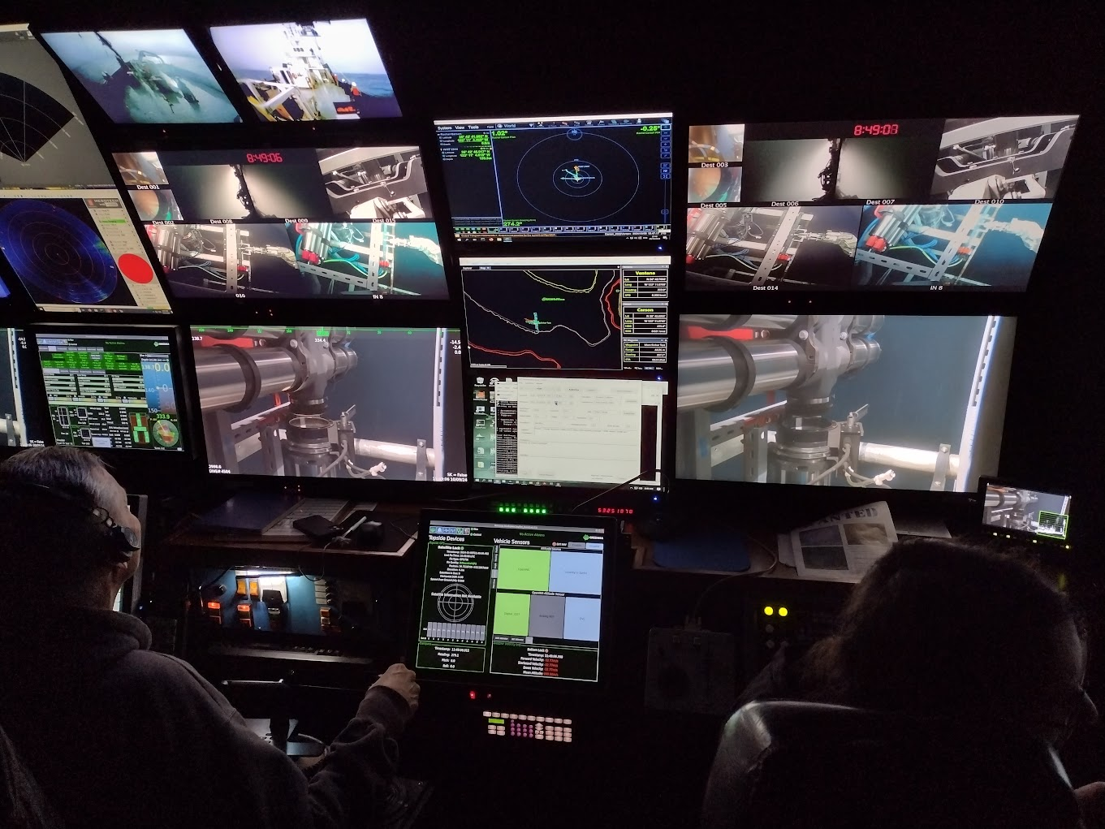
Figure 3: The view of the complete SINKER instrument from the ROV control room during October 9, 2024 test dive.

