Project Number:

Project Start: Jan. 1, | 2023 | Project Duration (in years): | 1 of 3

Please indicate if proposal includes requests for any of the following (mark all that apply).

Ship Time |  |  | ROV |  |  | AUV |  |  | Wave Glider |  |  | Mini ROV

Please indicate what type of project is being proposed (mark only one).

 |  |  |  | x
Feasibility/Scoping  [<100 days effort] |  |  | Development |  |  | Research |  |  | Infrastructure² |  |  | Education |  |  | Time Series |  |  | Institute Initiative

Project Manager: Paul Roberts
Principal Investigator: Colleen Durkin
Lead Scientist: Francisco Chavez
Lead Engineer: Paul Roberts

Project Title: SINKER

Please indicate which category best describes the project theme (mark only one).

 | x
Ocean  biogeochemistry |  |  | Ecosystem dynamics |  |  | Ocean visualization |  |  | Exploration & discovery

Please indicate percentage of effort on this project anticipated for 2023 toward these three highest institutional goals (percentage total should equal 100%).

Goal | Developing/adapting innovative technologies | Utilizing developments to explore and understand ocean systems | Technology/knowledge transfer
Percentage | 100 | 0 | 0

- ABSTRACT (all projects)
Briefly provide a high-level summary of the project (ideally no more than 1/2 page).

The mechanisms that control carbon export to the deep ocean by sinking particles are under-observed and poorly modeled, due in large part to the difficult of maintaining biologically-resolved observations of particle flux over time. This project will develop a new instrument capable of imaging sinking particle types, measure their fluxes, measure their sinking speeds, and sustain these measurements over ecologically and biogeochemically relevant time periods. The SINKER (SINKing Ecology Robot) will be moored on the seafloor, initially designed for deployment at the MARS cabled observatory. When sinking particles settle through a collection cylinder, they will be imaged by a set of cameras, and images will be used to identify particle types (e.g. fecal pellet, aggregate, organism) and to calculate their sinking speeds. To detect the full size range of particles that influence the ecology of carbon export, two side-facing camera systems will be used that focus on different imaged volumes. To calculate fluxes, a set of upward facing cameras will image particles after they settle on an upward-facing collection plate. The frequency and time-integration of these upward facing cameras will enable more robust calculations of flux than is possible from the side-facing cameras. A wiper will be used to clean off the particles from the imaging plate. The ability to sustain ecologically-resolved observations of sinking particles will transform our understanding of the biological carbon pump and enable major advances in biogeochemical modeling and monitoring.

- PROPOSAL (all projects)

Background
- Importance: Sinking particles transport particulate organic carbon away from the surface ocean and into the deep ocean, where they fuel deep sea ecosystems and also sequester carbon away from the atmosphere. The amount of carbon exported to the deep ocean is poorly quantified and modeled, and there is growing consensus that ecological mechanisms of particle export must be accounted for to improve estimates.
- Problem: We do not fully understand the time scales over which these ecological mechanisms of carbon export vary (e.g. hourly to seasonal), and current methodological approaches cannot adequately sustain observations over relevant time scales. We do not know how fast different particle types sink, which limits our ability to incorporate biological details into models. We need new technology that can solve these observational limitations.

- SINKER will be capable of collecting continuous observations of the sinking particles, generating ecological-resolved observations of flux and sinking speeds from a bottom-moored location, sustainable over long time periods and at high time resolution.

- The data generated by SINKER would differ from existing technologies by resolving sinking particle size, sinking speed, identity, and quantity. In this way it will complement the capabilities of pelagic particle imaging instruments, which cannot distinguish between sinking and non-sinking particles, and also other sediment traps that cannot fully resolve the size, identity, and sinking speed of captured particles.

- This instrument development project is linked to the goals of the Carbon Flux Ecology (902111) project and synergistic with the proposed SES development project (led by C. Huffard), and is a fundamental part of the Durkin lab’s mission within the next 5 years to create autonomous and remote observational approaches that resolve the ecological drivers of carbon export.

Nature and Scope of the Proposed Project
Please provide a sense of the scale and scope of the proposed work. Is this a large de novo R&D effort, modest platform/sensor integration, targeted science investigation with minimal or no engineering needs, extension of current program, small-scale scoping exercise expected to lead to a larger effort, or other? If the project is intended to be multiple years, how will the anticipated level of effort likely change over time?

- This is a new engineering effort that leverages existing technologies previously developed at MBARI (Planktivore, EyeRIS, SES). The instrument will be designed to be plugged in at the MARS node and will collect in-situ images of sinking particles in order to quantify both carbon flux and sinking speeds of different particle types. Images will identify the ecological source of particles (various fecal pellet types, aggregates, organisms, various particle sizes) which are used to estimate their contributions to carbon fluxes.

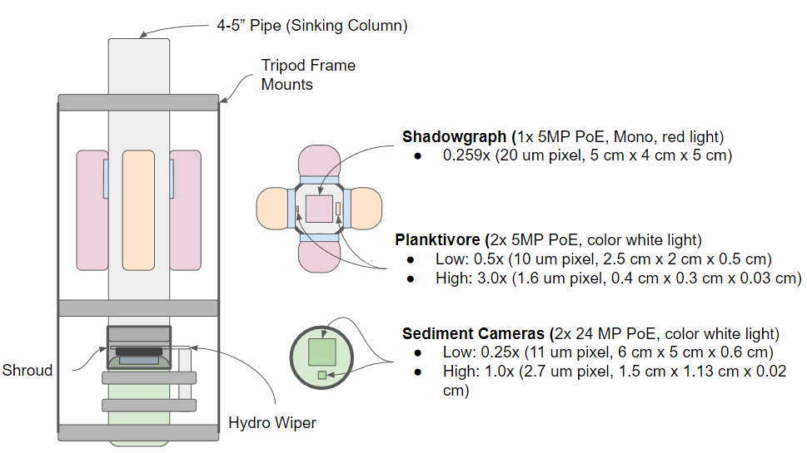
- We will reuse the existing AyeRIS 1500 m AUV pressure housing design for the upward facing sediment cameras build on the existing Planktivore housing design and optics to implement the shadowgraph and Planktivore cameras with a common pressure housing design shared between all four optics pods. The new instrument will utilize existing infrastructure (MARS), and will be deployable using MBARI assets (e.g. Rachel Carson).

Figure 1. Conceptual drawing of the system showing the two free-space imaging systems (Shadowgraph and Planktivore) imaging sinking particles through the side of the 4” pipe. At the bottom of the pipe a sediment camera images particles that collect on the viewport at two complimentary magnifications. A mechanical wiper periodically wipes the upward facing port clean to initiate a new sample.

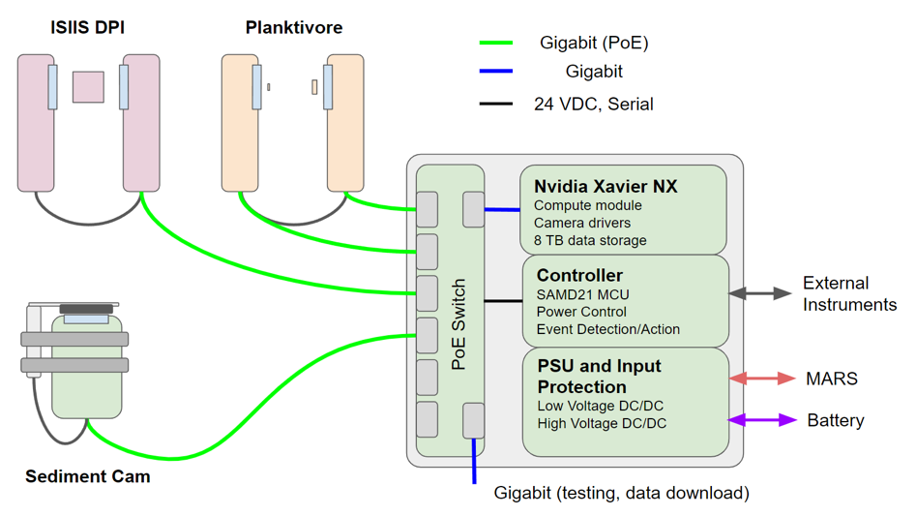
Future contextual sensors
Figure 2: Block diagram of the high-level system interface. The three imaging systems connect to the interface through Power over Ethernet (PoE). Inside the interface can, a managed PoE switch interfaces with the Nvidia Xavier NX for camera control, image acquisition, image processing and local storage. A microcontroller interfaces the upstream power systems with the NX and PoE switch. Ethernet data are accessible from the system either through MARS or through a dedicated gigabit port.

- The choice of camera systems is based on our requirements to
1) identify particle types from 50−5000 µm
2) assign sinking speeds to those particle types
3) accurately quantify their fluxes.
The shadowgraph camera will effectively detect sinking speeds of large, rare particles (~500−5000 µm) because it images and focuses through a large volume. The Planktivore cameras will measure the sinking speeds (m d⁻¹) of smaller particles (~30−300 µm high magnification, ~200-1500µm low magnification). Because these cameras will not be running continuously or sample sufficient volume to accurately quantify fluxes (# m⁻² d⁻¹), the upward facing cameras will be required for flux calculations.

- Software efforts in year 1 will integrate EyeRIS and Planktivore camera acquisition software for camera control, region of interest detection, and recording. Data from SINKER will be integrated into the RIMS database to visualize camera data.

- Efforts during the first year will primarily consist of designing, building, and testing in the test tank. When the MARS node becomes available in 2024, efforts will shift toward field deployments, calibrations, and data processing.

Does this activity relate to one or more 2023 proposals your team is submitting?
If so, provide a list of relevant projects by project/DQ # and provide a brief description of how they are related. Since resources are limited and cuts during Phase 1 are likely, please indicate where this project fits in the hierarchy of your priorities. Does this proposal take precedent over other ongoing or planned activities?

- 902111: Carbon Flux Ecology
- Concurrently proposed project: SES (lead by Huffard)
- 708176: NASA EXPORTS
- DQ22-02: Collaborative Research: An open, platform-agnostic sediment trap controller and imaging sensor.

After the 3-year development period, SINKER operation would be included within the Carbon Flux Ecology project (902111). The NASA EXPORTS project (708176) is ending in 2023.
DQ22-02 is synergistic with this effort, including building a very similar upward-facing particle imager for a Lagrangian platform. The concurrently proposed SES project has overlapping goals with this work, and we foresee these two instruments being deployed at MARS together in the future. The SES could be used as the event detector to trigger a remotely located SINKER.

Anticipated Shared Resource Needs
What staffing is required to advance the work in 2023 (e.g., is this a multi-faceted engineering development or a targeted science investigation that does not require significant use of shared personnel)? Is in-house or contract manufacturing needed? What level of ship/ROV/AUV (DMO) support is likely? If this is intended to be a multi-year effort, please provide a rough indication of anticipated shared resource needs over the duration of the project (e.g., will stay flat, will significantly increase in Year X, will significantly decrease by Year Y).

Project Team includes:
- Paul Roberts- SE/EE (~300 hrs)
- Alana Sherman/Paul McGill- EE (~300 hrs total)
- François Cazenave- ME (~300 hrs)
- Rich Henthorn – SE (~120 hrs)
- Brian Schlining – SE (~40 hrs)
- Machinist to fabricate parts
- Mechanical and Electrical technician help for assembly
Facilities
- Machine shop
- Test tank
- Future years: ship time and ROV to deploy and test at sea
- MARS node

We anticipate that the level of effort will remain consistent for the first two years of this project as we develop and deploy the instrument. Some of these resources will be in less demand once the instrument is deployed and collecting data.

Anticipated Expenses
What rough order of magnitude direct expense budget is anticipated annually over the course of the project? Is procurement of specialized capital equipment or outside contractors required? Will there be annual travel?

This project’s direct expenses will be under $100k. The majority of the costs goes to pressure housings, cables, connectors, cameras, and optics. Due to the requirement of long (1 year) deployment duration, we anticipate most of the pressure housings will be made from Titanium. Where possible we will use existing titanium stock from MBARI.

No specialized equipment or travel is expected for this first year.

Intellectual Property (IP) Considerations

None, since we expect to build this out of existing instrumentation.

Data

Images will be acquired of particles sinking in the water column and settling on the sediment camera plate. Building from the existing real-time detection software built for EyeRIS and Planktivore, these images will be processed locally on the NX to extract regions of interest, particle size, and location information in real time. These reduced data will be stored locally and also transferred remotely to a server on shore (when a connection is available).

Worst-case archival data storage requirements for the system are 60 TB/year for continuous operation at very high temporal resolution. Expected use cases will likely be on the order of 5–10 TB/year. Up to 8 TB could be stored locally on the instrument. Data will be stored on shore on spinning disk storage for post processing and web hosting using the RIMS database developed for EyeRIS and Planktivore. Archival data not needed for immediate analysis would be stored on LTO tape.

Anticipated Impact

Sustained, ecologically resolved observations of particle fluxes in Monterey Bay will benefit most core lab projects at MBARI, either by contributing contextual data related to carbon flux or by observing specific organisms/fecal pellets of interest to individual programs. In the long term, this tool could be exported for use at other cabled observatories or be deployed on batteries for uncabled process studies. This instrument could be co-deployed and/or linked with the SES to capture complementary observations of flux.

Anticipated Outreach Needs

None expected during the instrument development period

Continuing Projects Only: Status Report
Briefly provide an update of the current project relative to what was proposed for 2022 by responding to the prompts below. If the project includes multiple subproject projects, please list each of these under a subheading as you deem appropriate.

Current status of project and results to date

[Click here to enter text]

What percentage of labor and budget have been used through the 1st half of year?

[Click here to enter text]

Will you complete the current year’s scheduled work?

[Click here to enter text]

Significant changes from previous project proposal

[Click here to enter text]

Over the past two years, what peer-reviewed publications, education and/or outreach activities have resulted directly from this project? Please be brief.

[Click here to enter text]

All Projects: Specific Plans for 2023

Research Activities

This project is primarily an engineering/technology development effort, especially in 2023. Research efforts in 2023 will primarily be for method and design testing. Once a prototype is designed, we will observe how sinking particles enter the settling tube under various flow conditions in the test tank. Trap designs have been extensively tested and discussed in the literature (for example: Gardner 1985, DSR I 32:349-36, Buesseler et al. 2007 J. Mar. Res. 65: 345-416) and biases of different designs are well described. With these long-accepted best practices in sediment trap design in mind, these flow observations in the test tank are intended to constrain conditions of potential collection biases for our instrument.

Engineering/technology development

Engineering activities will center around the design and implementation of the SINKER instrument. The first quarter will focus on design with at least one design review planned for March 2023. Pending results of the review, a critical design review may follow shortly after and fabrication will begin in the second quarter. The bulk of the fabrication effort is in machine shop time with modest requests for electronic and mechanical assembly. Bench testing will follow in the third quarter and if all goes well a test dive on the ROV is planned for the fourth quarter.

The design for SINKER is broken up into sub-systems and each subsystem leverages existing MBARI project outputs to expedite technology development. These subsystems and associated activities are briefly described below.

- Compute Node:
  - Reuses existing AyeRIS 1500 m pressure housing design with very minimal modifications
  - Builds on the Bioinspiration Lab multicamera Power over Ethernet (PoE) design.
  - Builds on time-lapse camera and AyeRIS power-path controllers
  - Integrates a modern compute module based on collective experience with the Nvidia Jetson platform
- Sediment Camera:
  - Reuses existing AyeRIS 1500 m pressure housing design with very minimal modifications
  - Builds on the Planktivore strobe design to cover a larger area and illuminate the external surface of the view port for reflectance-mode imaging of settled particles
  - Integrates two off-the-shelf telecentric lenses and two off-the-shelf 24 MP PoE cameras.
  - Uses Zebra-Tech Hydro-Wiper brushes with in-house mechanical actuators based on oil-filled stepper motors to expand the depth rating of the wiper to meet SINKER requirements.
- Planktivore
  - Builds on existing Planktivore optics and housings to expand imaging and standardize housing and interface for use with a wide range of magnifications
  - Revises existing Planktivore interface to use PoE cameras
- Shadowgraph
  - Builds on recent versions of the ISIIS DP imaging system
  - Uses off-the-shelf telecentric lenses for illumination and imaging from Opto-Engineering

Once the sub-systems have been fabricated and tested on the bench, we envision tank tests with the systems mounted to sinking column and visualization of the flow of particles in the column to validate the position of the imaged volumes relative to the inlet of the column.

We anticipate some iteration after initial tank tests to address issues that may arise with the design of the sinking column and placement of the imaging systems. Once we have finalized the column and confirmed functionality of all of the systems we hope to complete one or two test dives with SINKER mounted to and powered by the ROV at a location close to MARS.

With the short timeline for development in 2023 and level of reuse of mechanical and camera/optical designs from existing projects we plan to review resources towards the end of 2022 to see if we can begin purchasing some components and machining parts in the final quarter of 2022.

Field programs (detail ship requirements/deployments/diver requirements)

In addition to describing anticipated field programs, please be sure to include requirements for specific platforms and equipment (Dorado AUVs, LRAUVs, Wave Glider, mini ROV, etc.) for each proposed field program so that expectations are clear. Requests must also be entered in the budget entry system.

If the SINKER is complete and passing tank tests before the end of the year, a test dive on Ventana will be attempted. To enable this, we are requesting the following:

# of Days | Ship | Vehicle needs | Requested dates | Deployment objectives
2 | R/V Rachel Carson | ROV Ventana | Dec | Test SINKER while connected to Ventana and sitting on bottom near MARS

Specific deliverables

- Design of the instrument and at least one design review
- Fabrication of the pressure housings and internal mechanical and electrical interfaces to support off-the-shelf cameras, lenses, and compute node.
- Bench test of all cameras and illumination with confirmation of imaged volume and optical resolution using standard resolution targets.
- Visualization of particle sinking in the proposed column with known particles and specification of the location of the free-space imaging volumes in the sinking column.
- Tank test of complete instrument with known particles
- ROV-dive field test of the instrument as opportunity arises towards the end of the year

Milestones and required personnel (see personnel classification list for staff classifications)

2023 Project Start Date:  01/02/2023 | Milestone 1 | Milestone 2 | Milestone 3 | Milestone 4 | Milestone 5 | Total Resources (in hours) for each resource category for all milestones listed here
Milestone Date | 1st quarter | 1nd quarter | 2r^{d} quarter | 3rd quarter | 4th quarter
Milestone Description | Preliminary review | Critical review | Assembly and fabrication | Benchtop tests & Tank test | ROV dive at MARS
Electrical Engineer  (Paul R., Paul M., Alana) | 200 | 100 | 125 | 125 | 50 | 600
Software Eng-Embedded  (Rich H.) |  |  |  | 120 |  | 120
Software Eng-Info Eng  (Brian S.) |  |  |  | 40 |  | 40
Mechanical Engineer  (Francois) | 150 | 25 | 75 | 25 | 25 | 300
Mechanical Eng-Division
Mechanical Eng-Mfg
Associate Engineer
Electrical Tech |  |  | 160 |  |  | 160
Software Tech
Mechanical Tech |  |  | 68 |  |  | 68
Machinist |  |  | 378 |  |  | 378
Divers
Video Lab
(Add other categories/rows as needed)

Budget justification

A breakdown of the major cost items is shown in the following table. Hyperlinks to sheets with details for the major cost items are included. The items are listed in order from highest to lowest cost and each line item includes tax, shipping, and a 15% margin to account for variations in price, supply chain issues forcing selection of alternate parts. The vast majority of the cost comes from cameras, lenses, housings, and cables and connectors.

Hardware Budget | Cost
Compute Node | $19,415.79
Sediment Camera | $15,960.13
Planktivore | $16,441.81
Shadowgraph | $14,608.38
MARS Interface | $12,575.00
Mechanical Raw Materials | $9,058.00
Laptop (Instrument Control/Debug) | $2,200.00
Supplies Tools | $1,000.00
Software Licenses | $1,500.00
Supplies General | $1,000.00
Total | $93,759.10

Project team

Paul Roberts
Alana Sherman
Paul McGill
François Cazenave
Colleen Durkin
Francisco Chavez
Ray Thompson (Machine Shop)
Aaron Schnittger (Mechanical Tech)
James McClure (Electronics Tech)

External consultants/contractors
If you propose to engage an external consultant/contractor, please attach a sufficiently detailed SOW and budget proposal from the vendor. If approved, a fully executed Independent Contractor Agreement must be in place before work can begin.

None planned

Project lab and office space requirements
In addition to any changes to current space usage, please also include anticipated office and lab needs for students, postdocs, collaborators, etc.

Given the synergy between the proposed project and the Planktivore and EyeRIS projects we are requesting bench and storage space that can be kept free from activities that create significant amounts of dust. A work bench with at least 8’ of length and 2’ width is needed and a space for tools, and computer setup. The hope is that this space could become used for all of the associated imaging system development projects.

Risk matrix (development and infrastructure projects only)

 | Technical Risk | Organizational Risk | Tech Transfer Risk | Labor Estimate Risk
High
Medium | X |  |  | X
Low |  | X | X

Compliance Considerations
Please respond “Yes” or “No” to each line item below, and provide details as necessary.

CATEGORY | Yes/No | DETAILS
Isotope Use (see policy and cruise planning)  Will the project use stable or radioisotopes? | No
Battery waste over 4 liters (1 gallon)  Indicate type and amount. | No
Liquid hazardous waste over 60 liters (15 gallons)  Indicate composition and quantity. | No
Export Regulation  Foreign collaborations or international travel? | No
Technology access  Any potential exposure to proprietary information about export controlled equipment? | No
Export controlled purchases  Items purchased/in possession or to be purchased that are not on list? | No
Export controlled items (hardware, software, tech data)  Items to be transferred outside US (temporarily or permanently)? To what countries (including International Waters)? | No
Encryption Items  Use of non-commercial (specially licensed, non-mass-market) encryption or information security software? | No
Work covered by Marine Sanctuary permit?  Yes, if work falls under blanket authorization. | Yes | We spoke to Mandy about this
Work conducted in SESAs?  ID # for Sanctuary Ecologically Significant Areas | No
Equipment deployed with anchors?  Give details for deployment; recovery if < 500lbs | Yes/ not in 2023
CA Fish & Wildlife permit required for samples? | No
Working in State Marine Protected Area? | No
Require Coast Guard PATON for buoys?  Private Aid to Navigation. Permit in hand? | No
Require Local Notice to Mariners  Indicate who will be submitting | No
Permits from other agencies? | No
Use of active acoustics not already on list? | No

This date and number should remain the same for the duration of the project. If your project start date for 2023 is not January 1, please indicate the start date in the first cell of the milestone chart. Format for duration example: “Year 2 of 5”.
Development and infrastructure projects must complete the risk matrix (see end of the proposal form).
Not all projects will require all four titles to be filled in. Please indicate individuals only for those titles that are appropriate for your project.
This category includes transfer of hardware, know-how, publications, presentations, etc.
This number should be the same number you entered on the web budget resource requests for this particular resource.

