ABSTRACT FORM

Project Title: SINKER: SINKing Ecology Robot
Expected Project Duration (in years): 3

PI | Project Manager | Lead Scientist | Lead Engineer
Colleen Durkin | Paul Roberts | Colleen Durkin  Francisco Chavez | Paul Roberts

Project Overview
- Importance: Sinking particles transport particulate organic carbon away from the surface ocean and into the deep ocean, where they fuel deep sea ecosystems and also sequester carbon away from the atmosphere.

- Knowledge gaps: The amount of carbon exported to the deep ocean is poorly quantified and modeled, and there is growing consensus that ecological mechanisms of particle export must be accounted for to improve estimates.
- Problem: We do not fully understand the time scales over which these ecological mechanisms of carbon export vary (e.g. hourly to seasonal), and current methodological approaches cannot adequately sustain observations over relevant time scales. We do not know how fast different particle types sink, which limits our ability to incorporate biological details into models. We need new technology that can solve these observational limitations.

- SINKER will be capable of collecting continuous observations of the sinking particles, generating ecological-resolved observations of flux and sinking speeds from a bottom-moored location, sustainable over long time periods and at high time resolution.

- The data generated by SINKER would differ from existing technologies by resolving sinking particle size, sinking speed, identity, and quantity. In this way it will complement the capabilities of pelagic particle imaging instruments, which cannot distinguish between sinking and non-sinking particles, and also other sediment traps that cannot fully resolve the size, identity, and sinking speed of captured particles.

- This instrument development project is linked to the goals of the Carbon Flux Ecology (902111) project and synergistic with the proposed SES development project (led by C. Huffard), and is an important step toward the Durkin lab’s mission to create autonomous and remote observational approaches that resolve the ecological drivers of carbon export.

Is this project one of multiple projects your team plans to submit?
- 902111: Carbon Flux Ecology
- Concurrently proposed project: SES (lead by Huffard)
- 708176: NASA EXPORTS
- DQ22-02: Collaborative Research: An open, platform-agnostic sediment trap controller and imaging sensor.

After the 3 year development period, SINKER operation would be included within the Carbon Flux Ecology project (902111). The NASA EXPORTS project (708176) is ending in 2023 and most efforts will be performed by postdoc Sasha Kramer during that time period.
The pending NSF OTIC proposal would involve development work that is synergistic with this effort, including building a very similar upward facing particle imager for a Lagrangian platform.
The concurrently proposed SES project has overlapping goals with this work, and we forsee these two instruments being deployed at MARS together in the future. The SES could be used as the event detector to trigger a remotely located SINKER to collect data or change the collection rate.

Nature and Scope of the Proposed Project

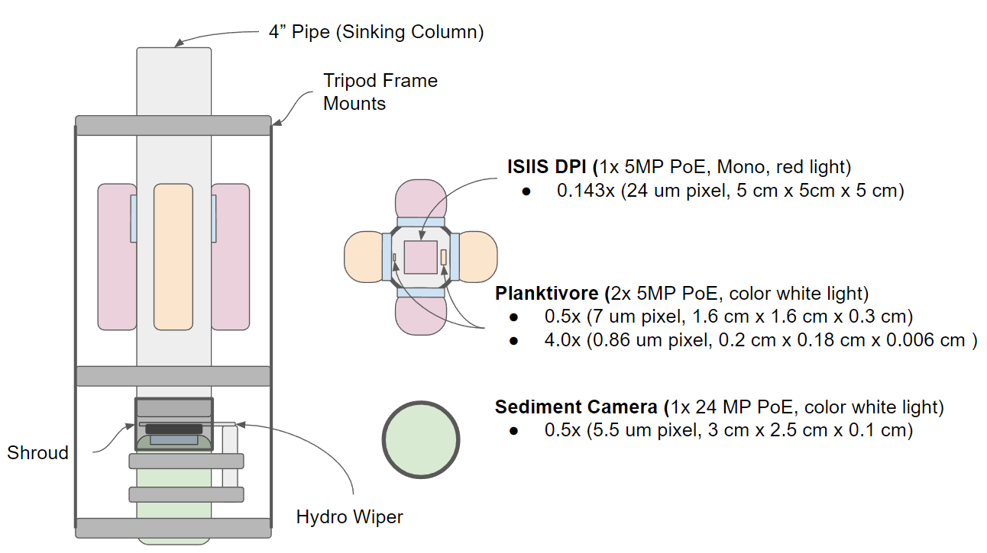

Figure : Conceptual drawing of the system showing the two free-space imaging systems (ISIIS DPI and Planktivore) imaging sinking particles through the side of the 4” pipe. At the bottom of the pipe a sediment camera images particles that collect on the viewport. A Zebra-Tech hydro wiper periodically cleans the port on regular intervals to define the accumulation time.

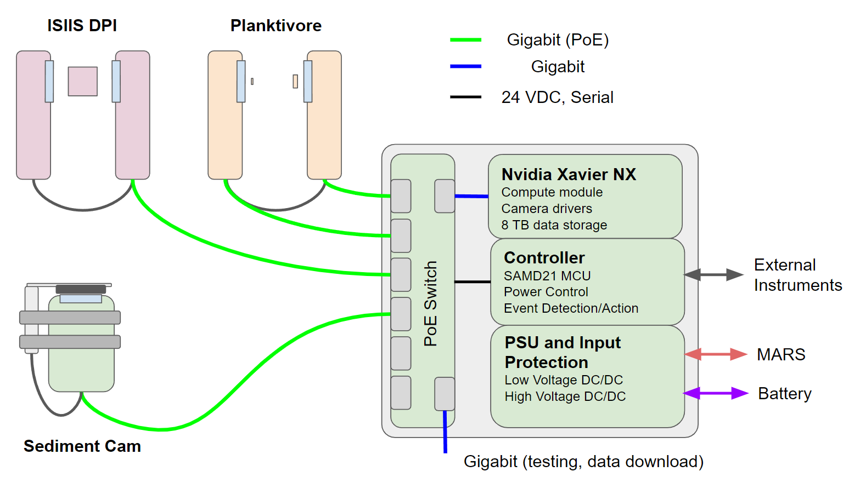

Figure : Block diagram of the high-level system interface. The three imaging systems connect to the interface through Power over Ethernet (PoE). Inside the interface can a managed PoE switch interfaces with the Nvidia Xavier NX for camera control, image acquisition, image processing and local storage. A microcontroller interfaces the upstream power systems with the NX and PoE switch. Ethernet data is accessible from the system either through MARS or through a dedicated gigabit port.

- This is a new engineering effort that leverages existing technologies previously developed at MBARI (Planktivore, EyeRIS, SES). The instrument will be designed to be plugged in at the MARS node and will collect in situ images of sinking particles in order to quantify both carbon flux and sinking speeds of different particle types. Images will identify the ecological source of particles (various fecal pellet types, aggregates, organisms, various particle sizes) which are used to estimate their contributions to carbon fluxes.

- We anticipate using the existing Planktivore camera design and an existing commercially available imaging system (ISIIS). Design of the upward-facing camera will build upon existing camera system designs (e.g. SES). The new instrument will utilize existing infrastructure (MARS), will be deployable using MBARI assets (e.g. Rachel Carson).

- Data generated by this instrument will be processed and stored using existing computational structures designed for the EyeRIS and Planktivore cameras.

- Efforts during the first year will primarily consist of designing, building, and testing in the test tank. When the MARS node becomes available in 2024, efforts will shift toward field deployments, calibrations, and data processing.

Anticipated Shared Resource Needs
Project Team includes:
- Paul Roberts (~300 hrs)
- Alana Sherman/Paul McGill (~300 hrs total)
- Francois Cazenave (~300 hrs)
- Machinist to fabricate parts
- Mechanical and Electrical technician help for assembly
Facilities
- Machine shop
- test tank
- future years: ship time and ROV to deploy and test at sea
- MARS node

We anticipate that the level of effort will remain consistent for the first two years of this effort as we develop and deploy the instrument. Some of these resources will be in less demand once the instrument is deployed and collecting data.

Anticipated Expenses
This project’s direct expenses will probably fall between $50k-100k. Due to the requirement of long (1 year) deployment duration, we anticipate most of the pressure housings will be made from Titanium. However, there may be existing Ti housings we can reuse to lower the costs. The same is true for ODI connectors to operate on MARS, if we can borrow or reuse some we could save a lot of money (and time).

Intellectual Property (IP) Considerations

No, since we expect to build this out of existing instrumentation.

Data
The instrument will use Gigabit Power over Ethernet (PoE) to interface with the three imaging systems. A managed PoE switch will connect the Planktivore, ISIIS DPI, and sediment camera instruments to the interface can. Inside the interface an Nvidia Jetson Xavier NX compute module will connect to the cameras through the PoE switch for camera control and image acquisition. The NX will have an 8TB NVME drive for local data storage and gigabit ethernet for external data download / realtime transfer.

A SAMD21 microcontroller will interface the NX and the PoE switch to power input ports on the interface can for low-voltage battery operation (for short duration deployments and testing) and long duration operation on MARS. The controller will also enable the system to enter a low-power sleep mode ( ~ 10mW) while listening for external input to trigger short duration imaging events based on external sensor data. During these events the controller will bring up the NX and PoE switch for a configurable length of time and then gracefully shut them down to save power during battery-powered missions.

Images will be acquired of particles sinking in the water column and settling on the sediment camera plate. Building from the existing real-time detection software built for EyeRIS and Planktivore, these images will be processed locally on the NX to extract regions of interest and particle size and location information in real-time. These reduced data will be stored locally and also transferred remotely to a server on shore (when a connection is available).

Worst-case archival data storage requirements for the system are 60 TB/year for continuous operation at very high temporal resolution. Expected use cases will likely be on the order of 5-10 TB/year. Up to 8 TB could be stored locally on the instrument. Data will be stored locally on spinning disk storage for post processing and web hosting using the RIMS database developed for EyeRIS and Planktivore. Archival data not needed for immediate analysis would be stored on LTO tape.

Anticipated Impact
Sustained, ecologically-resolved observations of particle fluxes in Monterey Bay will benefit most core lab projects at MBARI, either by contributing contextual data related to carbon flux or by observing specific organisms/fecal pellets of interest to individual programs. In the long-term, this tool could be exported for use at other cabled observatories or be deployed on batteries for uncabled process studies. This instrument could be co-deployed and/or linked with the SES to capture complimentary observations of flux. After we demonstrate a successful deployment of this instrument, we anticipate making a future request to create a public-facing website so that data on carbon export in Monterey Bay can be easily accessed and explored by anyone. This would likely occur beyond the 3-year scope of the current proposal.

Anticipated Outreach Needs

This need would only arise at the end of the 3-year project, after demonstrating a successful instrument design and deployment (likely within the Carbon Flux Ecology lab project).

