Project Number:

Project Start: Jan. 1, | 2023 | Project Duration (in years): | 2 of 3

Please indicate if proposal includes requests for any of the following (mark all that apply).

Ship Time |  |  | ROV |  |  | AUV |  |  | Wave Glider |  |  | Mini ROV

Please indicate what type of project is being proposed (mark only one).

 |  |  |  | x
Feasibility/Scoping  [<100 days effort] |  |  | Development |  |  | Research |  |  | Infrastructure² |  |  | Education |  |  | Time Series |  |  | Institute Initiative

Project Manager: Paul Roberts
Principal Investigator: Colleen Durkin
Lead Scientist: Francisco Chavez
Lead Engineer: Paul Roberts

Project Title: SINKER

Please indicate which category best describes the project theme (mark only one).

 | x
Ocean  biogeochemistry |  |  | Ecosystem dynamics |  |  | Ocean visualization |  |  | Exploration & discovery

Please indicate percentage of effort on this project anticipated for 2023 toward these three highest institutional goals (percentage total should equal 100%).

Goal | Developing/adapting innovative technologies | Utilizing developments to explore and understand ocean systems | Technology/knowledge transfer
Percentage | 35 | 65 | 0

- ABSTRACT (all projects)
Briefly provide a high-level summary of the project (ideally no more than 1/2 page).

The mechanisms that control carbon export to the deep ocean by sinking particles are under-observed and poorly modeled, due in large part to the difficult of maintaining biologically-resolved observations of particle flux over time. This project will develop a new instrument capable of imaging sinking particle types, measure their fluxes, measure their sinking speeds, and sustain these measurements over ecologically and biogeochemically relevant time periods. The SINKER (SINKing Ecology Robot) will be moored on the seafloor, initially designed for deployment at the MARS cabled observatory. When sinking particles settle through a collection cylinder, they will be imaged by a set of cameras, and images will be used to identify particle types (e.g. fecal pellet, aggregate, organism) and to calculate their sinking speeds. To detect the full size range of particles that influence the ecology of carbon export, two side-facing camera systems will be used that focus on different imaged volumes. To calculate fluxes, a set of upward facing cameras will image particles after they settle on an upward-facing collection plate. The frequency and time-integration of these upward facing cameras will enable more robust calculations of flux than is possible from the side-facing cameras. A wiper will be used to clean off the particles from the imaging plate. The ability to sustain ecologically-resolved observations of sinking particles will transform our understanding of the biological carbon pump and enable major advances in biogeochemical modeling and monitoring.

- PROPOSAL (all projects)

Background
- Importance: Sinking particles transport particulate organic carbon away from the surface ocean and into the deep ocean, where they fuel deep sea ecosystems and also sequester carbon away from the atmosphere. The amount of carbon exported to the deep ocean is poorly quantified and modeled, and there is growing consensus that ecological mechanisms of particle export must be accounted for to improve estimates.
- Problem: We do not fully understand the time scales over which these ecological mechanisms of carbon export vary (e.g. hourly to seasonal), and current methodological approaches cannot adequately sustain observations over relevant time scales. We do not know how fast different particle types sink, which limits our ability to incorporate biological details into models. We need new technology that can solve these observational limitations.

- SINKER will be capable of collecting continuous observations of the sinking particles, generating ecological-resolved observations of flux and sinking speeds from a bottom-moored location, sustainable over long time periods and at high time resolution.

- The data generated by SINKER would differ from existing technologies by resolving sinking particle size, sinking speed, identity, and quantity. In this way it will complement the capabilities of pelagic particle imaging instruments, which cannot distinguish between sinking and non-sinking particles, and also other sediment traps that cannot fully resolve the size, identity, and sinking speed of captured particles.

- This instrument development project is linked to the goals of the Carbon Flux Ecology (902111) project and synergistic with the proposed SES development project (led by C. Huffard), and is a fundamental part of the Durkin lab’s mission within the next 5 years to create autonomous and remote observational approaches that resolve the ecological drivers of carbon export.

Nature and Scope of the Proposed Project
Please provide a sense of the scale and scope of the proposed work. Is this a large de novo R&D effort, modest platform/sensor integration, targeted science investigation with minimal or no engineering needs, extension of current program, small-scale scoping exercise expected to lead to a larger effort, or other? If the project is intended to be multiple years, how will the anticipated level of effort likely change over time?

- This is year 2 of a new engineering effort that leverages existing technologies previously developed at MBARI (Planktivore, EyeRIS, SES). The instrument will be designed to be plugged in at the MARS node and will collect in-situ images of sinking particles in order to quantify both carbon flux and sinking speeds of different particle types. Images will identify the ecological source of particles (various fecal pellet types, aggregates, organisms, various particle sizes) which are used to estimate their contributions to carbon fluxes.

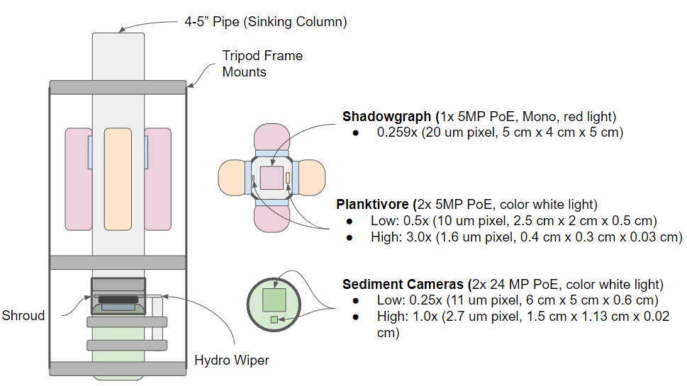
- We will reuse the existing Chiton 1500 m AUV pressure housing design for the upward facing sediment cameras build on the existing Planktivore housing design and optics to implement the shadowgraph and Planktivore cameras with a common pressure housing design shared between all four optics pods. The new instrument will utilize existing infrastructure (MARS), and will be deployable using MBARI assets (e.g. Rachel Carson).

Figure 1. Conceptual drawing of the system showing the two free-space imaging systems (Shadowgraph and Planktivore) imaging sinking particles through the side of the 4” pipe. At the bottom of the pipe a sediment camera images particles that collect on the viewport at two complimentary magnifications. A mechanical wiper periodically wipes the upward facing port clean to initiate a new sample.

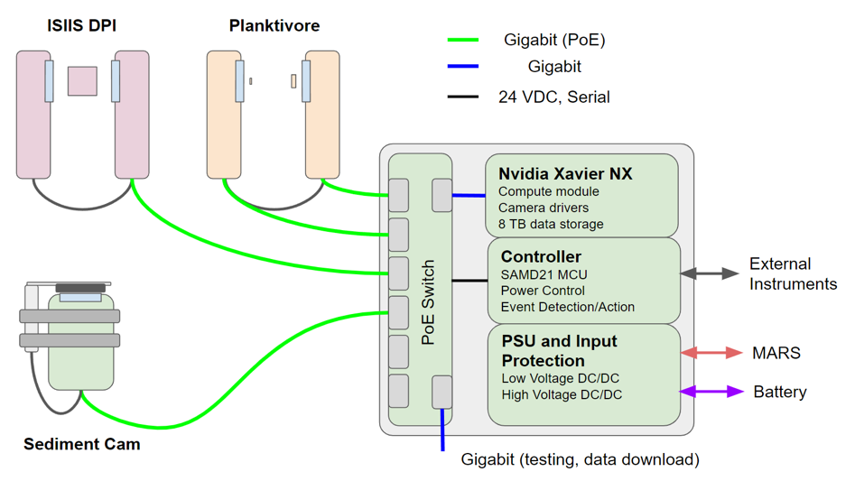
Future contextual sensors
Figure 2: Block diagram of the high-level system interface. The three imaging systems connect to the interface through Power over Ethernet (PoE). Inside the interface can, a managed PoE switch interfaces with the Nvidia Xavier NX for camera control, image acquisition, image processing and local storage. A microcontroller interfaces the upstream power systems with the NX and PoE switch. Ethernet data are accessible from the system either through MARS or through a dedicated gigabit port.

- The choice of camera systems is based on our requirements to
1) identify particle types from 50−5000 µm
2) assign sinking speeds to those particle types
3) accurately quantify their fluxes.
The shadowgraph camera will effectively detect sinking speeds of large, rare particles (~500−5000 µm) because it images and focuses through a large volume. The Planktivore cameras will measure the sinking speeds (m d⁻¹) of smaller particles (~30−300 µm high magnification, ~200-1500µm low magnification). Because these cameras will not be running continuously or sample sufficient volume to accurately quantify fluxes (# m⁻² d⁻¹), the upward facing cameras will be required for flux calculations.

- Software efforts in year 1 will integrate Chiton and Planktivore camera acquisition software for camera control, region of interest detection, and recording. Data from SINKER will be integrated into the RIMS database to visualize camera data.

- Efforts during the first year will primarily consist of designing, building, and testing in the test tank. When the MARS node becomes available in 2024, efforts will shift toward field deployments, calibrations, and data processing.

Does this activity relate to one or more 2024 proposals your team is submitting?
If so, provide a list of relevant projects by project/DQ # and provide a brief description of how they are related. Since resources are limited and cuts during Phase 1 are likely, please indicate where this project fits in the hierarchy of your priorities. Does this proposal take precedent over other ongoing or planned activities?

- 902111: Carbon Flux Ecology – long-term Sinker operation will be included in this project
- 902305: SES – complimentary but different flux observations sustained over time. The SES could be used to trigger battery-powered SINKER deployments.
- 701164: SnoCam+ (external, NSF-OTIC) – Similar upward facing camera design for a synergistic effort but applied to upper mesopelagic Lagrangian platforms.

.

Anticipated Shared Resource Needs
What staffing is required to advance the work in 2023 (e.g., is this a multi-faceted engineering development or a targeted science investigation that does not require significant use of shared personnel)? Is in-house or contract manufacturing needed? What level of ship/ROV/AUV (DMO) support is likely? If this is intended to be a multi-year effort, please provide a rough indication of anticipated shared resource needs over the duration of the project (e.g., will stay flat, will significantly increase in Year X, will significantly decrease by Year Y).

Project Team includes:
- Alana Sherman- EE (~ 100 hrs)
- Paul Roberts- SE/EE (~150 hrs)
- George Stern- EE (~150 hrs)
- Paul McGill- EE (~200 hrs)
- Enoch Nicholson - ME (~400 hrs)
- Francois Cazenave – (~200 hrs)
- Rich Henthorn – SE (~150 hrs)
- Carlos Rueda – SE (~250 hrs)
- Machinist to fabricate parts
- Mechanical and Electrical technician help for assembly
Facilities
- Machine shop
- Test tank
- Ship time and ROV to deploy and test at sea
- MARS node

We anticipate that the level of effort will remain consistent for the first two years of this project as we develop and deploy the instrument. Some of these resources will be in less demand once the instrument is deployed and collecting data.

Anticipated Expenses
What rough order of magnitude direct expense budget is anticipated annually over the course of the project? Is procurement of specialized capital equipment or outside contractors required? Will there be annual travel?

This project’s direct expenses will be under $85k. The major cost item is purchasing the Aquadopp current profiler ($25k) and purchasing cables and connectors as needed for MARS integration ($30k). Remaining budget expenses are to support iteration of the wiper mechanical design ($15k) and building additional battery packs for stand alone deployments ($15k) if MARS is not available.

Intellectual Property (IP) Considerations

None, since we expect to build this out of existing instrumentation.

Data

Images will be acquired of particles sinking in the water column and settling on the sediment camera plate. Building from the existing real-time detection software built for Chiton and Planktivore, these images will be processed locally on the NX to extract regions of interest, particle size, and location information in real time. These reduced data will be stored locally and also transferred remotely to a server on shore (when a connection is available).

Worst-case archival data storage requirements for the system are 60 TB/year for continuous operation at very high temporal resolution. Expected use cases will likely be on the order of 5–10 TB/year. Up to 8 TB could be stored locally on the instrument. Data will be stored on shore on spinning disk storage for post processing and web hosting using the RIMS database developed for Chiton and Planktivore. Archival data not needed for immediate analysis would be stored on LTO tape.

Anticipated Impact

Sustained, ecologically resolved observations of particle fluxes in Monterey Bay will benefit most core lab projects at MBARI, either by contributing contextual data related to carbon flux or by observing specific organisms/fecal pellets of interest to individual programs. In the long term, this tool could be exported for use at other cabled observatories or be deployed on batteries for uncabled process studies. This instrument could be co-deployed and/or linked with the SES to capture complementary observations of flux.

Anticipated Outreach Needs

None expected during the instrument development period

Continuing Projects Only: Status Report
Briefly provide an update of the current project relative to what was proposed for 2022 by responding to the prompts below. If the project includes multiple subproject projects, please list each of these under a subheading as you deem appropriate.

Current status of project and results to date

Most of the design resources for the project have been utilized and we are ready to begin fabrication of the housings, electronics, and instrument frame pending a design review. We are still on track to have the system built and tested by the end of the year.

What percentage of labor and budget have been used through the 1st half of year?

Thus far we have used 59% of the budgeted labor and 71% of the budgeted expenses. The bulk of the expenses were purchased in 2022 through a budget transfer.

Will you complete the current year’s scheduled work?

It is likely we will complete the proposed work this year with the exception of an integration on the sediment camera wiper design that was deemed necessary in the design process. This activity will be performed next year after we have collected field data.

Significant changes from previous project proposal

The only significant change from the previous proposal is to purchase and integrate a high-resolution acoustic profiler (3000m Aquadopp Profiler 2MHz) to SINKER. This will enable measurement of three-component currents along a profile of several meters length with centimeter resolution ranging from the base of the instrument up to a meter above the sinking column. Because the SINKER is a moored instrument near the seafloor, collecting co-located observations of current speeds with our flux observations will be critical for data interpretation. Available data from this region suggest that our trap design will collect particles with minimal bias >90% of the time, but will have an under- or over-colleciton bias during intermittent periods of high current speeds. We will require current speed measurements to account for this bias.

Over the past two years, what peer-reviewed publications, education and/or outreach activities have resulted directly from this project? Please be brief.

We are 6 months into year 1 of this project and have not produced any publications.

All Projects: Specific Plans for 2024

Research Activities

This project is primarily an engineering/technology development effort. Research efforts in 2024 will primarily be toward processing and analysis of any data generated by test deployments. We will use tools similar to those designed for other imagers (e.g. SES, Planktivore, Chiton) to generate preliminary results that help us determine whether modifications are needed for future test deployments

Engineering/technology development

Engineering efforts in 2024 will primarily be focused on integrating SINKER with MARS, adding a current profiler, and iterating the mechanical wiper design to address any issues that might arise in test deployments. In addition to the hardware tasks, a prototype web interface to SINKER will be developed to enable particle statistics and images to be viewed from shore when SINKER is integrated with MARS.

Field programs (detail ship requirements/deployments/diver requirements)

In addition to describing anticipated field programs, please be sure to include requirements for specific platforms and equipment (Dorado AUVs, LRAUVs, Wave Glider, mini ROV, etc.) for each proposed field program so that expectations are clear. Requests must also be entered in the budget entry system.

SINKER will be ready for test deployment in early 2024, but it is unlikely that plugs at the MARS node will be available until later in the year. We plan to conduct:
- Two, 1-week deployments of SINKER on battery power to test basic functionality when moored on the seafloor
- One, 1-month deployment of SINKER at MARS when plugs become available. Presumably SINKER will need to be recovered for modification.
- One redeployment of SINKER at MARS for the remainder of the year and into 2025.

# of Days | Ship | Vehicle needs | Requested dates | Deployment objectives
7 | R/V Rachel Carson | ROV Ventana | Feb, May, Sept | Deploy and recover SINKER at MARS

Specific deliverables

- SINKER will be deployed at MARS and left to run continuously for 1 year by the end of the year.
- The Sediment camera wiper mechanism will be revised as needed based on field deployments and qualified for long term use (up to 1 year) at 1000 m
- A high-resolution acoustic sensor will be added to SINKER to enable real-time 3C current measurements to enhance carbon flux estimates
- A preliminary data visualization portal will be developed to provide access to particle statistics and particle images

Milestones and required personnel (see personnel classification list for staff classifications)

2023 Project Start Date:  01/02/2023 | Milestone 1 | Milestone 2 | Milestone 3 | Milestone 4 | Milestone 5 | Total Resources (in hours) for each resource category for all milestones listed here
Milestone Date | 1st quarter | 1nd quarter | 2r^{d} quarter | 3rd quarter | 4th quarter
Milestone Description | Integration of Aquadopp | MARS deployment | Wiper Qualification | MARS Deployment | Data Visualization web interface
Electrical Engineer  (Paul R., Paul M. Geroge Stern, Alana S.) | 100 | 100 | 130 | 230 | 60 | 620
Software Eng-Embedded  (Rich H.) | 80 |  | 80 |  |  | 160
Software Eng-Info Eng  (Carlos R.) |  |  |  | 160 | 160 | 320
Mechanical Engineer  (Enoch and Francois) | 100 | 150 | 150 |  |  | 400
Mechanical Eng-Division
Mechanical Eng-Mfg
Associate Engineer
Electrical Tech |  | 60 | 60 |  |  | 160
Software Tech
Mechanical Tech | 80 | 80 | 80 | 60 |  | 300
Machinist |  | 80 | 80 |  |  | 160
Divers
Video Lab
(Add other categories/rows as needed)

Budget justification

The main new expense in 2024 is to purchase and integrate a Nortek Aquadopp ADP into SINKER. The aquadopp cost is $25k. Additional funds are requested for wiper materials and revision to the wiper design as needed, maintenance on existing parts in SINKER, and MARS integration.

Item | Cost | Notes/Details
Nortek Aquadopp profiler 2 MHz (3000 m housing) | $25k | $20k for instrument purchase, $5k for cables, connectors and parts to integrate with SINKER
MARS integration / SINKER maintenance | $30k | Cables, connectors, and fixtures as needed to integrate with MARS
Sediment camera wiper iteration | $15k
Additional battery packs for standalone deployments | $15k

Project team

Paul Roberts
Alana Sherman
Paul McGill
François Cazenave
Colleen Durkin
Francisco Chavez
Enoch Nicholson
Carlos Rueda
George Stern
Ray Thompson (Machine Shop)
James McClure (Electronics Tech)

External consultants/contractors
If you propose to engage an external consultant/contractor, please attach a sufficiently detailed SOW and budget proposal from the vendor. If approved, a fully executed Independent Contractor Agreement must be in place before work can begin.

None planned

Project lab and office space requirements
In addition to any changes to current space usage, please also include anticipated office and lab needs for students, postdocs, collaborators, etc.

We plan to continue to use the table allocated in the common use lab and space in the Durkin lab. To the extent possible, we could like to consolidate SINKER with other imaging systems into an imaging lab space.

Risk matrix (development and infrastructure projects only)

 | Technical Risk | Organizational Risk | Tech Transfer Risk | Labor Estimate Risk
High
Medium |  | X
Low | X |  | X | X

Compliance Considerations
Please respond “Yes” or “No” to each line item below, and provide details as necessary.

CATEGORY | Yes/No | DETAILS
Isotope Use (see policy and cruise planning)  Will the project use stable or radioisotopes? | No
Battery waste over 4 liters (1 gallon)  Indicate type and amount. | No
Liquid hazardous waste over 60 liters (15 gallons)  Indicate composition and quantity. | No
Export Regulation  Foreign collaborations or international travel? | No
Technology access  Any potential exposure to proprietary information about export controlled equipment? | No
Export controlled purchases  Items purchased/in possession or to be purchased that are not on list? | No
Export controlled items (hardware, software, tech data)  Items to be transferred outside US (temporarily or permanently)? To what countries (including International Waters)? | No
Encryption Items  Use of non-commercial (specially licensed, non-mass-market) encryption or information security software? | No
Work covered by Marine Sanctuary permit?  Yes, if work falls under blanket authorization. | Yes | We spoke to Mandy about this
Work conducted in SESAs?  ID # for Sanctuary Ecologically Significant Areas | No
Equipment deployed with anchors?  Give details for deployment; recovery if < 500lbs | Yes | We plan to deploy SINKER at MARS by the end of 2024 and leave it there for one year
CA Fish & Wildlife permit required for samples? | No
Working in State Marine Protected Area? | No
Require Coast Guard PATON for buoys?  Private Aid to Navigation. Permit in hand? | No
Require Local Notice to Mariners  Indicate who will be submitting | No
Permits from other agencies? | No
Use of active acoustics not already on list? | Yes | Nortek Aquadopp (2 MHz)

This date and number should remain the same for the duration of the project. If your project start date for 2023 is not January 1, please indicate the start date in the first cell of the milestone chart. Format for duration example: “Year 2 of 5”.
Development and infrastructure projects must complete the risk matrix (see end of the proposal form).
Not all projects will require all four titles to be filled in. Please indicate individuals only for those titles that are appropriate for your project.
This category includes transfer of hardware, know-how, publications, presentations, etc.
This number should be the same number you entered on the web budget resource requests for this particular resource.

