Project Number: | 902306

Project Start: Jan. 1, | 2023 | Project Duration (in years): | 3 of 3¹

Please indicate if proposal includes requests for any of the following (mark all that apply).

 | x |  |  | x
Ship Time |  |  | ROV |  |  | AUV |  |  | Wave Glider |  |  | Mini ROV

Please indicate what type of project is being proposed (mark only one).

 |  |  |  | x
Feasibility/Scoping  [<100 days effort] |  |  | Development |  |  | Research |  |  | Infrastructure² |  |  | Education |  |  | Time Series |  |  | Institute Initiative

Project Manager: Paul Roberts
Principal Investigator: Colleen Durkin
Lead Scientist: Francisco Chavez
Lead Engineer: Paul Roberts

Project Title: SINKER

Please indicate which category best describes the project theme (mark only one).

 | x
Ocean  biogeochemistry |  |  | Ecosystem dynamics |  |  | Ocean visualization |  |  | Exploration & discovery

Please indicate percentage of effort on this project anticipated for 2025 toward these three highest institutional goals from the Strategic Roadmap (percentage total should equal 100%).

Goal | Innovate and Build | Explore and Protect | Inspire and Engage
Percentage | 65 | 35 | 0

- ABSTRACT (all projects)
Briefly provide a high-level summary of the project (ideally no more than 1/2 page).

The mechanisms that control carbon export to the deep ocean by sinking particles are under-observed and poorly modeled, due in large part to the difficult of maintaining biologically-resolved observations of particle flux over time. This project will develop a new instrument capable of imaging sinking particle types, measure their fluxes, measure their sinking speeds, and sustain these measurements over ecologically and biogeochemically relevant time periods. The SINKER (SINKing Ecology Robot) will be moored on the seafloor, initially designed for deployment at the MARS cabled observatory. When sinking particles settle through a collection cylinder, they will be imaged by a set of cameras, and images will be used to identify particle types (e.g. fecal pellet, aggregate, organism) and to calculate their sinking speeds. To detect the full size range of particles that influence the ecology of carbon export, two side-facing camera systems will be used that focus on different imaged volumes. To calculate fluxes, a set of upward facing cameras will image particles after they settle on an upward-facing collection plate. The frequency and time-integration of these upward facing cameras will enable more robust calculations of flux than is possible from the side-facing cameras. A wiper will be used to clean off the particles from the imaging plate. The ability to sustain ecologically-resolved observations of sinking particles will transform our understanding of the biological carbon pump and enable major advances in biogeochemical modeling and monitoring.

- PROPOSAL (all projects)

Background
Provide context for the project, being sure to address these questions:
- What fundamental problem does this project address, and why is it important?
- What makes this work relevant to MBARI and the Packard Foundation?
- Is this effort linked to other internal or externally funded projects or collaborative efforts?
- Where does this work fit into the ~5–10 year plan for your group, at MBARI, and in the field?

- Importance: Sinking particles transport particulate organic carbon away from the surface ocean and into the deep ocean, where they fuel deep sea ecosystems and also sequester carbon away from the atmosphere. The amount of carbon exported to the deep ocean is poorly quantified and modeled, and there is growing consensus that ecological mechanisms of particle export must be accounted for to improve estimates.
- Problem: We do not fully understand the time scales over which these ecological mechanisms of carbon export vary (e.g. hourly to seasonal), and current methodological approaches cannot adequately sustain observations over relevant time scales. We do not know how fast different particle types sink, which limits our ability to incorporate biological details into models. We need new technology that can solve these observational limitations.

- SINKER will be capable of collecting continuous observations of the sinking particles, generating ecological-resolved observations of flux and sinking speeds from a bottom-moored location, sustainable over long time periods and at high time resolution.

- The data generated by SINKER would differ from existing technologies by resolving sinking particle size, sinking speed, identity, and quantity. In this way it will complement the capabilities of pelagic particle imaging instruments, which cannot distinguish between sinking and non-sinking particles, and also other sediment traps that cannot fully resolve the size, identity, and sinking speed of captured particles.

- This instrument development project is linked to the goals of the Carbon Flux Ecology (902111) project and synergistic with the proposed SES development project (led by C. Huffard), and is a fundamental part of the Durkin lab’s mission within the next 5 years to create autonomous and remote observational approaches that resolve the ecological drivers of carbon export.

Nature and Scope of the Proposed Project
Please provide a sense of the scale and scope of the proposed work. Is this a large de novo R&D effort, modest platform/sensor integration, targeted science investigation with minimal or no engineering needs, extension of current program, small-scale scoping exercise expected to lead to a larger effort, or other? If the project is intended to be multiple years, how will the anticipated level of effort likely change over time?

- This is year 3 of a new engineering effort that leverages existing technologies previously developed at MBARI (Planktivore, Chiton, SES). The instrument is designed to be plugged in at the MARS node and will collect in-situ images of sinking particles in order to quantify both carbon flux and sinking speeds of different particle types. Images will identify the ecological source of particles (various fecal pellet types, aggregates, organisms, various particle sizes) which are used to estimate their contributions to carbon fluxes.
- The system consists of a common interface can that supports ROV and MARS deployment along with a collection of camera systems cabled to the interface can via power, gigabit ethernet, and RS-232. All housings are titanium with tempered glass flat view ports and 1000 m safe working depth. A drawing of the system with deployment frame is shown in Figure 1
- The choice of camera systems is based on our requirements to
1) identify particle types from 50−5000 µm
2) assign sinking speeds to those particle types
3) accurately quantify their fluxes.
The shadowgraph camera will effectively detect sinking speeds of large, rare particles (~500−5000 µm) because it images and focuses through a large volume. The Planktivore cameras will measure the sinking speeds (m d⁻¹) of smaller particles (~30−300 µm high magnification, ~200-1500µm low magnification). Because these cameras will not be running continuously or sample sufficient volume to accurately quantify fluxes (# m⁻² d⁻¹), the upward facing cameras will be required for flux calculations.
- Software efforts in year 3 will focus on software for autonomous deployment running on battery power, MARS integration, and developing a prototype dashboard for SINKER data and control.

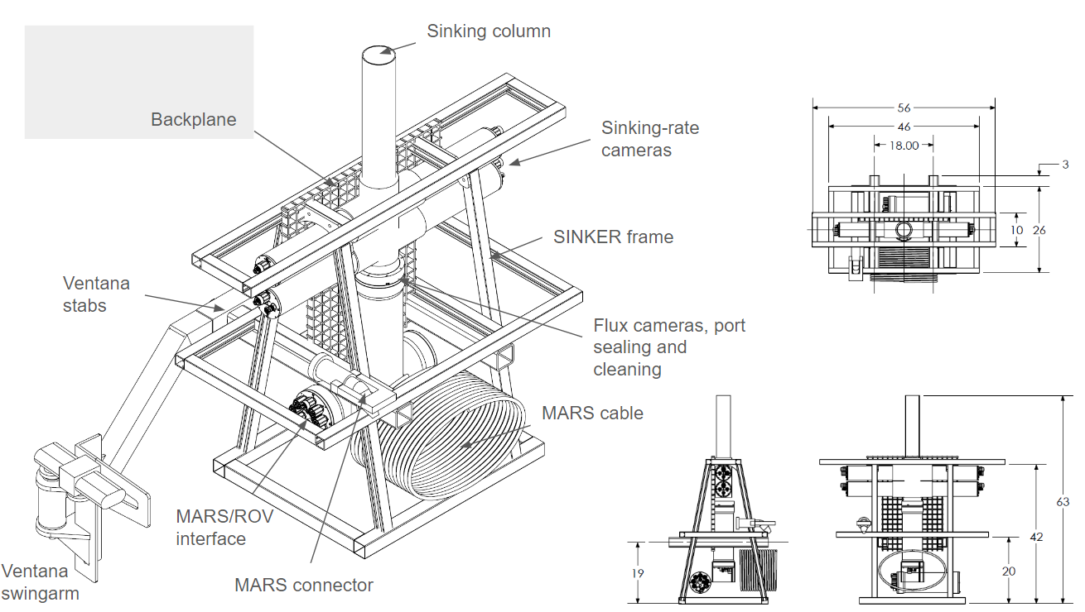
Figure 1: Drawing of the final SINKER deployment frame showing the system mounted to the stabs on the port-side ROV Ventana swingarm. Side- and top-view projections of the frame are shown on the right with dimensions in inches.

Does this activity relate to one or more 2025 proposals your team is submitting?
If so, provide a list of relevant projects by project/DQ # and provide a brief description of how they are related. Since resources are limited and cuts during Phase 1 are likely, please indicate where this project fits in the hierarchy of your priorities. Does this proposal take precedent over other ongoing or planned activities?

- 902111: Carbon Flux Ecology – long-term SINKER operation will be included in this project
- 902305: SES – complimentary but different flux observations sustained over time. We hope to deploy SINKER and SES together in 2025.
- 701164: SnoCam+ (external, NSF-OTIC) – Similar upward facing camera design for a synergistic effort but applied to upper mesopelagic Lagrangian platforms.

Anticipated Shared Resource Needs
What staffing is required to advance the work in 2025 (e.g., is this a multi-faceted engineering development or a targeted science investigation that does not require significant use of shared personnel)? Is in-house or contract manufacturing needed? What level of ship/ROV/AUV (DMO) support is likely? If this is intended to be a multi-year effort, please provide a rough indication of anticipated shared resource needs over the duration of the project (e.g., will stay flat, will significantly increase in Year X, will significantly decrease by Year Y).

Project Team includes:
- Paul Roberts- SE/EE (~160 hrs)
- George Stern- EE (~160 hrs)
- Paul McGill- EE (~160 hrs)
- Enoch Nicholson - ME (~320 hrs)
- Rich Henthorn – SE (~320 hrs)
- Carlos Rueda – SE (~240 hrs)
- Machinist to fabricate parts (~160 hrs)
- Mechanical and Electrical technician help for assembly and fabrication (~240 hrs)
Facilities
- Machine shop
- Test tank
- Ship time and ROV to deploy and test at sea
- MARS node

Anticipated Expenses
What rough order of magnitude direct expense budget is anticipated annually over the course of the project? Is procurement of specialized capital equipment or outside contractors required? Will there be annual travel?

As the development effort will be completed in 2024, we expect expenses under $30k to support purchase of additional MARS cables/connectors if needed, and maintenance of wear items on SINKER such as the actuators, and wiper.

Intellectual Property (IP) Considerations
Do you anticipate a need for a cooperative research and development agreement or licensing arrangement with an external entity? Will the work potentially result in a patentable product or service? Will novel IP and/or custom-made equipment be created, and how might it be disseminated (e.g., license agreement and/or collaborations)?

For additional guidance please review MBARI’s intellectual property internal web page: https://mww.mbari.org/itd/ip/.

None, since we expect to build this out of existing instrumentation.

Data
What data will be generated? How will they be managed/stored? Are any special data visualization needs anticipated?

Images will be acquired of particles sinking in the water column and settling on the sediment camera plate. Building from the existing real-time detection software built for Chiton and Planktivore, these images will be processed locally on the NX to extract regions of interest, particle size, and location information in real time. These reduced data will be stored locally and also transferred remotely to a server on shore (when a connection is available).

Worst-case archival data storage requirements for the system are 60 TB/year for continuous operation at very high temporal resolution. Expected use cases will likely be on the order of 5–10 TB/year. Up to 8 TB could be stored locally on the instrument. Data will be stored on shore on spinning disk storage for post processing and web hosting using the RIMS database developed for Chiton and Planktivore. Archival data not needed for immediate analysis would be stored on LTO tape.

Anticipated Impact
Who are the consumers of the instruments, methods, technology, and data that will be generated within and beyond MBARI? Will the project create tangible connections with other organizations (e.g., academic, NGO, MBA, MBNMS, state or federal agency)?

Sustained, ecologically resolved observations of particle fluxes in Monterey Bay will benefit most core lab projects at MBARI, either by contributing contextual data related to carbon flux or by observing specific organisms/fecal pellets of interest to individual programs. In the long term, this tool could be exported for use at other cabled observatories or be deployed on batteries for uncabled process studies. This instrument could be co-deployed and/or linked with the SES to capture complementary observations of flux.

Anticipated Outreach Needs
Thinking about the audiences/consumers you highlighted in the question above, do you anticipate needing to create outreach assets to help increase your impact? If so, please specify whether you anticipate needing to work with ITD and also specify what type of asset (story, graphic, animation, video, etc.) you might need.

None expected during the instrument development period

Continuing Projects Only: Status Report
Briefly provide an update of the current project relative to what was proposed for 2024 by responding to the prompts below. If the project includes multiple subproject projects, please list each of these under a subheading as you deem appropriate.

Current status of project and results to date

During the first half of 2024 we have completed two dives with the SINKER sediment cameras. Based on data collected during the dives it was determined that sealing the sinking column was essential and thus the sediment camera interface to the sinking column and wiper were redesigned. The new design is complete and will be tested in the field on July 9 2024.

Design of the external battery system is complete (including review with the EE BSC) and parts should be available for testing by the end of the summer of 2024.

Due to the need to redesign the wiper and sealing mechanism we have pushed deployment of the complete system (with side-looking cameras and acoustic sensor as shown in Figure 1) to oour last field day of 2024 in October.

What percentage of labor and budget have been used through the 1st half of year?

We have spent about 25% of the expenses and used 50% of the labor request. Spending on larger cost items like the Aquadopp and MARS cables will occur after our July cruises.

Will you complete the current year’s scheduled work?

We expect to complete the build of the system by the end of the year, but will not deploy on MARS until next year.

Significant changes from previous project proposal

No significant changes are planned

Over the past two years, what peer-reviewed publications, education and/or outreach activities have resulted directly from this project? Please be brief.

No publications have been produced yet. We expect to begin data collection for scientific applications once the instrument is complete and deployed at MARS

All Projects: Specific Plans for 2025

Research Activities

Research efforts in 2025 will be focused on processing and analysis of any data generated by test deployments. We will use tools similar to those designed for other imagers (e.g. SES, Planktivore, Chiton).

Engineering/technology development

Engineering efforts in 2025 will consist of completing an autonomous deployment of SINKER for roughly one-week, completing a coordinated deployment with SES at MARS, and subsequently deploying SINKER permanently on MARS.

Field programs (detail ship requirements/deployments/diver requirements)

In addition to describing anticipated field programs, please be sure to include requirements for specific platforms and equipment (Dorado AUVs, LRAUVs, Wave Glider, mini ROV, etc.) for each proposed field program so that expectations are clear. Requests must also be entered in the budget entry system. Note that AUV deployment numbers and diver requirement questions are also included in the Compliance and Planning Considerations Form described at the end of this proposal form.

# of Days | Ship | Vehicle needs | Requested dates | Deployment objectives
2 | R/V Rachel Carson | ROV Ventana | March | Deploy and recover SINKER  in stand-alone configuration
2 | R/V Rachel Carson | ROV Ventana | July | Deploy and recover SINKER at MARS for testing with SES
3 | R/V Rachel Carson | ROV Ventana | Oct | Deploy SINKER at MARS with opportunity to recover and redeploy if needed.

Piloting/Watchkeeping
If you plan to use a platform that requires piloting/watchkeeping, please provide a high level staffing plan, including who will be responsible for these duties.

We do not plan to use any platforms that require piloting/watchkeeping

Specific deliverables

- SINKER will be deployed autonomously for 1-2 weeks
- SINKER will be deployed at MARS and left to run for up to one month in coordination with SES deployments.
- A preliminary data visualization portal will be developed to provide access to particle statistics and particle images
- SINKER will be deployed at MARS and left to run continuously by the end of the year.

Milestones and required personnel (see personnel classification list for staff classifications)

[Click here to enter text]

2025 Project Start Date:  MM/DD/2025 | Milestone 1 | Milestone 2 | Milestone 3 | Milestone 4 | Milestone 5 | Total Resources (in hours) for each resource category for all milestones listed here
Milestone Date | 1st Quarter | 2nd Quarter | 3rd Quarter | 4th Quarter
Milestone Description | Autonomous deployment | Coordinated deployment with SES at MARS | Data Portal | MARS deployment
Electrical Engineer | 160 | 160 | 40 | 160 |  | 520
Software Eng-Embedded | 240 | 120 |  |  |  | 360
Software Eng-Info Eng |  |  | 240 |  |  | 240
Mechanical Engineer | 160 | 80 |  | 80 |  | 320
Mechanical Eng-Division
Mechanical Eng-Mfg
Associate Engineer
Electrical Tech | 40 | 20 |  | 40 |  | 100
Software Tech
Mechanical Tech | 40 | 20 |  | 40 |  | 100
Machinist | 40 | 20 |  | 40 |  | 100
Divers
Video Lab
(Add other categories/rows as needed)

Budget justification

Item | Cost | Notes/Details
MARS integration | $20k | Gigabit MARS cable/connector upgrade as needed.
SINKER maintenance | $15k | Replacing wear items, fixtures, and actuators as needed

Project team

Colleen Durkin
Francisco Chavez
Paul Roberts
Alana Sherman
Paul McGill
George Stern
François Cazenave
Enoch Nicholson
Carlos Rueda
Rich Henthorn

Ray Thompson
James McClure

External consultants/contractors
If you propose to engage an external consultant/contractor, please attach a sufficiently detailed SOW and budget proposal from the vendor. If approved, a fully executed Independent Contractor Agreement must be in place before work can begin.

None Planned

Project lab and office space requirements
In addition to any changes to current space usage, please also include anticipated office and lab needs for students, postdocs, collaborators, etc.

We plan to continue to use space in the Durkin lab. To the extent possible, we could like to consolidate SINKER with other imaging systems (Chiton, EyeRIS, Planktivore, Piscivore-Cam, 4k camera, Optim camera) into an imaging lab space if/when such a space may become available.

Risk matrix (development and infrastructure projects only)

 | Technical Risk | Organizational Risk | Tech Transfer Risk | Labor Estimate Risk
High
Medium |  | x
Low | x |  | x | x

Compliance and Planning Considerations

All responses must be recorded in the Google form linked below. A form must be submitted for every project.

Link to Google Compliance and Planning Considerations form -OR- https://forms.gle/mRYKKEztAPYaiTz7A

This date and number should remain the same for the duration of the project. If your project start date for 2025 is not January 1, please indicate the start date in the first cell of the milestone chart. Format for duration example: “Year 2 of 5”.
Development and infrastructure projects must complete the risk matrix (see end of the proposal form).
Not all projects will require all four titles to be filled in. Please indicate individuals only for those titles that are appropriate for your project.
This category includes transfer of hardware, know-how, publications, presentations, etc.
This number should be the same number you entered on the web budget resource requests for this particular resource.

