Sinker electrical test plan
SAMD21 SOM
- Plug in USB cable and verify 3.3V.
- Flash Arduino bootloader from programming header
- Flash Hardware checkout build and replug in USB.
- Report Build # and test menu in the terminal
- Run led test (on 1s, off 1s 5x)
- Run flash test (suggest read write erase A5/5A and report)
- Run sensor test to verify sensor communication and I2C bus reset
  - Set BME280off low and talk to BME280 and at minimum report communication or respond with current pressure, temp, humidity
  - Set BME280off high and verify no communication
- Run Vref test (configure 3.3V as reference, report PA04 voltage)
- Run RS232 test (connect Port 1 TX/RX to Port 2 RX/TX. Verifies communication, TX and RX enable and RS232 connected discretes which could be used to wake the uC and enable the transciever)
  - enable both channels: RS232_P2TXon(PA14), RS232_P2RXon(PA15), RS232_P1TXon(PA06), RS232_P1RXon(PA07)
  - send A5 through 10x at 115kbps and verify reception
  - Verify PA27 and PA28, (valid com channel connected), are high
  - Disable P2 TX and verify PA27, P1 valid com channel) goes low
  - Disable P1 TX and verify PA28, P2 valid com channel) goes low
  - Enable P1 and P2 TX and disable RX, transmit a bit and verify no communication
  - Report results
- Run Open collector test (connect an LED to Open collector from 3.3V, set OC_en and LED high 1s then low 1s 5x)
- Run a GPIO test until a key is entered to stop (catch solder bridges\opens by using a scope to verify IO change only when they are supposed to).
  - Apply a pull up on PA02/03/10/11/18/19/20/21, PB02/03/22/23.
  - Set each pin one by one to 0 for 0.5s starting with PA02, PA03… PB23 and then restarting until a key is entered. Toggle the LED on each change.
- Run a camera strobe trigger test
  - Report the status of the PA02 (high means the strobes are charged and ready to fire)
  - Create low to high edge on PA10
  - 5us later create a 5us wide high pulse on PB02

Sinker Control Board
Run steps 1 – 8 under SAMD21 SOM. Pinout and controller are identical and the same SW module and bootloader may be used.
9) Check I2C RTC time and date – this will work after the daughter board chip has been installed (planned for late December 2023).
a) Using the I2C bus, send the read time message to 0x53 and display the current time, time is formatted in BCD format
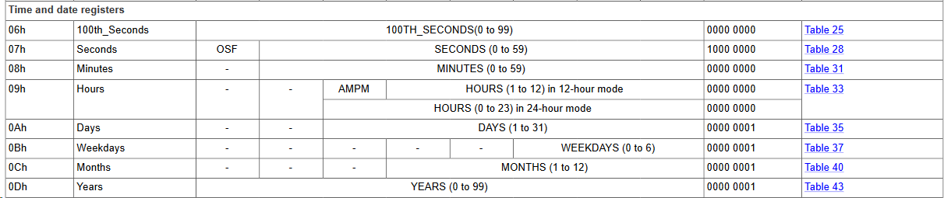
b) ask the user if they wish to enter a new time; if so, perform an OTP reset to load calibration data into flash for low power battery operation and then set the time to the desired value
c) install RTC battery, remove all board power for ~1min and run 9a to verify RTC power
d) run an interrupt test; configure the alarm function for a time 1s in advance, configure interrupts and set the uC to look for a high to low transition on PB22.
10) Initialize all the external peripherals to off and verify the I2C GPIO expander talks
a) Set PA09, GPI0reset_L high taking the GPIO port out of reset.
b) Using the I2C bus, send a command to 0x20 to write 0x0 to output registers 0x02, 0x03 to initialize outputs to 0.
c) Write 0x0 to output registers 0x06, 0x07 to configure the pins as outputs
d) Read back all written addresses and verify they match programmed state.
Note: during normal operation, the card should run this initialization procedure shortly after startup. GPIO channels will be turned on and enabled during the following steps.
11) Check system power utilization by reading the values from the battery charger (0x68) via the I2C bus. Read:
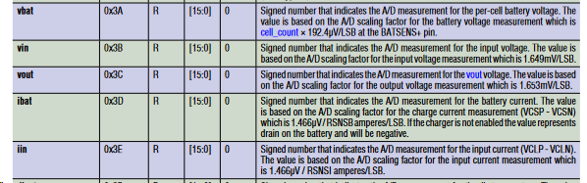

- Test the 12V rail. The rail provides power to AGX Orin/Ethernet Switch after their respective power gates are enabled; disable the supply when unused to minimize power.
- Set PB03 high to enable 12V
- Measure 12V across TP5/6
- Enable the ethernet switch. Note: the enable is logically ORed with the RPI watchdog so either interface may control it.
a) set PA14 high
b) measure 12V on J9 pins ½ and verify it can drive a >350mA load (or the switch); note: there may be some leakage even if the interface is off.
- Test uC Orin Interfaces: Power, strobe, and UART. All interfaces are available regardless of the state of Orin. SW should tristate the UART and strobe pins when Orin is shutoff to minimize current draw.
- Strobe: uC Strobe input PA27/J16-4 and uC Strobe output PA28/J16-5 were added as a provision for time sensitive communication between the uC and Orin; they may not be needed and are connected to logic IO pins on Orin which could be changed based on system need. At a card level, they may both be tested by configuring the pins as outputs and toggling state; at a system level they should be correctly configured as tristate or input and output to minimize power.
- Verify OrinUART is working via a loop test, jumper J16-1,2 and TX a known value on PA22 and RX the value on PA23
- Enable Orin power and verify load. Current draw may be used to determine when Orin has shutdown and the port may be safely powered down. Orin may be turned on by the RPI or uC; whatever controller turned Orin on must turn it off.
                - Connect Orin or a dummy load to the Orin power connector J10-1,2; dummy loads should be 2.1-24ohms, below 24ohms(0.5A) current accuracy may decrease.
                - Enable Orin power by setting P1.7 of the GPIO expander on the I2C bus to 1. (0x20 read the current value of P1 from 0x03, set bit 7 to 1 and write the value back to 0x03)
                - Enable current measurement by setting P1.6 of the GPIO expander high. Setting this pin high consumes system power even when Orin is off (14mW off, 140mW on). The analog measurement will be 99% settled 0.5ms after being enabled.
                - To sample the current measurement, set ADCselect0(PA20), ADCselect1(PA19) and ADCselect2(PA18) high to configure the analog mux to ch8.
                - Configure the uC ADC to measure PA02. Different references may be chosen to improve resolution. The most accurate reference is the 2.5V external reference, then an internal 1.0V reference and the least accurate 3.3V rail are also available. The 2.5V reference should be suitable for most Orin current measurements. The measured voltage may be converted to current using Vmeasure=Iout*309.5/500. Report the current measured at the port.
- Verify power, communication, current measurement and ground fault status of external ports 1-5, modem and flow sensor. All ports are configured the same except the Modem power is a regulated 12V instead of the System voltage.
- Connect the real peripheral or a 1 – 2A dummy load to each port. Ports will not normally exceed 1A. Power to the port is disabled and auto retries if current exceeds 3A.
- Enable/disable port power and report the current using the procedure in 14.c.ii-v The 2 enable pins connected to the GPIO expander change based on the following pictures
GPIO Expander - 0x20 registers
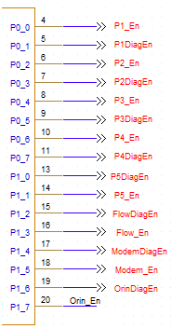
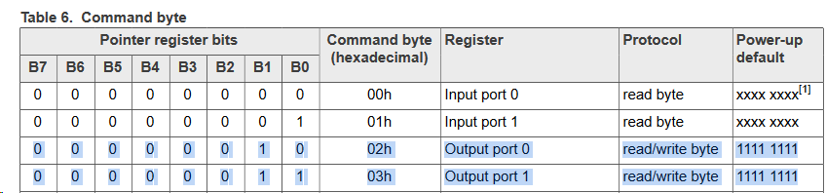
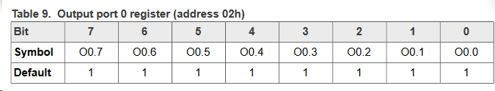
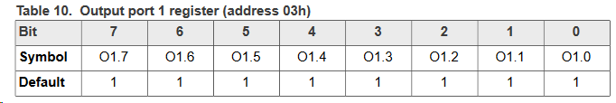

- Verify the serial data connections are working using a loop back test. The serial data streams are multiplexed; point to point communication can only be established with one port at a time. RS232select0 (PA07), RS232select1 (PA11) and RS232select2 (PA15) set the active serial data port. RS232en (PA21) enables communication when high and saves power when low. For example, to communicate with port1, set RS232select0 high and RS232en high.
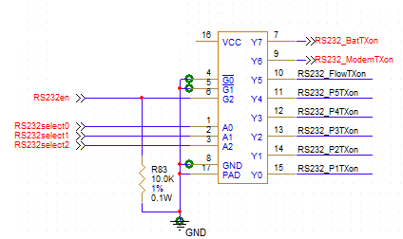
- Test the isolation monitor. In addition to nonconductive insulation, all ports have a high and low side power regulation which electrically isolates the port when not in use stopping potential ground faults. The isolation monitor is an experimental circuit intended to monitor changes in the nonconductive insulation before a port is powered up. The isolation monitor is capable of detecting extremely small leakage currents and may be noisy. The monitor works by charging up a capacitor connected to the isolated port, disabling the charge and measuring how quickly the cap discharges. To initiate a measurement, power off the port and set the Portname*DiagEn pin on the port expander to high for about 100us. Turn off the DiagEn pin and configure the analog mux to read the current from the selected channel using procedure 15.b but configure the ADC to read the voltage from PA03 (IsoSense_Ain1). The voltage should be read about 15 microseconds after turning off the DiagEn pin to detect leakage greater than 100uA. Longer wait times will detect smaller and smaller leakage currents. An additional circuit can monitor for leaks between power rails and to ground by charging up a cap to 2.5V connecting the voltage to the anode briefly and then measuring the resulting node voltage. Set AnodeEn (PB02) high and set ADCselect 1, 2 high; then set ADC select 0,1,2 high and measure the voltage using the 2.5V reference. The voltage should be close to 2.5V.

- RPi interface – The system may contain a Raspberry Pi to facilitate remote recovery. The Raspberry Pi can reset or flash new firmware in both the control board and AGX Orin on command via ethernet. The Pi will be configured to act as a watch dog and is reset via the Orin ethernet port. If the Pi has not been reset after its timer expires, it will set RPi Enable high and then create a high to low transition on the RPi clock line to enable the reset and debugging interface. When the interface is enabled, it turns on the 12V power supply and enables the ethernet switch to make the PI accessible remotely via the debugging or MARs ports and it unlocks the following discretes:
  - RPi_uCReset_L resets the control board when low; it should be configured with a pullup before the debugging interface is enabled. The Pi can be configured with an Arduino loader and communicate with the USB debugging port.
  - RPi_Orin_En enables Orin power when high.
  - RPi_Orin_reset connects to the Orin reset button and forces a full system reset when set high.
  - RPi_Orin_ForceReset is used to flash the Orin. Setting the signal high while powering up the Orin causes the bootloader to wait for a new image on the USB port. The Pi has sufficient RAM and flash to store an Orin image and load the image via the USB port using the NVIDIA Orin Flash loader utility. The utility contains a scripting interface to allow it to be run remotely.
The Orin’s BIOS must be configured to look for boot images on the external device; the Orin will fall back to the internal memory if no device is found.
The Pi contains a USB On The Go port which allows it to act as a device or hub. The Pi should be configured to mount the port in mass storage device mode with a bootable image created using the Orin SDK. The image can be loaded remotely over the MARS data connection.

