Bubble Camera Proposal
1. Objective & Operational Scope
This proposal details the engineering framework and procurement authorization for a high-endurance Subsea Bubble Camera System. Optimized for space-constrained deployment within a standard 6" Blue Robotics watertight enclosure footprint, the platform will be deployed for 3 days and 2 nights at Milos Beach, Greece. The primary technical milestone is the continuous acquisition of synchronous side-by-side optical stereo imagery to map subsea gas seepage volumes and calculate precise 3D bubble plume rise rates. Operating continuously for 72 hours guarantees strict temporal correlation with Distributed Acoustic Sensing (DAS) seafloor geophysics arrays during low-noise night intervals. The system will be hand carried through the airport in mid-October.
2. High-Level System Requirements
- Optical Geometry: Continuous synchronous side-by-side stereo frame acquisition via a unified UVC stream to eliminate dual-system sync drift.
- Structural Depth Rating: The entire enclosure, viewport, sealing rings, and electrical penetrations must provide verified structural integrity down to a minimum operating depth of 25 meters (2.5 bar hydrostatic load).
- Power Autonomy: Complete standalone electrical execution for 72 continuous compute hours and 28 total night illumination hours without external cabling or surface links.

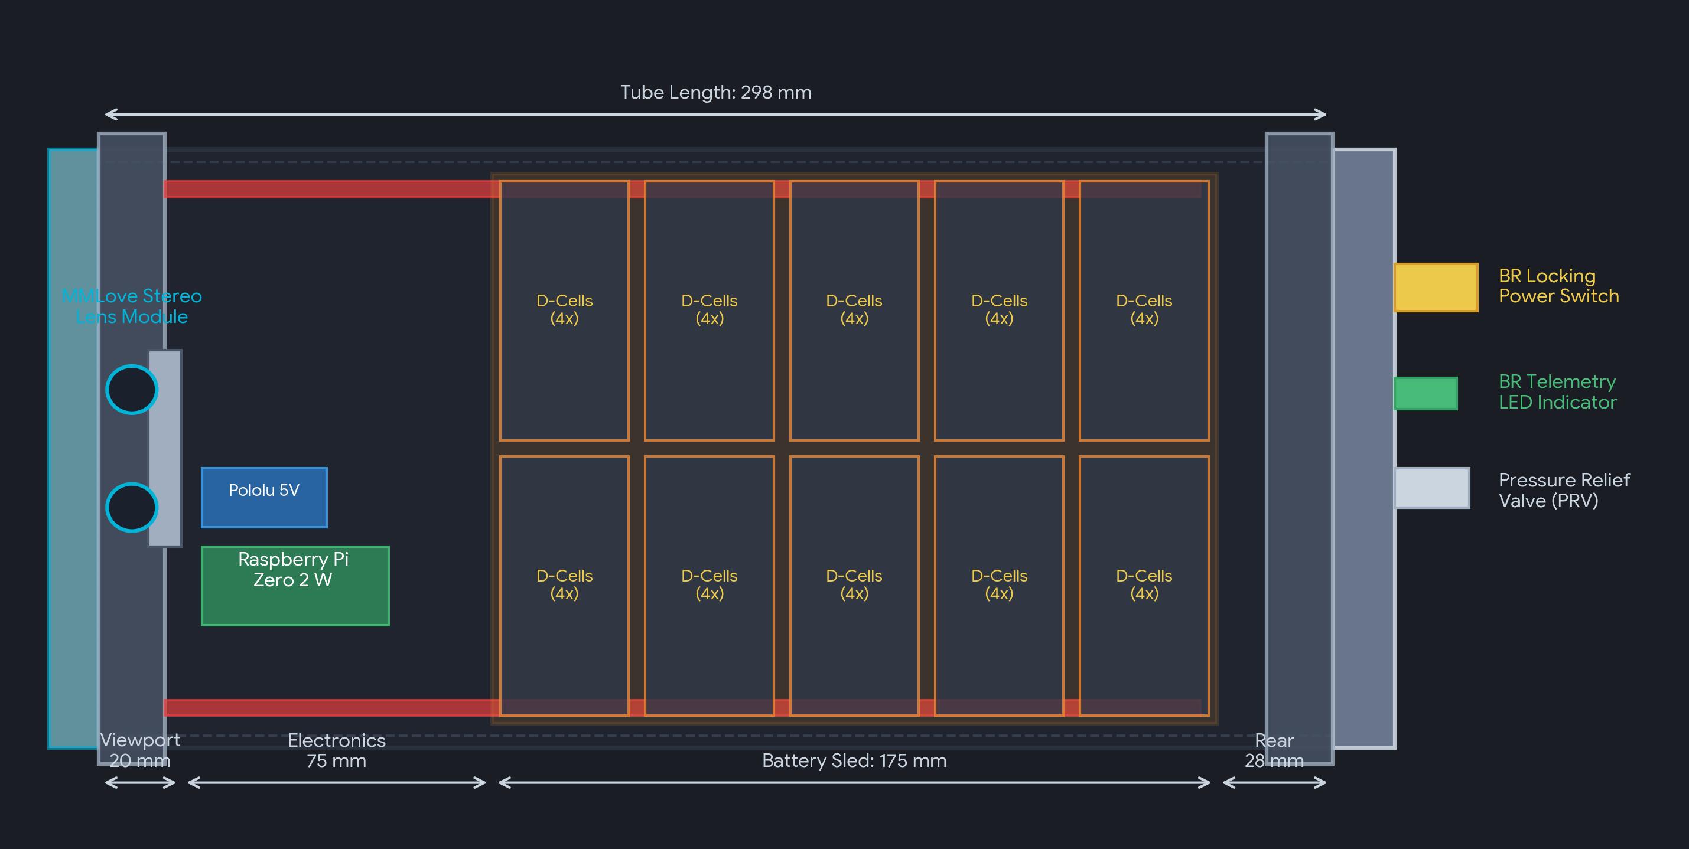
4. Mission Power Architecture & Battery Budget Verification
The mission covers 3 days and 2 nights (72 hours total compute time). Based on astronomical conditions for Milos, Greece in early November, the area experiences 14 hours of dusk-to-dawn darkness per night, totaling 28 hours of total illumination. The core compute system and status LED operate continuously for the full 72 hours.

Subsystem / Component | Draw (W) | Active Time | DC-DC Efficiency | Total Energy (Wh)
Pi Zero 2 W + MMLove USB Stereo Camera Module | 3.00 W | 72 Hours | 88% (Pololu Buck) | 245.45 Wh
Blue Robotics LED Status Indicator (can probably turn off after 5 min) | 0.20 W | 72 Hours | 97% (Direct Bus) | 14.85 Wh
Dual Lumen Lights (Configured at 2.0W each) | 4.00 W | 28 Hours | 97% (Direct Bus) | 115.46 Wh
TOTAL CORE MISSION ENERGY DEMAND | - | 72 Hours | Calculated Load | 375.76 Wh
Required Energy Supply (incl. 25% Design Margin) | - | - | 1.25 Engineering Multiplier | 469.70 Wh
Actual Delivered Energy Capacity (10S4P Battery Sled) | - | - | 40 D-Cells @ 17Wh | 680.00 Wh

Lumen Driver Drop-Out Voltage & Dimming Analysis:
- Drop-Out Voltage Boundary: Blue Robotics Lumen subsea lights operate via integrated buck-boost constant-current drivers requiring an input between 10V and 48V. Our 10S alkaline configuration starts at 15V nominal, drops to a mid-life average of 11V, and reaches a near-depleted cutoff of 10V. If cell voltages drop below 1.0V each (10V total pack), the light drivers hit their drop-out threshold, causing illumination shutdown or strobe failure. Managing the floor above 10V is a vital mission limit.
- Dimming Level Optimization: The baseline calculation assigns 4.0W total power to the dual Lumens (2.0W each, roughly a 13% dimming level). Since the un-margined 3-day / 2-night total draw is only 375.76 Wh and our 10S4P block safely yields 680 Wh, we hold a net surplus of 304.24 Wh of raw storage headroom. For optimal optical data capture, you can comfortably dial up the light output to 10W total (5W per light, roughly 33% full brightness) for the full 28 hours of darkness. This raises total lighting energy to 288.6 Wh, fully utilizing the battery envelope without reaching the 10V drop-out boundary prematurely.
5. Data Storage Verification Matrix
Data storage security has been calculated to verify that the high-endurance 256GB MicroSD card provides complete headroom for the continuous 3-day / 72-hour synchronous capture session:
- Video Stream Configuration: The MMLove module encodes dual-lens frames into a single side-by-side unified UVC stream. Operating at 1080p resolution and a stabilized 15 frames per second (fps) under an optimized H.264 compression wrapper, the stream maintains a steady target bitrate of 4.00 Mbps (Megabits per second).
- 72-Hour Data Volume Math: 4.00 Mbps / 8 bits = 0.50 Megabytes per second (MB/s). Multiplying across the continuous deployment window yields: 0.50 MB/s x 3,600 seconds/hour = 1,800 MB/hour (1.80 GB/hour). Over the full 72 hours, total storage consumption equals exactly 129.60 GB.
- Net Storage Safety Margin: 129.60 GB (Required Data) vs 256.00 GB (Available Space) provides a massive +97.5% storage buffer. This excess capacity handles filesystem overhead, file allocation index mapping, and extended buffer windows if recovery logistics are delayed on the third day.
6. Field Deployment Plan
- Location & Coordinates: Milos Beach, Greece, targeting localized gas venting and bubble-plume thermal chimneys on the shallow continental shelf.
- Target Operational Depth: Stabilized benthic deployment at a maximum depth of 25 meters sitting on the seafloor to watch upward gas trajectories.
- Logistics & Dive Operations: Handled entirely via Contract Diver Operations (authorized via Pre-allocated Account 902401). Commercial divers will execute seafloor stabilizing placement, alignment relative to the DAS array line, and final recovery tracking on day three.
- Seafloor Anchoring: Tripod to mount on seafloor, ballasted slightly negatively buoyant so it is diver manageable.
7. Material Procurement Budget
Component | Quantity | Notes | Price
Blue Robotics 6" Enclosure (WTE6-ASM-R1, 298mm) | 1 | Structural Frame | $150.00
6" Flanges, Flat Acrylic Front Port, Aluminum Cap | 1 | Viewport / Seal | $420.00
BR Subsea Locking Power Switch & LED Module | 1 | 97% Direct Bus | $47.00
M10 High-Pressure Penetrators & Brass Plugs Set | 15 | O-Ring Sealed | $150.00
MMLove Synchronous Stereo Camera + Pi Zero 2 W | 1 | 88% Pololu Buck | $95.00
High-Endurance 256GB MicroSD Storage Card | 2 | Continuous Write | $150.00
Blue Robotics Lumen Lights (Dual-Light Assembly) | 2 | 97% Direct Bus | $385.00
Pololu 5V 2.5A Step-Down Buck Regulators | 2 | Backup + Primary | $30.00
Bulk Alkaline D-Cell Batteries & Standard Trays | 80 | 40 Cells (10S4P) for 1 pack | $100.00
Custom 3D printed internal Desiccant | 1 | Chassis Mounting | $0
Heavy-Duty Subsea Tripod Mount & Ballast Weights | 1 Mount | Benthic Anchor | $250.00
TOTAL MATERIALS & HARDWARE PROCUREMENT | - | Estimated Base | $1,777.00
Contract Diver Operations (Logistics Account 902401) | - | Seafloor Install | $2,000.00
8. Resource & Labor Allocation
- Johann: 40 Hours. Wiring, CAD design/3Dprinting, assembly, ballasting, testing
- Paul Roberts: 20 Hours. Software, testing. More time required after to process data?

9. Other Notes
- The Blue Robotics 6” Locking tubes are out of stock, they are expected to be back in stock July 10th, this may add additional cost to get the locking tube option.

