Distributed Acoustic Sensing (DAS) Setup and Operation Guide

Sintela documentation found at:
https://portal.sintela.com
you need to set up an account to sign in. Once on the portal, if you click on the Documentation link in the left-hand menu. This will open the screen below. Most of the relevant information is under the User Manual or the Maintainer Manual.
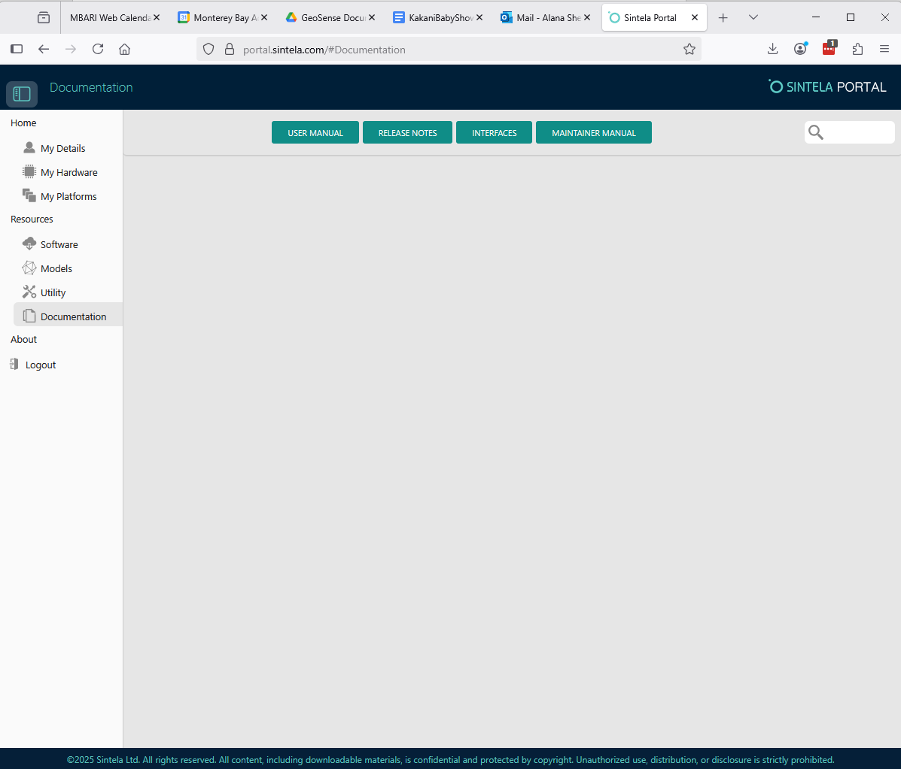
Figure 1. Sintela Portal Documentation Page.

Step 1: Required Equipment to Run the DAS
To operate the Sintela Nano Distributed Acoustic Sensing (DAS), ensure you have the following items:
- Laptop – A laptop with the capability to manually configure its IP address. It must have a mouse to be able to use all functions of the Nano web interface.
- Power Supply – A power source capable of providing 28 volts at 2 amps.
- Ethernet Switch – For network connectivity between the laptop and the DAS.
- Battery Backup / UPS (Uninterruptible Power Supply) – Recommended if you plan to record data for extended periods to prevent data loss during power interruptions.

Step 2: Configure the Computer to Communicate with the DAS
Note: DAS stands for Distributed Acoustic Sensing.
To establish communication between your computer and the DAS, follow these steps:
- Assign the Computer's IP Address
  - Open the Control Panel
  - Click on “Network and Internet”
  - Click on “Network and Sharing Center”
  - Click on “change Adapter Options” on the left hand side of the window.
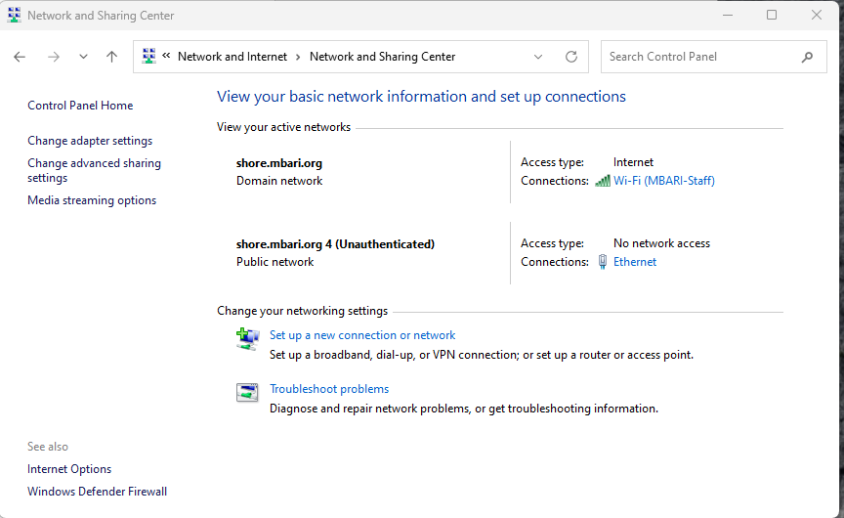

Figure 2. Network and Sharing Center.
- Select Ethernet in the Network Connections window. Right click on “Ethernet” and choose “Properties”
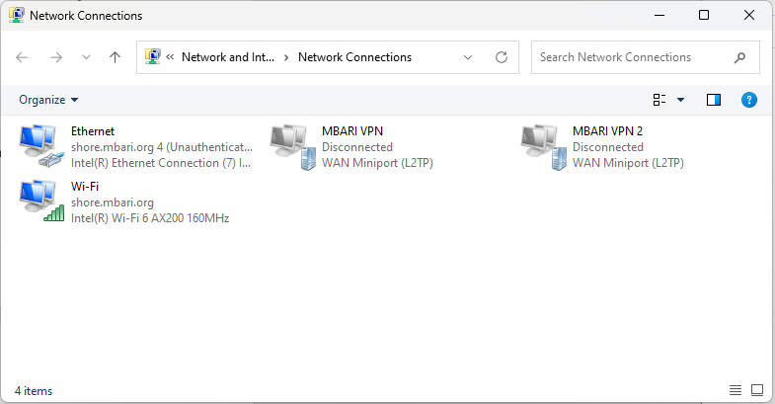
Figure 3. Right click on Ethernet and select Properties.
- In the Ethernet Properties window select Internet Protocol Version 4. You can double click this link to bring up the IPV4 Properties
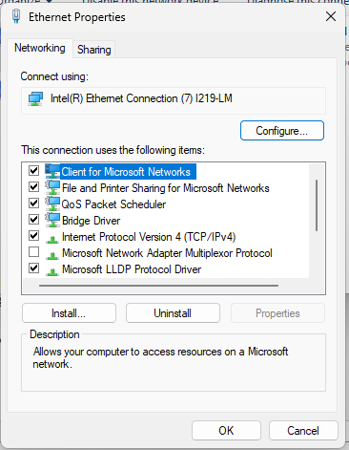
Figure 41. Ethernet Properties Window.
- Set the computer’s IP address to a static value within the same network space and subnet as the DAS.
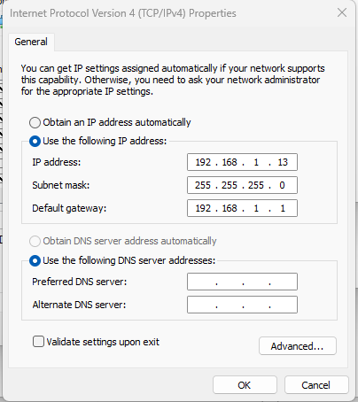
Figure 52. Set IP address to static IP.
Use the following settings:
  - IP Address: 192.168.1.N (where N is any number except 236)
  - Subnet Mask: 255.255.255.0
  - Gateway: Leave blank or set to 192.168.1.1 (not critical for local-only connection)
The DAS unit itself is configured to IP address 192.168.1.236.
- Verify IP Address Configuration
Open a Command Prompt (Windows) and run the following command:
>ipconfig
This will list all current IP configurations. Check for the Ethernet adapter and confirm that it is set to the static IP address you assigned.
Note: If your Ethernet cable is not connected to a network or device, the Ethernet interface may not appear in the ipconfig results.

Step 3: Preparations Before Powering On the DAS
Before turning on the Distributed Acoustic Sensing (DAS) unit, complete the following steps:
- Verify Fiber Optic Cable Connection
  - Ensure a fiber optic cable is securely connected to the ET2000 connector on the instrument.
  - Confirm the cable is properly seated; a loose connection may cause the instrument to power on but produce no data.
- Connect Power Supply (without energizing yet)
  - Attach the power cable to the power supply, ensuring both the positive and negative leads are securely connected but do not turn on the power yet.
  - Confirm the voltage and current settings on your power supply:
    - Voltage: Between 24–28 V (typically 28 V)
    - Current Limit: 2 A
In normal operation, the DAS draws approximately 1 A at 28 V.
- Observe Laser Safety Precautions
The DAS may involve active laser components. Before powering on:
  - Ensure laser safety protocols are followed.
  - In a lab setting:
    - Lock the lab door to prevent entry.
    - Post visible laser warning signs.
    - Wear appropriate laser safety goggles.
    - Cover the instrument with the black shroud to reduce ambient light exposure.
  - Complete the Laser Safety Checklist – This form must be filled out and reviewed before the instrument is powered on.

Step 4: Powering On the DAS
Once the room is secured and you are in compliance with all laser safety protocols, you may proceed to power on the DAS unit.
- Apply Power to the Instrument
  - Ensure that both leads of the power cable are properly connected to the power supply.
  - Turn on the power supply.
The current should gradually ramp up to approximately 1 amp.
- Wait for System Boot
  - Allow at least one minute for the system to boot up fully.
- Check Network Connectivity
  - Open a Command Prompt window on your computer.
  - Use the ping command to verify the DAS is online:
- ping 192.168.1.236
  - If you receive replies from the DAS IP address, the system is online and ready for interaction.
- Access the Instrument
  - Open a web browser and go to:
  - http://192.168.1.236:8081
  - This address opens the DAS web interface for configuration and control.

Step 5: Connecting to the Instrument
- Access the Login Page
Open your web browser and navigate to:
http://192.168.1.236:8081

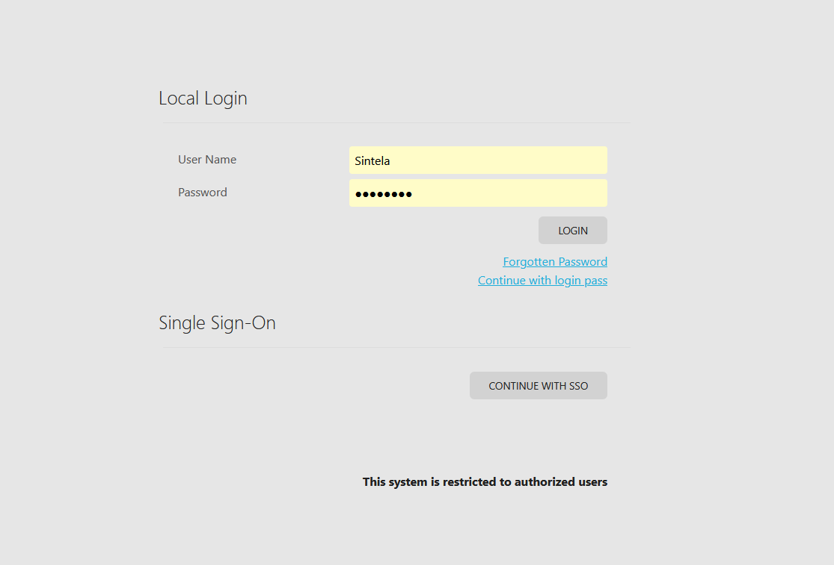
Figure 6. Onyx Login Page
- Login Credentials
  - Username: Sintela (capital S, then lowercase i-n-t-e-l-a)
  - Password: 3n?1n33R
- Access the Web Interface
After logging in, you will be directed to the instrument’s web interface.
- The main menu is found in the upper right corner. The icon is four horizontal lines. When you click on the icon you will see the different pages available. It is generally easiest to open each in a new tab as you will go between them during set up.
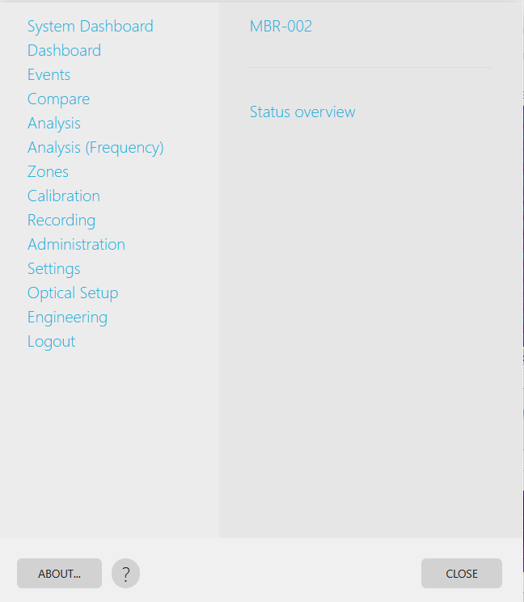
Figure 7. Main Menu on Onyx GUI.
- Navigate to the Analysis Tab
Typically, you’ll start your work by selecting the Analysis tab from the menu accessed by clicking the horizontal lines on the upper left corner of the screen.

Step 6: Using the Analysis Tab
- The top window in the Analysis tab displays real-time “waterfall” data.
- The x-axis represents the distance along the cable, and the y-axis represents time.
- It typically takes a few minutes for the system to calibrate the cable and begin producing useful data.
- During calibration, the display will mostly appear yellow until the data becomes valid.

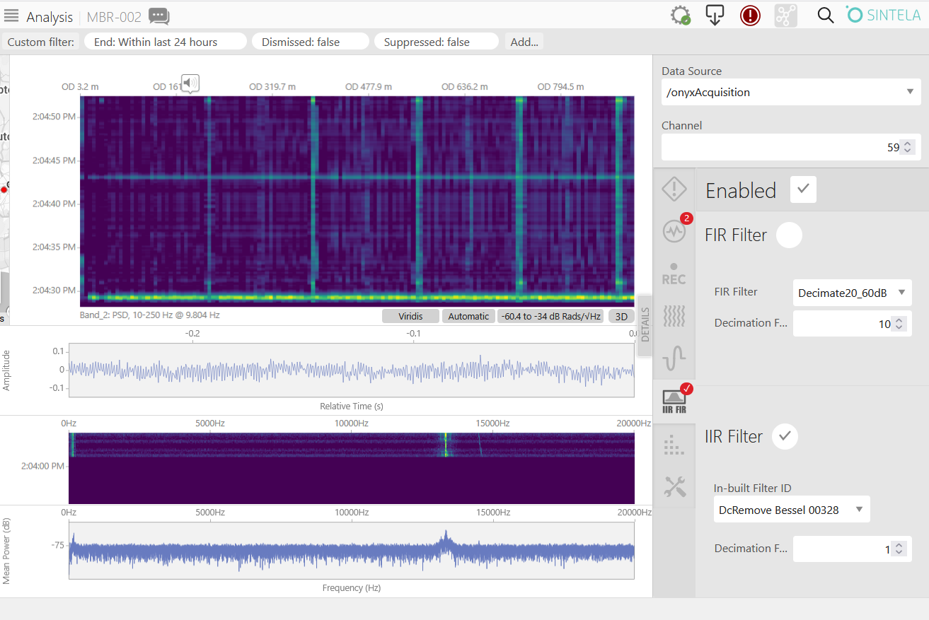
Figure 8. Analysis Tab.

Right-Hand Panel Tools
- On the right-hand side of the Analysis window, there are several tools to help examine the data.
- The first tool to click looks like five wavy lines side-by-side. This tool lets you select the frequency band you want to analyze.
- The bands correspond to different frequency ranges.
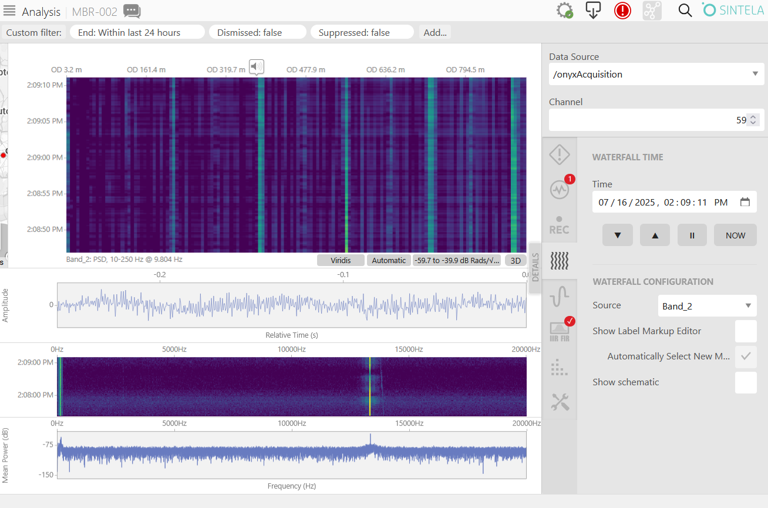

Using the Noise Floor Processor
- From the Main Menu open the Optical Setup tab.
- In the Optical Setup page, select the “RF & Sequencing” tab on the left-hand menu.
- Select the Advanced tab at the top of the page.
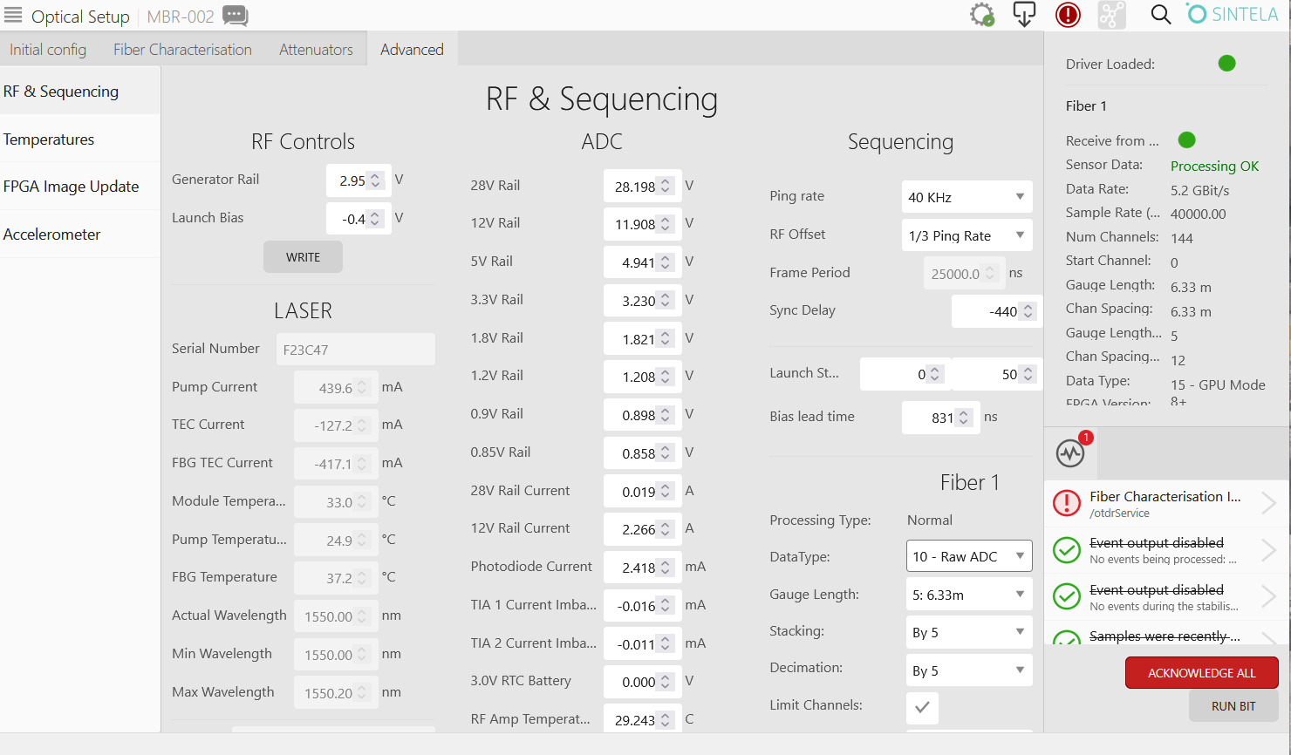
- On the rightmost column, set RF Offset to “No RF offset”, to save this, you must press the “Write” button at the bottom of the column.
- Return to the “Analysis” tab
- From the menu next to Source, select the Noise Floor Processor.
- Wait until you have a full window of new data processed by the Noise Floor Processor.
- In the top window, use the rectangular selection tool to select nearly the entire region containing valid data.
- Drag the rectangle so it fills that area.
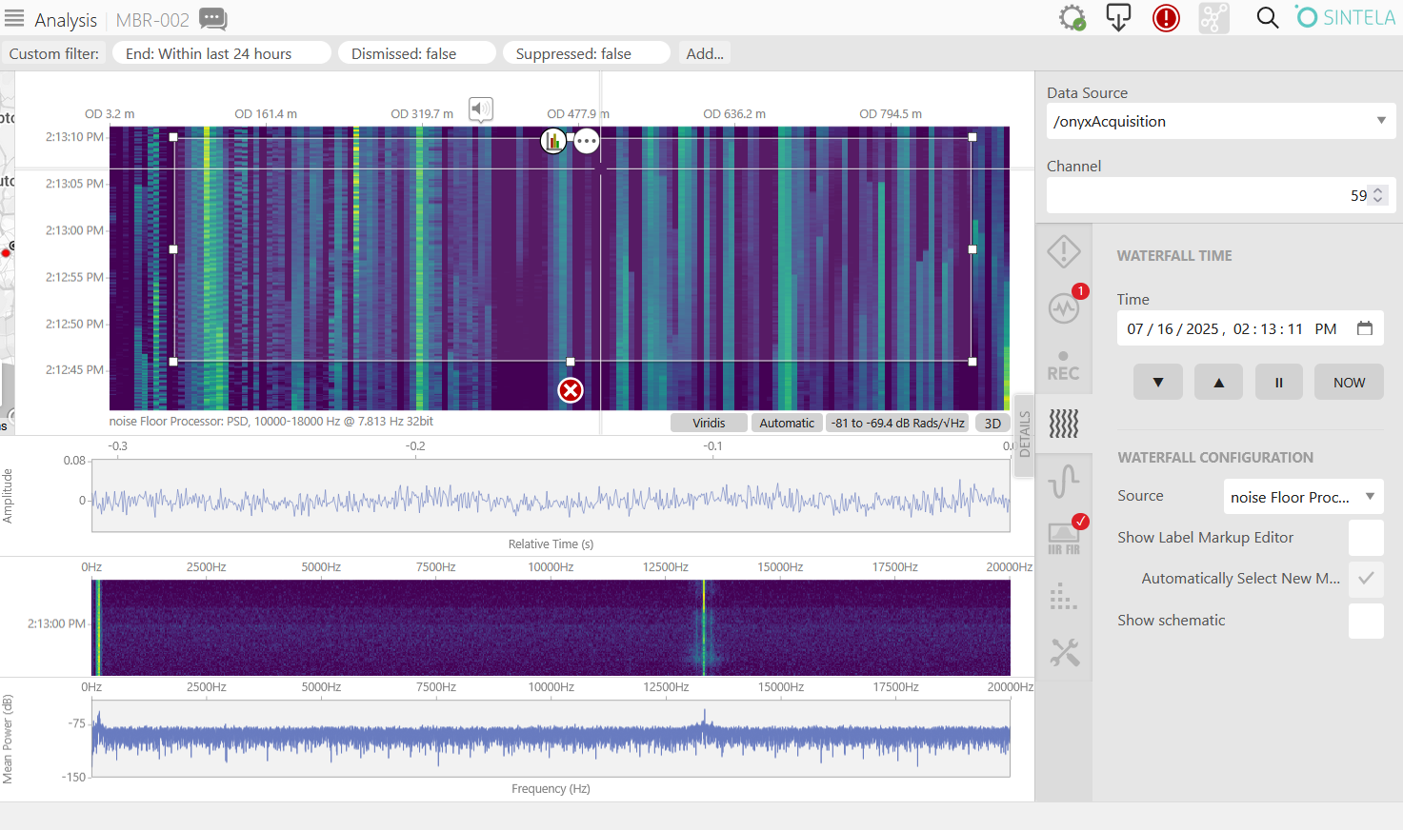
- Press the circular chart button at the top of the rectangle (if you do not see the chart button click on the three dots and it will appear) to display the value distribution for the noise.
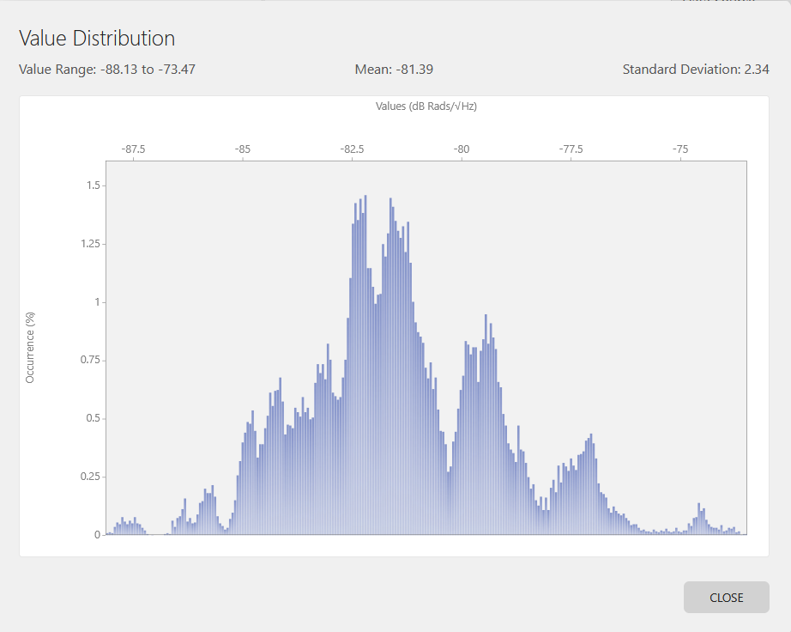
- The expected noise floor value is typically around -81.6 dB (Mean values).
- When finished go back to Optical Setup and return the RF Offset to “1/3 Ping Rate”. You must press the “write” button for this value to be saved.

Validating Instrument and Cable Operation
- After validating the noise floor, return to the Analysis tab.
- It is common to check band 1 (1-10 Hz) or band 2 (10-250 Hz) next. Select this band by clicking on the wavy line icon on the right side of the screen. You can create a signal on different parts of the cable by taping or lightly scratching the cable.
- This step helps ensure the instrument and fiber optic cable are functioning correctly together.

Using the Waterflow Plot Controls
- The waterflow plot needs to be restarted after making the noise floor measurement.
- To restart playback, click the arrow with a vertical line at the top left corner of the screen — this plays the data forward.
- The symbol that looks like an equal sign (=) pauses the data stream.
- Once in band 1 or band 2, start interacting with the cable by tapping it at various points to confirm you see corresponding signals on the display.
- Make sure data scaling is set to “automatic” this is the button on the lower middle of the waterfall plot.
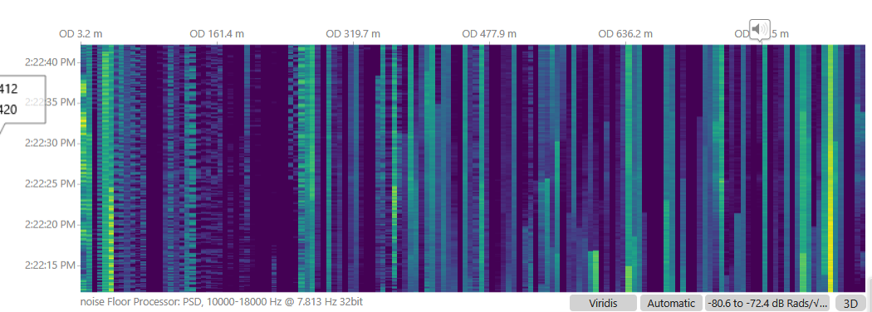

Additional Right-Hand Panel Tools
- The symbol resembling a histogram is where you enable and disable filters.
  - Make sure filters are enabled at the top of this window.
  - Check the IIR filter box; this filter removes DC components.
  - No other settings in this panel usually need to be changed.
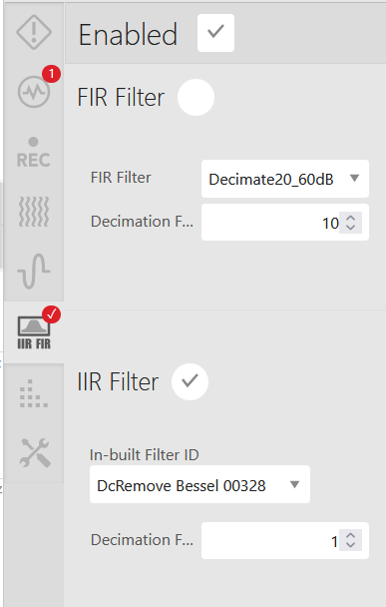
- The panel below with a cluster of dots is the FFT configuration.
  - Typically, the only parameter adjusted here is the FFT size.
  - Default is usually 64K, but if processing takes too long, you may reduce this size.
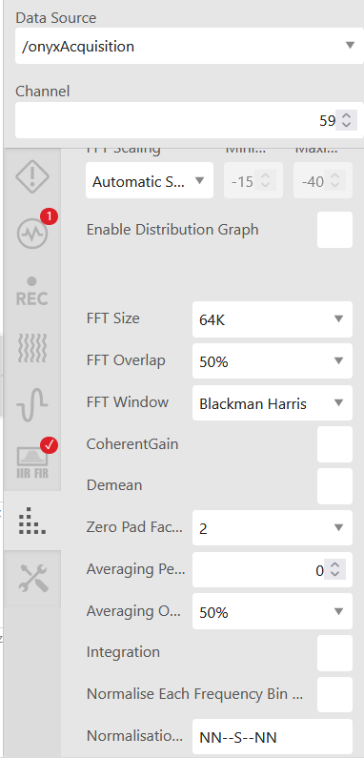
- At the bottom of the side panel, watch for the REC indicator.
  - It shows whether the recorders are actively recording.
  - Keeping an eye on this status is important during data collection.

Step 7: Exploring Other Panels on the User Interface
- Switching Panels
  - Click on the straight line icon in the upper left-hand corner of the interface.
  - This allows you to switch between different windows or panels.
- Recording Panel
  - Manual Recording Panel
    - Select the Manual Recording panel (usually the first window).
    - Here, you can confirm that active recording is occurring.
  - Recording Browser Panel
    - Navigate to the Recording Browser tab.
    - Locate the folder where recordings are saved.
    - Verify that recordings exist in the selected folder to confirm data is being captured properly.
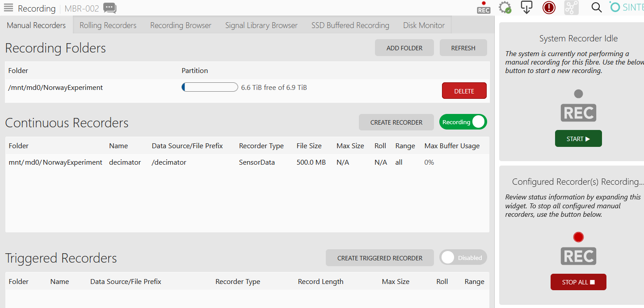
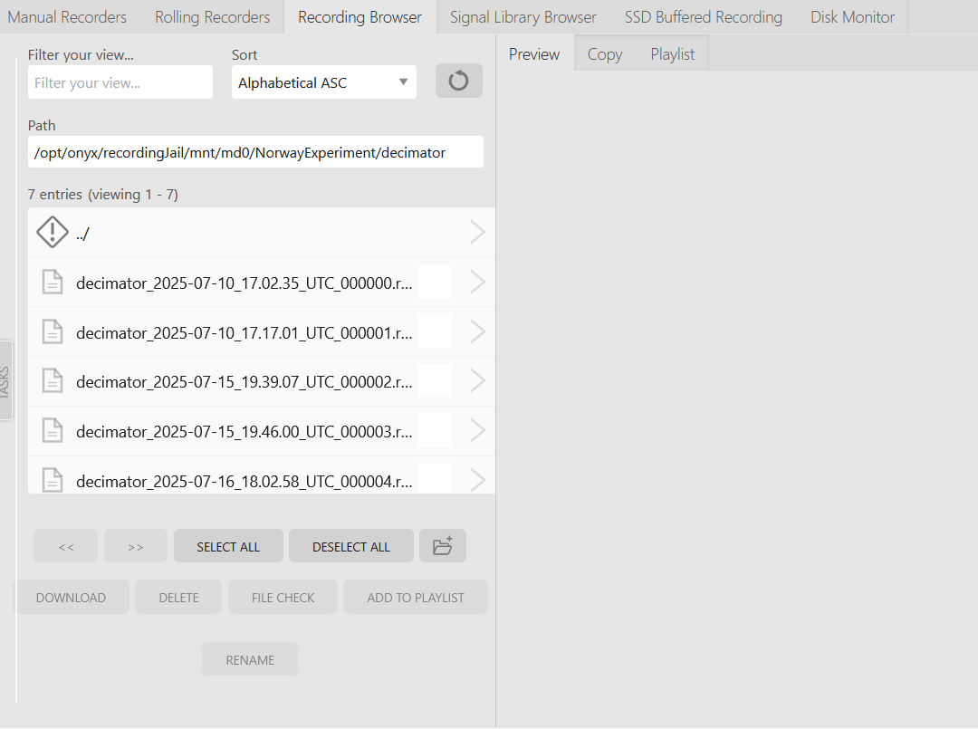
- Using the Optical Setup Panel
- Accessing the Optical Setup Panel
  - Navigate to the Optical Setup panel in the user interface.
  - Confirm that the MBARI config 3 is applied; this is the active configuration.
    - Creating and Modifying Configurations
      - In this panel, you can create new configurations or modify existing ones as needed.
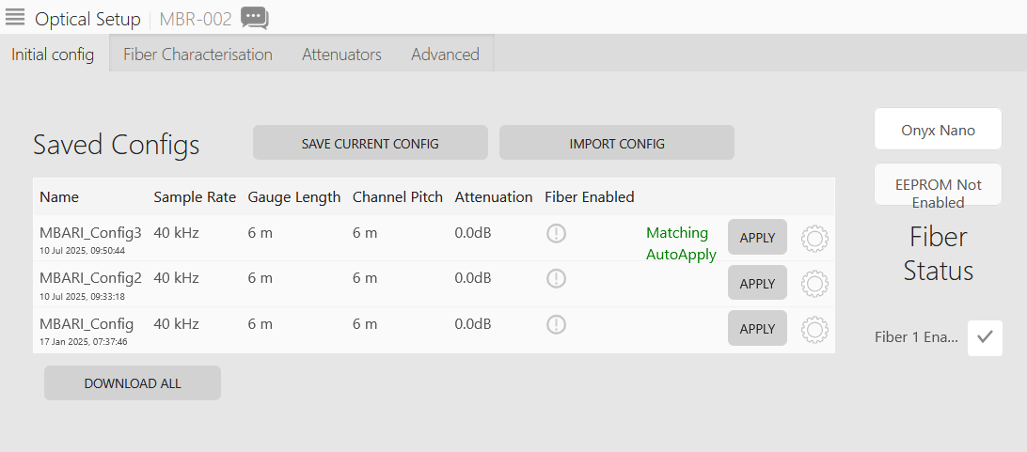
- Accessing Diagnostic Information
  - Go to the Advanced tab within the Optical Setup panel.
  - On the left-hand side, click RF and Sequencing.
  - Scroll to the bottom of this page to access diagnostic data from the instrument, including:
    - Temperature readings
    - Current consumption
    - Voltage levels
- Usage
  - This diagnostic information is valuable for troubleshooting and when seeking technical support.

Step 9: Changing the Instrument IP Settings
- While the web interface doesn’t currently offer a direct menu for changing IP settings, you can access a special configuration page by navigating to a specific URL.
- Reference: https://sintela.atlassian.net/wiki/spaces/DEMO/pages/18776119/How+to+change+the+ONYX+IP+address

Update Manager
- Ensure you are connected directly to the unit
- Use a browser window to navigate to the IP address in the following format: xxx.xxx.xxx.xxx:4444
- Log in to the software when prompted
- Navigate to the Network tab
- Click Edit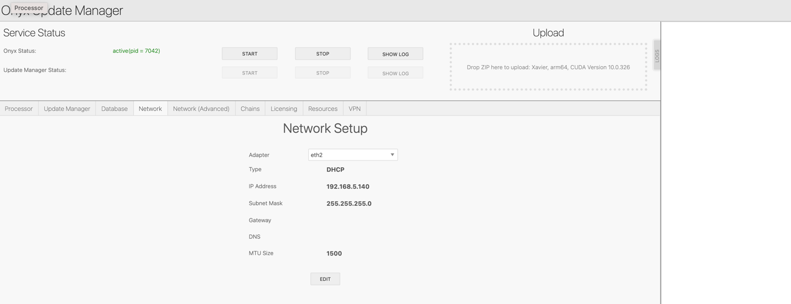
- Set the desired network settings and click Apply
- The new settings will now be applied to the system and can be accessed by the new IP address

