GeoSense Elevator Deploy and Recovery - Reference Description
A summary of past MBARI science user practices for surface recovery. Prepared for integration into the receiving vessel's procedures by the ship's Master and crew.

1. Purpose and Use
This document summarizes how MBARI science and marine operations teams have previously recovered the GeoSense elevator package and its fiber-optic tether at the end of a deployment. It is provided for reference only. The receiving vessel's Master and deck leadership retain full authority to determine the final procedure, safety controls, and deck choreography appropriate for their platform and conditions.

2. System Background (Operational Context)
- The GeoSense package is a free-fall elevator that carries a dense ~500m single-mode fiber-optic cable on a spool to the seafloor. After landing, an ROV lays the fiber on the seafloor and connections are made for DAS (Distributed Acoustic Sensing) measurements. See Figure1*
- Recovery: The unit runs on battery power and is recalled acoustically, releases its anchor, and surfaces positively buoyant for ship retrieval.
- Equipment Specs: The elevator mass, buoyancy, and lift points vary by configuration; vessel crew should verify weights/SWLs and lifting geometry during planning.
- Handling Note: The fiber-optic tether is bend-radius restricted and must be handled with large, gentle curves and protected from crushing, kinks, and sharp edges.

3. Roles and Interfaces (Observed in Past Operations)
- Bridge / Conning Officer: Selects and maintains heading/speed to control relative motion, announces propulsion changes, and ensures the tether remains clear of propulsion.
- Deck Lead / Bosun: Coordinates deck evolution, positions crew, prepares slings/tag lines, and identifies exclusion zones.
- Winch / Crane Operator: Performs slow, coordinated lifts and hauls with immediate response to 'Stop/Standby' calls.
- Cable/Tether Watch: Monitors fiber path, bend radius, and potential chafe or sweep hazards; verifies connector care.
- Science/Engineering Representative: Provides equipment constraints (lift points, connector handling, power-down/lockout steps) and assists with post-recovery inspection.

4. Vessel Orientation and Approach (Reference Practices)
Past recoveries have used different orientations depending on recovery station and conditions.

- Side Recovery (Port/Starboard): Approaches have commonly been made with current astern, allowing the elevator to drift aft and outboard toward the recovery side. This tends to keep the fiber streaming aft and away from forward hull features. See Figure2*
- Aft A-Frame Recovery: The recovery line was typically routed through the A-frame, along the stern, and up the port-side rail to the grappling point. Once surfaced, the package was grappled from the port-side rail and attached to the recovery line. After attachment, the elevator was allowed to drift aft of the A-frame while crew sequentially dropped line segments from the rail to maintain control. It has been common to secure the port aft propeller during this period to reduce risk of line ingestion.
- Relative Motion: Minimal way (often just enough for steerage) is used to reduce swinging and boarding loads. Vessels avoid sternway while any line is in the water.

5. Deck Preparation (Common Elements Observed)
- Clear the work area of trip hazards and unsecured objects.
- Mark exclusion zones for bights, potential sweep paths, and under-load areas.
- Stage tag lines (floating/soft), heaving lines/boat hooks, slings/shackles, and wide-radius rollers.
- Plan cable path with wide radii and protect deck edges with chafe gear.
- Confirm comms: working channel, hand signals, and stop-work indicators.

6. Deployment Sequence
- Initial Preparation: The crane is set up to pick the elevator from its lift line, using a quick release or other mechanism to release the package from the crane when appropriate.
- Control: Tag lines are attached to reduce swinging when the elevator is picked up.
- Lift: Once the deck crew and bridge team are happy with the position of the ship and the readiness of the crew, the hold-down straps are released, and the elevator will be lifted by the crane. All the fiber optic cable will be contained on a spool on the elevator.
- Release: Once the elevator is lifted over the rail of the ship and placed in the water, it can be released by the ship crew to free fall to the seafloor.

7. Reference Recovery Sequence
- Initial Contact: Bridge maintains orientation while a boat hook or heaving line brings the grab point within reach.
- Control: Attach tag lines (both sides if possible) to control yaw and heave-induced swing. Take light winch/crane strain to stabilize. See Figure 3*
- Positioning: Align the lifting apex over the intended landing zone while tag lines moderate motion. The Tether Watch verifies the fiber path remains smooth.
- Lift: Lift just clear of the water to confirm balance and control. The bridge holds a steady course while tag lines limit pendulum motion. See Figure 4*
- Land: Slow inboard movement to the prepared landing area; land onto dunnage/mats. Once stable, apply mechanical securing (lashings/chain blocks).
- Fiber & Connectors: De-energize or safe the system. Disconnect and cap connectors immediately to prevent contamination. Recover fiber with large-radius coils (no foot traffic or sharp turns).
- Ship positioning during fiber recovery: The ship moves slowly up current such that the fiber streams out behind the ship during the recovery of the fiber.

7. Communication Patterns (Examples Only)
- Package in sight / alongside.
- Request steady on this course.
- Taking light strain.
- Tag lines on / clear to lift.
- Landing on deck / stand by to secure.
- Stop (used by any person observing a hazard).

8. Fiber-Optic Handling Notes (Key Considerations)
- Maintain generous bend radius at all times; avoid kinks, torsion, and crushing loads. See Figure 5*
- Use rollers/fairleads sized for the bend radius; fit chafe guards at edges.
- Keep fiber clear of propulsion and running gear.
- Haul Fiber onboard. See Figure 6*
- Connector hygiene: keep dry/clean and cap promptly to avoid salt spray and grit.

9. Contingencies Observed in Past Operations
- Unsafe Motion: Pause/hold or lower to water to re-stabilize and re-approach.
- Suspected Chafe: Freeze movement, back out last action, and re-route with added protection.
- Loss of Steerage: Avoid astern thrust with line in the water; consider buoying off for later recovery if risk develops.
- Adverse Weather: Defer recovery until conditions improve as determined by ship's command.

10. Post-Recovery Practices (Reference)
- Freshwater rinse and visual inspection of package and fiber (nicks, flat spots).
- Connector service (dry, cap, stow with desiccant).
- Operational log of conditions and debrief among teams for lessons learned.

11. Checklists (For Vessel Adaptation)
- Planning: Recovery station selected; deck layout and landing zone prepared; exclusion zones marked; gear staged/inspected; comms check complete.
- Approach: Visual on package; minimal way maintained; heaving line/tag lines ready.
- Lift & Secure: Lift just clear for balance; inboard swing controlled; land and mechanically secure.
- Fiber: System safed; connectors capped; fiber recovered with large-radius coils and stowed dry.

12. Document Intent and Authority
This description is intended to inform the receiving vessel's planning with an example of prior practice. It does not prescribe a procedure and should be adapted or replaced by the ship's approved methods. Final decisions regarding configuration, sequence, and safety controls reside with the vessel's Master and deck leadership.

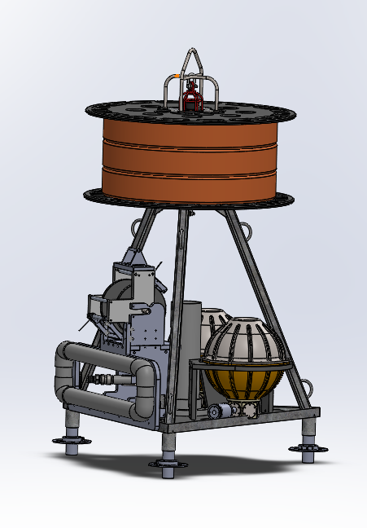
Figure 1-GeoSense Elevator
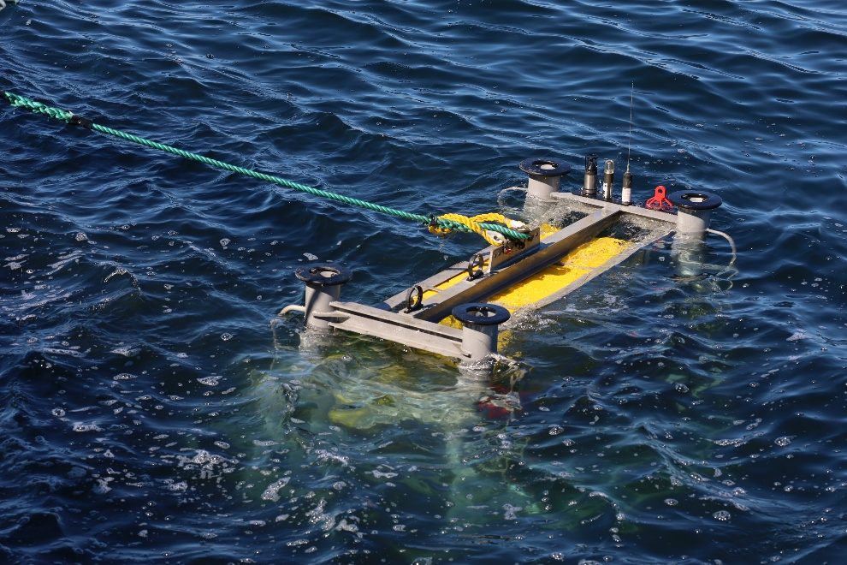
Figure 2-Side Recovery Approach

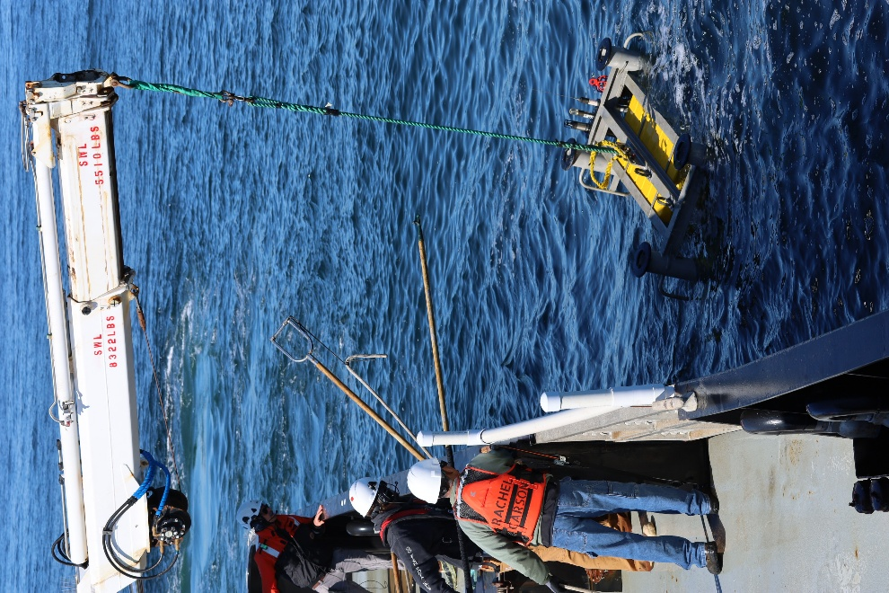
Figure 3-Side Recovery Lift

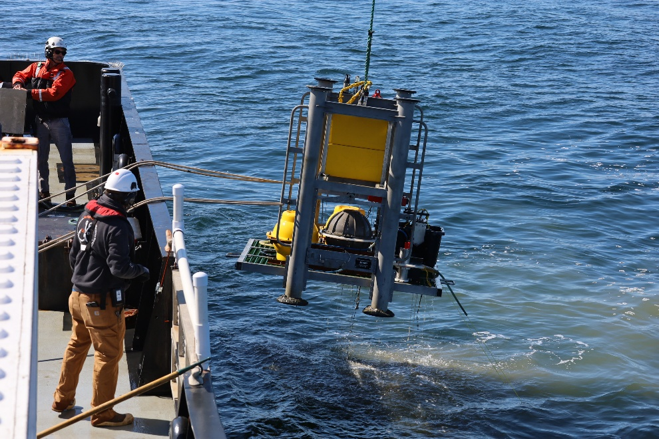
Figure 4-Secure Tag Lines (Control)

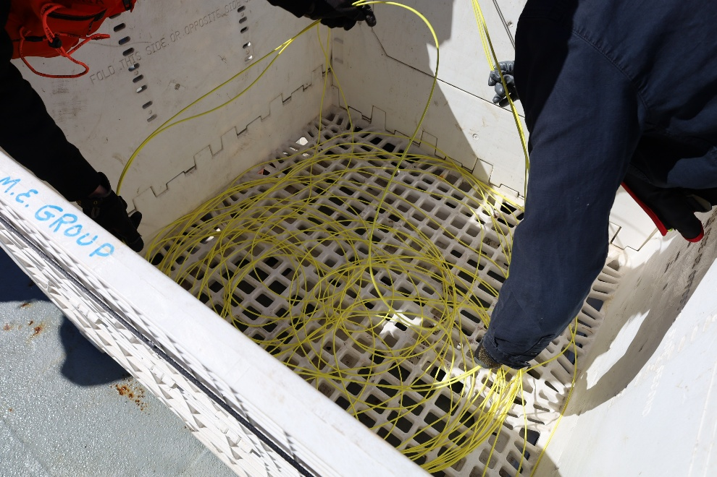
Figure 5-Fiber Management

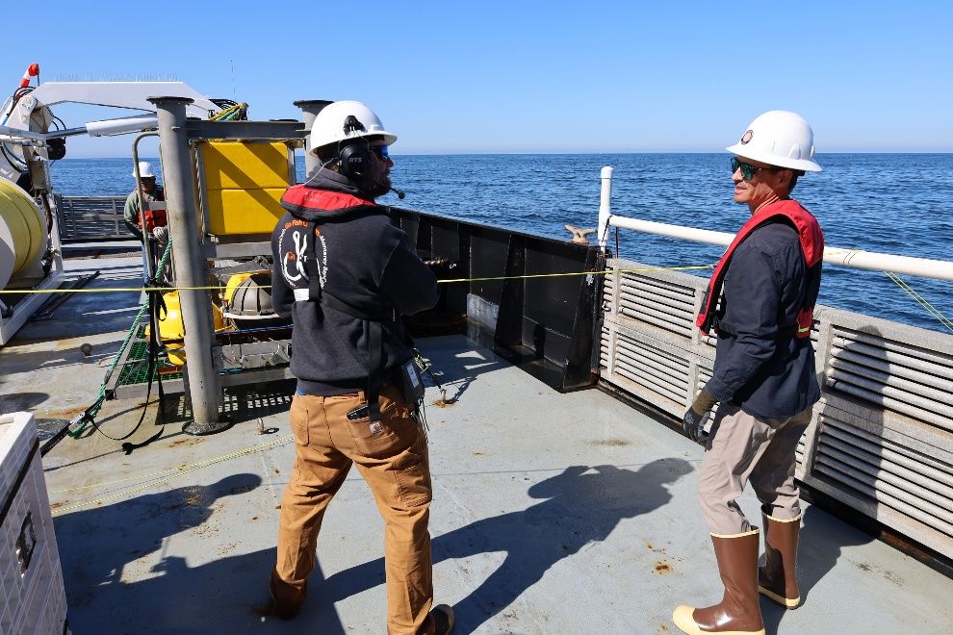
Figure 6-Haul fiber Onboard

