RAID check on Sintela DAS system
Here are the instructions to check your RAID configuration from Matt Read of Sintela:
Log into the DAS with username ‘sintela’, password ‘5intela_440’ with a five in place of the ‘S’:
$ ssh sintela@192.168.1.236
Both disks should be configured as part of a RAID 1 array (md0). If the RAID is in a degraded state, then redundancy is lost, and the data will only be on one disk. This can happen If there is a disk hardware fault, the disk has been hot swapped, or the system boots with only one disk attached.
From our call yesterday though your RAID 1 configuration looked ok for our software, but here are the instructions if you wish to still check.
To check the state of the RAID please boot with both disks attached. Our GUI software doesn't natively support RAID so the following will need to be done via running commands over ssh.
First check that both disks are enumerating in Linux:
lsblk | grep "sd"
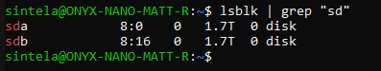
If both disks appear you can then check the status of the RAID md0:
sudo mdadm --detail /dev/md0 && cat /proc/mdstat
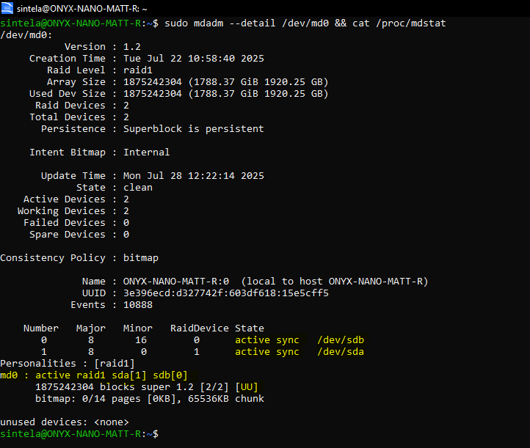
The image above shows the RAID configured correctly. If you instead see the following:
Failure state:
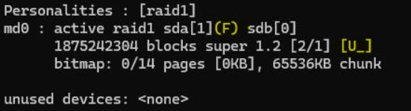
Missing drive state:
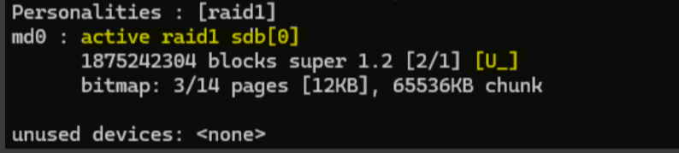

If you see a failure state or a missing drive from the RAID you can run the following command to re-add the missing or failed disk to the RAID 1 array:
sudo mdadm --re-add /dev/md0 /dev/sda
It should be noted that this command was for my example with the issue with sda, if you find that your issue is with sdb please update the command accordingly. After running this command re check the raid with the command:
cat /proc/mdstat
If you have any issues, please don't hesitate to reach out and I can jump on a call.
Many thanks,

