

Introduction
Optical Setup – Technical Notes
A DAS system is an optical sensor that measures the variation of the strain experienced by the optical fiber as a function of position. Since the absolute strain (i.e. the DC content) of the fiber cannot be determined via a DAS method, and instead only the change (i.e. the AC content) can be determined, DAS is often referred to as a vibration or an acoustic sensor. The range of frequencies typically measured by a DAS system extend well beyond the upper and lower limits of human hearing however, and so the term acoustic sensor is somewhat limiting.

Many different DAS methods exist but fundamentally they are all attempting to measure the physical extension or compression of the optical fiber, and report this as a function of distance along the fiber.
Onyx 1.0 and Onyx 1.1 (Peta) employ a coherent optical time-domain technique to extract the optical phase as a function of position and use the recovered optical phase to infer the strain experienced by the optical fiber as a function of position.

OTDR
OTDR, optical time-domain reflectometry, is a technique used for DAS for many decades. A short, high-intensity optical probe pulse is generated and launched into the fiber under test. As the pulse propagates along the fiber, a small fraction of the probe is scattered via Rayleigh scattering. A yet smaller fraction of this scattered light is then captured by the optical fiber and guided back toward the interrogation system. The captured scattered light is routed to the detection system where in the case of coherent detection, as used in Onyx interrogators, it is mixed with light from the same optical source from which the probe was generated. This is termed the local oscillator or LO. In this way the scattered signal is amplified prior to detection. It is then possible to extract both the intensity of the scattered light as a function of time as well as the phase of the scattered light relative to the phase reference supplied by the LO. Since the time at which the probe was launched is known, the time delay between the measurement and of the scatter intensity and phase can be directly mapped to fiber location and the strain of a particular section of fiber inferred.

Pulse Width
The Onyx system generates a relatively short high-intensity interrogation pulse with which to probe the optical fiber. The first user-defined variable is the pulse width, and this defines the width of the interrogation pulse. For clarity we should define what this means with respect to the diagram in figure 1.
Idealised Pulse
Pulse Width

Actual Pulse
Rise Time
Fall Time
Figure 1 – Pulse width definition

COMMERCIAL-IN-CONFIDENCE 1 of 8 Rev 1.1

The optical pulse can be specified in increments of the sequencer base clock or sequencer units (SUs). For simplicity the units are defined in the distance occupied by the launch pulse in the fiber as observed by the interrogator itself. Assuming a speed of light of 299,792,458 m/s and a refractive index of 1.4682, a 10 ns pulse will occupy 1.02 m.
For Onyx 1.0 an SU is defined as 0.851 m in length. Onyx 1.1 (Peta) generates the launch pulse in a different manner and allows a much smaller increment of approximately 0.044 m.
The user can request the idealised pulse shape as shown in red in figure 1. The pulse generated however is limited by the bandwidth of the optical switch employed in Onyx 1.0 and 1.1 (Peta). The realised pulse, as shown in blue in figure 1, will exhibit a slew rate limited by the switching speed; typically the rise and fall time of the switch is of the order of 0.5 m. This limits the minimum pulse width to of the order of 1.3 m before significant loss in launch power. Onyx 1.1 (Peta) in advanced mode offers more detailed control of the pulse shape, allowing an arbitrary window to be applied to pre-shape the launch pulse.

Sample Rate
This variable determines the repetition rate for the pulses and is related to the length of the fiber being interrogated. As previously described, a probe pulse is launched to interrogate the fiber, and as it propagates, light is scattered, captured and guided back to the interrogator where we measure its phase and intensity. Therefore, we must wait the time required for the probe pulse to reach the most distant end of the fiber and for the additional time for the scattered light to return from the end and be detected, i.e. the round-trip time. A sample rate (or pulse-repetition frequency, PRF) of 10 kHz therefore equates to a fiber length of 10 km, 20 kHz equates to 5 km, etc., assuming as before a speed of light of 299,792,458 m/s and a refractive index typical of single-mode fiber of 1.4682. If we exceed this maximum sample rate, the scatter from the first pulse will not have returned to the interrogator before scatter from the second pulse has started to return. We will therefore observe overlap of the signals from multiple probe pulses and we will not be able to resolve the strain for the overlapped fiber section. If we choose a ping rate lower than that required by the fiber length, the data will exhibit large gaps where no scattered light is being returned and detected and the resulting signal-to-noise ratio of the system will be degraded. It is therefore important to choose the appropriate sample rate for the fiber under test. The Onyx system will automatically choose this rate based on the longest measured fiber under the fiber characterisation tab.

Gauge Length
As described previously, the OTDR technique employed by Onyx 1.0, 1.1 and similar coherent-detection DAS techniques yields an output related to the phase shift between the probe pulse and the Local Oscillator (LO), i.e. it yields the cumulative or integrated phase evolution of the probe pulse as a function of distance. What is sought is the phase shift as measured over a defined measurement section or gauge length, in an equivalent manner to placing a strain gauge over a given measurement pitch. Systems perform this by taking the differential of the measured cumulative phase at a fixed temporal/spatial pitch. The equivalent model would be the comparison of the optical phase recovered between the probe pulse and a delayed virtual copy of the probe pulse. Figure 2 shows the definition of measurement gauge length. The system is configured to output a phase measurement which is the difference between the phase measured by the second pulse (green) and the first pulse (red). Onyx 1.0 allows a gauge length to be defined in integer multiples of 1.595 m. Onyx 1.1 allows again a finer resolution of 0.71 m (when configured for Mode 9) or 0.53 m (when configured for Mode 8).
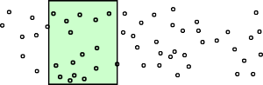
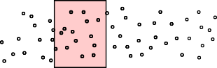

Gauge Length
Figure 2 – Definition of gauge length

It should be noted at this time that caution should be taken when defining the gauge length and pulse width and how they interact in terms of data properties and quality. In order to describe the reason for the interaction of pulse width and gauge length, we need to define some additional terms with reference to figure 3.
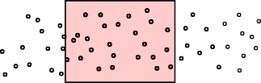
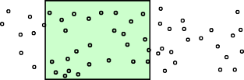
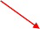

Gauge Length
Phase-Center Location Prob
Phase-Center Location Prob
B
Phase Center (A)
Phase Center (B)
A
Actual Gauge Length
Figure 3 – Defined gauge length vs actual gauge length

Due to the statistical nature of Rayleigh scattering, the exact effective position from which the scatter originated, and hence the position from which the optical phase has been measured, cannot be exactly determined. This location is termed the phase center and for each specific location along the fiber, the phase center will vary within the envelope of the probe pulse. Figure 3 shows a representation of the probability-density function for the phase-center location, and as illustrated the phase center can vary within the pulse envelope. The most probable location however is the weighted center of the pulse envelope. The defined gauge length is the distance between the pulse and the virtual pulse, however the actual gauge length for a given location is the distance between the phase centers for pulse A and pulse B. The actual gauge length therefore varies as a function of distance along the fiber. The average gauge length will be the defined gauge length but at the extremes, although improbable, the allowable range of the actual gauge length will be the defined gauge length +/- the pulse width. Although very improbable, certain fiber locations can exist where these limits are met.
This is important because as the gauge length varies so does the transduction coefficient of the sensor, directly changing the theoretical relationship between strain and measured phase modulation.
When the pulse width is small compared to the gauge length, this is a small effect and can be neglected. However, as the pulse width approaches the gauge length, this effect becomes significant and depending on the specific application, should be avoided. Figure 4 highlights these issues. In an extreme case when the pulse width exceeds the gauge length, it is possible for the leading phase center for pulse A to overtake the lagging phase center for pulse B. In this extreme situation the polarity of the sensor will be inverted, which should also be avoided.

Defined Gauge Length

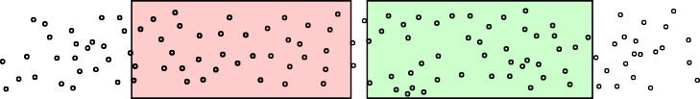
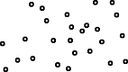
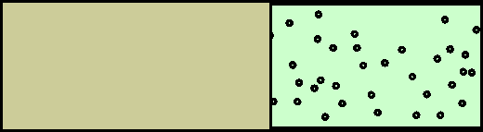
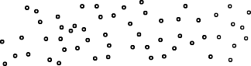
Fading Mitigation is Reduced

If phase centres overlap - Phase Inversion
Figure 4 – Gauge length variation due to pulse width and possible phase polarity inversion

Stacking
As previously described, Rayleigh scattering is a statistical mechanism and thus along with variations in phase center and gauge length, the amplitude of the scatter will also vary as a function of location. Certain locations will exhibit a near-zero scatter amplitude and thus make it difficult to extract the phase at that location. This phenomenon is termed Rayleigh fading. Onyx employs several mechanisms to combat signal fading, the first being dual polarisation interrogation, and the second being signal stacking. When the pulse width is small with respect to the gauge length and when we have a target strain modulation correlated over the gauge length, we can extract a higher signal-to-noise measurement and simultaneously reduce gauge-length variation and fading, improving system fidelity and linearity by summing signals or stacking over a given stacking pitch.
As illustrated in figure 5, we calculate the phase difference over a fixed gauge length but sampled multiple times within the first gauge length at a sub-pitch less than the gauge length. Each time the phase difference is recalculated, the probe pulse has moved along the fiber and thus illuminates different scatter elements within the fiber. The scatter statistics for each sub-pitch channel are uncorrelated from the last and by summing the contributions from many sub-pitch channels, the gauge-length fading statistics are significantly improved. The signal-to-noise is also improved as the signal is coherently summed over the original gauge length as multiple sub-pitch channels are stacked.
The cost is a slight reduction in the achievable spatial resolution, however since the signal is required to be correlated over the stack and the stack is chosen correctly, the resulting resolution is appropriate for the signal being extracted.
Onyx 1.0 allows the stacking to be chosen again in integer multiples of the 1.595 m spacing allowed for the gauge length. We recommend typically stacking by half of the gauge length. When looking at low-frequency or broadside signals this can be extended to the gauge length or beyond. For example, if a pulse width of 2.4 m is chosen with a gauge length of 6.4 m, we would recommend a stacking pitch of 3.2 m, or perhaps up to the 6.4 m gauge length.
Onyx 1.1 (Peta) employs the same stacking philosophy but allows the user to define the stacking pitch in integer multiples of 0.71 m (when configured for Mode 9) or 0.53 m (when configured for Mode 8).

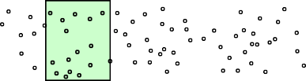
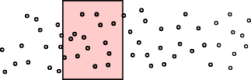

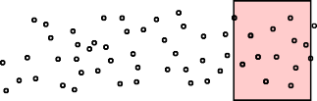
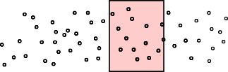
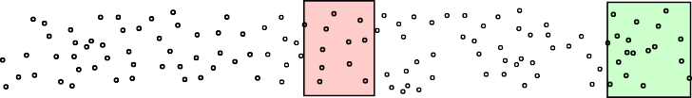
Figure 5 – Spatial stacking Channel Pitch

Gauge Defined
For Onyx 1.0, all of the data processing described above is calculated independently for every 1.595 m section of fiber. Instead of outputting a channel every 1.595 m, the data processing then allows the user to choose a decimated output channel pitch to reduce data rate and files sizes if required. For Onyx 1.0, the output channel decimation rate cannot be less than the stack size, and so if a stack of 4 sub-channels at 1.595m pitch is chosen, each output channel will be spaced by 6.38 m.

For Onyx 1.1, the output channel decimation has been made independent of the stack size chosen and the user has the freedom to output as many output channels as they wish, independent of the chosen stack length. The sub-channel stack pitch is also reduced when compared to Onyx 1.0 and is 0.71 m (when configured for Mode 9) or 0.53 m (when configured for Mode 8).

Mode 8 and Mode 9
Coherent Rayleigh scattering is a statistical mechanism and thus the signal for critical system variables such as scatter amplitude, gauge length, phase center and gauge center vary as a function of position. It is therefore desirable to mitigate these variations as much as possible, and there are several techniques available by which this can be achieved. Sintela employ both polarisation and spatial diversity (stacking) techniques. The signal processing methods by which the signals are recovered and combined from different polarisation streams and from different locations are named mode 8 and mode 9.
Mode 8 is a general-purpose algorithm and can combine multiple diverse data streams into a single, higher-SNR data stream without significant processing overhead. This mode is good for large modulation depths up to and near the Nyquist limit without showing significant distortion. However, at frequencies below 100 Hz there is a moderate penalty in the form of additional 1/f noise above the theoretical minimum. Therefore, where low-frequency data is desired, mode 8 can limit the achievable signal-to-noise ratio.
Mode 9 was developed for a specific application, that of vertical seismic survey. This application employs a fiber vertically installed in a borehole, where we can assume that the fiber is quiet and static and where the environment is changing only very slowly. A test signal from 5–100 Hz is then used to perform the vertical seismic profile and the responses generated by the DAS system are small in amplitude. Mode 9 is therefore able to significantly reduce the 1/f corner of the DAS data and achieve higher SNR than would be possible using mode 8 in this application. However, this comes at a cost of dynamic range. Mode 9 will only perform linearly for modulation depths below 1 radian and will significantly distort above this. Mode 9 operates with a fixed time constant alignment reference and so the user must:
- Set the DC Reference Filter cutoff below the band of interest
- Ensure that the modulation depth due to environmental change at rates higher than the filter cutoff remain in the small-angle regime.
The reason for the differences between Modes 8 and 9 is due to the approach taken to stacking independent DAS data streams and combating fading, gauge-length and phase-center variation. The fundamental difference between Mode 8 and Mode 9 and methods employed by other DAS systems is that stacking is performed prior to phase recovery by processing the cumulative phase-modulated carrier itself using vector manipulations rather than by conventional techniques.
In order for spatial stacking to function efficiently, we have to make the assumption that the strain field is evenly distributed over the gauge-length spatial interval and thus the AC signals are correlated over multiple samples over the gauge length. However as with polarisation diversity, the bias phase for each of the scatter locations is independent, or at least at a different angle, and thus we cannot simply stack the vectors from each location without first removing the bias phase or aligning the vectors to be stacked to a common basis.
Mode 8
In simple terms mode 8 removes the bias phase from individual vectors by time differentiating them. This is achieved by taking the difference between the phase on the current ping relative to the previous ping. Note differentiation occurs in vector space, so a vector unchanging in time will result in a vector aligned with the x axis and one changing at a fixed rate will occur at an angle relative to the x axis equal to the phase difference between consecutive samples. This yields a vector whose angle is no longer related to the phase of the light but rather the rate of change of the phase, or its instantaneous frequency (IF). If the strain field is correlated then this will have the effect of removing the bias phase and allowing all vectors to be pointing in the same direction, allowing stacking without significant distortion. This is a very tolerant method and allows stacking over large dynamic ranges. Following stacking, the angle of the resultant stacked vector can be recovered but must then be integrated in time for each location in order to recover the phase, which presents an issue. Amplitude noise in the vector measurement is coupled to phase noise at this point in the algorithm, adding a small random error. At low frequencies and long integration times this error increases the noise floor in the form of a 1/f noise profile at low frequencies. Typically, at frequencies lower than 100 Hz the 1/f noise floor is the dominant contributing noise factor.
Mode 9
A second method is to explicitly reference and purposefully align the vectors prior to stacking without the need to take a time differential. In this way we avoid the integration step and thus avoid the addition of 1/f noise in the signal. The challenge is how to reference the vector, i.e. how to remove the bias phase.
What is done in mode 9 is to low-pass filter the I and Q components of the vector with a fixed time constant, thus removing the AC signal component and leaving only the DC bias phase. This time constant is set by the user prior to signal acquisition. Unfortunately, the resource requirements for this filter limit the internal bit growth and thus the low-cut point of the filter relative to the chosen pulse repetition frequency (PRF). Note: the filter allows a factor of 100,000 between the low-cut threshold and the PRF. At a PRF of 20 kHz, the lowest filter low- cut threshold is 0.2 Hz, and at 1kHz a low-cut threshold of 0.01Hz, for example.
We measure the low-pass filtered ‘time average’ of each vector to be stacked and define this time-average result as the individual reference vector. To allow stacking, we then define a common reference vector by simply adding the individual reference vectors. We then explicitly rotate the instantaneously measured vectors for each location onto the commonly defined reference vector. This allows the rotated instantaneously measured vectors to be stacked without distortion.
This referencing has the effect of removing any modulation below the low-cut threshold of the filter chosen at the time of acquisition. It is therefore important to set this filter as low as can be tolerated by the natural drift within the environment at the time of acquisition. However, the fact that the vectors are being aligned to a constantly evolving filtered reference means that at rates below the filter cutoff, the reference itself will move and thus the near-DC modulation will also be recovered. The effect is that we get good low-distortion stacking above and below the filter cutoff but at and around the filter cutoff the signals will be distorted and reconstructed poorly. Another limitation of Mode 9 is the handling of large angle modulation. Since we are simply taking the time average of the vector with a fixed time constant, if the vector rotates around the circle within the time constant of the filter, the resultant filtered vector length will approach zero and a form of fading occurs where the algorithm loses its reference and thus starts to distort and/or overscale (i.e. where the phase evolution can exceed pi per measurement).
Transfer of data to OnyxAcquisition signal-processing chain and the action of the leaky filter

We have described in detail the firmware-implemented signal-processing and stacking algorithms that take place within the FPGA. This yields a data stream, consisting of measurements of the phase/strain at every location of the fiber monitored. A great advantage of the Onyx DAS system is that any additional signal processing the user may want to perform to garner additional value from this data can be performed at the edge within the processing hardware in the unit itself. This is accomplished by transferring the phase/strain data to an Nvidia-based processor within the unit. Onyx 1.0 employs an Nvidia-Xavier-based processing platform whereas the Onyx 1.1 employs an upgraded and more powerful Orin-based platform. The additional signal-processing steps employed within the Onyx are tailored by the modification of a signal-processing chain that can be easily modified and configured by the user. Figure 6 shows a typical chain, employed for general data inspection.
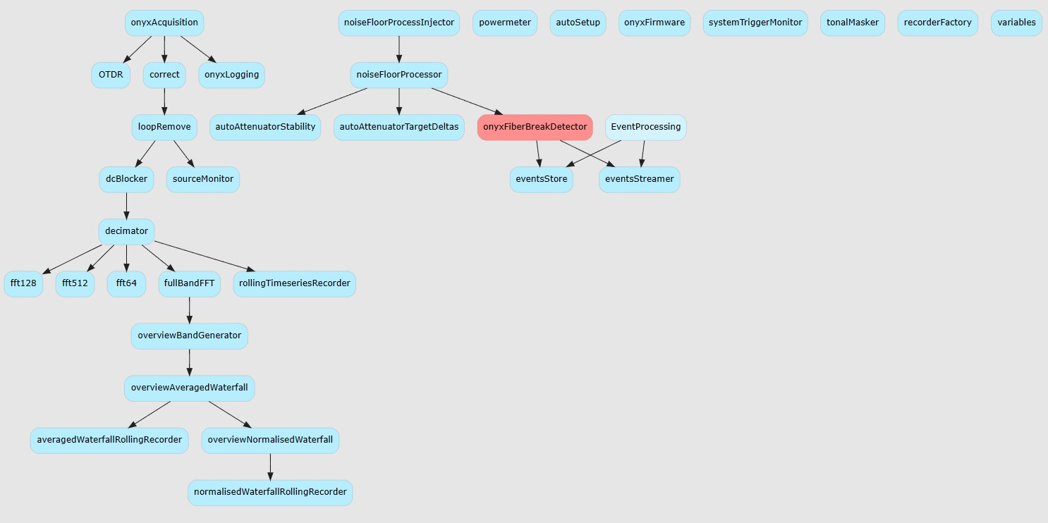
Figure 6 – Example signal-processing chain

Data is transferred from the FPGA to the processing chain via the top interface block, labelled ‘onyxAcquisition’. To maintain a fixed bit depth in the data-transfer protocol, the format of the data in the link represents the change in phase between interrogation pings, for each channel, and not the unwrapped phase. In this way the data may be assumed to be in the range +/- π and can be represented accurately using a signed 16-bit integer.
The first function of the OnyxAcquisition block is therefore to perform an integration to recover the phase in each spatial channel. The OnyxAcquisiton then outputs a data stream representing the unwrapped phase measurement over the gauge length defined for each spatial channel. The precision of the signal processing maintained in the processing chain is 32-bit float.
Given the near-DC response of the DAS system, the OnyxAcquisition Integrator can build up significant DC if the fiber is changing in temperature or strained consistently in the same direction for an extended period. Given the low noise floor of the Onyx DAS system, the dynamic range required in the signal processing chain can be significant if required to simultaneously measure tiny AC variations on a large DC pedestal.
The dynamic range available within a 32-bit float is in essence 23 bits, i.e. 138 dB, given a noise floor of -90 dBrads. This means that at DC levels of the order of 250 rads, the processing chain will begin to saturate and lose significance, degrading the achievable noise floor if the bandwidth reduction and averaging occurs on the data with the DC pedestal intact.
For this reason, the integrator block within the OnyxAcquisition has a decay constant, or leaky filter. The action of this filter is to decay the value stored in the integrator’s accumulator on successive samples.
The way this filter operates is as follows. A sample comes in for a specific output channel, which is added to the accumulator. The accumulator is then decayed by the filter coefficient and the decayed value is output. The next sample comes in and the procedure is repeated. The result is that the leaky filter acts as a single-pole high-pass filter.
The cutoff frequency of the filter (f_{c}) is related to the decay-filter coefficient via the formula:
𝑅 = 𝑒−2𝜋.𝑓𝑐/𝑃𝑅𝐹

where PRF is the interrogation sample rate.
If information about the very-low-frequency data and the small higher-frequency AC variations is required simultaneously, is it sensible to split the chain into two parallel streams, with the first acting on an AC-coupled output from the OnyxAcquisition block and the second on a DC or near-DC-coupled output representing the low-frequency band of interest.

