Project Number: | 902401

Project Start: Jan. 1, | 2024 | Project Duration (in years): | Year 1 of 3¹

Please indicate if proposal includes requests for any of the following (mark all that apply).

 | X
Ship Time |  |  | ROV |  |  | AUV |  |  | Wave Glider |  |  | Mini ROV

Please indicate what type of project is being proposed (mark only one).

 |  |  |  | X
Feasibility/Scoping  [<100 days effort] |  |  | Development |  |  | Research |  |  | Infrastructure² |  |  | Education |  |  | Time Series |  |  | Institute Initiative

Project Manager: Alana Sherman
Principal Investigator: Aaron Micallef
Lead Scientist:
Lead Engineer:

Project Title: Geo-Sense

Please indicate which category best describes the project theme (mark only one).

 |  |  |  |  |  |  |  |  |  | X
Ocean  biogeochemistry |  |  | Ecosystem dynamics |  |  | Ocean visualization |  |  | Exploration & discovery

Please indicate percentage of effort on this project anticipated for 2024 toward these three highest institutional goals from the Strategic Roadmap (percentage total should equal 100%).

Goal | Innovate and Build | Explore and Protect | Inspire and Engage
Percentage | 100%

- ABSTRACT (all projects)

Distributed Acoustic Sensing (DAS) technology can characterize fine-scale geomorphic processes over multi-kilometer distances, enable long-term time-lapse monitoring, and be deployed in logistically challenging areas. Although it has recently been shown to be a powerful approach to detect seafloor hazards, DAS has not been deployed in the study of seafloor geomorphic processes.

Geo-Sense is a 3-year development project that will address two key research questions: (1) How do we take the rapidly developing DAS technology and deploy it as an autonomous instrument?; (2) Is DAS technology effective at monitoring sedimentary flows in Monterey Canyon? Activities in year 1 include a feasibility study to establish if and how a portable DAS prototype instrument should be developed. A simple DAS prototype instrument will be designed, assembled, tested and deployed in early 2025, to coincide with field observations planned by Paull and colleagues in the head of Monterey Canyon. In year 2, DAS data acquired by the prototype and the MARS cable will be compared with the field data to assess if sedimentary flows can be detected and what information can be gleaned on their behavior. Year 3 will be devoted to working towards a more optimal system design for a portable DAS. If successful, Geo-Sense will transform our ability to monitor a wide range of seafloor processes at high temporal constraints and across major geographic gaps, thus leading to a step change in our understanding of the initiation and evolution of active seafloor processes.

- PROPOSAL (all projects)

Background

Problem: Distributed Acoustic Sensing (DAS; Figure 1) – a technique that measures the phase change in Rayleigh scattered laser light from fiber-optic cables to calculate ground strain at fine spatial resolution (range bins <5 cm) and long lengths (>100 km) – has recently been shown to be a powerful technology to detect seafloor hazards (e.g., earthquakes, ocean currents). DAS can carry out multiple measurements of strain along the path of a cable, capturing local topographic deformation. As a result, DAS has transformative potential in geomorphology, because it can characterize fine-scale processes (in terms of location, timing, transformation, erosion and velocities), enable long-term time-lapse monitoring, and be deployed in logistically challenging areas. DAS technology has not been deployed to investigate seafloor geomorphic processes thus far. Reasons include: (i) limited availability of submarine cables and access to dark fibers and interrogators, and (ii) submarine cables tend to be located away from seafloor processes of interest. As a result, the sensitivity of cable configurations, interrogator units, and analytical approaches to monitor seafloor processes (e.g., sedimentary flows, slope failure, fluid flow and escape) remains unknown.

Research questions: This is a development study that will address the following two research questions:

- How do we take the rapidly developing DAS technology and deploy it as an autonomous instrument?
- What information can DAS technology provide on the initiation and behavior of sedimentary flows in Monterey Canyon?

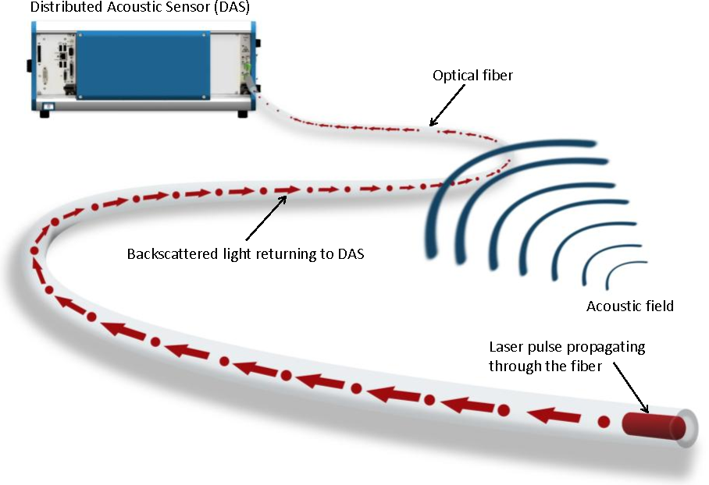

Figure 1: Schematic illustration of DAS infrastructure (source: Johannessen, K., et al. (2012). Distributed Acoustic Sensing - A New Way of Listening to Your Well/Reservoir. Paper presented at the SPE Intelligent Energy International).

Significance:
- Importance: (1) A wide range of seafloor processes (e.g., creep, fluid flow and seepage) frequently operate at small spatial scales, yet they tend to have an extensive impact on continental margin geomorphology. DAS technology holds great promise for detecting and understanding such seafloor processes in unprecedented detail, duration and spatial coverage. (2) This program opens up the potential of using existing submarine cable networks (including MARS) to monitor seafloor processes such as sedimentary flows, which are a threat to infrastructure and play a role in the transport and burial of organic carbon, nutrients and contaminants.
- Timeliness: (1) A DAS interrogator has been installed on MARS in July 2022 and is expected to be operational for at least 5 years. This monitoring exercise, and the Geo-Sense program, will overlap with an experiment planned by Charlie Paull in November 2024–March 2025, which will monitor sedimentary flows in Monterey Canyon using Ocean Bottom Seismometers and moored sensors, providing a unique opportunity to calibrate DAS data. (2) The components for distributed sensing have started to become affordable enough to make a stand-alone system economically feasible.
- Uniqueness: (1) This will be the first time that DAS technology has been used to monitor seafloor geomorphic processes. (2) I am aware of only one attempt to develop a self-sustaining, portable DAS system (Shell, 2013, for pipeline surveillance, leak detection, and in-well monitoring).

Relevance to MBARI and Packard Foundation: MBARI is uniquely positioned to implement the proposed program: (i) The MARS cable, which MBARI operates and maintains, is already connected to a DAS interrogator (owned by University of California, Berkeley), with data collection planned from July 2022 for at least 5 years. It is located in proximity to Monterey Canyon, where multiple sedimentary flows occur every year. The geometry of the MARS cable provides the azimuthal coverage necessary for triangulation of events. (ii) Program makes good use of engineering expertise in adapting instrumentation for deployment in deep-water settings. Our engineering group also has expertise in laser systems and seismometers that would be applicable to this project. (iii) It builds on existing links with the University of California, Berkeley and Stanford University.

The program directly aligns with four strategic priorities: (i) Build scalable technologies to improve ocean health assessments, (ii) Map the deep seafloor at high resolution, (iii) Advance ocean-based artificial intelligence, and (iv) Study the impacts of climate change and other ocean threats.

Internal and external project links:
- Concurrent Seafloor Processes internal proposal (902312, Micallef)
- Concurrent CSEM (controlled-source electromagnetics) internal proposal (902402, Micallef)
- Concurrent Continental Margins internal proposal (901023, Paull)

Alignment with ~5–10 year plan for my research group, MBARI and the field of seafloor geomorphology: The 10 year vision for the Seafloor Processes lab is to become a global leader in the characterization of a wide range of active seafloor processes at fine temporal scales. The lab will address the following key scientific questions: (i) What are the characteristics of seafloor processes? (ii) How do these processes interact with the seafloor? and (iii) What are the key drivers and controlling factors of the processes and associated landform evolution? These questions will be addressed using a combination of repeat surveying and in situ monitoring, supported by automated detection and classification, and advanced numerical methods.

By the end of the Geo-Sense project, MBARI will have an instrument that will be fundamental for monitoring and characterizing active processes (in terms of location, dimensions, timing, triggers and behavior) at fine spatial and temporal scales at targeted locations for months-long durations. Although the focus will initially be on sedimentary flows, the instrument will be easily adapted to monitor a wide range of other seafloor process, for example slope instability and fluid flow/seepage. In addition, the Geo-Sense project will help open new scientific applications for the MARS cable.

Nature and Scope of the Proposed Project
This project represents a medium-sized R&D effort. The project team proposes to hold a review in spring 2024, at which point a decision can be made to proceed with the prototype system on a time scale that aligns with the Monterey Canyon field experiment, or to scale back the goals and shift to a feasibility project.

Year 1 (2024): Activities planned to address question 1 include a feasibility study carried out in consultation with MBARI engineers and DMO personnel, as well as scientific and industry leaders, to establish whether a portable DAS prototype should be developed and, if yes, how. To address question 2, and if the proposed design passes the concept review stage, we will construct and test a prototype DAS system. Existing components at MBARI can be utilized (e.g., instrument housings and benthic frames). Depending on the deployment strategy, other MBARI hardware may be refurbished.

Year 2 (2025): The portable DAS prototype and cable will be deployed in Monterey Canyon in early 2025 to overlap with field experiments planned by Charlie Paull and colleagues. DAS data— acquired by the prototype and the interrogator on the MARS cable—will be compared with data from the field experiments and publicly available databases to assess if sedimentary flows can be detected and what information can be gleaned on their behavior. Machine learning algorithms will be developed for signal recognition in DAS data.

Year 3 (2026): Take what lessons we have learned from the prototype deployment and work towards a more optimal system design for the portable DAS.

Does this activity relate to one or more 2024 proposals your team is submitting?
Concurrently proposed internal projects:
- Seafloor Processes (Micallef): This is the core science project for the Seafloor Processes lab, which will focus on active seafloor processes at fine spatial and temporal scales.
- CSEM (Micallef): CSEM focuses on developing controlled-source electromagnetic instruments to detect fluid flow and seepage.
The Geo-Sense technology will be directly relevant to monitoring sedimentary flows, and later on fluid flow and seepage, both of which are key themes of the two programs listed above. Data from the Seafloor Processes program will inform the activities to address question 2.

Hierarchy of priorities:
- Seafloor Processes
- Geo-Sense
- CSEM

Anticipated Shared Resource Needs

Year 1:
The MBARI team comprises:
Science
- Aaron Micallef
- Charlie Paull, Roberto Gwiazda, Eve Lundsten – MARS DAS data analyses and calibration with field data
- John Ryan – access to and interpretation of MARS hydrophone data
Engineering
- Aaron Schnittger or mechanical engineer TBD (240 hrs) - prototype assembly
- Alana Sherman (400 hrs) - project management, system engineering
- Denis Klimov (280 hrs) – evaluation of DAS interrogator candidates and event-trigger mechanisms; preliminary system architecture and algorithms
- Paul McGill (280 hrs) - battery power calculations and instrument power reduction strategies, as well as interfacing to MARS
- Rich Henthorn (120 hrs) - contributions to event-triggered response
- Yanwu Zhang (20 hrs) - MARS DAS data analysis and contributions to event-triggered response
DMO
- Knute Brekke (80 hrs) - cable laying strategies, as well as the MARS DAS system
- Marine operations technician or mechanical technician (160 hours) – deployment concept development, cable laying preparation, assembly of ocean-going assets

The R/V David Packard is requested for 2 days in 2024 to test the deployment strategy, and 4 days in early 2025 to deploy and recover the prototype. The machine shop will be required to assemble the prototype.

Anticipated Expenses

Expenses for year 1:
- Visit to Sintela premises ($1,645)
- Prototype development ($113,000)

In years 2–3 we plan iterations on prototype instrument ($30,000) and procurement of batteries for additional deployments ($20,000).

Intellectual Property (IP) Considerations
There might be the need to sign a non-disclosure agreement with an industry partner for MBARI engineers to access information on interrogator and cable components. This will be determined by December 2023 after consulting with the suppliers.

Data
150 TB of DAS data in year 1. These will be stored on Titan.

Anticipated Impact
Consumers of project outputs include:
- Scientists: Program has a strong potential to promote the widespread application of monitoring approaches for a wide range of seafloor processes at high temporal constraints and across major geographic gaps. This will lead to a step change in our understanding of the initiation and evolution of active seafloor processes, while reducing monitoring costs.
- Industry: Transformation of industry’s ability to better situate seafloor infrastructure (e.g., cables, pipelines, blue-energy platforms) and monitor geohazard impacts on these assets, geological storage (e.g., sub-seafloor storage of carbon and hydrogen), and environmental change.
- Society: Improvement of early warning systems for offshore natural hazards.
Connections with other organizations:
- University of California, Berkeley (Julien Marty, Brian Pardini)
- Stanford University (George Hilley, Steve Dobbs)
- University of Durham (Pete Talling)
- National Oceanography Centre (Michael Clare)
- GEOMAR (Christian Berndt)
- OptaSense (Andres Chavarria, Victor Yartsev)
- Sintela (David Hill)

Anticipated Outreach Needs
Assistance communicating this work to the general public will be requested when the project has accomplishments to share (social media, infographics, press release). None is required for 2024.

All Projects: Specific Plans for 2024

Research Activities

Not applicable.

Engineering/technology development

Activities in relation to question 1: How do we take the rapidly developing DAS technology and deploy it as an autonomous instrument?
To help facilitate the startup of the Seafloor Processes lab, a small group of engineers has been devoting time to exploring the feasibility of a portable DAS system. This feasibility study will continue through the first quarter of the 2024. During the spring of 2024 we propose to hold a concept design review that will serve as a decision point for pursuing the rapid development of a prototype system to be deployed in the first months of 2025 in conjunction with the planned field experiment in Monterey Canyon head.

  - Identify the latest instrument designs in DAS technology.
  - Develop a conceptual design of a portable DAS prototype. This would lean heavily on reusing existing housings and proven designs to the extent possible to minimize risk and development time. Protocols for deployment/recovery of the system will be included in this design.
  - Carry out a SWOT (strengths, weaknesses, opportunities and threats) analysis for these designs.
  - Conduct a design review in spring 2024, which will be attended by key personnel, with the goal of deciding whether or not to proceed with proposed concept design.

The above tasks will be carried out by consulting MBARI engineers and DMO personnel, as well as scientific and industry leaders, via online and in-person meetings. Preliminary consultation has already taken place with members of the SZ4D initiative, colleagues at University of California, Berkeley, Stanford University, OptaSense and Sintela. An in-person meeting with Sintela, the supplier of the interrogator, is planned at their premises in Bristol (UK) in early 2024.

Activities in relation to question 2: What information can DAS technology provide on the initiation and behavior of sedimentary flows in Monterey Canyon?
The following tasks are planned for 2024 to develop a portable DAS prototype instrument:

  - If approved, proceed to critical design review and detailed design of simplest prototype identified from the feasibility study. An example of a potential design is shown in Figure 2.
  - Selection of an appropriate deployment and recovery protocol.
  - Procurement of a 1 --km-long DAS cable (from DeRegt or Sercel), 20 kWhrs of Li primary batteries, and a DAS interrogator (Sintela). A new model from Sintela will have a range of 5 km, dimensions of 300 × 200 × 75 mm, mass of 5 kg, and a power consumption of 30–40 W. The proposed battery package would allow a 1–2 month-long deployment. Considering that 6 sedimentary flows are expected between November 2024 and March 2025, the probability that a sedimentary flow will be monitored during the 1–2 month long deployment of the DAS prototype in early 2025 is high.
  - Assembly of the prototype instrument. The above components will be housed in repurposed housings from the MOOS/Canyon Dynamics program.
  - Testing of the prototype (in the laboratory and test tank) and the deployment/recovery protocol in the field.

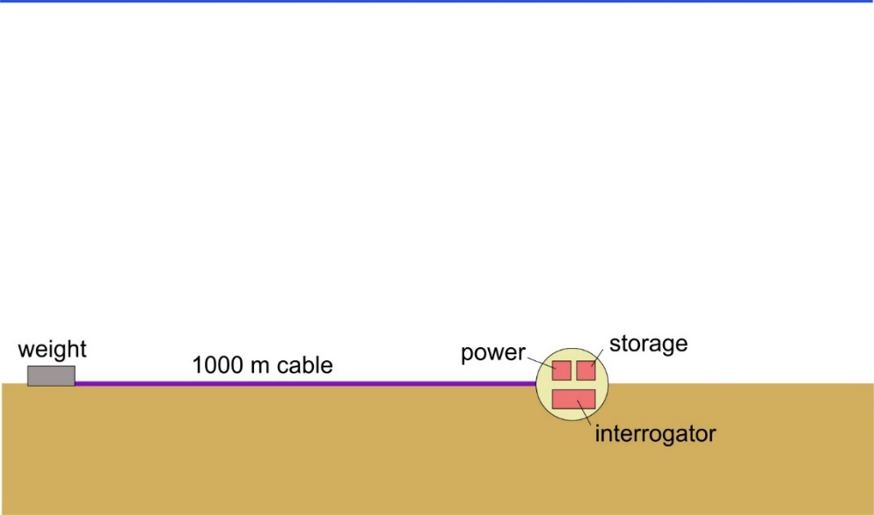
Figure 2: Conceptual design of the simplest Geo-Sense prototype. 1000 m is the longest cable length that will be considered.

In 2025, the following tasks are envisaged:

  - Deployment/recovery of the DAS prototype and cable in Monterey Canyon in February–March 2025 (Figure 3). According to the potential supplier of the interrogator, the cable does not need to be buried.
  - Download and processing of data acquired by MARS DAS between November 2024 and March 2025.
  - Comparison of signals measured by prototype with MARS DAS data, in-house and publicly available data on seismic, biological and oceanographic events, and the field measurements from Monterey Canyon between November 2024 and March 2025, to isolate sedimentary flows. Being closer to the sedimentary flows, signals from the prototype are expected to be easier to detect and more information-rich than those from MARS.
  - Continuation of the development of a portable DAS system based on lessons learned with the prototype deployment.

Tasks 2.7–2.8 will ideally be carried out by a new post-doc. Alternatively, Micallef will be in charge of these tasks.

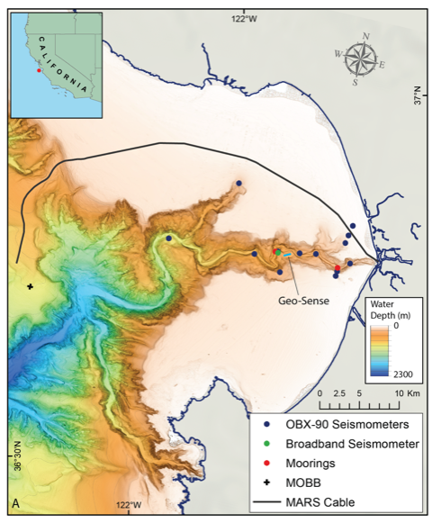
Figure 3: Bathymetric map of Monterey Canyon showing where the various instruments, to be deployed during the experiment planned by Charlie Paull and colleagues, will be located. The proposed location of the prototype instrument is on an area of flat and smooth seafloor at 150–200 m water depth in between two seismometers and close to the deeper mooring.

The long-term goal of this project is to design a more elaborate portable sensing prototype that allows long-term autonomous deployment (e.g., powered by wave energy, or using power reduction strategies such as event-trigger mechanisms) using a range of cable configurations. Monitoring of a wider range of processes (e.g., fluid flow and discharge), and the development of algorithms for rapid data reduction, will also be considered.

Field programs (detail ship requirements/deployments/diver requirements)

Ship requirements:
2 days on the R/V David Packard after September 2024 to test the deployment/recovery strategy.
4 days on the R/V David Packard in February–March 2025 to deploy and recover the prototype and cable.
Although a deployment/recovery strategy needs to be defined, an ROV will likely be required during the above operations.
These Geo-Sense operations can be combined with efforts from other projects.

Risk management
Taking into account the abstract feedback as well as the research we have conducted during the ensuing month, two high-risk elements to this development have been identified as:

- Sanctuary permitting
- Finding an available DAS system with physical size and power consumption specifications that would be feasible for an autonomous underwater system

Below is a brief update on these aspects:
- Permitting: We are working with Mandy Allen on initial discussions with the sanctuary regarding permits. The project team is working on a one-page summary that Mandy can present to her contacts at the sanctuary.
- Appropriate DAS instrument: We have had detailed and encouraging talks with the commercial DAS vendor Sintela. They are currently developing a low-cost, low-power DAS system for distances of <5 km. This system would cut the power by 70–80% from the rack-mounted units and easily fit into a pressure housing. Better yet is that it is designed to work autonomously. From our discussions, we believe two 17” battery spheres would provide enough energy to power the system for 1–2 months.

The proposed timeline for the development of the prototype instrument and its deployment (tasks 2.1–2.6) is intentionally aggressive because the field experiment in the Monterey Canyon head by Paull and colleagues is a unique opportunity to test and calibrate our instrument. In the case where deployment during this time is not possible (e.g., permit is not available in time), we may consider deployment in an active, instrumented canyon elsewhere (e.g., Scripps Canyon, California; Astoria Canyon, Cascadia Margin).

Specific deliverables

D1: Internal report on the outcomes of the feasibility study, including designs of prototypes, and deployment/recovery mechanisms (2024)
D2: Detailed design of simplest prototype (2024)
D3: Prototype of a portable DAS sensing system (2024)
D4: Raw and processed data, and scientific publication, on the effectiveness of DAS to monitor sedimentary flows in Monterey Canyon (2025)
D5: Python code for signal recognition in DAS data from MARS (2025)

Milestones and required personnel (see personnel classification list for staff classifications)

2024 Project Start Date:  01/01/2024 | Milestone 1 | Milestone 2 | Milestone 3 | Milestone 4 | Total Resources (in hours) for each resource category for all milestones listed here
Milestone Date | April 2024 | June 2024 | September 2024 | October 2024
Milestone Description | Concept review decision point | Design completed and components procured | Prototype assembled | Prototype and deployment/recovery strategy tested
Electrical Engineer | Sherman (100)  Klimov (70) McGill (70) Zhang (20) | Sherman (100)  Klimov (70)  McGill (70) | Sherman (100) Klimov (70)  McGill (70) | Sherman (100) Klimov (70)  McGill (70) | 400 A.S  280 D. K.  280 P.M.  20 Y.Z.
Software Eng-Embedded | Henthorn (60) |  |  | Henthorn (60) | 120 R.H.
Software Eng-Info Eng
Mechanical Engineer
Mechanical Eng-Division
Mechanical Eng-Mfg
Associate Engineer | Schnittger (120) | Schnittger (60) | Schnittger (60) |  | 240 A.S.
Electrical Tech
Software Tech
Mechanical Tech
Machinist
Divers
Video Lab
Marine operations technician | (50) | (50) | (60) |  | 160
DMO | Brekke (40) |  |  | Brekke (40) | 80 K.B.

Budget justification (year 1)

Activities in relation to question 1:

A two-day visit to Sintela’s premises in Bristol, UK, in early 2024. Funds are requested to cover the travel expenses of one engineer:
- Return flight ($700)
- Accommodation ($600)
- Subsistence ($195)
- Land transport ($150)
Sub-total: $1,645

Activities in relation to question 2:

These expenses are primarily related to the development and testing of the prototype, and the refurbishment of available components prior to deployment in February 2025:
- Prototype development:
  - DAS interrogator from Sintela ($55,000 for new, low power stand-alone interrogator)
  - Battery package ($20,000 for 20 kWhrs of Li primary batteries)
  - Underwater cable appropriate for DAS application ($20,000)
  - FO connectors ($10,000)
  - Beacons ($5,000) (these may already be part of the elevator and not required)
  - Materials to create frame and other mechanical components of the system ($3,000)
Sub-total: $113,000

Total cost: $114,645

Project team

MBARI:
Science
- Aaron Micallef
- Charlie Paull
- Roberto Gwiazda
- Eve Lundsten
- John Ryan
Engineering
- Alana Sherman
- Aaron Schnittger
- Denis Klimov
- Paul McGill
- Rich Henthorn
- Yanwu Zhang
DMO
- Knute Brekke
- Marine operations technician

University of California, Berkeley:
- Julien Marty
- Brian Pardini
University of Durham:
- Pete Talling
National Oceanography Centre:
- Michael Clare
GEOMAR:
- Christian Berndt
Sintela:
- David Hill

External consultants/contractors
Not applicable

Project lab and office space requirements
- 1 PI office (no need for change)
- Shared lab space (no need for change)
- Office space for potential post-doc (new request)
- Storage space for portable DAS prototype and 1 km cable (<15 m³; new request)

Risk matrix (development and infrastructure projects only)

 | Technical Risk | Organizational Risk | Tech Transfer Risk | Labor Estimate Risk
High |  |  |  | X
Medium | X
Low |  | X | X

Compliance Considerations

All responses must be recorded in the Google form linked below. A form must be submitted for every project.

Link to Google Compliance Considerations form -OR- https://forms.gle/wVCb9VRRuYBU5yvF8

Form has been submitted online.

This date and number should remain the same for the duration of the project. If your project start date for 2024 is not January 1, please indicate the start date in the first cell of the milestone chart. Format for duration example: “Year 2 of 5”.
Development and infrastructure projects must complete the risk matrix (see end of the proposal form).
Not all projects will require all four titles to be filled in. Please indicate individuals only for those titles that are appropriate for your project.
This category includes transfer of hardware, know-how, publications, presentations, etc.
This number should be the same number you entered on the web budget resource requests for this particular resource.

