Project Number: | 902401

Project Start: Jan. 1, | 2024 | Project Duration (in years): | Year 2 of 3¹

Please indicate if proposal includes requests for any of the following (mark all that apply).

 | X |  |  | X
Ship Time |  |  | ROV |  |  | AUV |  |  | Wave Glider |  |  | Mini ROV

Please indicate what type of project is being proposed (mark only one).

 |  |  |  | X
Feasibility/Scoping  [<100 days effort] |  |  | Development |  |  | Research |  |  | Infrastructure² |  |  | Education |  |  | Time Series |  |  | Institute Initiative

Project Manager: Alana Sherman
Principal Investigator: Aaron Micallef
Lead Scientist:
Lead Engineer: Aaron Schnittger

Project Title: Geo-Sense

Please indicate which category best describes the project theme (mark only one).

 |  |  |  |  |  |  |  |  |  | X
Ocean  biogeochemistry |  |  | Ecosystem dynamics |  |  | Ocean visualization |  |  | Exploration & discovery

Please indicate percentage of effort on this project anticipated for 2024 toward these three highest institutional goals from the Strategic Roadmap (percentage total should equal 100%).

Goal | Innovate and Build | Explore and Protect | Inspire and Engage
Percentage | 45% | 45% | 10%

- ABSTRACT (all projects)
Briefly provide a high-level summary of the project (ideally no more than 1/2 page).

Distributed Acoustic Sensing (DAS) technology can characterize fine-scale geomorphic processes over multi-kilometer distances, enable long-term time-lapse monitoring, and be deployed in logistically challenging areas. Although it has recently been shown to be a powerful tool for detecting seafloor hazards, DAS has rarely been deployed in the study of seafloor geomorphic processes.

Geo-Sense is a 3-year development project that will address two key research questions: (1) How do we take the rapidly developing DAS technology and deploy it as an autonomous instrument? (2) Is DAS technology effective at monitoring seafloor processes? Activities in year 2 entail the deployment of a DAS prototype instrument in early 2025 to coincide with field observations planned by Paull and colleagues in the head of Monterey Canyon (Seismosands). DAS data acquired by the prototype and the MARS cable will be compared with the field data to assess if sedimentary flows can be detected and what information can be gleaned on their behavior. A second deployment is planned in late 2025 at Extrovert Cliff to assess the effectiveness of DAS at monitoring active cold seeps. Part of year 2 will be devoted to acquiring replacement parts for the portable DAS, integrating a hydrophone, developing machine-learning algorithms for signal recognition, and evaluating the feasibility of new deployments in 2026.

If successful, Geo-Sense will transform our ability to monitor a wide range of seafloor processes at high temporal constraints and across major geographic gaps, thus leading to a step change in our understanding of the initiation and evolution of active seafloor processes.

- PROPOSAL (all projects)

Background
Provide context for the project, being sure to address these questions:
- What fundamental problem does this project address, and why is it important?
- What makes this work relevant to MBARI and the Packard Foundation?
- Is this effort linked to other internal or externally funded projects or collaborative efforts?
- Where does this work fit into the ~5–10 year plan for your group, at MBARI, and in the field?

Background

Problem: Distributed Acoustic Sensing (DAS) – a technique that measures the phase change in Rayleigh scattered laser light from fiber-optic cables to calculate ground strain at fine spatial resolution (range bins <1 m) and long lengths (>100 km) – has recently been shown to be a powerful technology to detect seafloor hazards (e.g., earthquakes, ocean currents). DAS can carry out multiple measurements of strain along the path of a cable, capturing local topographic deformation. As a result, DAS has transformative potential in geomorphology, because it can characterize fine-scale processes (in terms of location, timing, transformation, erosion and velocities), enable long-term time-lapse monitoring, and be deployed in logistically challenging areas. DAS technology has rarely been deployed to investigate seafloor geomorphic processes thus far. Reasons include (i) limited availability of submarine cables and access to dark fibers and interrogators, and (ii) submarine cables tend to be located away from seafloor processes of interest. As a result, the sensitivity of cable configurations, interrogator units, and analytical approaches to monitor seafloor processes (e.g., sedimentary flows, slope failure, fluid flow, and escape) remains unknown.

Research questions: This is a development study that will address the following two research questions:

- How do we take the rapidly developing DAS technology and deploy it as an autonomous instrument?
- Is DAS technology effective at monitoring seafloor processes?

Significance:
- Importance: (1) A wide range of seafloor processes (e.g., creep, fluid flow and seepage) frequently operate at small spatial scales, yet they tend to have an extensive impact on continental margin geomorphology. DAS technology holds great promise for detecting and understanding such seafloor processes in unprecedented detail, duration and spatial coverage. (2) This program opens up the potential of using existing submarine cable networks (including MARS) to monitor seafloor processes such as sedimentary flows, which are a threat to infrastructure and play a role in the transport and burial of organic carbon, nutrients and contaminants.
- Timeliness: (1) A DAS interrogator has been installed on MARS since July 2022 and is expected to be operational for at least 5 years. This monitoring exercise, and the Geo-Sense program, overlap with the Seismosands experiment planned by Charlie Paull in November 2024–March 2025, which will monitor sedimentary flows in Monterey Canyon using Ocean Bottom Seismometers and moored sensors, providing a unique opportunity to calibrate DAS data. (2) The components for distributed sensing have started to become affordable enough to make a stand-alone system economically feasible.
- Uniqueness: (1) This will be the first time that DAS technology has been used to monitor sedimentary flows on the seafloor. (2) I am aware of only one attempt to monitor seafloor seeps with DAS, and to develop a self-sustaining, portable DAS system (Shell, 2013, for pipeline surveillance, leak detection, and in-well monitoring).

Relevance to MBARI and Packard Foundation: MBARI is uniquely positioned to implement the proposed program: (i) The MARS cable, which MBARI operates and maintains, is already connected to a DAS interrogator (owned by University of California, Berkeley), with data collection planned from July 2022 for at least 5 years. It is located in proximity to Monterey Canyon, where multiple sedimentary flows occur every year. The geometry of the MARS cable provides the azimuthal coverage necessary for triangulation of events. (ii) This program uses MBARI engineering expertise to adapt instrumentation for deployment in deep-water settings. Our engineering group also has expertise in laser systems and seismometers that would be applicable to this project. (iii) It builds on existing links with the University of California, Berkeley and Stanford University.

The program directly aligns with four strategic priorities: (i) Build scalable technologies to improve ocean health assessments, (ii) Map the deep seafloor at high resolution, (iii) Advance ocean-based artificial intelligence, and (iv) Study the impacts of climate change and other ocean threats.

Internal and external project links:
- Concurrent Seafloor Processes internal proposal (902312, Micallef)
- Concurrent CSEM (controlled-source electromagnetics) internal proposal (902402, Micallef)
- Concurrent Continental Margins internal proposal (901023, Paull)
- Concurrent internal proposal “Finding and Identifying Water Column Methane Bubble Streams Using an LRAUV” (902507, Ussler)

Alignment with ~5–10 year plan for my research group, MBARI and the field of seafloor geomorphology: The 10 year vision for the Seafloor Processes lab is to become a global leader in the characterization of a wide range of active seafloor processes at fine temporal scales. The lab will address the following key scientific questions: (i) What are the characteristics of seafloor processes? (ii) How do these processes interact with the seafloor? and (iii) What are the key drivers and controlling factors of the processes and associated landform evolution? These questions will be addressed using a combination of repeat surveying and in situ monitoring, supported by automated detection and classification, and advanced numerical methods.

By the end of the Geo-Sense project, MBARI will have an instrument that will be fundamental for monitoring and characterizing active processes (in terms of location, dimensions, timing, triggers and behavior) at fine spatial and temporal scales at targeted locations for months-long durations. Although the focus will initially be on sedimentary flows and fluid seepage, the instrument will be easily adapted to monitor a wide range of other seafloor process, for example volcanic instability and groundwater flow. In addition, the Geo-Sense project will help open new scientific applications for the MARS cable.

Nature and Scope of the Proposed Project
Please provide a sense of the scale and scope of the proposed work. Is this a large de novo R&D effort, modest platform/sensor integration, targeted science investigation with minimal or no engineering needs, extension of current program, small-scale scoping exercise expected to lead to a larger effort, or other? If the project is intended to be multiple years, how will the anticipated level of effort likely change over time?

This project represents a medium-sized R&D effort.

Year 2 (2025): The portable DAS prototype and cable will be deployed in Monterey Canyon in early 2025 to overlap with field experiments planned by Charlie Paull and colleagues (Seismosands). DAS data— acquired by the prototype and the interrogator on the MARS cable—will be compared with data from the field experiments and publicly available databases to assess if sedimentary flows can be detected and what information can be gleaned on their behavior. A second deployment is planned in late 2025 at Extrovert Cliff to assess the effectiveness of DAS at monitoring active cold seeps. Part of year 2 will be devoted to refining the instrument design using what was learned in the first deployment, acquiring spare parts for the portable DAS, integrating a hydrophone, developing machine learning algorithms for signal recognition, and evaluating the feasibility of new deployments in 2026.

Year 3 (2026): Data from the second deployment will be analyzed and insights from the prototype deployments integrated to refine the portable DAS system design for a third deployment. Project results will be broadly disseminated through scientific publications, presentations at conferences, and by sharing technologies with other research institutions.

Does this activity relate to one or more 2024 proposals your team is submitting?
If so, provide a list of relevant projects by project/DQ # and provide a brief description of how they are related. Since resources are limited and cuts during Phase 1 are likely, please indicate where this project fits in the hierarchy of your priorities. Does this proposal take precedent over other ongoing or planned activities?

Concurrently proposed internal projects:
- Seafloor Processes (Micallef): This is the core science project for the Seafloor Processes lab, which will focus on active seafloor processes at fine spatial and temporal scales.
- CSEM (Micallef): CSEM focuses on developing controlled-source electromagnetic instruments to detect fluid flow and seepage.
The Geo-Sense technology will be directly relevant to monitoring sedimentary flows and fluid seepage, both of which are key themes of the two programs listed above. Data from the Seafloor Processes program will inform the activities to address question 2.

Hierarchy of priorities in 2025:
- Geo-Sense: Activity 1: Sensing sedimentary flows in Monterey Canyon
- Seafloor Processes: Activity 2
- Seafloor Processes: Activity 1
- CSEM: Activity 1
- Geo-Sense: Activity 3: Working towards a more optimal DAS design
- CSEM: Activity 2
- Seafloor Processes: Activity 6
- Geo-Sense: Activity 2: Cold seeps at Extrovert Cliff
- Geo-Sense: Activity 4: Evaluate feasibility of deployments in 2026
- Seafloor Processes: Activity 5
- Seafloor Processes: Activity 3
- Seafloor Processes: Activity 4

Anticipated Shared Resource Needs
What staffing is required to advance the work in 2024 (e.g., is this a multi-faceted engineering development or a targeted science investigation that does not require significant use of shared personnel)? Is in-house or contract manufacturing needed? What level of ship/ROV/AUV (DMO) support is likely? If this is intended to be a multi-year effort, please provide a rough indication of anticipated shared resource needs over the duration of the project (e.g., will stay flat, will significantly increase in Year X, will significantly decrease by Year Y).

Year 2:
The MBARI team comprises:
Science
- Aaron Micallef
- Rebecca Englert (MBARI postdoc), Charlie Paull, Roberto Gwiazda, Eve Lundsten – DAS data analyses and calibration with field data
Engineering
- Aaron Schnittger (240 hrs) – final instrument assembly, deployment support, system refinement
- Alana Sherman (400 hrs) - project management, system engineering, deployment support
- Denis Klimov (240 hrs) – support with fiber optics terminations/connections, bench testing, deployment preparations
- Paul McGill (280 hrs) – testing and integration, deployment support, system refinement
- Rich Henthorn (160 hrs) – software support of the system
- Carlos Rueda (160 hrs) – development of signal recognition code
- François Cazenave
- (40 hours) – evaluation of integration with Power Buoy in 2026
- Mechanical tech time (120 hours) – fabrication of system and modifications
- Electrical tech time (80 hours) – wiring of interfaces, fiber preparation, and splicing
DMO
- Bryan Touryan-Schaefer (120 hrs) – marine operations expertise
- Marine operations technician or mechanical technician (80 hours) – deployment concept development, cable laying preparation, assembly of ocean-going assets

The R/V Packard and R/V Rachel Carson (with ROV Ventana) are requested for 3 (24 hr) days and 1 (10 hr) day, respectively in mid-January and mid-February 2025 to deploy, inspect and recover the instrument and cable from Monterey Bay. The R/V Packard is requested for 2 (24 hr) days in the last quarter of 2025 to deploy and recover the Geo-Sense instrument and cable from Extrovert Cliff.

Anticipated Expenses
What rough order of magnitude direct expense budget is anticipated annually over the course of the project? Is procurement of specialized capital equipment or outside contractors required? Will there be annual travel?

Expenses for year 2:
- Large expense purchases include:
  - Spare armored fiber-optic cable: $50,000
  - Spare FO connectors/cable assembly: $15,000
  - Instrument cables/rubber molded connectors: $5000
  - Batteries: $10,000
  - Materials for operations and engineering tests $5,000
- Remaining costs will include supplies for the engineering lab, operations, and conference presentation.

In year 3, we plan iterations on the prototype instrument and cable ($100,000) and procurement of batteries for additional deployments ($30,000).

Intellectual Property (IP) Considerations
Do you anticipate a need for a cooperative research and development agreement or licensing arrangement with an external entity? Will the work potentially result in a patentable product or service? Will novel IP and/or custom-made equipment be created, and how might it be disseminated (e.g., license agreement and/or collaborations)?

For additional guidance please review MBARI’s intellectual property internal web page: https://mww.mbari.org/itd/ip/.

No.

Data
What data will be generated? How will they be managed/stored? Are any special data visualization needs anticipated?

20 TB of raw and processed data, to be hosted on Titan.

Anticipated Impact
Who are the consumers of the instruments, methods, technology, and data that will be generated within and beyond MBARI? Will the project create tangible connections with other organizations (e.g., academic, NGO, MBA, MBNMS, state or federal agency)?

Consumers of project outputs include:
- Scientists: Program has a strong potential to promote the widespread application of monitoring approaches for a wide range of seafloor processes at high temporal constraints and across major geographic gaps. This will lead to a step change in our understanding of the initiation and evolution of active seafloor processes, while reducing monitoring costs.
- Industry: Transformation of industry’s ability to better situate seafloor infrastructure (e.g., cables, pipelines, blue-energy platforms) and monitor geohazard impacts on these assets, geological storage (e.g., sub-seafloor storage of carbon and hydrogen), and environmental change.
- Society: Improvement of early warning systems for offshore natural hazards.
Connections with other organizations:
- University of California, Berkeley (Julien Marty)
- Lawrence Berkeley National Laboratory (Li-Wei Chen)
- Caltech (Zhongwen Zhan)
- University of Durham (Pete Talling)
- National Oceanography Centre (Michael Clare)
- GEOMAR (Christian Berndt)
- Sintela (David Hill)

Anticipated Outreach Needs
Thinking about the audiences/consumers you highlighted in the question above, do you anticipate needing to create outreach assets to help increase your impact? If so, please specify whether you anticipate needing to work with ITD and also specify what type of asset (story, graphic, animation, video, etc.) you might need.

Assistance communicating this work to the general public will be requested when the project has accomplishments to share. Specifically, we will need illustrations and animations of a gravity flow, along with explanations of the physics behind the DAS and the prototype, for use in press releases and presentations. If ITD is able to assist with the production of these assets, it would be greatly appreciated. If not, we have allocated funds to hire external consultants for this purpose.

Continuing Projects Only: Status Report
Briefly provide an update of the current project relative to what was proposed for 2023 by responding to the prompts below. If the project includes multiple subproject projects, please list each of these under a subheading as you deem appropriate.

Current status of project and results to date

Sherman oversees the overall project management, ensuring that project milestones are met on time and within budget. Sherman is also the lead engineer in charge of coordinating the engineering efforts, making sure that technical solutions are implemented effectively and align with the project's scientific requirements. Micallef guides the scientific direction of the project, ensuring that the research objectives align with MBARI’s goals and the scientific community’s needs. Sherman, Micallef and the team of engineers meet weekly to review project progress and manage risks.

The following tasks have been carried out in 2024:

  - The latest instrument designs in DAS technology have been identified.
  - A conceptual design of a portable DAS prototype was developed. This leans heavily on reusing existing housings and proven designs to the extent possible to minimize risk and development time. Protocols for deployment/recovery of the system have been included in this design.
  - A SWOT (strengths, weaknesses, opportunities and threats) analysis was carried out for these designs.
  - Cable and system design reviews were held in April-May 2024. These meetings were attended by key personnel from MBARI and external experts to determine whether and how to proceed with the proposed concept design.

Components already at MBARI (e.g. housings) were identified. An in-person meeting with Sintela, the supplier of the interrogator, took place at their premises in Bristol (UK) on the 15th March 2024.

  - Critical design review and detailed design of simplest prototype identified from the feasibility study (Figure 1).

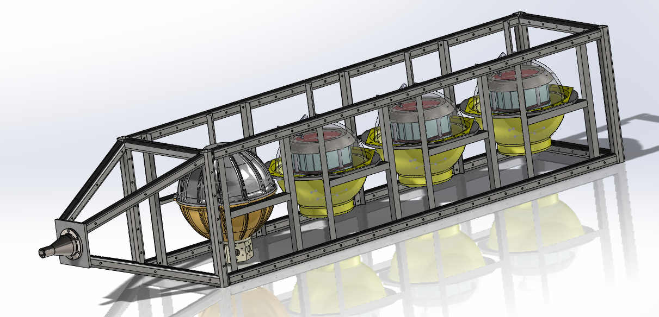
Figure 1: Prototype design with a titanium pressure housing for the DAS instrument and three glass spheres for batteries.

  - After various discussions with the DMO and Captain Andrew, an appropriate deployment and recovery protocol was selected (Figure 2). In late fall of 2024, when most DMO crew have returned to MBARI we will hold an operational review. This review will cover the fine details of the deployment and recovery.

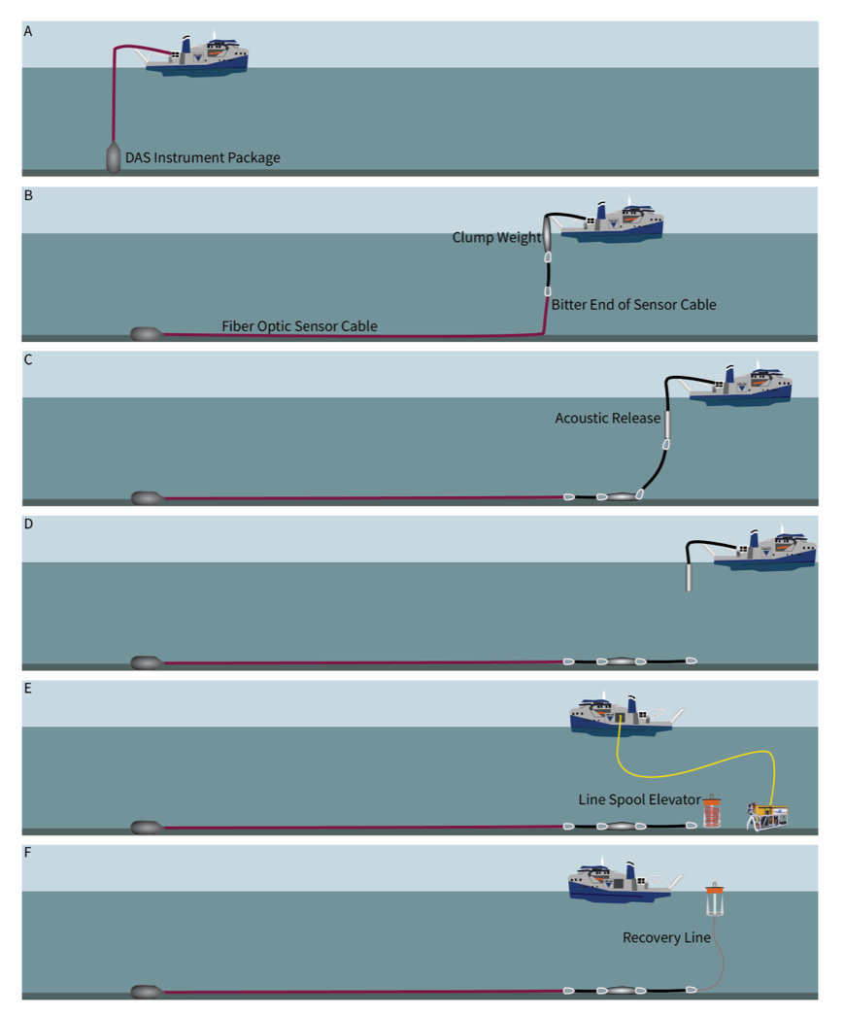.
Figure 2: Deployment and recovery strategy (originally proposed by Paull).

  - Procurement of system components:
    - Cable: Based on the deployment/recovery strategy, sea-state simulations, and the characteristics of the MacArtney winch, the cable need to be armored, torque-balanced, with a minimum breaking strength of over 50 kN, a bend radius of 0.3 m, and a weight in water exceeding 0.32 kg/m. After soliciting quotes and conducting meetings with eight vendors, a 1-kilometer-long DAS cable has been ordered from Winchester, with an expected delivery in October 2024.
    - DAS interrogator: We need a system that can resolve seismic waves with a frequency range of 0-20 Hz, capable of operating at temperatures of 4-8°C and using the existing battery design for 17” pressure housings. We have thus ordered a Sintela Onyx Nano system, which has a range of 10 km, spatial resolution of 1 m, dimensions of 300 × 200 × 75 mm, mass of 5 kg, and a power consumption of 30–40 W. Delivery is expected in September 2024. Modifications to the original system are currently ongoing in terms of modifying the mounting frame design, thermal modelling, software setup and integration of SSDs.
    - Batteries: 30 kWhrs of Li primary batteries have been purchased and delivered. The proposed battery package would allow a 31-42 day-long deployment. Considering that 6 sedimentary flows are expected between November 2024 and March 2025, the probability that a sedimentary flow will be monitored during the deployment of the DAS prototype in early 2025 is high.
    - Connectors: Rubber-molded cables have been purchased from Subconn. Fiber optic penetrators are proving harder to procure in Ti. However, we have received a quote for a Ti penetrator cable assembly from ISE that should meet our needs.

What percentage of labor and budget have been used through the 1st half of year?

Labor: As of June 1, we have used 40% of our labor budget. We do not see any concern that we will exceed the amount of labor budgeted for the year.

Budget: We have used all of our budget this year but will be moving $20k of funds from CSEM (902402) to Geo-Sense (902401) to cover our budget overrun. All the large-ticket items have already been purchased, with the exception of a fiber-optic penetrator (~$6k), and possibly the cost of having our cable professionally terminated ($4-8k).

Will you complete the current year’s scheduled work?

The original plan for the remainder of the year included the following tasks: (2.4) Assembly of the prototype instrument. (2.5) Testing of the prototype (in the laboratory and test tank) and the deployment/recovery protocol in the field. Both tasks are anticipated to be completed by the end of the year; however, testing the deployment/recovery protocol may be affected by the R/V David Packard's schedule.

Significant changes from previous project proposal

$20,000 will be transferred to this project from project 902402 to cover the cable purchase, which was more expensive than anticipated. These funds were redirected from the allocation to reconfigure the SWAN CSEM system, which was ultimately unnecessary.

Over the past two years, what peer-reviewed publications, education and/or outreach activities have resulted directly from this project? Please be brief.

- Micallef et al. (2024) Fiber optic sensing of submarine gravity flows, Fiber Optic Sensing in Geosciences – Galileo Conference, Catania, Italy (poster presentation).

All Projects: Specific Plans for 2025

Research Activities

Activities in relation to objective 2: Is DAS technology effective at monitoring seafloor processes?

Activity 1: Sensing sedimentary flows in Monterey Canyon

  - Deployment of the DAS prototype and cable in Monterey Canyon (Figure 3) in mid-January 2025 and its recovery in mid-February. The prototype and cable will be inspected by ROV soon after deployment.
  - Download and processing of data acquired with the DAS prototype, and with the MARS DAS between November 2024 and March 2025.
  - Comparison of data measured by prototype and MARS DAS with in-house and publicly available data on seismic, biological and oceanographic events, and the Seismosands field measurements from Monterey Canyon between November 2024 and March 2025 (e.g. moored hydrophones and ADCPs, OBSs, repeat seafloor mapping), to isolate signals associated with sedimentary flows, and correlate signal characteristics with sedimentary flow characteristics (e.g. timing, velocity, thickness). Being closer to the sedimentary flows, signals from the prototype are expected to be easier to detect and more information-rich than those from MARS.
  - Generate illustrations and animations of a gravity flow, along with explanations of the physics behind the DAS and the prototype, for use in press releases and presentations.

Tasks 1.2 and 1.3 will be carried out by Englert.

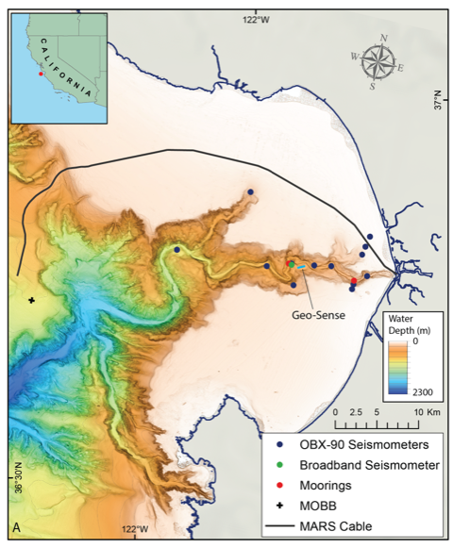
Figure 3: Bathymetric map of Monterey Canyon showing where the various instruments, to be deployed during the Seismosands experiment planned by Charlie Paull and colleagues, will be located. The proposed location of the prototype instrument is on an area of flat and smooth seafloor at about 400 m water depth in between two seismometers and close to the deeper mooring.

Activity 2: Cold seeps at Extrovert Cliff

  - Only one published study to date, by Caudron et al. (2024), has utilized DAS technology to detect underwater (low-intensity, CO₂) degassing. This research highlights how DAS technology may characterize the spatial and temporal evolution of degassing and enhance our understanding of gas-sediment interactions, including gas migration pathways. An ideal location to further explore these capabilities is Extrovert Cliff, located at 36.7767°N, 122.0850°W in Monterey Bay, which features a series of about six cold seeps arranged along a 220° trend at the 950 m depth contour. At several of these seeps, visual signs of flow include "blow out" holes, which suggest fluid conduits, accompanied by bacterial mats and clams. The seeps have shown vigorous outflow in recent times. A short-term deployment of the prototype instrument and cable, equipped with a hydrophone, is proposed for the last quarter of 2025. The equipment can be fully deployed and recovered during a one-week cruise, and a circular cable geometry will be considered. The DAS measurements will allow quantification of seepage rates and their temporal evolution, as well as imaging of sub-seafloor structure using passive seismic data. Data processing and analyses will ideally be carried out by a new post-doc (Jonathan Ford, who will apply for a Marie Curie fellowship). Alternatively, Micallef will be in charge of the task. An alternative study site to Extrovert Cliff is Coal Point in the Santa Barbara Channel (34.3797°N, 119.8621°W), which is known for its continuous, high-intensity methane seepage documented since 1946 at water depths of approximately 60 m. The Santa Barbara site could be considered in future years but is not part of our plans for 2025.

Engineering/technology development

Activities in relation to objective 1: How do we take the rapidly developing DAS technology and deploy it as an autonomous instrument?

Activity 3: Working towards a more optimal DAS design

  - Lessons learned from the initial deployment, including insights into the operational challenges and the effectiveness of the data collection methodologies used, will inform adjustments to equipment setup, deployment strategies and data analysis techniques. These will enhance the reliability and precision of subsequent deployments.
  - Procure replacement and spare parts, such as cable with enhanced-backscatter fiber, FO connectors, cable and rubber-molded connectors, and batteries.
  - Integrate a SoundTrap ST600 underwater sound recorder into the DAS prototype to detect acoustic waves in the water column and detect signals in a higher-frequency range than those captured by the cable. A SoundTrap ST600 is already available at the Seafloor Processes lab.
  - Utilize the data collected from the initial deployment to develop machine-learning algorithms specifically designed to identify signals associated with sedimentary flows. Implementing these algorithms will facilitate the real-time detection and monitoring of sedimentary flows in the MARS DAS system. Carlos Rueda, with help from Yanwu Zhang and Paul McGill, will lead this effort.

A design review for tasks 3.1 and 3.3 is planned in June 2025.

Activity 4: Evaluate feasibility of deployments in 2026

  - Initiate plans for a third field deployment in 2026. Assess the feasibility of three potential options: (i) Wave-power buoy: Integration of the prototype instrument and cable with the wave-power buoy to enable long-term deployments. (ii) Axial Seamount: Axial Seamount is an active submarine volcano that has erupted three times since its discovery in the 1980s. It is also home to one of the world's most sophisticated underwater volcanic observatories, which monitors seismicity, fluid flow, and displacement, among others. This makes it an ideal location for the long-term deployment of the prototype instrument. Powered by a primary node of the Ocean Observatory Initiative, the instrument will enable the investigation of various seafloor processes and allow for the calibration of the DAS signal using high-resolution field data. (iii) Available boreholes in areas of active seafloor creep (e.g. Tuaheni Slide, New Zealand) and sub-seafloor fluid flow systems (e.g. IODP 406 wells off New England, planned in 2025), as well as access to a research vessel with the necessary specifications and an appropriate power supply, will be assessed for deploying the cable and prototype instrument in a borehole long-term.

Field programs (detail ship requirements/deployments/diver requirements)

In addition to describing anticipated field programs, please be sure to include requirements for specific platforms and equipment (Dorado AUVs, LRAUVs, Wave Glider, mini ROV, etc.) for each proposed field program so that expectations are clear. Requests must also be entered in the budget entry system. Note that AUV deployment numbers and diver requirement questions are also included in the Compliance and Planning Considerations Form described at the end of this proposal form.

Ship requirements:
3 (24 hr) days on the R/V Packard in mid-January and mid-February 2025 to deploy and recover the instrument and cable in Monterey Bay. The timing of this deployment is critical as it needs to coincide with the Seismosands field experiment led by Paull.
1 (10 hr day) on the R/V Rachel Carson (with ROV Ventana) soon after the deployment in mid-January 2025 to inspect the cable.
2 (24 hr) days on the R/V Packard in the last quarter 2025 to deploy and recover the instrument and cable from Extrovert Cliff.

These Geo-Sense operations can be combined with efforts from other projects (e.g. proposal 901101 by Caress). We will collaborate with Mandy Allen to obtain a permit from the sanctuary, similar to what we did for the Monterey Canyon deployment.

Piloting/Watchkeeping
If you plan to use a platform that requires piloting/watchkeeping, please provide a high level staffing plan, including who will be responsible for these duties.

Micallef and the entire Geo-Sense engineering team will be onboard during deployment and recovery operations.

Specific deliverables

D1: Raw and processed data, and scientific publication, on the effectiveness of DAS to monitor sedimentary flows in Monterey Canyon
D2: Illustrations and animations
D3: Raw data related to DAS monitoring of cold seeps at Extrovert Cliff
D4: Python code for recognition of signals associated with sedimentary flows in DAS data
D5: Revised prototype instrument
D6: Internal report on the outcomes of the feasibility study

Milestones and required personnel (see personnel classification list for staff classifications)

2025 Project Start Date:  MM/DD/2024 | Milestone 1 | Milestone 2 | Milestone 3 | Milestone 4 | Milestone 5 | Milestone 6 | Total Resources (in hours) for each resource category for all milestones listed here
Milestone Date | Winter 2025 | September 2025 | December 2025 | December 2025 | December 2025 | December 2025
Milestone Description | Seismosands  deployment | Revised prototype instrument  & Future  Deployment  Planning | Scientific publication based on DAS data processing from Monterey Canyon | Illustrations and animations | Raw DAS data from Extrovert Cliff | Signal recognition code
Electrical Engineer | 160 (A.S.)  160 (P.M.)  100 (D.K.) | 200 (A.S.)  120 (P.M.)  100 (D.K.) | 40 (A.S.)  40 (D.K.) |  |  |  | 400 (A.S.)  280 (P.M.)  240 (D.K.)
Software Eng-Embedded | 80 (R.H.) | 80 (R.H.) |  |  |  |  | 160 (R.H.)
Software Eng-Info Eng |  |  |  |  |  | 160 (C. R.)  20 (Y.Z.) | 160 (C.R.)  20 (Y. Z.)
Mechanical Engineer | 120 (A.S.) | 120 (A.S.)  40 (F.C.) |  |  |  |  | 240 (A.S.)  40 (F.C.)
Mechanical Eng-Division
Mechanical Eng-Mfg
Associate Engineer
Electrical Tech |  | 80 |  |  |  |  | 80
Software Tech
Mechanical Tech |  | 120 |  |  |  |  | 120
Machinist
Divers
Video Lab
DMO | 80 (B.T-S.)  80 MOT TBD | 40 (B. T-S.) |  |  |  |  | 120 (B.T-S.)  80 MOT TBD

Budget justification

Activity 1:
- Animations and illustrations: $10,000
- Sub-total: $10,000

Activity 2: No cost

Activity 3:
- Purchase of:
  - Spare armored fiber-optic cable: $50,000
  - Spare FO connectors/cable assembly: $15,000
  - Instrument cables/rubber molded connectors: $5000
  - Batteries: $10,000
  - Materials for operations and engineering tests $5,000
- Outside services for cable termination testing $4000 (TMT labs)
- Conference travel to present engineering aspects (Oceans 2025) of project $5000
- Supplies general $2000

Sub-total: $96,000

Activity 4: No cost

Total cost: $106,000

Project team

MBARI:
Science
- Aaron Micallef
- Rebecca Englert (MBARI postdoc)
- Charlie Paull
- Roberto Gwiazda
- Eve Lundsten
Engineering
- Alana Sherman
- Aaron Schnittger
- Denis Klimov
- Paul McGill
- Rich Henthorn
- Carlos Rueda
- Yanwu Zhang
- François Cazenave
DMO

- Bryan Touryan-Schaeffer

University of California, Berkeley:
- Julien Marty
Lawrence Berkeley National Laboratory:
- Li-Wei Chen
Caltech:
- Zhongwen Zhan
University of Durham:
- Pete Talling
National Oceanography Centre:
- Michael Clare
GEOMAR:
- Christian Berndt
Sintela:
- David Hill

External consultants/contractors
If you propose to engage an external consultant/contractor, please attach a sufficiently detailed SOW and budget proposal from the vendor. If approved, a fully executed Independent Contractor Agreement must be in place before work can begin.

This may apply if the generation of the illustrations and animations is outsourced. An SOW and budget proposal are attached.

Project lab and office space requirements
In addition to any changes to current space usage, please also include anticipated office and lab needs for students, postdocs, collaborators, etc.

- Office space for a potential postdoc (new request). We can continue to do engineering work in the Seafloor Processes lab. We will probably require high-bay space to assemble the instrument during deployment prep. This could occur in the bay of new building G depending on availability.

Risk matrix (development and infrastructure projects only)

 | Technical Risk | Organizational Risk | Tech Transfer Risk | Labor Estimate Risk
High
Medium |  |  |  | X
Low | X | X | X

Compliance Considerations

All responses must be recorded in the Google form linked below. A form must be submitted for every project.

Link to Google Compliance and Planning Considerations form -OR- https://forms.gle/mRYKKEztAPYaiTz7A

Statement of Work: Creation of Illustrations and Animations for a Submarine Sedimentary Flow, Distributed Acoustic Sensing and the Geo-Sense prototype

Objective:

The objective of this Statement of Work (SOW) is to create detailed illustrations and animations that accurately depict a submarine sedimentary flow and elucidate the physics behind Distributed Acoustic Sensing (DAS) technology and the Geo-Sense prototype. These visual materials will be utilized in press releases and presentations to effectively communicate complex scientific concepts to a broad audience, including scientists, stakeholders, and the general public.

Scope of Work:

Illustrations and Animations of a Submarine Sedimentary Flow:

- Develop a high-resolution, scientifically accurate illustration that depicts the various stages of a submarine sedimentary flow.
- Create dynamic animations that show the movement and interaction of sediments and fluids in a submarine sedimentary flow, highlighting key processes and characteristics.
- Include annotations and supplementary text to explain critical features and stages within the gravity flow.

Explanations of the Physics Behind DAS:

- Provide a detailed visual explanation of the physical process behind DAS, highlighting how they can be harnessed to detect and interpret acoustic signals.
- Develop animations that demonstrate how DAS technology captures acoustic signals generated by seafloor processes.

Prototype Demonstrations:

- Create detailed visual representations of the prototype instrument, showcasing its design and components.
- Animate the prototype’s deployment and operation in a marine environment, emphasizing its capabilities and the type of data it collects.
- Include side-by-side visual comparisons of data collected with traditional methods versus the prototype to highlight improvements and advantages.

Deliverables:

- A complete set of digital illustrations and animations in high-definition formats suitable for integration into digital media, presentations, and print materials.
- Accompanying descriptive texts for each illustration and animation to enhance understanding and accessibility.

Timeline:

- Initial concepts and drafts to be presented within 4 weeks of project commencement.
- Revisions and finalizations to be completed within 8 weeks of initial draft acceptance.
- Final delivery of all materials 10 weeks from the start date, pending review and approval of final drafts.

Budget:

- $10,000

Review and Approval:

- All materials will undergo a review process to ensure accuracy and effectiveness.
- Feedback will be provided within one week of each submission phase, and necessary revisions will be incorporated in subsequent drafts.

This date and number should remain the same for the duration of the project. If your project start date for 2024 is not January 1, please indicate the start date in the first cell of the milestone chart. Format for duration example: “Year 2 of 5”.
Development and infrastructure projects must complete the risk matrix (see end of the proposal form).
Not all projects will require all four titles to be filled in. Please indicate individuals only for those titles that are appropriate for your project.
This category includes transfer of hardware, know-how, publications, presentations, etc.
This number should be the same number you entered on the web budget resource requests for this particular resource.

