Project Number: | 902401

Project Start: Jan. 1, | 2024 | Project Duration (in years): | Year 3 of 3¹

Please indicate if proposal includes requests for any of the following (mark all that apply).

 | X |  |  |  |  |  | X
Ship Time |  |  | ROV |  |  | AUV |  |  | Wave Glider |  |  | Mini ROV

Please indicate what type of project is being proposed (mark only one).

 |  |  |  | X
Feasibility/Scoping  [<100 days effort] |  |  | Development |  |  | Research |  |  | Infrastructure² |  |  | Education |  |  | Time Series |  |  | Institute Initiative

Project Manager: Alana Sherman
Principal Investigator: Aaron Micallef
Lead Scientist: Aaron Micallef
Lead Engineer: Aaron Schnittger

Project Title: Geo-Sense

Please indicate which category best describes the project theme (mark only one).

 |  |  |  |  |  |  |  |  |  | X
Ocean  biogeochemistry |  |  | Ecosystem dynamics |  |  | Ocean visualization |  |  | Exploration & discovery

Please indicate percentage of effort on this project anticipated for 2026 toward these three highest institutional goals from the Strategic Roadmap (percentage total should equal 100%).

Goal | Innovate and Build | Explore and Protect | Inspire and Engage
Percentage | 30% | 60% | 10%

- ABSTRACT (all projects)
Briefly provide a high-level summary of the project (ideally no more than 1/2 page).

Distributed Acoustic Sensing (DAS) technology can characterize fine-scale geomorphic processes over multi-kilometer distances, enable long-term continuous monitoring, and be deployed in logistically challenging areas. Although it has recently been shown to be a powerful tool for detecting seafloor hazards, DAS has rarely been deployed in the study of seafloor geomorphic processes.

Geo-Sense is a 3-year development project that will address two key research questions: (1) How do we take the rapidly developing DAS technology and deploy it as an autonomous instrument? (2) Is DAS technology effective at monitoring seafloor processes? We have spent the first two years of this project designing and developing the instrument. We expect to complete three deployments, two in the Monterey Canyon and one terrestrial near a borehole test site, by the end of 2025. Engineering efforts will continue to optimize fiber construction and acoustic coupling, as well as the acquisition and integration of components necessary for future deep-sea deployments.

In year 3, activities will focus on deploying DAS in two volcanic and hydrothermal environments in the South Aegean Volcanic Arc to assess its effectiveness in detecting seafloor fluid flow, venting, and magmatic unrest. In Paleochori Bay, Milos, a DAS interrogator and 700 m of fiber-optic cable will be deployed for five days to monitor shallow hydrothermal venting across a densely active seabed. In the Kolumbo submarine volcano, a 3 km cable and the Geo-Sense DAS system with a hydrophone will be deployed for one month to monitor volcanic tremors, fluid migration, and precursory seismic signals associated with dike intrusion. Simultaneously, DAS data will be acquired using existing telecom cables between Santorini and Ios, which will be coordinated by Greek collaborators.

Additionally, in year three, we also plan to conduct a three-day sea trial using the Sintela Nano DAS mounted on an LRAUV with a trailing fiber to evaluate its performance in mobile acoustic sensing. The goal of this is to assess the feasibility of using DAS on AUV in future years.

If successful, Geo-Sense will transform our ability to monitor a wide range of seafloor processes at high temporal constraints and across major geographic gaps, thus leading to a step change in our understanding of the initiation and evolution of active seafloor processes.

- PROPOSAL (all projects)

Background
Provide context for the project, being sure to address these questions:
- What fundamental problem does this project address, and why is it important?
- What makes this work relevant to MBARI and the Packard Foundation?
- Is this effort linked to other internal or externally funded projects or collaborative efforts?
- Where does this work fit into the ~5–10 year plan for your group, at MBARI, and in the field?

Problem: Distributed Acoustic Sensing (DAS) – a technique that measures the phase change in Rayleigh scattered laser light from fiber-optic cables to calculate ground strain at fine spatial resolution (range bins <1 m) and long lengths (>100 km) – has recently been shown to be a powerful technology to detect seafloor hazards (e.g., earthquakes, ocean currents). DAS can carry out multiple measurements of strain along the path of a cable, capturing local topographic deformation and dynamic ground motion. In addition to along-cable sensing, DAS has the potential to resolve subsurface processes with depth, such as fluid migration or gas accumulation. This adds a critical new dimension to seafloor monitoring, enabling the characterization of both surface- and depth-dependent phenomena. As a result, DAS has transformative potential in geomorphology because it can characterize fine-scale processes (in terms of location, timing, transformation, erosion, and velocities), enable long-term time-lapse monitoring, and be deployed in logistically challenging areas. DAS technology has rarely been deployed to investigate seafloor geomorphic processes thus far. Reasons include (i) limited availability of submarine cables and access to dark fibers and interrogators, and (ii) submarine cables tend to be located away from seafloor processes of interest. As a result, the sensitivity of cable configurations, interrogator units, and analytical approaches to monitor seafloor processes (e.g., sedimentary flows, slope failure, fluid flow, and escape) remains unknown.

Research questions: This is a development study that will address the following two research questions:

- How do we take the rapidly developing DAS technology and deploy it as an autonomous instrument?
- Is DAS technology effective at monitoring seafloor processes?

Significance:
- Importance: (1) A wide range of seafloor processes (e.g., creep, fluid flow, and seepage) frequently operate at small spatial scales, yet they tend to have an extensive impact on continental margin geomorphology. DAS technology holds great promise for detecting and understanding such seafloor processes in unprecedented detail, duration, and spatial coverage. (2) This program opens the potential of using existing submarine cable networks (including MARS) to monitor seafloor processes such as sedimentary flows, which are a threat to infrastructure and play a role in the transport and burial of organic carbon, nutrients, and contaminants.
- Timeliness: (1) A DAS interrogator has been installed on MARS since July 2022 and is expected to be operational for at least five years. (2) The components for distributed sensing have started to become affordable enough to make a stand-alone system economically feasible. (3) The proposed work at Kolumbo is particularly timely given the seismic crisis that began in early 2025, which has renewed widespread scientific and public interest in understanding this active submarine volcanic system.
- Uniqueness: (1) This will be the first time that DAS technology has been used to monitor sedimentary flows on the seafloor. (2) I am aware of only one attempt to monitor seafloor seeps with DAS (Caudron et al., 2024) and to develop a self-sustaining, portable DAS system (Shell, 2013) for pipeline surveillance, leak detection, and in-well monitoring.

Relevance to MBARI and Packard Foundation: MBARI is uniquely positioned to implement the proposed program: (i) The MARS cable, which MBARI operates and maintains, is already connected to a DAS interrogator (owned by the University of California, Berkeley), with data collection planned from July 2022 for at least 5 years. It is located near Monterey Canyon, where multiple sedimentary flows occur every year. The geometry of the MARS cable provides the azimuthal coverage necessary for the triangulation of events. (ii) This program uses MBARI engineering expertise to adapt instrumentation for deployment in deep-water settings. Our engineering group also has expertise in laser systems and seismometers that would apply to this project. (iii) It builds on existing links with the University of California, Berkeley, and Stanford University.

The program directly aligns with four strategic priorities: (i) Build scalable technologies to improve ocean health assessments, (ii) Map the deep seafloor at high resolution, (iii) Advance ocean-based artificial intelligence, and (iv) Study the impacts of climate change and other ocean threats.

Internal and external project links:
- Concurrent Seafloor Processes internal proposal (902312, Micallef)
- Concurrent Scalable Marine Robotics internal proposal (902204, Troni)
- External projects: MULTI-MAREX, SANTORY

Alignment with ~5–10 year plan for my research group, MBARI, and the field of seafloor geomorphology: The 10-year vision for the Seafloor Processes lab is to become a global leader in the characterization of a wide range of active seafloor processes at fine temporal scales. The lab will address the following key scientific questions: (i) What are the characteristics of seafloor processes? (ii) How do these processes interact with the seafloor? and (iii) What are the key drivers and controlling factors of the processes and associated landform evolution? These questions will be addressed using a combination of repeat surveying and in situ monitoring, supported by automated detection and classification and advanced numerical methods.

By the end of the Geo-Sense project, MBARI will have an instrument that will be fundamental for monitoring and characterizing active processes (in terms of location, dimensions, timing, triggers, and behavior) at fine spatial and temporal scales at targeted locations for months-long durations. Although the focus will initially be on sedimentary flows and fluid seepage, the instrument can be easily adapted to monitor a wide range of other seafloor processes, such as volcanic instability and groundwater flow. In addition, the Geo-Sense project will help open new scientific applications for the MARS cable by enabling the use of DAS for real-time monitoring of active geological processes (beyond earthquakes).

Nature and Scope of the Proposed Project
Please provide a sense of the scale and scope of the proposed work. Is this a large de novo R&D effort, modest platform/sensor integration, targeted science investigation with minimal or no engineering needs, extension of current program, small-scale scoping exercise expected to lead to a larger effort, or other? If the project is intended to be multiple years, how will the anticipated level of effort likely change over time?

This project represents a medium-sized R&D effort combining targeted science investigations with modest sensor integration and engineering development. In year 3, the focus shifts toward field validation of DAS technology in geologically active marine settings, including volcanic and hydrothermal systems in the South Aegean Volcanic Arc. The work includes two deployments (5 days in Milos, up to 1 month in Kolumbo) and three one-day mobile DAS sea trials using an LRAUV. While science objectives are central, engineering efforts continue in parallel to optimize deep-sea deployment capabilities.

Does this activity relate to one or more 2026 proposals your team is submitting?
If so, provide a list of relevant projects by project/DQ # and provide a brief description of how they are related. Since resources are limited and cuts during Phase 1 are likely, please indicate where this project fits in the hierarchy of your priorities. Does this proposal take precedent over other ongoing or planned activities?

Concurrently proposed internal projects:
- Seafloor Processes (Micallef): This is the core science project for the Seafloor Processes lab, which will focus on active seafloor processes at fine spatial and temporal scales.
- CSEM (Micallef): CSEM focuses on developing controlled-source electromagnetic instruments to detect fluid flow and seepage. This project will be paused during 2026.
The Geo-Sense technology will be directly relevant to monitoring fluid seepage, which is a key theme of the two programs listed above.

Hierarchy of priorities in 2026:
- 902602 Mapping LRAUV
- 902401 Geo-Sense: Kolumbo fieldwork
- 902312 Seafloor processes: Antarctica expedition
- 902401 Geo-Sense: Milos fieldwork
- 902401 Geo-Sense: DAS on LRAUV tests
- 902312 Seafloor processes: French Polynesia expedition
- 902312 Seafloor processes: Remapping of Monterey Canyon

Anticipated Shared Resource Needs
What staffing is required to advance the work in 2026 (e.g., is this a multi-faceted engineering development or a targeted science investigation that does not require significant use of shared personnel)? Is in-house or contract manufacturing needed? What level of ship/ROV/AUV (DMO) support is likely? If this is intended to be a multi-year effort, please provide a rough indication of anticipated shared resource needs over the duration of the project (e.g., will stay flat, will significantly increase in Year X, will significantly decrease by Year Y).

The MBARI team comprises:
Science
- Aaron Micallef
- Seafloor processes research technician/specialist (to be engaged in October 2025)
Engineering
- The project team will still comprise Aaron Schnittger, Denis Klimov, Rich Henthorn, Alana Sherman, and Bryan Touryan Schaefer (DMO). We anticipate that the total request for these engineers and technicians will sum up to around 1,800 hours.
- Jared Figurski (~3 days) - R/V Paragon operations
The R/V Paragon is requested for 3 (8-hour) days in March 2026 to deploy and recover the LRAUV with DAS and cable.

Anticipated Expenses
What rough order of magnitude direct expense budget is anticipated annually over the course of the project? Is procurement of specialized capital equipment or outside contractors required? Will there be annual travel?

Expenses for year 3:
The requested expenses total $120k. This amount could decrease significantly pending a proposal for external ship time.

Intellectual Property (IP) Considerations
Do you anticipate a need for a cooperative research and development agreement or licensing arrangement with an external entity? Will the work potentially result in a patentable product or service? Will novel IP and/or custom-made equipment be created, and how might it be disseminated (e.g., license agreement and/or collaborations)?

For additional guidance please review MBARI’s intellectual property internal web page: https://mww.mbari.org/itd/ip/.

No

Data
What types of data will be generated? Please estimate generated data in gigabytes (GB) or terabytes (TB). How will they be managed/stored? Are any special data visualization needs anticipated?

10 TB of raw and processed data hosted on Thalassa.

Anticipated Impact
Who are the consumers of the instruments, methods, technology, and data that will be generated within and beyond MBARI? Will the project create tangible connections with other organizations (e.g., academic, NGO, MBA, MBNMS, state or federal agency)?

Consumers of project outputs include:
- Scientists: The program has a strong potential to promote the widespread application of monitoring approaches for a wide range of seafloor processes at high temporal resolution and across major geographic gaps. This will lead to a step change in our understanding of the initiation and evolution of active seafloor processes while reducing monitoring costs.
- Industry: Transformation of industry’s ability to better situate seafloor infrastructure (e.g., cables, pipelines, blue-energy platforms) and monitor geohazard impacts on these assets, geological storage (e.g., sub-seafloor storage of carbon and hydrogen), and environmental change.
- Society: Improvement of early warning systems for offshore natural hazards.

Connections with other organizations:
- Zhongwen Zhan (Caltech)
- Paraskevi Nomikou (National and Kapodistrian University of Athens)
- Christos Evangelidis (National Observatory of Athens)
- David Hill (Sintela)

Anticipated Outreach Needs
Thinking about the audiences/consumers you highlighted in the question above, do you anticipate needing to create outreach assets to help increase your impact? If so, please specify whether you anticipate needing to work with ITD and also specify what type of asset (story, graphic, animation, video, etc.) you might need.

When the project has accomplishments to share, we will request assistance communicating this work to the general public.

Continuing Projects Only: Status Report
Briefly provide an update of the current project relative to what was proposed for 2025 by responding to the prompts below. If the project includes multiple subproject projects, please list each of these under a subheading as you deem appropriate.

Current status of the project and results to date

The following tasks have been carried out in 2025:

Activities 1: Completion of the Geo-Sense system and initial deployments

  - The first deployment of Geo-Sense during the Seismosands field program

Despite many delays in receiving critical components and some last-minute failures, the Geo-Sense instrument was assembled and tested in mid-January 2025 in time to deploy during the ongoing Seismosands experiment (Figures 1 and 2). During this deployment, a failure on the Sintela Nano board caused the system to stop recording early. Nevertheless, we collected 9 days of data during which seismic signals were detected. We learned a great deal about the safe deployment and recovery of the instrument, as well as improvements we can make to the process of laying the cable along the desired track.

  - Simultaneous MARS DAS data collection
Additionally, a Sintela Peta DAS interrogator was installed on the MARS cable in November 2025 and subsequently disconnected at the end of April 2025. This enabled us to increase the number of simultaneous measurements during the Seismosands experiment.

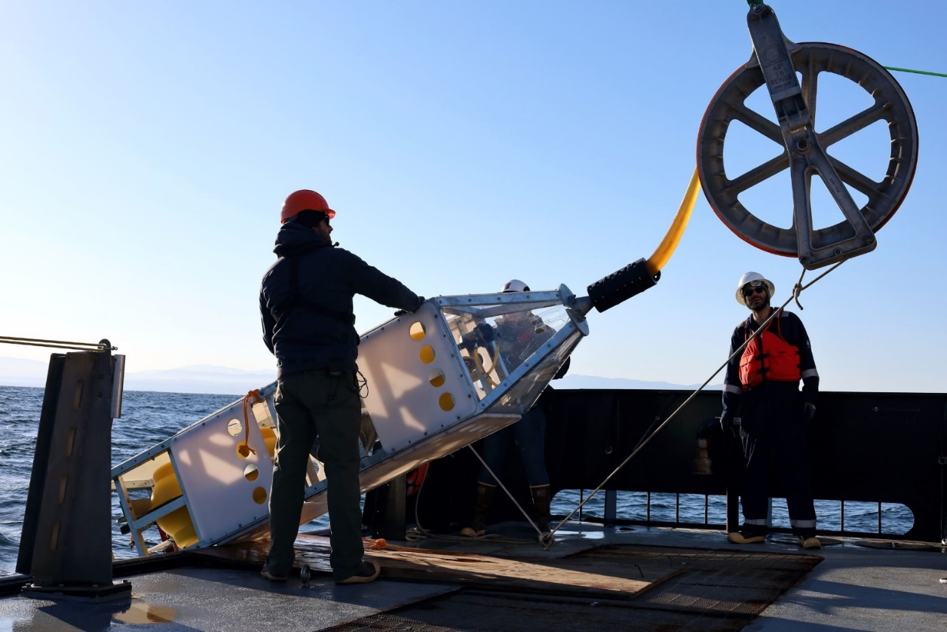
Figure 1. Geo-Sense being lowered off the deck of the R/V Rachel Carson.

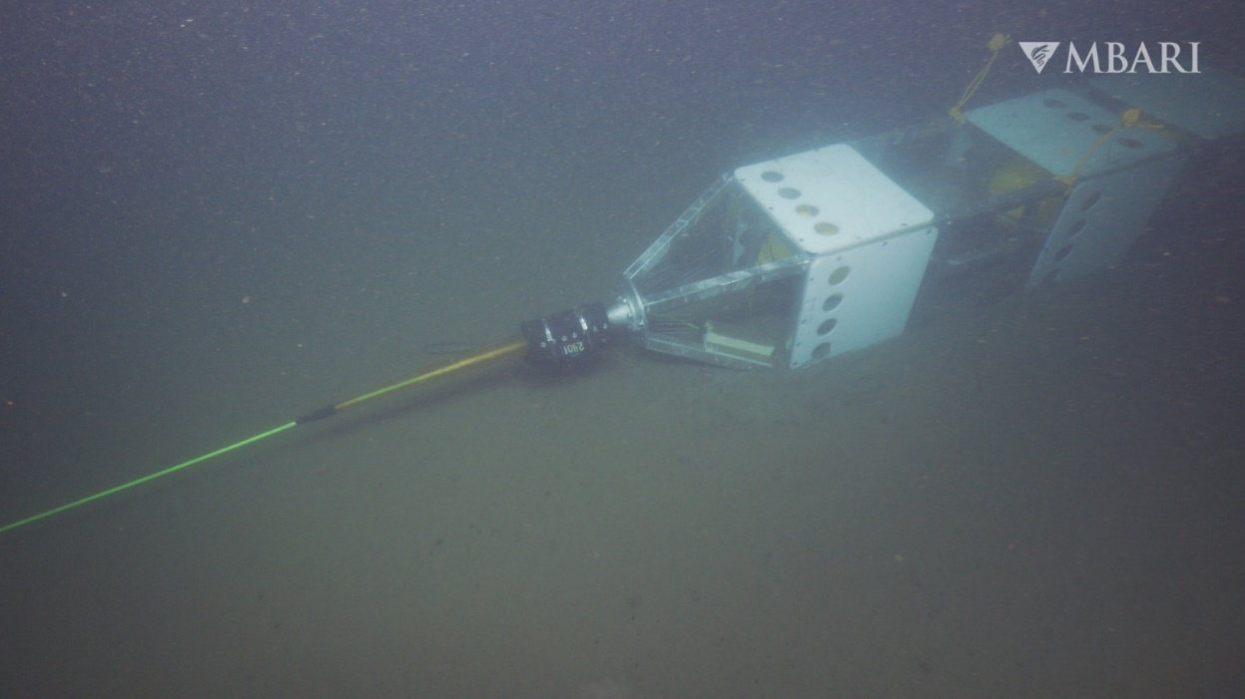
Figure 2. Geo-Sense on the seafloor during the Seismosands experiment.
Activity 2: Data analysis of Geo-Sense and MARS DAS instruments

The data from both the prototype DAS and the MARS DAS systems have been downloaded and are currently being processed and visualized. These datasets are being compared with available seismic, biological, and oceanographic records, as well as with field measurements from the SeismoSands experiment conducted in Monterey Canyon between November 2024 and April 2025. Initial results suggest that the prototype DAS performs well in detecting and locating earthquakes (see Figures 3 and 4) and may also be capable of capturing tidal current signals within the canyon. No gravity flows were recorded during its deployment period. In contrast, the MARS DAS system appears less effective than the seismometers at detecting gravity flows but performs well in recording earthquakes, surface waves, and potentially internal and infragravity waves.

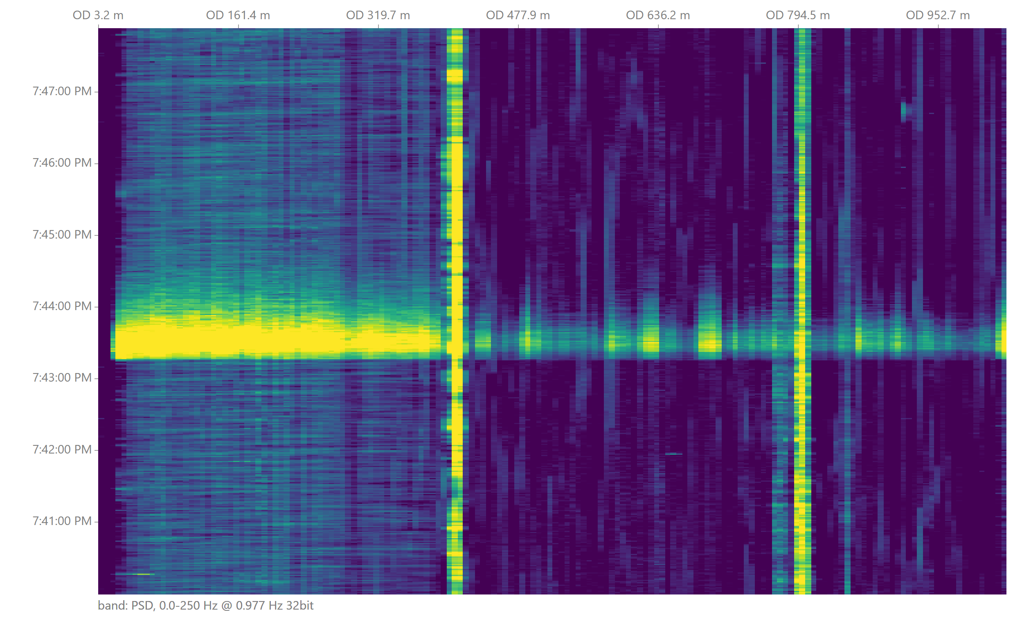
Figure 3. DAS data (waterfall plot) from the Geo-Sense cable showing a M2 earthquake.

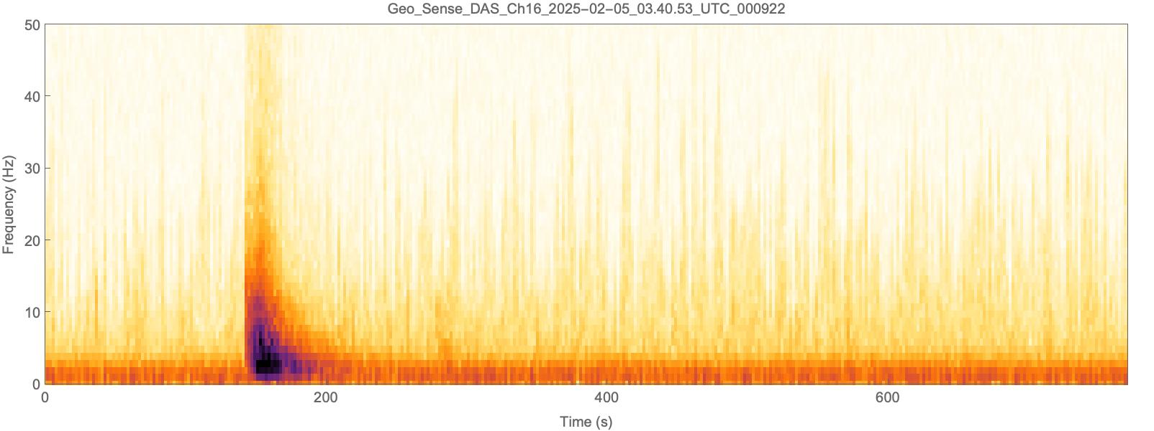
Figure 4. Spectrogram showing the M2 earthquake in Figure 3.

Activity 3: Further improvements to the Geo-Sense system

3.1 Lessons learned from the initial deployment will be incorporated into future deployments. These include the use of a block with a speed readout capability to improve deployment monitoring and ensure optimal cable placement.

3.2 Replacement and spare parts have been or will be procured, including fiber-optic connectors, black hole attenuators, and batteries.

3.3 A SoundTrap ST600 underwater sound recorder is being integrated into the DAS prototype to detect acoustic waves in the water column and to capture signals in a higher-frequency range than those recorded by the fiber-optic cable.

3.4 We have money set aside to purchase another cable. After our October deployment, we will have enough knowledge and experience to determine which cable construction to invest in.

Activity 4: Outreach and dissemination

An artist was commissioned to create illustrations and an animation depicting a gravity flow, along with explanatory visuals of the underlying physics of DAS and the prototype system. These products are now available and are intended for use in press releases, presentations, and public outreach. Follow this link to view the animation: https://drive.google.com/file/d/1xkAXy6v6Xkd-kNdna_6ZQWcAqqZluuec/view?usp=sharing.

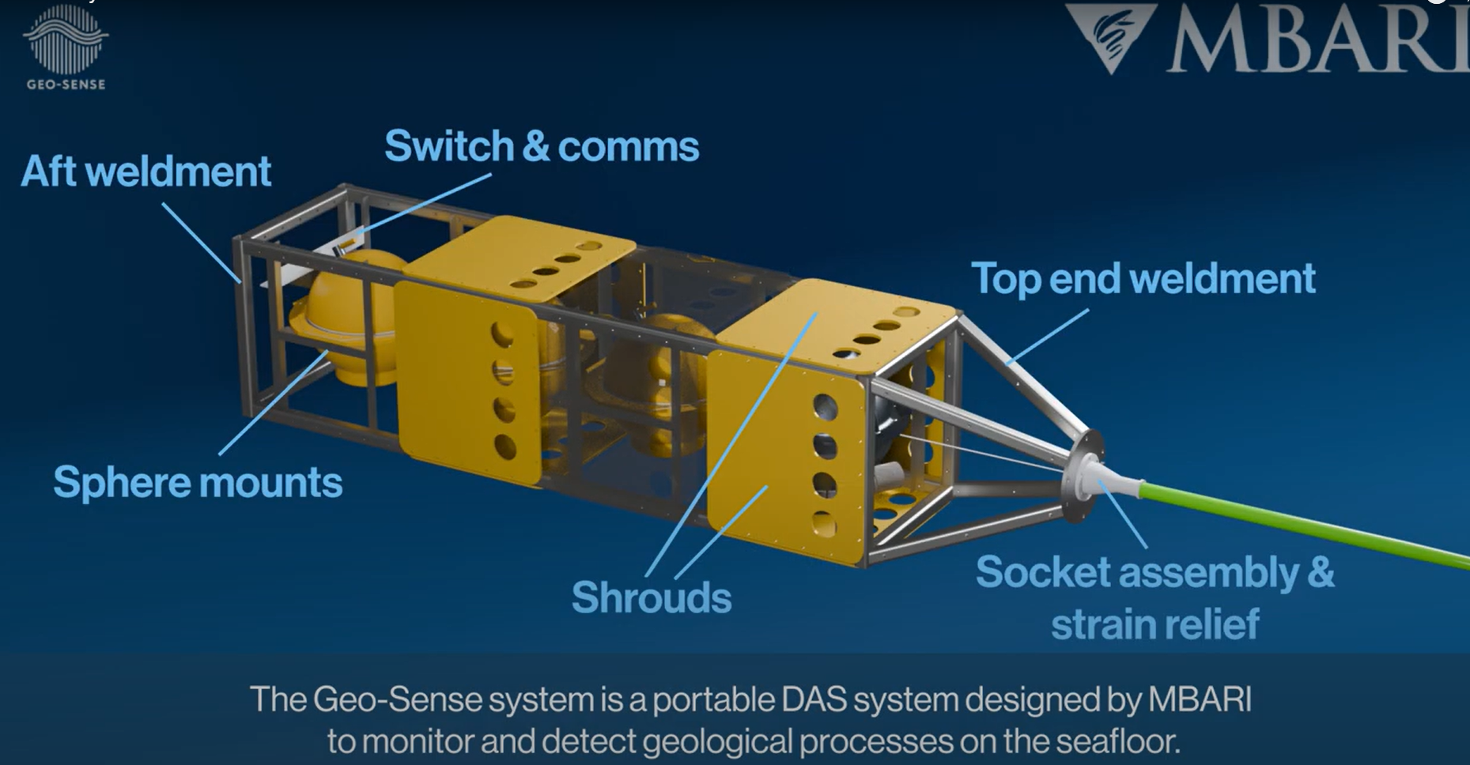
Figure 5. A still image from the Geo-Sense animation.

What percentage of labor and budget have been used through the 1st half of year?
As of June 1, we have used 100% of our labor budget. This overrun is primarily due to a large amount of technician time (and engineering labor) that was used in January, as the integration we expected to occur in the fall of 2024 did not happen until January 2025. The only engineer who will significantly overrun their hours is Aaron Schnittger. Aaron has the opportunity to help deploy the system in Norway. This, combined with the remaining work over the course of the year, will probably bring Aaron over 200 hours.

Budget: We have used 35% of our budget this year. We anticipate that we will use all of our budget. We are awaiting further field testing before allocating the bulk of the remaining funds to a cable and/or battery pack.

Will you complete the current year’s scheduled work?

Yes. We have changed some of our deployment plans based on the best science opportunities, as described in the next section.

Significant changes from the previous project proposal

There are two significant changes to our prior proposal:

- The original plan was to deploy the DAS prototype at Extrovert Cliff for one week in October 2025 to quantify fluid seepage rates and their temporal evolution and to image sub-seafloor structures using passive seismic data. However, following an ROV survey of Extrovert Cliff conducted by Giancarlo Troni and his team, it became evident that there is currently no active gas seepage at the site. It was, therefore, decided to revise the planned deployment: the R/V David Packard ship time in October 2025 will now be dedicated to deploying a lighter DAS cable using an ROV on the southern flank of Monterey Canyon. This will allow for more complex deployment geometries than a straight-line layout and may enable the detection of gravity flows, which was not achieved during the initial deployment. The experiment will also provide critical insights into the cable's coupling properties and the resulting data quality.
- An opportunity arose in which the Geo-Sense system can be used for a terrestrial deployment at the Svelvik CO₂ Field Lab in Norway in late July 2025. This project will integrate passive and active DAS, Electrical Resistivity Tomography (ERT), and pore pressure measurements to assess the effectiveness of surface-deployed DAS systems for monitoring vertical and horizontal gas migration, quantifying fluxes, and monitoring pore pressure changes. The experiment will be conducted with a thinner, more flexible cable, and a rack-mount chassis has been built for the instrument. Lab and tank tests have been conducted to ensure the modifications work as expected. The activity is partially funded by the project Geo-Inquire (https://www.geo-inquire.eu/).

Over the past two years, what peer-reviewed publications, education and/or outreach activities have resulted directly from this project? Please be brief.

- Social media posts.
- Animation and illustrations (activity 4).
- Micallef et al. (2024) Fiber optic sensing of submarine gravity flows, Fiber Optic Sensing in Geosciences – Galileo Conference, Catania, Italy (poster presentation).
- Clivati, C., Schulten, I., Micallef, A., Donadello, S., Agius, M.R., Aiken, C., Mura, A., Levi, F., Calonico, D., Xuereb, A., (2025) Fiber sensing with internet cables: Monitoring offshore oceanographic and geological processes in the central Mediterranean Sea. EGU General Assembly 2025, Vienna, Austria.
- MBARI Behind the Scenes Story: https://www.mbari.org/news/mbari-researchers-deploy-innovative-new-tech-for-seafloor-monitoring/
- Micallef et al. (2025) Interactions between sedimentary flows and submarine canyon morphology at monthly timescales, INCISE, Barcelona, Spain (oral presentation).

All Projects: Specific Plans for 2026

Research Activities

Activities in relation to objective 2: Is DAS technology effective at monitoring seafloor processes?

Activity 1: Aegean fluid circulation

As our overarching goal is to identify which seafloor processes DAS is most effective at illuminating, we have focused on the most impactful deployment opportunities. We are aware that, given the constraints of R/V David Packard ship time, it is not possible to deploy the system along the Cascadia margin. The South Aegean Volcanic Arc (Figure 6) hosts some of the most active and accessible volcanic and hydrothermal systems in Europe. In this context, DAS offers a novel opportunity to monitor subsurface processes at high spatial and temporal resolution. Two fieldwork campaigns are proposed, which will be combined into a single trip planned for either May or September 2026.

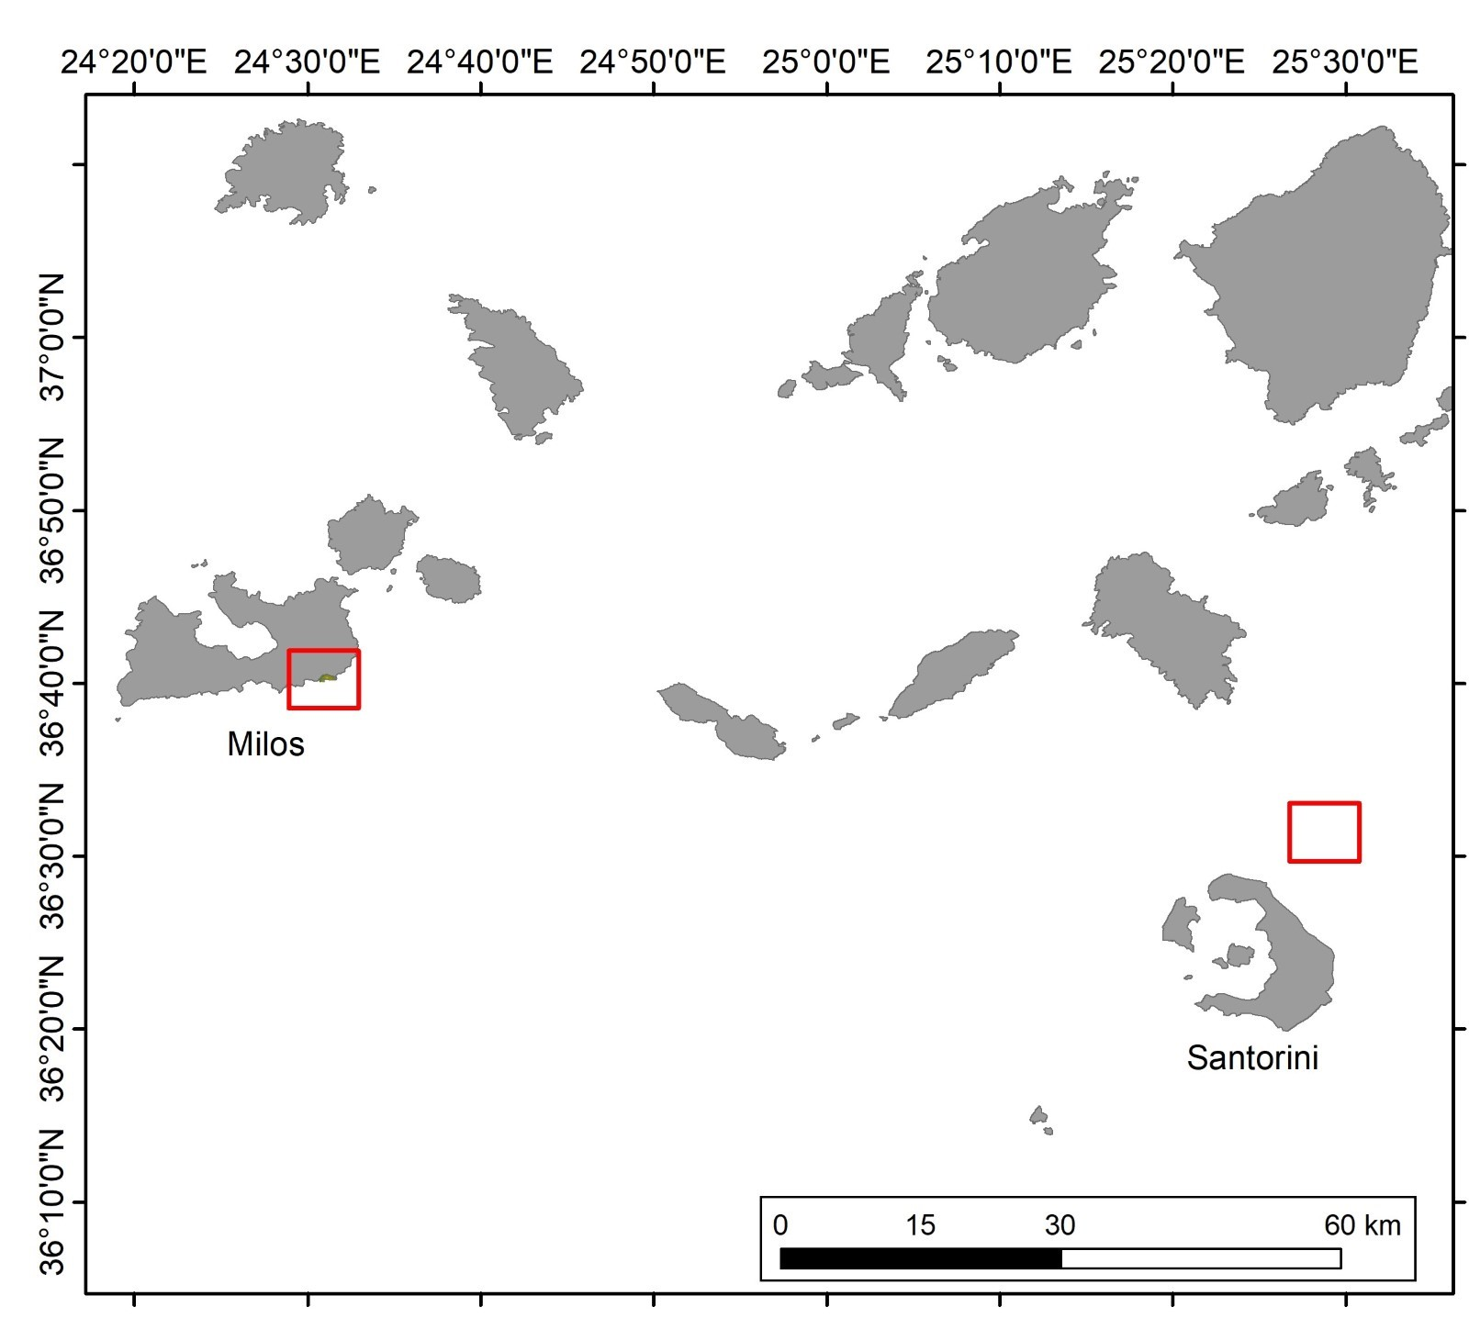
Figure 6: Map showing the study sites in the Aegean Sea.

1.1 Deployment of the Geo-Sense instrument (with hydrophone) and fiber-optic cable in Kolumbo.

The Christiana–Santorini–Kolumbo volcanic field in the South Aegean is one of the most active volcanic regions in Europe. Kolumbo is a fully submerged caldera with a depth of around 500 m, which last erupted in 1650. Hydrothermal venting at Kolumbo is concentrated along the northern edge of the caldera floor, where a ~200 m-wide field features tall chimney structures, abundant CO₂ bubble streams, and vigorous high-temperature fluid discharge exceeding 200 °C.

The 2025 volcano-tectonic crisis in the Aegean Sea offered an unprecedented view into the coupled magmatic systems beneath Santorini and Kolumbo volcanoes. Beginning in July 2024, ground deformation and increased gas emissions signaled unrest beneath Santorini. On 27 January 2025, an intense seismic swarm began near Kolumbo, lasting over 30 days and evolving in distinct phases - from deep tremor to rapid, shallow earthquake migration towards Anhydros Island at ~1 km/h. Over 28,000 earthquakes were recorded, revealing a segmented, ascending dike intrusion. At least 12 seismic surges marked periods of accelerated dike growth, often associated with large earthquakes (MW > 5) at the dike tip. Moment tensor analysis indicates NW–SE extension consistent with normal faulting.

The first proposed fieldwork will focus on the Kolumbo submarine volcano (Figure 7), located approximately 7 km NE of Santorini, where we will deploy the Geo-Sense instrument with a hydrophone and the fiber-optic cable to investigate volcanic tremors, subsurface fluid migration, hydrothermal venting, and potential precursory signals of volcanic unrest. DAS offers a novel opportunity to resolve these processes in unprecedented spatial and temporal resolution.

The project team has spent the past month investigating various research vessels and ROVs available to carry out this work. After many discussions with collaborators in Greece familiar with the available vessels, the team has come up with a plan that provides the best science measurements with the least operational risk. Furthermore, in July, we will submit an external proposal to CNR Italy, requesting ship time on the R/V Gaia Blu (formerly R/V Falkor), a vessel that is highly capable of these operations.

Key elements of the fieldwork include:
- Deployment duration: 2-4 weeks
- Cable: 1-3 km long, Linden fiber-optic cable
- Ship and ROV: There are several possibilities for deploying the instrument, this is based on the different configurations of the instrument as well as the availability of local ships and ROVs. Here we have listed two options. For more information, please refer to Appendix B.
  - Option 1: Using the R/V Aegao and Max Rover ROV for the deployment and the R/V Philia for the instrument recovery; both will be hired for this operation (HCMR: https://www.hcmr.gr/en/equipment/researchvessels_underwatervehicles/rvs/).
  - Option 2: Possible use of R/V Gaia Blu (formerly R/V Falkor) pending external proposal.
- Deployment method: We plan on deploying the instrument on an elevator and using an ROV to lay out the cable. The same scheme will be tested locally in October 2025 during our planned ship time on the R/V David Packard. Using the ROV during deployment will enable us to ensure the tether is laid in the safest location, and we will also be able to geolocate it. We will use an acoustic release system to recover the elevator and then spool in the deployed cable.
- Water depth: 300–500 m
- Location: The cable will be laid from the western slope, which is composed of pumice and located near an active vent field in the northern part of the caldera, and will terminate near the base of the central vent (~500 m). This path intersects key structural features and fluid pathways, providing optimal sensitivity to volcanic tremors and deformation.
- Simultaneous acquisition: DAS data will also be collected using existing telecommunication cables (e.g., COSMOTE) extending between Santorini and Ios, with an onshore interrogator coordinated by Dr. Christos Evangelidis.
- Local collaborators: Prof. Paraskevi Nomikou (National and Kapodistrian University of Athens) and Dr. Christos Evangelidis (National Observatory of Athens)

A formal letter of support from the government of Greece, underscoring the strategic relevance and broader impact of this project, is included in Appendix A.
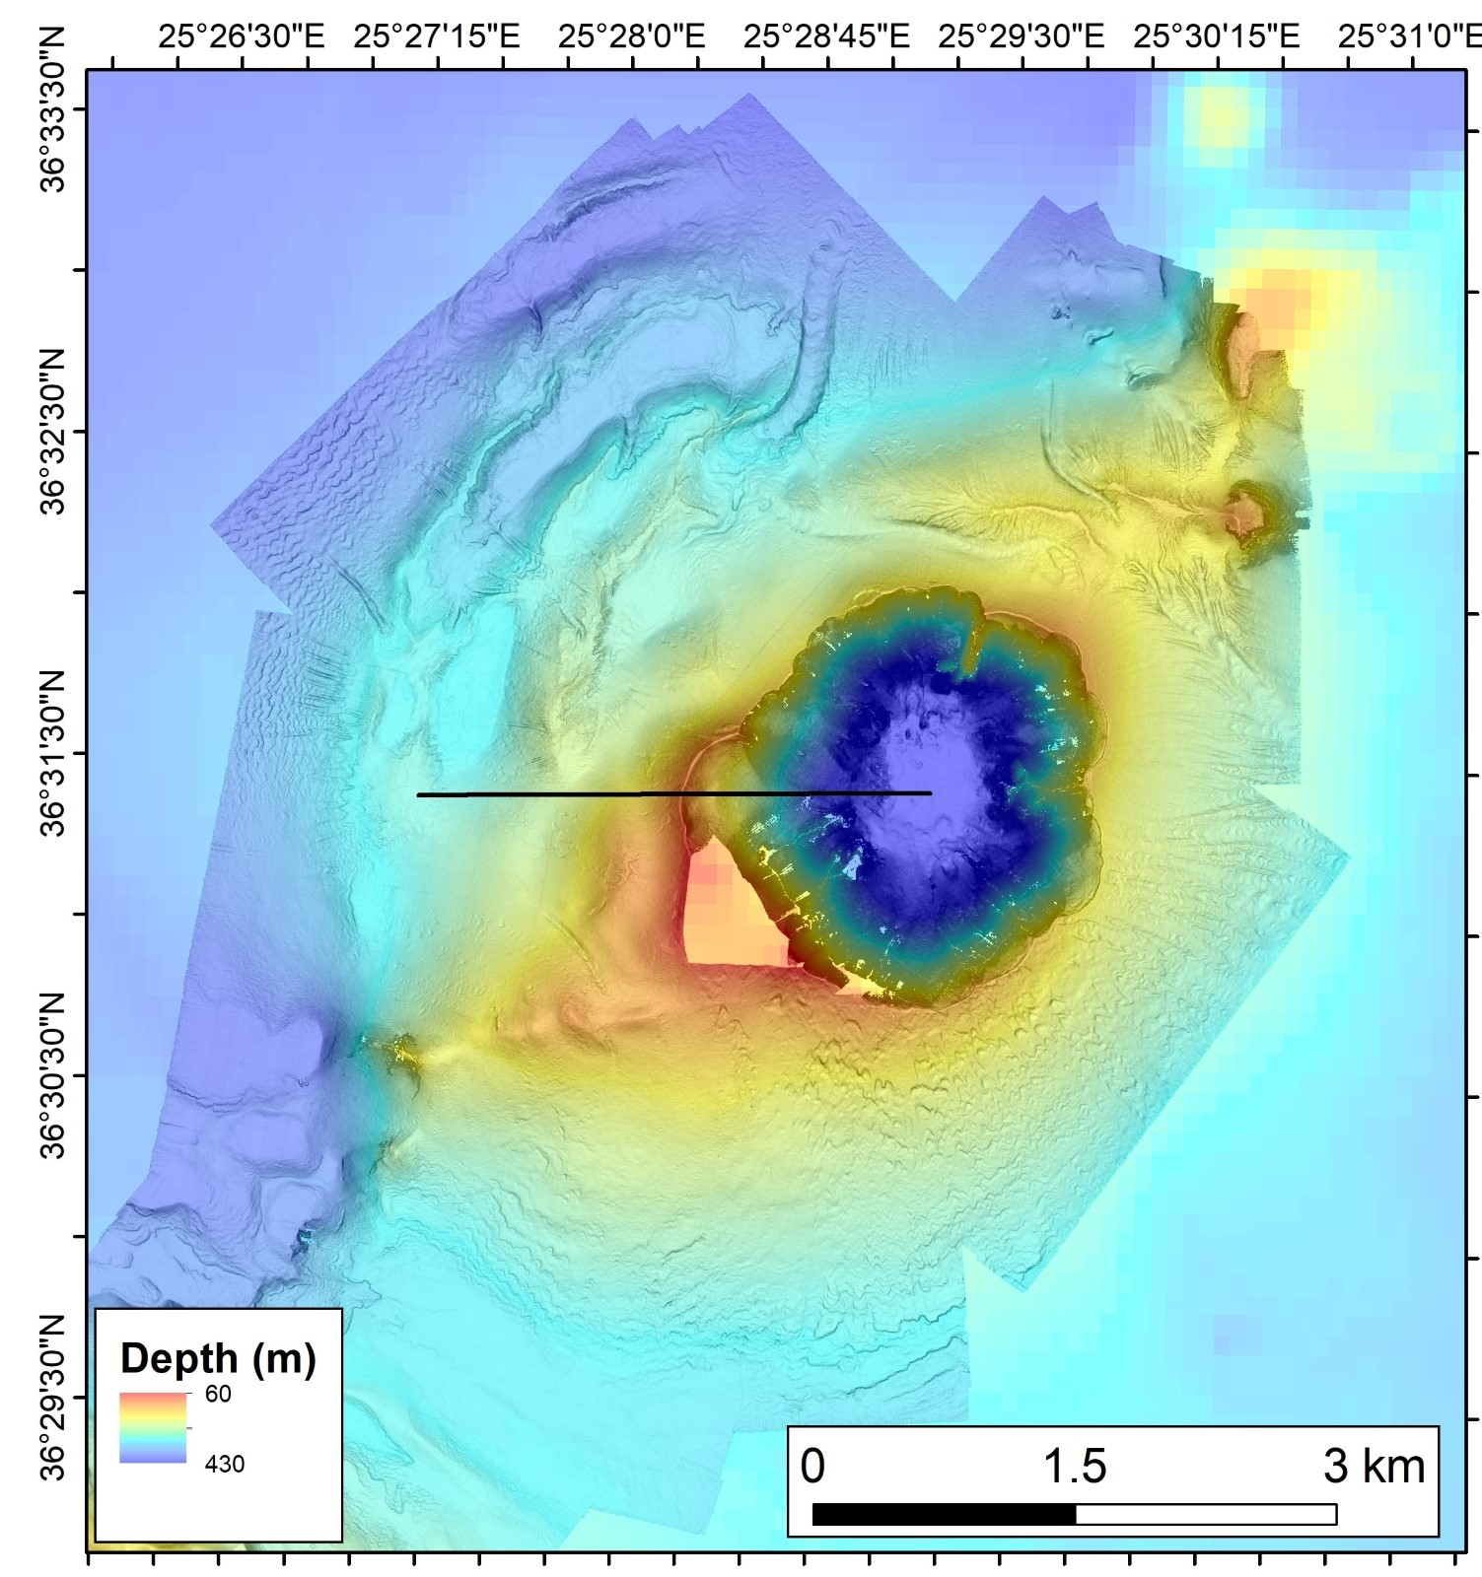

Figure 7 Seafloor depth map of Kolumbo volcano. The black line denotes the proposed location of the deployed cable. Source: Research cruise POS 510.

1.2 Deployment of the DAS interrogator and fiber-optic cable in Paleochori Bay, Milos.

The second fieldwork will test the effectiveness of DAS to detect and quantify hydrothermal venting in Paleochori Bay, Milos. This site is located within the South Aegean Volcanic Arc, a tectonically and volcanically active region shaped by the subduction of the African Plate beneath the Eurasian Plate. The island of Milos, a Quaternary volcanic island that emerged less than 2 million years ago, is characterized by high heat flow and a fault-controlled subsurface structure that facilitates fluid circulation through thinned continental crust. As a result, Milos hosts one of the largest known active shallow-submarine to coastal geothermal systems. Paleochori Bay (Figure 8), in particular, is among the most accessible shallow marine hydrothermal fields in the Mediterranean, with a dense concentration of gas and fluid vents emerging from sandy and rocky substrates at depths shallower than 20 m. These vents emit CO₂-rich gases, hydrothermal fluids, and trace elements that play a significant role in element transport, sediment alteration, and the development of chemosynthetic microbial and invertebrate communities.

The deployment will span three full operational days, with an additional day allocated before and after for setup and recovery. The DAS interrogator, designed to fit into a portable travel case, will be hosted and powered by Sirocco, a restaurant located at Paleochori Bay (Figure 9). From there, the Linden fiber-optic cable will be extended and buried from the restaurant to the beach. Approximately 700 m of cable will then be deployed offshore, down to a maximum depth of 15 m) using a spool from a dive boat, with (non-MBARI) divers guiding the cable to intersect as many hydrothermal vents with variable seepage rates as possible while maintaining a safe offset of 1 m to avoid thermal damage. Seepage rates will be estimated using video footage obtained by divers. Cable positioning will be mapped via surface GPS while snorkeling, carried out by the diving company. Both the restaurant and the diving company have already been contacted, with arrangements facilitated by local collaborator Prof. Paraskevi Nomikou of the National and Kapodistrian University of Athens. This deployment will allow the detection and analysis of a wide range of acoustic signals associated with bubble emissions from hydrothermal vents. These signals are expected to vary across different areas of the bay, potentially reflecting differences in bubble size and nucleation processes. The temporal distribution of these acoustic events will offer insight into evolving gas seepage patterns and may reveal correlations with environmental or volcanic activity.

These efforts will be coordinated with the CoMPAS lab, which will focus on Palaeochori/Spathi Bay and parts of Milos Bay, conducting mapping missions to investigate bacterial mats and hydrothermal precipitates associated with hydrothermal outflows.

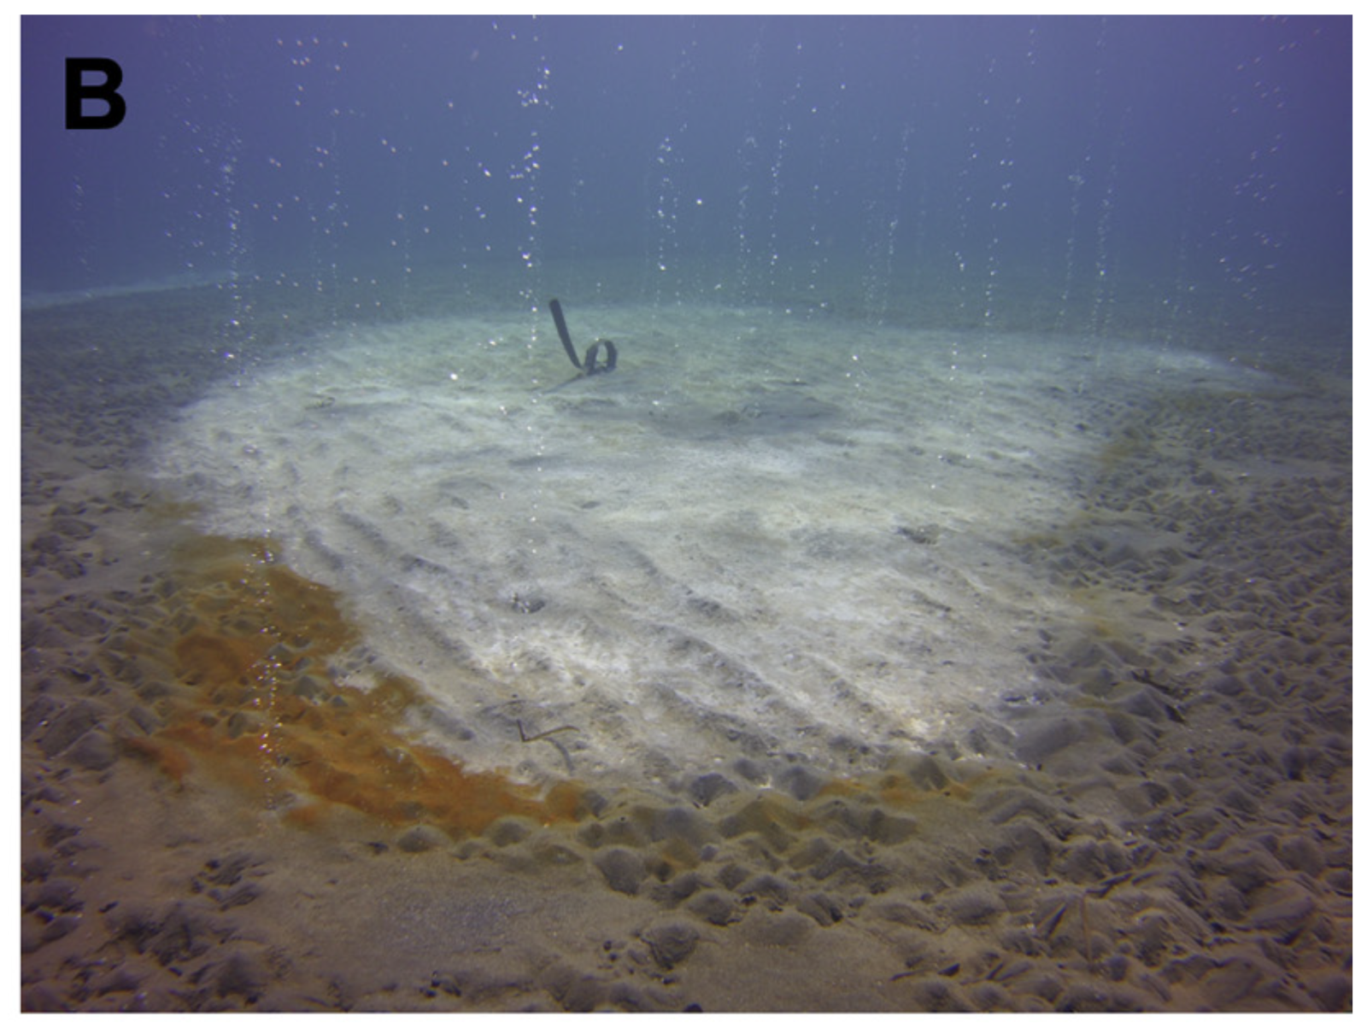
Figure 8: Hydrothermal venting and bacterial mat in Paleochori Bay. Source: Khimasia et al. 2021).

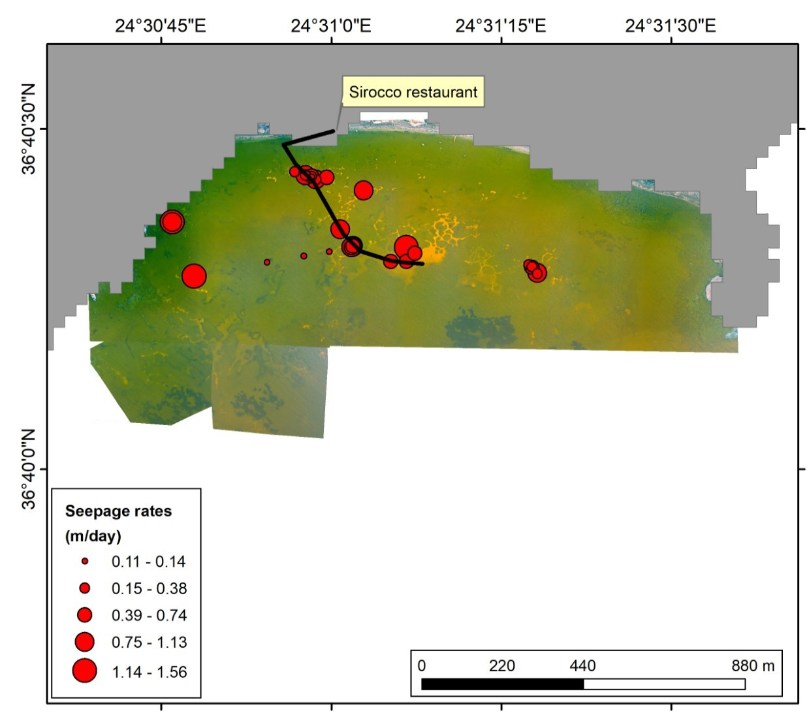
Figure 9 Drone photomosaic of Paleochori Bay, showing planned cable deployment (black line) and vent seepage rates (red circles). Sources: Khimasia et al. (2021), Martelat et al. (2019).

Engineering/technology development

Activity 2: Support of field programs:
The engineering team will address the technical and operational challenges necessary to meet the needs of the proposed field programs. For each field program, the appropriate cable and instrument configuration will be selected and tested. Furthermore, we will work on developing safe and reliable operational plans for the deployment of the instrument and laying of the cable.

Activity 3: LRAUV test

We propose a three-day sea trial to test the integration and performance of the Sintela Nano DAS system deployed from an LRAUV equipped with a 100 m trailing fiber-optic cable. This test will evaluate the viability of using mobile DAS platforms for spatiotemporal monitoring of seafloor and water column processes.

The objectives of the test are:
- Confirm the mechanical and electrical compatibility between the DAS interrogator, the LRAUV platform, and the trailing fiber system.
- Assess the acoustic noise introduced by the vehicle’s propulsion system, drag-induced vibrations on the cable, and environmental noise, to define signal-to-noise thresholds for future science missions.
- Test the acoustic coupling between the trailing fiber-optic cable and the surrounding water column, including sensitivity to ambient noise, vehicle maneuvers, and depth changes.

We are considering three fiber types for DAS deployment, each based on SMF-28 fiber but differing in mechanical design and sensitivity characteristics. Each of the three deployments will test a different design. We also plan to purchase a housing end cap, while the fiber optic penetrator will be fabricated at MBARI, with associated material costs.

Activity 4: Geo-Sense instrument maintenance and upgrades.

After each deployment, we will incorporate the lessons learned and improve the systems. There are a few upgrades to the system that we plan to complete before the end of the three-year program:

- Redesign the dry-side fiber optic interface can on the Ti sphere to increase the pressure rating. This will allow the whole system to be used for deeper deployments moving forward, as the rest of the housings are rated to 4 km.
- Integrate a cable payout counter into the system (may be completed in 2025)
- Iterate on ROV deployment spool using lessons learned from October 2025 deployments. This may include incorporating a motor with speed control to unspool.
- As the DAS instrument was a very early prototype, we are continually upgrading the software and capabilities as development continues at Sintela. We expect these upgrades to continue in year three.

Field programs (detail ship requirements/deployments/diver requirements)

In addition to describing anticipated field programs, please be sure to include requirements for specific platforms and equipment (Dorado AUVs, LRAUVs, Wave Glider, mini ROV, etc.) for each proposed field program so that expectations are clear. Requests must also be entered in the budget entry system. Note that AUV deployment numbers and diver requirement questions are also included in the Compliance and Planning Considerations Form described at the end of this proposal form.

Ship requirements:
3 (8 hr) days on the R/V Paragon in March 2026 to deploy and recover the LRAUV with DAS and fiber optic cable in Monterey Bay.

We will collaborate with Mandy Allen to obtain a permit from the sanctuary if needed.

Piloting/Watchkeeping
If you plan to use a platform that requires piloting/watchkeeping, please provide a high level staffing plan, including who will be responsible for these duties, by completing the chart below.

Shift | Deployment 1-DAS LRAUV Test Day 1 | Deployment 2- DAS LRAUV Test Day 2 | Deployment 3 -DAS LRAUV Test Day 3
Daytime | Denis Klimov | Micallef lab hire | Rich Henthorn
Swing | Person Name | Person Name | Person Name
Graveyard | Person Name | Person Name | Person Name

Specific deliverables

D1: Raw and processed data and scientific publication on volcanic tremors, subsurface fluid migration, and hydrothermal venting at Kolumbo.
D2: Raw and processed data and scientific publication on the effectiveness of DAS to monitor hydrothermal venting in Paleochori Bay
D3: Raw and processed data and scientific publication on LRAUV test
D4: An improved and field-tested autonomous DAS instrument

Milestones and required personnel (see personnel classification list for staff classifications)

2026 Project Start Date:  01/01/2026 | Milestone 1 | Milestone 2 | Milestone 3 | Milestone 4 | Total Resources⁶ (in hours) for each resource category for all milestones listed here
Milestone Date | All 2026 | March 2026 | May/September 2026 | May/September 2026
Milestone Description | System maintenance and upgrades | LRAUV test | Paleochori Bay  deployment | Kolumbo deployment
Milestone Priority for 2026  (Rate 1-5)⁷ | 4 | 3 | 2 | 1
Electrical Engineer | 120 A.S.  120 D.K. | 100 A.S.  100 D.K. | 80 A.S.  40 D.K. | 120 A.S.  40 D. K. | 420 A.S.  300 D.K.
Software Eng-Embedded | 40 R.H. | 40 R.H. | 40 R.H. | 40 R.H. | 160 R.H.
Software Eng-Info Eng
Mechanical Engineer
Mechanical Eng-Division
Mechanical Eng-Mfg
Associate Engineer | 100 A.S. | 100 A.S. | 120 A.S. | 80 A.S. | 400 A.S.
Electrical Tech | 40 C.B. | 40 C.B. |  | 80 C.B. | 160 C.B.
Software Tech
Mechanical Tech | 80 |  |  | 120 | 200 TBD
Machinist
Divers
Video Lab
DMO | 40 B.TS.  40 J.F. | 80 B.TS. |  | 120 B.TS. | 240 B.TS.  40 J.F.

Budget justification

Activity 1.1:
- Travel: $8,000 (three people - Micallef and two others - will travel to Milos and Kolumbo for both deployments; recovery from Kolumbo will be carried out by Micallef and one additional person).
- Accommodation in port prior to deployment and recovery (10 person nights): $1000
- Subsistence in port (10 person days): $500
- Shipping of 20 ft container with Geo-Sense instrument, cable, and possibly winch: awaiting ($10,000)
- Instrument deployment and recovery - 2 options:
  - R/V Aegaeo research vessel and ROV hire for instrument deployment (two days for transit to and from the Kolumbo) - $62,500. R/V Philia for recovery of the instrument at the end of the experiment – $27,000. Total cost of ship and ROV time = $89,500.
  - R/V Gaia Blu (freely available through application and collaboration with CNR Italy; call for applications opens in July, with decisions announced by the end of November 2025)

Sub-total: $109,000

Activity 1.2:
- Internal travel to port (×3): $500
- Accommodation in Milos – 5 nights (×3): $2,000
- Subsistence in Milos 5 days (×3): $750
- Shipping of cable from Milos: $2500
- Supplies for field work: $100
- Diving company services: $2,000
- Sub-total: $7850

Activity 3:
Purchase of:
- Housing endcap: $1,500
- Fiber penetrator: $600 (MBARI built using Seacon shell)
- Interfacing cables and connectors: $2,000
The three fiber-optic cables to be tested will be supplied free of charge by Sintela.

Sub-total: $4,100

Total cost: $120,950

Project team

MBARI:
Science
- Aaron Micallef (40% time)
- Seafloor Processes Lab research technician/specialist (40% time)

Engineering
- Alana Sherman
- Aaron Schnittger
- Denis Klimov
- Rich Henthorn
- Brett Hobson
- Chris Beebe

DMO
- Bryan Touryan-Schaeffer
- Jared Figurski

External:
- Zhongwen Zhan (Caltech)
- Paraskevi Nomikou (National and Kapodistrian University of Athens)
- Christos Evangelidis (National Observatory of Athens)
- David Hill (Sintela)

External consultants/contractors
If you propose to engage an external consultant/contractor, please attach a sufficiently detailed SOW and budget proposal from the vendor. If approved, a fully executed Independent Contractor Agreement must be in place before work can begin.

Not applicable.

Project lab and office space requirements
In addition to any changes to current space usage, please also include anticipated office and lab needs for students, postdocs, collaborators, etc.

No need beyond the current Seafloor Processes lab space.

Risk matrix (development and infrastructure projects only)

 | Technical Risk | Organizational Risk | Tech Transfer Risk | Labor Estimate Risk
High |  | X |  | X
Medium | X |  | X
Low

Compliance and Planning Considerations

All responses must be recorded in the Google form linked below. A form must be submitted for every project.

Link to Google Compliance and Planning Considerations form -OR- https://forms.gle/uKJrxRuRaBHUL8vT8

Appendix A. Government support letter.

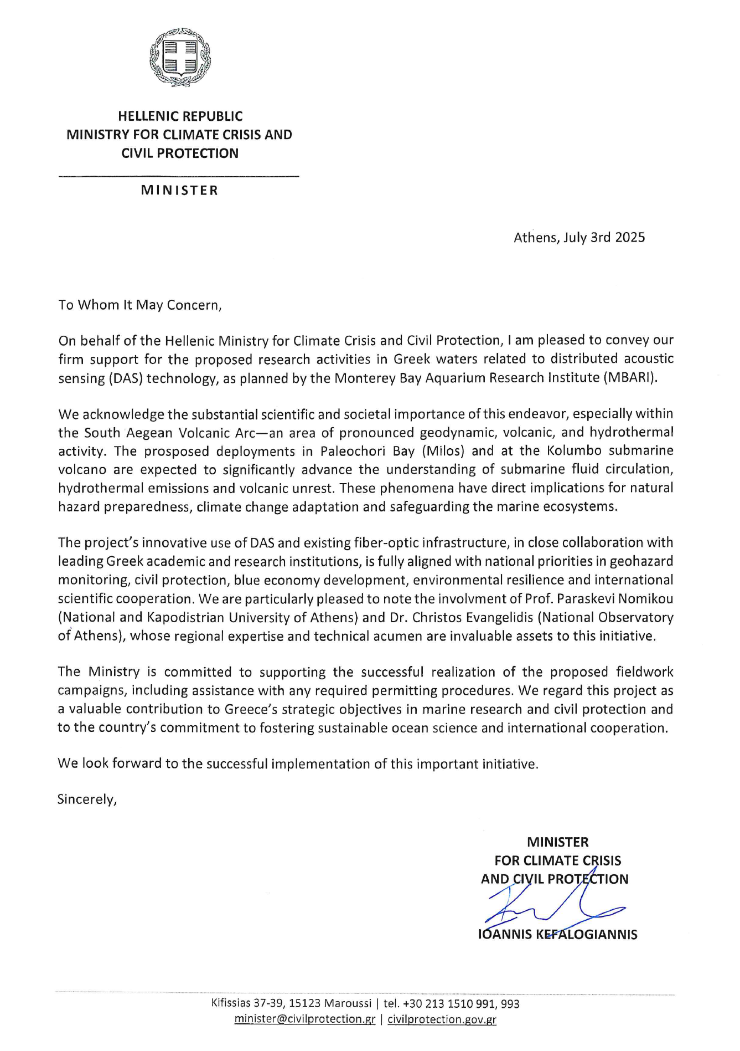

Appendix B. Deployment options for Kolumbo.

For those interested in greater detail, we have several options for this proposed deployment, cable laying, and subsequent recovery.

  - Deployment and cable laying:
Option 1:
Our preferred method for this deployment is to put the instrument and the batteries on an elevator. This elevator is released overboard and sinks to the seafloor. Then, an ROV is deployed from the surface vessel and flies down to the elevator. Using its manipulator, the ROV will acquire the sensing cable on a spool (note this deployment uses a much thinner cable than used in our original deployment). The ROV will slowly back away from the elevator, unspooling the sensing cable until it is all lying on the seafloor. At that point, the spool, containing the optics required for the bitter end, is rested on the seafloor. The advantage of this method is that you can very carefully control where the cable is laid out, and also geolocate the cable along its path. The disadvantage is that it requires an ROV. It is important to note that we will attempt this in the Monterey Bay in October 2025 and have been working through the details of this with the Doc Ricketts pilots.

Option 2:
A second option is to use the armored cable we previously deployed and deploy the instrument as we did last January. In this case, we have lowered the instrument package first and then paid out the cable from the winch as the ship moves along the desired track. This is an easier deployment, from the perspective that it does not require an ROV; however, there is much less control over where the cable ends up.

  - Recovery
Option 1:
If we use an elevator, then recovery can be done by acoustically releasing the elevator. Once the elevator reaches the surface, the cable will be fed onto a winch and slowly pulled in. In an ideal world, an ROV would be on hand to act as a backup for the acoustic release and also to help if there is any fouling or issue during recovery. The addition of an ROV incurs a significant cost. For this reason, our estimate of the cost of ship time only uses the ROV for deployment, which is essential.
Option 2:
If we deploy using the original configuration, then the system must be recovered using the bitter end of the cable. While this could be achieved by using an acoustic release that unspools a buoyant lift line, we would be hesitant to attempt this without the use of an ROV. An acoustically released lift line could get tangled or fouled, making it impossible to acquire from the surface. In summary, option 2 is possible without any ROV intervention but the team believes the risk is not worth the cost savings.

  - Research Vessels
    - There are two vessels available for hire from HCMR, the R/V Aegaeo and the R/V Philia. At this point they are only able to operate their ROV the Max Rover from the R/V Aegaeo. To optimize cost and success of the mission, we have proposed using the R/V Aegaeo and the Max Rover to deploy the instrument (configured as an elevator). We would then recover with the R/V Philia. The Philia has a large A-frame and would have deck space for a winch to collect the cable on.
    - We are submitting a proposal requesting ship time on the R/V Gaia Blu (formerly SOI’s Falkor). This ship has a very large A-frame, and we have heard they have acquired an ROV. If not, we can still rent the Max Rover or another local ROV to do the work. If this is funded, we will do a shorter deployment, stay onboard the whole time, and conduct other related science, including mapping of the area.
    - Finally, there are some private vessels that can accommodate Max Rover and are available in Greece. One vessel is similar in size to the R/V Aegaeo, and would be capable of deploying either via option 1 or option 2. The cost of these vessels would be higher than the Aegaeo.

In summary, there are several options for deployment and recovery, as well as differing abilities of vessels.

This date and number should remain the same for the duration of the project. If your project start date for 2026 is not January 1, please indicate the start date in the first cell of the milestone chart. Format for duration example: “Year 2 of 5”.
Development and infrastructure projects must complete the risk matrix (see end of the proposal form).
Not all projects will require all four titles to be filled in. Please indicate individuals only for those titles that are appropriate for your project.
This category includes transfer of hardware, know-how, publications, presentations, etc.
Modify layout/text of chart, as needed.

