Thank you for your thoughtful and detailed feedback. Our responses as requested are below.

Aaron and Alana
______________________________________________________________________

- Taking this feedback into careful consideration, please share any revisions to your operational plan and schedule including any requests for MBARI vessel time.

902401:

We understand that the cost of an external ship to conduct the proposed field operations near Kolumbo is prohibitive. As mentioned in the proposal, we are awaiting the proposal call for Gaia Blu (formerly Falkor) through CNR in Italy. As such, we will remove the cost of the ship time from the budget entry. We would like to keep the costs of shipping, in the event that ship time is granted. We have been in talks with Matt Schultz, and he has provided a more accurate estimate of the shipping cost for a container from Oakland to Greece. The round-trip estimate is $26,000. We also increased the cost of shipping the cable to Milos, to be more conservative. Removing funding for an external ship and making these changes reduces the overall cost by $71,000.

We strongly agree with the comments that it would be very helpful to practice this deployment locally before trying it on a foreign ship. That is what we had planned to do during our October Packard cruise. Due to the necessary cancellation of the cruise, we have requested days on the Rachel Carson in January 2025 to conduct these tests. We can do this operation on either ship; we are flexible if that helps with scheduling. The timing of the ship days (during December or January) is more important than the vessel.

- Please revise costs for the Aegean expeditions, providing an assessment of priorities and feasibility. We may have to cut a portion of the budget depending on Phase 2 outcomes.

As stated above we cut $71,000 from the budget. The 902401 project total is now $49,950.

- Please provide more detail on the LRAUV fiber test. Where are the resources for integrating this into the LRAUV? No LRAUV engineering team members are requested in the proposal.

Our plans for testing the DAS on the LRAUV involve using an existing housing that fits into the nose cone (we included funds as a contingency if the housing identified does not work). The only thing that needs to be replaced is the end cap. We will pay Sintela to modify the chassis to fit into the existing housing, as the current chassis design was made for a sphere and is too wide to fit into the AUV housing. We have discussed this with Sintela, and they do not anticipate it will be a significant amount of work or cost. Furthermore, as the chassis provides heat sinking to critical components, their expertise is required. We have the funds to cover this in 2025. The one part MBARI will need to build is a fiber penetrator. Aaron Schnittger plans to base this on designs that were used in previous projects.

As for the deployment plan, the idea would be to put the LRAUV into the water and then slowly back the Paragon away from the vehicle, paying out 100 m of cable (provided by Sintela). On the bitter end would be a sea anchor. The vehicle would then perform its mission (after speaking with Brett, we believe we can reuse an existing mission script). The goal of these deployments is to evaluate the viability of using mobile DAS platforms for spatiotemporal monitoring of seafloor and water column processes. This is intended as a feasibility test, not the design of a new vehicle payload.

We have added 30 hours each of Brett's and Quinn's time to assist with testing and deployment.

- Bryan Touryan-Shaeffer is oversubscribed. His DMO commitments, particularly the commissioning of the Packard and Doc Ricketts and the turnaround of the new MARS node, have to be his priority. We cannot guarantee that the hours you requested are available. Are there other personnel available that could address this need?

We recognize how important Bryan’s time is to other critical projects for the institute. Bryan’s unique combination of experience with DAS, fiber optics, and complex deployments has made him a vital contributor to our project. Unfortunately, it is not a skill set that we can replace with another member of DMO. There are undoubtedly other people with fiber and operational experience, but I think it is unlikely they will be much more available than Bryan. In short, we will very gratefully accept as much of Bryan’s time as is available and will use whatever time of his we have as judiciously as possible.

902312:

We would also like to request rescheduling of the following activity under project 902312, as it was cancelled from the 2024 and 2025 work plans:

Document and quantify the feedback between geomorphic and biological change at the fine-scale using the LASS system:

The reciprocal coupling between seafloor processes and landforms, and ecological and evolutionary processes, is still poorly constrained over a range of spatial and temporal scales and in a number of settings. This stems from a lack of long-term monitoring of physical processes and biota, an inadequate geological record, and inappropriate data resolutions. Here, I propose exploring the extent of geomorphic changes related to both geologic processes and benthic biological communities at Tubeworm Slump using LASS. Numerous chemosynthetic biological communities have been documented along the western headwall of the Tubeworm Slump in association with methane oozing from relatively fresh exposures on the slump’s headwall. The faunal succession of these communities appears to be following the retreating sulfate-methane interface into the subsurface, boring into the rock and cutting notches and small caves in the process. The frequent occurrence of notches and caves on recently exposed mudstone surfaces on the flanks of Monterey Canyon suggests that bioerosion caused by chemosynthetic organisms may be a widespread process. The Tubeworm Slump has been mapped twice with mapping AUVs, but the scale of the changes that are anticipated are too small to be measured using the 1-m data. By integrating cm-scale topographic data with mm-scale imagery from LASS (Figure 1), it will be possible to constrain the extent and geomorphic signature of seafloor modification by chemosynthetic biological communities.

Requests:

- Ship-time: In collaboration with Caress (proposal 901101). 6 (24-hr long) days of LASS using ROV Doc Ricketts on the R/V David Packard are requested for 2026. We would be happy to team up with other PIs as part of a 10 day expedition, especially if it involves work at Sur Ridge.
- Labor: Martin (144); Kecy (144), Risi (144)
- Specific deliverables: Raw and processed data on bio-erosion at Tubeworm Slump.
- Milestone date: December 2026
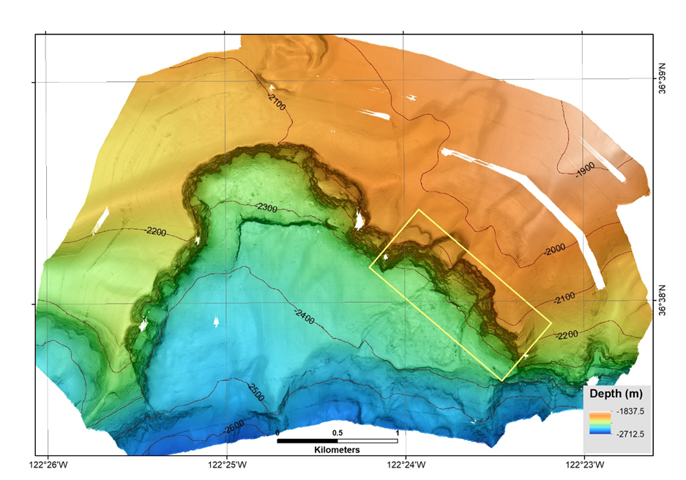
Figure 1: 1-m resolution AUV bathymetric coverage from Tubeworm Slump. Yellow rectangle denotes seafloor area where LASS surveys will be carried out.

- We struggled to untangle what funding was requested internally and externally and to align the spreadsheet you sent with what was entered in the Adaptive system. Please ensure that your entries are correct and update the additional spreadsheet you provided to match, including clear connection to project numbers, both internal and external. Make sure the Amazon Canyon project is captured.

To help clarify the budget we have attached a spreadsheet. We have checked that Budget Entry and the attached spreadsheet are aligned. All the requests submitted in the proposals are internal, but some elements of the projects listed are externally funded. Also, we have added the following items to the budget entry of 902312, with explanations below:

- Amazon Canyon: After proposal 902312 was submitted, I was informed by the Schmidt Ocean Institute that my proposal “Turbidity currents in the Amazon Canyon: Impacts on seafloor, benthic ecosystems, and carbon flow (MATRICS)” will be supported in May 2026. This 35-day expedition aims to test the hypothesis that turbidity currents are currently active in the Amazon Canyon, and to assess their impacts on geomorphology, benthic ecosystems, carbon, and microplastics flow. I can cover the following costs from the 2025 budget:
  - Travel for four MBARI staff: $10,000
  - Consumables: $500
  - Moorings components: $10,000
In addition, I would like to request funds to cover the following expenses in 2026:
  - Shipping of samples: $2,500
  - Sample analyses (geochronology, elemental analyses, organic carbon analyses, Fourier-transform infrared spectroscopy): $10,000
  - Moorings return shipping (Oakland to Fortaleza): $10,000
  - Mike Conway labor to prepare moorings: 3 weeks
The mooring expenses have arisen because the University of Durham, which had originally planned to provide them, is no longer able to do so.
- Increase in travel expenses for South Africa: $1000. This change is because the trip will no longer be part of the return journey to Europe, as originally planned, since I will need to travel to Brazil to participate in the Amazon cruise at the same time.
- Research specialist expenses: $4000 to attend South Africa conference: Flight ($3,000), accommodation, subsistence and registration fee ($1000).
- Social media manager (external consultant): $6000. I am requesting funding for a part-time social media manager for 12 months to substantially grow my audience and strengthen outreach - public via Instagram and professional/scientific via LinkedIn. This support will deliver a growth-focused strategy (editorial calendar, asset editing, consistent posting, community engagement, and targeted campaigns) guided by analytics. It will enable accessible, visually rich coverage of my upcoming expeditions and research, with clear, reported metrics for follower growth, reach, and engagement to ensure sustained expansion and impact.

