Construction of Site-Specific 1D Subsurface Models for CSEM Profiles Northern Antarctic Peninsula – South Shetland Islands – Bransfield Strait (Central Bransfield Basin).

Objectives
This report outlines the methodology used to construct site-specific 1D electromagnetic models and forward responses along four Controlled-Source Electromagnetic (CSEM) survey profiles, Profiles 1a, 1b, 2a, and 2b (see Figure 1), based on bathymetric data and published literature, with the aim of detecting shallow free-gas pockets and relict subsea permafrost.
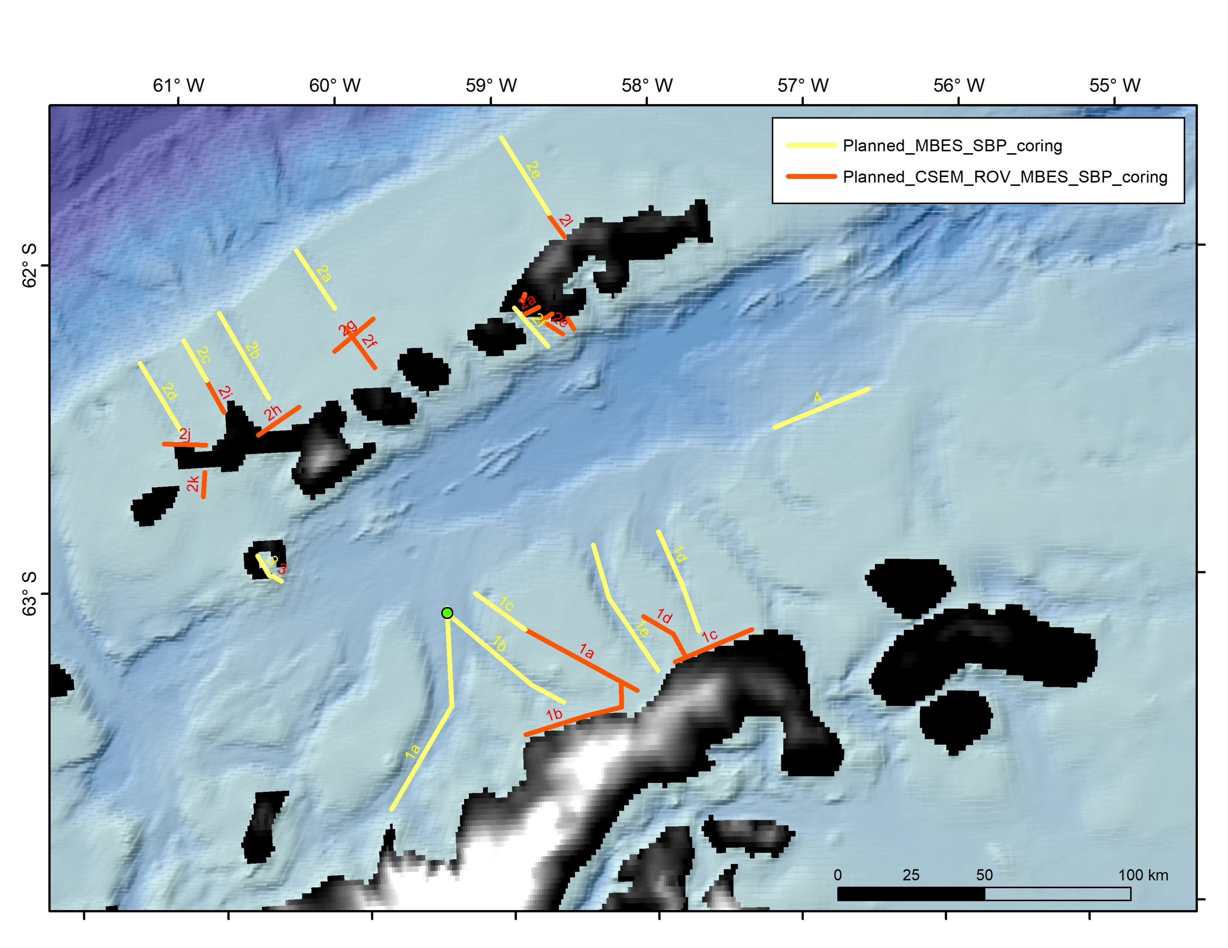
Figure 1. Study area in the Northern Antarctic Peninsula–South Shetland Islands, Bransfield Strait (Central Bransfield Basin) showing planned survey lines. Orange polylines mark the proposed CSEM tracks, specifically transects 1a, 1b and 2a, 2b. Yellow lines indicate complementary MBES/SBP/coring reconnaissance profiles.

Data and Rationale

Informed by bathymetry and previous work (García et al., 2009; 2011b; Muñoz & Wellner, 2018; Workman et al., 2024), a shallow-shelf setting was modeled in which cold bottom waters and glacimarine/hemipelagic drapes with meltwater-laminated interbeds are interpreted to favor resistive lenses at 10–40 m bsf (relict permafrost) and very shallow free gas; gas hydrate is considered unlikely at the shallow water depths encountered (≤100 m)

Electrical Properties Used

Seawater: 3.2 S/m; Holocene hemipelagic/glacimarine mud: 0.8–1.0 S/m; Meltwater-laminated sand/silt: 0.7–0.8 S/m; Glacimarine compound mud/diamicton: 0.6–0.7 S/m; Soft subglacial till: 0.4–0.5 S/m; Relict permafrost (ice in pores): 0.001–0.01 S/m (0.005 S/m used); Shallow free gas: 0.02–0.10 S/m (0.08 S/m used).
1D Models per Line

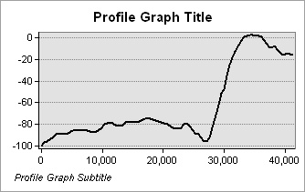
Profile 1a
Figure 2. Bathymetric sections for the 1a CSEM survey lines. The x-axis represents the distance along each profile in meters, and the y-axis shows seafloor depth in meters).
Model 1 with shallow free gas (0-30 km) (see Figure 3)
- Layer 1: 0–80 m → Seawater
- Layer 2: 80–87 m (0.9 S/m) → Holocene hemipelagic/glacimarine mud
- Layer 3: 87-95 (0.08 S/m) → Shallow free gas lens
- Layer 4: > 95 m (0.8 S/m) → Remaining Holocene mud-Meltwater-laminated sand/silt
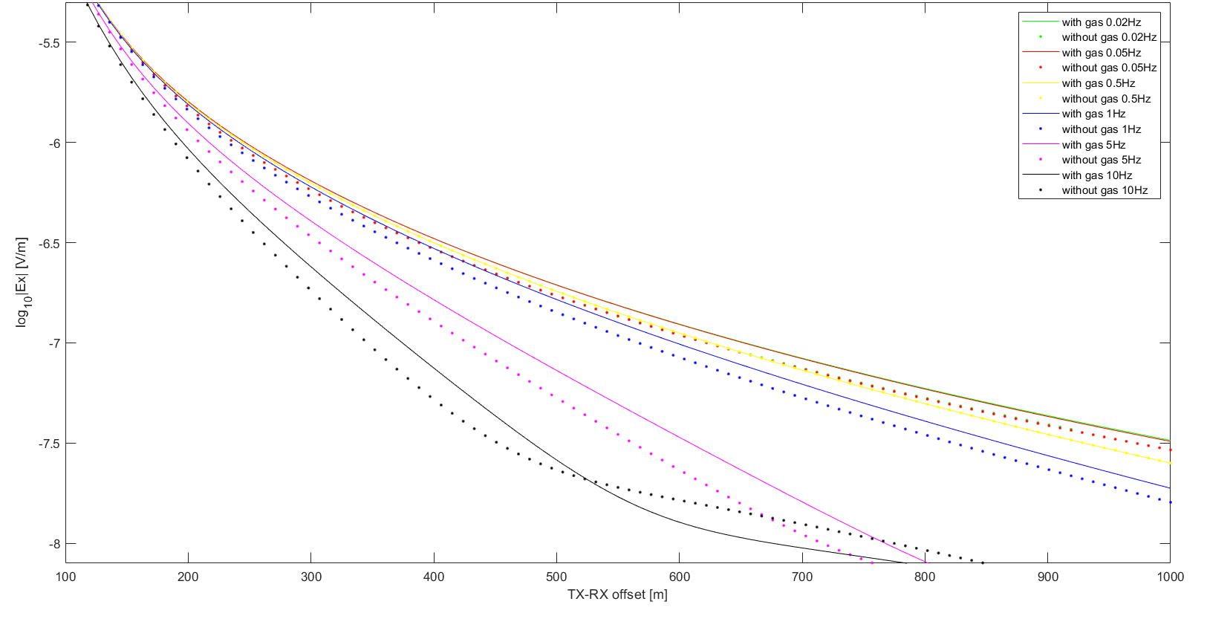
Figure 3. Modeled CSEM electric field responses (log₁₀|Ex| in V/m) for Model 1 from Profile1a, as a function of transmitter–receiver offset (100–1000 m). Solid lines represent scenarios including free gas lens; dotted lines represent the same models without free gas. Each color indicates a different transmission frequency (0.02 Hz to 10 Hz). The presence of free-gas significantly increases the EM response amplitude, especially at larger offsets ( > 200m) and higher frequencies (≥1 Hz), highlighting its detectability under shallow bathymetry and low-conductivity conditions.

Model 2 with shallow free gas (35-45 km) (see Figure 4)
- Layer 1: 0–20m → Seawater
- Layer 2: 20–80 m (0.9 S/m) → Holocene hemipelagic/glacimarine mud
- Layer 3: 80-88 (0.08 S/m) → Shallow free gas lens
- Layer 4: > 88 m (0.8 S/m) → Remaining Holocene mud-Meltwater-laminated sand/silt
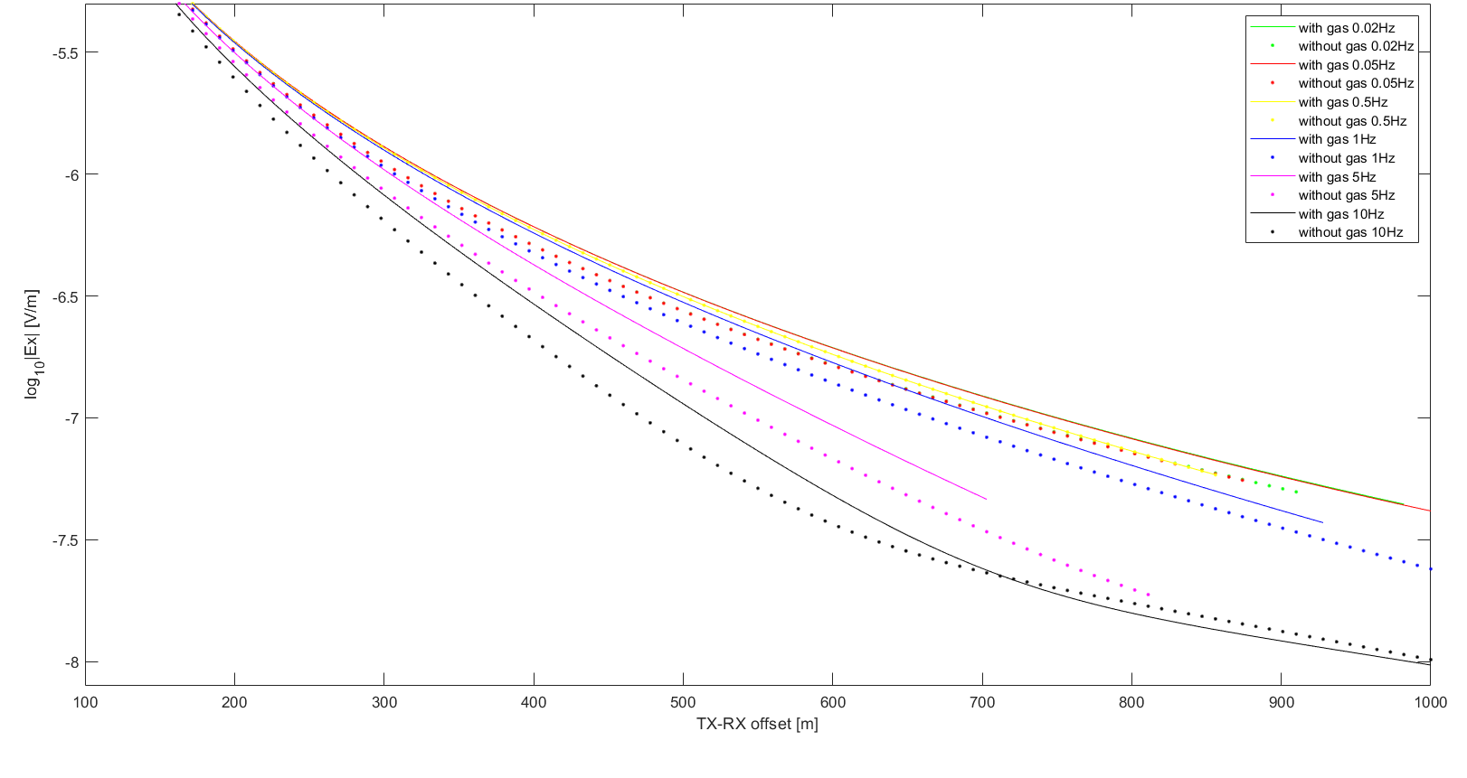
Figure 4. Modeled CSEM electric field responses (log₁₀|Ex| in V/m) for Model 2 from Profile1a, as a function of transmitter–receiver offset (100–1000 m). Solid lines represent scenarios including free gas lens; dotted lines represent the same models without free gas. Each color indicates a different transmission frequency (0.02 Hz to 10 Hz). The presence of free-gas significantly increases the EM response amplitude, especially at larger offsets ( > 200m) and higher frequencies (≥1 Hz), highlighting its detectability under shallow bathymetry and low-conductivity conditions.

Model 3 with relict permafrost (0-30 km) (see Figure 5)
- Layer 1: 0–80m → Seawater
- Layer 2: 80–90 m (0.9 S/m) → Holocene hemipelagic/glacimarine mud
- Layer 3: 90-110 (0.005 S/m) → Relict permafrost lens
- Layer 4: > 110 m (0.7 S/m) → Meltwater-laminated sand/silt- Glacimarine compound mud
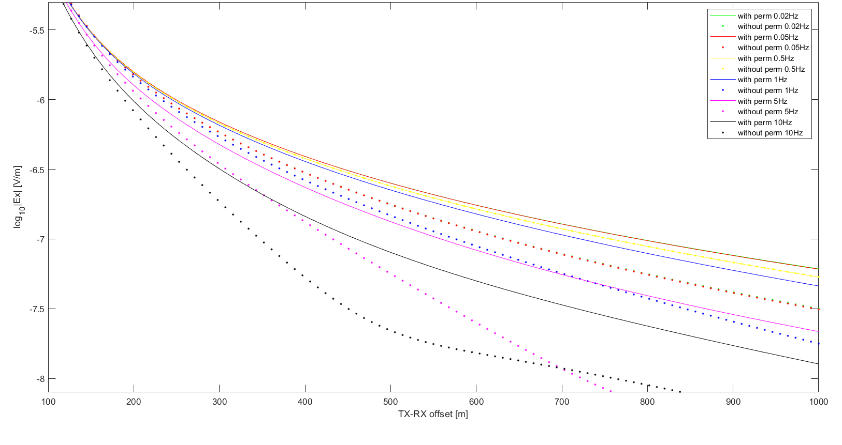
Figure 5. Modeled CSEM electric field responses (log₁₀|Ex| in V/m) for Model 3 from Profile1a, as a function of transmitter–receiver offset (100–1000 m). Solid lines represent scenarios including relict permafrost; dotted lines represent the same models without permafrost. Each color indicates a different transmission frequency (0.02 Hz to 10 Hz). The presence of relict permafrost significantly increases the EM response amplitude, especially at larger offsets ( > 200m) and higher frequencies (≥1 Hz), highlighting its detectability under shallow bathymetry and low-conductivity conditions.

Model 4 with relict permafrost (35-45 km) (see Figure 6)
- Layer 1: 0–20m → Seawater
- Layer 2: 20–80 m (0.9 S/m) → Holocene hemipelagic/glacimarine mud
- Layer 3: 80-100 (0.005 S/m) → Relict permafrost lens
- Layer 4: > 100 m (0.7 S/m) → Meltwater-laminated sand/silt- Glacimarine compound mud
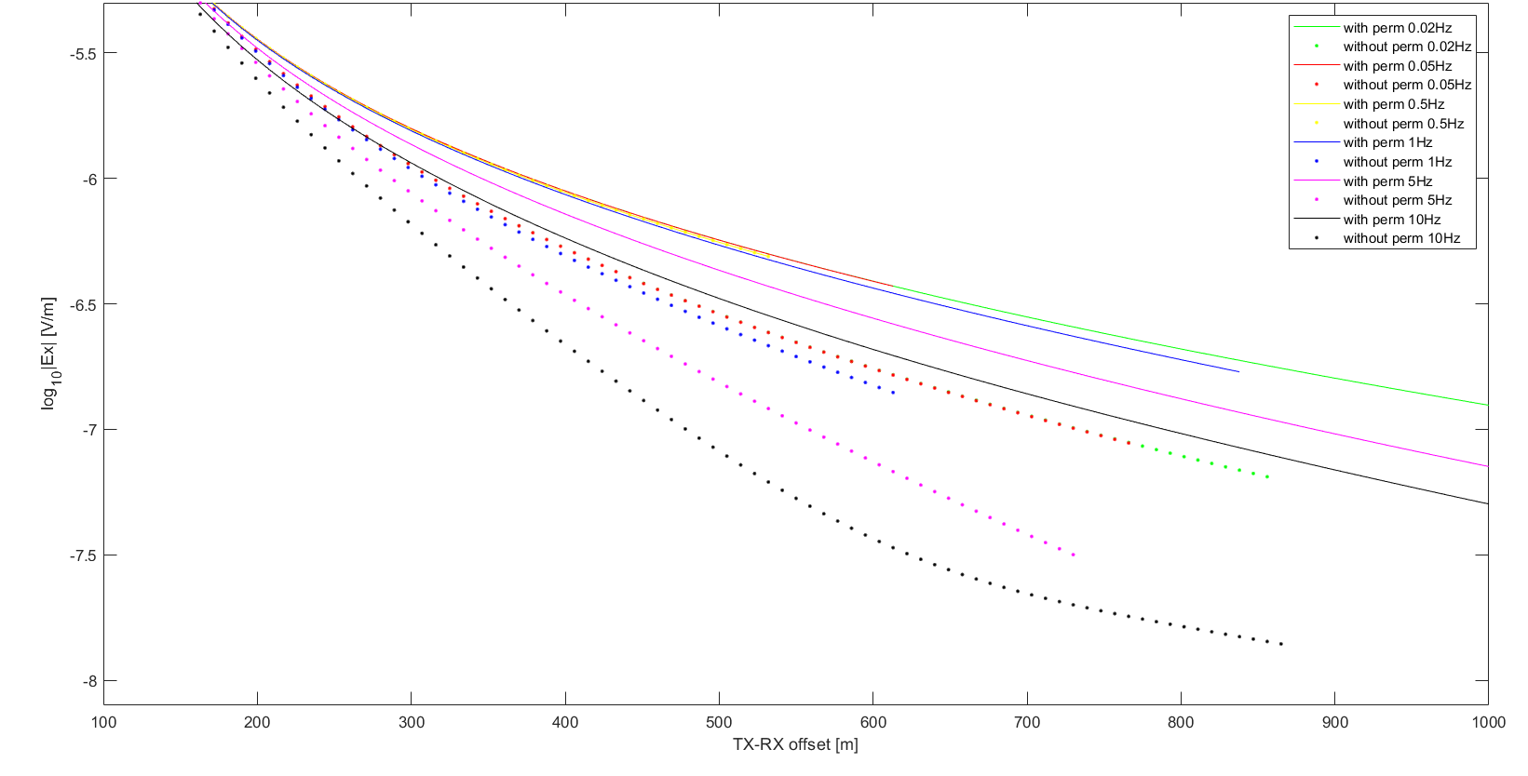
Figure 6. Model4 from Profile 1a. Forward-modelled inline electric-field amplitude, log10|Ex| (V/m), versus TX–RX offset for frequencies 0.02–10 Hz, comparing the background case and a relict permafrost scenario. Solid lines represent scenarios including relict permafrost; dotted lines represent the same models without permafrost. The permafrost case yields systematically higher |Ex| at a given offset, with the separation increasing toward higher frequencies and larger offsets, indicating good detectability in the shallow-water setting.
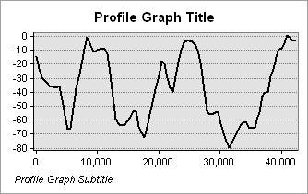
Profile1b
Figure 7. Bathymetric sections for the 1b CSEM survey lines. The x-axis represents the distance along each profile in meters, and the y-axis shows seafloor depth in meters).
Model 1 with shallow free gas (5-6 km; 12-20km; 28-38km) (see Figure 8)
- Layer 1: 0–60 m → Seawater
- Layer 2: 60–67 m (0.9 S/m) → Holocene hemipelagic/glacimarine mud
- Layer 3: 67-85 (0.08 S/m) → Shallow free gas lens
- Layer 4: > 85 m (0.8 S/m) → Remaining Holocene mud-Meltwater-laminated sand/silt
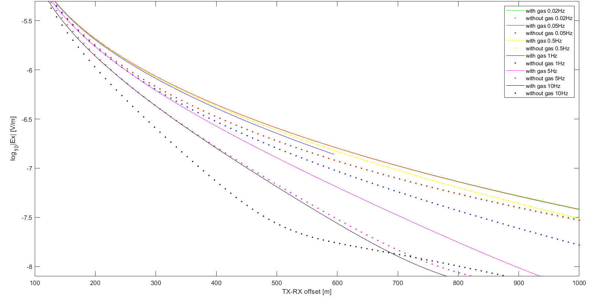
Figure 8. Modeled CSEM electric field responses (log₁₀|Ex| in V/m) for Model 1 from Profile1b, as a function of transmitter–receiver offset (100–1000 m). Solid lines represent scenarios including free gas lens; dotted lines represent the same models without free gas. Each color indicates a different transmission frequency (0.02 Hz to 10 Hz). The presence of free-gas significantly increases the EM response amplitude, especially at larger offsets ( > 200m) and higher frequencies (≥1 Hz), highlighting its detectability under shallow bathymetry and low-conductivity conditions.

Model 2 with shallow free gas (6-12 km; 20-25 km) (see Figure 9)
- Layer 1: 0–10m → Seawater
- Layer 2: 10–67 m (0.9 S/m) → Holocene hemipelagic/glacimarine mud
- Layer 3: 67-75 (0.08 S/m) → Shallow free gas lens
- Layer 4: > 75 m (0.8 S/m) → Remaining Holocene mud-Meltwater-laminated sand/silt
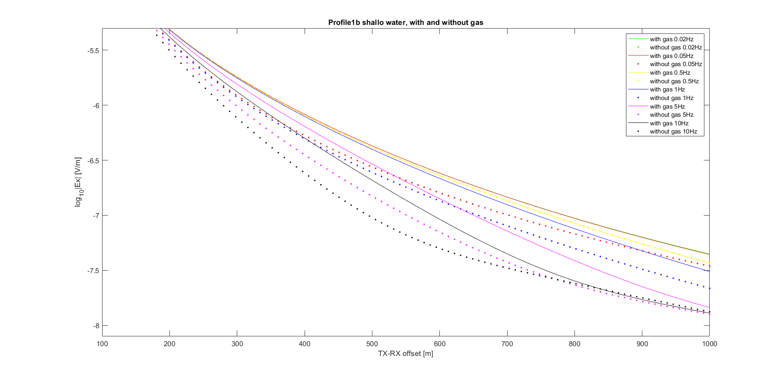
Figure 9. Modeled CSEM electric field responses (log₁₀|Ex| in V/m) for Model 2 from Profile1b, as a function of transmitter–receiver offset (100–1000 m). Solid lines represent scenarios including free gas lens; dotted lines represent the same models without free gas. Each color indicates a different transmission frequency (0.02 Hz to 10 Hz). The presence of free-gas significantly increases the EM response amplitude, especially at higher frequencies (≥1 Hz), highlighting its detectability under shallow bathymetry and low-conductivity conditions.

Model 3 with relict permafrost (5-6 km; 12-20km; 28-38km) (see Figure 10)
- Layer 1: 0–60m → Seawater
- Layer 2: 60–70 m (0.9 S/m) → Holocene hemipelagic/glacimarine mud
- Layer 3: 70-90 (0.005 S/m) → Relict permafrost lens
- Layer 4: > 90 m (0.7 S/m) → Meltwater-laminated sand/silt- Glacimarine compound mud
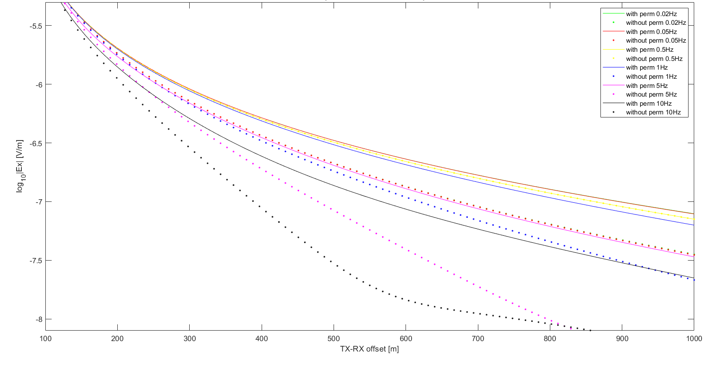
Figure 10. Modeled CSEM electric field responses (log₁₀|Ex| in V/m) for Model 3 from Profile1b, as a function of transmitter–receiver offset (100–1000 m). Solid lines represent scenarios including relict permafrost; dotted lines represent the same models without permafrost. Each color indicates a different transmission frequency (0.02 Hz to 10 Hz). The presence of relict permafrost significantly increases the EM response amplitude, especially at larger offsets ( > 150m) and higher frequencies (≥1 Hz), highlighting its detectability under shallow bathymetry and low-conductivity conditions.

Model 4 with relict permafrost (6-12 km; 20-25 km) (see Figure 11)
- Layer 1: 0–10m → Seawater
- Layer 2: 10–70 m (0.9 S/m) → Holocene hemipelagic/glacimarine mud
- Layer 3: 70-90 (0.005 S/m) → Relict permafrost lens
- Layer 4: > 90 m (0.7 S/m) → Meltwater-laminated sand/silt- Glacimarine compound mud
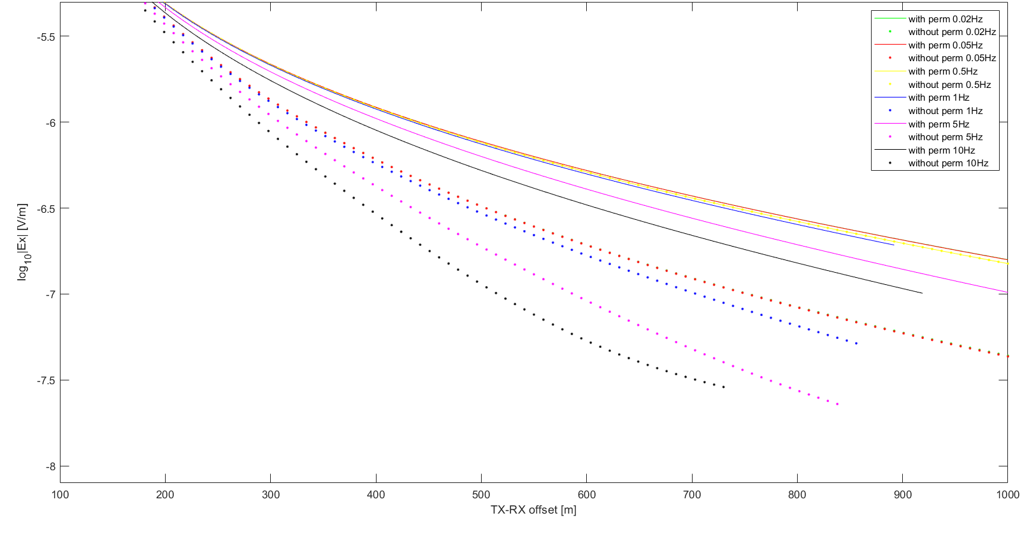
Figure 11. Model4 from Profile 1b. Forward-modelled inline electric-field amplitude, log10|Ex| (V/m), versus TX–RX offset for frequencies 0.02–10 Hz, comparing the background case and a relict permafrost scenario. Solid lines represent scenarios including relict permafrost; dotted lines represent the same models without permafrost. The permafrost case yields systematically higher |Ex| at a given offset, with the separation increasing toward higher frequencies and larger offsets, indicating good detectability in the shallow-water setting.
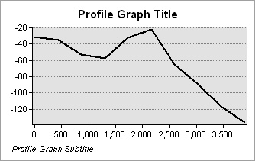
Profile 2a
Figure 12. Bathymetric sections for the 2a CSEM survey lines. The x-axis represents the distance along each profile in meters, and the y-axis shows seafloor depth in meters).

Model 1 with shallow free gas (3-3.5 km) (see Figure 13)
- Layer 1: 0–100 m → Seawater
- Layer 2: 100–107 m (0.9 S/m) → Holocene hemipelagic/glacimarine mud
- Layer 3: 107-115 (0.08 S/m) → Shallow free gas lens
- Layer 4: > 115 m (0.8 S/m) → Remaining Holocene mud-Meltwater-laminated sand/silt
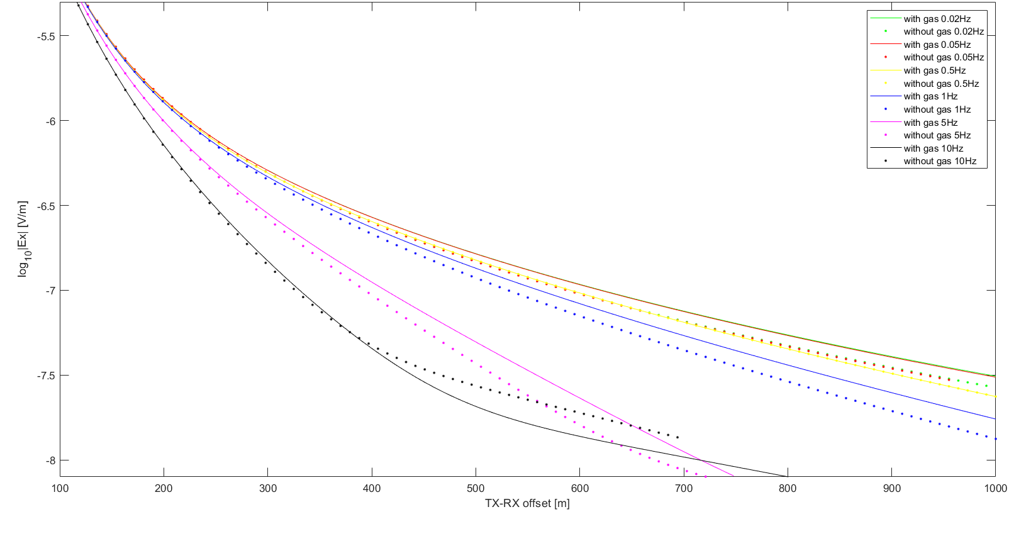
Figure 12. Modeled CSEM electric field responses (log₁₀|Ex| in V/m) for Model 1 from Profile 2a, as a function of transmitter–receiver offset (100–1000 m). Solid lines represent scenarios including free gas lens; dotted lines represent the same models without free gas. Each color indicates a different transmission frequency (0.02 Hz to 10 Hz). The presence of free-gas significantly increases the EM response amplitude, especially at larger offsets ( > 350-400m) and higher frequencies (≥1 Hz), highlighting its detectability under shallow bathymetry and low-conductivity conditions.

Model 2 with shallow free gas (0.2-1.5 km) (see Figure 13)
- Layer 1: 0–60m → Seawater
- Layer 2: 60–67 m (0.9 S/m) → Holocene hemipelagic/glacimarine mud
- Layer 3: 67-75 (0.08 S/m) → Shallow free gas lens
- Layer 4: > 75 m (0.8 S/m) → Remaining Holocene mud-Meltwater-laminated sand/silt
Figure 13. Modeled CSEM electric field responses (log₁₀|Ex| in V/m) for Model 2 from Profile2a, as a function of transmitter–receiver offset (100–1000 m). Solid lines represent scenarios including free gas lens; dotted lines represent the same models without free gas. Each color indicates a different transmission frequency (0.02 Hz to 10 Hz). The presence of free-gas significantly increases the EM response amplitude, especially at higher frequencies (≥1 Hz), highlighting its detectability under shallow bathymetry and low-conductivity conditions.

Model 3 with relict permafrost (3-3.5 km) (see Figure 14)
- Layer 1: 0–100m → Seawater
- Layer 2: 100–110 m (0.9 S/m) → Holocene hemipelagic/glacimarine mud
- Layer 3: 110-130 (0.005 S/m) → Relict permafrost lens
- Layer 4: > 130 m (0.7 S/m) → Meltwater-laminated sand/silt- Glacimarine compound mud
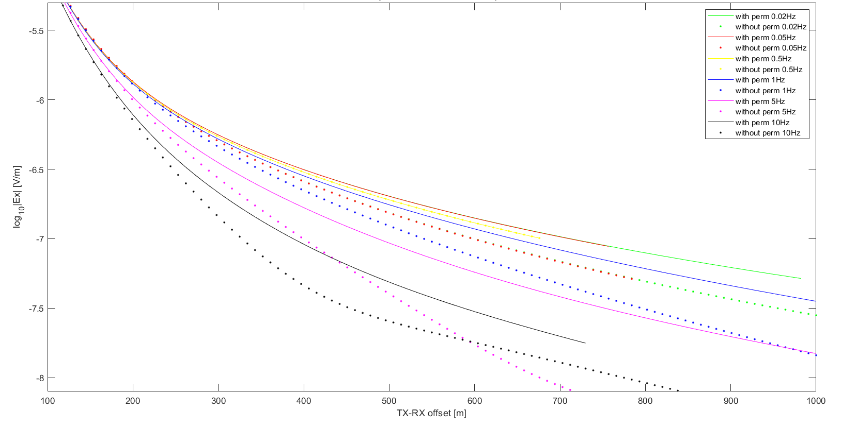
Figure 14. Modeled CSEM electric field responses (log₁₀|Ex| in V/m) for Model 3 from Profile2a, as a function of transmitter–receiver offset (100–1000 m). Solid lines represent scenarios including relict permafrost; dotted lines represent the same models without permafrost. Each color indicates a different transmission frequency (0.02 Hz to 10 Hz). The presence of relict permafrost significantly increases the EM response amplitude, especially at larger offsets ( > 200 m) and higher frequencies (≥1 Hz), highlighting its detectability under shallow bathymetry and low-conductivity conditions.

Model 4 with relict permafrost (0.2-1.5 km) (see Figure 15)
- Layer 1: 0–60 m → Seawater
- Layer 2: 60–80 m (0.9 S/m) → Holocene hemipelagic/glacimarine mud
- Layer 3: 80-100 (0.005 S/m) → Relict permafrost lens
- Layer 4: > 100 m (0.7 S/m) → Meltwater-laminated sand/silt- Glacimarine compound mud
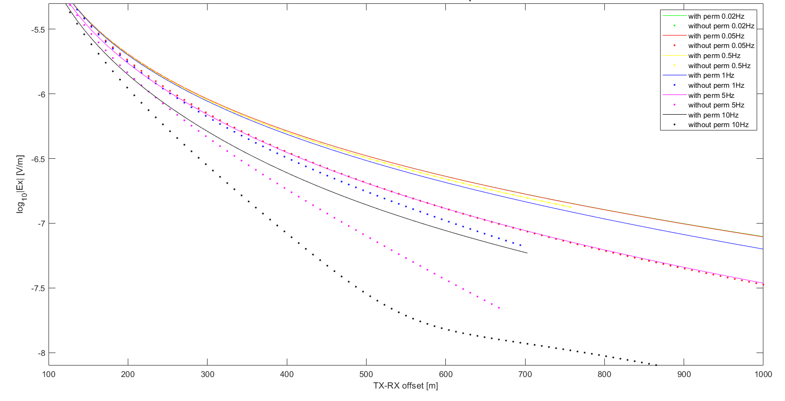
Figure 15. Model4 from Profile 2a. Forward-modelled inline electric-field amplitude, log10|Ex| (V/m), versus TX–RX offset for frequencies 0.02–10 Hz, comparing the background case and a relict permafrost scenario. Solid lines represent scenarios including relict permafrost; dotted lines represent the same models without permafrost. The permafrost case yields systematically higher |Ex| at a given offset, with the separation increasing toward higher frequencies and larger offsets, indicating good detectability in the shallow-water setting.

Profile 2b
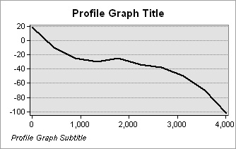
Figure 16. Bathymetric sections for the 2b CSEM survey lines. The x-axis represents the distance along each profile in meters, and the y-axis shows seafloor depth in meters).

Model 1 with shallow free gas (3-4 km) (see Figure 17)
- Layer 1: 0–100 m → Seawater
- Layer 2: 100–107 m (0.9 S/m) → Holocene hemipelagic/glacimarine mud
- Layer 3: 107-115 (0.08 S/m) → Shallow free gas lens
- Layer 4: > 115 m (0.8 S/m) → Remaining Holocene mud-Meltwater-laminated sand/silt
Figure 17. Modeled CSEM electric field responses (log₁₀|Ex| in V/m) for Model 1 from Profile 2b, as a function of transmitter–receiver offset (100–1000 m). Solid lines represent scenarios including free gas lens; dotted lines represent the same models without free gas. Each color indicates a different transmission frequency (0.02 Hz to 10 Hz). The presence of free-gas significantly increases the EM response amplitude, especially at larger offsets ( > 350-400m) and higher frequencies (≥1 Hz), highlighting its detectability under shallow bathymetry and low-conductivity conditions.

Model 2 with shallow free gas (0.5-3 km) (see Figure 18)
- Layer 1: 0–40m → Seawater
- Layer 2: 40–47 m (0.9 S/m) → Holocene hemipelagic/glacimarine mud
- Layer 3: 47-55 (0.08 S/m) → Shallow free gas lens
- Layer 4: > 55 m (0.8 S/m) → Remaining Holocene mud-Meltwater-laminated sand/silt
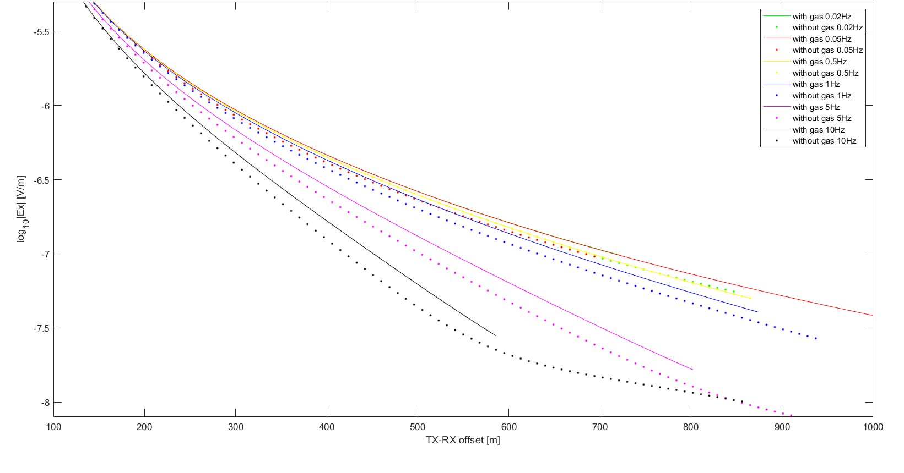
Figure 18. Modeled CSEM electric field responses (log₁₀|Ex| in V/m) for Model 2 from Profile2b, as a function of transmitter–receiver offset (100–1000 m). Solid lines represent scenarios including free gas lens; dotted lines represent the same models without free gas. Each color indicates a different transmission frequency (0.02 Hz to 10 Hz). The presence of free-gas significantly increases the EM response amplitude, especially at larger offset ( >200 m) and higher frequencies (≥1 Hz), highlighting its detectability under shallow bathymetry and low-conductivity conditions.

Model 3 with relict permafrost (3-4 km) (see Figure 19)
- Layer 1: 0–100m → Seawater
- Layer 2: 100–110 m (0.9 S/m) → Holocene hemipelagic/glacimarine mud
- Layer 3: 110-130 (0.005 S/m) → Relict permafrost lens
- Layer 4: > 130 m (0.7 S/m) → Meltwater-laminated sand/silt- Glacimarine compound mud
Figure 19. Modeled CSEM electric field responses (log₁₀|Ex| in V/m) for Model 3 from Profile2b, as a function of transmitter–receiver offset (100–1000 m). Solid lines represent scenarios including relict permafrost; dotted lines represent the same models without permafrost. Each color indicates a different transmission frequency (0.02 Hz to 10 Hz). The presence of relict permafrost significantly increases the EM response amplitude, especially at larger offsets ( > 200 m) and higher frequencies (≥1 Hz), highlighting its detectability under shallow bathymetry and low-conductivity conditions.

Model 4 with relict permafrost (0.5-3 km) (see Figure 20)
- Layer 1: 0–40 m → Seawater
- Layer 2: 40–110 m (0.9 S/m) → Holocene hemipelagic/glacimarine mud
- Layer 3: 110-140 (0.005 S/m) → Relict permafrost lens
- Layer 4: > 140 m (0.7 S/m) → Meltwater-laminated sand/silt- Glacimarine compound mud
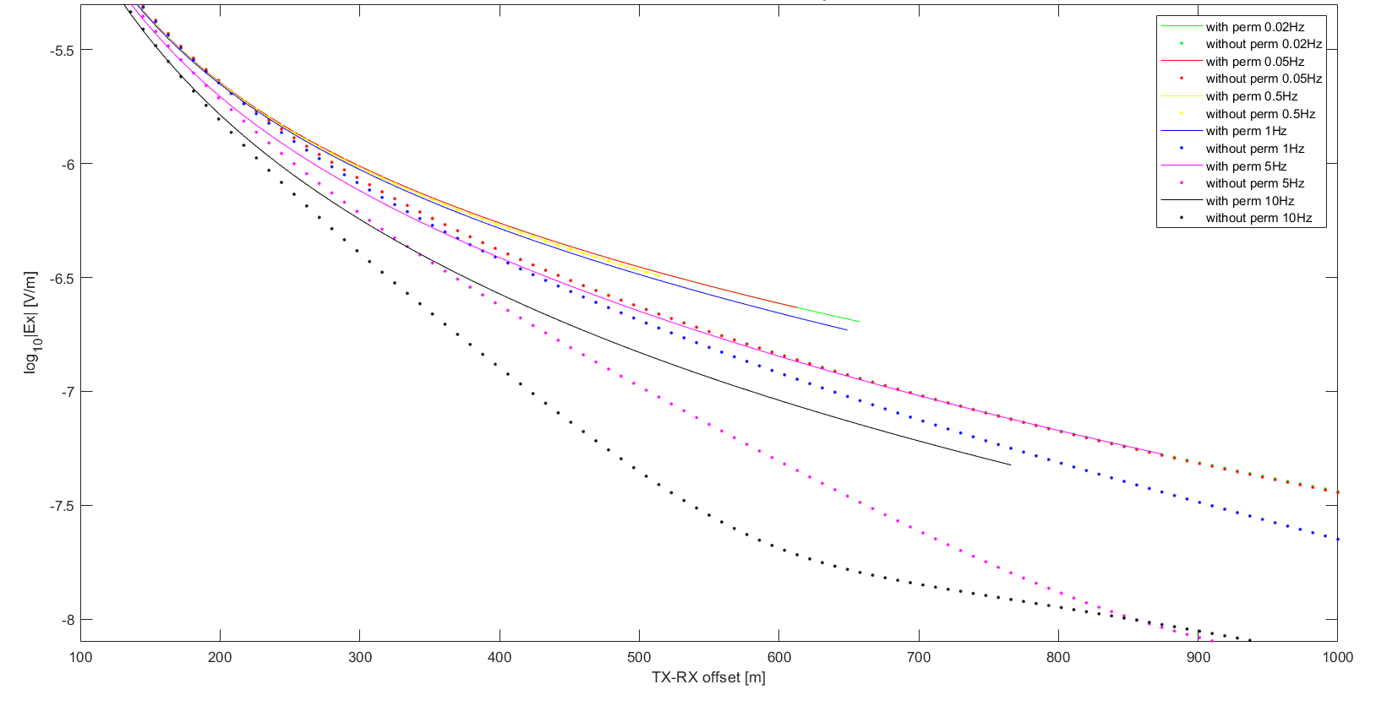
Figure 20. Model4 from Profile 2b. Forward-modelled inline electric-field amplitude, log10|Ex| (V/m), versus TX–RX offset for frequencies 0.02–10 Hz, comparing the background case and a relict permafrost scenario. Solid lines represent scenarios including relict permafrost; dotted lines represent the same models without permafrost. The permafrost case yields systematically higher |Ex| at a given offset, with the separation increasing toward higher frequencies and larger offsets, indicating good detectability in the shallow-water setting.

CSEM Field Setup and Source Configuration for Antarctic Peninsula – Technical Summary
Based on forward modelling tests, final source configuration and acquisition settings for upcoming marine CSEM surveys along profiles in the South Shetland Islands – Bransfield Strait are summarised here. The aim is to optimize signal sensitivity both for shallow free gas and shallow permafrost detection (depth 10-40 m b.s.f.) using a frequency-domain approach.
1. Transmission Mode: Full-Duty Sinusoidal at 5 Hz
- Signal type: Full-duty, sqare waveform
- Frequency: 5 Hz (fixed)
- Current amplitude: 25 A
- Transmission continuity: 30 or 60 seconds pause between 60 seconds cycles
This choice ensures:
- Maximum signal strength for EM field detection
- Stability of waveform (no fast current switching required)
- Compatibility with frequency-domain 1D modelling performed
- Potential to exploit harmonics generated by slight waveform imperfections
2. TriggerBox Configuration
c f 1 # Full-duty mode (square wave, 5 Hz)
c l 200 # Period = 100 ms → 5 Hz
c d 60 # Duration: 60 seconds of transmission
c p 30 (60) # Pause: 30 or 60 seconds between cycles
c w 1 # Wait full minute (sync to full minute)
c s # Save settings
s # Start transmission

3. Navigation Speed
- Recommended vessel speed: 1.0 knots (0.5 m/s)
This speed ensures:
- ~10 cm spatial resolution per 5 Hz cycle
- Sufficient lateral sampling relative to the 300–450 m offset range
- Stable source-receiver geometry without excessive cable motion
4. Receiver Setup: Self-Potential Loggers
- Sampling Frequency: 10 kHz
- Offset range: 300–450 m (2 Rx deployed + 1 Rx on board)
5. Gain Calibration and Testing Procedure
To prevent signal clipping and ensure optimal resolution before field acquisition:
- Initial Gain Setting: Begin with Gain = 0 (±4.096 V input range) on all channels to prevent saturation under unknown signal levels.
- Monitor Raw Signal: After the first few minutes of transmission, inspect raw voltage levels (e.g., .ef1, .ef2, .ef3 files).
- Adjust Gain if Needed:
  - If the maximum observed signal is below ~100 mV, lower the gain (e.g., Gain = 21 or 42) to improve resolution.
  - Avoid gain settings that limit the input range below ±20 mV unless signal levels are confirmed stable and low.
- Dynamic Range Buffer: Maintain a 20–30% margin below full-scale to accommodate unexpected peaks.

Justification for Configuration
- 5 Hz full-duty transmission yields clear field amplitude separation between background case and both relict permafrost and free gas lens scenario in the top 10–40 m b.s.s.
- Half-duty or transient-mode sources introduce timing and synchronization complexities not justified by marginal gain in sensitivity.
- Continuous square signal maximizes SNR and matches the assumptions in our forward modeling.
- An offset range of 300–450 m is sufficient to discriminate both relict permafrost and shallow free-gas lenses from the background within the top 10–40 m bsf, and it reduces signal noise on RX2 (the farthest receiver).

