FLAIR Antarctic Expedition Media Strategy
Expedition: January-February 2026 — R/V Hesperides (Spain)
Duration: 7 days at sea
Scientific Focus: Fluid flow, methane seepage, offshore groundwater, glacial history, chemosynthetic communities, submarine permafrost
Tools in use: Multibeam, sub-bottom profiling, CSEM (SWAN), ROV imagery, pore water chemistry, coring, CTD
Audience: General public, scientific community, policymakers, students, press

1. Media Goals

The strategy should:

1. Raise public awareness
Highlight why studying seafloor fluids under climate warming matters: methane release, hidden freshwater reserves, changes in seafloor geomorphology, and vulnerable ecosystems.

2. Position this expedition at the frontier of Antarctic research
Emphasize innovations (first offshore groundwater assessment in Antarctica using CSEM, characterisation of seeps and chemosynthetic habitats, new glacial reconstructions, predictive modelling).

3. Provide real-time storytelling
Through social media, StoryMaps, videos, and daily updates.

4. Simplify communication for policymakers
Clear outputs relating to methane, polar ecosystems, and glacial systems to support COP talks, briefings, and national science agencies.

2. Target Audiences and Channels

A. General Public
- Instagram / Facebook / LinkedIn: daily updates with short videos
- YouTube: 1 short documentary-style piece

B. Scientists
- AGU, EGU, Ocean Sciences Meeting
- SCAR, SOOS, IMBeR networks
- Peer-reviewed papers (open access)
- Cruise report & data deposited in MGDS, R2R

C. Policymakers
- COP 2026 talk (?)
- 2 page policy brief on methane flux, benthic ecosystems, and climate feedbacks

D. Students & Educators
- Short explainer videos on:
  - What are seeps?
  - What is Antarctic offshore groundwater?
  - Why does seabed methane matter?

3. Media Outputs

1. Expedition Branding
- Expedition logo

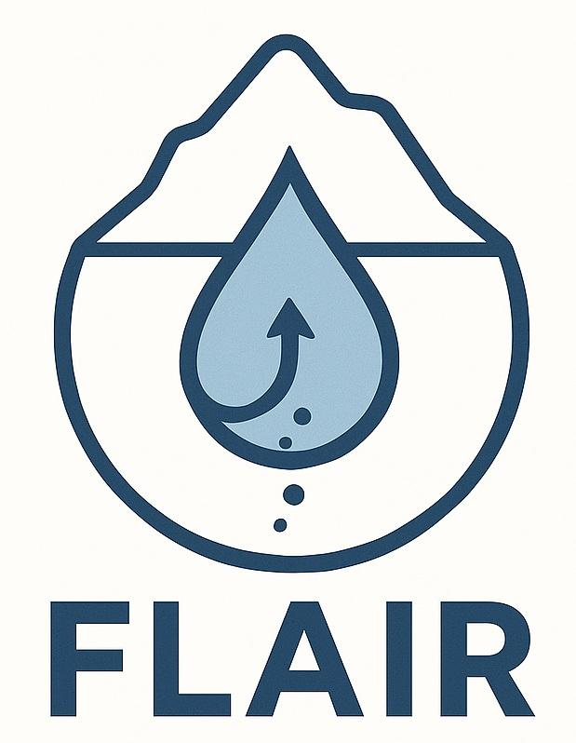

- High-resolution map of transects (to be determined)

2. Press Release
- After expedition

3. Visual Products

Photography
- Deck operations (SWAN deployment, ROV launch, coring, CTD ops)
- Team portraits for media use
- ROV imagery of seeps, fauna, geomorphology
- High-res 3D shaded bathymetry
- Scientists in cold-weather gear

Video
- Short clips (15–30 seconds) for social media
- Explainer videos
  - “What is controlled-source electromagnetics?”
  - “How do methane seeps form?”
  - “How do we sample pore water in Antarctica?”
- Mini-documentary (3–7 minutes)
  - Pre-departure interviews
  - Life at sea
  - Key scientific discoveries

4. Interactive StoryMap
- Daily logs + map tracking
- Photos, videos, ROV frames
- Method and science explainers (CSEM, SBP, methane flux estimation)

5. Social Media Campaign

Suggested hashtag: #FLAIRAntarctica #AntarcticFluids

Daily posts (scheduled):

Day 1 | Departure, ship, route
Day 2 | Multibeam mapping & methane flares
Day 3 | CSEM deployment
Day 4 | Core recovery & porewater sampling
Day 5 | ROV dive highlights (fauna, seep structures)
Day 6 | Team interviews
Day 7 | Wrap-up, first results

4. Roles

Onboard Media Officer: Aaron Micallef

Shore-based Communications
- MBARI Comms team (media distribution, editing)
- University of Barcelona (Spanish-language outreach)
- University of Milano-Bicocca (Italian media and biodiversity angle)
- GEOMAR (German-language outreach)
- UNIS (Norwegian-language outreach)

Videographer
Aaron Micallef to:
- handle camera work (Canon EOS RP, GoPro)
- record b-roll
- conduct simple interviews with lav mic

5. Timeline

Phase 1 — Pre-expedition (Now → Jan 2026)
- Confirm communications contacts at each institution.
  - UNIS: ingridn@unis.no
- Create StoryMap skeleton (Amblas).
- Prepare templates for social posts.
- Packing list:
  - EOS RP + 2–3 lenses
  - Gimbal
  - GoPro + metal bar mount
  - Batteries (non-rechargeable lithium allowed depending on airline rules)
  - Mic
  - Backup SSDs

Phase 2 — Expedition (January 2026)

Daily:
- 2–5 good photos
- 15–30 sec video
- Short science explanation
- One StoryMap update
- Social media post

Phase 3 — Post-expedition (Feb–Dec 2026)

- Press release
- Media package (see below)
- Produce 3–7 min mini-documentary
- Write policy brief
- Publish peer-reviewed papers
- Prepare AGU/EGU conference abstracts
- Public lectures

6. Media Package

FLAIR Antarctic Expedition Media Packet

1. Title: FLAIR: Fluid–seafloor interactions across the Antarctic seafloor under climate-driven change
2. Core Message
A pioneering expedition to uncover how melting, methane seepage, and groundwater systems beneath the Antarctic seafloor shape climate, ecosystems, and seafloor evolution, using cutting-edge mapping, controlled-source electromagnetics, and ROV exploration.
3. Why This Matters
- Western Antarctic Peninsula is warming faster than almost anywhere in the southern hemisphere.
- The seafloor may be releasing methane, a potent greenhouse gas.
- Vast groundwater reservoirs may be hidden under Antarctic shelves.
- Fluid flow may shape underwater landscapes, trigger slope failures, and sustain unique ecosystems.
4. Expedition Overview
- Ship: R/V Hesperides (Spain)
- Duration: 7 days of scientific work
- Location: Bransfield Basin and South Shetland Islands
- Objectives:
  - Map fluid migration pathways
  - Identify groundwater and seepage sites
  - Sample sediments, porewater, and water column
  - Document chemosynthetic communities
  - Reconstruct past glacial dynamics
  - Model future seafloor change
5. Key Technologies
- Multibeam echosounder (EM712 and EM124)
- Sub-bottom profiler (TOPAS PS 18)
- CSEM system (first Antarctic application)
- ROV with CTD, water samplers, HD cameras
- Gravity and monotype coring
6. Scientific Team
7. Media Contacts
- Lead: Communications officers at MBARI, UB, Milano-Bicocca, GEOMAR, UNIS
8. Visual Assets
- Expedition logo
- Map of transects
- Team photos
- Vessel photos
- Sample ROV frames
- Pre-approved high-res bathymetry
9. Social Media Handles
- MBARI
- Participating institutions
- Own accounts
10. Frequently Asked Questions
- Why study seafloor fluids?
- What is offshore groundwater?
- How does warming influence the Antarctic seabed?
- What makes this expedition unique?

