Technology Control Plan/Logistics – Micallef Shipment to Chile for Antarctic cruise

1. Overview of the Program
The FLAIR expedition is an international, non-commercial scientific research mission aimed at characterizing marine hydrogeological systems on the northern Antarctic Peninsula. The field program will take place from 20 January to 4 February 2026, operating from R/V Hespérides. All exported commodities will be used solely for scientific data acquisition and sampling. No commercial, military, or dual-use operational application is involved.
2. Items to Be Shipped
From the United States, the following item(s) will be exported:
- SWAN Controlled-Source Electromagnetic (CSEM) system
(Owned by University of Malta; includes transmitter, receiver nodes, cables, and associated control electronics. Export-controlled items listed in table below.*)
- SARAD RTM 1688-2 radon monitor (non-ITAR, non-ECCN)
- Ancillary scientific materials (e.g., small sensors, sampling equipment)
*SWAN System (CSEM)
Item Description | ECCN | Control
Item Description | ECCN | Malta | Chile
Magson Amir Selfpot Logger | EAR99
SWAN Silvion CSS1 Port | 6A006.b | NS2 (AT1 - N/A) | NS2 (AT1 - N/A)
Zonge Transmitter | EAR99
Columbus P-10 Pro GPS Unit | 7A994 | (AT1 - N/A) | (AT1 - N/A)
Garmin 16x GPS Sensor | 7A994 | (AT1 - N/A) | (AT1 - N/A)
Whole system | 6A006 | NS2 (AT1 - N/A) | NS2 (AT1 - N/A)

3. Chronological Sequence of the Transaction
3.1 Pre-Shipment (United States – December 2025)
- MBARI prepares the SWAN CSEM system for export, including testing, packing, and documentation.
- The system is shipped from the United States to the port of Punta Arenas, Chile, with an expected arrival before 7 January 2026.
- Custody during transport remains with the certified international freight carrier.
- The shipping label will include the vessel agent address:
Buque BIO Hespérides (Armada Española), c/o Shackleton’s Way Agente de Buques, Pedro Sarmiento de Gamboa 846, Punta Arenas, Chile.
Required customs note: “mercancía / Rancho de nave en transito a la antártica.”
3.2 Receipt and Port Logistics (Punta Arenas – 7 January 2026)
- Upon arrival in Punta Arenas, the SWAN CSEM system is received by the vessel agent (Milenko Buljan). The cases hosting the system will be secured/locked.
- The system remains in a secure staging area under the responsibility of the vessel agent until loaded.
- The instrument is loaded onto R/V Hespérides under the supervision of the ship captain.
3.3 Transfer of Custody and Control
- Prior to embarkation: Custody is held by the vessel agent.
- Once loaded on the vessel (7 January):
Physical custody transfers to the R/V Hespérides captain while remaining secuer and locked in container on the vessel.
- MBARI personnel (Aaron Micallef or Johann Voigtlander) will open the cases and inspect the shipment upon embarkation (20 January 2026).
- The system is installed and operated exclusively by MBARI personnel and collaborating scientists (with no access to export controlled items, software or technical data), under the authority of the expedition’s Principal Investigator (PI), Aaron Micallef.
4. Vessels and Modes of Transport
- Air Transport: United States → Punta Arenas (freight).
- Research Vessel: R/V Hespérides will transport the equipment from Punta Arenas to the study areas on the northern Antarctic Peninsula.
- Return Shipping: R/V Hespérides → Punta Arenas → return freight to the United States.
5. Scientific Activities Using the Exported Item
5.1 Deployment and Use of the SWAN CSEM System
During the cruise (21 Jan – 31 Jan 2026), the SWAN CSEM system will be used to:
- Conduct controlled-source electromagnetic surveys along designated transects.
- Image sub-seafloor hydrogeological structures.
- Identify resistivity anomalies linked to fluid pathways, seepage zones, and sedimentary reservoirs.
The CSEM system will be deployed from the aft deck of R/V Hespérides. It will operate within standard scientific tow depths and speeds (typical towing speeds 1–2 knots). The equipment will not be transferred, loaned, or demonstrated to any third party. All operations remain under MBARI staff control.
5.2 Integration With Other Instruments
The CSEM system will operate simultaneously with other instrumentation on the vessel:
- Multibeam echosounders (EM712, EM124)
- Single beam (EA600)
- Sub-bottom profiler (TOPAS PS18)
The SWAN system does not interact with military, commercial, or restricted instrumentation.
5.3 Data Handling
- All raw CSEM data remain under MBARI control.
- Processed data will be shared only with approved scientific collaborators under the cruise data-policy framework.
6. End of Mission and Return of the Commodity to the United States
6.1 Offloading in Punta Arenas (from 4 February 2026 onwards)
- After completion of scientific activities, the SWAN CSEM system will be placed in locked cases by MBARI personnel and offloaded at Punta Arenas.
- Custody transfers back to the vessel agent under MBARI supervision.
6.2 Return Logistics
- The SWAN CSEM system will be packed for international return shipment.
- The intended return route is:
  - Punta Arenas → MBARI (United States)
7. End of Transaction
The transaction concludes once the SWAN CSEM system is back at MBARI. No components will remain abroad beyond the duration of their authorized scientific analyses.

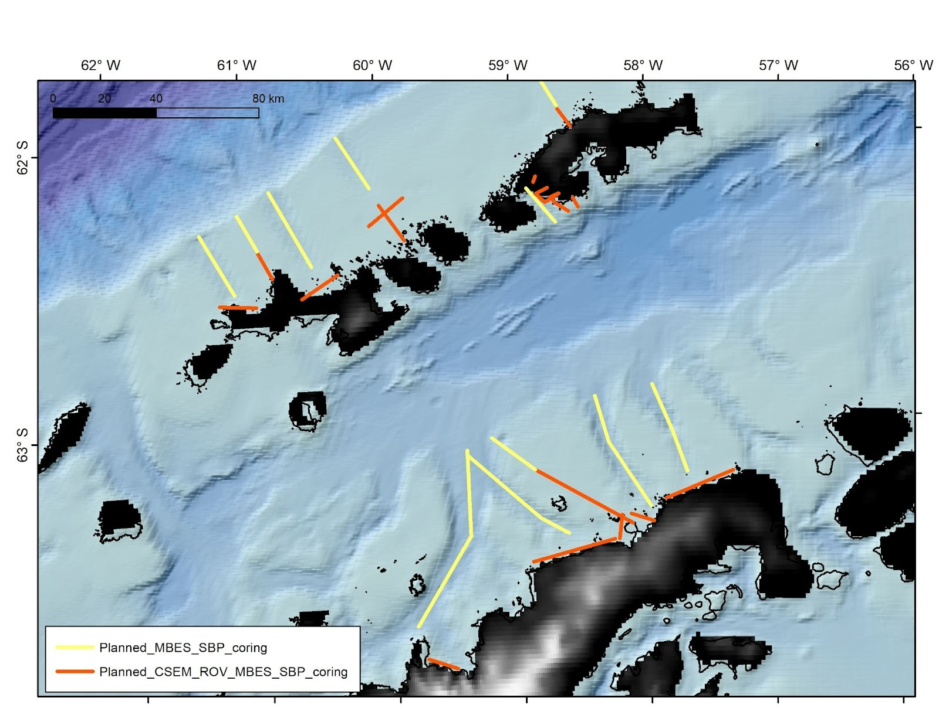Figure 1: The map shows potential transects. Only two orange transects and two yellow transects will be surveyed during the expedition.

