Dive 1:
Location: Deception Island, deployed from the Hesperides while anchored.
Latitude: -62 58.6015 Longitude: -60 37.8092
Max depth: 102.4m
Water sample: 3 liters taken at 93.1m
Summary: Rich benthic ecosystem, sponges, corals, ribbon worms
CTD:
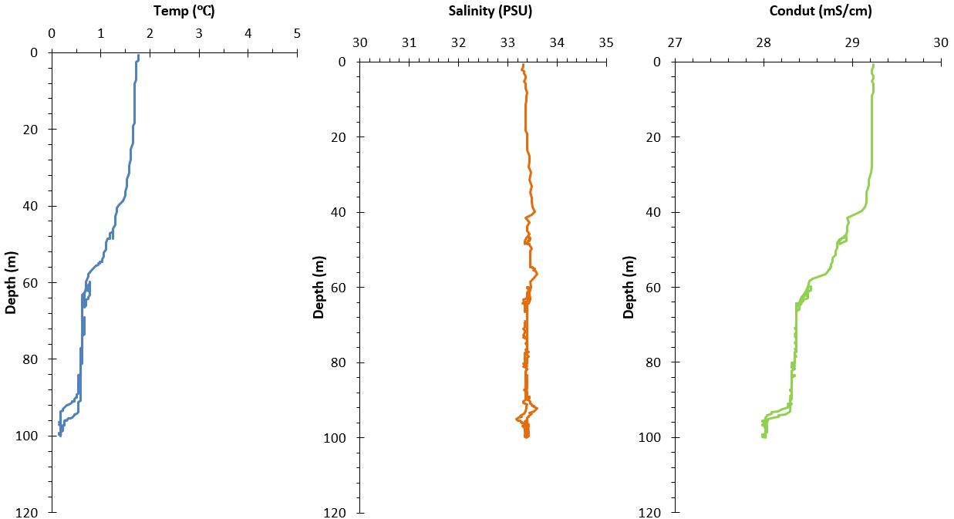
Hightlight Photos:

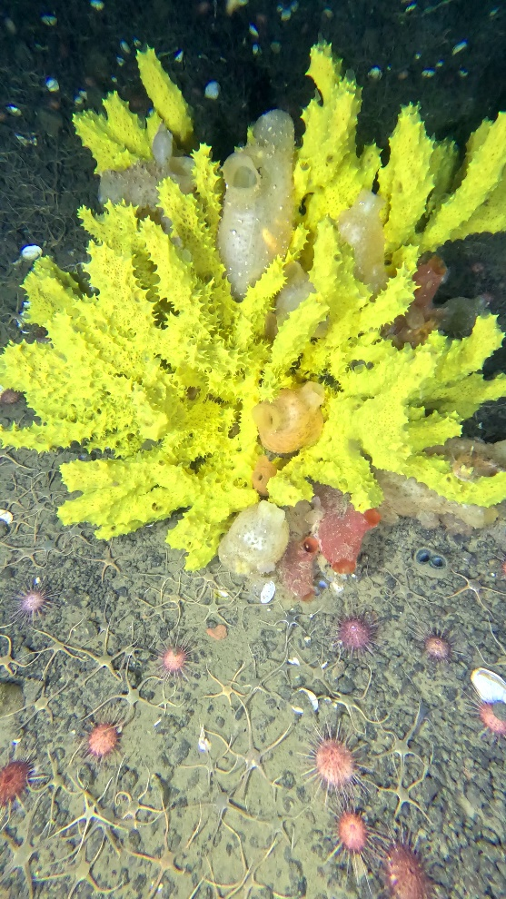
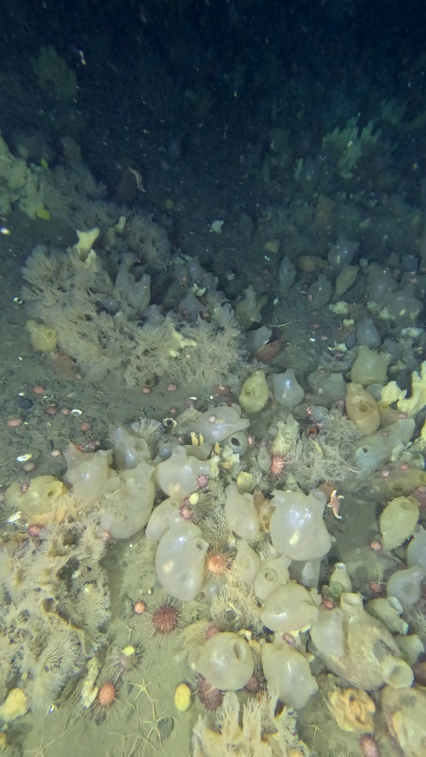

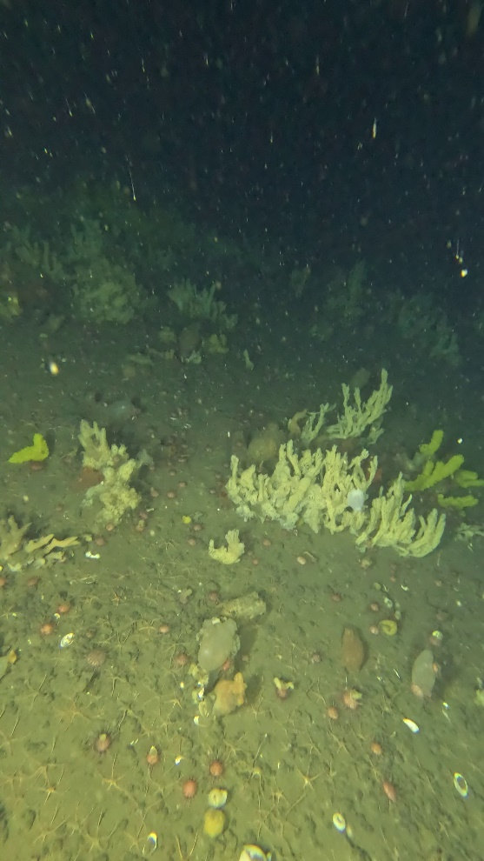
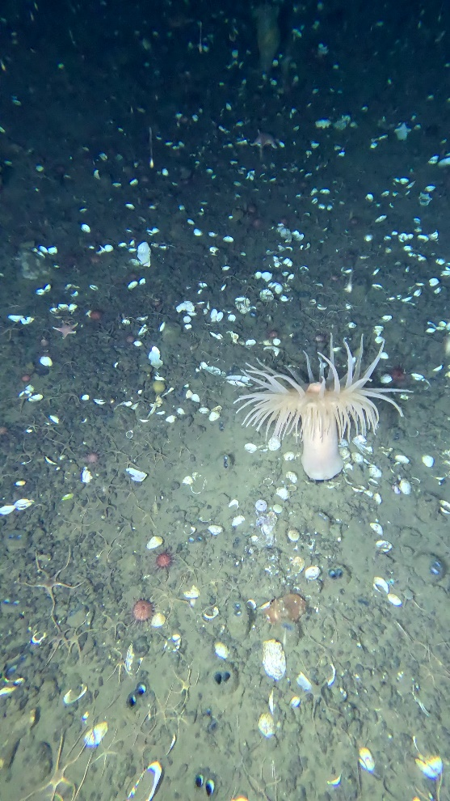

Dive 2:
Location: Right off King Sejong Station
Latitude: -62.2195066, Longitude: -58.7939250
Max depth: 84.5m
Water sample: 3 liters taken at -62.2m, next to a large barrel shaped sponge.
Summary: Rich marine life
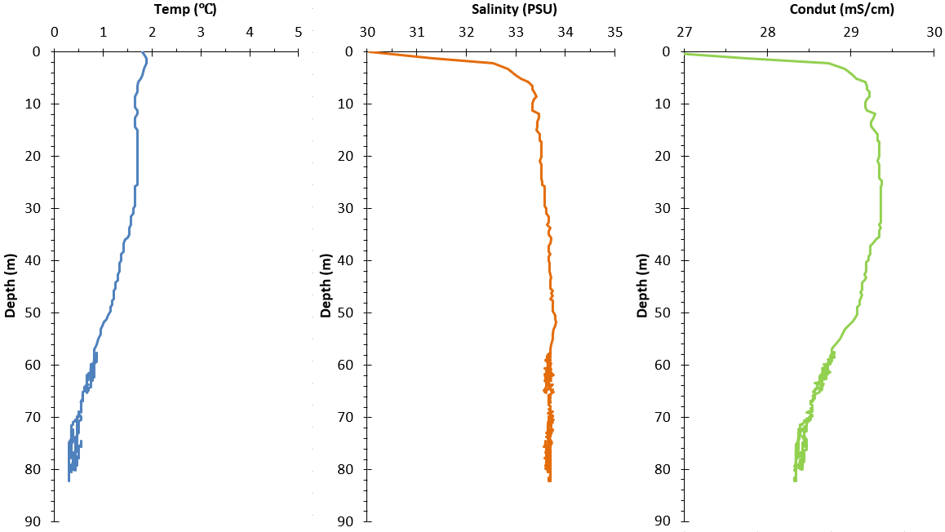

Highlight Photos:
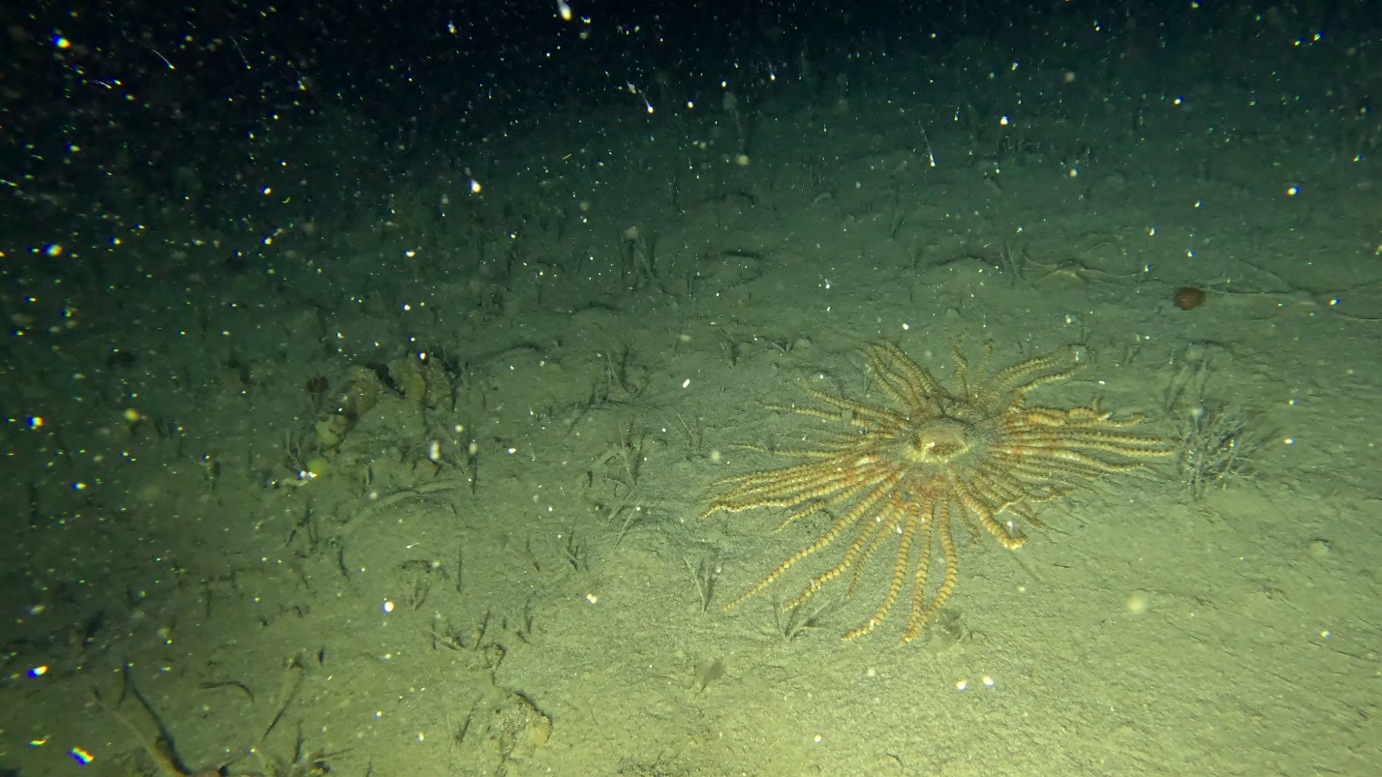
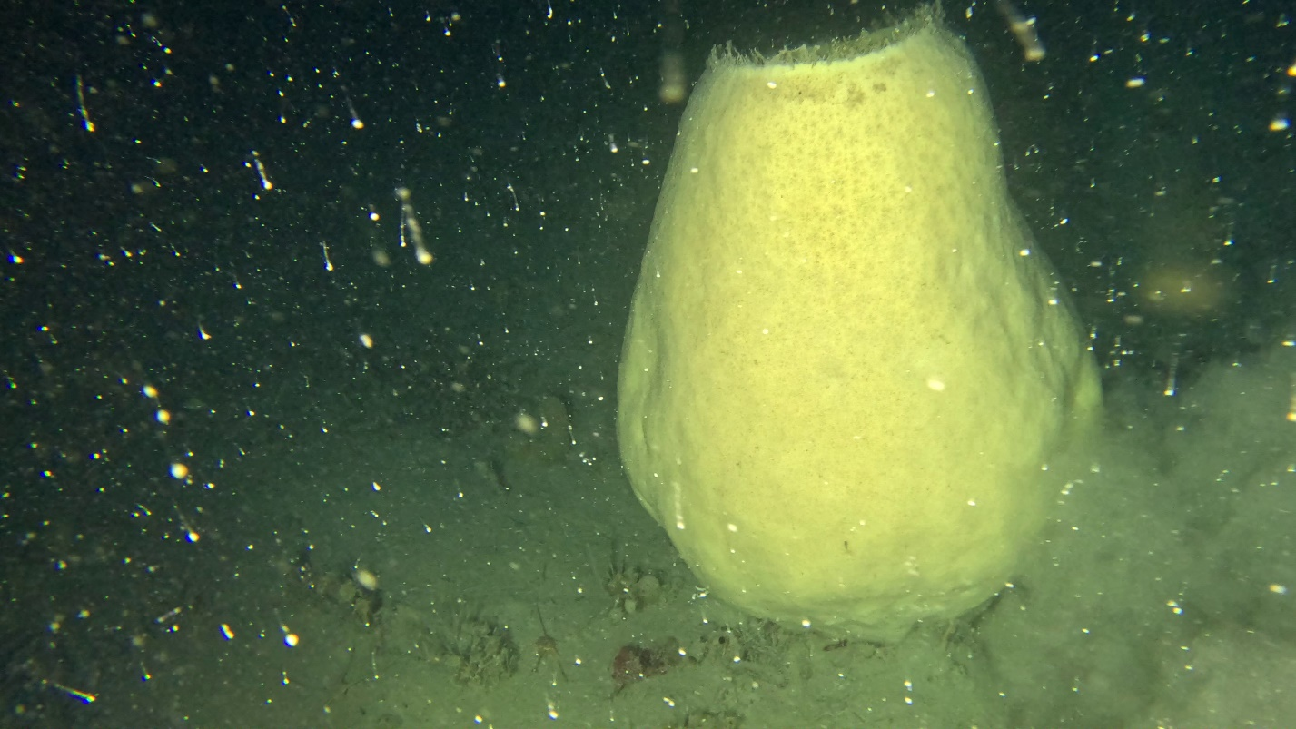
Figure 1. Labidaster Annulatus Antarctica
Figure 2. Giant Sponge
Dive 3:
Location: Approximately 1km North East of King Sejong Station
latitude: -62.2120183, Longitude: -58.7603556
Max depth: 121.2m
Water sample: 3 liters taken at 116.7m. There was a slight malfunction with the niskin bottle which resulted in some sediment getting in the sample.
Summary: Less marine life than the other surveys
CTD:
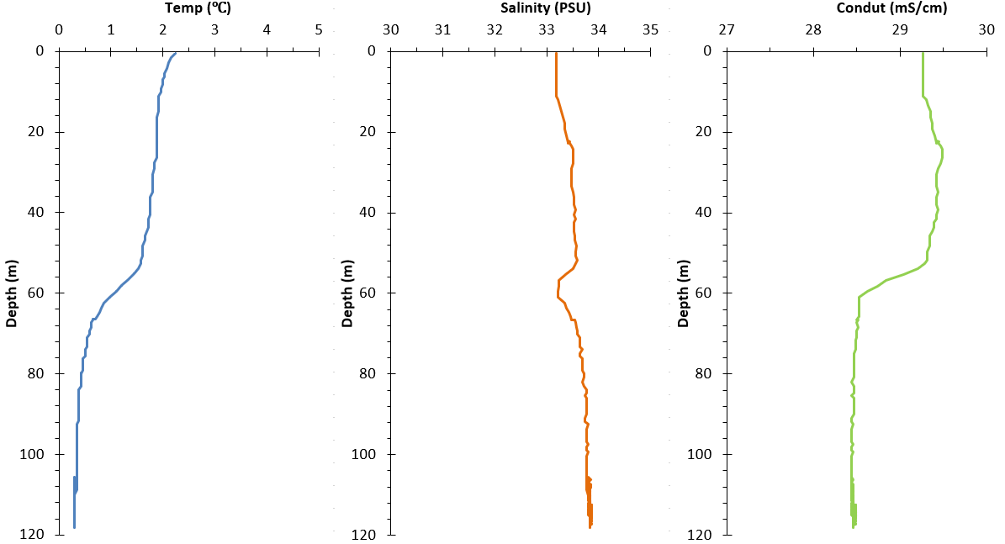

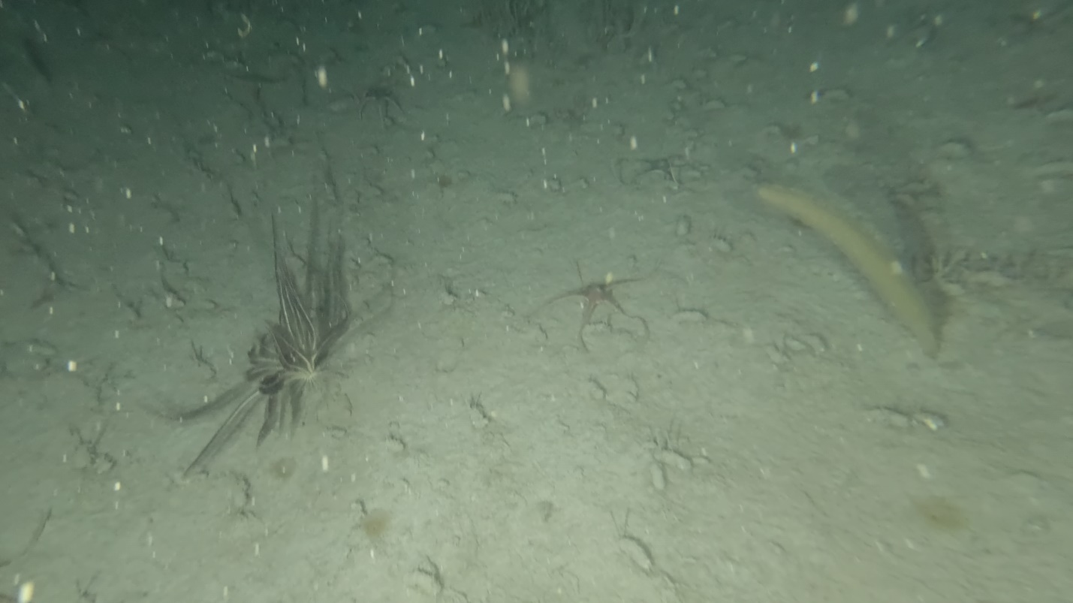
Highlight Photos:
Figure 3. Feather Star and XX?

