Construction of Site-Specific 1D Subsurface Models for CSEM Profiles in the Canadian Beaufort Sea
Objective:
This report outlines the methodology used to construct site-specific 1D electromagnetic response along three Controlled Source Electromagnetic (CSEM) survey profiles ARA05C Line 14, ARA05C Line 1, and ARA04C Line 1 ( see Figure 1), based on bathymetric data, field observations, and published literature.
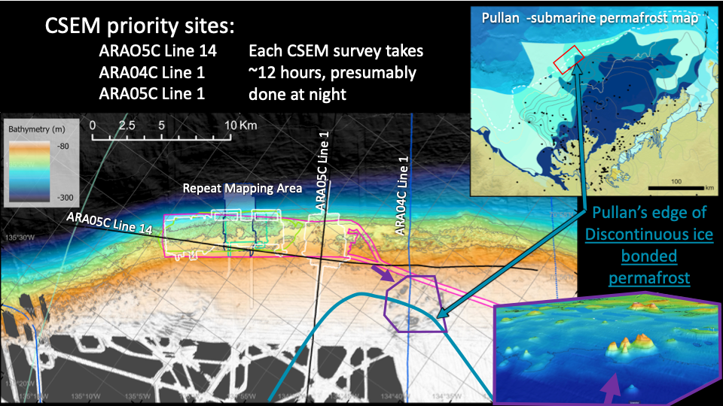
Figure 1. Map of CSEM priority survey lines overlaid on bathymetry and permafrost distribution in the Canadian Beaufort Sea. Profiles ARA05C Line 14, ARA05C Line 1, and ARA04C Line 1 are shown crossing the shelf edge and slope. The background map highlights areas of continuous and discontinuous ice-bonded permafrost based on Pullan et al. (1987), with the red box indicating the current survey area. The colour gradient reflects seafloor bathymetry, ranging from shallow (light yellow) to deep (blue/black). Massive ice exposures were previously observed along ARA05C Line 14 in water depths of ~160 m.

1. Data Sources and Rationale
The construction of the 1D models was guided by three primary sources:
- Bathymetric and positional data from .ste files provided by Charlie Paull, defining profile paths and seafloor depths.
- Field observations by Charlie Paull (2022–2024), including direct evidence of massive ice outcrops on the seafloor along ARA05C Line 14.
- Scientific literature:
  - Sherman et al. (2017): Surface towed electromagnetic system for mapping of subsea Arctic permafrost.
  - Riedel et al. (2015): Temperature measurements and thermal gradient estimates on the slope and shelf-edge region of the Beaufort Sea, Canada
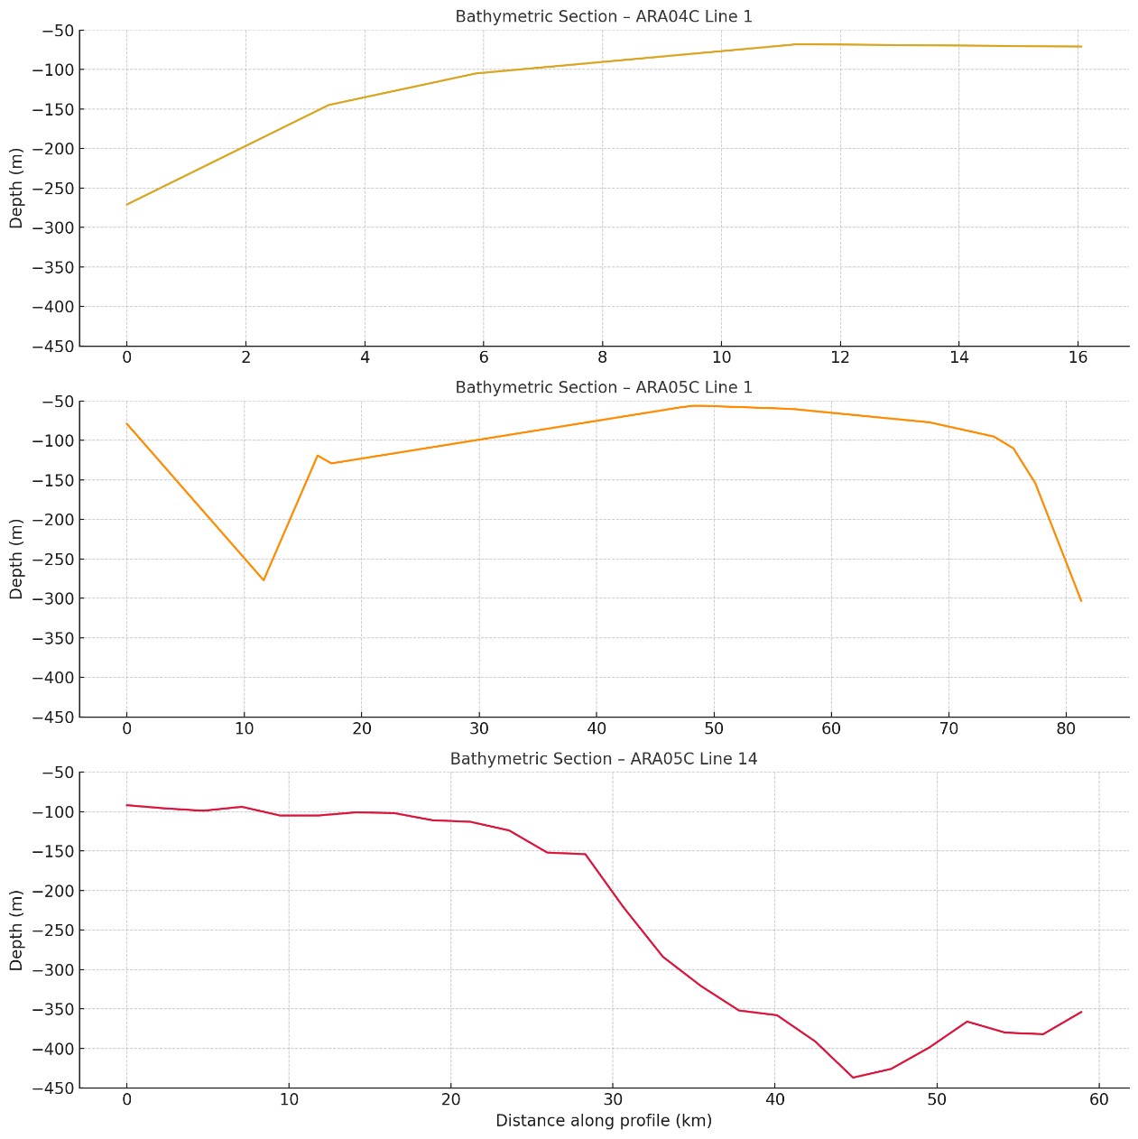
  - Paull et alp. (2024): Massive ice outcrops and thermokarst along the arctic shelf edge: by products of ongoing groundwater freezing and thawing in the sub‐surface
Figure 2. Bathymetric sections for the three CSEM survey lines: ARA04C Line 1 (top), ARA05C Line 1 (middle), and ARA05C Line 14 (bottom). The x-axis represents the distance along each profile in kilometers, and the y-axis shows seafloor depth in meters (inverted scale). These sections highlight the bathymetric variability from the shallow shelf (ARA04C) to deeper slope environments (ARA05C), which is essential for constructing geologically constrained 1D conductivity models.

2. Modelling Approach
Each model is built as a horizontally layered 1D structure. The key steps include:
- Segmenting each profile into zones with consistent bathymetric and geological conditions.
- Identifying expected subsurface structure (e.g., ice-bonded permafrost, melted permafrost, saline sediments) for each zone.
- Assigning electrical conductivity values to each layer based on empirical and literature-based values.
Conductivity Reference Values:
- Seawater: 3.3 S/m
- Saline saturated sediment: 0.3 – 0.5 S/m
- Ice-rich permafrost: 0.01-0.001 S/m
- Melted/degrading permafrost: 0.05 – 0.1 S/m
- Freshwater-saturated sands: 0.05 – 0.2 S/m

3. Site-Specific 1D Models
ARA04C Line 1
Model 04-A (0–5 km) (see Figure 3):
- Bathymetry: <100 m
- Layer 1: 0–80 m → Seawater
- Layer 2: 80–120 m (0.01 S/m) → Ice-rich permafrost
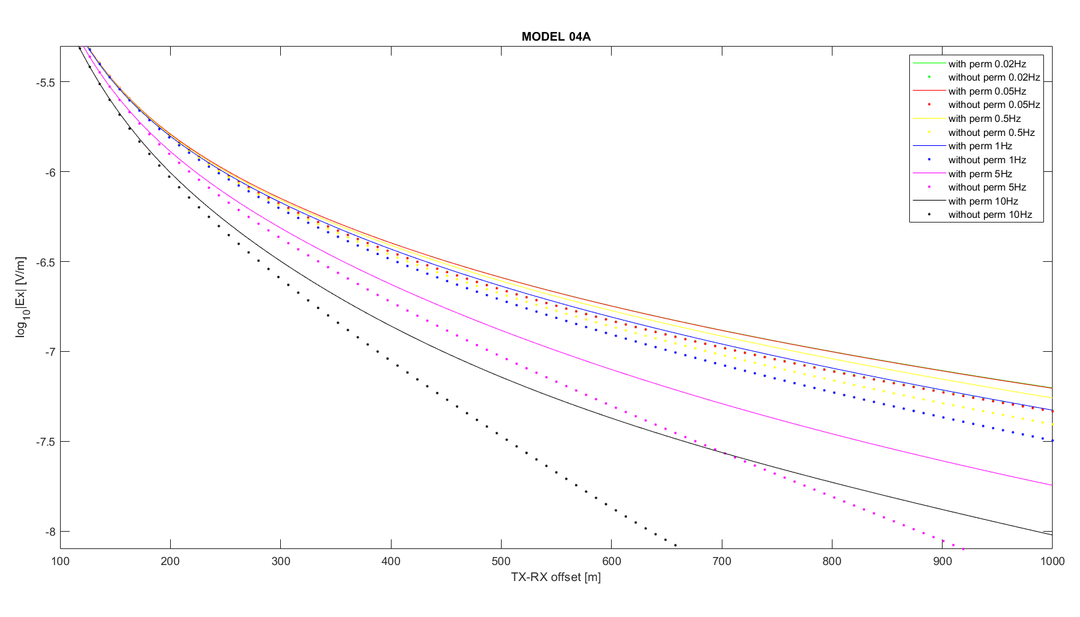
- Layer 3: >120 m (0.3 S/m) → Saline sediment
Figure 3. Modeled CSEM electric field responses (log₁₀|Ex| in V/m) for Model 04A as a function of transmitter–receiver offset (100–1000 m). Solid lines represent scenarios including ice-bonded permafrost; dotted lines represent the same models without permafrost. Each color indicates a different transmission frequency (0.02 Hz to 10 Hz). The presence of permafrost significantly increases the EM response amplitude, especially at larger offsets and higher frequencies (≥1 Hz), highlighting its detectability under shallow bathymetry and low-conductivity conditions.
Model 04-B (5–15 km) (see Figure 4):
- Bathymetry: 100–140 m
- Layer 1: 0–120 m → Seawater
- Layer 2: 120–145 m (0.05 S/m)→ Freshwater sands
- Layer 3: 145–180 m (0.1 S/m) → Melted permafrost
- Layer 4: >180 m (0.3 S/m) → Saline sediment
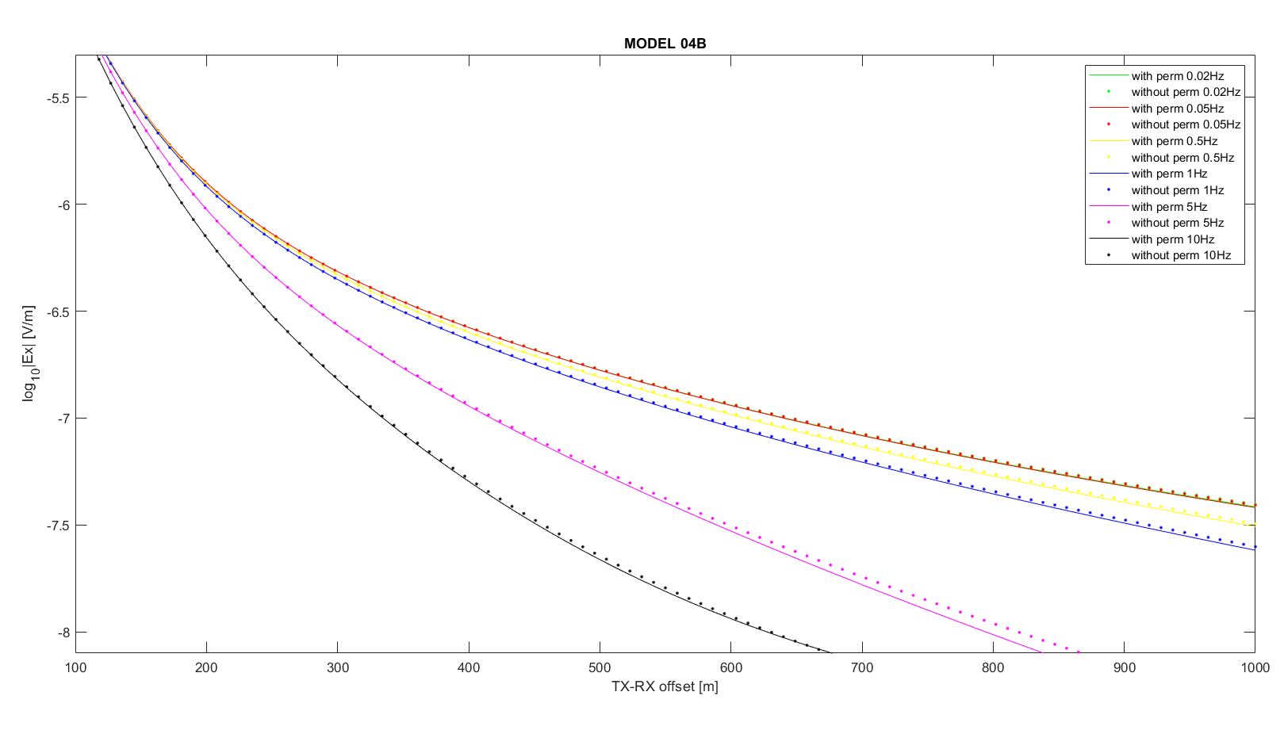Figure 4. CSEM forward modeling results for Model 04B, comparing electric field magnitudes (log₁₀|Ex| in V/m) at varying transmitter–receiver offsets (100–1000 m) across frequencies from 0.02 Hz to 10 Hz. Solid lines represent scenarios including partially degraded permafrost; dotted lines show equivalent models without permafrost. The differences in signal strength, especially at higher frequencies (≥1 Hz), reflect the modest influence of intermediate-conductivity permafrost layers buried beneath a saline sediment overburden.

Model 04-C (>15 km):
- Only seawater and conductive sediment (0.3–0.5 S/m)
ARA05C Line 1
Model 05-A (0–10 km) (see Figure 5):
- Bathymetry: 80–130 m
- Layer 1: 0–90 m → Seawater
- Layer 2: 90–130 m (0.01 S/m)→ Ice-rich permafrost
- Layer 3: >130 m (0.3 S/m)→ Sediment (0.3 S/m)
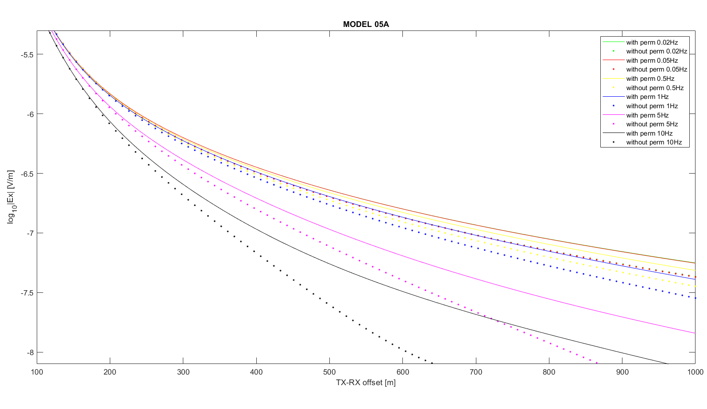Figure 5. CSEM electric field responses (log₁₀|Ex| in V/m) for Model 05A, shown as a function of transmitter–receiver offset (100–1000 m) and frequency (0.02–10 Hz). Solid lines represent simulations including a shallow ice-bonded permafrost layer; dotted lines represent equivalent models without permafrost. The inclusion of permafrost leads to consistently stronger electric field signals, particularly at higher frequencies (≥1 Hz), underscoring the model’s sensitivity to the presence of high-resistivity frozen layers near the seafloor.
Model 05-B (10–25 km) (see Figure 6):
- Bathymetry: 140–200 m
- Layer 1: 0–150 m → Seawater
- Layer 2: 150–180 m (0.05 S/m) → Freshwater sands
- Layer 3: 180–220 m (0.1 S/m)→ Degrading permafrost
- Layer 4: >220 m (0.3 S/m)→ Saline sediment
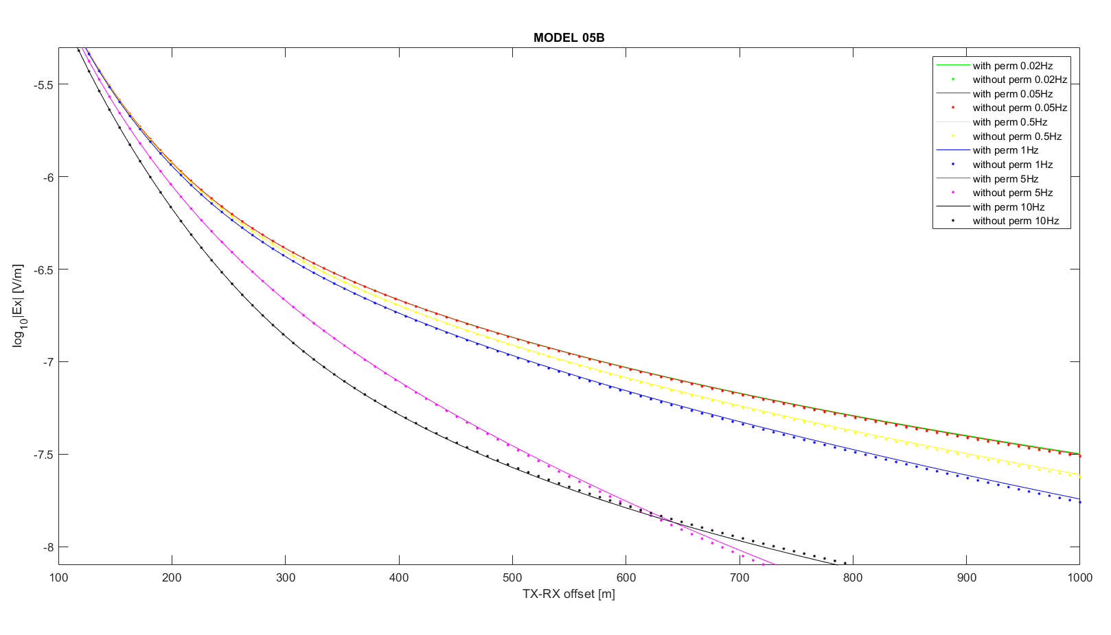Figure 6. Simulated CSEM electric field responses (log₁₀|Ex| in V/m) for Model 05B as a function of transmitter–receiver offset (100–1000 m) across frequencies from 0.02 Hz to 10 Hz. Solid lines represent scenarios including a buried, partially degraded permafrost layer; dotted lines show the corresponding models without permafrost. Little differences in field amplitude are showed at high frequencies and long offsets.
Model 05-C (>25 km):
- Bathymetry: >250 m
- Only seawater and conductive sediment
ARA05C Line 14
Model 14-A (0–10 km) (see Figure 7):
- Bathymetry: ~110 m
- Layer 1: 0–110 m (3.3 S/m)→ Seawater
- Layer 2: 110–150 m (0.001 S/m)→ Ice-rich permafrost
- Layer 3: 150–200 m (0.3 S/m)→ Saline sediment
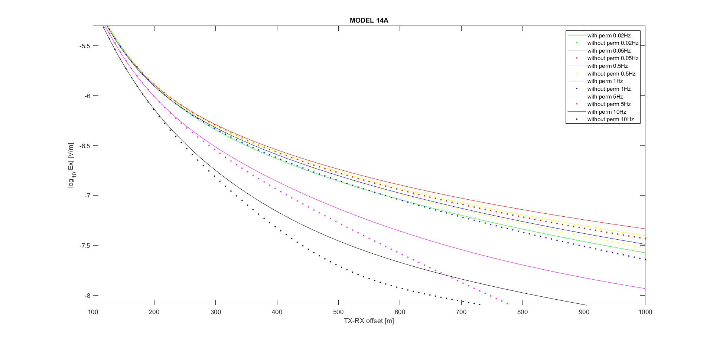Figure 7. CSEM modelling results for Model 14A showing electric field responses (log₁₀|Ex| in V/m) as a function of transmitter–receiver offset (100–1000 m) for multiple frequencies (0.02–10 Hz). Solid lines represent models including an ice-bonded permafrost layer beneath shallow water; dotted lines represent the same structure without permafrost. The differences in response is notably stronger with permafrost at higher frequencies and longer offsets, indicating excellent detectability under these nearshore, low-bathymetry conditions.
Model 14-B (10–30 km) (see Figure 8):
- Bathymetry: 130–180 m
- Layer 1: 0–160 m → Seawater
- Layer 2: 160–185 m (0.05 S/m) → Freshwater sands
- Layer 3: 185–230 m (0.1 S/m) → Melted permafrost
- Layer 4: >230 m (0.3S/m) → Saline sediment
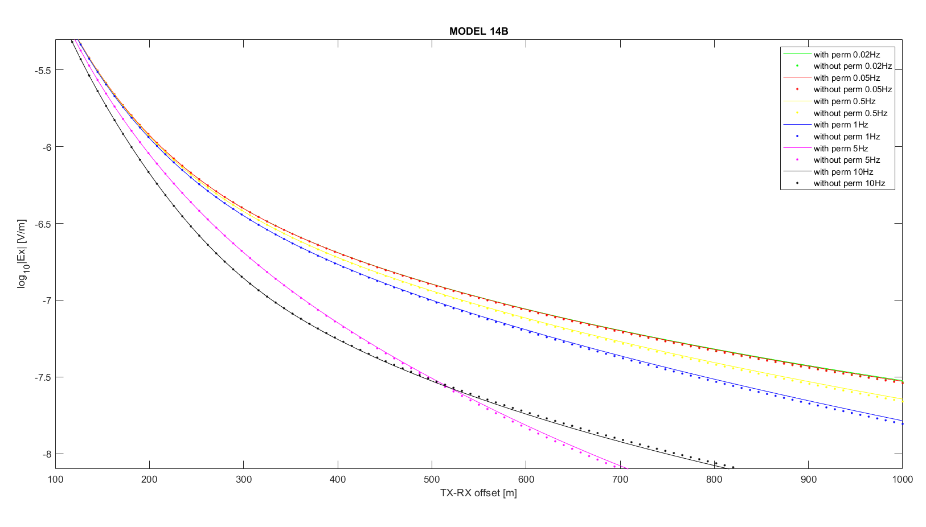Figure 8. CSEM electric field responses (log₁₀|Ex| in V/m) for Model 14B, plotted as a function of transmitter–receiver offset (100–1000 m) for multiple transmission frequencies (0.02–10 Hz). Solid lines represent simulations that include a buried, partially thawed permafrost layer; dotted lines represent models without permafrost. The presence of transitional permafrost causes moderate signal enhancement at mid-to-high frequencies, particularly at intermediate offsets, indicating its detectability even when not directly beneath the seafloor
Model 14-C (>30 km):
- Bathymetry: >300 m
- Layer 1: 0–320 m → Seawater
- Layer 2: >320 m (0.3S/m) → Saline sediment

CSEM Field Setup and Source Configuration for Arctic Survey – Technical Summary
Based on forward modelling tests, final source configuration and acquisition settings for upcoming marine CSEM surveys along profiles in the Canadian Beaufort Sea are summarised here. The aim is to optimize signal sensitivity for shallow permafrost detection (depth <150–200 m) using a frequency-domain approach.
1. Transmission Mode: Full-Duty Sinusoidal at 5 Hz
- Signal type: Full-duty, sinusoidal waveform
- Frequency: 5 Hz (fixed)
- Current amplitude: 25 A
- Transmission continuity: Continuous (no pause)
This choice ensures:
- Maximum signal strength for EM field detection
- Stability of waveform (no fast current switching required)
- Compatibility with frequency-domain 1D modelling performed
- Potential to exploit harmonics generated by slight waveform imperfections
2. TriggerBox Configuration
c f 1 # Set to full-duty mode
c l 200 # Frequency 5 Hz (period = 200 ms)
c d 0 # Continuous transmission
c p 0 # No pause between transmissions
c w 0 # Immediate start
c s # Save settings
s # Start transmission

3. Navigation Speed
- Recommended vessel speed: 1.0 knots (0.5 m/s)
This speed ensures:
- ~10 cm spatial resolution per 5 Hz cycle
- Sufficient lateral sampling relative to the 300–600 m offset range
- Stable source-receiver geometry without excessive cable motion
4. Receiver Setup: Self-Potential Loggers
- Sampling Frequency: 10 kHz
- Offset range: 300–600 m (2 Rx deployed + 1 Rx on board)
5. Gain Calibration and Testing Procedure
To prevent signal clipping and ensure optimal resolution before field acquisition:
- Initial Gain Setting: Begin with Gain = 0 (±4.096 V input range) on all channels to prevent saturation under unknown signal levels.
- Monitor Raw Signal: After the first few minutes of transmission, inspect raw voltage levels (e.g., .ef1, .ef2, .ef3 files).
- Adjust Gain if Needed:
  - If the maximum observed signal is below ~100 mV, lower the gain (e.g., Gain = 21 or 42) to improve resolution.
  - Avoid gain settings that limit the input range below ±20 mV unless signal levels are confirmed stable and low.
- Dynamic Range Buffer: Maintain a 20–30% margin below full-scale to accommodate unexpected peaks.

Justification for Configuration
- 5 Hz full-duty transmission yields clear field amplitude separation between frozen and unfrozen sediment models in the top 150–200 m.
- Half-duty or transient-mode sources introduce timing and synchronization complexities not justified by marginal gain in sensitivity.
- Continuous sinusoidal signal maximizes SNR and matches the assumptions in our forward modeling.

