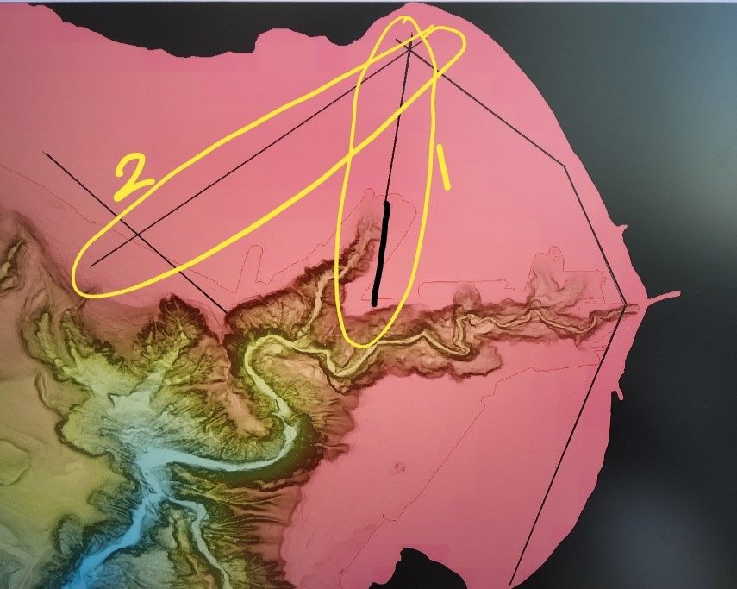
Transect 1 (9.5 nautical miles):
N/E Latitude: 36.962084°
N/E Longitude-121.937092°
S/W Latitude: 36.804267°
S/W Longitude: -121.962061°

Transect 2 (12.7 nautical miles):
N/E Latitude: 36.961052°
N/E Longitude: -121.929009°
S/W Latitude: 36.827343°
S/W Longitude: -122.133825°

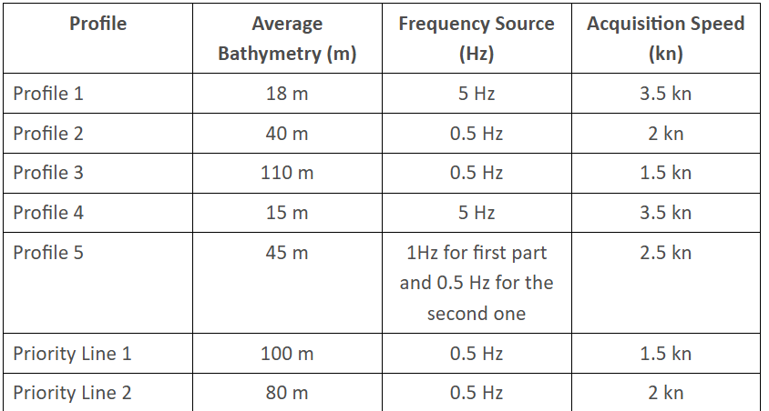
Gains of dataloggers = 000110, 36
Ch 0 = 0
Ch 1 = 1
Ch 2 = 2

