SWAN numerical modelling and sensitivity analysis for Arctic region
There exists an analytic solution for the electromagnetic field (𝐄, 𝐁) caused by time-harmonic oscillations of the form exp(𝑖𝜔𝑡) in the current passed through a horizontal electric dipole (HED) transmitter that is towed on the surface of the sea above a plane-layered Earth. The analytic solution computer program has been written in the fortran language to simulate the electromagnetic response of the Earth caused by the HED excitation. A simple geo-electrical model of a sub-seafloor permafrost, as coded into the computer program, is shown in Figure 1, below.
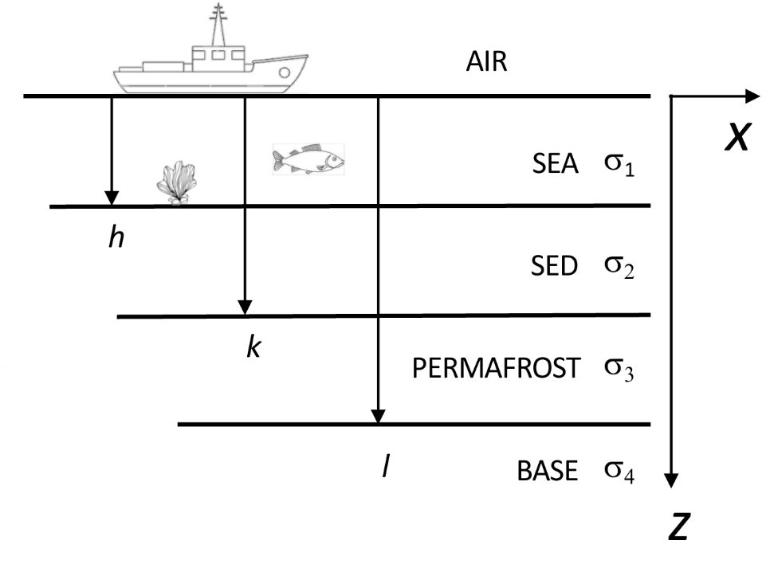
Figure 1. Geo-electrical model of a relict permafrost.
We have computed the electromagnetic reponse for a number of modeling scenarios and these are illustrated below. There are several fixed model parameters that remain constant for all simulations. The TX dipole moment 𝑃 is 200 Am. The quantities modeled are the in-line responses |𝐸x| and |𝐸z| as a function of TX-RX offset 𝜌, where 150 m < 𝜌 < 1 km. The TX is located on the sea surface whereas the RX is located at depth 2.0 m below the sea surface. The seawater (SEA) conductivity 𝜎₁ is 3.2 S/m. The basal-layer (BASE) conductivity 𝜎₂ is 0.7 S/m. The AIR conductivity 𝜎₀ is 5*10⁻⁶ S/m, which is effectively close to zero. Two different model parameters are shown in Table 1.
Table 1. Variable geo-electrical model parameters
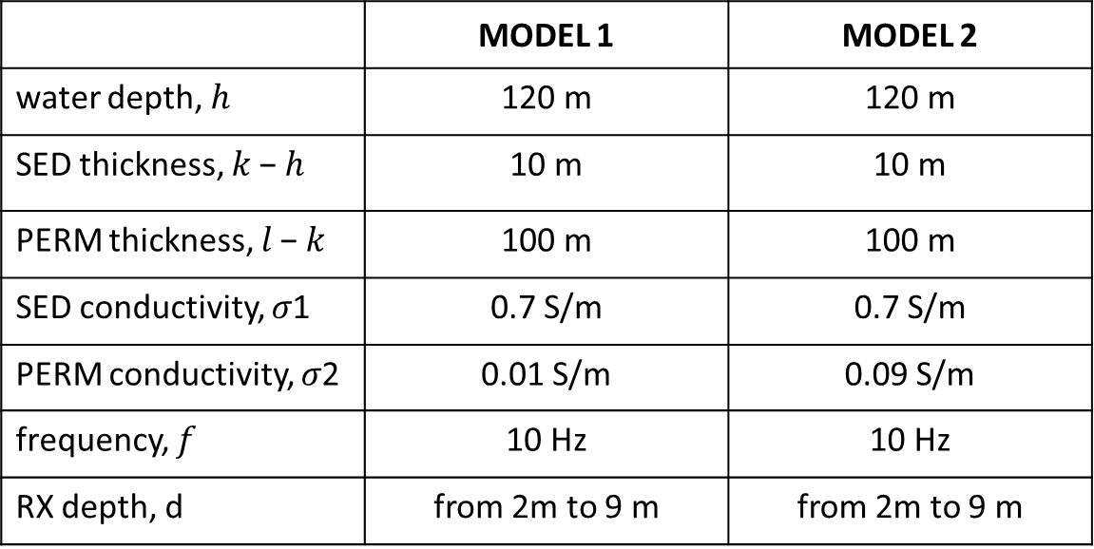
Modelling results
In Figure 2 we consider both the |𝐸x| and |𝐸z| responses of the model 1 with 2 m RX depth. These parameters are also indicated on the figure. The TX is located on the left edge of the figure at the AIR/SEA interface. The TX-RX offset (range) is shown on the 𝑥-axis and depth is given on the 𝑧-axis. Shown is the base-10 logarithm of the Ex response (Figure 2 a), given in V/m. The largest values are close to the TX and the smallest ones are in the permafrost layer at large range. The presence of the geo-electrical layers, including the permafrost, evidently distort the Ex contour lines. The effect of this distortion at the RX location just beneath the sea surface is quantified below.
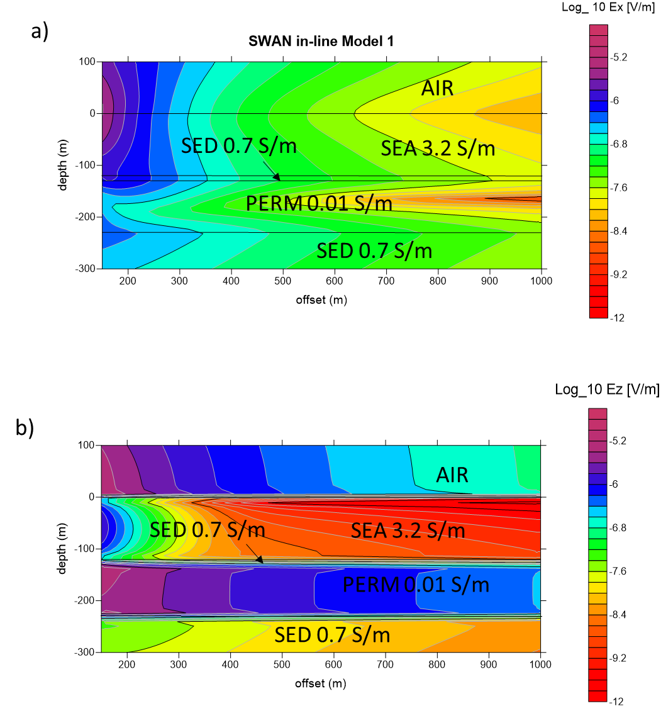
Figure 2. In-line Ex and Ez responses of the Model 1.

The Ez response (Figure 2b) is dramatically affected by the presence of the seawater and permafrost layers. In particular the response is greatly reduced in the conductive seawater and somewhat enhanced in the permafrost, the latter being more resistive (0.01 S/m) than the enclosing SED and BASE layers (0.7 S/m).
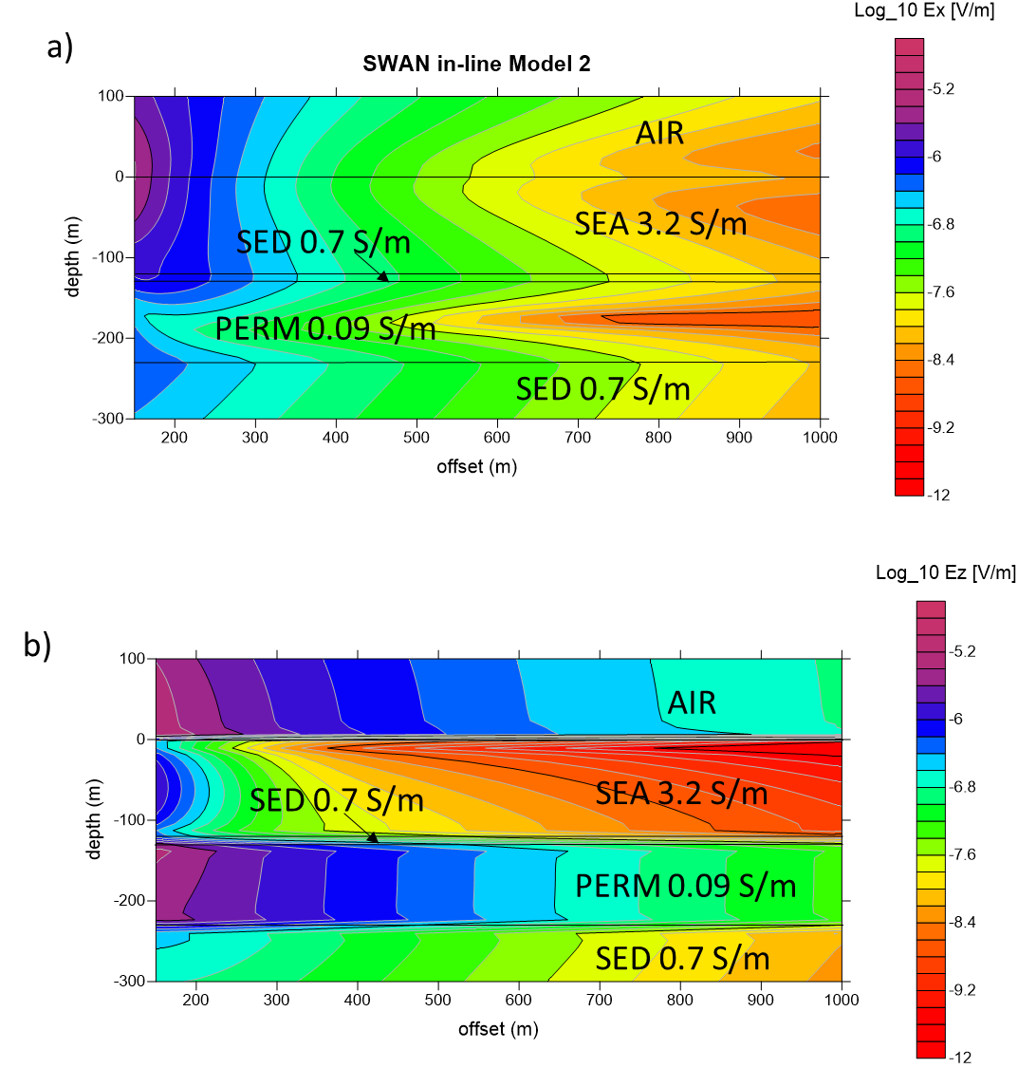
Figure 3. In-line Ez response of the canonical model.
In Figure 3 the |𝐸x| and |𝐸z| responses for the model 2 are visualized, always considering 2 m RX depth. The contour-lines in model 2 show the same behaviours of model 1. In detail, both Ex and Ez responses presents higher values in permafrost layer than in the model 1, due to decreasing of permafrost resistivity.
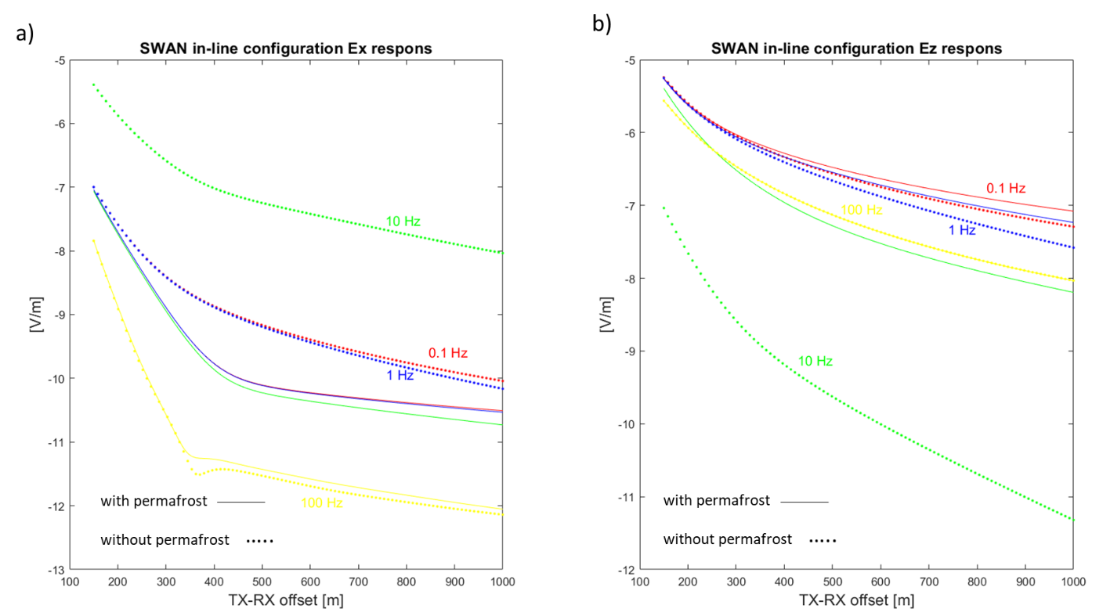
Figure 4. a) Ex and b) Ez responses of the Model 1, with and without the permafrost computed using different source frequencies.
The effect of the sub-seafloor permafrost layer on the Ex and Ez responses for Model 1 is isolated in Figure 4 a-b. The responses are computed for the Model 1 at the RX depth of 2 m below the sea surface considering different source frequencies (0.1-1-10-100 Hz). The model without the permafrost is defined by the PERM conductivity 𝜎₂=0.7 S/m, i.e., it is equal to that of the SED/BASE background layers.
Observing Figure 4 we can note that:
1. The Ez component shows a magnitude higher than Ex for all analysed frequency sources, both for the model with permafrost and the model without permafrost.
2. For a frequency source of 0.1 Hz, the model with permafrost exhibits higher values for both Ex and Ez components.
3. Using a frequency source of 10 Hz, the model without permafrost presents higher values of Ex, while the higher values of Ez components are observed for a frequency source of 0.1 Hz.
4. Both electric field components show the most significant differences between the model with permafrost and the model without permafrost for a frequency source of 10 Hz. This significant difference is observed for all distances between the transmitter and receivers taken into account.
5. In detail, the Ex responses obtained using a frequency source of 10 Hz are higher for the model without permafrost than the model with permafrost. Conversely, in Ez responses, an opposite behaviour is observed.
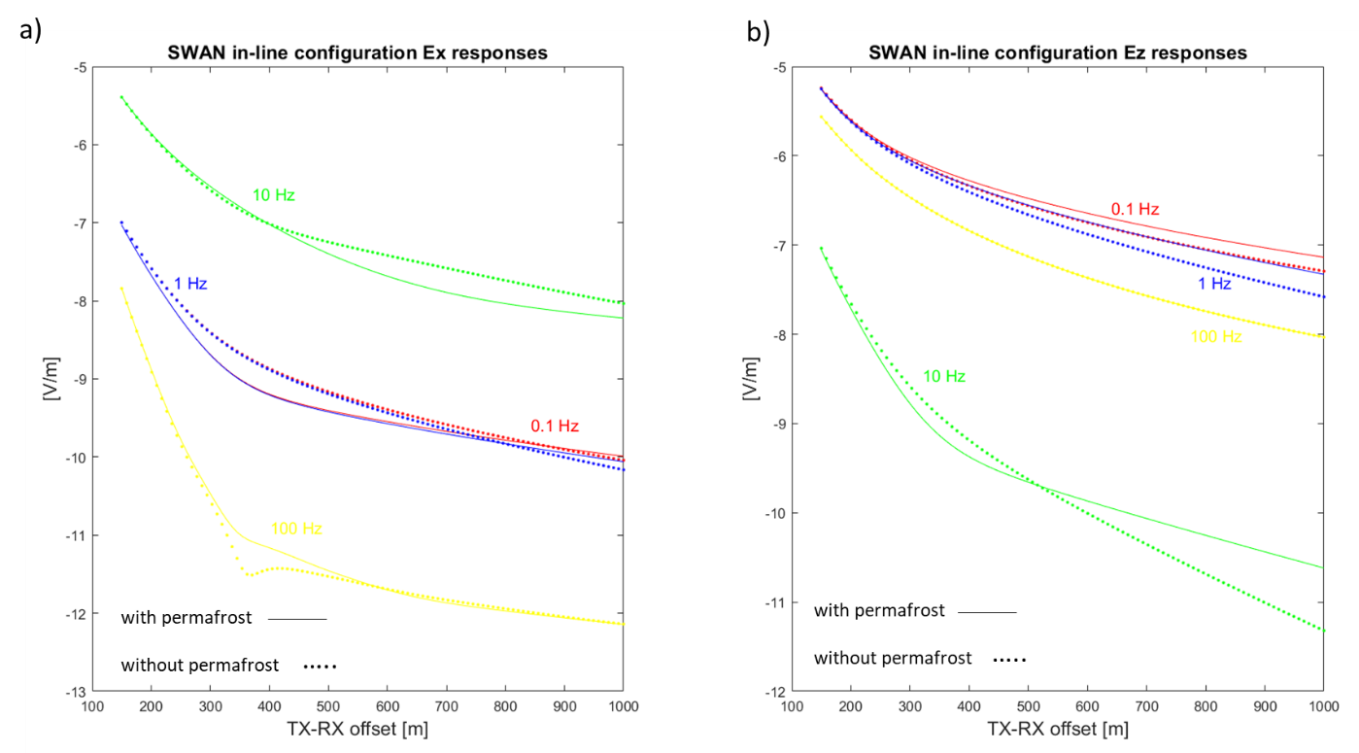
Figure 5. a) Ex and b) Ez responses of the Model 2, with and without the permafrost computed using different source frequencies.
Figure 5 displays the Ex and Ez responses for Model 2. Once again, the responses are computed for the Model 2 at the RX depth of 2 m below the sea surface considering different source frequencies (0.1-1-10-100 Hz). The model without the permafrost is defined by the PERM conductivity 𝜎₂=0.7 S/m, i.e., it is equal to that of the SED/BASE background layers.
Observe detailly Figure 5 we can note that:
1. The Ez component shows a higher magnitude than Ex for almost all analysed frequency sources, both for the model with permafrost and the model without permafrost, except for a frequency of 10 Hz.
2. For both the model with permafrost and the model without permafrost, the higher values of Ex are recorded for a frequency source of 10 Hz, while the higher magnitudes of the Ez component are exhibited for 0.1 Hz.
3. The Ex responses show the most significant differences between the model with permafrost and the model without permafrost for a frequency source of 0.1 Hz when small offsets are considered (up to 500 m). On the other side, the maximum differences between the two models, observed at large offsets for Ex components, are recorded using a frequency source of 10 Hz (starting from 400 Hz). In both cases, the model without permafrost shows a higher magnitude than the model with permafrost.
4. The Ez responses show the most significant differences between the model with permafrost and the model without permafrost for a frequency source of 10 Hz. In detail, for small offsets (up to about 500 m), the model without permafrost has higher magnitudes than the model with permafrost. When the offsets are increased, however, the model without permafrost presents lower values of Ez response than the model with permafrost. In detail, while model 1 characterized by a permafrost layer with a low resistivity value show a Ex response lower than the model without permafrost layer for
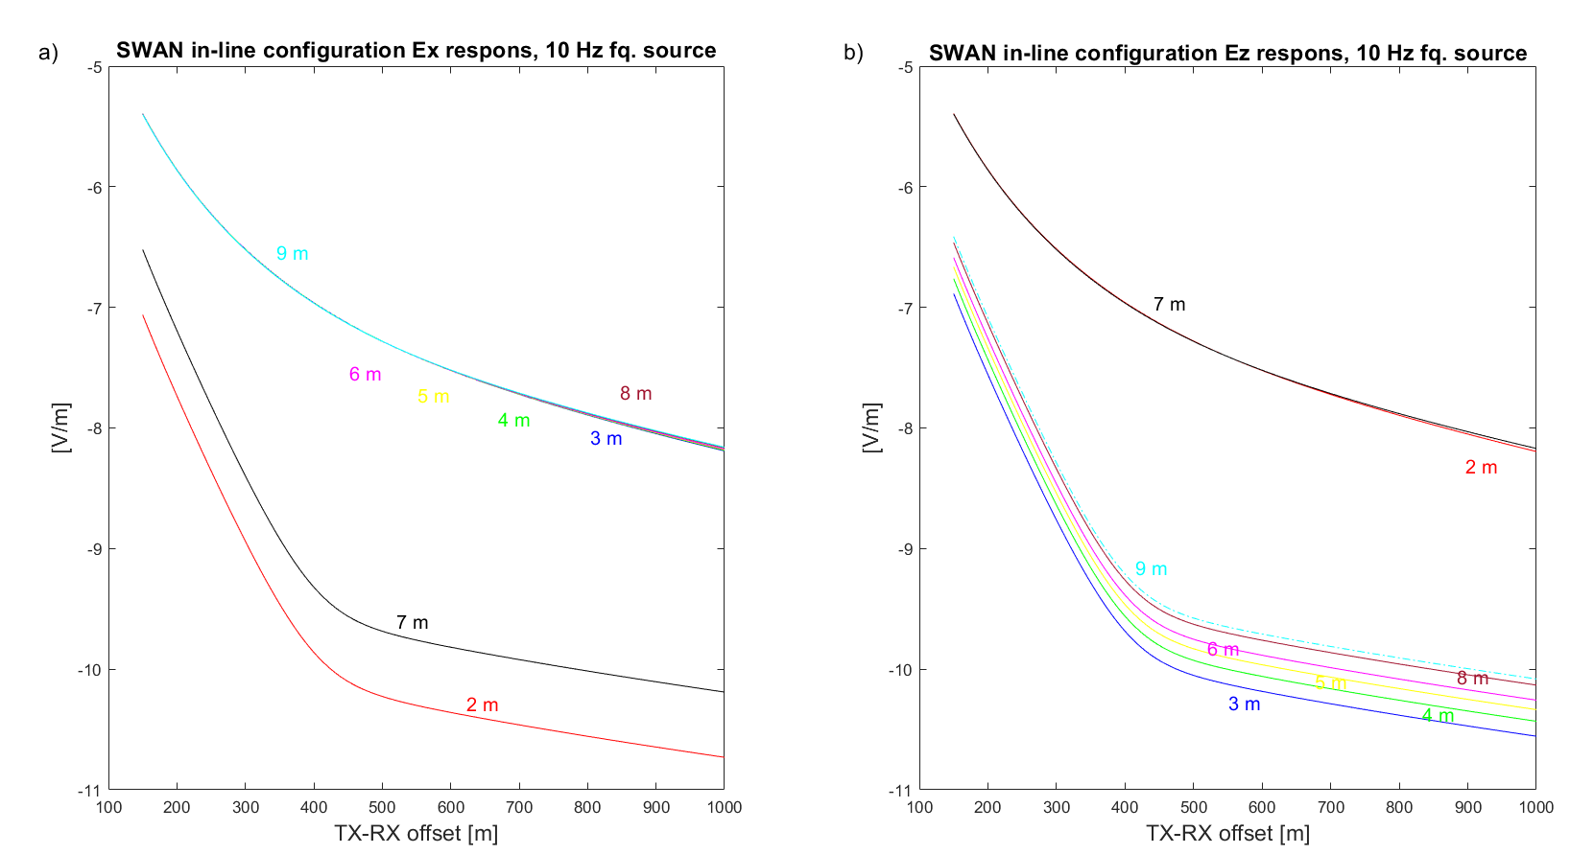
Figure 6. a) Ex and b) Ez responses of the Model 1 computed considering different receivers’ depths.
The effect of different receivers’ depths on the Ex and Ez responses for Model 1 is isolated in Figure 6 a-b. The responses are computed for the Model 1 at the RX depths of 2-3-4-5-6-7 m below the sea surface considering a source frequency of 10 Hz.
Observing Figure 6 we can note that:
1. The Ex responses present very close values in terms of magnitude for different RX depths. However, a different behaviour is observed for RX depths of 7 and 2 m b.s.s., which lead to a strong decrease in Ex magnitude.
2. For Ez component, the increase in RX depth led to an increase in Ez magnitude, except for RX depths of 2 and 7 m, which resulted in the highest magnitudes of the Ez response.
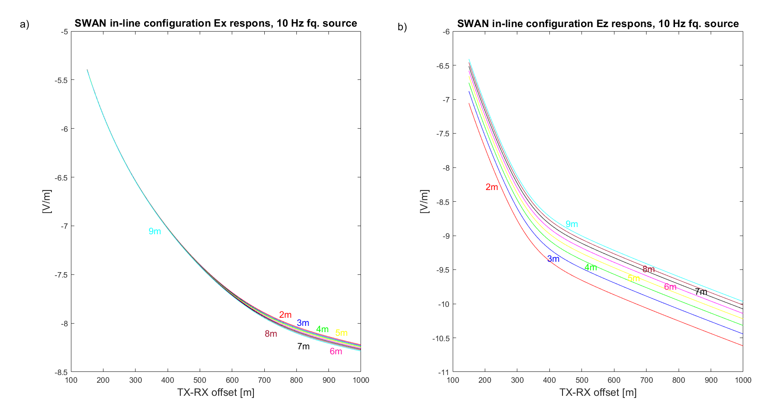 Figure 7. a) Ex and b) Ez responses of the Model 2 computed considering different receivers’ depths.
The effect of different receivers’ depths on the Ex and Ez responses for Model 2 is isolated in Figure 7 a-b. The responses are computed for the Model 2 at the RX depths of 2-3-4-5-6-7 m below the sea surface considering a source frequency of 10 Hz.
Observing Figure 7 we can note that:
1. The Ex component of the electric field doesn't appear to be particularly influenced by RX depth;
2. The Ez responses are affected by RX depth, showing an increase in amplitude with an increase in water depth. This behaviour seems more evident for large offsets.
Conclusions
The first important evidence that emerges from the analysis of the two different models (Model1 and Model2) is the close similarity in Ex and Ez responses. Both models also exhibit the most significant differences, in terms of Ex and Ez responses, when compared to their respective models without a permafrost layer, particularly at a frequency source of 10 Hz. Therefore, this frequency appears to be the most suitable for detecting the presence of a permafrost layer. At this frequency, both models show lower magnitudes of Ex responses compared to the model without a permafrost layer, especially for large offsets.
Furthermore, upon analysing the behaviour of both models with varying RX depth, we observed that a permafrost layer characterized by a lower resistivity value (Model1) is more affected in the Ex component compared to a permafrost layer with higher resistivity (Model2). This effect of RX depth on the Ex response of Model1 led us to consider an RX depth ranging between 4-5 m b.s.s. as the optimal depth for the receivers, as it increases the magnitude of Ex and helps minimize errors related to depth uncertainty.

