CSEM Deployment Procedure for R.V. Fulmar

Background:
SWAN is a surface-towed CSEM system (Figure 1), which has been developed by the University of Malta, GEOMAR and Texas A&M, to detect fluids within the upper 200 m of the seafloor in water depths of up to about 100 m. The SWAN CSEM system was developed utilizing commercially available components, namely the ZTEM-30 transmitter from Zonge International and SelfPot Loggers from Magson GmbH. The system has been configured as a surface-towed, dipole-dipole system. It consists of a 100 m-long horizontal electrical transmitter antenna and an array of up to four 25 m-long autonomous receiver units, each carrying a 10 m-long horizontal electrical dipole. Each receiver is separated by approximately 125-250 m of line, resulting in a total system length of 500-1000 m. The receiver units and control unit are battery-powered and have a lifespan of over 72 h. The source signal is generated by a current transmitter onboard the research vessel. A control unit records the transmitted currents and voltages. The transmitter and receiver geometries are continuously determined using GPS tracking on multiple buoys located at each transmitter electrode, above each receiver, and at the tail of the streamer. To mitigate potential damage from ship traffic, the depth of the streamer can be adjusted prior to deployment between 2 and 10 m below sea surface. The different segments comprising the system, from receivers to placement buoys, are connected to the tow-rope through soft shackles applied at each joint, making the system modular with few metallic components. Data acquisition can take place at speeds of up to 2.5 knots.

More information on the system is available here:

Pastoressa, A.E., Haroon, A., Everett, M.E., Rohde, L., Bartels, T., Wollatz-Vogt, M., Faghih, Z., Franz, G.K., Micallef, A., 2023. SWAN: A surface-towed modular controlled-source electromagnetic system for mapping submarine groundwater discharge and offshore groundwater resources. The Leading Edge 42, 590-597.

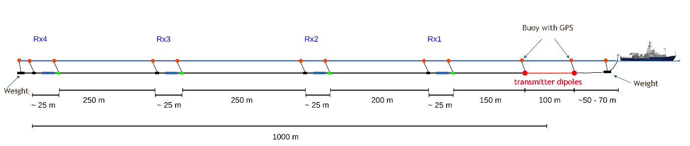
Figure 1. SWAN CSEM prototype. (Note we will only deploy Rx1 and Rx2 – lengths are incorrect).

System Components:


Figure 2. AGO DBW-6 winch. (Blue winch)

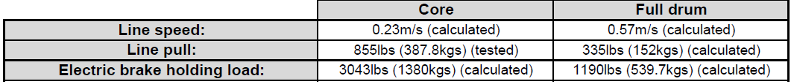Figure 3. AGO DBW-6 Winch Specs (Blue winch)
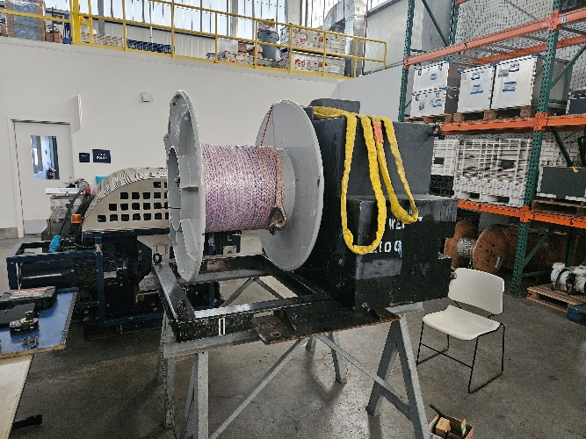
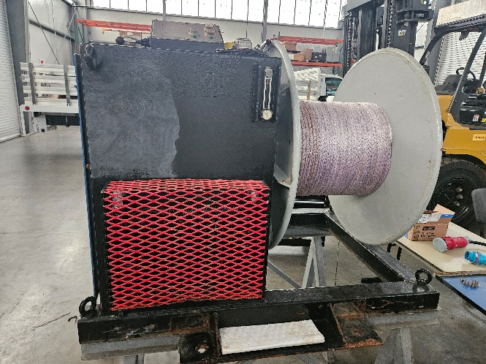
Figure 4. Black Winch

Black Winch Specs:
- 1500lb line pull
- 1.22 m/s at core
- 8.6kW at full load
- brake rating 2600 lbs
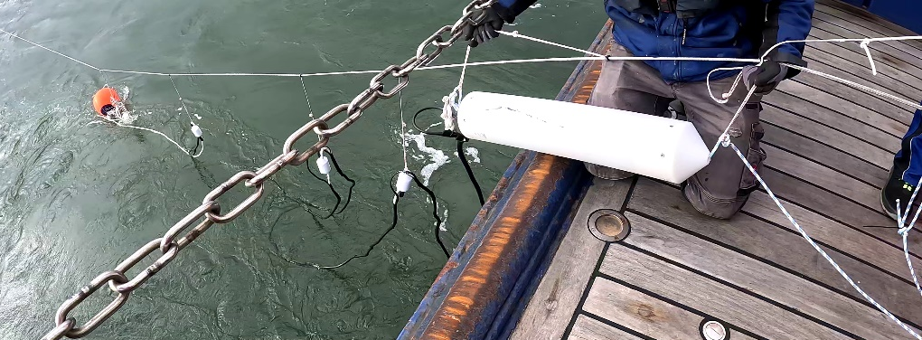

Figure 5. Datalogger and Receiver Instruments (All soft shackled onto main line)

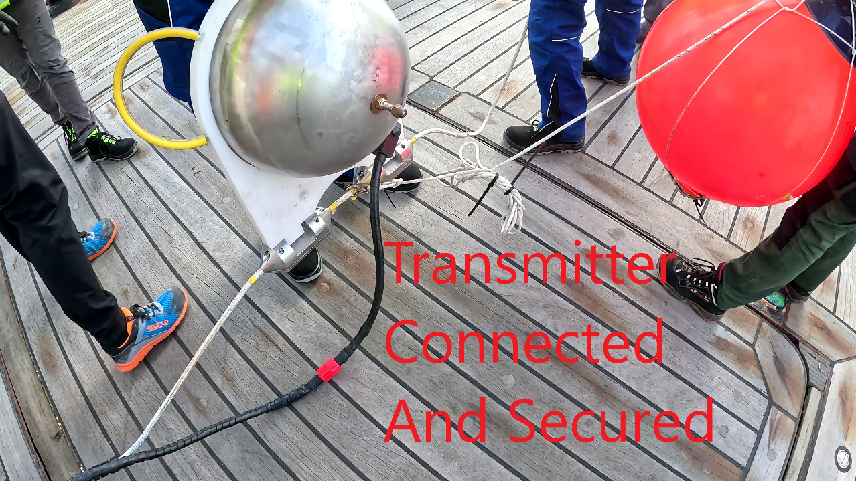

Figure 6. Transmitter (Large stainless sphere), Rope Clamps, Surface Float
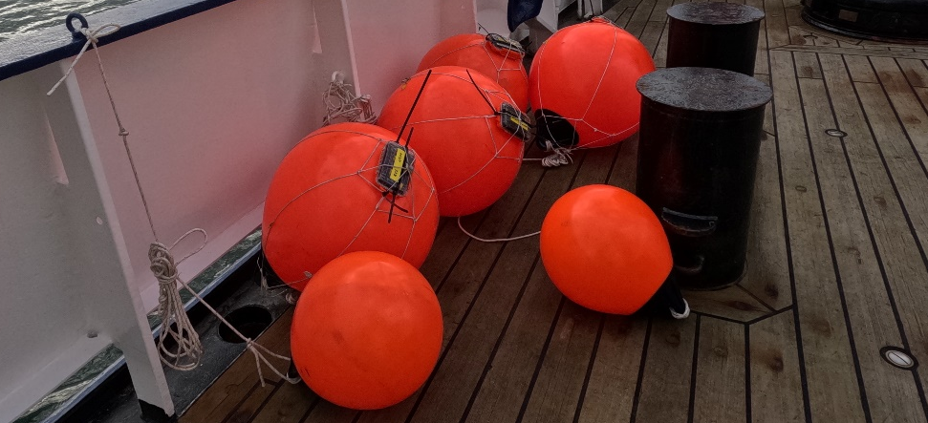

Figure 7. Surface Floats with GPS loggers attached

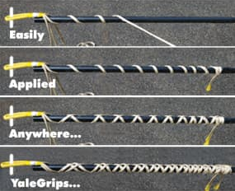

Figure 8. Yale Grip to holdback line (From switching from blue to black winch)
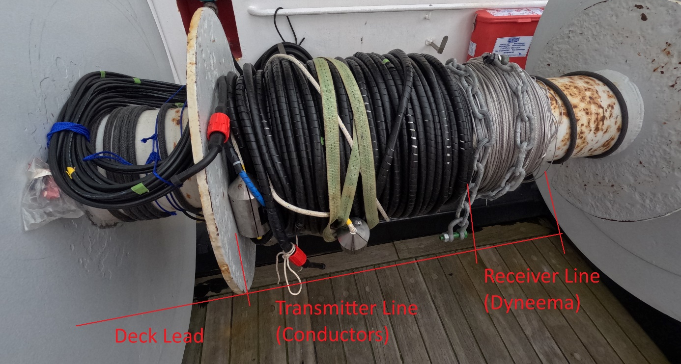

Figure 9. Different lines

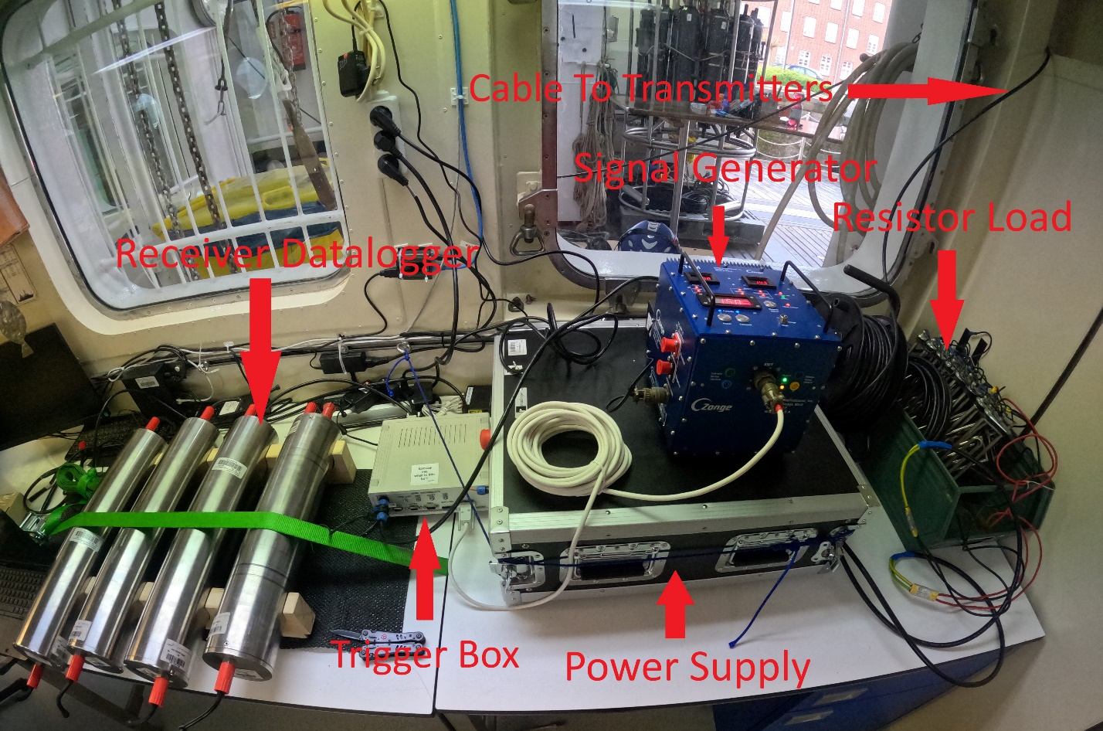

Figure 10. Topside Electronics
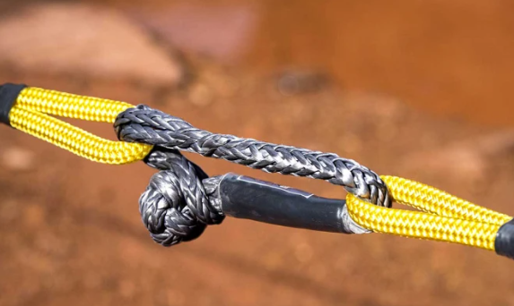

Figure 11. Soft Shackle

Deployment Procedure:

- Initial Deployment: Deployment will begin several nautical miles before reaching the first transect line. The exact distance will be finalized after conducting practice runs with the system. For the first deployment, we will allow plenty of time to ensure a safe and careful setup.
- Receiver Line Preparation: The receiver line (shown on the right side of Figure 9) will be pre-installed on the blue winch (see Figure 2). We will deploy the weight using a surface float, followed by approximately 35 meters of Dyneema line until the first datalogger's soft shackle connection point is on deck. The datalogger will be prepared prior to deployment.

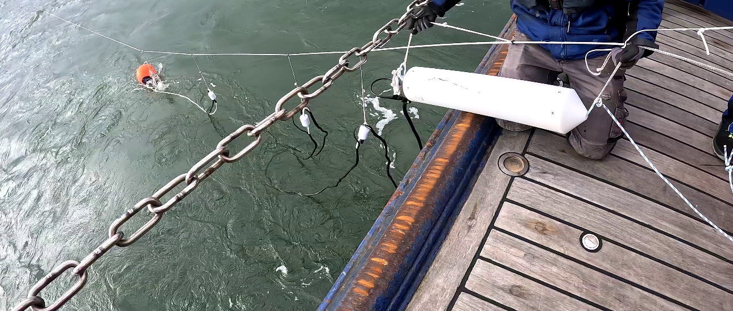

Figure 12. Datalogger and receiver deployed

- Dyneema Between Receivers: There is approximately 400 meters of Dyneema line between Rx2 and Rx1. Rx1 will follow the same deployment procedure as Rx2 (refer to Step 2).
- Remaining Dyneema on Blue Winch: Approximately 400 meters of Dyneema line remains on the blue winch and needs to be spooled out.
- Switching to Black Winch: Once the blue winch has been fully spooled out, we will use a Yale grip (see Figure 8) to detach the load from the blue winch, allowing us to connect the line to the black winch using a soft shackle.
- Connecting the First Transmitter: After the black winch is connected, we can remove the Yale grip and attach the first transmitter (illustrated in Figure 6) to the line, plugging in the conductor.
- Deploying the Second Transmitter: The black winch can be spooled out until the second transmitter line is on deck. The deployment procedure for the second transmitter will be identical to that of the first.
- Final Deployment and System Setup: The remaining line can then be deployed. The deck lead (Previously disconnected and wound around the winch) will be brought into the ship and connected to the topside electronics (see Figure 10), allowing the system to be powered up.

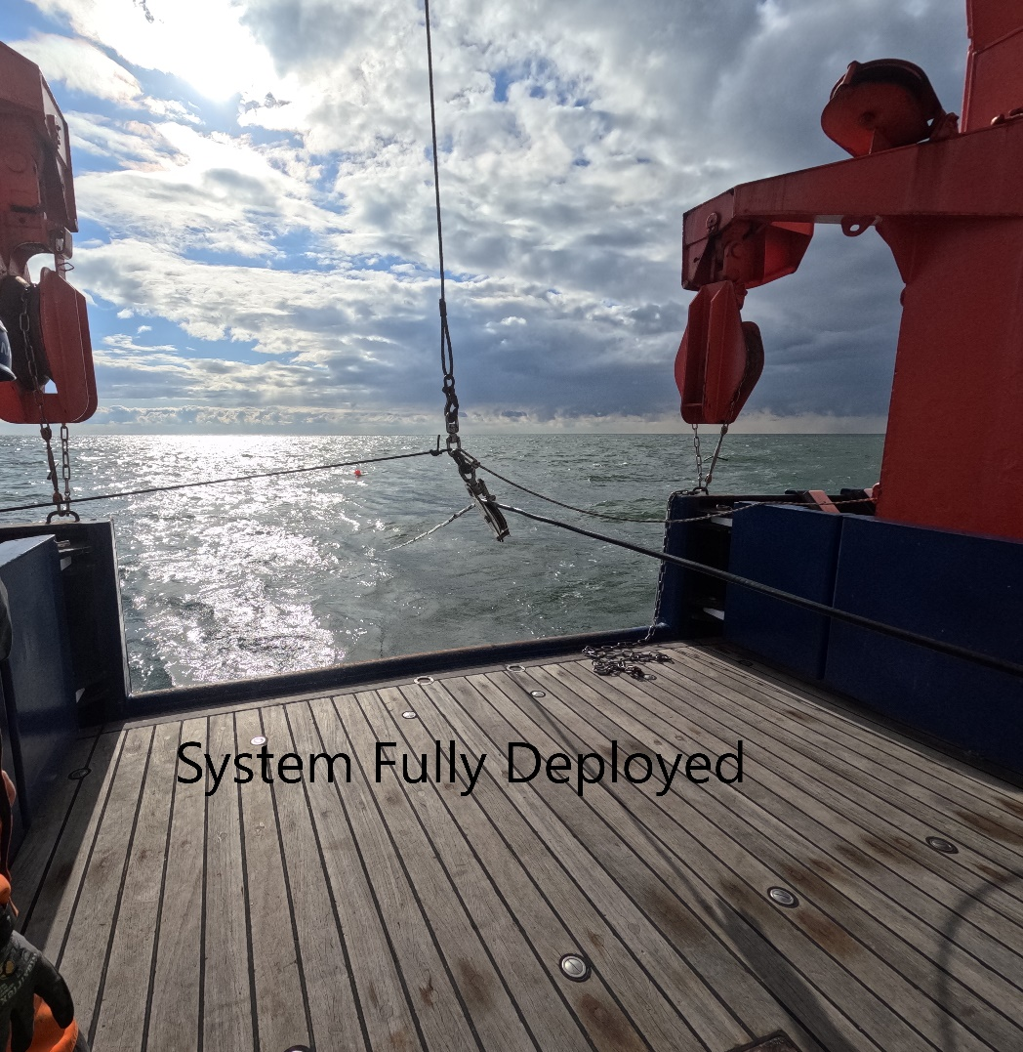

Figure 13. The line can be secured in the A-frame. Continuous monitoring of the line and surrounding boats is essential.

Deployment Notes:
- Deployment will require a minimum of 3 people on deck. 1 person on the winch with radio comms to the bridge, and 2 people on deck staging and preparing the next deployment components.
- At all times during deployment, marine mammals must be observed and recorded.

Recovery Procedure:

Recovering the system is essentially deployment in reverse.

Environmental impact

The electric and magnetic fields generated by marine electromagnetic surveys may have effects on animals that are electro- or magnetosensitive; however, how marine electromagnetic surveys potentially affect marine organisms is largely unknown (Nyqvist, D., Durif, C., Johnsen, M.G., De Jong, K., Forland, T.N., Sivle, L.D., 2020. Electric and magnetic senses in marine animals, and potential behavioral effects of electromagnetic surveys. Marine Environmental Research 155, 104888.). Marine electromagnetic surveying is generally considered to have a low environmental impact. The electromagnetic fields used in these surveys are much weaker than those from natural sources such as lightning or the Earth's magnetic field. The controlled, low-intensity and low duration electromagnetic signals generated by SWAN are thus unlikely to cause significant harm. The SWAN system's surface-towed design, which allows for depth adjustments, helps minimize the risk of interactions with marine animals.

