CSEM Manual
- Equipment List
  - Hardware
    - Restricted components
      - Datalogger - 3 month wait time
      - Seawater reference (electrode) – immediate
    - Receiver datalogger (Titanium housing)
      - This houses the datalogger PCB, Alkaline battery, and a PoE PCB. While connected via Ethernet (Via the SYNC MCBH side), all PCBs inside are powered by PoE and does not drain the battery. Once disconnected from PoE, the battery will start to drain. Do not plug the electrodes into the SYNC side, use the plug on the other side of the can.
      - There is a protective hard plastic shell which keeps tension off of the electrical cable while towing.
    - Receiver Electrode String
      - These get soft shackled to the main line. The datalogger gets soft shackled to the main line to a steel thimble connector. There are sliding hard O-rings which get soft shackled to each electrode. The surface buoy gets connected to the back end of the datalogger.
      - These log at 10kHz
      - DO NOT DEPLOY CONNECTED TO “SYNC” SIDE OF DATALOGGER
    - Trigger Box
      - This is getting time from GPS NMEA strings and triggers the Zonge signal generator to start/stop. It was set to 90 seconds on, 30 seconds off. Occasionally the NMEA string would come in with the wrong format and mess up the triggers. This needs to be manually recorded and also reset.
        - Why aren’t they using an atomic clock to trigger it instead of NMEA?
    - Zonge signal generator
      - This device is using an H bridge to alternate the electrical polarity between the two transmitters. For testing, it can be plugged into an appropriately sized resistive load (see manual for more info). Be sure to monitor the temperature, try not to let it get >50 degree C.
    - Transmitters
      - These are just hollow stainless spheres. It is important to clamp them to the main line in such a way that there is no force on the plastic housing and all of the tension is on the main line and not the electrical cables. The GPS Buoy gets mounted between the clamps via a steel clamp
      - It is unknown how long these will last. They rust out and are considered to be consumable. Find an alternative for replacement dipoles/spares.
    - GPS Buoy Loggers
      - Log at 1Hz
      - Cable tied to buoy, then inflate the buoy.
  - Software
    - Hydra 4 (GEOMAR made program)
      - GUI to set parameters of transceiver datalogger – can also just use command line shell interface. More details in manual
    - Data processing
      - Use FileZilla or similar to directly download data from the IP address of the datalogger to a PC and back it up. 1 datalogger in binary format for 1 day is ~20GB. If in ASCII format it can be >100GB.
        - They are using a ‘supercomputer’ to actually process the data and analyze it.
    - Calibration
  - Toolbox
    - Silicon grease
    - Anti-seize copper paste
    - Allen keys
    - Socket set
    - Cable ties
    - Soft shackle dummies
    - Spare hardware
    - Soldering Iron
    - Multimeter
    - Spare subcon dummies
    - D cell batteries for GPS loggers
    - Large alkaline batteries for dataloggers
- Pre-deployment checklist
  - Ready winch
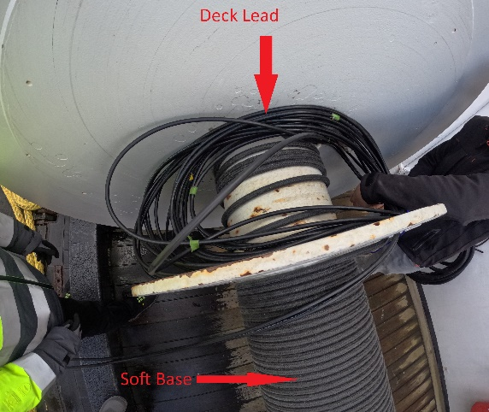
    - Securely attach the line to the winch

    - Wind everything in reverse, keep tension on the line and secure items as they go on. Mind electrical wires being crimped/pulled. All tension needs to be on the line.
- Operations
  - Deployment
- Talk to the captain, deployment usually takes ~1 hour so the boat needs to line up the transect with enough distance from the starting point. Go 3Knots during deployment and ~1.5-2knots while logging (depending on frequency).
- Deploy the Tail buoy (with GPS logger) and chain first.
- Deploy the 2nd receiver (2x buoys (with 1x GPS logger on the buoy closest to the ship)). Soft shackle the plastic weight, electrodes, and receiver logger to the main line. Deploy the buoys on the down-current side to avoid tangles.
- Deploy the 1st receiver the same as the 2nd.
- Deploy the 2nd transmitter. Bolt it in place, plug it in, and attach the buoy and deploy on the down-current side to avoid tangles. Let it fill with water and sink before using the winch to deploy more line.
- Deploy the 1st transmitter the same as the 2nd. Just be careful not to tangle anything.
- When you get to the end of the winch, slow down until the end of the line. Detach the deck lead, feed the cables to the Zonge signal generator.
- Secure the winch line on a pulley roller.
- Turn on the power supply and it will begin to trigger.
- Every 15 min, visually check that all the buoys are still in place, check the trigger box logs, and check that the signal generator is cycling correctly.
  - Recovery
    - Recovery is essentially deploying in reverse. Turn off the power supply, secure the deck leads to the winch, detach winch from pulley roller.
    - Partially lift the first transmitter out of the water and let it drain for a minute. Lift it out and detach the 2 bolts and buoy. Dummy off the connectors.
    - Repeat for the second transmitter.
    - Pull out the first transceiver, undo the soft shackles and dummy them off with spare pieces of rope. Once it is entirely removed, continue winding in the winch.
    - Repeat for the second transceiver.
    - Wind in the last chain weight and tail buoy, secure the winch.
- Post-deployment checklist
  - Loggers plugged into PoE so they don’t discharge battery
  - GPS dataloggers downloaded and powered off
  - Deck lead is dummied off
  - Power supply off
  - Rinse off everything with freshwater
- Troubleshooting
- Notes/Tips
  - Our winch will be a lot smaller, so possibly the way the transceivers are deployed may have to change so that it’s not rolled into the winch and crushed.
  - GPS loggers on buoys can be improved greatly – recommend using a Spot Trace gps system or similar
  - Might be good to have another SubConn connector between the start of the winch electricals and the deck lead.
  - Increase the length of line on the receiver weight slightly so everything pays out easier.
  - The new receiver line has been re-spliced and is functional.

What modifications have been made?
Compare winch systems – bring datasheets
- On the Alkor they have a massive hydraulic winch with ~2 meters of space. They were wrapping the electrical cables separately to the dyneema line.
Type of lines
- Tail Buoy – 6mm Dyneema – Rx – 6mm dyneema – Rx – 10mm Dyneema – tx – thick rope – Tx – thick rope – Winch
- They different sections of line are soft shackled together. This allows for some modularity, reparability, and also the ability to disconnect in case of emergency.
Titanium housings – why are they using them? Cheaper alternative?
- Absolutely can be made cheaper and possibly slimmer. They are using Alkaline batteries, the only way to check voltage is to open it up or use Hydra 4 software or terminal lines.
- Use Blue Robotics aluminum housings?
- Use protected lithium-ion batteries?
- Off switch?
Data quality control
Fulmar/paragon/minimal vessel size integration?
- Having at least 4-5 meters of deck space really helps to connect the Transceiver to the winch. Having at least 3 people to hold things/deploy is best.

Putty Settings:
- Use control-J to add a \n character in putty
- Use T to set time
- Use manual for everything else
- Use the following settings:

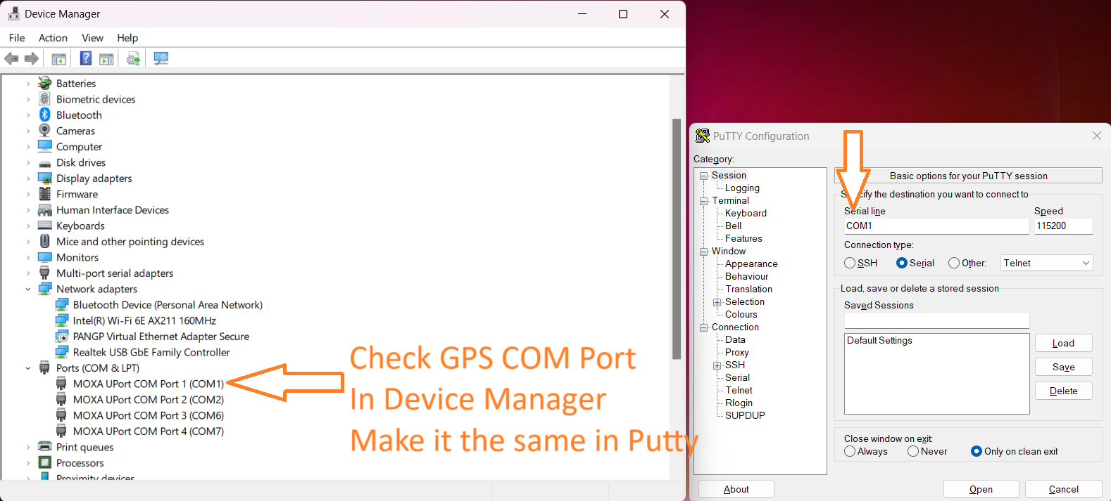
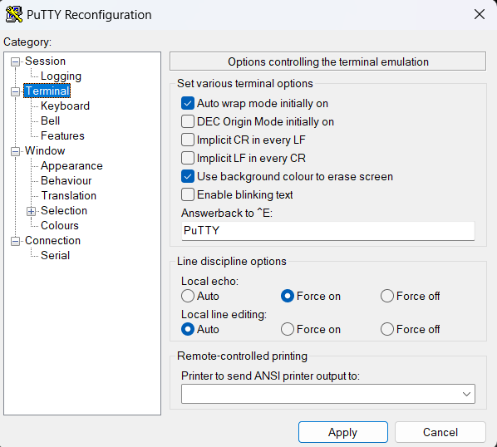
Triggerbox Steps
- **Buy a ‘proper’ RS232 -> USB converter
- Connect to triggerbox via RS232 and putty on 115200/8/1 USING \n characters (use control + J)
- Confirm GPS connection is good by typing “GPS”. The NMEA strings should start showing up, confirm there is an “A” in the 3rd column. Use “q” to exit
- Use “T” + control J to set triggerbox time
- Change any settings, reference the manual
- To start triggering, type “s” + control J
- To stop triggering, type “q”

Datalogger Steps:
- *see if there’s a way to sync PC time accurately, or maybe sync PC time to GPS? Is that possible?
- Install battery. Secure with tape & zip ties
- Datalogger: Connect to the network by changing IPv4 IP to 192.168.124.1, subnet mask 255.255.255.0
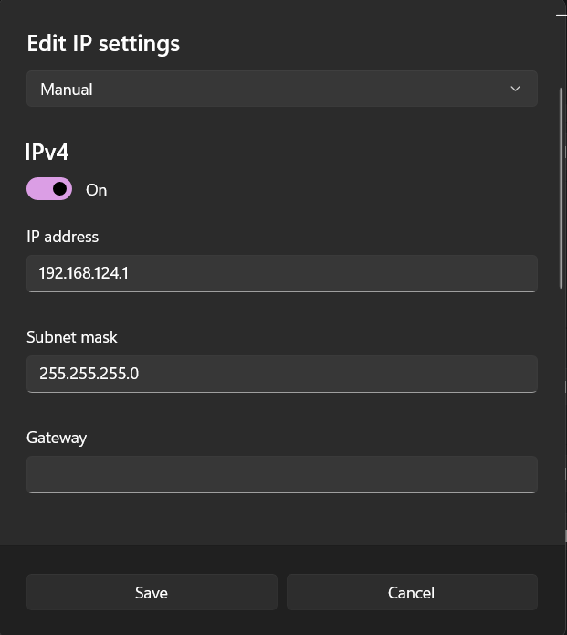
- Edit SelfPotLogger_SocketClient.cfg file to add all IP addresses of the dataloggers (see manual)
- Open SelfPotLogger_SocketClient.exe. Confirm all dataloggers are connected
- Synchronize time on dataloggers using “s” command
- Change any other settings if necessary referencing the manual
- Check voltage of battery
- Check gains by downloading “user.selfplot” from FileZilla, open using notepad++
- To change gains, use the command “w” then “<DevID> 0 261 <Binary settings, check page 13 on manual>”
- Gain settings for North Sea trip: Ch 0 = 0, Ch1 = 1, Ch2 = 2.
- *May be easier to just edit “user.selfplot” to adjust gains.
- Change sampling frequency by typing “w” then “<devID> 0 0 X” where X can be 0=1Hz, 1=10Hz, 2=100Hz, 3=500Hz, 4=1kHz, 5=5kHz, 6=10kHz. (We used 1kHz in North Sea). Or edit “user.selfplot”. This defaults to 0=1Hz upon powerup, Edit this before deployment
- Start logging all loggers by typing “w” then “0 0 1 2”
- Stop logging by typing “w” then “0 0 1 0”
- To download data, use FileZilla or similar, type in the IP address of the logger with username = “ftpuser” and password = “SelfPotLogger”. Drag and drop files onto PC.

Start logging:
After the time sync is successful, and the dataloggers have a battery. Use the command:
w 0 0 1
This command starts logging on all dataloggers!

w 0 0 0 4 This command sets logging to 1khz sample rate

