Subscribe to DeepL Pro to edit this document.
Visit www.DeepL.com/pro for more information.

TRIGGERBOX CSEM
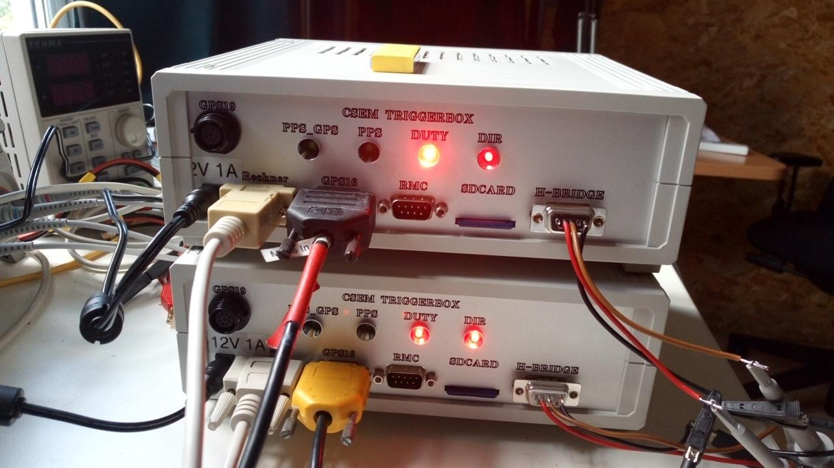

General description:

The trigger box controls an H-bridge that supplies a dipole with a constant current.
The following settings are possible:
Fullduty mode:
The dipole is supplied with a positive current for a defined time without a break, immediately followed by a negative current for the same time.
Half-duty mode:
In contrast to full-duty mode, a pause of the same length of time is inserted between each change in current direction.
Time period:
The time span can take the following values:
100ms, 200ms, 500ms, 1000ms, 2000ms
Break:
Optionally, a pause can be introduced between individual transmission processes.
To do this, the pause length and the transmission duration must be defined in seconds.
If the pause length is zero, transmission is uninterrupted.
Waiting for minutes to start:
Optionally, you can wait for the start of the next minute at the start of transmission.

The trigger box contains a TCXO-based timebase that is permanently synchronised with a GPS.
This ensures that the system continues to function even if the GPS system fails.

All settings can be changed via the serial interface or via the initfile.txt file.

The current parameters are recorded in the log file at the start of transmission
The start and end of the transmission processes are then added.
Communication via computer socket (115200/8/1):
(Commands must be terminated with line feed "\n")

triggerbox menu
T set time Device is synchronised with GPS(required at the beginning)
The time is displayed after synchronisation
(cancel with "q "+[enter])
c config Menu for changing the options
s send Start the send process(cancel with "q "+[enter])
z get time What time is it?
r reset Restart the device
G GPS-shell ( Direct shell to GPS (Cancel with "q "+[enter])
C Clock-shell Direct shell to the timebase(cancel with "q "+[enter])
v version The version
F File menuMove around on the SD card
sh:>

file menu
Fl =List FilesLists all files
Fd xxx =delete xxxDeletes individual file
Ff show freespaceShows free memory space
FF delete all filesDeletes everything except seismic.ini
Fm x y move file x to y Renames file x to y
shell:>

config
usage:
c g 9/6 set GPSSets GPS to either Garmin19 or Garmin16
c l [2000/1000/500/200/100]msSets time period
c f 1/0 set fulldutySets Fullduty/Halfduty
c w 1/0 set wait_for_minute wait_for_minute
c d xxx set duration(s) Sets the duration of the transmission process (if pause !=0)
c p xxx set pause(s) Sets pause duration
c s save to initfile.txtSaves the settings to SD
c r read init_fileReads settings from SD

actual settings:
fullduty n
length 200 ms
duration 3 s
pause 2 s
gps 6
wait_minute j
sh:>

Necessary connections:
1. computer to computer socket
2nd SD card (FAT32)
3. DC supply cable 12V 1A.
4. H-bridge to H-bridge socket
5. a) Garmin19 via Weipustecker
b) Garmin16 via GPS16 socket

PINOUTS:

Calculator 115200/8/1
2=to the calculator
3=from the computer
5=mass

GPS16 9600Bd
(Cable colours from Garmin)
1:+5v (red)
2: data from gps (white)
3: data from microcontroller (blue)
4: pps (grey)
5: gnd (yellow and black)
6: Shield

Weipu connector (RS485)
1:black
2:brown
3:red
4:orange
5:yellow TX-GPS+
6:green TX-GPS-
7:blue
8:violet
9:nc

RMC 9600Bd (for testing only)
3=NMEA from GPS19 (TTL not RS232!!!)
4=PPS (GPS19 | GPS16)
5=mass

H-bridge (exit to ZT30)
1=GND
2=Direction+
3=Direction-
4=Duty+
5=Duty-
6=res1+
7=res1-
8=res2+
9=res2-

Sync the selfpots

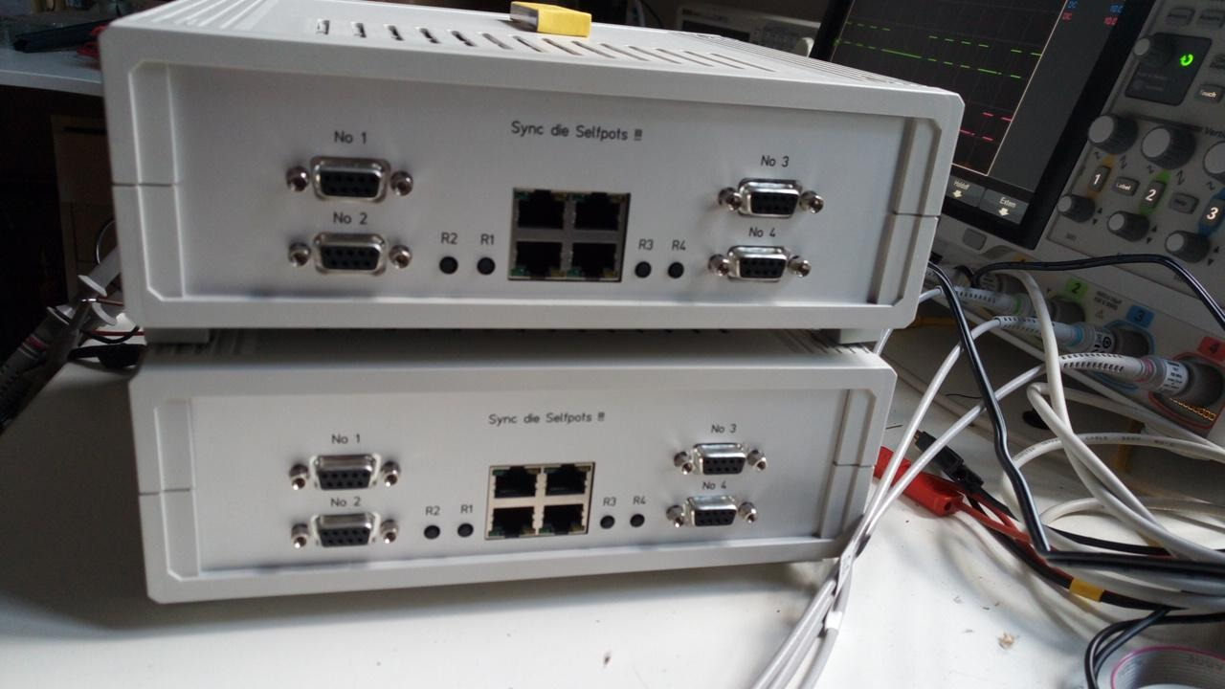

There are four D-Sub 9 connections for self-pot loggers on the back of the CSEM trigger box.

1=ETH1
2=ETH2
3=ETH3
4=ETH6
5=nc
6=Sync+
7=Sync-
8=GND
9=12V

The self-pots are supplied with operating voltage via the trigger box.
The sync lines are fed by the connected GPS; if the PPS or GPS is missing, the (Sync+) line automatically becomes positive and the (Sync-) line negative.
(this prevents the self-pots from going to sleep)
The Ethernet connection is routed to the RJ45 patch panel. A small hub must then be connected here.

The buttons R1-R4 can be used to wake up the corresponding selfpots if the GPS is missing. Sync+ of the respective logger is low as long as the button is pressed.
The corresponding green LED on the patch panel is then off.
(The yellow LEDs show the PPS from the GPS)

Questions? mwollatz-vogt@geomar.de

