There are 6 Columbia P10-Pro GPS units and Pelican waterproof cases. These record GPS position of the boat, transmitters, receivers, and the tail buoy. Data is stored on an internal SD card. Battery life should last ~50 hours.
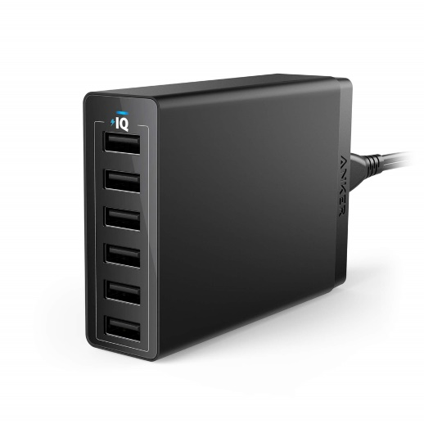
- Charge all batteries using the Anker charger the day before deployment using micro USB cables. LEAVE THESE CABLES CONNECTED TO THE CHARGER

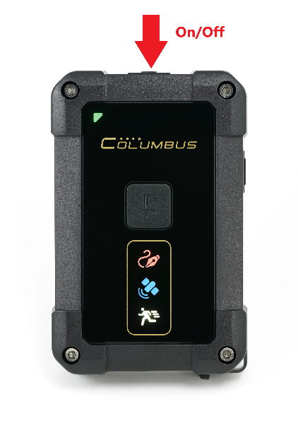
- Push the top on/off button. Let it face the sky and wait for the blue satellite icon to turn on and the green status indicator should start flashing.

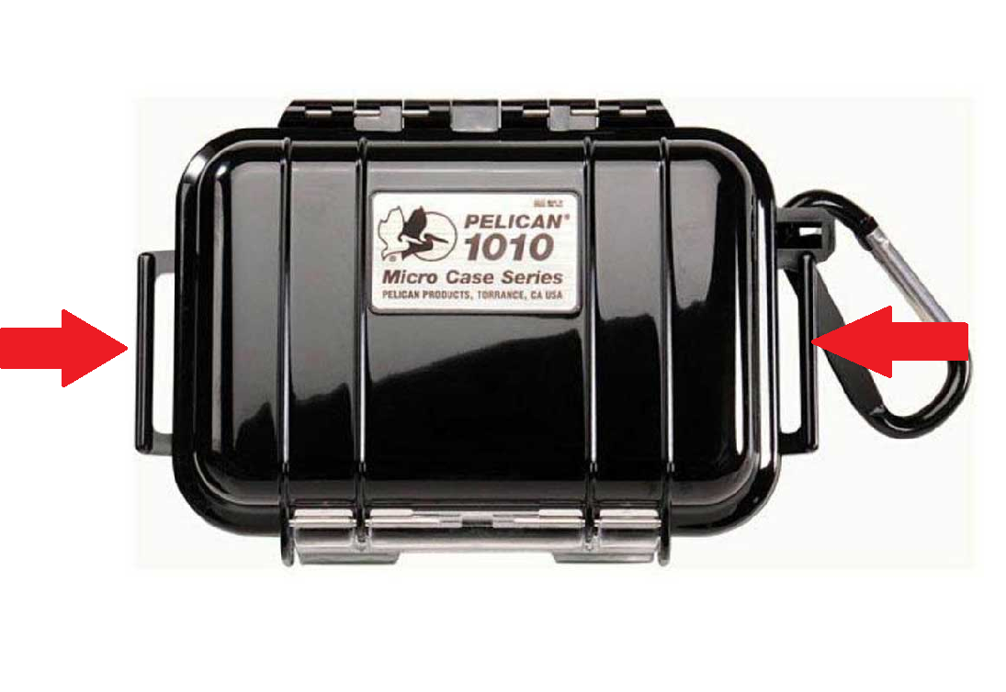
- Install in 3D printed shell and secure the GPS unit in Pelican 1010 case. Zip tie the pelican cases to the correspondingly labelled surface buoy’s netting (Tail, Rx2, Rx1, Tx2, Tx1), ensuring it is facing up (opposite of the line on the buoy). Secure the one labelled “Boat” on the ship facing the sky.

- After deployment, click the on/off button until no lights are on, copy SD card data to the hard drive.

