SWAN system

SWAN is a surface-towed CSEM system (Figure 1), which has been developed by the University of Malta, GEOMAR and Texas A&M, to detect fluids within the upper 200 m of the seafloor in water depths of up to about 100 m. The SWAN CSEM system was developed utilizing commercially available components, namely the ZTEM-30 transmitter from Zonge International and SelfPot Loggers from Magson GmbH. The system has been configured as a surface-towed, dipole-dipole system. It consists of a 100 m-long horizontal electrical transmitter antenna and an array of up to four 25 m-long autonomous receiver units, each carrying a 10 m-long horizontal electrical dipole. Each receiver is separated by approximately 125-250 m of line, resulting in a total system length of 500-1000 m. The receiver units and control unit are battery-powered and have a lifespan of over 72 h. The source signal is generated by a current transmitter onboard the research vessel. A control unit records the transmitted currents and voltages. The transmitter and receiver geometries are continuously determined using GPS tracking on multiple buoys located at each transmitter electrode, above each receiver, and at the tail of the streamer. To mitigate potential damage from ship traffic, the depth of the streamer can be adjusted prior to deployment between 2 and 10 m below sea surface. The different segments comprising the system, from receivers to placement buoys, are connected to the tow-rope through soft shackles applied at each joint, making the system modular with few metallic components. Data acquisition can take place at speeds of up to 2.5 knots.

More information on the system is available here:

Pastoressa, A.E., Haroon, A., Everett, M.E., Rohde, L., Bartels, T., Wollatz-Vogt, M., Faghih, Z., Franz, G.K., Micallef, A., 2023. SWAN: A surface-towed modular controlled-source electromagnetic system for mapping submarine groundwater discharge and offshore groundwater resources. The Leading Edge 42, 590-597.

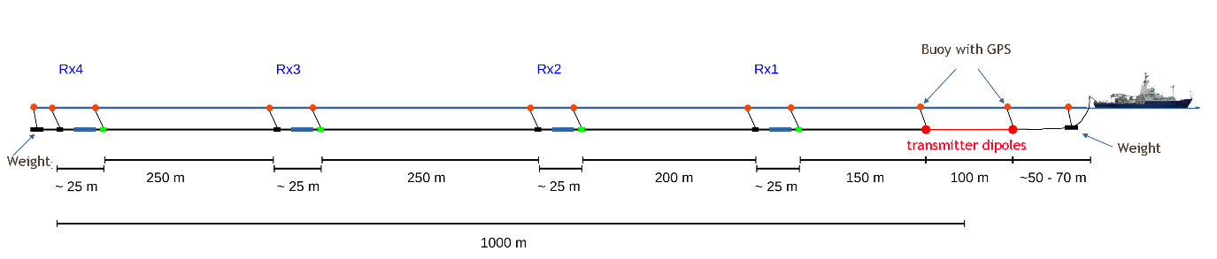
Figure 1: SWAN CSEM prototype.

SWAN system deployment and recovery

A AGO DBW-6 winch (Figure 2) will be used. It needs to be securely bolted on the research vessel and powered up.


Figure 2: AGO DBW-6 winch.

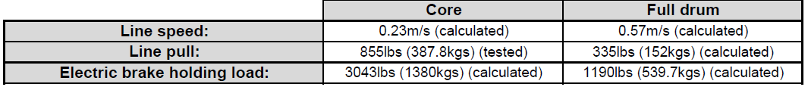
Figure 3: AGO DBW-6 Winch Specs
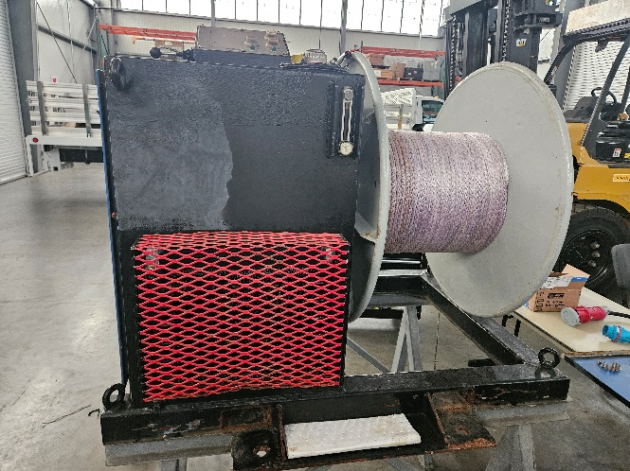
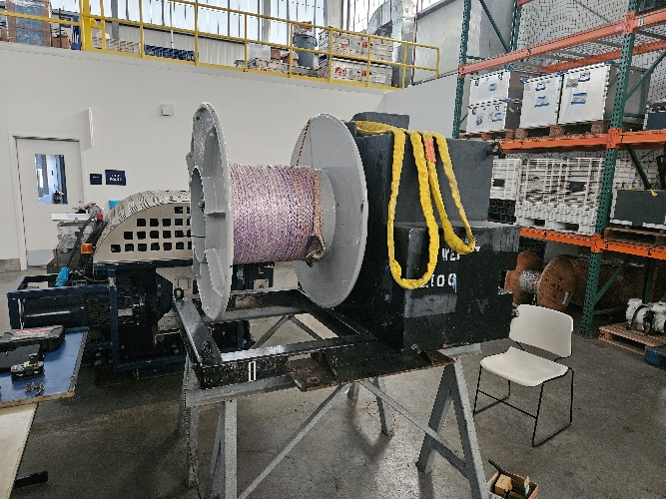
Figure 4: Black Winch
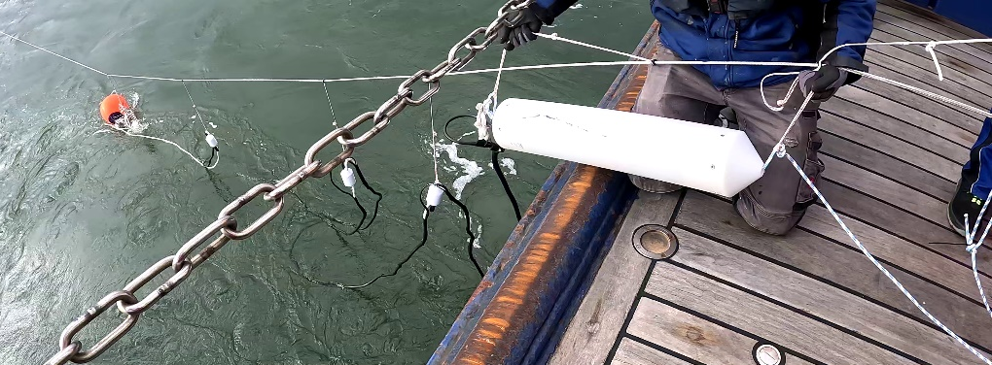

Figure 5: Datalogger and Receiver Instruments

Before deployment starts the, five main components of the CSEM streamer will be pre-staged. These are: 1) The ## kg end weight and tail buoy. 2) The tow line consisting of 950 m of 5mm Dyneema line, which will be pre-spooled onto the line spooling winch (Figure 2). 3) Two receivers (Rx1 to RX2) and associated flotation buoys with GPS loggers. These receivers weight ??~12 kg and are shown in figure 5 4). The 200 m long cable electric cable and transmitter dipoles pre-spooled onto another a separate winch (Figure 4).

The entire deployment process may take over an hour; therefore, the deployment should be started with the Araon positioned on the intended survey line, but ?? nautical miles ahead of the desired survey target.

The deployment of the SWAN system will occur in two stages. Deployment starts
with the Araon going ahead at dead slow to match or slightly exceed the line spool winch’s payout. The end weight and its floats will be deployed first (Figure 1). This is followed by the sequential deployment of Rx2 and Rx1. The receivers and buoys will be secured to the tow lines using soft shackles.

Once the 150 m line segment following the last receiver (RX-1, figure 1) is deployed, the load on the tow line will be transferred to the bitter end of the transmitter section. This will be done by attaching the line to a hold-back, which the transmitter is connected. The transmitter cable will then be paid out by hand until the final weight is deployed (right side of Figure 1). The conductors will be connected to the transmitter inside the vessel, and the system will be powered on.

Recovery of the system will essentially follow the deployment process in reverse. The vessel will reverse to allow the transmitter line to be recovered. Once the transmitters are recovered, the receiver line will be attached to the winch, and the remaining line will be reeled in.

Deployment and recovery will require a minimum of 3 people.

Environmental impact

The electric and magnetic fields generated by marine electromagnetic surveys may have effects on animals that are electro- or magnetosensitive; however, how marine electromagnetic surveys potentially affect marine organisms is largely unknown (Nyqvist, D., Durif, C., Johnsen, M.G., De Jong, K., Forland, T.N., Sivle, L.D., 2020. Electric and magnetic senses in marine animals, and potential behavioral effects of electromagnetic surveys. Marine Environmental Research 155, 104888.). Marine electromagnetic surveying is generally considered to have a low environmental impact. The electromagnetic fields used in these surveys are much weaker than those from natural sources such as lightning or the Earth's magnetic field. The controlled, low-intensity and low duration electromagnetic signals generated by SWAN are thus unlikely to cause significant harm. The SWAN system's surface-towed design, which allows for depth adjustments, helps minimize the risk of interactions with marine animals.

