Marine Imaging Workshop 2024  October 7th to 10th 2024  7700 Sandholdt Rd  Moss Landing, CA. 95039 USA  Phone:1-831-775-1700 Fax:1-831-775-1646 | INVOICE

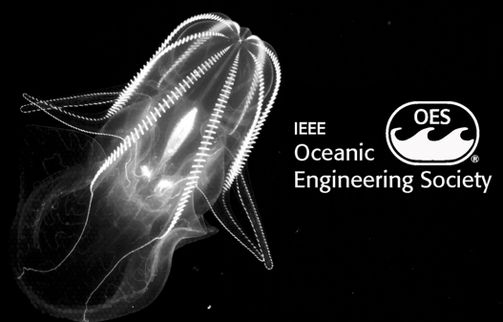
Invoice #101

Date: 10 Jul 2024
To:  Clara Rodrigues  Biology Department - CESAM  Aveiro Campus, Uni of Santiago  Aveiro, Portugal 3810-193  Email: clara.rodrigues@ua.pt | Ship To:  Clara Rodrigues  Biology Department - CESAM  Aveiro Campus, Uni of Santiago  Aveiro, Portugal 3810-193  Email: clara.rodrigues@ua.pt

Comments or special instructions:
Full workshop attendance with Ice Breaker, Gala Dinner and Breakout Sessions
SALESPERSON | P.O. NUMBER | REQUISITIONER | SHIPPED VIA | F.O.B. POINT | TERMS
W Kirkwood | Verbal/email | Clara Rodrigues | email | N/A | Due on Receipt

QUANTITY | DESCRIPTION | UNIT PRICE | TOTAL
1 | MIW 2024 Registration for Sofia Ramalho | $550.00 | $550.00
1 | MIW 2024 Registration for Clara Rodrigues | $550.00 | $550.00
 | SUBTOTAL | $1,100.00
 | SALES TAX | 0.00
 | SHIPPING & HANDLING | 0.00
 | TOTAL due | $1,100.00
Make all checks payable to “MIW 2024 – 605590”
If you have any questions concerning this invoice, contact: Bill Kirkwood, miw@mbari.org, 1-831-775-1707
Thank you for JOINing us at MIW 2024!

