Monthly Transactions & Balance Report

- Navigate to cashflows by clicking Treasury > Cash Management > Cash Flow

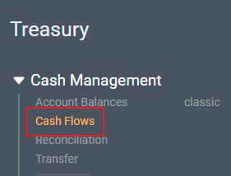
- Ensure the “Cash Flow & Balance” page view is loaded.

If not, check you User Setting to ensure “Default Page View” is set to “<default system view>” by clicking on the user icon on the upper right hand right of the page:  click on user settings 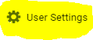 and ensure that the Default Page View is set to Default View 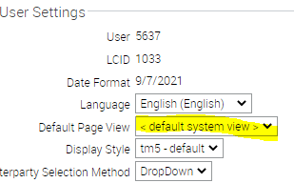

Set filters to include whatever information you want on your statement, such as “From” and to “Date”, HOP, Account, Category, Payment Reference, etc.

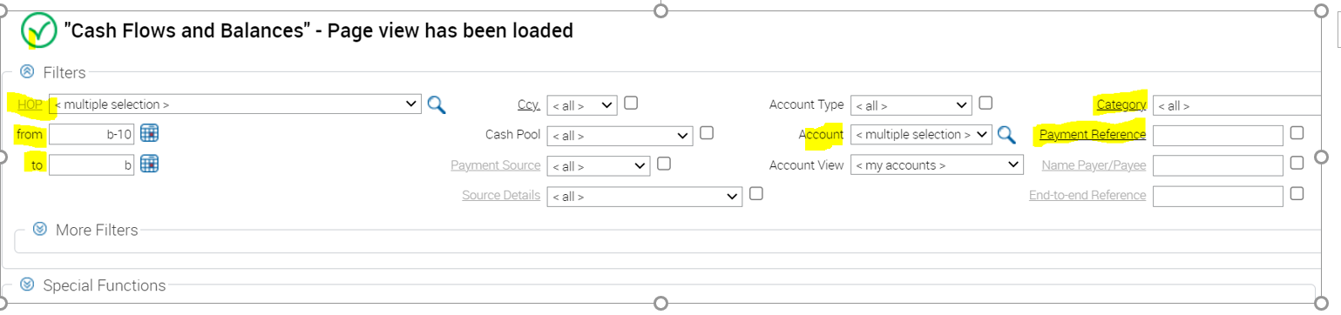

Activating Filters
  - All data in tm5 appears in tables. Filters control the results displayed in a table. Columns control the type of data displayed in a table.

- The Filters bar appears above the table. Set the “from” and “to” date for your report, and ensure that HOP# and Account filters display your CB account number then refresh the page

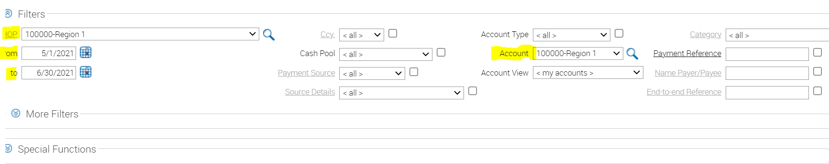

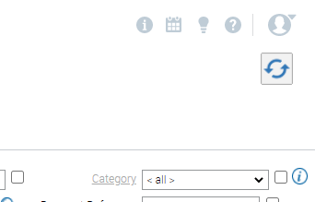
Refresh

- The balance and transactions will be displayed.
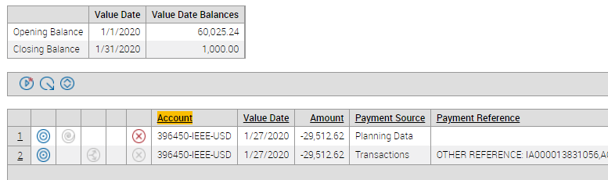
If this box is not displayed, open More Filters, navigate to the bottom of the box and click Show Balance, then refresh the page. (See below)

Activating More Filters to Show Balances - navigate to the bottom of the box and click Show Balance, then refresh the page.

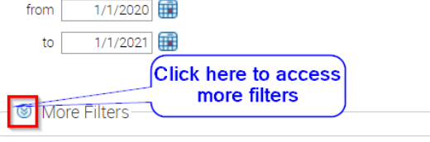
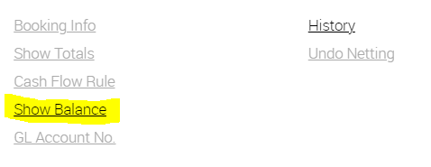

- The column “Payment Source” will say “Planning Data” are expected cash flows that have not occurred yet (checks, outing wires, and ACH payments). Transactions are actual cash flows that are reported by the bank on account statements. Reconciling planning data against transactions helps tm5 to identify if our expected cash flows have occurred as reported on the account statements issued by the bank.

If a payment hasn’t been reconciled to the statement transaction – Please follow the instructions below to reconcile
transactions. “Planning Data” will affect the closing balance.

Note: Reconciliation must be done 1 to 1 otherwise the rev/exp type + task will not carry-over from the payment request to the transaction

  - Navigate to reconciliation page by selecting Treasury > Cash Management > Cash Flows

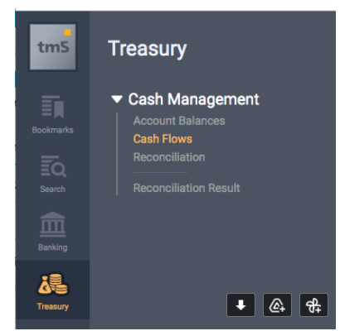

  - Select a “Planned Cash Flow” from the left side panel

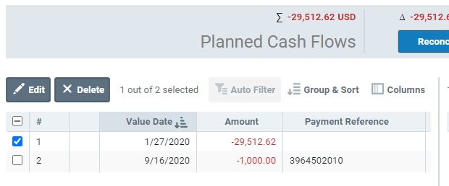

  - Use the filters to find the corresponding account statement “Transaction”
Notable Filters:
- Book Date Transactions (when transaction was booked on the statement)
- Amount (amount of the transaction)
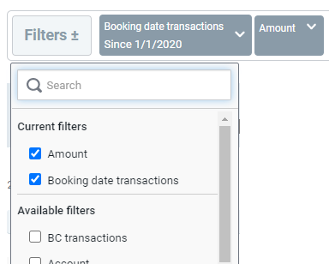

  - Select the corresponding “Transaction” from the right side panel – tm5 will calculate a difference between the “Planned Cash Flow” and “Transaction” and display this above the “Reconcile” button
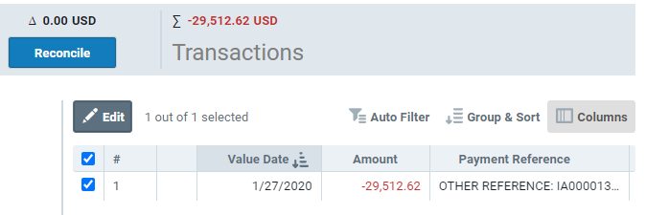

  - Click on “Reconcile” – this copies the Task and Expenditure Type information from the “Planned Cash Flow” to the statement “Transaction”

- Once the statement is configured to your liking, you can right click, pick Print and save as PDF.
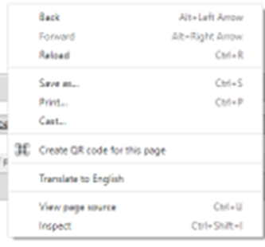

- Or you can click the Export to Excel button and a csv files will be downloaded. Highlight column A and choose Text To Columns from Data to parse the csv file. The opening and closing balance does not download in the csv file.

