Proposed 907X system for Ventana FO Can Replacement. Cost ~$70K.

Remote:
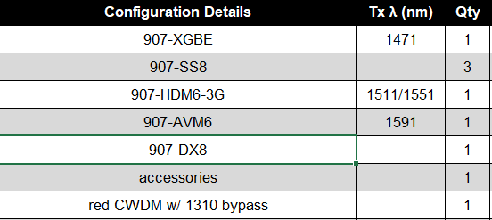
Console:
