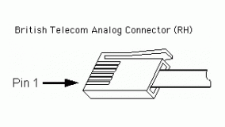

British Telecom Analog (BTA) – Right Hand
- Pin 1 = Sensor output (+/-10V)
- Pin 2 = GND
- Pin 3 = Vres (resistance reference)
- Pin 4 = AutoIDENT (not supported on all sensors)
- Pin 5 = Power (+5VDC)
- Pin 6 = Sensor output (0-5V)

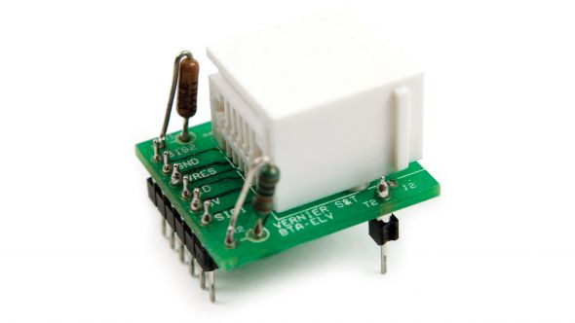

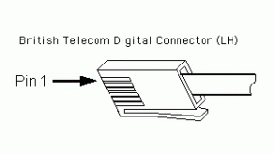

British Telecom Digital (BTD) – Left Hand
POS. | DEFAULT | MOTION DETECTOR | PHOTOGATE | RADIATION MONITOR | ROTARY MOTION
Pin1 | DIO0 | Echo | Input | Countinput | CCWcount
Pin2 | DIO1 | Init |  |  | CWcount
Pin3 | DIO2 | AutoID
Pin4 | PWR  (5.3V) | PWR  (5.3V) | PWR  (5.3V) | PWR  (5.3V) | PWR  (5.3V)
Pin5 | GND | GND | GND | GND | GND
Pin6 | DIO3 |  |  |  | X4res.

