26SEP16 0500 local.
- I reflashed new program in CPF without opening pcase.
  - Only changed sed trap loiter timespan from 240 min to 215 min
- Power cycled CPF and visually checked for proper init.
- Measured Batt, VAC, RH, and BP. All looked normal (didn’t record this anywhere)
- Rotated Sed trap and installed/filled bottles
- Power down.

26SEP16 0700 local
- Swiped magnet
- Watched CPF initialize properly (ran hyd motor and checked all sensors). Unfortunately didn’t keep serial log file.
- Received SBD at 0702 from initial float try. Reported Batt=32.72V, Vac=836.1, and BP=54.52. Try to find RH
- Looked one last time at serial BT feed and it was in ABSETFAST state, which is normal
- Received SBD from iBCN at 0712.
- ~0715 deployed from WF via aft port crane.
  - Quick release system used
  - Did not appear to hit ship during transit down to water line
  - Release deployed without issue
  - Float immediately sank at what appeared to be a slow, normal rate
  - 36 53.99N 122 20.476W

26SEP16 0800 local
- Had not heard from float so began using dunker to range on the underwater acoustic modem.
- Successfully heard ranges from 670-770 meters
- Called in wave glider to locate modem
26SEP16 afternoon
- Ran Radius 400m results:
-Target position is lat:36.9005360636 lon:-122.342168294 depth:642.131444526
27SEP16 0920
1. Ran Radius 800m result:
  - Target position is lat:36.9005561947 lon:-122.34214752 depth:648.208724727
11OCT16 recovered with Ventana on dive 3970.
- Dropweight
  - Lead weight missing at the scene
  - Guiotinne fired.
  - Disk was .0165” thickness (pink)
  - Obviously fired at some point
- Implosion
- SD card recovered in mangled external case
  - McGill attempted to mount in new case and read. No joy
  - Sent to Secure Data Recovery Services in Campbell, CA.
    - Case 101679
    - Could not recover any data because “monolythic chip was cracked in half”
- Main 10 amp fuse looks intact, like it didn’t burn
- Tore apart lower end and noticed high pressure hydraulics seemed sealed
  - Hydraulic pump showed no signs of water intrusion, nor corrosion on the inside
  - Hydraulic manifold showed no signs of water intrusion nor corrosion on the inside
  - External reservoir had dirt and water with ??? cc’s of oil. Dirt and water ingress most likely during and after implosion.
- Top cap has damage on the side
  - Significant blow (see pic
  - 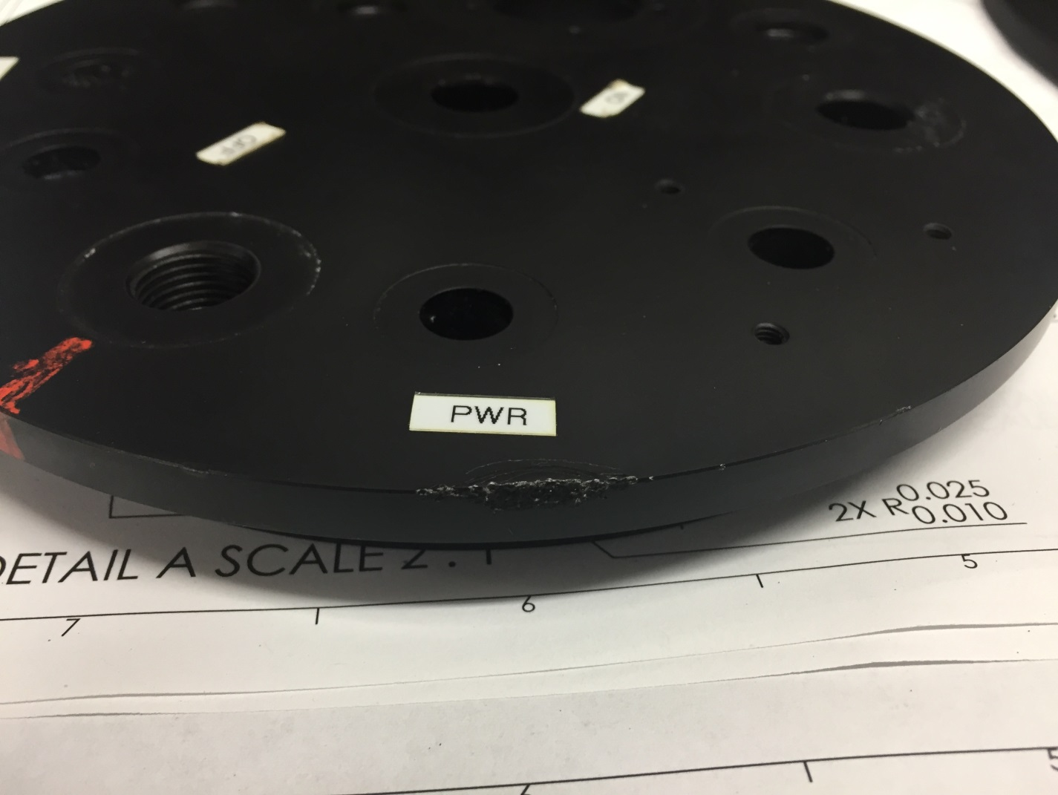
- Pressure housing has damage on side opposite main implosion. Looks like a wire cable dragged across it
  - 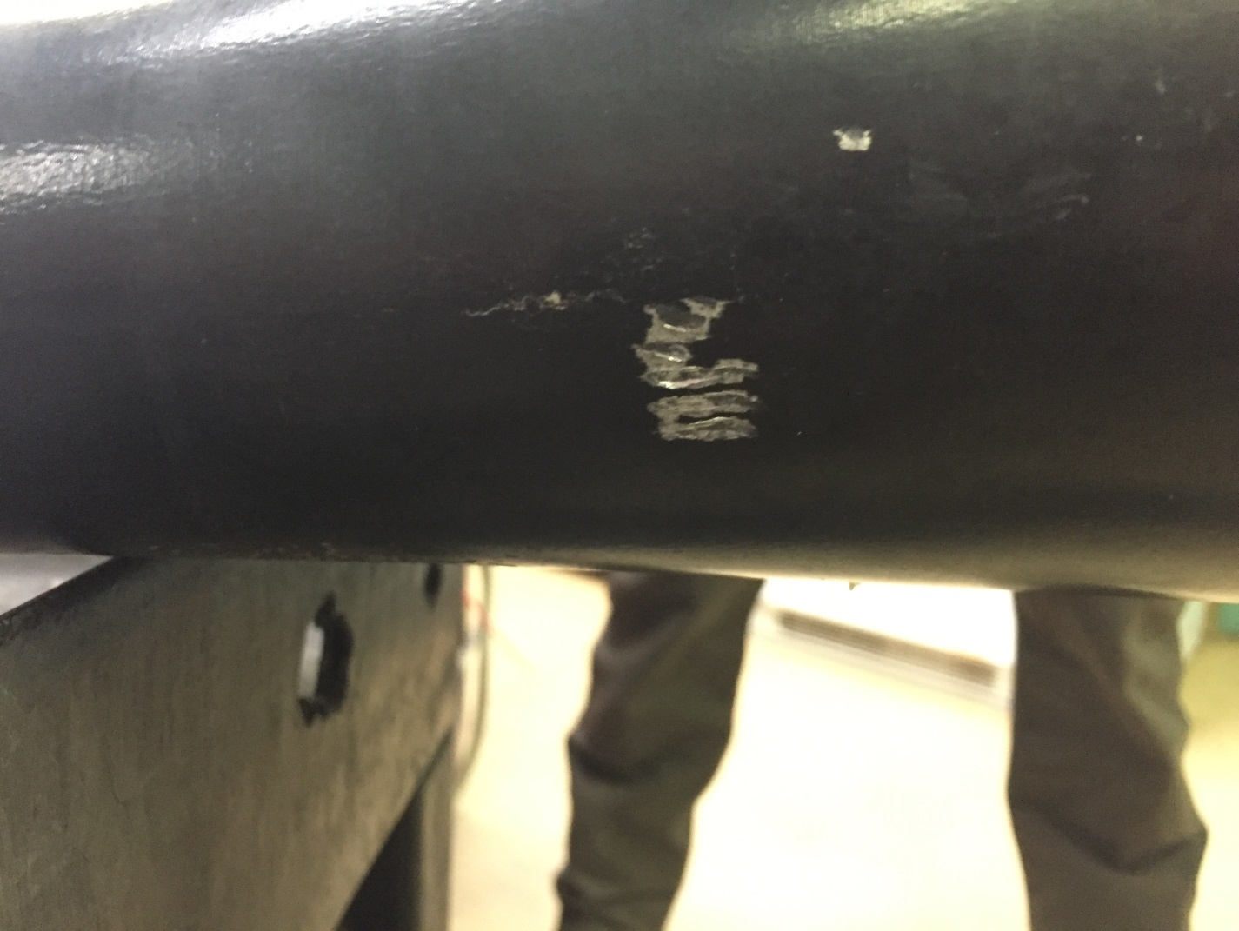
- Mapped debris field