TO: Mandy Allen
FROM: Gene Massion
DATE: July 12, 2016
Subject: Description of accidental oil discharge in MBNS
As required by MBARI’s ONBS permit number MBNMS-2015-002, this memo will describe an accidental oil discharge that occurred on April 21, 2016 in the Monterey Bay National Marine Sanctuary. During deployment of the Coastal Profiling Float (CPF) off the R/V Paragon, the CPF was damaged, flooded and sank to the bottom in 380 meters of water (Figure 1). Recovery required an ROV and was therefore not possible with the Paragon. We were able to recover the damaged float using the R/V Rachel Carson and the ROV Ventana on April 25, 2016. Almost all of the CPF was recovered. We were unable to find the GPS/Iridium Antenna, antenna stem and the CTD inlet cover. We presume this were these parts that were broken off as a result of the damage and the damaged antenna stem caused the flooding. These parts are primarily made of aluminum and hard plastic. Inspection of the damaged float after recovery identified the loss of approximately 3 liters (0.8 gallons) of oil contained in the CPF internal oil reservoir. The oil is used as part of the CPF buoyancy engine to control the depth of the profiling float.
Immediately after damaging the float, we commenced a search for the unit. We ran a circle pattern with the Paragon and were unable to visually locate the CPF. We then repeated the search using the underwater USBL tracking system and roughly an hour after the incident occurred we located the CPf on the ocean bottom at latitude and longitude 36.79216 -121.88901. No oil sheen was detected at any time during this search. After recovery of the CPF, it was evident that the damage to the unit would have caused immediate flooding. Our assumption is the CPF sank to the bottom immediately after the damage occurred and the loss of oil started somewhere well below the surface or on the bottom.
As part of the initial development of the CPF, we investigated the current state of the art in “environmentally friendly” oils and chose Renewable Lubricants Bio-Ultimax, a vegetable based, non-mineral, hydraulic oil for use in the CPF. The technical data sheet and the safety data sheet are attached to this memo and can also be found at
http://renewablelube.com/files/6014/4745/1411/3Aa-Bio-Ultimax_1000__2000_Hydraulic_Fluids.pdf
and
http://renewablelube.com/files/3314/6669/7488/81001_81003_81004_81006_81007-Bio-Ultimax_1000_Hydraulic_Fluids_ISO_32_SDS.pdf
Some of the more pertinent points are listed here.
- “Bio-Ultimax™ 1000 Hydraulic Fluids meet the Environmental Protection Agency (EPA) 2013 Vessel General Permit (VGP) guidelines for Environmentally Acceptable Lubricants (EALs), and should be used in hydraulic systems where LOW TOXICITY, BIODEGRADABILITY and NON-BIOACUMMULATION properties are required. They exceed the acute toxicity (LC-50 / EC-50 >1000 ppm) criteria adopted by the US Fish and Wildlife Service and the US EPA. Bio-Ultimax™ Hydraulic Fluids are ENVIRONMENTALLY RESPONSIBLE lubricants that are formulated from renewable agricultural biobased resources.”
- Ultimate Biodegradation classification PW within 28 days per ASTM D-5864 Aerobic Aquatic Biodegradation of Lubricants
- Meets the ISO 15380 environmentally acceptable hydraulic fluids standard for “Environmentally Friendly” products.
- Meets or exceeds the USDA standards for “Biobased products”.
- Meets or exceed EPA/US fish and Wildlife Service 560/6-82-002, 003 Ecotoxicity LC-50/EC-50 standards
Based on the evidence that the oil release probably occurred well below the surface, no observed sheen on the ocean surface and the low toxicity, high biodegradability and non-bioaccumulation properties of the oil; we don’t believe any significant negative impact is likely.

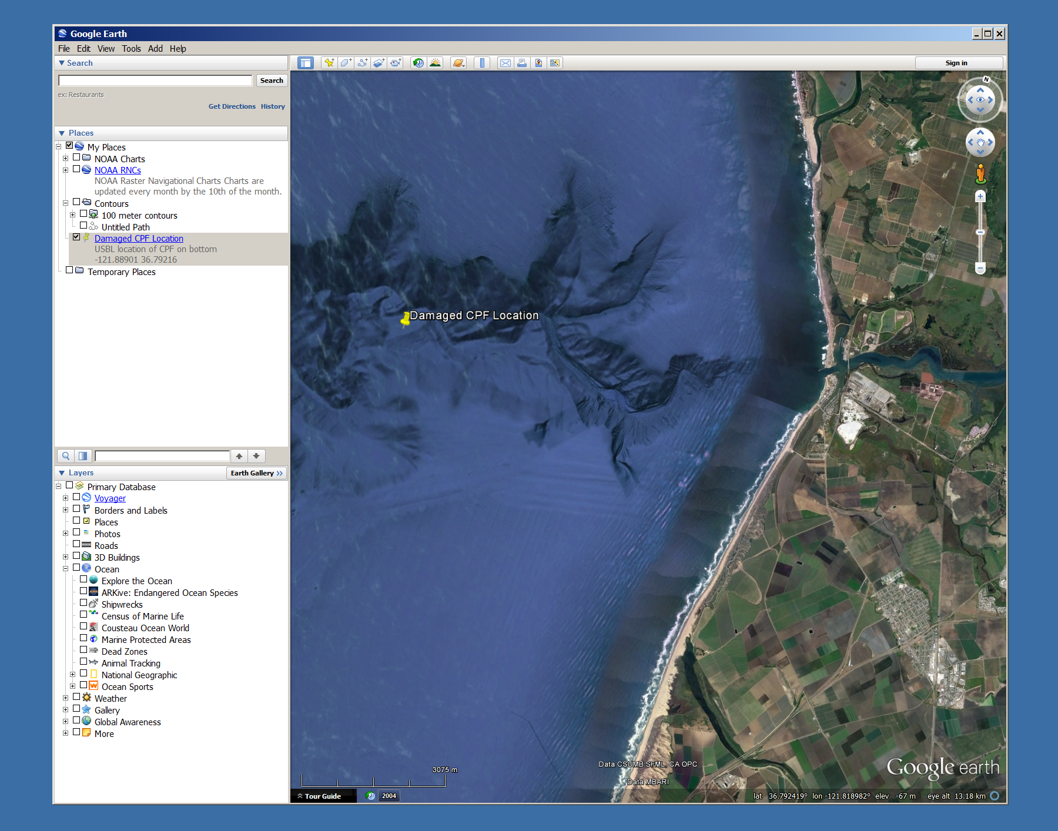
Moss Landing
Figure 1 USBL Location of CPF on bottom

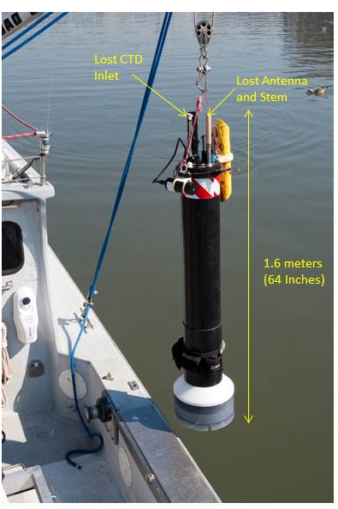
Figure 2 Coastal Profiling Float

