Project Summaries
Below are brief summaries and listings of team members for MBARI projects supported by the David and Lucile Packard Foundation, but not otherwise highlighted in this report. Also included are projects that received significant funding from external agencies, as indicated in each entry.

Coastal Profiling Float
Project leads: Ken Johnson, Gene Massion
Project manager: Gene Massion
Project team: Paul Coenen, Brent Jones, Eric Martin, Paul McGill, Ed Mellinger, Jose Rosal
Collaborator: Dana Swift, University of Washington, Seattle

The Coastal Profiling float has successfully completed test tank and at sea deployments meeting all our functional requirements. We are currently running a more rigorous set of at-sea tests to ensure we are ready for the next milestone: long term, autonomous deployments in Monterey Bay. Acquiring and processing the science data is an inherent part of the development testing and we have developed the applications required to ensure the CPF also is meeting our science requirements. In addition, we have worked with the Chavez Lab to deliver 2 more CPFs that are currently undergoing at-sea testing for use on the CANON project.
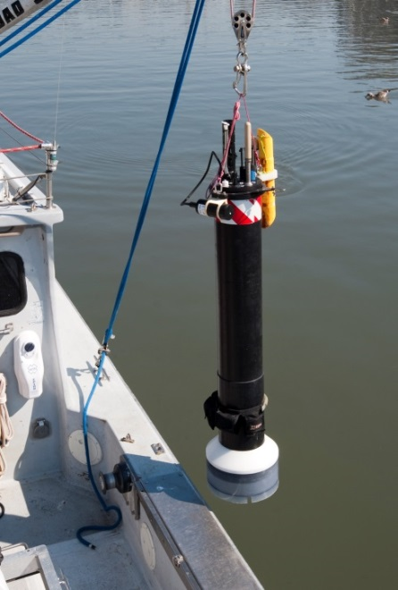
The coastal profiling float.

