Results, Testing April 3rd

Test Regimen

Test | Iridium Power | Iridium  Gnds X | Housing  Closed | CPF  On | 12V  On | 5V  On | Length (Hours) | Performance | Notes
A | X |  | X |  |  |  | 1 | Excellent
B | X | X | X |  |  |  | 0.5 | Excellent | Baseline
C | X | X | X | X | X | X | 1 | Good
D | X | X | X | X |  |  | 1 | Good | Same above
E | X | X | X |  |  |  | 0.25 | Excellent | Baseline
F |  |  | X | X | X | X | 0.5 | OK | CPF connected to NAL

Test Results

Test A
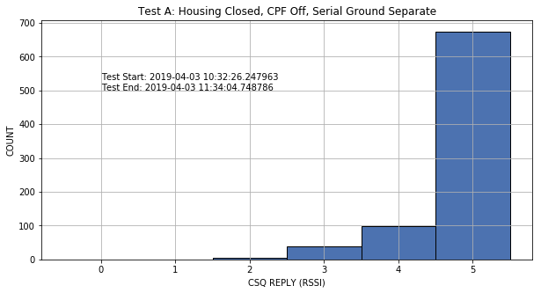

Test B
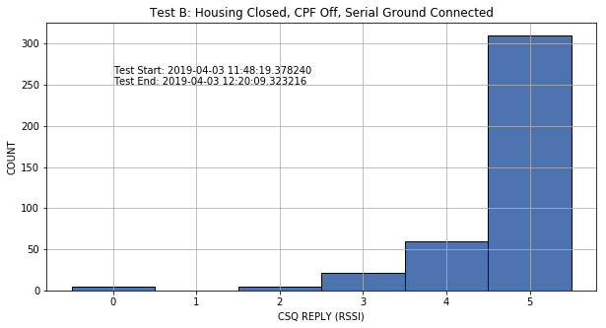

Test C
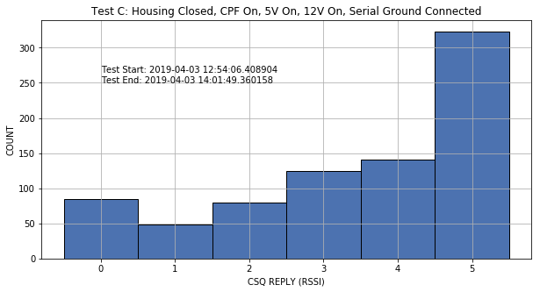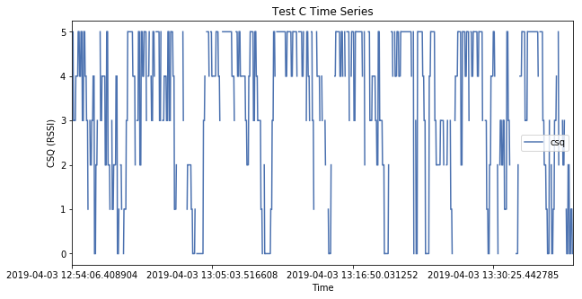

Test D
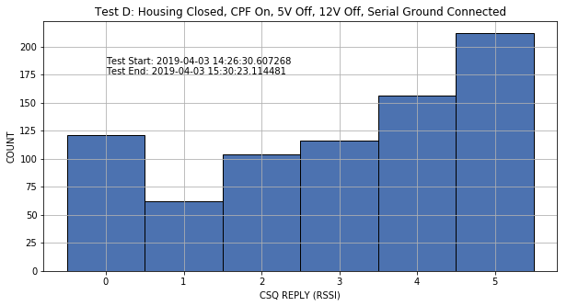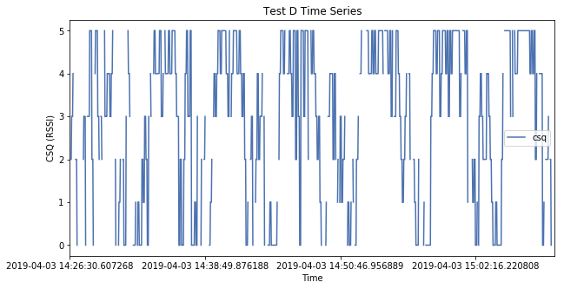

Test E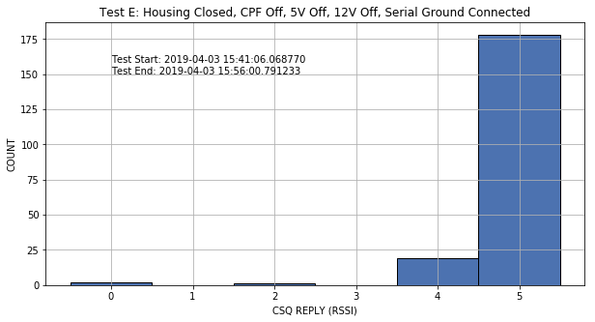

Test F
