CPF Digital I/O Circuit Card Assembly (CCA) Statement of Work
Version 1.0 2019 Jan 31
- Introduction
We’re replacing the prototype CPF DIO board with a new design. The existing board (see schematic below) provides interfaces to the following.
1) a GPS
2) a pressure, temperature, humidity sensor
3) a position sensor
4) the motorized valve.
Power switching is provided for the GPS, PTH and position sensor. The existing CPF motherboard supports 2 flavors of Power Switch Boards (see schematic below). Both flavors provide 3X RS232 or TTL UART serial interface “channels”. One flavor uses the native UARTs on the CPF and the other flavor provides additional UART channels using I2C/UART bridges. Each channel also provides power at 3.3, 5 or 12 volts (jumper selectable), power on/off control, over current protection and an energy monitor. We’d like to make the new DIO board turn the existing interfaces into something like the Power Switch Board channels. Some additional functionality is also required.

The new DIO board needs the following.
- Physically meet the CPF motherboard and card cage form factor
- Replace the existing GPS, PTH, position sensor and motorized valve interfaces with CPF power switch “like” channels.
- Provide a reasonable number of expansion I2C channels for future instruments
- Make available GPIO lines accessible.
- Replace the existing RS232 to Bluetooth adapter.
- Provide a 12V connector for motor controller VL power.

- Form Factor
  - Same as existing power switch board (app 2.125” x 6”)
  - Backplane connector: DIN41612 48 pins (Digikey A32810-ND, TE 5650948-5)
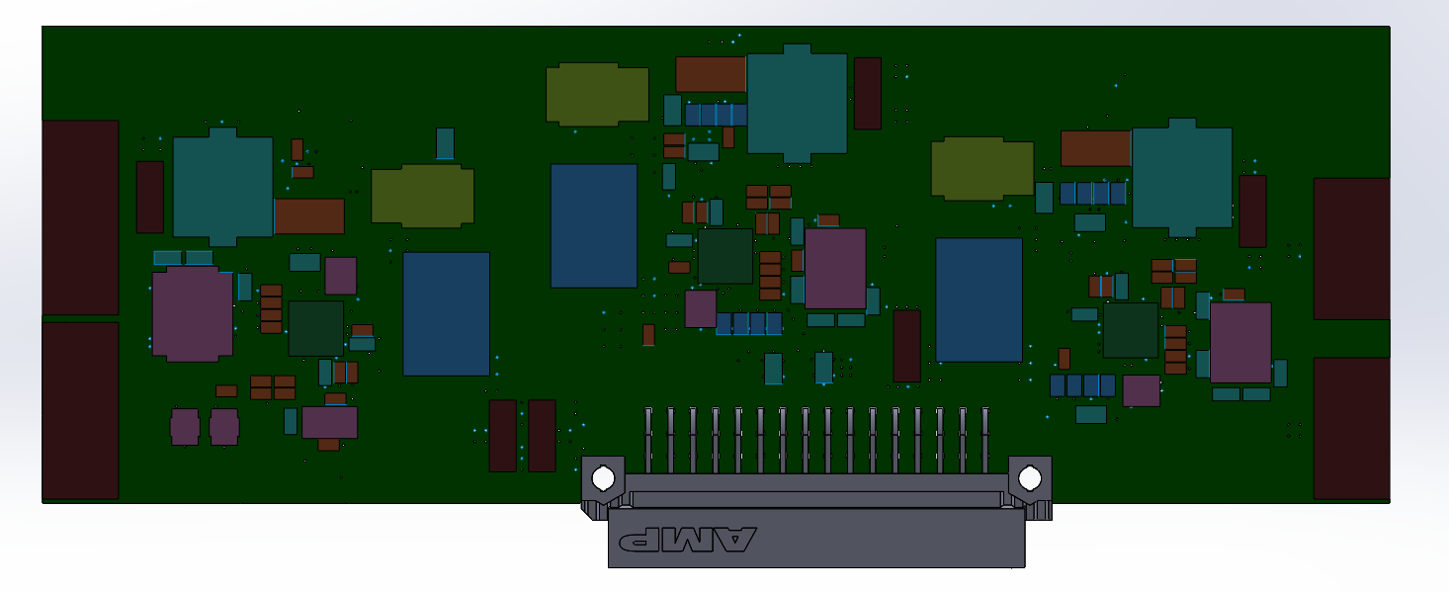
  - Channel connectors: We are currently using Harwin Datamate 6, 10 and 12 way connectors and it makes sense to stick with these. Note: some interfaces on the existing DIO CCA use 2 connectors for historical reasons. The new design should use one connector per channel.
Figure 1 Existing CPF Power Switch CCA
- GPS Channel
  - Pretty much just like the existing circuit although it may make sense to use the same power switch and overcurrent protection as the existing power switch CCA. Energy monitoring is not required.
- PTH Channel
  - We’d like to provide the existing PTH module (Roboshop RM-G185) on the new DIO CCA.
  - Using the existing COTS module and a mating connector on the new DIO CCA is OK.
  - Moving the circuitry from the existing COTS module directly on to the DIO CCA is OK if we can convince ourselves it is low risk.
  - Energy monitoring is not required.
- Position Sensor Channel
  - The position sensor is really just a Linear Technology LTC2485 ADC evaluation module (LTC 956A) with an I2C interface connected to a string pot.
  - Pretty much just like the existing circuit although it may make sense to use the same power switch and overcurrent protection as the existing power switch CCA. Energy monitoring is not required.
- Motorized valve channel
  - Pretty much just like the existing circuit although it may make sense to use the same power switch and overcurrent protection as the existing power switch CCA. Energy monitoring is not required.
- Expansion I2C Channels
  - At least one and up to 3 I2C channels with power switching and overcurrent protection. Energy monitoring is desirable but not required.
- GPIO Lines
  - Any unused backplane GPIO lines should be brought out to a connector (or 2). Note, some backplane GPIO lines may we marked for future use, these should be brought out also.
- Bluetooth module
  - We are currently using a stand alone Sena SD1000 Bluetooth module to communicate over the CPF RS232 console port though the housing (no external antenna) to a PC. This module is big and power hungry and replacing it with a lower power, smaller module mounted on the DIO board would be an advantage. An I2C or potentially SPI interface would be even better than the current RS232 module. We have a development kit for a Sena OEM module that might be appropriate although it is definitely worth looking at other modules. Energy monitoring is not required.
- 12 Volt connector for Elmo motor controller VL circuitry
  - Just need to provide a connector with 12 Volts. Power switching would be nice and could/should be controlled by the same GPIO line currently controlling the Elmo motor controller main power.
- Isolation and current limiting
  - The amount of isolation and current limiting, etc is TBD
- Test points
  - Provide test points or test connector for ….

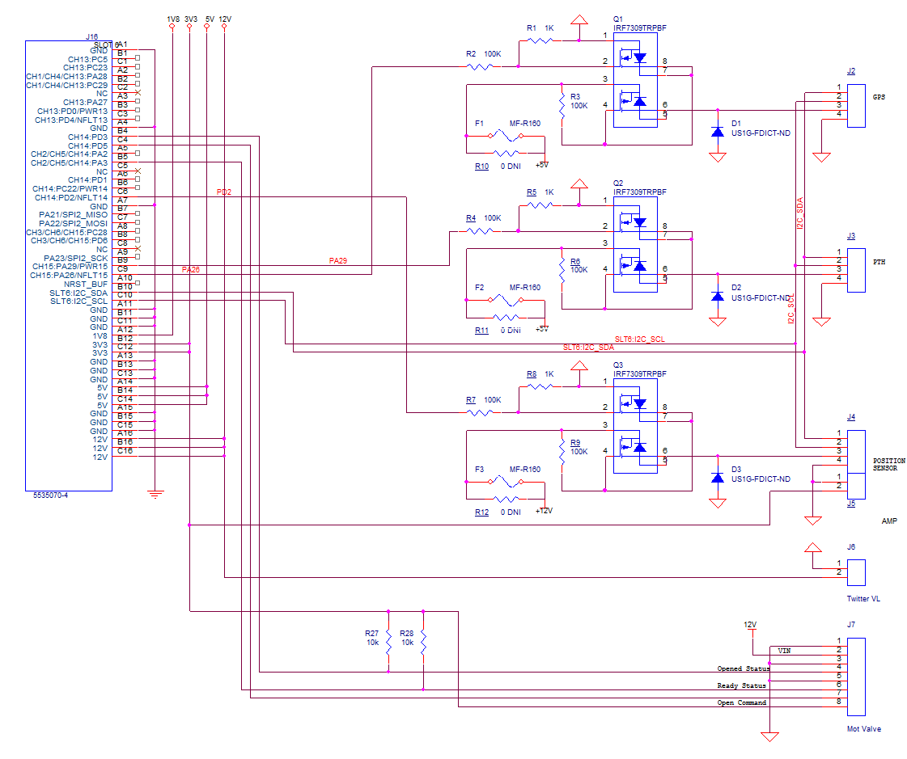
Existing DIO board schematic

Existing CPF Power Switch Board schematic
