Evaluating the VN-100 IMU/AHRS as an Inertial Current Meter in Coastal Profiling Floats

Luke Dorrian, Georgia Institute of Technology

Mentor: Gene Massion

Summer 2020

Keywords: Coastal Profiling Float, Water Column Velocity, Inertial Current Meter, Signal Processing

ABSTRACT
The Monterey Bay Aquarium Research Institute has been developing a Coastal Profiling Float (CPF) equipped with various biogeochemical and physical sensors to enable long-term continuous coastal ocean observation. In order to keep measuring within the coast, the CPF must maintain its location within an assigned region to avoid drifting out to sea or onto the shore. This paper concerns the evaluation the ability of the low-cost VN-100 Inertial Measurement Unit (IMU) to measure magnitudes of acceleration similar to what would be seen in the ocean. It also outlines the current signal processing approaches used to filter the acceleration data and generate proper velocity profiles. With the current experimental method, we have determined a modest lower limit of acceleration detection for the system and identified a path forward to fully defining the limitations of the VN-100 as an Inertial Current Meter.

INTRODUCTION
The coastal seas are one of the most biologically productive environments on our planet. They make up approximately 7% of the planet, yet account for the vast majority of the world’s fishery contributions [Burke L. et al. (2001)]. Coastal seas are the world’s fisheries and play a significant role in CO₂ sequestration. It is estimated that macroalgae in the ocean alone could sequester as much as 268 gigatons of carbon each year, significantly more than any country’s carbon emissions [Krause-Jensen D. et al. (2016)]. Quantifying the carbon flux among other chemical and physical properties of these seas is essential in accurately evaluating the health of local fisheries and understanding the current and future impacts of climate change on these critical ecosystems.
Scientists have access to continuous physical, biological and chemical data of the open ocean through the Argo and SOCCOM programs, which manage a vast fleet of profiling floats that collect information about the top 2000 meters of the open ocean [Argo (2000)]. Data from the Argo and SOCCOM programs is invaluable because it also estimates the heat content of the open ocean which forms the basis of climate modeling. Because of the sheer number of floats within the fleet, as shown in Figure 1, enough data has been collected to devise new climate feedback mechanisms, seasonal carbon flux, and other important attributes of the open ocean [SOCCOM Program (2019)].
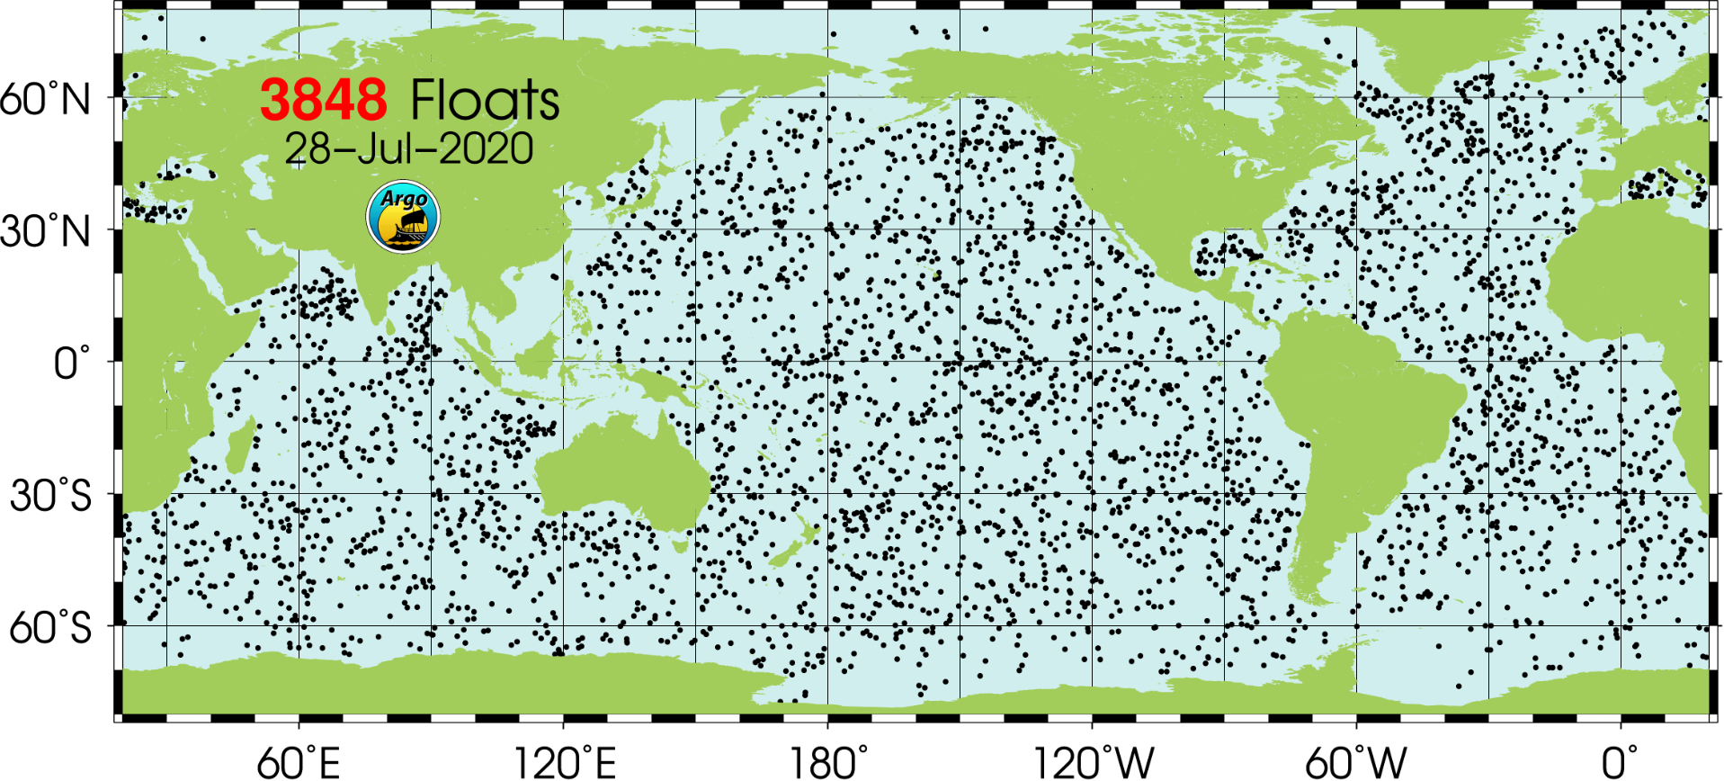
Figure 1. A look at the locations of all the Argo floats, as of July 28th, 2020 Credit: Argo DOI
Profiling floats have already proven to be a reliable method of continuous ocean observation. At the Monterey Bay Aquarium Research Institute (MBARI), engineers and scientists have been developing a profiling float that would fit the needs of a coastal ocean observation system. Unlike its open ocean counterparts, a Coastal Profiling Float (CPF) must maintain its location in an assigned region while avoiding drifting out to the sea. Manually picking these floats up and dropping them off is not logistically feasible while installing a motor to drive the float would use too much power. We aim to take advantage of the currents in order to keep our float within its assigned area.
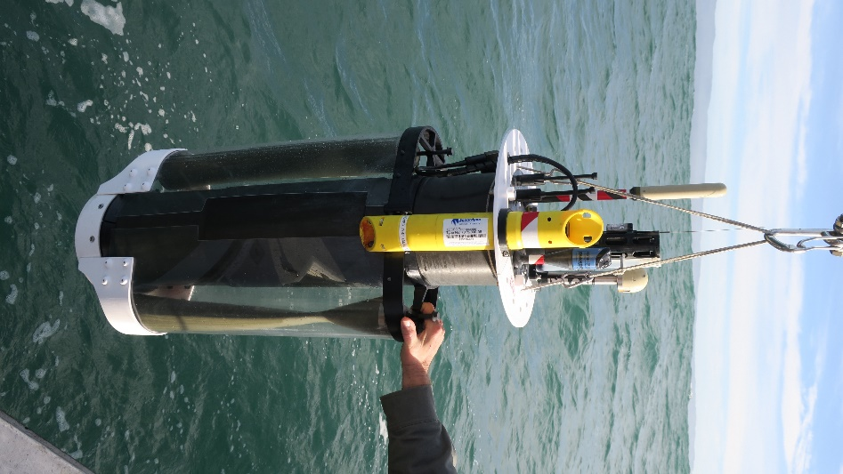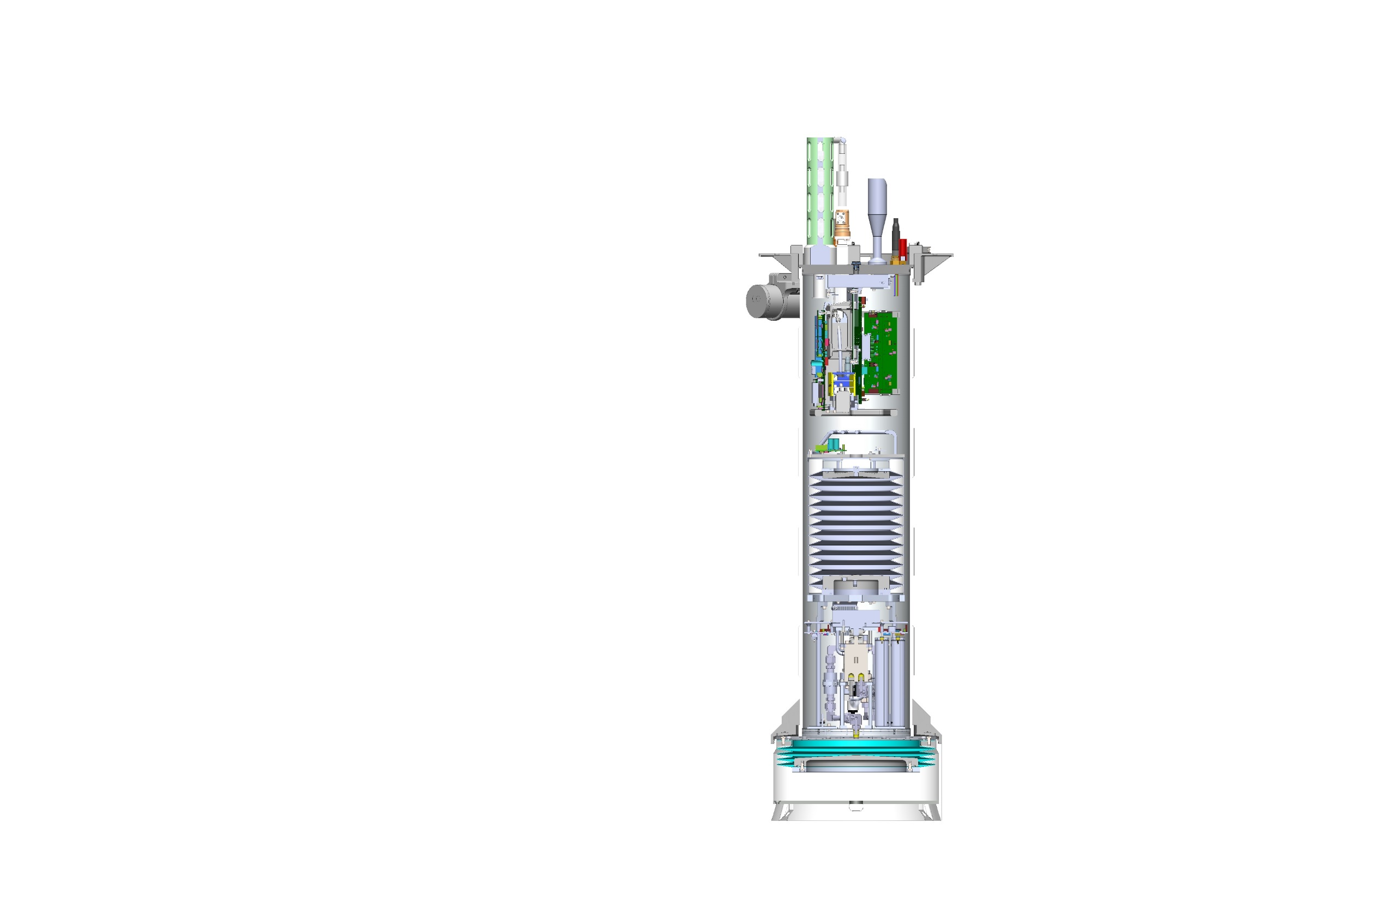
Figure 2. A CAD Drawing and Photo of a 2018 CPF Model, Credit: Gene Massion
Using an oil bladder system, the CPF is able to control its buoyancy to achieve a maximum depth of 500 meters or park at the seafloor. While ascending, the CPF will record the magnitude and directions of the current velocities while a pressure sensor onboard associates this data with the appropriate depth. If a storm or an unexpected current moves the CPF out of its assigned region, the CPF could sink to a depth where the current is traveling in the opposite direction, returning it automatically. Whenever a CPF surfaces, it will transmit this data to shore so that MBARI personnel can decide what direction and depths are needed to keep the CPF in its assigned region. This process is visualized in Figure 3 but we hope to automate in the future.
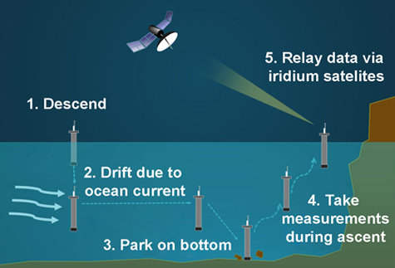
Figure 3. Typical Mission Cycle of a Coastal Profiling Float, Credit: MBARI Public Website
Surface currents are often measured using GPS. We cannot use this type of system underwater; the incoming and outgoing signals would be too distorted. Acoustic Doppler Current Profilers (ADCPs) use high frequency, short duration sounds or “pings” to measure the absolute velocity of the currents [Teledyne Marine (2016)] however there are several in situ limitations such as turbulence and water clarity. Furthermore, the CPF exists within a true LaGrangian reference frame while ADCPs cannot [Teledyne Marine (2016)]. We require a system that can accurately measure the current velocities relative to the seafloor while also drifting at that same speed.
Inertial Measurement Units (IMUs) are devices that can measure a body’s acceleration to calculate its attitude and orientation using an array of accelerometers, magnetometers, and gyroscopes [SBG Systems (2018)]. They are often used in aircraft to keep the planes level or at a desired orientation [Arrow Electronics (2020)] but have also been used in both surface and subsurface navigation, including “dead reckoning” in submarine navigation [Titterton, D. et al. (2004)]. Since acceleration is known, it can be integrated to obtain a calculated velocity and position of a body. However, miniscule measurement errors can accumulate in the calculated velocities and positions over time [CH Robotics] and thus an IMU is calibrated and rigorously tested before being taken to the market. Even with these calibrations, miniscule measurement errors are present and current applications of IMUs in navigation often couple these measurements with a GPS system to correct them [CH Robotics]. New advances in technology have led to the creation of microelectromechanical (MEMS)-based IMUs that are low power, lightweight, and significantly cheaper. However, a MEMS-based IMU is always subject to noise and can still costs tens of thousands of dollars.
Additionally, we would be measuring extremely small accelerations within the ocean, as seen in the figures below:
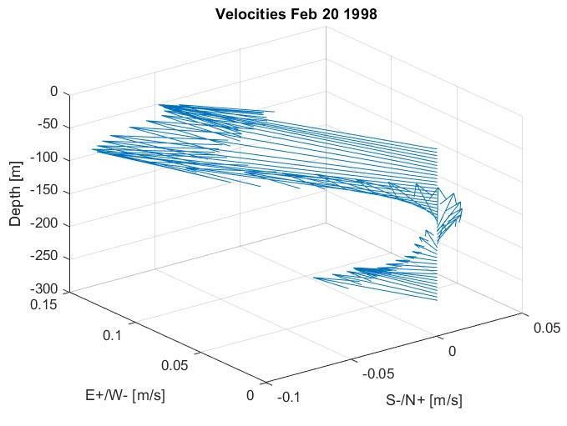
Figure 4. Velocity Profile of the Upper 250 Meters of the Monterey Bay, February 20th 1998
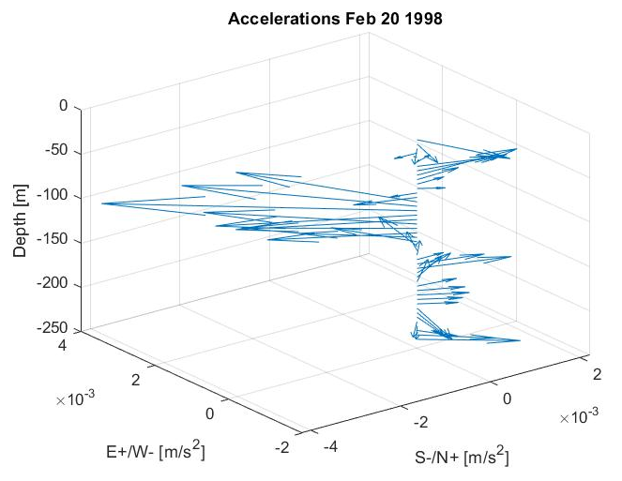
Figure 5. Resultant Accelerations of the Previous Velocity Profile
As shown in Figure 5, the accelerations we seek to measure are better measured in cm/s², less than 0.1 m/s². Furthermore, the deep the CPF travels the smaller the magnitudes of accelerations it will experience. Most, if not all current uses of the IMUs are measuring a much greater acceleration to calculate much greater, and more tolerant to measurement error, velocity profiles.
Considering this challenge and the cost of a tactical grade IMU, it is worth evaluating the performance and resolution of the low-cost, low-power VN-100 IMU and its ability to calculate an accurate velocity profile. The accuracy of the VN-100 in resultant velocity profiles are indicative of whether or not it is worth investing in a more resolute IMU that could measure the magnitude of accelerations that we would see in the ocean currents. The following sections detail the experimental method used to determine the VN-100’s resolution and its ability to construct accurate velocity profiles.

MATERIALS AND METHODS
Evaluating the VN-100 requires an experiment that can generate a constant low-magnitude acceleration (<< 1 m/s²) to be measured by the IMU. Then the output signal must be filtered to eliminate as much noise and bias as possible where it will then be used to construct velocity profiles. Along with the dynamic component, static (non-moving) data was recorded and compared to expected values to determine the lower limit of acceleration detection for the VN-100.

GENERATING CENTRIPETAL ACCELERATION
The VN-100 is attached to an outfitted miniature remote-controlled car which will drive in circles at a constant speed and radius. The radius is kept constant by a string attached and kept taut to the vehicle. Since the crawler is remote-controlled, a speed can be kept relatively constant while it is running. The time it takes for the car to complete one revolution is recorded to calculate a tangential velocity. The tangential velocity and the radius of the circle are used in the following equations to determine the centripetal acceleration:

$$V_{tx}=\frac{r*2π}{T_{x }}$$
$$A_{cx}=\frac{V_{tx}^{2}}{r}$$
In these equations, r represents the radius of the circle (in meters). The time it takes to complete revolution x is represented by $T_{x }$and acknowledges that the crawler does not travel at a completely uniform speed and thus the calculated tangential velocity and centripetal acceleration will have slightly different values for each revolution. The crawler is equipped with Bluetooth so that the dynamic data is automatically recorded via the VectorNav Control Center application. While communication via Bluetooth would not be available on the CPF, this makes the current experimental process much more efficient.
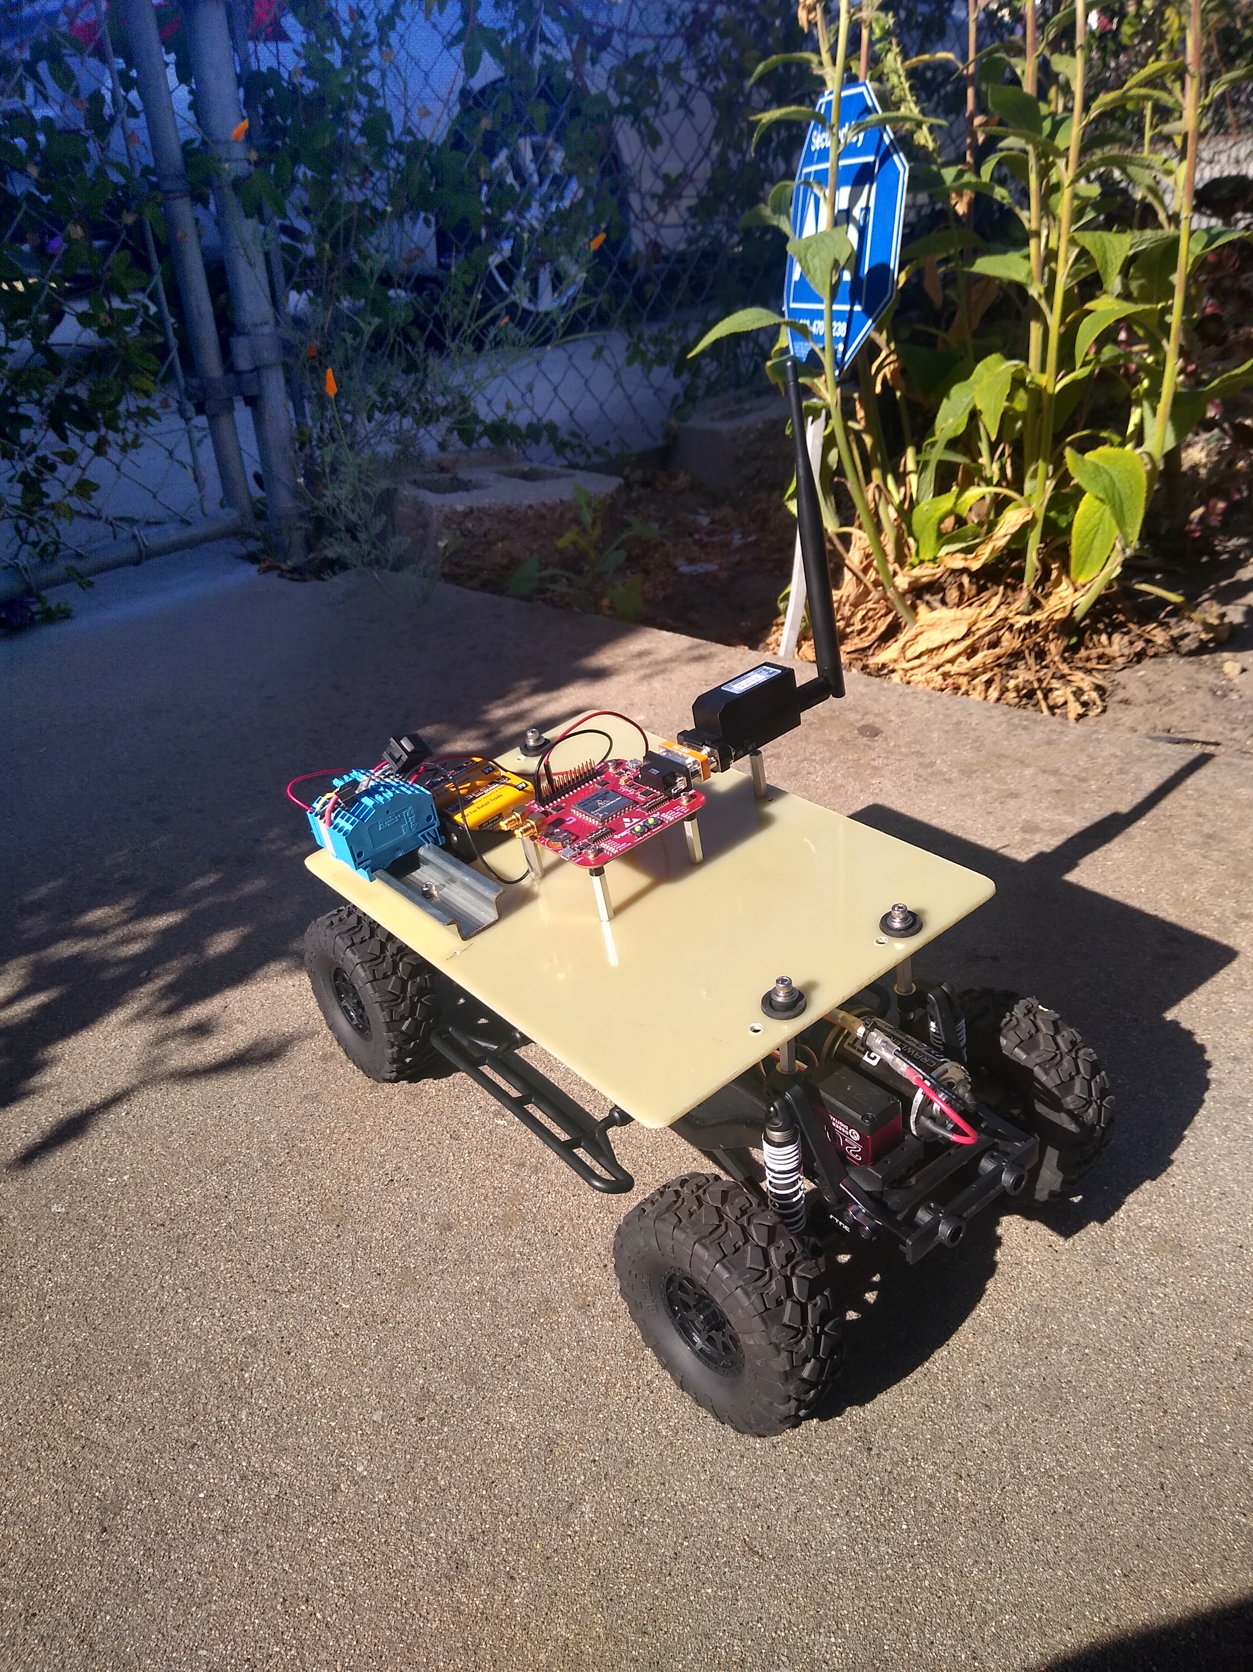
Figure 6. Picture of the outfitted RC Crawler

The measured acceleration can be compared with the expected acceleration to determine the efficacy of a filter and the lower limit of detection for the IMU, which concerns the magnitude of an acceleration signal that can still be extracted from the included noise.

IMU DATA LOGGER SYSTEM
The current experimental method involves transmitting the IMU data to a computer via Bluetooth. This would not be a viable method while deployed within the Coastal Profiling Float. Instead, an IMU data logger system was created to write these measurements to an SD card to be transmitted via satellite back to shore for analysis whenever the CPF surfaces. Data from the VN-100 is transmitted via the TX2 pin to the STM32L4R9AI Discovery Board. A picture of the current system can be found below.
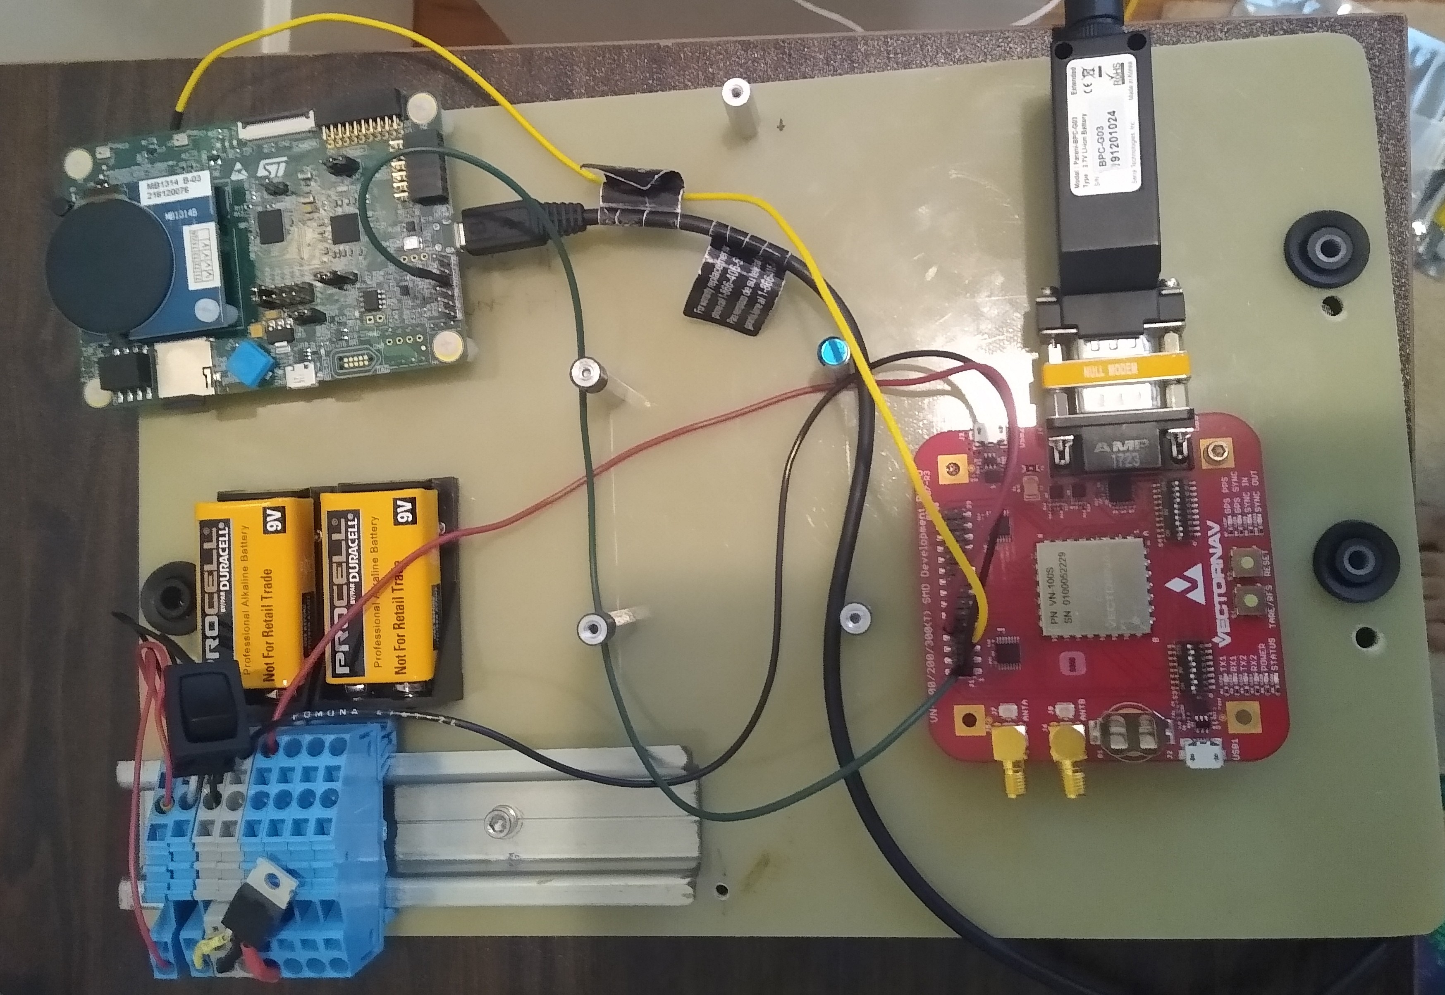
Figure 7. Picture of the current IMU Data Logger System
A double buffer system was created on the data logging program on the STM32L4R9AI Discovery Board in order to store and record the incoming binary IMU data faster than the board is receiving it. The logging program is currently run externally through Visual Studio 2017 but this too will be self-contained within the CPF in the future.

RESULTS/ DISCUSSION

NED REFERENCE FRAME

The VN-100 has the ability to measure accelerations in two different reference frames [VectorNav Technologies (2017)]. The first reference frame treats the center of the IMU as the origin for an XYZ reference frame. However, the yaw, pitch, and roll must each be accounted for to calculate the true direction and magnitude of measured accelerations. In the interest of accuracy and time, we chose to measure acceleration using a North-East-Down (NED) reference frame, using the earth’s magnetic field to determine a true, unchanging North, East, and Down reference frame regardless of the orientation of the IMU [VectorNav Technologies (2017)]. Additionally, the LinearBodyNED mode of the VN-100 removes measured acceleration due to gravity [VectorNav Technologies (2017)]. This reference frame’s accuracy as a true NED reference frame depends on the resolution and accuracy of the VN-100’s three equipped magnetometers for each axis. With this mode, a non-moving IMU ideally measures no acceleration in all 3 components of the reference frame.

With the crawler moving at a constant speed in the circle, the acceleration due to centripetal force will always point towards the center. Because we are measuring using a North-East-Down reference frame, we expect to see two sinusoidal acceleration signals (representing the North and East accelerations, the down acceleration is omitted as it is assumed to be 0) with a phase offset of π/2 when the car is running. Their amplitudes should match the calculate magnitude of centripetal acceleration.

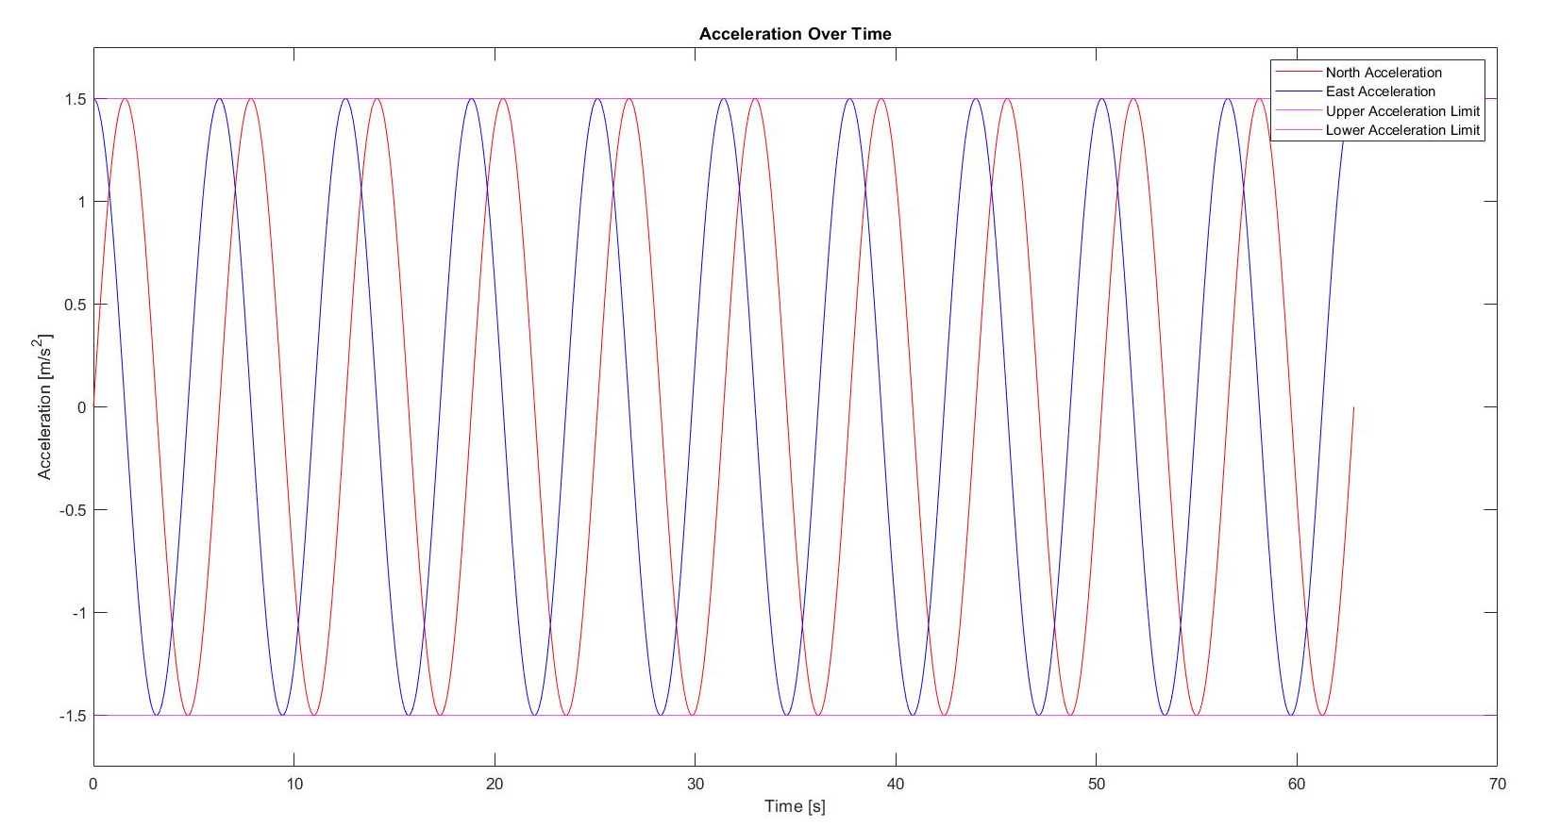
Figure 8. An Idealized Acceleration Signal where the RC Crawler is moving at a constant speed

Similarly, the calculated velocity data would be sinusoidal, with amplitudes ideally matching the calculated tangential velocity of the crawler.

RESULTS
The CPF will first begin taking acceleration measurements while parked on the seabed. Using this static data, we can estimate the minimum noise the IMU will experience while using this current experimental method.
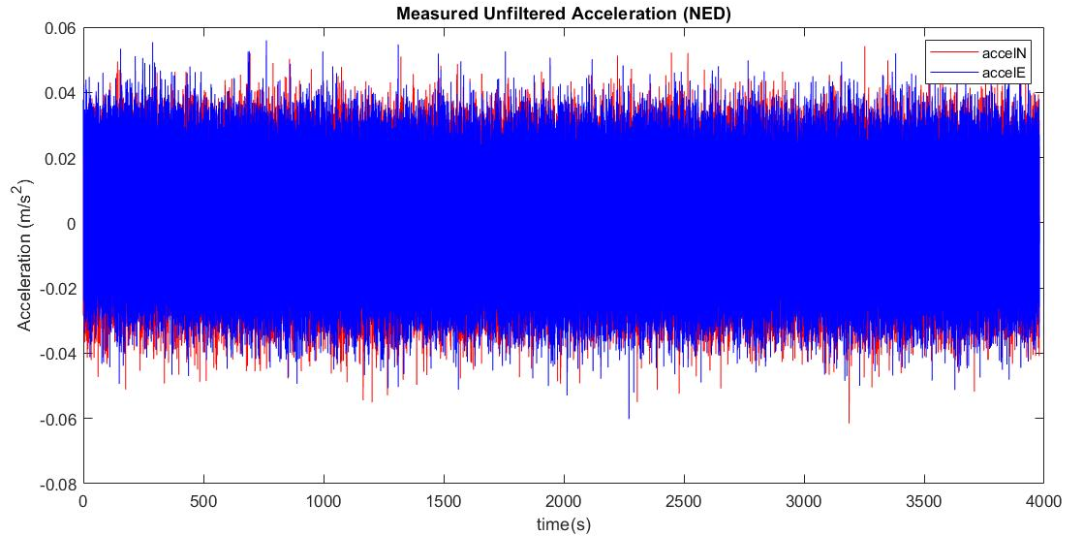
Figure 9. An Hour of Unfiltered Static Acceleration Data
Figure 9 shows that the experimental method, the sampling frequency, and the noise density, alignment error, and in-run bias stability of the VN-100 [VectorNav Technologies (2017)] contributes to a minimum noise of roughly 0.04 m/s². This noise can be significantly reduced through filtering.
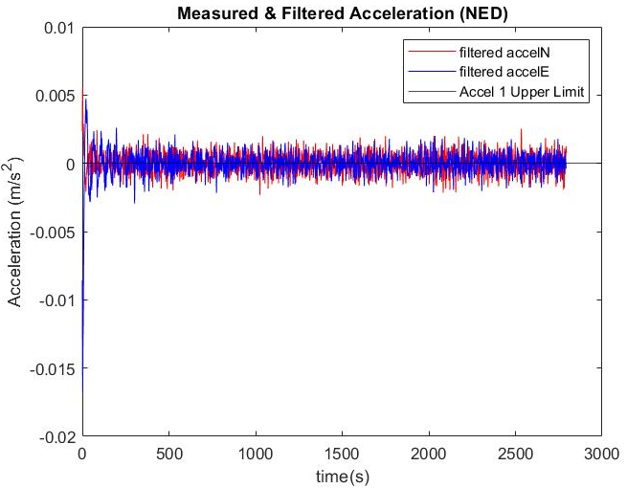
Figure 10. Filtered Acceleration Data with No Smoothing
Introducing dynamic data to our measurements requires a filter with different properties as we are seeking to include sinusoidal signals of extremely low frequencies. For instance, a Welch power spectral density analysis of a 5’4” test where the car ran at full speed showed a frequency spike at roughly 0.1308 Hz. This goes in line with the calculated frequency of the acceleration signal at 0.128 Hz. In contrast, static data was assumed to be a DC (0 Hz) signal, so we simply used a lowpass filter and detrended the data.
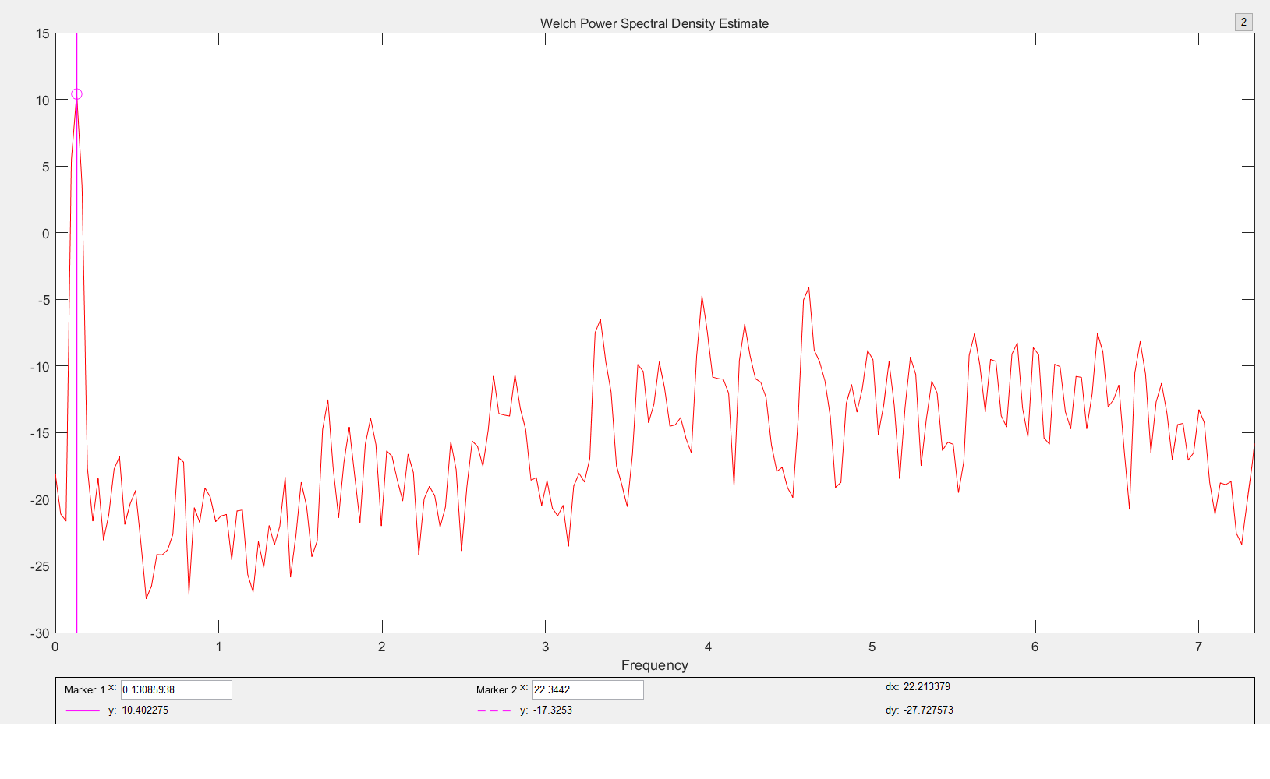
Figure 11. Welch Power Spectral Density Estimate for the 5’4” Signal
However, that method would not be a viable option within the CPF, it should be able to stop recording regardless of its final velocity. The clear sinusoidal characteristics of the unfiltered acceleration signal can be seen in Figure 12.
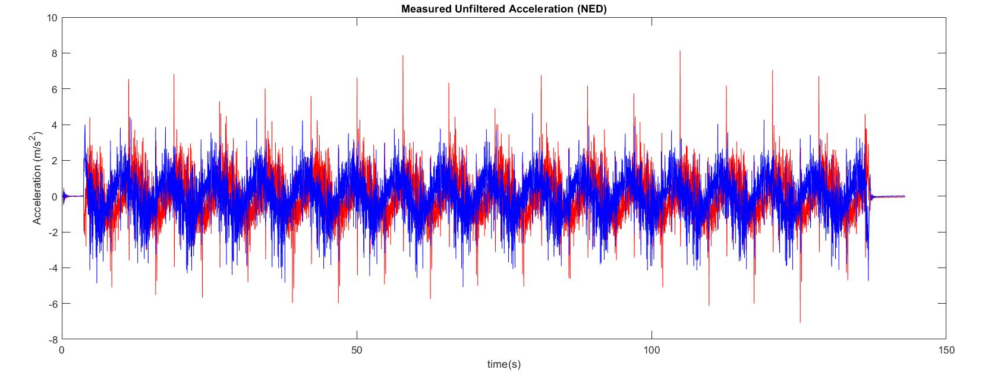
Figure 12. Unfiltered Accelerations from the 5’4” Circle Run
We initially integrated velocity from the unfiltered acceleration signal, then filtered the data as seen in Figure 13. We assumed that the characteristics of the signal would be amplified in integration, making them easier to filter in the velocity signal.
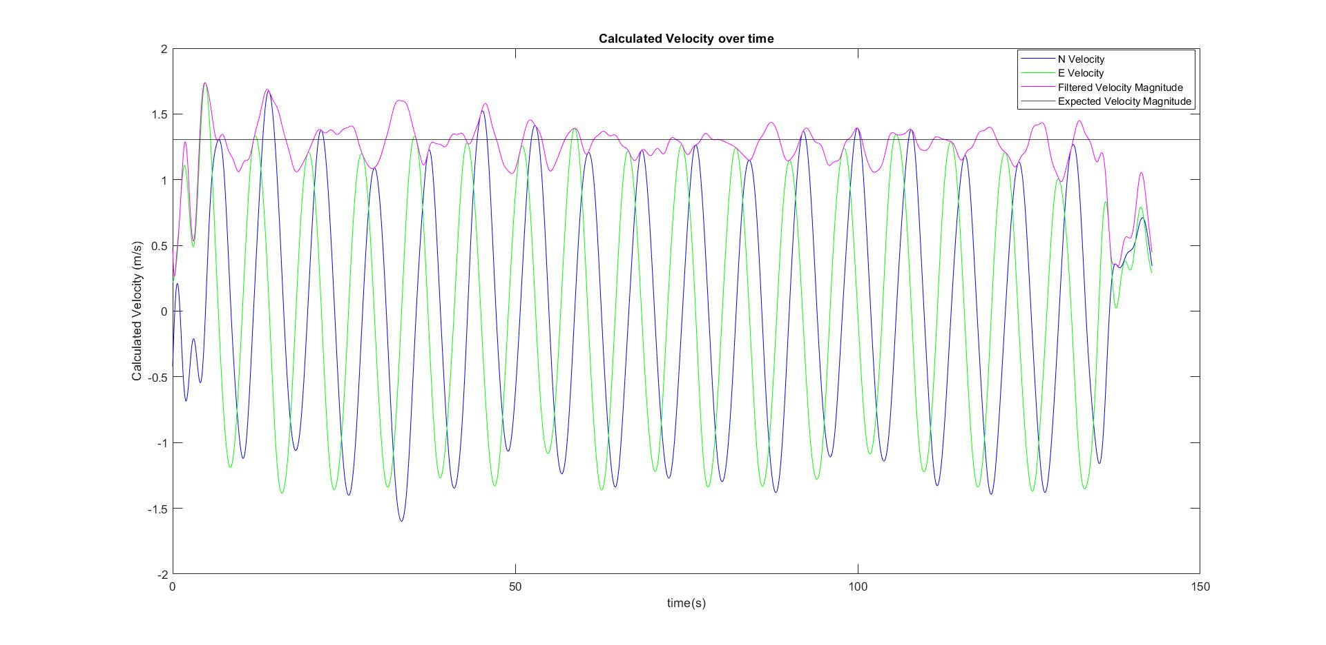
Figure 13. Filtered Velocity Profile from the 5’4” Circle Run
However, this filtering approach did not properly account for the short periods of time when there was static data. We chose instead to create velocity profiles from filtered acceleration data, with a filter designed to include signals within our desired frequency range.
Because the velocity of a CPF would change over time, we include static and dynamic data in our tests. Additionally, the car would travel at distinct speeds to generate different acceleration magnitudes. In Figure 14, there exists four different modes in the test. First, the car begins recording static data. Then, it travels at its fastest speed of roughly 1.684 m/s. It slows down by roughly a factor of 4, traveling at ~ 0.82 m/s. Finally, the RC Crawler inches slowly around the circle at a velocity of ~0.23 m/s.
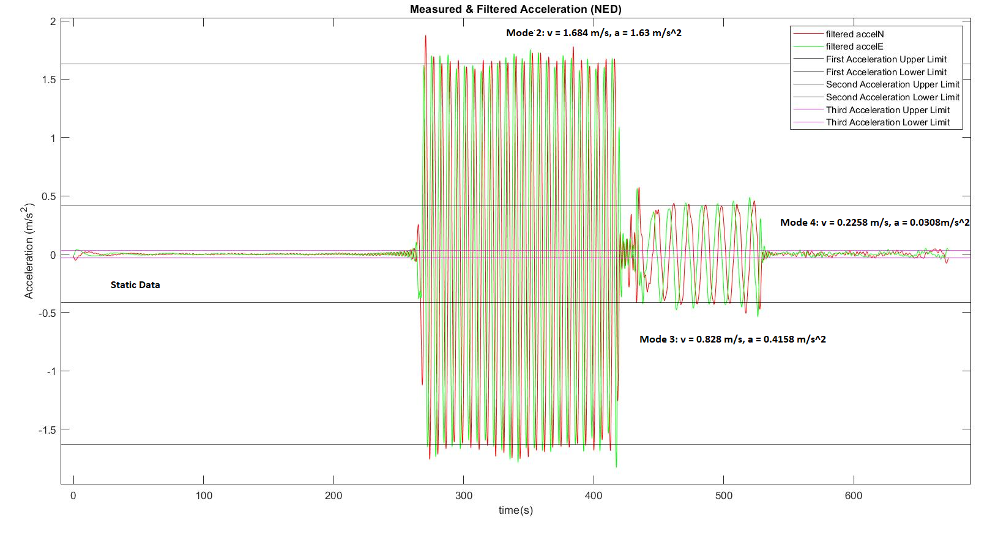
Figure 14. Filtered Acceleration Data from 5’5” Circle Run
In the static data, very slight oscillations are still visible. We see a similar peak induced at the beginning which is believed to be a result of the current bandpass filter. In Modes 2 and 3, the sinusoidal characteristics of the signal are clearly visible and their amplitudes hover around the desired value. Oscillations here are likely due to the fact that the RC Crawler does not move at a completely uniform speed but it is also likely the current bandpass filter also plays a role in altering, or “enveloping” these amplitudes [Steven S. (1997)]. In Mode 3, the sinusoidal signal is still clearly visible; the signal can easily be extracted from the noise. However, a slight drift is noticeable near the end of that mode. Finally, in mode 4 noise is much more visible at a = ~0.0308 m/s². However, a sinusoidal signal of extremely low frequency, much lower than the present noise, can be seen. This means that even at this low magnitude, an acceleration signal can still be properly extracted from the noise. These observations are supported in the accompanying velocity profile, as shown in Figure 15.
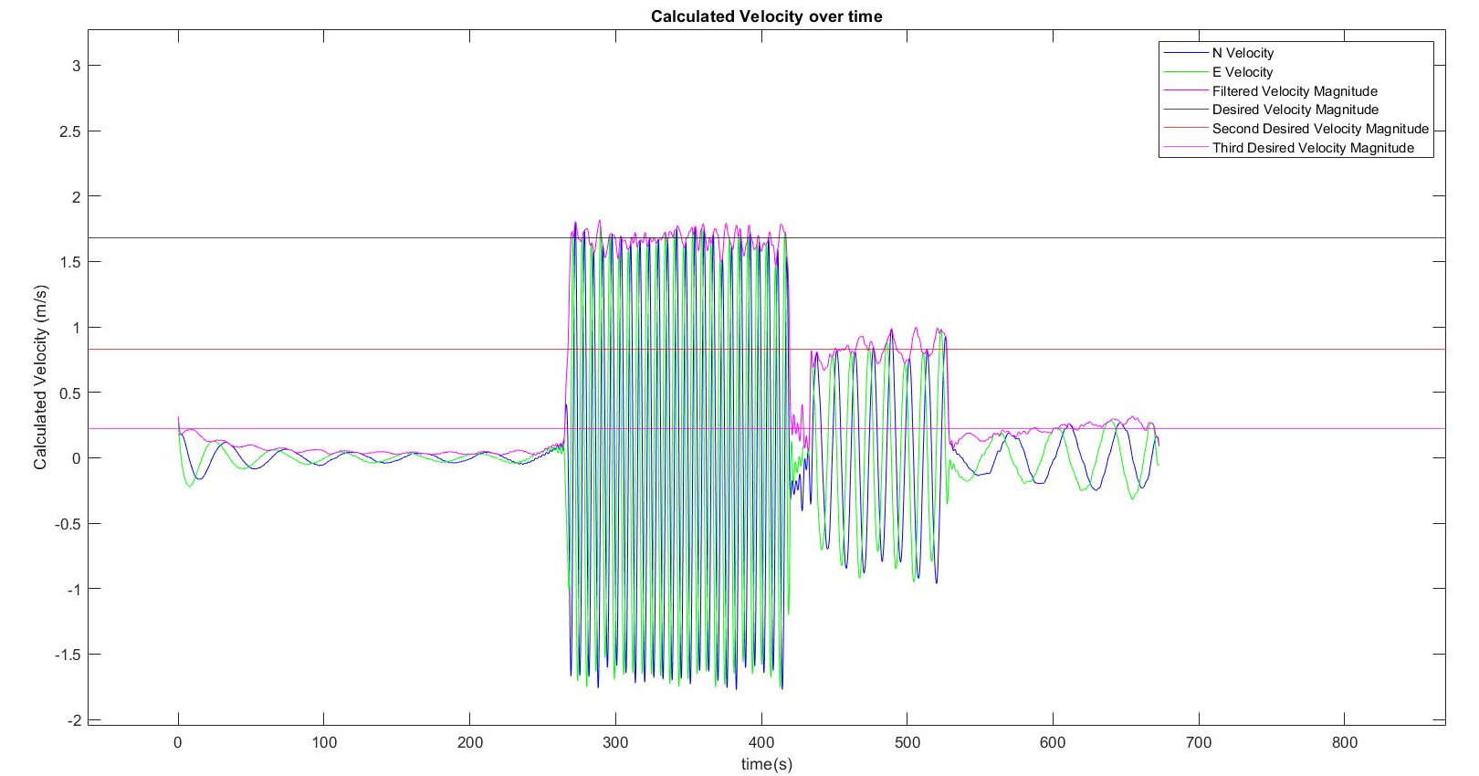
Figure 15. Filtered Velocity Profile from 5’5” Circle Run
When we directly filtered the velocity profile, we still come to the same observations. A clear sinusoidal signal can be extracted from all 3 modes. However, there appears to be more of a drift as the acceleration signal magnitudes gets lower and weaker. Some of this drift can be corrected by an average mean filter to create “bins” of velocity measurements for each 10 meters traveled by the CPF.

CONCLUSIONS
The current experimental process has determined a modest lower limit of detection. However, it was also subject to noise that could not be easily filtered out with a simple bandpass filter. Because of the extremely low frequencies (< 0.15 Hz) and magnitudes (<< 1 m/s²) we are measuring, and remaining noise has the potential to significantly alter the acceleration measurements and velocity profiles. The noise sources come from both expected and unexpected sources. For example, the engine of the RC Crawler, bias of the VN-100, and extremely small terrain variances are contributors but at these low frequencies and accelerations, the internal vibration of the earth as well as nearby powerplants and moving cars could play a role in extremely low frequency noise generation. Within the ocean, much of this noise is removed. However, we were unable to test the IMU on site due to the limitations of a virtual internship.
The current filtering process clearly has limitations. It appears that the current bandpass filtering approach via MATLAB induces some sinusoidal signals in the static data and can alter the magnitudes of recorded acceleration signal. Additionally, each test required a filter with slightly different settings. A better understanding of signal processing is needed to extract proper acceleration signals at lower accelerations using the current experimental method.
Despite these challenges, we have still been able to extract accurate acceleration signals and velocity profiles involving accelerations as low as ~0.03 m/s² or ~3 cm/s² (3/1000th of the acceleration due to gravity).
THE PATH FORWARD
In order to completely define the lower limit of detection for the VN-100, a new experimental method must be created in order to eliminate noise and generate a truly constant acceleration experienced by the IMU. We can do this by creating a programmable rotary table, calibrated to move at extremely low speeds. We can also use this rotary table to gradually change that speed to better simulate the type of conditions that would be seen in the ocean.
A better signal processing approach is essential for extracting proper signals from lower accelerations. The current filter ultimately assumes that a signal “repeats” itself after a given time [Steven S. (1997)], which is not applicable to signals from the real world. We need a filter that can be applied to any measurement seen in the ocean. Further research into wavelet filtering might yield better results in future tests.
We assumed that the RC crawler operates as a single particle with the center of mass coincident with the center of the IMU. Although the differences are likely to be minimal considering the mass of the crawler, the magnitude of accelerations experienced, and the fact that the current results still closely line up with the expected values. It is worth considering when the IMU is deployed onto the CPF which will have a much greater mass.
While the exact lower limit of detection for the VN-100 has yet to be found, we have proven that an inexpensive IMU can measure these extremely low accelerations. With a more accurate system, better signal processing, and a more reliable and comprehensive experimental method, it is certainly possible that an IMU could properly estimate the water column velocities of the coastal seas, making the Coastal Profiling Float a more feasible system for continuous coastal ocean observation.

ACKNOWLEDGEMENTS
Many thanks to Gene Massion for being both an optimist and a realist and the invaluable advice he gave over this summer regarding the engineering process. I have learned a great deal about being an engineer in both a science-focused setting as well as an industry setting. I look forward to working with him and MBARI in the future and am excited to see where this ongoing project leads to.
Thank you as well to George Matsumoto and Megan Basset for organizing the 2020 MBARI Summer Internship despite the clear challenges of working in a virtual setting.
Finally, thank you to the VectorNav Technologies Support Team. They have always answered my questions in a clear and comprehensive way and have given me a path forward when I did not know where to go. They were an excellent resource to consult.

REFERENCES
Access to SOCCOM Program Key Outcomes: https://soccom.princeton.edu/content/key-outcomes
Argo (2000). Argo float data and metadata from Global Data Assembly Centre (Argo GDAC). SEANOE. https://doi.org/10.17882/42182
Arrow Electronics (2020) – What is IMU? Inertial Measurement Unit Work & Applications. https://www.arrow.com/en/research-and-events/articles/imu-principles-and-applications
Burke L., Yumiko K., Kassem K., Revenga C., Spalding M., McAllister D., (2001). Pilot Analysis of Global Ecosystems: Coastal Ecosystems. The World Resources Institute: 2-4. http://pdf.wri.org/page_coastal.pdf
CH Robotics Library – Using Accelerometers to Estimate Position and Velocity http://www.chrobotics.com/library/accel-position-velocity
Krause-Jensen, D., Duarte, C. Substantial role of macroalgae in marine carbon sequestration. Nature Geosci 9, 737–742 (2016). https://doi.org/10.1038/ngeo2790
SBG Systems (2018) - What is an Inertial Measurement Unit? https://www.sbg-systems.com/inertial-measurement-unit-imu-sensor/
Steven S. (1997). The Scientist and Engineer's Guide to Digital Signal Processing California Technical Publishing, ISBN-10: 0966017633
Streiff, L. New Coastal Profiling Float for Diagnosing Ocean Health. MBARI News (2020). https://www.mbari.org/coastal-profiling-float/
Teledyne Marine (2016). Ocean Observer III 38 kHz ADCP. http://www.teledynemarine.com/Lists/Downloads/ocean_observer_lll_datasheet_lr.pdf
Titterton, D. H., Weston, J. L. (2004). Strapdown Inertial Navigation Technology. Reston, VA: American Institute of Aeronautics and Astronautics.
VectorNav Technologies (2017). VN-100 IMU/AHRS Product Data Sheet. https://www.vectornav.com/docs/default-source/datasheets/vn-100 datasheet.pdf?sfvrsn=8e35fd12_3
VectorNav Technologies (2017). VN-100 IMU/AHRS User Manual. https://www.vectornav.com/docs/default-source/documentation/vn-100-documentation/vn-100-user-manual-(um001).pdf?sfvrsn=b49fe6b9_32

