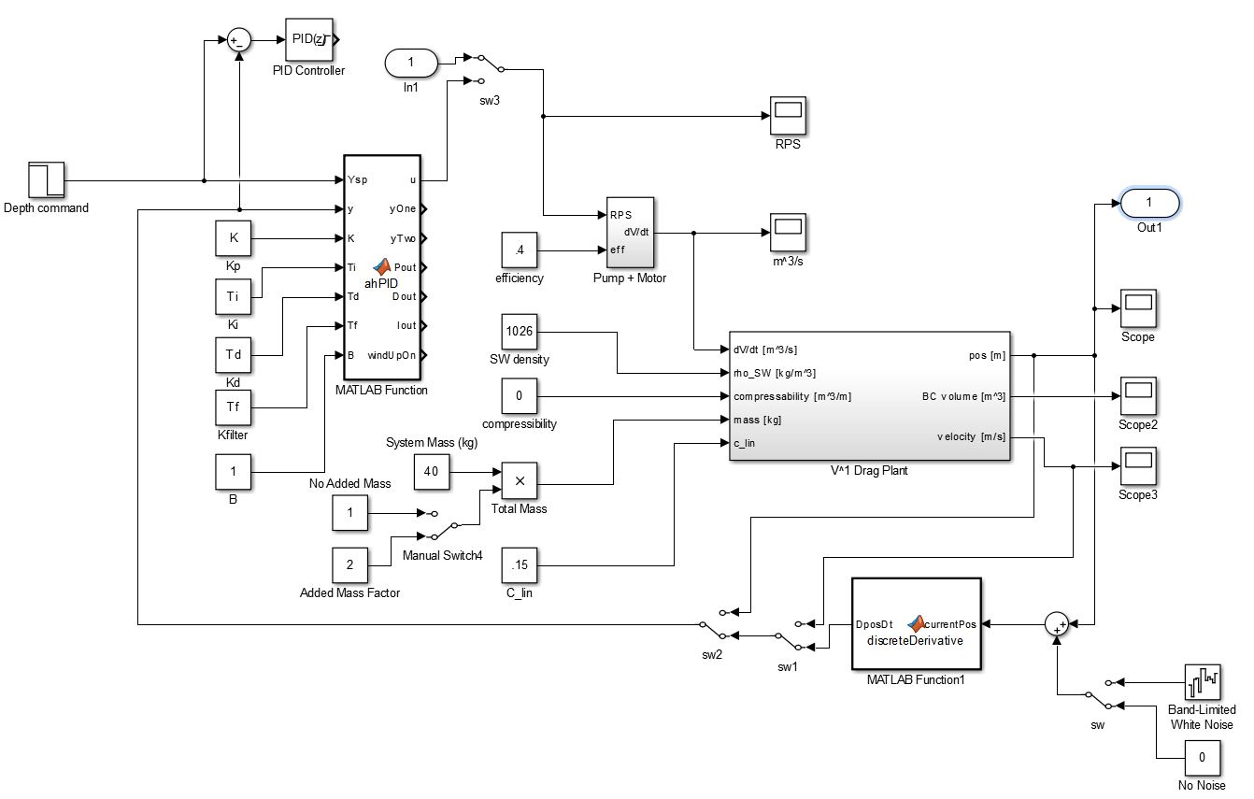
Note placement of in/out ports. After connecting them, run the model. Then run the below function to get a linearized transfer function:
>> simulink2TF('plant_drag_lin') % Function code below
Output:
Your transfer function is:
T =
3.483e-05
----------------
s^3 + 0.1469 s^2

function simulink2TF(model);
% This function gives a linearized transfer function from a simulink model.
% To run this, you must place "in" and "out" ports within your model, and
% then run the simulation. Afterwards you can do this. See Gene Massion for
% document showing placement of in/out ports.

% Example: simulink2TF('profiling_float_model')
% model - string of simulink block model name
%
% Laughlin Barker
% Summer Intern 201
% Chem. Sensors Lab

% Create matricies for (linearized) SS model based on block diagram
% gives SYS.a, SYS.b, SYS.c, SYS.d for standard Ax + Bu, Cx + Du SS model
SYS = linmod(model);

TSS = ss(SYS.a,SYS.b,SYS.c,SYS.d);

[num,den] = tfdata(TSS,'v');

disp('Your transfer function is: ')
T = tf(num,den)

%Now plot RL
figure;
rlocus(TSS);

