

Instruction Manual:
CPF Velocity Estimation Program
Summer Internship 2016 Nicholas Raymond
8/12/2016

Objective
This document provides details about the Matlab code develop for the MBARI Coastal Profiling Float (CPF) project written and develop by Nick Raymond for the MBARI 2016 Sumer Internship project while working with mentor Gene Massion.
The program evaluates the performance of filtering methods when estimating velocity profiles from accelerometer sensor measurements taken on the Newport Linear Translation Stage, shown below, and is intended to be used as tool for future work so that more effective filter methods can be tested and validated before the velocity estimation algorithm is integrated within the CPF project.
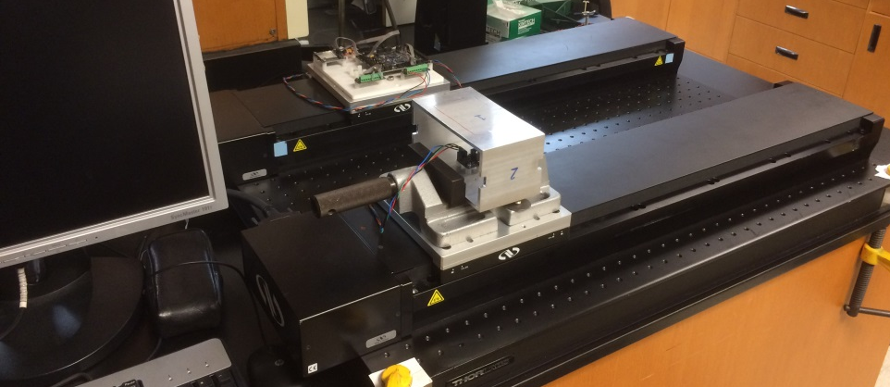
Figure 1: Experimental setup of sensor and linear translation table for collecting acceleration data.

Path Trajectory and Signal Analysis Program

Overview
This is a program to simulate and then compare acceleration and velocity profiles generated from the linear translation stage using the BNO055 IMU. The code is meant to be a stand along program, and includes nested functions and filter settings within the body of the program; there are no external references besides the initial file for importing acceleration data.
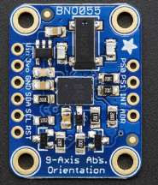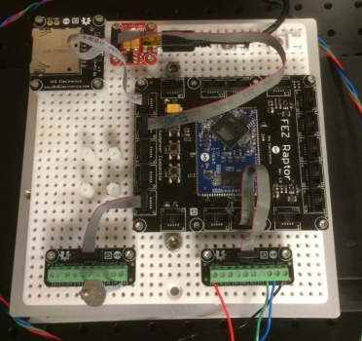
Figure 2: BNO055 sensor and GHI data acquisition hardware used for experiments.

Simulation
The user first specifies the following settings, which determine the shape of the desired velocity profile. This is referred to as the “simulated” velocity profile and represents the TRUE profile that we wish to obtain from the sensor measurements. The final error calculations reference this profile, and subsequent acceleration calculations are determined from these initial conditions.
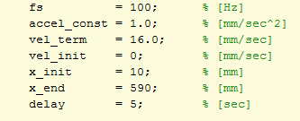
Figure 3: User specified settings for generating the simulated velocity profile.
The user must then specify the length of time that the simulation will run for. For the example in this document, a total simulation run time of 10 minutes was programmed with the following command:
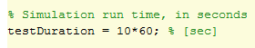
Figure 4: Variable to control the duration of the simulation, 10 minutes was selected for this example.

Velocity Profile
The velocity profile is calculated from the equations of motion for a particle accelerating with constant acceleration. The equations are shown below:
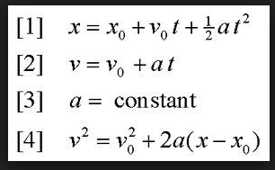
Figure 5: Equations of motion used to calculate the desired simulation velocity profile.
Using the initial conditions already specified in the above section, the velocity profile is determined as a piece wise function, having four unique sections, by solving for the change in time between the desired terminal velocity values. In this way, the desired velocity and acceleration values constrain the solution and we solve for unique points in time and position. These position and time values are then used to program the linear translation stage during the experiment in later steps.
Given the specified parameters from Figure 1 the following velocity profile is obtained, which was programmed to have a terminal velocity of 200 mm/sec:
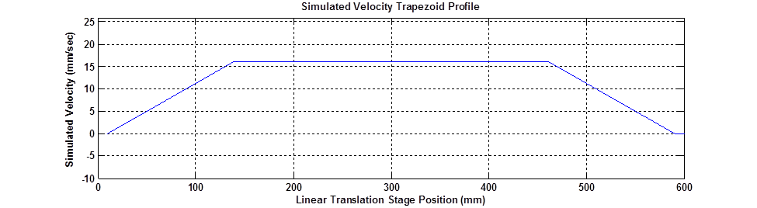
Figure 6: Velocity profile derived from initial conditions and velocity/acceleration constraints.
It is important to note that this plot represents the velocity vs linear stage position and is made from only four unique points. This represents that translation stage starting at the home position and traveling to the end of the linear stage. Note: the linear stage is 600 mm long, but we limit the range of travel to be between 10 - 590 mm. This is done to prevent the table from hitting the limit switches at the ends of the track, when using higher velocities and accelerations. The following plot represents one complete cycle on the linear stage, where the table moves to the end of the track and then returns to the starting position.
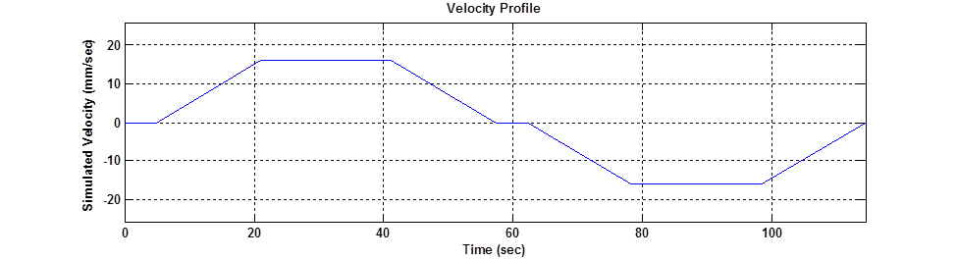
Figure 7: Simulated velocity profile for a single cycle with the linear table.
Once this profile has been created, we can determine the total number of cycles that will be completed within the allotted simulation time (ex. 10 minutes), to obtain the final simulation velocity profile:
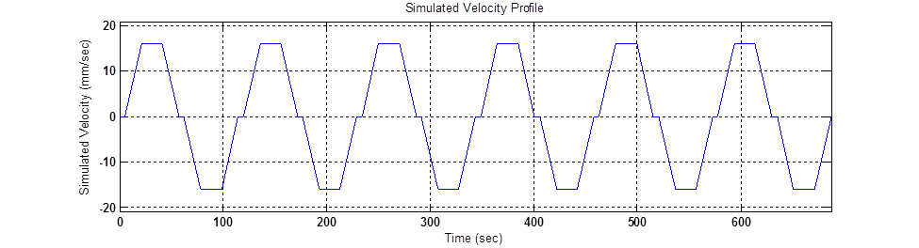
Figure 8: Simulated velocity profile for entire simulation run time of 10 minutes, with six cycles.

Acceleration Profile
The simulated acceleration profile is created from the discrete points in time where there is a change in piecewise velocity profile. The variable timeSIM represents a vector of these unique time points. Since accelerations are assumed to be constant, a simple alternating square wave signal represents the simulated acceleration profile. As with the velocity profile, once a complete acceleration profile cycle has been created, it is easy build a larger acceleration profile to span the full simulation run time (ex. 10 minutes).
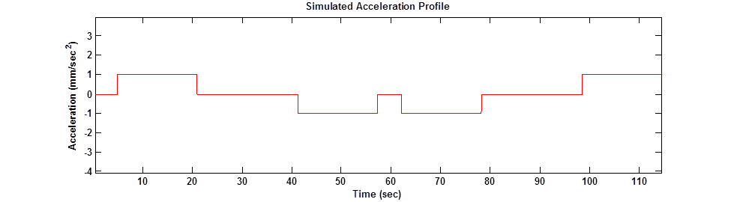
Figure 9: Simulated acceleration profile for one cycle of the translation stage.
Figure 10: Simulated acceleration profile for entire simulation run time of 10 minutes, with six cycles.
Once the simulated acceleration profile has been created, a copy of the profile is made. This copy of the profile has a higher density of points distributed along the curve with the density of the added points being equal to the desired sampling rate that will be used by the sensor (ex. 100 Hz). As a verification step, the simulated acceleration profile in Figure 8 is numerically integrated using the cumulative trapezoid rule to obtain a numerical estimate of the corresponding velocity profile. This numerical approximation of the velocity (generated from the simulated acceleration profile) is then compared to the original simulated velocity profile, shown in Figure 6, as a check to verify that the generated acceleration profile produces the desired velocity profile. The results are shown below:
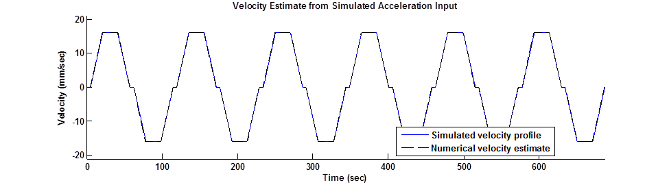
Figure 11: Verification step to ensure that the programmed acceleration profile will result in the desired velocity profile as specified by the user inputs.

PSD for simulation profiles
The Welch method is used to obtain an estimate of the power spectral density from the acceleration profile, using the acceleration profile with the larger density of data points. This information can then be used to predict the dominant frequencies that would be detected within the experimental sensor data. The Welch method is called with the following command, and produces the following plot:
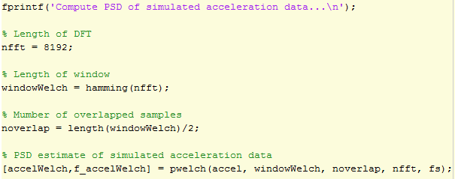
Figure 12: Matlab commands to call the Welch method on the simulated acceleration data.
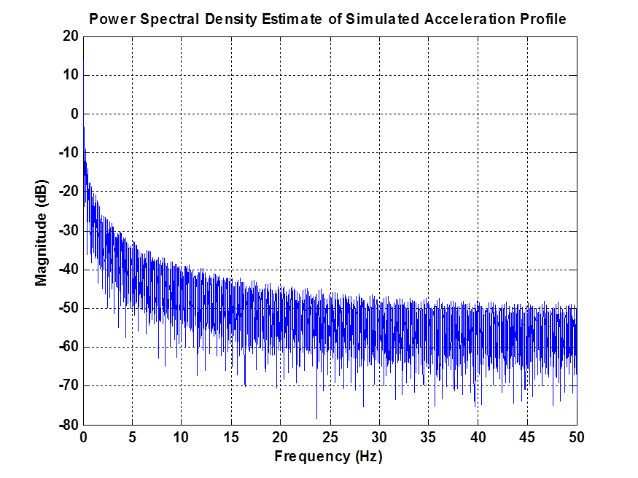
Figure 13: PSD obtained by applying the Welch method on the simulated acceleration profile.

Simulation Results and Outputs
Pertinent information about the simulation settings and calculated values are printed to the workspace. This information can then be used to program the linear translation stage and setup the data logger for running experiments. An example of the printed information is shown below:
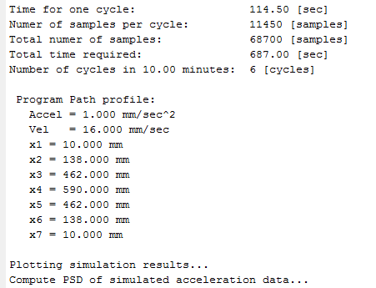
Figure 14: Print out of information used to setup the linear translation table experiments.

Simulation Plots – Turn ON/OFF
If you do not want to show all the simulation plots every time you run the program, simply change the following variable to false, and the previous figures will not be generated.
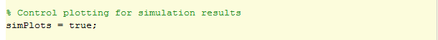
Figure 15: Simulation plots will print to screen.
Figure 16: Simulation plots will NOT print to screen.

Experimental Sensor Data

Import sensor data
The user must specify the directory and filename to open the desired sensor output file. The variable fileName is used to specify both directory and file name, as shown below:
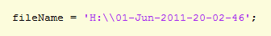
Figure 17: Figure 13: Proper format for Inputting the filename and directory.
IMPORTANT!!!
This program assumes that the data from each sensor axis is saved in a separate text file. As an example, the accelerometer on the BNO055 has three axes, XYZ, so the data streams from this sensor will have 3 unique files, as shown below:
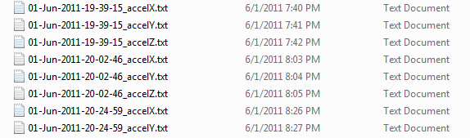
Figure 18: Example of file naming convention from the BNO005 data logger.
We see that all three of these highlighted files share the same “01-Jun-2011-20-02-46” as part of the file name, and then have different ending to differentiate between the XYZ axes. When inputting the file name and directory, you DO NOT include the “_accelX.txt” or “_accelY.txt” or “_accelZ.txt”. Simply use the data and time stamp to indicate which files you want to open. In this way, the user must only give one input, but the program will process all three axes of data.
Figure 19: Proper format for Inputting the filename and directory.
The function bytes2float() was created and is defined at the bottom of the program. The bytes2float() function opens the sensor text file, reads the byte data, and performs all the operations to combine the LSB and MSB and output the appropriate engineering units for the accelerometer. The function outputs both 16 bit signed-integers and doubles. The doubles have units of m/sec^2, while the integer output represents the actual output from the sensor before dividing by a factor of 100 (as referenced from the BNO055 data sheet with the sensor configured to output m/sec^2 units). The intent of the int16 values is to allow the user to perform integer calculations without fear of truncation error, if needed.
As an example, here is the output from bytes2floats() for both the int16 and doubles:
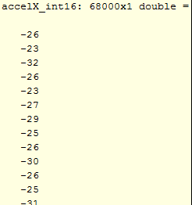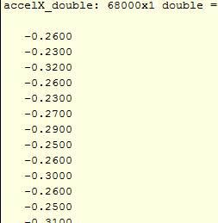
Figure 20: Example of outputs from accelX_int16 and accelX_double.
Below are the function calls that import the sensor data:
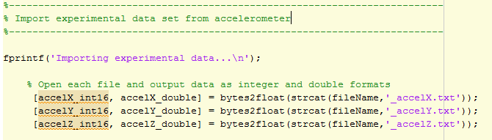
After the raw sensor data is imported, all three data streams are combined into the array accelEXP, and the raw sensor values are plotted in units of mm/sec^2.
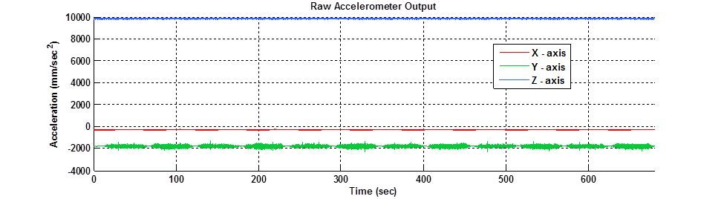
Figure 21: Raw accelerometer outputs displayed on a single graph, used to verify that import was successful.

PSD for experimental data
The Welch method is used to obtain an estimate of the power spectral density (PSD) for the XYZ axes of the sensor data. The function pwelch() is used to obtain the PSD estimates, and a Hamming window is implineted with a 50% overlap. This information is then used to determine the dominant frequencies that within the raw sensor signal, and can be compared to the PSD for the simulated acceleration signal in order to differentiate between noise and the true signal of interest. The following code is used to create three PSD estimates, and the results re then plotted. Before calculating the PSD for each axis, the raw sensor data is processed with the detrend() function to remove any trend in the signal and the inputs are cast as doubles.
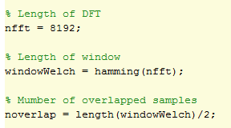
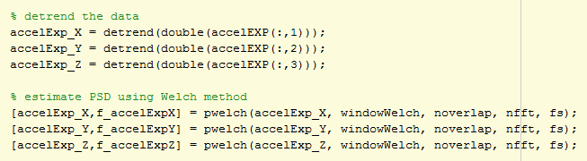
Figure 22: Portion of the code that calculates the PSD for all three sensor axes.
Below is an example of the plot command that is called to create the PSD plots that shows magnitude vs frequency for the experimental sensor data.
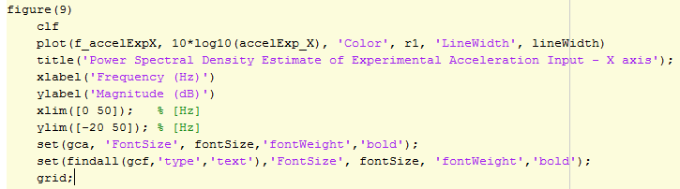
Figure 23: Examp0le of plot command to show PSD for sensor data.
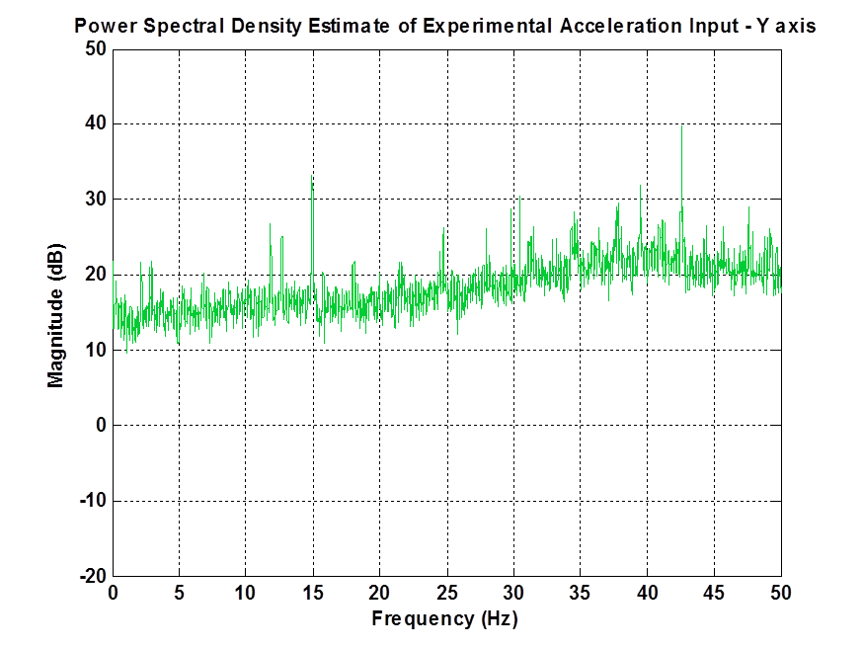
Figure 24: Resulting plot of the y-axis data after processing with the Welch method to obtain an estimate of the PSD.

Remove offsets
With proper sensor calibration, it should be possible to remove the large offsets seen in Figure 19. One of the benefits of the BNO055 is that is has an onboard calibration algorithm that works to remove this offset in real time. For these data sets, this function was not used since initial attempts to configure the sensor and save the offset and write them to the IMU were not successful. With more work, it should be possible to calibrate the BNO055. Alternatively, it was also discovered that by simple high pass filtering the offsets could also be removed with great success. Therefore, while this offset removal was written into the code, it is suggested that alternative methods be implemented.
A calibration function is included in this program, but it was found that better results were obtained with the matlab function detrend(). However, it should be noted that the detrend() function may be removing a significant portion of the acceleration signal, and therefore may not be the best solution for removing the offsets.
For more information on how this calibration process works, please see the following reference:
High-Precision Calibration of a Three-Axis Accelerometer, by Mark Pedley
http://cache.freescale.com/files/sensors/doc/app_note/AN4399.pdf

Filter Experimental data
In this program, two types of filtering techniques are used:
- Denoise filter – referenced from signal processing literature (reference)
- Moving average filter – IIR filter with specified A and B coefficients
The filters used in the program are created by individual function calls, and are defined at the bottom of the program. A brief overview of each filter is given below, however it is important to note that more testing is needed to determine the BEST filter.
Denoise Filter
The denoise filter has two parameters that can changes to improve the performance of the filter. Through trial and error, it was found that this filter is very effective at filtering the noisy accelerometer signal and performs very well over a range of accelerations ( we tested a range from 1 – 150 mm/sec^2). However, at this time the filter is treated more as a “black box” and further study is needed to fully understand how the filter functions. For this example, the raw data is processed with the detrend() function to remove the offset before applying the Denoise filter. For these experiments, this was found to produce good results, however a more robust filtering method for the go-to-sea code should avoid the detrend() function since it may be removing portions of the signal in the processing.
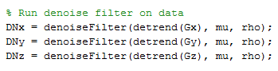
Figure 25: Function call to apply the Denoise filter to the raw sensor data.
Since more study is needed to fully understand how this Denoise filter works, a secondary function denoiseParameterTest() was created to allow the user to test various values of mu or rho and perform a rudimentary “guess and check” method to better tune the parameters. The user can specify the starting mu parameter value, and specify the incremental change in mu for five sequential runs. The filter is then applied to the raw data set, and the five mu values along with the simulated acceleration profile signal are plotted together for a visual comparison. The specific mu values are printed to the workspace window, so that the legend in the plot correlates to a specific numerical value. Note: only one parameter (mu or rho) is incremented during the function call, if the user wants to test ranges of rho they must slightly modify the function definition. For the range of values tests, it was found that mu had a much larger influence on improving the filter performance. But more testing is needed.
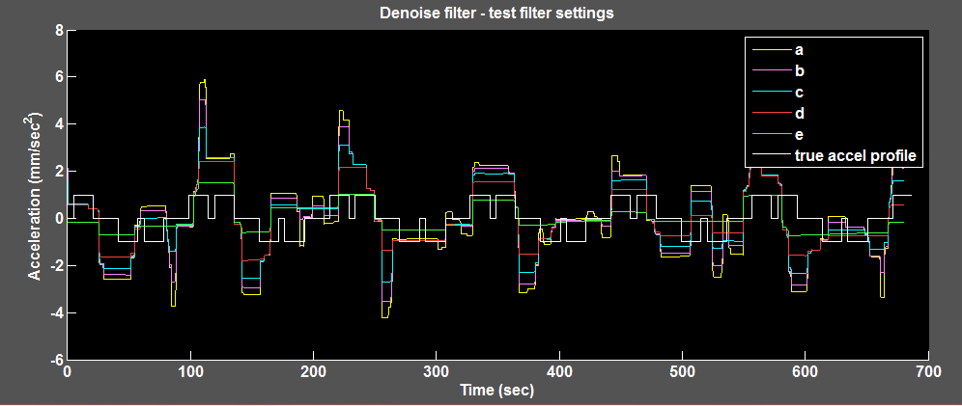
Figure 26: Resulting plot generated from the denoiseParameterTest() function.
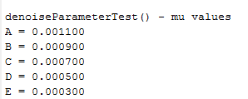
Figure 27: Output printed to workspace from the denoiseParameterTest() function showing values of mu used for the test.
To run the denoiseParameterTest() the user can change the following lines to call the function. It is also recommended that a break point be added after this line, so the user can look at the output plots and determine the best mu value accordingly.
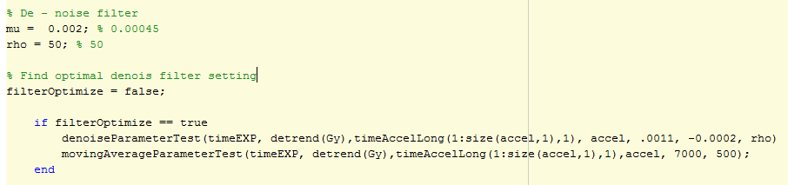
Figure 28: Section of code that allow the user to activate the test for visualizing changes to the denoise filter parameters.
Moving Average
This is an example of an IIR filter, where the A coefficient is given a value of one, and the B coefficients are determined by the number of data points that will be average together (N) as specified by the user. Once values for the A and B coefficients are known, the matlab function filter() is then applied to the raw data. The function movingAverageFulter() is defined at the bottom of the program, and is shown below:
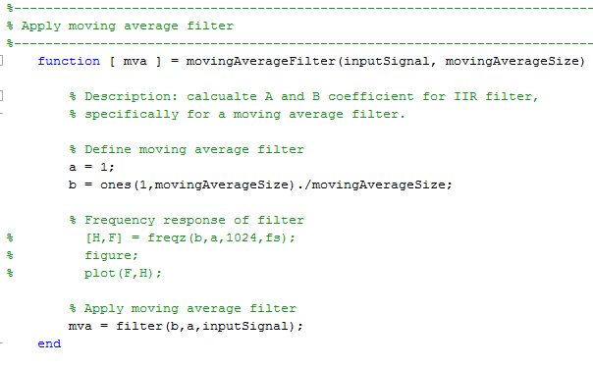
Figure 29: Function definition for creating the moving average filter.
Just as with the Denoise filter, a secondary function was created to test a range of N values for the moving average filter. In this way various filter settings can be compared and allow the user to better tune the filter for the specified input signal. The output from this function, movingAverageParameterTest() is shown below.
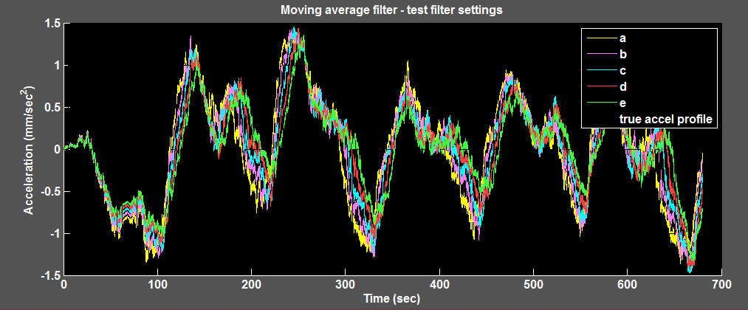
Figure 30: Output plot from the function movingAverageParameterTes() to visually compare difference in filter settings.

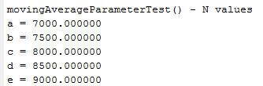
Figure 31: Numerical output from function movingAverageParameterTest() sent to the workspace.
Below is a plot of the y-axis acceleration profiles after applying the two types of filters. There is an obvious phase delay between the experimental and simulated data, and this will be corrected in following sections.
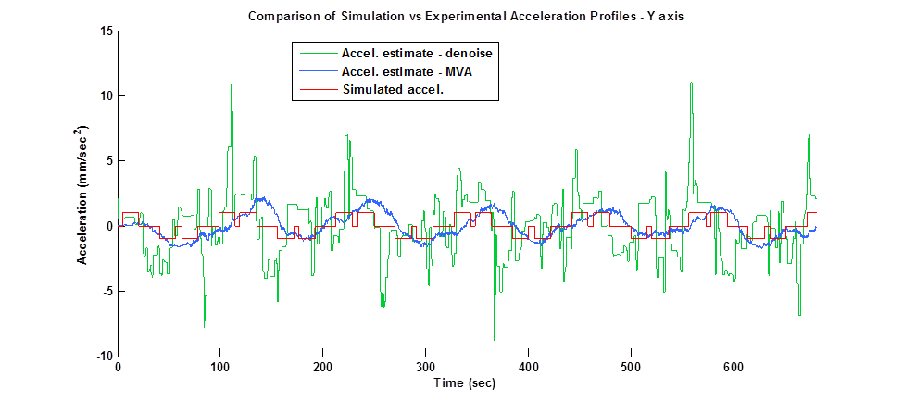
Frequency Selective Filters
These set of filters were not incorporated into this program, however it is believed that these filters offer the best performance and most flexibility. More work is needed, but it is possible to create individual function calls and apply either bandpass or highpass filters to the data set to remove offsets and high frequency noise if optimally tuned.

Calculate Velocity Estimate
After the sensor data was been filtered with either the Denoise or Moving Average filter, we perform numerical integration by calling the cumtrapz() function. The cumtrapz() function implements the trapezoid rule to make the numerical estimate of the velocity, and in doing so makes the assumption that the data is sample at 1 Hz. As a result, the output must be multiplied by a factor of (1/fs) to obtain the correct output units of mm/sec. In this example the sampling rate fs = 100 Hz. The velocity estimates for each axis are stored the arrays velx, vely, and velz where the first column is the denoise filtered data and the second column in the moving average filtered data.
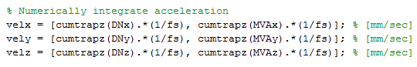
Figure 32: Numerical integration to obtain velocity estimate from filtered acceleration data.

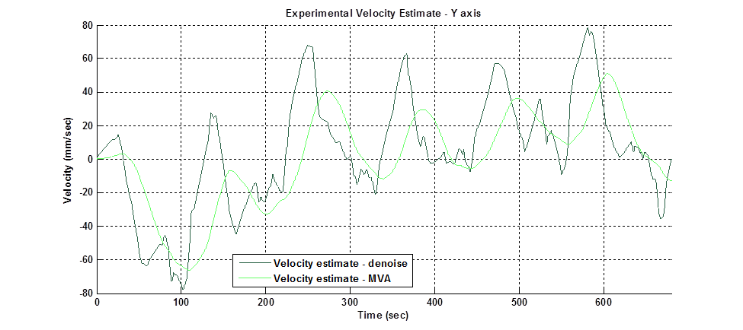
Figure 33: Plot showing the velocity estimates from both types of filtering methods for the y-axis.
We see that there is a periodic wavform superimposed with the velocity estimate. This is due to low frequency noise that was not filtered out from either the Denoise or Moving Average filter methods. To obtain the final estimate of the velocity profile, we must remove this periodic waveform from the velocity signal.

Remove nonlinear trend
In this program, a 12th order polynomial is fit to the velocity profile and then subtracted. This removes the unwanted periodic waveform from the signal and produces the final velocity estimate. This low-order polynomial fit method is referenced from the Matlab help tutorials (reference) and the results are shown below along with the function that was created to perform this operation. In future work, a bandpass filter may be implemented before the numerical integration step, and if tuned properly, should ellieviate the need to use this polynomial fit method altogether. While the currentl polynomial fit approach works with this data set, the data is periodic and only approximated the types of signals we expect to see in the ocean, therefore it is not desirable to use this polynomial fit approach on data collected from the ocean.
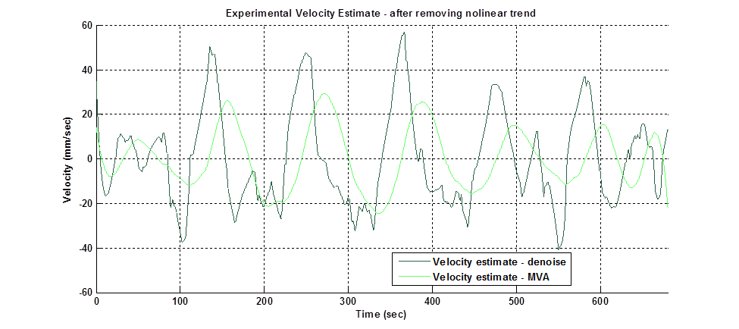
Figure 34: Final velocity estimate after subracting a low-order polynomial from the cumztrap() output.
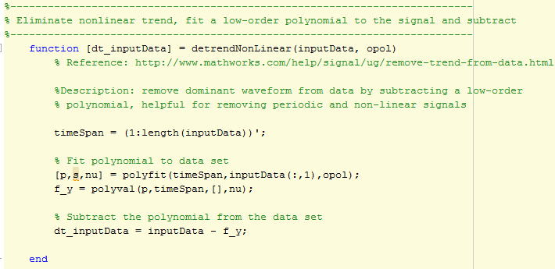
Figure 35: Function created to remove the periodic wave form from the cumztrap() output.

Compare Simulation vs Experimental Data
The final step in this program is to compare the experimental data to the simulated acceleration and velocity profiles.

Correct phase shift
There will be a phase shift between the experimental data and the simulated data. This must be corrected in both the acceleration and velocity profiles before we can make accurate error calculations. First we need to plot the experimental acceleration and velocity profiles WITHOUT any phase shift correction terms. To do this, set shift_accel == false and shift_vel == false. We can look at the acceleration or velocity plots and determine the phase shift using the following method:
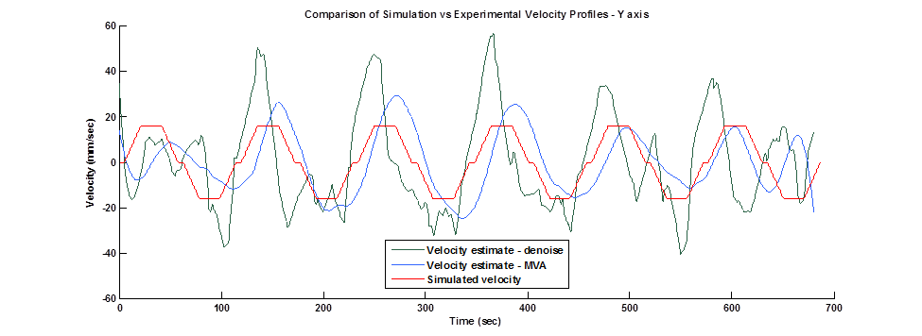
Figure 36: Velocity plot showing phase difference between the experimental and simulation.
Then zoom to look at a peak in the profile and determine the amount of phase (in seconds) for each of the profiles.

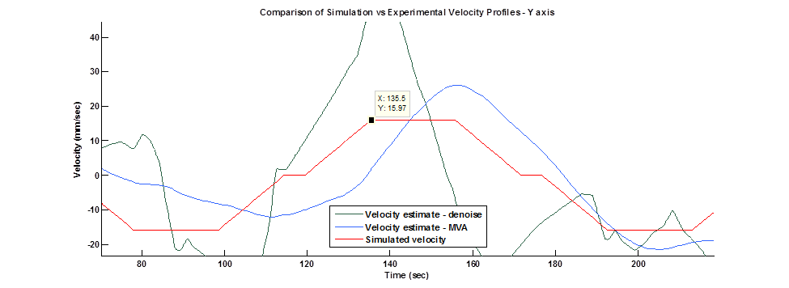
Figure 37: Manually determine the phase shift (in seconds) between the simulation and experimental data.

In this example, we note that the simulation velocity profile (red line) has a reference point of 135.5 seconds, while the denoise filtered profile (green line) has a reference point at 122.6 seconds and the moving average profile (blue line) has a reference point at 144.8 seconds. These values are saved in the following variables and then we turn shift_vel == true to rerun the plot. We obtain the following phase corrected plot.
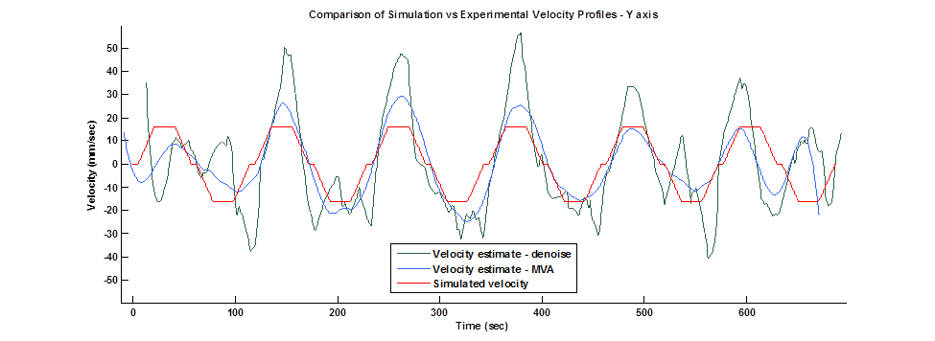

Error calculations
A performance metric is needed so that we can compare the performance of the filtering methods. We first determine the time intervals when the velocity profile should be constant. This is determined from the simulated velocity profile and the discrete points in time are saved to the variable indexVel which is a two column array. These values are then used to calculate the mean and rms values using the function errorCalcualtion() defined at the bottom of the program. An error plot is then created to show the results of mean values and rms from the experimental data.
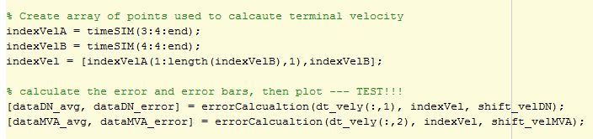
Figure 38: Section of code where the mean and rms values are calculated for the experimental data.
By modifying the outputs from the function errorCalcualtion() it is possible to obtain measurements of the standard deviation or variance. For the plots shown below, the standard deviation was plotted.
Figure 39: Plot showing the average constant velocity values from experimental data, along with errors bars that represent one standard deviation.

Appendix:
function[ ] = pathTrajectoryCreator()

% Creator: Nick Raymond
% Organization: MBARI
% Date: Jul 8, 2016
% Version: 1.0.0

%xxxxxxxxxxxxxxxxxxxxxxxxxxxxxxxxxxxxxxxxxxxxxxxxxxxxxxxxxxxxxxxxxxxxxxxxx
%
% DESCRIPTION
%
%xxxxxxxxxxxxxxxxxxxxxxxxxxxxxxxxxxxxxxxxxxxxxxxxxxxxxxxxxxxxxxxxxxxxxxxxx

% This is a program to simulate and compare acceleration and velocoty profiles from
% simualtion and experimental data collected on linear translation stage.

% Step 1:
% Simulate an acceleration profile by specifying constant accel,
% terminal velocity, and simulation run time. A perfect acceleration
% profile (no AWGN or offset) is created from 9 discrete points calcaulted
% from the kinematics of particle motion. This pure signal is then used to
% create a larger data set that represents an acceleration profile obtained
% from an accelerometer sensor over the full simulation time, having many
% more intermediate points data points as specifed by a desired simulation sampling freq.

% Step 2:
% An estimate of the PSD for simulated acceleration signal is
% created using the Welch method to look at the freq spectru. Then the
% simulated accel signal is numerically intergrated using the trapezoid rule
% to obtain a pure velocity profile (no AWGN or offset). This is the
% simulated velocioty profile that will be compared to the epxerimental results in
% Step ## when performing error analysis. The information from this
% simulation is used to inform the opperator about setting up the
% experiment on the translation slide such as position values, and total
% number of samples needed for programming the DAQ.

% Step 3:
% Import the experimental data. Detrend the data, look at the PSD.

%Step 4:
% Filter the experimental data, numerically integrate and apply a freq.
% selective filter to obtain the final experimental velocity estimate.

% Step 5:
% Compare the simulation data with the experimental data and calcualte the
% percent error as a function of time.

%close all
clear fig
clc

%xxxxxxxxxxxxxxxxxxxxxxxxxxxxxxxxxxxxxxxxxxxxxxxxxxxxxxxxxxxxxxxxxxxxxxxxx
%
% SIMULATION DATA
%
%xxxxxxxxxxxxxxxxxxxxxxxxxxxxxxxxxxxxxxxxxxxxxxxxxxxxxxxxxxxxxxxxxxxxxxxxx

%-------------------------------------------------------------------------
% Create simulation of acceleration and velocity profiles
%-------------------------------------------------------------------------

n = input('Enter a run number: ');

% Switch statement - user can input value from 1 to 5 to load files
switch n
case 1
disp('Run A')
fs = 100; % [Hz]
accel_const = 150.0; % [mm/sec^2]
vel_term = 200.0; % [mm/sec]
vel_init = 0; % [mm/sec]
x_init = 10; % [mm]
x_end = 590; % [mm]
delay = 5; % [sec]

% File name of Run A
%fileName = '/Users/nicholasRaymond/Box Sync/01 - MBARI/SignalProcessing_02/data/Trapezoid table motion/01-Jun-2011-19-20-56';
%fileName = 'C:\Users\nraymond\Downloads\data\Accel_Raw_Data_Trapezoid\01-Jun-2011-19-20-56';
fileName = '\\atlas.shore.mbari.org\projectlibrary\CPF\Interns\NichRaymond\Software\SignalProcessing_Final\Sensor Data\01-Jun-2011-19-20-56';

% Horizontal velocity profile shift values
crossSIM_vel = 7.06;
crossDN_vel = 11.90;
crossMVA_vel = 16.05;

% Horizontal acceleration profile shift values
crossSIM_accel = 0;
crossDN_accel = 0;
crossMVA_accel = 0;

case 2
disp('Run B')
fs = 100; % [Hz]
accel_const = 100.0; % [mm/sec^2]
vel_term = 40.0; % [mm/sec]
vel_init = 0; % [mm/sec]
x_init = 10; % [mm]
x_end = 590; % [mm]
delay = 5; % [sec]

% File name of Run A
%fileName = '/Users/nicholasRaymond/Box Sync/01 - MBARI/SignalProcessing_02/data/Trapezoid table motion/01-Jun-2011-19-39-15';
fileName = '\\atlas.shore.mbari.org\projectlibrary\CPF\Interns\NichRaymond\Software\SignalProcessing_Final\Sensor Data\01-Jun-2011-19-39-15';

% Horizontal velocity profile shift values
crossSIM_vel = 7.06;
crossDN_vel = 11.90;
crossMVA_vel = 16.05;

% Horizontal acceleration profile shift values
crossSIM_accel = 0;
crossDN_accel = 0;
crossMVA_accel = 0;

case 3
disp('Run C')
fs = 100; % [Hz]
accel_const = 10.0; % [mm/sec^2]
vel_term = 50.0; % [mm/sec]
vel_init = 0; % [mm/sec]
x_init = 10; % [mm]
x_end = 590; % [mm]
delay = 5; % [sec]

% File name of Run A
%fileName = '/Users/nicholasRaymond/Box Sync/01 - MBARI/SignalProcessing_02/data/Trapezoid table motion/01-Jun-2011-20-02-46';
fileName = '\\atlas.shore.mbari.org\projectlibrary\CPF\Interns\NichRaymond\Software\SignalProcessing_Final\Sensor Data\01-Jun-2011-20-02-46';

fileName = 'H:\\01-Jun-2011-20-02-46';

% Horizontal velocity profile shift values
crossSIM_vel = 0;
crossDN_vel = 0;
crossMVA_vel = 0;

% Horizontal acceleration profile shift values
crossSIM_accel = 0;
crossDN_accel = 0;
crossMVA_accel = 0;

case 4
disp('Run D')
fs = 100; % [Hz]
accel_const = 5.0; % [mm/sec^2]
vel_term = 35.0; % [mm/sec]
vel_init = 0; % [mm/sec]
x_init = 10; % [mm]
x_end = 590; % [mm]
delay = 5; % [sec]

% File name of Run A
%fileName = '/Users/nicholasRaymond/Box Sync/01 - MBARI/SignalProcessing_02/data/Trapezoid table motion/01-Jun-2011-20-24-59';
fileName = '\\atlas.shore.mbari.org\projectlibrary\CPF\Interns\NichRaymond\Software\SignalProcessing_Final\Sensor Data\01-Jun-2011-20-24-59';

% Horizontal velocity profile shift values
crossSIM_vel = 0;
crossDN_vel = 0;
crossMVA_vel = 0;

% Horizontal acceleration profile shift values
crossSIM_accel = 0;
crossDN_accel = 0;
crossMVA_accel = 0;

case 5
disp('Run E')
fs = 100; % [Hz]
accel_const = 1.0; % [mm/sec^2]
vel_term = 16.0; % [mm/sec]
vel_init = 0; % [mm/sec]
x_init = 10; % [mm]
x_end = 590; % [mm]
delay = 5; % [sec]

% File name of Run A
%fileName = '/Users/nicholasRaymond/Box Sync/01 - MBARI/SignalProcessing_02/data/Trapezoid table motion/01-Jun-2011-20-44-59'
fileName = '\\atlas.shore.mbari.org\projectlibrary\CPF\Interns\NichRaymond\Software\SignalProcessing_Final\Sensor Data\01-Jun-2011-20-44-59';

% Horizontal velocity profile shift values
crossSIM_vel = 135.5;%145.3;
crossDN_vel = 122.6;%126.1;
crossMVA_vel = 144.8;%152.5;

% Horizontal acceleration profile shift values
crossSIM_accel = 0;
crossDN_accel = 0;
crossMVA_accel = 0;

otherwise
disp('Bad entry, enter other value between 1-5')
end

% Simulation run time, in seconds
testDuration = 10*60; % [sec]

%-------------------------------------------------------------------------
% Calcualte path trajectory from equations of motion - constant accel
%-------------------------------------------------------------------------

% Trajectory Part 1 - velocity ramp up
del_t1 = (vel_term - vel_init)/accel_const;
x_2 = x_init + vel_init*del_t1 + 0.5*accel_const*del_t1^2;
del_x1 = x_2 - x_init;

%Trajectory Part 3 - velocity ramp down
del_t3 = del_t1; % [sec]
x_4 = x_end; % [mm]
del_x3 = del_x1; % [mm]

% Trajectory Part 2 - constant velocity
x_3 = x_4 - del_x3; % [mm]
del_t2 = (x_3 - x_2)/vel_term; % [sec]
del_x2 = del_t2 * vel_term; % [mm]

% Part 4 - return trapezoid
del_x4 = del_x2; % [mm]
del_x5 = del_x1; % [mm]
del_x6 = del_x2; % [mm]
del_x7 = del_x3; % [mm]

del_t4 = delay; % [sec]
del_t5 = del_t1; % [sec]
del_t6 = del_t2; % [sec]
del_t7 = del_t3; % [sec]

t0 = 0; % [sec]
t1 = delay; % [sec]
t2 = t1 + del_t1; % [sec]
t3 = t2 + del_t2; % [sec]
t4 = t3 + del_t3; % [sec]
t5 = t4 + del_t4; % [sec]
t6 = t5 + del_t5; % [sec]
t7 = t6 + del_t6; % [sec]
t8 = t7 + del_t7; % [sec]

x1 = x_init; % [mm]
x2 = x1 + del_x1; % [mm]
x3 = x2 + del_x2; % [mm]
x4 = x3 + del_x3; % [mm]
x5 = x4 + del_x4; % [mm]
x6 = x5 + del_x5; % [mm]
x7 = x6 + del_x6; % [mm]
x8 = x7 + del_x7; % [mm]

time_delta = [ delay, del_t1, del_t2, del_t3, del_t4, del_t5, del_t6, del_t7]'; % [sec]
time_oneCycle = [t0, t1, t2, t3, t4, t5, t6, t7, t8]'; % [sec]
position_oneCycle = [x_init, x1, x2, x3, x4, x5, x6, x7, x8]'; % [mm]
velocity_oneCycle = [vel_init, vel_init, vel_term, vel_term, vel_init, vel_init, -vel_term, -vel_term, vel_init]';

% Initialize simulation timespan
timeSIM = time_oneCycle;

% Initialize simulation velocity profile
velocity = velocity_oneCycle;

% Calcualte the numer of repeated cycles based on total simulation time
numCycles = ceil(testDuration/max(time_oneCycle));

% True acceleration profile made up of eight points
accel_oneCycle = [0*ones(delay*fs,1);
accel_const*ones(int32(del_t1*fs),1);
0*ones(int32(del_t2*fs),1);
-accel_const*ones(int32(del_t3*fs),1);
0*ones(int32(del_t4*fs),1);
-accel_const*ones(int32(del_t5*fs),1);
0*ones(int32(del_t6*fs),1);
accel_const*ones(int32(del_t7*fs),1);
];

% time span
timeAccel_oneCycle = linspace(0,t8,int16(fs*t8))'; % [sec]
accel = accel_oneCycle;
timeAccelLong = timeAccel_oneCycle;

% Compute time series of simulation data
for i=1:numCycles-1

oldTime = timeSIM(end,1);

for j = 1:size(time_oneCycle,1)-1
newTime = oldTime + time_delta(j,1);
timeSIM = [timeSIM; newTime];
oldTime = newTime;
end

velocity = [velocity; velocity_oneCycle(2:end, 1)];
accel = [accel; accel_oneCycle];
timeAccelLong = [timeAccelLong; timeAccelLong(end,1)+timeAccel_oneCycle];

end

% Simulation velocity profile - estiamted from time series simulation data
velocity_estiamte = cumtrapz(accel).*(1/fs); %[mm/sec^2]

%-------------------------------------------------------------------------
% Print out helpful information for data logging
%-------------------------------------------------------------------------

fprintf('Time for one cycle: %.2f [sec]\n', time_oneCycle(end,1));
fprintf('Numer of samples per cycle: %.f [samples] \n',time_oneCycle(end,1)*fs);
fprintf('Total numer of samples: %.f [samples]\n', timeSIM(end,1)*fs);
fprintf('Total time required: %.2f [sec]\n', timeSIM(end,1));
fprintf('Number of cycles in %.2f minutes: %.f [cycles]\n\n ', testDuration/60, numCycles);
fprintf('Program Path profile: \n');
fprintf(' Accel = %.3f mm/sec^2 \n', accel_const);
fprintf(' Vel = %.3f mm/sec \n', vel_term);
fprintf(' x1 = %.3f mm \n', x1);
fprintf(' x2 = %.3f mm \n', x2);
fprintf(' x3 = %.3f mm \n', x3);
fprintf(' x4 = %.3f mm \n', x4);
fprintf(' x5 = %.3f mm \n', x3);
fprintf(' x6 = %.3f mm \n', x2);
fprintf(' x7 = %.3f mm \n\n', x1);

%--------------------------------------------------------------------------
% Plot the simulation resultes
%--------------------------------------------------------------------------

fprintf('Plotting simulation results...\n');

% Custom colors for plotting
r1 = [255/255 000/255 00/255];
g1 = [000/255 204/255 051/255];
b1 = [051/255 102/255 255/255];

r2 = [0.6902 0.0275 0.2706];
g2 = [042/255 098/255 070/255];
b2 = [000/255 000/255 153/255];

r3 = [255/255 153/255 153/255];
g3 = [102/255 255/255 102/255];
b3 = [000/255 255/255 255/255];

fontSize = 10;
lineWidth = 1;

% Control plotting for simulation results
simPlots = false;

if simPlots == true;
figure(1);
clf
plot(position_oneCycle, velocity_oneCycle,'b-', 'LineWidth', lineWidth)
title('Simulated Velocity Trapezoid Profile');
xlabel('Linear Translation Stage Position (mm)');
ylabel('Simulated Velocity (mm/sec)');
axis([0, 600 vel_init-10 max(velocity_oneCycle)+10]);
set(gca, 'FontSize', fontSize,'fontWeight','bold');
set(findall(gcf,'type','text'),'FontSize', fontSize, 'fontWeight','bold');
grid

figure(2)
clf
plot(time_oneCycle, velocity_oneCycle, 'b-', 'LineWidth', lineWidth);
title('Velocity Profile');
xlabel('Time (sec)');
ylabel('Simulated Velocity (mm/sec)');
axis([0, max(time_oneCycle) min(velocity_oneCycle)-10 max(velocity_oneCycle)+10]);
set(gca, 'FontSize', fontSize,'fontWeight','bold');
set(findall(gcf,'type','text'),'FontSize', fontSize, 'fontWeight','bold');
grid

figure(3)
clf
plot(timeSIM, velocity, 'b-', 'LineWidth', lineWidth);
title('Simulated Velocity Profile');
xlabel('Time (sec)');
ylabel('Simulated Velocity (mm/sec)');
axis([0, max(timeSIM) min(velocity)-5 max(velocity)+5]);
set(gca, 'FontSize', fontSize,'fontWeight','bold');
grid

figure(4)
clf
plot(timeAccel_oneCycle(1:size(accel_oneCycle,1),1),accel_oneCycle, 'r-', 'LineWidth', lineWidth);
title('Simulated Acceleration Profile');
xlabel('Time (sec)');
ylabel('Acceleration (mm/sec^2)');
axis([0, max(timeAccel_oneCycle) min(accel_oneCycle)-5 max(accel_oneCycle)+5]);
set(gca, 'FontSize', fontSize,'fontWeight','bold');
set(findall(gcf,'type','text'),'FontSize', fontSize, 'fontWeight','bold');

figure(5)
clf
plot(timeAccelLong(1:size(accel,1),1),accel, 'r-', 'LineWidth', lineWidth);
title('Simulated Acceleration Profile');
xlabel('Time (sec)');
ylabel('Acceleration (mm/sec^2)');
axis([0, max(timeAccelLong(1:size(accel,1))) min(accel)-5 max(accel)+5]);
set(gca, 'FontSize', fontSize,'fontWeight','bold');
set(findall(gcf,'type','text'),'FontSize', fontSize, 'fontWeight','bold');

figure(6);
clf
hold on
plot(timeSIM, velocity, 'b-', 'LineWidth', lineWidth);
plot(timeAccelLong(1:size(velocity_estiamte,1),1), velocity_estiamte, 'k--', 'LineWidth', lineWidth);
hold off
title('Velocity Estimate from Simulated Acceleration Input');
xlabel('Time (sec)');
ylabel('Velocity (mm/sec)');
axis([0, max(timeAccelLong(1:size(velocity_estiamte,1),1)) min(velocity)-5 max(velocity)+5]);
legend('Simulated velocity profile', 'Numerical velocity estimate', 'Location', 'best');
set(gca, 'FontSize', fontSize,'fontWeight','bold');
set(findall(gcf,'type','text'),'FontSize', fontSize, 'fontWeight','bold');
end

%--------------------------------------------------------------------------
% Determine PSD for simulated acceleration profile
%--------------------------------------------------------------------------

fprintf('Compute PSD of simulated acceleration data...\n');

% Length of DFT
nfft = 8192;

% Length of window
windowWelch = hamming(nfft);

% Mumber of overlapped samples
noverlap = length(windowWelch)/2;

% PSD estimate of simulated acceleration data
[accelWelch,f_accelWelch] = pwelch(accel, windowWelch, noverlap, nfft, fs);

figure(7)
clf
plot(f_accelWelch, 10*log10(accelWelch), 'b', 'LineWidth', lineWidth)
title('Power Spectral Density Estimate of Simulated Acceleration Profile');
xlabel('Frequency (Hz)')
ylabel('Magnitude (dB)')
xlim([0 50]); % [Hz]
set(gca, 'FontSize', fontSize,'fontWeight','bold');
set(findall(gcf,'type','text'),'FontSize', fontSize, 'fontWeight','bold');
grid;

%%

%xxxxxxxxxxxxxxxxxxxxxxxxxxxxxxxxxxxxxxxxxxxxxxxxxxxxxxxxxxxxxxxxxxxxxxxxx
%
% EXPERIMENTAL SENSOR DATA
%
%xxxxxxxxxxxxxxxxxxxxxxxxxxxxxxxxxxxxxxxxxxxxxxxxxxxxxxxxxxxxxxxxxxxxxxxxx

%--------------------------------------------------------------------------
% Import experimental data set from accelerometer
%--------------------------------------------------------------------------

fprintf('Importing experimental data...\n');

% Open each file and output data as integer and double formats
[accelX_int16, accelX_double] = bytes2float(strcat(fileName,'_accelX.txt'));
[accelY_int16, accelY_double] = bytes2float(strcat(fileName,'_accelY.txt'));
[accelZ_int16, accelZ_double] = bytes2float(strcat(fileName,'_accelZ.txt'));

% Raw sensor output
accelEXP = [accelX_double, -1*accelY_double, accelZ_double]*1000; % [mm/sec^2];

% Sample rate for data
fs = 100;

% Time span for experimental data
timeEXP = linspace(0, size(accelEXP,1), size(accelEXP,1))'/fs; % [sec]

figure(8);
clf
hold on
plot(timeEXP, accelEXP(:,1), 'Color', r1, 'LineWidth', lineWidth);
plot(timeEXP, accelEXP(:,2), 'Color', g1, 'LineWidth', lineWidth);
plot(timeEXP, accelEXP(:,3), 'Color', b1, 'LineWidth', lineWidth);
title('Raw Accelerometer Output');
xlabel('Time (sec)');
ylabel('Acceleration (mm/sec^2)');
legend('X - axis', 'Y - axis', 'Z - axis', 'Location', 'best');
xlim([0, max(timeEXP)]);
set(gca, 'FontSize', fontSize,'fontWeight','bold');
set(findall(gcf,'type','text'),'FontSize', fontSize, 'fontWeight','bold');
grid

%--------------------------------------------------------------------------
% Determine PSD for experimental acceleration data
%--------------------------------------------------------------------------

fprintf('Compute PSD of experimental acceleration data...\n');

% detrend the data
accelExp_X = detrend(double(accelEXP(:,1)));
accelExp_Y = detrend(double(accelEXP(:,2)));
accelExp_Z = detrend(double(accelEXP(:,3)));

% estimate PSD using Welch method
[accelExp_X,f_accelExpX] = pwelch(accelExp_X, windowWelch, noverlap, nfft, fs);
[accelExp_Y,f_accelExpY] = pwelch(accelExp_Y, windowWelch, noverlap, nfft, fs);
[accelExp_Z,f_accelExpZ] = pwelch(accelExp_Z, windowWelch, noverlap, nfft, fs);

figure(9)
clf
plot(f_accelExpX, 10*log10(accelExp_X), 'Color', r1, 'LineWidth', lineWidth)
title('Power Spectral Density Estimate of Experimental Acceleration Input - X axis');
xlabel('Frequency (Hz)')
ylabel('Magnitude (dB)')
xlim([0 50]); % [Hz]
ylim([-20 50]); % [Hz]
set(gca, 'FontSize', fontSize,'fontWeight','bold');
set(findall(gcf,'type','text'),'FontSize', fontSize, 'fontWeight','bold');
grid;

figure(10)
clf
plot(f_accelExpY, 10*log10(accelExp_Y), 'Color', g1)
title('Power Spectral Density Estimate of Experimental Acceleration Input - Y axis');
xlabel('Frequency (Hz)')
ylabel('Magnitude (dB)')
xlim([0 50]); % [Hz]
ylim([-20 50]); % [Hz]
set(gca, 'FontSize', fontSize,'fontWeight','bold');
set(findall(gcf,'type','text'),'FontSize', fontSize, 'fontWeight','bold');
grid;

figure(11)
clf
plot(f_accelExpZ, 10*log10(accelExp_Z), 'Color', b1)
title('Power Spectral Density Estimate of Experimental Acceleration Input - Z axis');
xlabel('Frequency (Hz)')
ylabel('Magnitude (dB)')
xlim([0 50]); % [Hz]
ylim([-20 50]); % [Hz]
set(gca, 'FontSize', fontSize,'fontWeight','bold');
set(findall(gcf,'type','text'),'FontSize', fontSize, 'fontWeight','bold');
grid;

%--------------------------------------------------------------------------
% Remove offsets from experimental accleration data
%--------------------------------------------------------------------------

fprintf('Applying offset and scaling corrections to experimental data...\n');
% reference: http://cache.freescale.com/files/sensors/doc/app_note/AN4399.pdf

g = 9810; % [mm/sec^2]

% convert accel data to double format
Gf = double(accelEXP);

% Calibration values obtained from calibration in six positions
Gfx = [948.6, -989.1]; % [mg]
Gfy = [1126.5, -793.5]; % [mg]
Gfz = [984.4, -981.4]; % [mg]

% Gain value
Wx = 1; % 2 / (Gfx(1)/1000 - Gfx(2)/1000);
Wy = 1; % 2 / (Gfy(1)/1000 - Gfy(2)/1000);
Wz = 1; %2 / (Gfz(1)/1000 - Gfz(2)/1000);

% Linear offset value
Vx = -(Gfx(1) + Gfx(2))/(Gfx(1) - Gfx(2))*g;
Vy = -(Gfy(1) + Gfy(2))/(Gfy(1) - Gfy(2))*g;
Vz = -(Gfz(1) + Gfz(2))/(Gfz(1) - Gfz(2))*g;

Gx = zeros(length(accelX_double),1);
Gy = zeros(length(accelX_double),1);
Gz = zeros(length(accelX_double),1);

% Apply gain and offsets
Gx(:,1) = Wx.*Gf(:,1) + Vx;
Gy(:,1) = Wy.*Gf(:,2) + Vy;
Gz(:,1) = Wz.*Gf(:,3) + Vz;

% Plot the corrected data
figure(12);
clf
hold on
plot(timeEXP, Gx, 'Color', r1,'LineWidth', lineWidth);
plot(timeEXP, Gy, 'Color', g1, 'LineWidth', lineWidth);
plot(timeEXP, Gz, 'Color', b1, 'LineWidth', lineWidth);
title('Experimental Accelerometer Data after Applying Offsets (no detrend)');
xlabel('Time (sec)');
ylabel('Acceleration (m/sec^2)');
legend('X - axis', 'Y - axis', 'Z - axis', 'Location', 'best');
xlim([0, max(timeEXP)]);
set(gca, 'FontSize', fontSize,'fontWeight','bold');
set(findall(gcf,'type','text'),'FontSize', fontSize, 'fontWeight','bold');
grid
hold off

figure(13);
clf
hold on
plot(timeEXP, detrend(Gx), 'Color', r1, 'LineWidth', lineWidth);
plot(timeEXP, detrend(Gy), 'Color', g1, 'LineWidth', lineWidth);
plot(timeEXP, detrend(Gz), 'Color', b1, 'LineWidth', lineWidth);
title('Experimental Accelerometer Data after Applying Offsets (with detrend)');
xlabel('Time (sec)');
ylabel('Acceleration (m/sec^2)');
legend('Y - axis: Raw Data', 'Y - axis: MVA filter', 'Location', 'best');
xlim([0, max(timeEXP)]);
set(gca, 'FontSize', fontSize,'fontWeight','bold');
set(findall(gcf,'type','text'),'FontSize', fontSize, 'fontWeight','bold');
grid
hold off

%--------------------------------------------------------------------------
% Filter the experimental acceleration data
%--------------------------------------------------------------------------

fprintf('Filtering experimental acceleration data...\n');

% De - noise filter
mu = 0.002; % 0.00045
rho = 50; % 50

% Find optimal denois filter setting
filterOptimize = true;

if filterOptimize == true
denoiseParameterTest(timeEXP, detrend(Gy),timeAccelLong(1:size(accel,1),1), accel, .0011, -0.0002, rho)
movingAverageParameterTest(timeEXP, detrend(Gy),timeAccelLong(1:size(accel,1),1),accel, 7000, 500);
end

% Run denoise filter on data
DNx = denoiseFilter(detrend(Gx), mu, rho);
DNy = denoiseFilter(detrend(Gy), mu, rho);
DNz = denoiseFilter(detrend(Gz), mu, rho);

% Run moving average filter on data
N = 4600;
MVAx = movingAverageFilter(detrend(Gx), N);
MVAy = movingAverageFilter(detrend(Gy), N);
MVAz = movingAverageFilter(detrend(Gz), N);

figure(14);
clf
hold on
plot(timeEXP, detrend(Gx),'Color', r1, 'LineWidth', lineWidth);
plot(timeEXP, MVAx, 'Color', r3, 'LineWidth', lineWidth);
plot(timeEXP, DNx, 'Color', r2, 'LineWidth', lineWidth);
hold off
title('Experimental Accelerometer Output - X axis');
xlabel('Time (sec)');
ylabel('Acceleration (mm/sec^2)');
legend('Sensor output', 'Moving average filter', 'Denoise filter', 'Location', 'Best');
xlim([0, max(timeEXP)]);
set(gca, 'FontSize', fontSize,'fontWeight','bold');
set(findall(gcf,'type','text'),'FontSize', fontSize, 'fontWeight','bold');
grid

figure(15);
clf
hold on
plot(timeEXP, detrend(Gy),'Color', g1, 'LineWidth', lineWidth);
plot(timeEXP, MVAy, 'Color', g3, 'LineWidth', lineWidth);
plot(timeEXP, DNy, 'Color', g2, 'LineWidth', lineWidth);
hold off
title('Experimental Accelerometer Output - Y axis');
xlabel('Time (sec)');
ylabel('Acceleration (mm/sec^2)');
legend('Sensor output','Moving average filter', 'Denoise filter', 'Location', 'Best');
xlim([0, max(timeEXP)]);
set(gca, 'FontSize', fontSize,'fontWeight','bold');
set(findall(gcf,'type','text'),'FontSize', fontSize, 'fontWeight','bold');
grid

figure(16);
clf
hold on
plot(timeEXP, detrend(Gz), 'Color', b1, 'LineWidth', lineWidth);
plot(timeEXP, MVAz, 'Color', b3, 'LineWidth', lineWidth);
plot(timeEXP, DNz, 'Color', b2, 'LineWidth', lineWidth);
hold off
title('Experimental Accelerometer Output - Z axis');
xlabel('Time (sec)');
ylabel('Acceleration (mm/sec^2)');
legend('Sensor output', 'Moving average filter', 'Denoise filter', 'Location', 'Best');
xlim([0, max(timeEXP)]);
set(gca, 'FontSize', fontSize,'fontWeight','bold');
set(findall(gcf,'type','text'),'FontSize', fontSize, 'fontWeight','bold');
grid

%--------------------------------------------------------------------------
% Numerical estimation of velocity profile from acceleration data
%--------------------------------------------------------------------------

fprintf('Numerical integration of experimental data...\n');

%reference: http://www.mathworks.com/help/matlab/ref/cumtrapz.html

% Numerically integrate acceleration
velx = [cumtrapz(DNx).*(1/fs), cumtrapz(MVAx).*(1/fs)]; % [mm/sec]
vely = [cumtrapz(DNy).*(1/fs), cumtrapz(MVAy).*(1/fs)]; % [mm/sec]
velz = [cumtrapz(DNz).*(1/fs), cumtrapz(MVAz).*(1/fs)]; % [mm/sec]

velx_detrend = detrend(velx); % [mm/sec]
vely_detrend = detrend(vely); % [mm/sec]
velz_detrend = detrend(velz); % [mm/sec]

fprintf('Remove nonlinear trend from velocity estimate...\n');

% Remove nonlinear trend from velocity estimate
dt_velx = [detrendNonLinear(velx(:,1),12), detrendNonLinear(velx(:,2),12)];
dt_vely = [detrendNonLinear(vely(:,1),12), detrendNonLinear(vely(:,2),12)];
dt_velz = [detrendNonLinear(velz(:,1),12), detrendNonLinear(velz(:,2),12)];

% Control the plotting of velocity estiamtion results
plotVelocityEstimate = false;

if plotVelocityEstimate == true
figure(18);
clf
hold on
plot(timeEXP, velx(:,1),'Color', r2, 'LineWidth', lineWidth);
plot(timeEXP, velx(:,2),'Color', r3, 'LineWidth', lineWidth);
title('Experimental Velocity Estimate - X axis');
xlabel('Time (sec)');
ylabel('Velocity (mm/sec)');
legend('Velocity estimate - denoise', 'Velocity estimate - MVA', 'Location', 'best');
xlim([0, max(timeEXP)]);
set(gca, 'FontSize', fontSize,'fontWeight','bold');
set(findall(gcf,'type','text'),'FontSize', fontSize, 'fontWeight','bold');
grid
hold off

figure(19);
clf
hold on
plot(timeEXP, vely(:,1),'Color', g2, 'LineWidth', lineWidth);
plot(timeEXP, vely(:,2),'Color', g3, 'LineWidth', lineWidth);
title('Experimental Velocity Estimate - Y axis');
xlabel('Time (sec)');
ylabel('Velocity (mm/sec)');
legend('Velocity estimate - denoise', 'Velocity estimate - MVA', 'Location', 'best');
xlim([0, max(timeEXP)]);
set(gca, 'FontSize', fontSize,'fontWeight','bold');
set(findall(gcf,'type','text'),'FontSize', fontSize, 'fontWeight','bold');
grid
hold off

figure(20);
clf
hold on
plot(timeEXP, velz(:,1),'Color', b2, 'LineWidth', lineWidth);
plot(timeEXP, velz(:,2),'Color', b3, 'LineWidth', lineWidth);
title('Experimental Velocity Estimate - Z axis');
xlabel('Time (sec)');
ylabel('Velocity (mm/sec)');
legend('Velocity estimate - denoise', 'Velocity estimate - MVA', 'Location', 'best');
xlim([0, max(timeEXP)]);
set(gca, 'FontSize', fontSize,'fontWeight','bold');
set(findall(gcf,'type','text'),'FontSize', fontSize, 'fontWeight','bold');
grid
hold off

figure(21)
clf
hold on
%plot(timeEXP,dt_velx(:,1), 'Color', r2, 'LineWidth', lineWidth)
plot(timeEXP,dt_vely(:,1), 'Color', g2, 'LineWidth', lineWidth)
%plot(timeEXP,dt_velz(:,1), 'Color', b2, 'LineWidth', lineWidth)

%plot(timeEXP,dt_velx(:,2), 'Color', r3, 'LineWidth', lineWidth)
plot(timeEXP,dt_vely(:,2), 'Color', g3, 'LineWidth', lineWidth)
%plot(timeEXP,dt_velz(:,2), 'Color', b3, 'LineWidth', lineWidth)

title('Experimental Velocity Estimate - after removing nolinear trend');
xlabel('Time (sec)');
ylabel('Velocity (mm/sec)');
xlim([0, max(timeEXP)]);
legend('Velocity estimate - denoise', 'Velocity estimate - MVA', 'Location', 'best');
set(gca, 'FontSize', fontSize,'fontWeight','bold');
set(findall(gcf,'type','text'),'FontSize', fontSize, 'fontWeight','bold');
grid;
hold off
end

%%

%xxxxxxxxxxxxxxxxxxxxxxxxxxxxxxxxxxxxxxxxxxxxxxxxxxxxxxxxxxxxxxxxxxxxxxxxx
%
% COMPARE RESULTS
%
%xxxxxxxxxxxxxxxxxxxxxxxxxxxxxxxxxxxxxxxxxxxxxxxxxxxxxxxxxxxxxxxxxxxxxxxxx

fprintf('Compare simulation and experimental results...\n');

% determine the horizontal offset for acceleration profiles
shift_accel = false;

if shift_accel == true
crossSIM_accel = 0;
crossDN_accel = 0;
crossMVA_accel = 0;

end

shift_accelDN = (crossDN_accel - crossSIM_accel); % [sec] default set to "0" for no shift
shift_accelMVA = (crossMVA_accel - crossSIM_accel); % [sec] default set to "0" for no shift

figure(22)
clf
hold on
plot(timeEXP-shift_accelDN, DNy, 'Color', g1, 'LineWidth', lineWidth);
plot(timeEXP-shift_accelMVA, MVAy, 'Color', b1, 'LineWidth', lineWidth);
plot(timeAccelLong(1:size(accel,1),1),accel, 'Color', r1, 'LineWidth', lineWidth);
title('Comparison of Simulation vs Experimental Acceleration Profiles - Y axis');
xlabel('Time (sec)');
ylabel('Acceleration (mm/sec^2)');
legend('Accel. estimate - denoise', 'Accel. estimate - MVA', 'Simulated accel.', 'Location', 'best');
%legend('Raw sensor acceleration values','Acceleration simulated', 'Location', 'best');
xlim([0, max(timeEXP)]);
set(gca, 'FontSize', fontSize,'fontWeight','bold');
set(findall(gcf,'type','text'),'FontSize', fontSize, 'fontWeight','bold');
% grid
hold off

% determine the horizontal offset for velocity plots
shift_vel = true;

if shift_vel == false
crossSIM_vel = 0;
crossDN_vel = 0;
crossMVA_vel = 0;
end

shift_velDN = (crossDN_vel - crossSIM_vel); % [sec] default set to "0" for no shift
shift_velMVA = (crossMVA_vel - crossSIM_vel); % [sec] default set to "0" for no shift

figure(23)
clf
hold on
plot(timeEXP-shift_velDN, dt_vely(:,1),'Color', g2, 'LineWidth', lineWidth);
plot(timeEXP-shift_velMVA, dt_vely(:,2),'Color', b1, 'LineWidth', lineWidth);
plot(timeAccelLong(1:size(velocity_estiamte,1),1), velocity_estiamte, 'Color', r1, 'LineWidth', lineWidth);
title('Comparison of Simulation vs Experimental Velocity Profiles - Y axis');
xlabel('Time (sec)');
ylabel('Velocity (mm/sec)');
legend('Velocity estimate - denoise', 'Velocity estimate - MVA','Simulated velocity', 'Location', 'best');

%xlim([0, max(timeEXP)]);
%ylim([-40, 40]);
% grid
set(gca, 'FontSize', fontSize,'fontWeight','bold');
set(findall(gcf,'type','text'),'FontSize', fontSize, 'fontWeight','bold');
hold off

%-------------------------------------------------------------------------
% Calcualte error in velocity estimate and plot
%-------------------------------------------------------------------------

fprintf('Determine error calcualtion points.\n');

% Create array of points used to calcaute terminal velocity
indexVelA = timeSIM(3:4:end);
indexVelB = timeSIM(4:4:end);
indexVel = [indexVelA(1:length(indexVelB),1),indexVelB];

% calculate the error and error bars, then plot --- TEST!!!
[dataDN_avg, dataDN_error] = errorCalcualtion(dt_vely(:,1), indexVel, shift_velDN);
[dataMVA_avg, dataMVA_error] = errorCalcualtion(dt_vely(:,2), indexVel, shift_velMVA);

% Plot the average velocity values and the error bars
figure(30);
clf
hold on
errorbar(abs(dataDN_avg(1:1:end)), dataDN_error(1:1:end),'ko-', 'LineWidth', lineWidth);
%errorbar(abs(dataMVA_avg(1:1:end)), abs(dataMVA_error(1:1:end)),'bo-', 'LineWidth',2);
title('Average Velocity Estimate and Error');
xlabel('Points of constant velocity');
ylabel('Velocity (mm/sec)');
%legend('Velocity estimate - denoise', 'Velocity estimate - MVA', 'Location', 'best');
%ylim([-60 60]);
set(gca, 'FontSize', fontSize,'fontWeight','bold');
set(findall(gcf,'type','text'),'FontSize', fontSize, 'fontWeight','bold');
hold off
grid;

%--------------------------------------------------------------------------
% Save average velocity and error values to local workspace
%--------------------------------------------------------------------------

ws = 'base'; % 'caller'
assignin(ws, 'dataDN_avg', dataDN_avg);
assignin(ws, 'dataDN_error', dataDN_error);
assignin(ws, 'dataMVA_avg', dataMVA_avg);
assignin(ws, 'dataMVA_error', dataMVA_error);

fprintf('Denoise filter settings: \n\n');
fprintf(' mu = %f \n', mu);
fprintf(' rho = %.4f\n\n', rho);
fprintf('Moving average filter settings: \n\n');
fprintf(' N = %.f \n\n', N);

figure(13);
clf
hold on
%plot(timeEXP, detrend(Gx), 'Color', r1, 'LineWidth', lineWidth);
plot(timeEXP, detrend(Gy), 'Color', g1, 'LineWidth', lineWidth);
%plot(timeEXP-shift_accelMVA, MVAy, 'Color', r1, 'LineWidth', lineWidth);
plot(timeAccelLong(1:size(accel,1),1),accel, 'Color', r1, 'LineWidth', lineWidth);
title('Experimental Accelerometer vs. Simulated Acceleration Profile');
xlabel('Time (sec)');
ylabel('Acceleration (m/sec^2)');
legend('Sensor data (removed offset)', 'Simulated acceleration', 'Location', 'best');
xlim([0, max(timeEXP)]);
set(gca, 'FontSize', fontSize,'fontWeight','bold');
set(findall(gcf,'type','text'),'FontSize', fontSize, 'fontWeight','bold');
grid
hold off

fprintf('Program END.\n');

%%

%xxxxxxxxxxxxxxxxxxxxxxxxxxxxxxxxxxxxxxxxxxxxxxxxxxxxxxxxxxxxxxxxxxxxxxxxx
%
% FUNCTION DEFINITIONS
%
%xxxxxxxxxxxxxxxxxxxxxxxxxxxxxxxxxxxxxxxxxxxxxxxxxxxxxxxxxxxxxxxxxxxxxxxxx

%--------------------------------------------------------------------------
% Import experimental data - output float array
%--------------------------------------------------------------------------
function[data_int16, data_double] = bytes2float(filePath)

% Description: import byte data and convert to int16 and doubles

% Open the file
fileID = fopen(filePath);

% Read the file, assuming signed 8 bit integers
A = fread(fileID);

% Close the file
fclose('all');

numSamples = length(A)/2;

%Data_byte = zeros(numSamples,2);
data_int16 = zeros(numSamples,1);
data_double = zeros(numSamples,1);

index = 1;
for q =1:2:numSamples*2
MyByteArray = [A(q) A(q+1)];
MyByteArray = uint8(MyByteArray);
MySingle = typecast(MyByteArray,'int16');
accelDouble = double(MySingle)/100.0; % [m/sec^2]

data_int16(index,1) = MySingle;
data_double(index,1) = accelDouble;

index = index + 1;
end

end

%--------------------------------------------------------------------------
% Calibration Sequence
%--------------------------------------------------------------------------
function[ ] = offsetCalcAccel(calibrationData)

% % Description: calcualte the calibration constands for accel
%
% % Plot the calibration data
% samples = linspace(0, size(calibrationData, 1), size(calibrationData, 1))';
%
% figure(1)
% plot(samples, calibrationData(:,1), 'r-', samples, calibrationData(:,2), 'g-', samples, calibrationData(:,3), 'b-' );
% xlabel('Samples');
% ylabel('Acceleration (m/sec^2)');
% title('Accelerometer Calibration');
% legend('x-axis', 'y-axis', 'z-axis', 'Location', 'best');
%
% % Identify the data ranges for each calbration position - manually input
% index = [
% 50, 1800;
% 2345, 3750;
% 4260, 5675;
% 6228, 7575;
% 8061, 9651;
% 10030, 11870;
% ];
%
% % Calcualte averages
% data_avg = zeros(6,3);
%
% for i = 1:6
%
% for j = 1:3
%
% data_avg(i,j) = mean(calibrationData(index(i,1):index(i,2),j));
% end
% end
%
% data_avg
%
% % Calcualte offset values
% for i=1:3
% temp = 0;
% for j = 1:6
% if data_avg(j,i) < 900 && data_avg(j,i) > -900
% temp = temp + data_avg(j,i);
% end
% end
% offset(1,i) = temp/4;
% end
%
% offset
end

%--------------------------------------------------------------------------
% Denoise signal function
%--------------------------------------------------------------------------
function [ g_filtered ] = denoiseFilter( g, mu, rho )

% Description: create a denoise filter
% g - the input signal you want to filer
% mu - filter parameter (more info needed)
% rho - filter parameter (more info needed)

% Apply the de-noise filter
g_filtered = denoisetv(g,mu, rho);

function [f] = denoisetv(g,mu, rho)
I = length(g);
u = zeros(I,1);
y = zeros(I,1);
%rho = 10;

eigD = abs(fftn([-1;1],[I 1])).^2;

for k=1:100
f = real(ifft(fft(mu*g+rho*Dt(u)-Dt(y))./(mu+rho*eigD)));
v = D(f)+(1/rho)*y;
u = max(abs(v)-1/rho,0).*sign(v);
y = y - rho*(u-D(f));
end
end

function y = D(x)
y = [diff(x);x(1)-x(end)];
end

function y = Dt(x)
y = [x(end)-x(1);-diff(x)];
end

end

%--------------------------------------------------------------------------
% Apply moving average filter
%--------------------------------------------------------------------------
function [ mva ] = movingAverageFilter(inputSignal, movingAverageSize)

% Description: calcualte A and B coefficient for IIR filter,
% specifically for a moving average filter.

% Define moving average filter
a = 1;
b = ones(1,movingAverageSize)./movingAverageSize;

% Frequency response of filter
% [H,F] = freqz(b,a,1024,fs);
% figure;
% plot(F,H);

% Apply moving average filter
mva = filter(b,a,inputSignal);
end

%--------------------------------------------------------------------------
% Eliminate nonlinear trend, fit a low-order polynomial to the signal and subtract
%--------------------------------------------------------------------------
function [dt_inputData] = detrendNonLinear(inputData, opol)
% Reference: http://www.mathworks.com/help/signal/ug/remove-trend-from-data.html

%Description: remove dominant waveform from data by subtracting a low-order
% polynomial, helpful for removing periodic and non-linear signals

timeSpan = (1:length(inputData))';

% Fit polynomial to data set
[p,s,nu] = polyfit(timeSpan,inputData(:,1),opol);
f_y = polyval(p,timeSpan,[],nu);

% Subtract the polynomial from the data set
dt_inputData = inputData - f_y;

end

%--------------------------------------------------------------------------
% Plot output from denoise filter over a range of mu values
%--------------------------------------------------------------------------
function[ ] = denoiseParameterTest(inputX, inputY, trueX, trueY, muStart, muDelta, rhoTest)

% Description: run five denoise filters with a range of mu values,
% then plots results to determine best filter settings,

% inputX - column matrix representing the time span of sensor signal,[sec]
% inputY - column matrix of the sensor signal amplitude, [mm/sec^2]
% trueX - column matrix representing time span of simulated signal, [sec]
% trueY - column matrix representing simulated signal amplitude, [mm/sec^2]
% muStart - starting value of filter parameter mu
% muDelta - incrimental change to mu parameter, can be negative
% rhoTest - value of filter parameter rho, remains constant over test

% Starting value for parameter mu
muTest = muStart;

outputY = zeros(length(inputX), 5);
strMat = ['a', 'b', 'c', 'd', 'e']';
fprintf('\ndenoiseParameterTest() - mu values\n');
for p = 1:5
% Print the mu value to workspace
fprintf('%s = %f\n', strMat(p,1), muTest);

% build a column matrix of filtered values
outputY(:,p) = denoiseFilter(inputY, muTest, rhoTest);

% increment the filter parameter
muTest = muTest + muDelta;

end

figure(50);
clf
hold on
plot(inputX, outputY, 'LineWidth', 1);
plot(trueX, trueY, 'Color', [255/255 255/255 255/255]);
title('Denoise filter - test filter settings');
xlabel('Time (sec)');
ylabel('Acceleration (mm/sec^2)');
legend('a', 'b', 'c', 'd', 'e', 'true accel profile');
set(gca, 'FontSize', 12,'fontWeight','bold');
set(findall(gcf,'type','text'),'FontSize', 12, 'fontWeight','bold');
whitebg(50,'k')
hold off

end

%--------------------------------------------------------------------------
% Plot output from denoise filter over a range of mu values
%--------------------------------------------------------------------------
function[ ] = movingAverageParameterTest(inputX, inputY, trueX, trueY, nStart, nDelta)

% Description: run five moving average filters, each with
%increasing number of averaging points, and plot the results to
%determine best filter settings

nTest = nStart;

outputY = zeros(length(inputX), 5);
strMat = ['a', 'b', 'c', 'd', 'e']';
fprintf('\nmovingAverageParameterTest() - N values\n');

for r = 1:5
fprintf('%s = %f\n', strMat(r,1), nTest);
% build a column matrix of filtered values
outputY(:,r) = movingAverageFilter(inputY, nTest);

% increment the filter parameter
nTest = nTest + nDelta;

end

figure(51);
clf
hold on
plot(inputX, outputY, 'LineWidth', 1);
plot(trueX, trueY, 'Color', [255/255 255/255 255/255]);
title('Moving average filter - test filter settings');
xlabel('Time (sec)');
ylabel('Acceleration (mm/sec^2)');
legend('a', 'b', 'c', 'd', 'e', 'true accel profile');
set(gca, 'FontSize', 12,'fontWeight','bold');
set(findall(gcf,'type','text'),'FontSize', 12, 'fontWeight','bold');
whitebg(51,'k')
hold off

end

%--------------------------------------------------------------------------
% Calcualte error of input signal and plot error bars
%--------------------------------------------------------------------------
function[ data_avg, data_std] = errorCalcualtion(dataInput, index, shift)

% Description: calcualte the average, rms, std, and variance for range of data

% convert from second to array index value
shift = shift*100;

% apply shift to the index matrix to compensate
index = int32(abs(index.*100 + shift));

% Initialize memory
data_avg = zeros(length(index),1);
data_rms = zeros(length(index),1);
data_std = zeros(length(index),1);
data_var = zeros(length(index),1);

% Calcualte values
for c = 1:length(index)
for d = 1:1
data_avg(c,d) = mean(dataInput(index(c,1):index(c,2),d));
data_rms(c,d) = rms(dataInput(index(c,1):index(c,2),d));
data_std(c,d) = std(dataInput(index(c,1):index(c,2),d));
data_var(c,d) = var(dataInput(index(c,1):index(c,2),d));
end
end
end

end

