MBARI 2016 Internship
Project: Coastal Profiling Float
Intern: Nick Raymond
Mentor: Gene Massion



Project Overview – created by Gene Massion

1. System Engineering
a. Problem definition: What’s the mission?
i. CPF Mission
ii. Nick’s Internship Mission
b. Risk identification
i. CPF Risks
1. Can we keep the float in the measurement volume?
2. Biofouling
ii. Nick’s risks
1. Fit all the work we’d like to do in <10 weeks
2. Can we assume the CPF stays vertical and all the accelerations are horizontal?
c. System architecture
i. Integrate IMU in existing CPF architecture or standalone chunk on the side.
d. Deliverables
i. Nick’s presentation
ii. Nick’s paper
2. Detailed design
a. Design the Matlab model
b. Electrical
c. Mechanical
d. Software
3. Test Plan
a. Benchtop
b. Test Tank
c. At sea
4. Get the TTP working on the bench and in the test tank.

Software

.Net Micro Framework
The .NET Framework was developed to standardize programming. (Note how we are talking about the full .NET Framework and not the Micro Framework.) Programming in .NET abstracts the underlying operating system. It offers a set of libraries that developers can use from many programming languages. The .NET Framework is very large and runs on PCs and not on microcontrollers. Also, the Page 4 of 68 www.GHIElectronics.com GHI Electronics,LLC .NET Micro Framework for Beginners .NET Micro Framework .NET framework has many things (methods) that wouldn't be very useful on microcontrollers. This is how .NET Micro Framework was born. The micro framework removed the unneeded libraries to shrink down the size of the framework. It also added few microcontroller specific features, for accessing pins for example. Due to similarities among these frameworks, similar code can run on PCs and on microcontrollers.
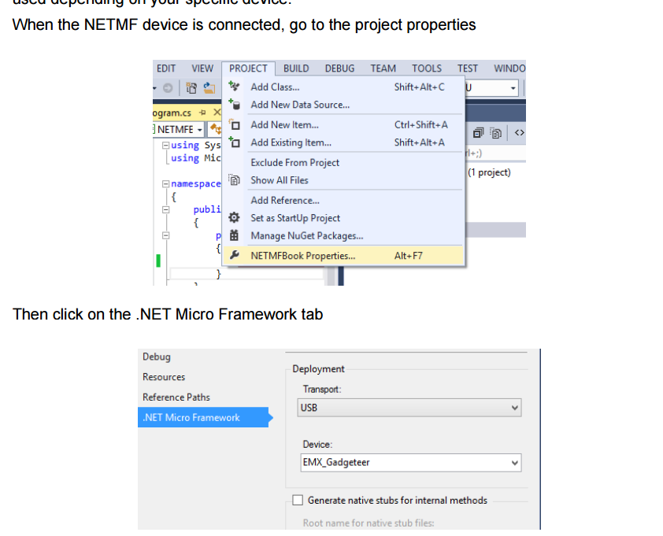
Figure 1: Connecting to hardware.
Difference between strings and Integer variables
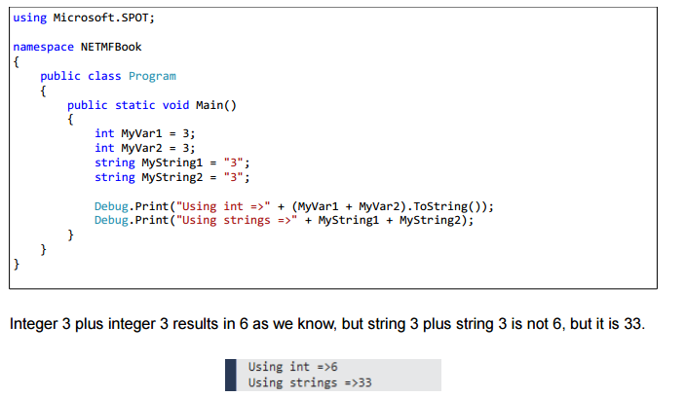

IMU Sensor

Bosh BNO055 IMU
Tasks: need to create drivers based on Adafruit libraries and data sheet so that we can interface this IMU with the GHI G400-S microcontroller board using I2S.
Information on I2C communication included below from page 90 of the Bosh data sheet.

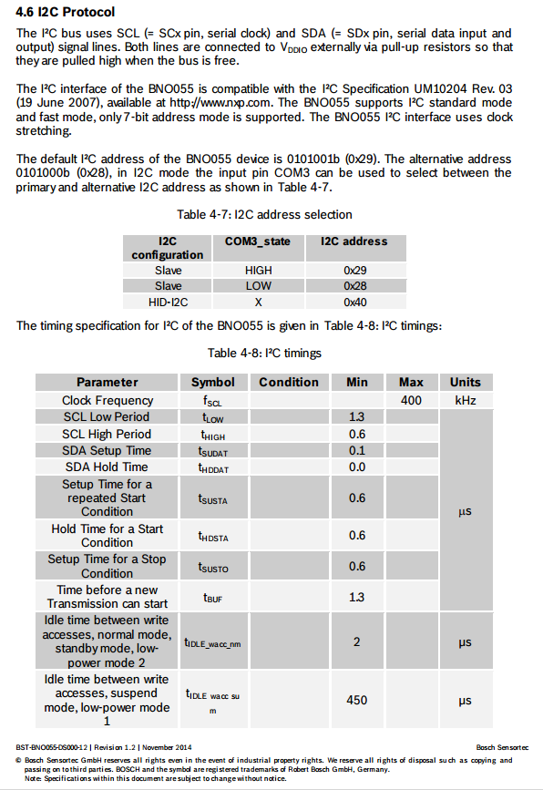
Figure 2: Information about I2C protocol for the Bosh BNO055 IMU.

6/08/2016

Getting the BNO055 to communicate with microcontroller

Was able to get the IMU to communicate with the microcontroller over I2C today with lots of help from Gene. The IMU used clock stretching where there salve device holds the clock line low to tell the master device to delay while the slave device works to finish he last request. When I was unable to establish communication with the IMU, I thought that the GHI hardware library did not have this functionality. The next step was to implement software I2C as an online reference verified the clock stretching was enabled in the software I2C library. After Gene and I had the device working with the software I2C, he asked me to check once more with the hardware I2C.
Here was the wiring that I used:
Socket X2 on the G400 microcontroller
Pin 8 > PA30 – SDA wired to Green Wire > SDA on IMU
Pin 9> PA31 – SCL wired to Blue wire > SCL on IMU
THIS WORKED! WE COULD READ THE TEMP SENSOR DEFAULT VALUE
using Microsoft.SPOT;
using Microsoft.SPOT.Hardware;

public class Program
{
public static void Main()
{
//create I2C object
//note that the netmf i2cdevice configuration requires a 7-bit address! It set the 8th R/W bit automatically.
I2CDevice.Configuration con =
new I2CDevice.Configuration(0x28, 400);
I2CDevice MyI2C = new I2CDevice(con);

// Create transactions
// We need 2 in this example, we are reading from the device
// First transaction is writing the "read command"
// Second transaction is reading the data
I2CDevice.I2CTransaction[] xActions =
new I2CDevice.I2CTransaction[2];

// create write buffer (we need one byte)
byte[] RegisterNum = new byte[1] { 0x34 };
xActions[0] = I2CDevice.CreateWriteTransaction(RegisterNum);
// create read buffer to read the register
byte[] RegisterValue = new byte[1];
xActions[1] = I2CDevice.CreateReadTransaction(RegisterValue);

// Now we access the I2C bus using a timeout of one second
// if the execute command returns zero, the transaction failed (this
// is a good check to make sure that you are communicating with the device correctly
// and don’t have a wiring issue or other problem with the I2C device)
if (MyI2C.Execute(xActions, 1000) == 0)
{
Debug.Print("Failed to perform I2C transaction");
}
else
{
Debug.Print("Register value: " + RegisterValue[0].ToString());
}
}
}

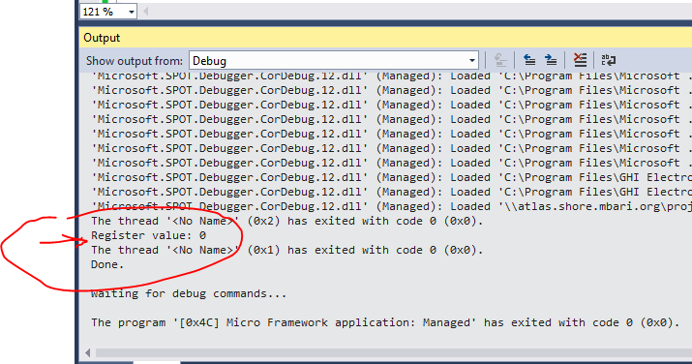
We now were able to communicate with the sensor.
My task is to now add the remaining registers and make a complete driver for the sensor.

Week 2:

Monday meeting with Gene
Now that the IMU is talking to the computer, we need to setup some experiments.

Tasks for this week:

- Need to determine the range of accelerometer data we can expect to measure from the underwater buoy as it drifts in the currents.
  - Use current profile data to calculate the range of accelerations assuming the buoy is a perfect velocity follower (ignore inertial effects).
    - Access MBARI data: http://dods.mbari.org/lasOASIS/main.pl?
    - Use backward difference calculation
    - Use center difference calculations
    - Plot acceleration profile using M1 and M0 buoys for NS and EW data points for day with average conditions, and day with fast currents.
    - Assume upward float velocity of 10cm/s
  - Use Simulink to create model, inputs a velocity current profile and then calculates the acceleration, velocity, and position of the buoy.
    - Use 30 kg mass for calculating the acceleration.
    - Use one of Gene’s example CPF > Calcs > BE_Controller_velocoty.sim to get started
    - Need to use added mass for the buoy
    - Need to loop up drag coefficient for cylinder body in radial flow (text book table)
    - Assume upward drifting velocity of 10 cm/s
    - Include Reynolds calculation, needed for drift
- Setup the Linear actuation on the bench top to test the acceleration output from the IMU for a known acceleration profile
  - Setup the linear actuator on the benchtop
  - Use software to setup velocity profiles
  - Mount sensor, log data and determine minimum accelerations that we can accurately measure
  - Use different signal processing methods to low pass, bandpass signal to see if we can estimate the actual acceleration values.

Current Velocity Profile – estimating acceleration range
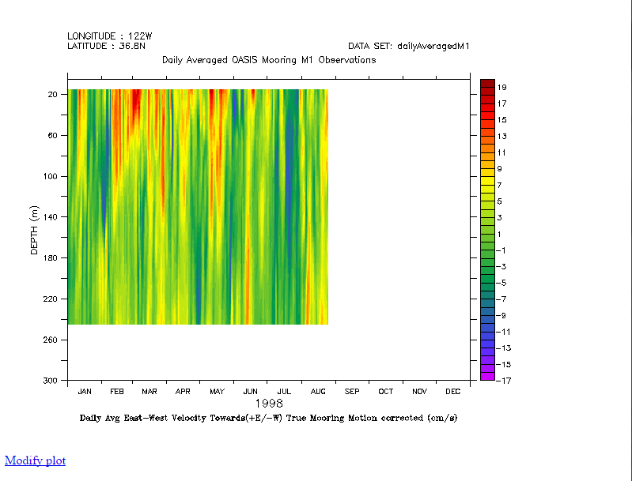
Figure 3: Velocity profile for 1998 from M1.
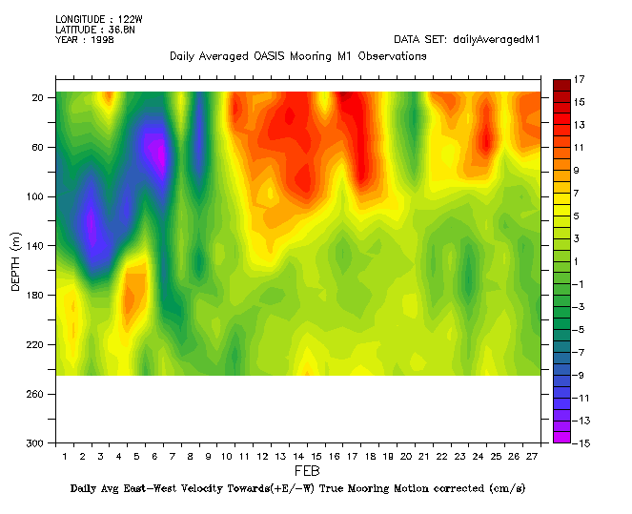
Figure 4: Velocity profile for month of February 1998 from M1 buoy.

Extreme Profile:

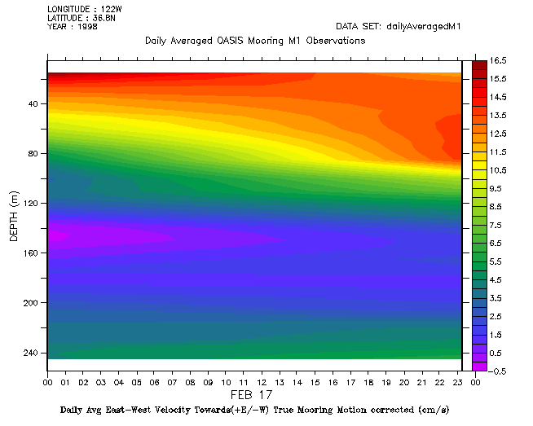
Figure 5: True mooring motion correction current velocity profile M1 for Feb 17, 1998, (+E/-W).

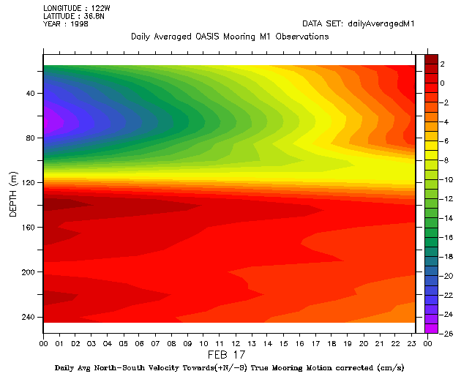
Figure 6: True mooring motion correction current velocity profile M1 for Feb 17, 1998, (+N/-S).

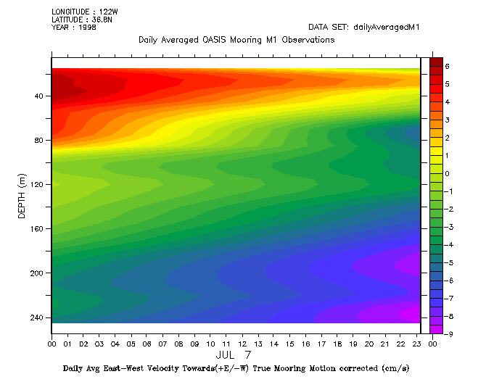
Figure 7: True mooring motion correction current velocity profile M1 for Jul 7, 1998, (+E/-W).
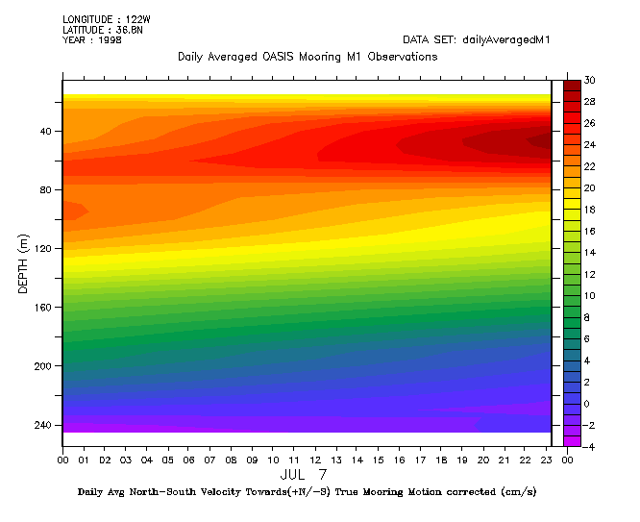
Figure 8: True mooring motion correction current velocity profile M1 for Jul 7, 1998, (+N/-S).

Typical profile:

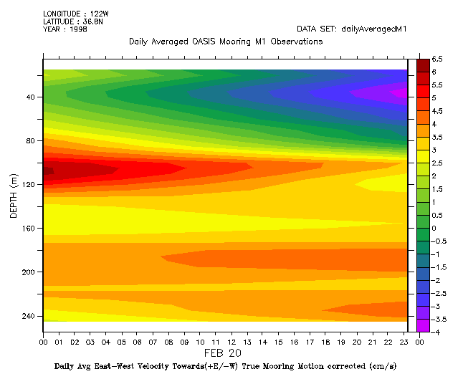
Figure 9: True mooring motion correction current velocity profile M1 for Feb 20, 1998, (+E/-W).
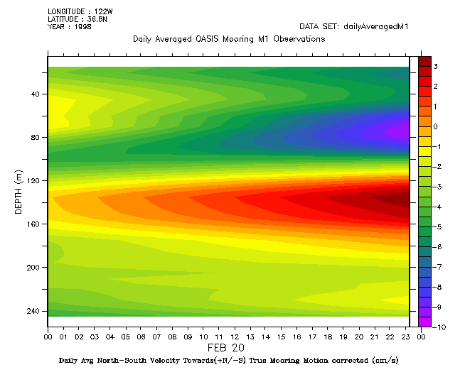
Figure 10: True mooring motion correction current velocity profile M1 for Feb 20, 1998, (+N/-S).

Calculations:
First I plotted the current profile as a function of depth, from the CSV files downloaded from the historical data provided by MBARI.
Next, I assumed that the float had a constant straight vertical floating velocity of 10 cm/s. With this assumption, it was possible to determine the time required to reach each depth with the float to produce a table of time versus horizontal current velocity. Assuming the float was a perfect velocity follower, such that the float had the same velocity as the current at a given current depth, I used the backwards difference formula to perform numerical integration and obtain acceleration as a function of time. This was then plotted, in units of both m/s2 and mg.

The sensor has a range of +- 2g, with a 14 bit accelerometer register, so this can provide a theoretical resolution of:

2^14 = 16348 divisions
Resolution: 2g/ 16348 divisions = 1.2239 e-4 g >>>> 0.12239 mg. This is not accounting for noise, so we are still an order of magnitude off of the needed resolution, based on the current velocity profiles we have looked at thus far. To mitigate noise, we can use low pass filtering by implementing a moving average on the data set. The effect of the reduction of noise is to the power of the square root of N, where N is the number of samples used to calculate the moving average. This can be used in practice, so we will run benchtop experiments to see if this is possible.

Drag force calculations

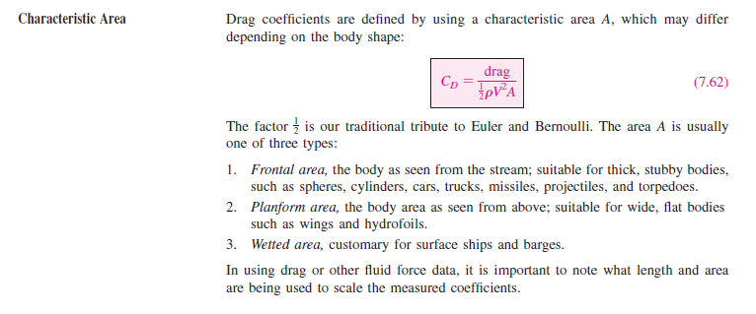
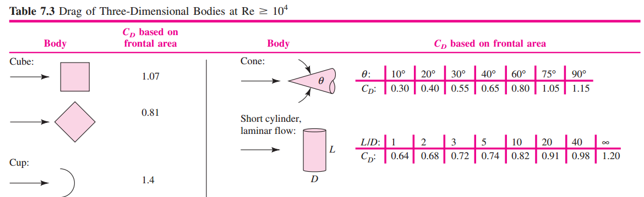
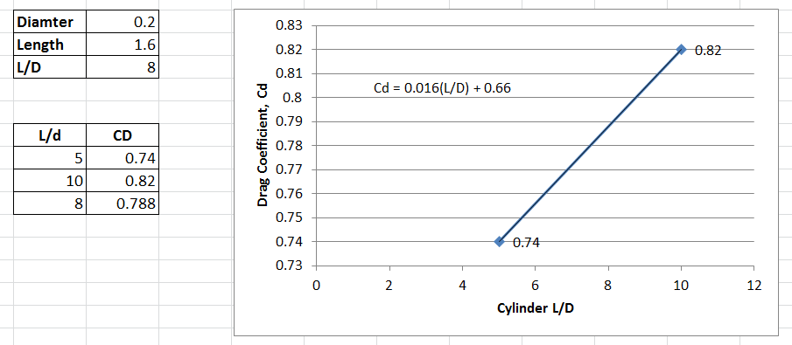
Figure 11: Drag Coefficient linear interpolation for cylinder (0.788).

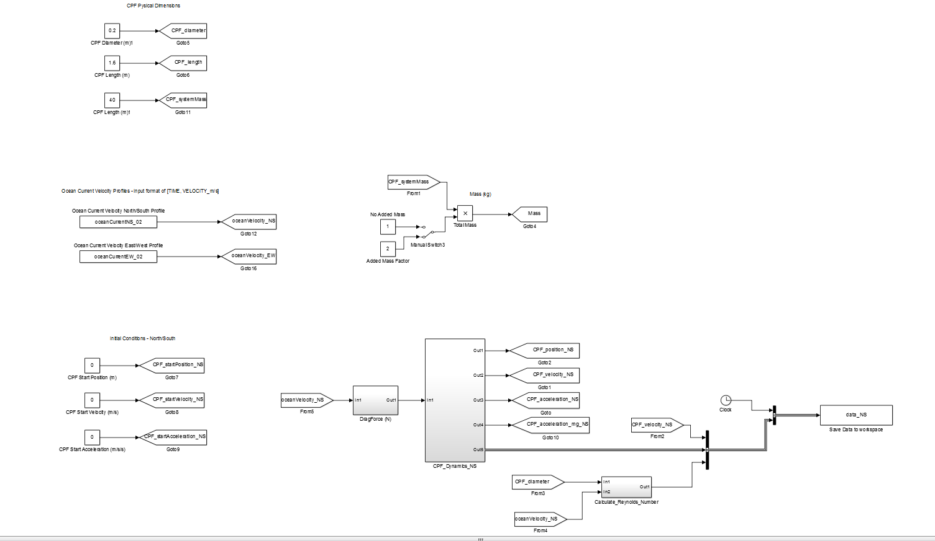
Figure 12: Simulink model of dynamics of CPF, accounting for drag and current velocity profile.

This week was spent developing a simulation model to predict the position, velocity, and acceleration of the float as it drifted in the underwater currents. This is important because we need to know the range of accelerations that we can expect to measure to ensure that our sensor will be sensitive enough to detect the changes in acceleration. Using real data collected from a moored buoy in Monterey Bay, M1, I was able to download a CSV file of underwater current profiles from February 1998 and use this information as the input to my model. This particular data was chosen because it had strong underwater currents.
Since the float has no active propulsion or steering, the only force acting on the float is caused by hydrodynamic drag. Assuming that the physical shape of the float can be modeled as a cylinder (pretty good assumption) it was possible to calculate the drag force acting on the float as it moved through the water at different velocities. Here we are assuming that the drag force is proportional to the square of the velocity of the object, which is why it was important to use real data about the underwater currents in Monterey. The historical data was obtained from the MBARI Live Access to DATA website: http://dods.mbari.org/lasOASIS/main.pl??&.
The rest of the week was spent developing the model in Simulink and testing the model to verify that the outputs were correct. Once complete, a set of plots was created so that we could look at all the data together. Based on this work, it looks like the range of expected accelerations that we need to detect will be from 0.05 to - 0.05 m/s/s. These are very small accelerations, and the sensor that we are currently using may not be sensitive enough to detect this without post processing and filtering of the data.
The next step (plans for next week) is to start testing the actual IMU sensor to characterize the noise profile and determine the smallest possible acceleration that we will be able to detect. To accomplish this, we are using a computer controlled moving table in the lab. We will mount the sensor to the table and accelerate the table very slowly and read the output from the IMU. By testing a range of acceleration, we can determine the sensitivity and noise profile of the sensor and compare this with the results from the dynamic simulation.

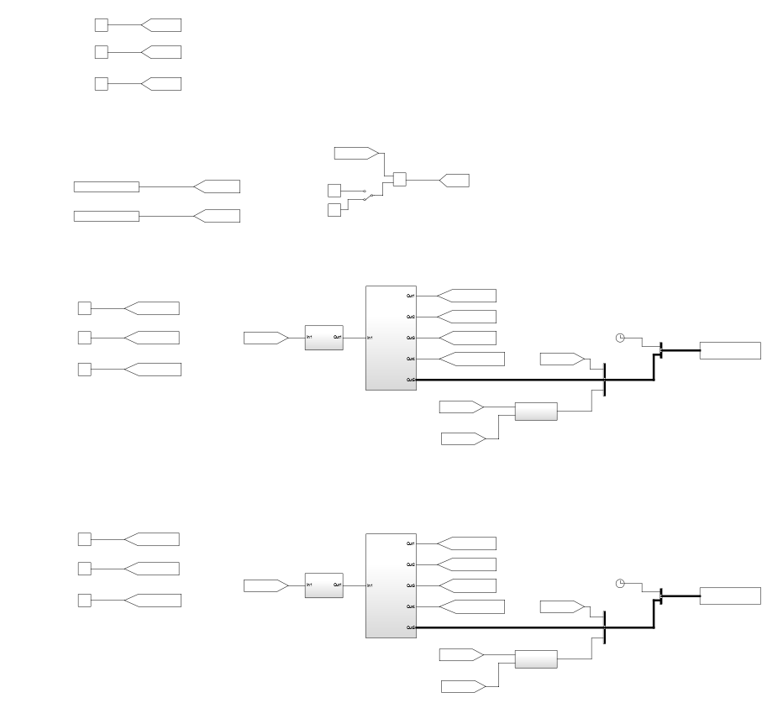
Figure 13: Simulink for N/S E/W CPF simulation, inputs are current profiles from MBARI data base.

Output files

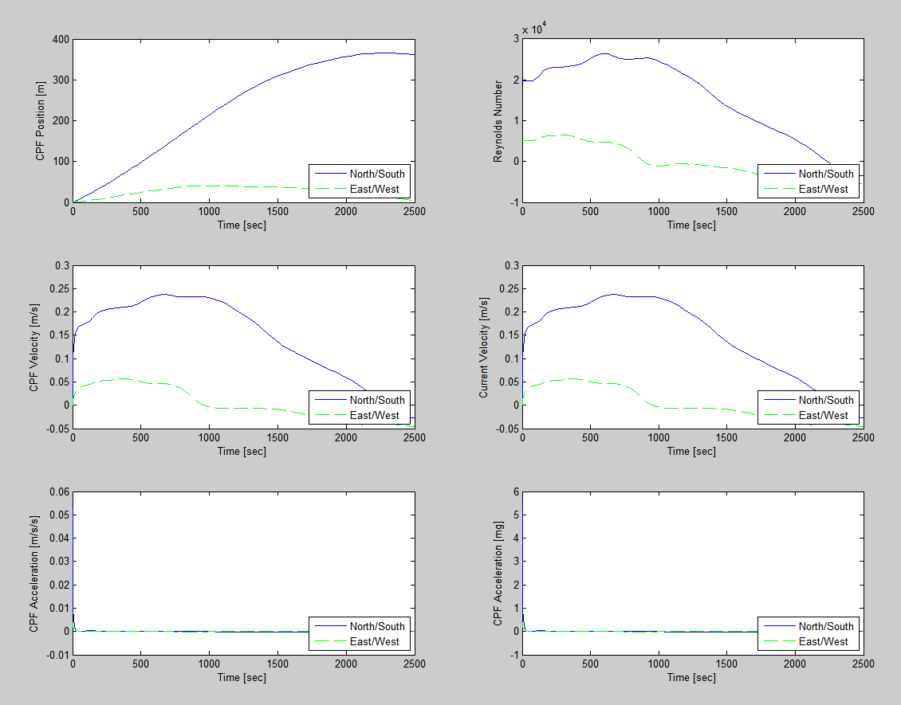
Figure 14: Output plots from the buoy dynamics Simulink model for both N/S and E/W directions.

Formatting ToString() function to control decimal places

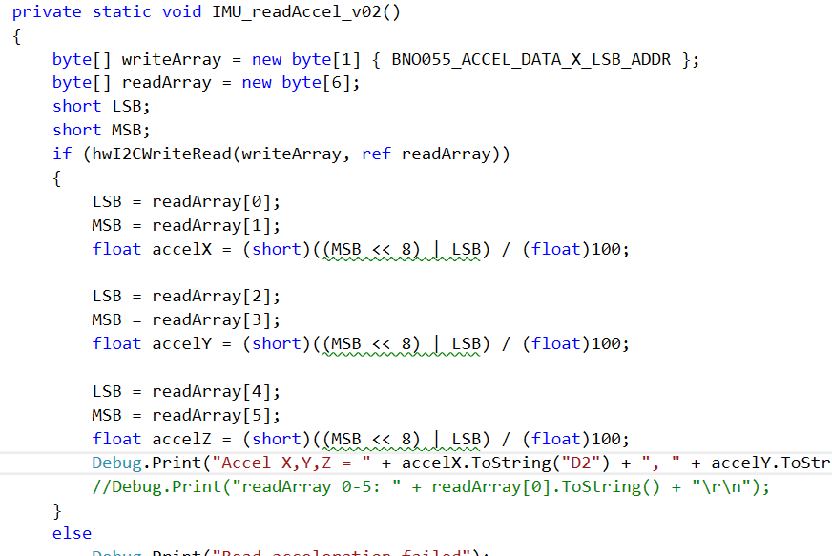

Week 3
Asked to add drag force calculations and simulation for vertical axis of CPF. Need to add a new drag force coefficient and copy+paste the modules from N/S and E/W to extend the model.

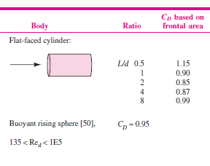
Figure 15: Drag coefficient for the CPF moving in the vertical axis.

Week 4
We have finished work on the sensor and data logger (while it is not operating perfectly, it is good enough to conduct experiments).
Now we are using the linear translation state to move the sensor and obtain acceleration data. The motion controller can have two different velocity profiles, either S-curve or trapezoid. Below are examples and I have decided to use s-curve to reduce the magnitude of the jerk since it is the jerk term that induces vibrations into the mechanical system.
Reference: http://www.pmccorp.com/support/technotes/tn1031.pdf
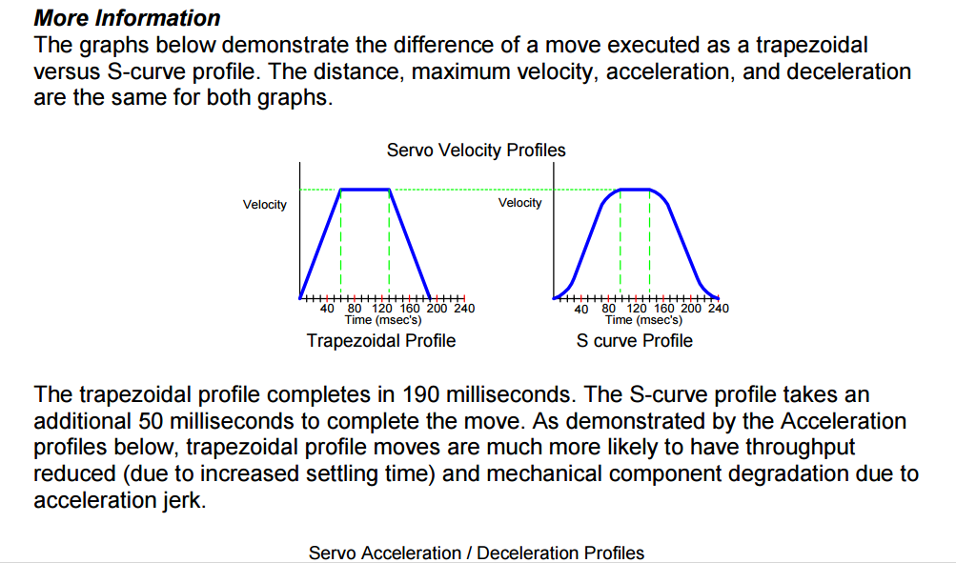
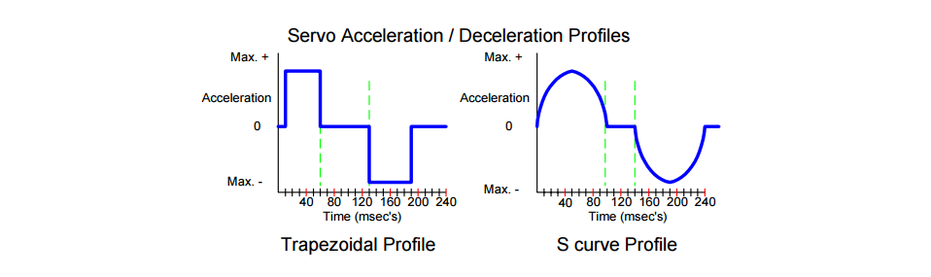

Week 6

