
SJ310 Data Compiler Program
Installation and Operation Manual
Nick Raymond
2/9/2015

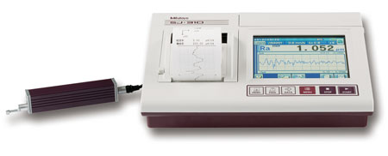

Objective:
Import the data output from the Mitutoyo SJ310 surface profilometer and obtain the surface roughness measurements for processing. Currently, files are either exported as single excel files, or as ASCII text files with headers and additional measurement settings. We need a way to automatically import multiple text files and extract only the roughness profile data before averaging the data together to get.

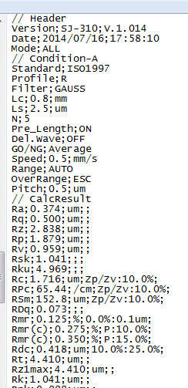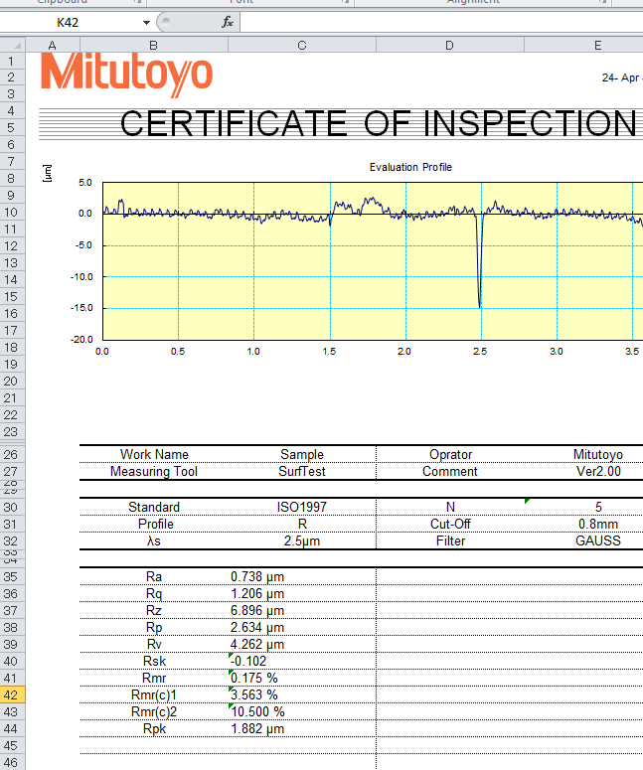
Figure 1: Measurement equipment outputs text files or Excel certificates, but we need an automated way to import multiple files at once.

Install the Program
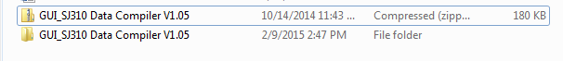
Figure 2: Unzip the compressed folder, and save the upzipped folder to your working directory.

Figure 3: Change your current folder to the directory with the SJ310 Data Compiler Folder.

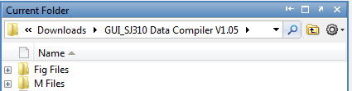
Figure 4: In this tutorial, the program folder is saved in the Downloads folder.

Now Matlab knows where to look for the Fig files and M files.

To load the GUI, go to File>New>GUI.

Load the GUI File
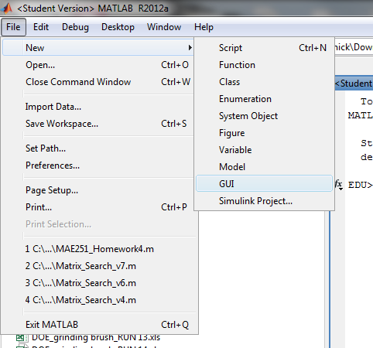
Figure 5: Load the GUI, or type “guide” in workspace.

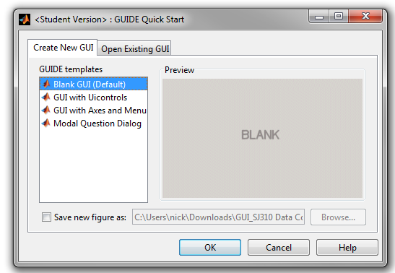
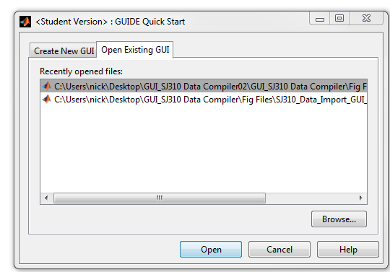
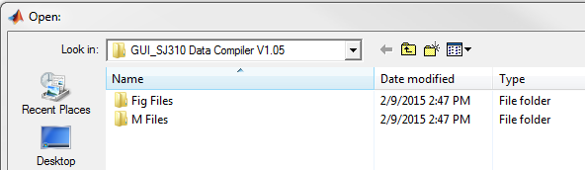
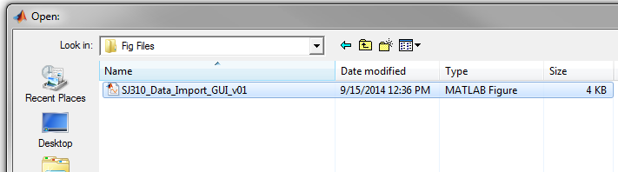

GUI Layout

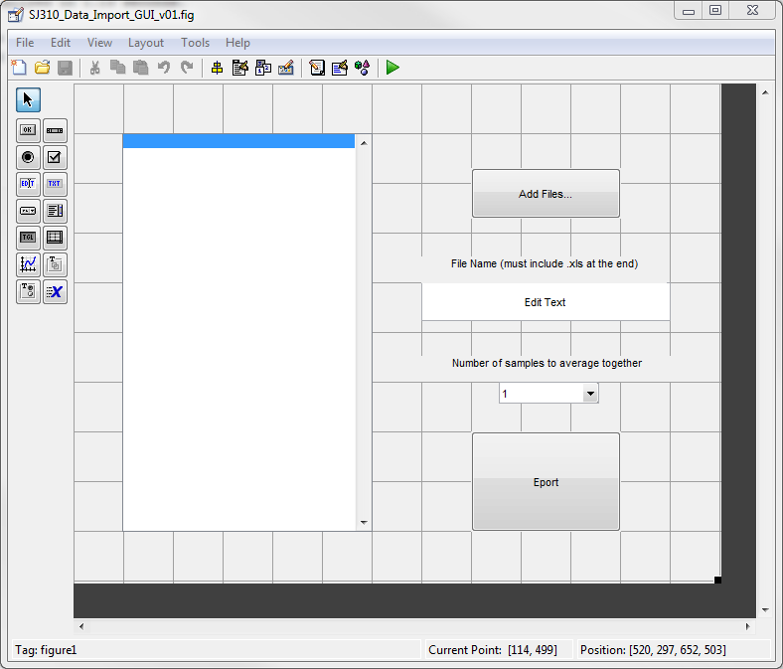
Figure 6: Click on the green triangle RUN button.
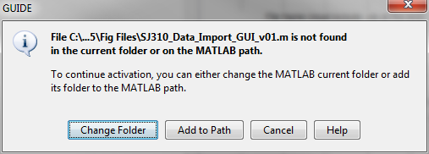
Figure 7: Click on Add to Path to make sure the folders are in the working directory.
Note: you should also right click on the Fig Files folder and M Files folder, and click Add path > Selected Folders and Subfolders just to be safe.

IMPORTANT: If you get an error when you run the program, about SJ310_Input_v05.m not being declared, then you need to perform this step.

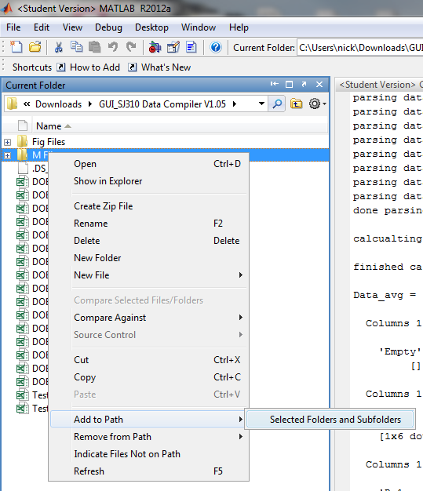
Figure 8: Add the M Files and Fig Files folders and subfolders to the working director.

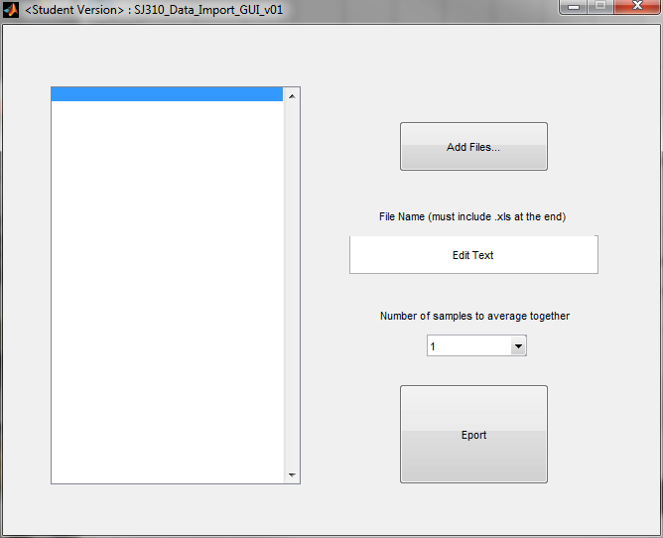
4
3
2
1
Figure 9: GUI, with inputs for user to search directories for data files to import, and then choose output file name for the excel file to be created.

Running the Program
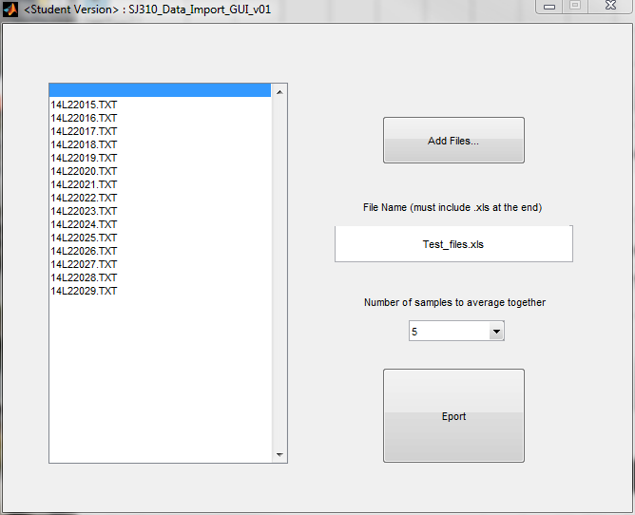
Figure 10: Add files and specify the file name for creating a new Excel document, also specify number of samples to average together, then hit Export button.

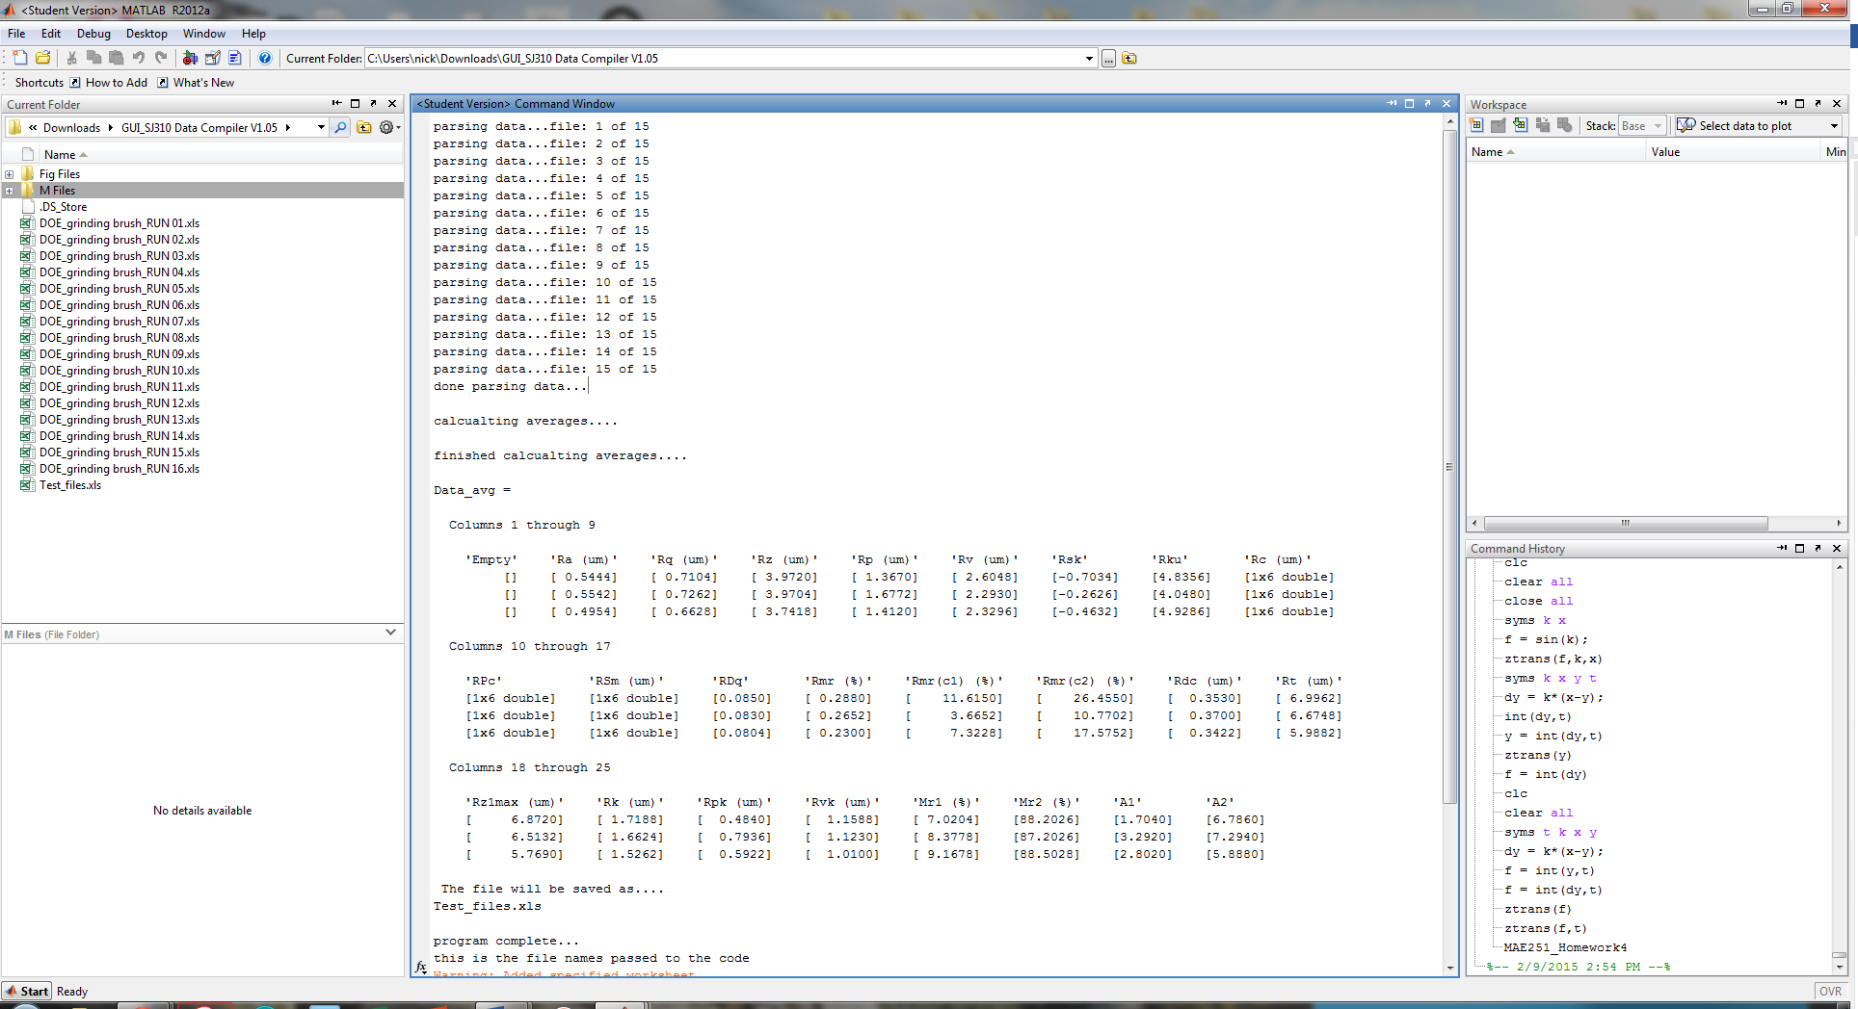
Figure 11: Real time progress update.

Figure 12: Successful completion of program message.

Accessing the Exported Excel File
Figure 13: New file has been saved to the Current Folder directory.

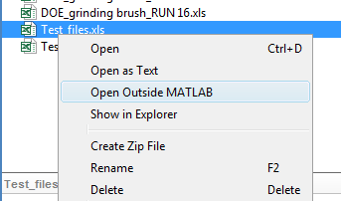
Figure 14: Open Excel file, right click on file in Current Folder and click on Open Outside of Matlab option.
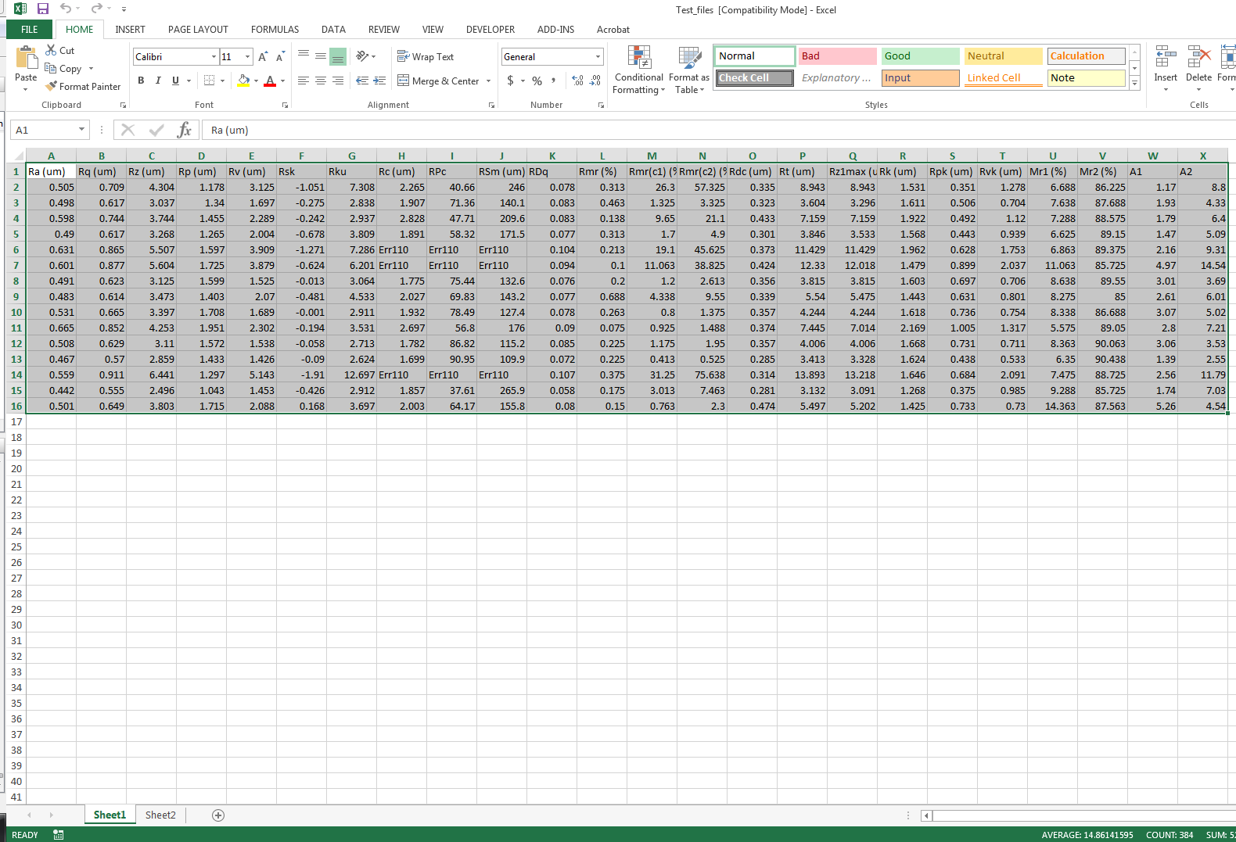
Figure 15: Sheet 1 - Values from all of the files listed in order by category.

In this example, we imported fifteen SJ310 text files, therefore Sheet1 has fifteen rows of values, with 24 columns. Each column is a different parameter that was calculated by the SJ310. Some entries have a value of Err110, this is from the SJ310 and is typical.
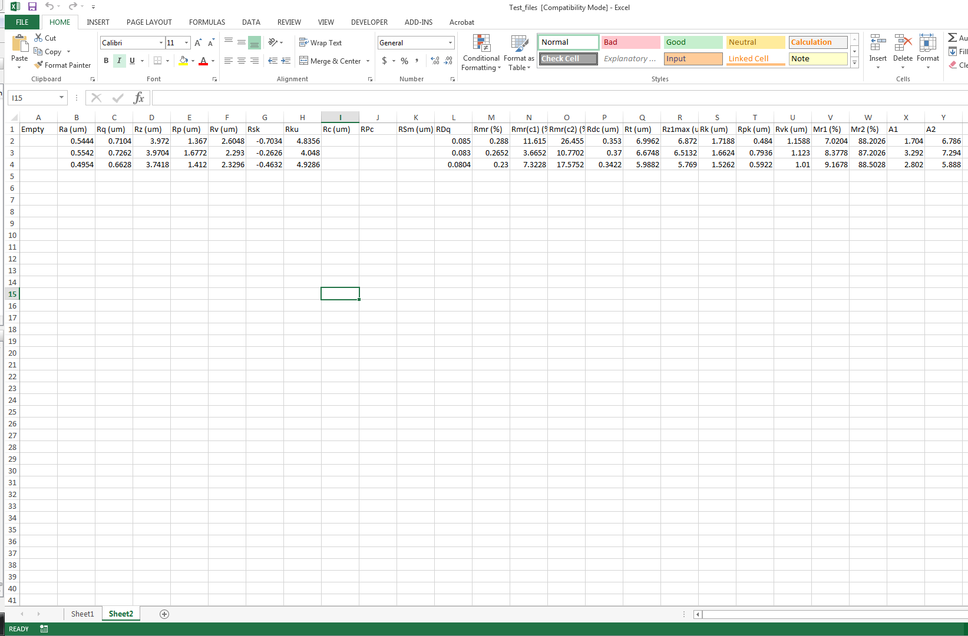
Figure 16: Sheet2 listed the averages of the values for each of the 24 parameters.

In this example, we imported fifteen SJ310 text files were every five measurements represents a different collection of points we want to average together. During the experiment we would mill the surface and then take five measurements before milling the surface again and taking five new measurements. The file names are organized in an ascending order, so we can easily keep track of which measurements were made first or last. Sheet2 represents the average values of calculated values. The entry in row 2 represents the first five measurements, row 3 represents the second set of five measurement… and so on.

Known Bugs

Importing text files
If you want to compile a large amount of files at one time, you need to have all the data files in a single folder in the order that you want them to be evaluated.
If the data is stored in different folders, the program will not run properly. For example, we have a total of 30 files split between two folders. We are able to click the Add Filess… button twice and the list shows that we have all 30 data files imported. However, the program will only evaluate the last 15 data files, not all 30.
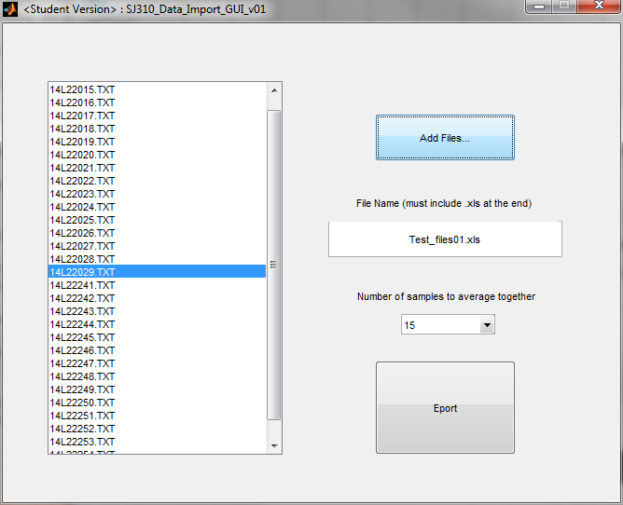
First 15 files from Folder A.
Second 15 files from Folder B.
Figure 17: Importing multiple files from different folders will not work, here only the files from Folder B will be compiled.

Use a Unique File Name When Saving
It is advised that you choose a new File name whenever you export a new set of data to an Excel. If you use the same file name, for example Test_files.xls, the file is simply written over BUT it is not erased beforehand! This means that you may have old values in the rows and columns of your new excel file if you write over the old excel file with the same name.

For example, if you save a file that initially has 20 rows of data on sheet1, and then use the same file name to save a new set of data, but this time there are only 10 rows of new data saved to sheet1, you will still have a total of 20 rows of data on sheet1 when you open the file. The first 10 will be new data values, but the bottom 10 rows will be from the previous save. To avoid issues, be sure to either delete the old excel file before using the same excel export name, or just use a different file name every time you export data.

