
Developing parameter estimation techniques for controller optimization of a Coastal Profiling Float
Nicholas Sohn, Swarthmore College

Mentor: Gene Massion

Summer 2013

Keywords: Coastal Profiling Float, Pressure Simulator, added mass, drag coefficient

ABSTRACT:
Several tools were developed to improve a theoretical model for optimizing the depth controller used in a Coastal Profiling Float. The pressure housing used in a test apparatus for simulating high-pressure effects on a buoyancy engine was designed to withstand pressures up to 750 psi. Several efficiency metrics were outlined and measured for a benchtop prototype. Finally, a test procedure and software tools were developed for simultaneously measuring the added mass and drag coefficient of a test tank prototype.

INTRODUCTION:
An understanding of the ocean climate requires quantitative data with a level of temporal and geographic resolution that would be impractical to achieve using conventional ocean measurement systems. The Argo program proposed an alternative method for large scale measurement of heat exchange in the ocean using a network of autonomous profiling floats distributed on a global scale. Since the first deployment of Argo floats in 200 over 3000 new floats have been deployed by organizations spanning across 23 countries. The success of the program is emphasized by the fact that currently over 100 research papers per year cite Argo data.
Despite the large amount of data that have become available in the deep ocean because of Argo floats, coastal waters have largely been avoided as sites for float deployments. Shallow waters and the proximity to the shore pose significant dangers to profiling floats that make coastal deployments impractical, especially considering the low heat content in these environments. While coastal settings may not have a significant role in heat exchange however, studying coastal environments is critical for understanding ocean acidification, hypoxia, and other effects that result in part from anthropogenic waste. A series of ocean floats modified for coastal measurements could provide a cost efficient method of quantifying these changes.
The largest challenge associated with using floats for coastal measurements is containing the floats within the region of interest without significant allocation of resources. Coastal currents could potentially push a profiling float into the coastline or further out to sea. Either of these scenarios would prevent a coastal float from collecting useful measurements. One solution is to program the floats to anchor on the sea floor until they collect data. This would reduce the risk of drifting and additionally minimize the potential for biofouling. Another solution is to program the float to change its depth and take advantage of serendipitous currents to correct for drifting. Both of these methods require significantly finer control and stronger lifting forces than an Argo float can provide.
The purpose of this project is to aid in the design of a ballast engine for a Coastal Profiling Float (CPF) modified from the Argo float design. The primary goal is to redesign a pressure simulator for testing the ballast engine efficiency. Additionally, this project seeks to refine the physical model of the float dynamics and improve the PID control loop for regulating buoy velocity and position. The remainder of this report is divided into sections describing the reimplementation of the pressure simulator, efficiency testing of the ballast engine, system characterization of the test tank prototype, and depth controller optimization.

PRESSURE SIMULATOR DESIGN:
During a single profiling measurement a CPF must travel through the water column starting at a depth anywhere from 100 to 50 meters up to the surface. As a result, the float is exposed to pressures ranging from around 15 psi at the surface 700 psi at depth. Varying pressure has a number of effects on the float including volume change from compression and the pressure head on acting against the float’s external oil reservoir. Consequently, the external pressure on the float influences the pump efficiency. One of the primary goals of this project was to re-implement a bench-top prototype capable of generating enough pressure to simulate pump behavior at depth. Before testing could be performed the pressure housing for the simulator had to be modified to withstand larger pressures. The first phase of this project was to quickly fabricate a mechanism to secure the pressure housing lid with minimal modifications to the existing design, shown in Figure 1 below.

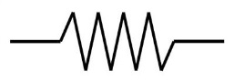
RPM
STP

STP
Reservoir
Bellows Housing
Bellows
Spring Loaded Piston
Pump
P

x1

x2
Figure 1 – The above schematic shows the setup for the pressure simulating apparatus. Measured variables are indicated in red.

Oil is pumped from a reservoir kept at atmospheric pressure to the bellows, which is housed within an aluminum drum. The housing is flooded with oil, which may pass to a spring loaded piston. The spring emulates the linear relationship between depth and pressure by providing an elastic force that resists piston displacement. The simulated pressure is measured using a pressure transducer in line with the piston, or by measuring the spring displacement. The bellows position and motor speed are also measured via a data acquisition system.

MODIFICATIONS TO THE PRESSURE HOUSING
The lid to the housing was originally secured using 16 ¼-20 bolts. These bolts had insufficient cross-sectional area to resist tensile loading, and excessive bolt elongation caused the O-ring seal to fail. For a 90 durometer O-ring the limit for extrusion is 0.020 in. The primary goal of this design was to prevent the housing lid from exceeding this deflection limit. Time and ease of fabrication were also important design considerations.
Under elastic deformation the extension of a material is proportional to the applied load and member length, and inversely proportional to the elastic modulus and cross-sectional area. The latter two of these sources of elongation were addressed. Sixteen 302 Stainless Steel C-clips placed around the perimeter of the bellows housing were chosen as the load bearing components, each of which had a throat width of 2.2 in and a thickness of 1.5 in, as indicated in Figure 2. This method increased the tensile area by a factor of 60, resulting in an overall elongation of .006 in at the O-ring gap.

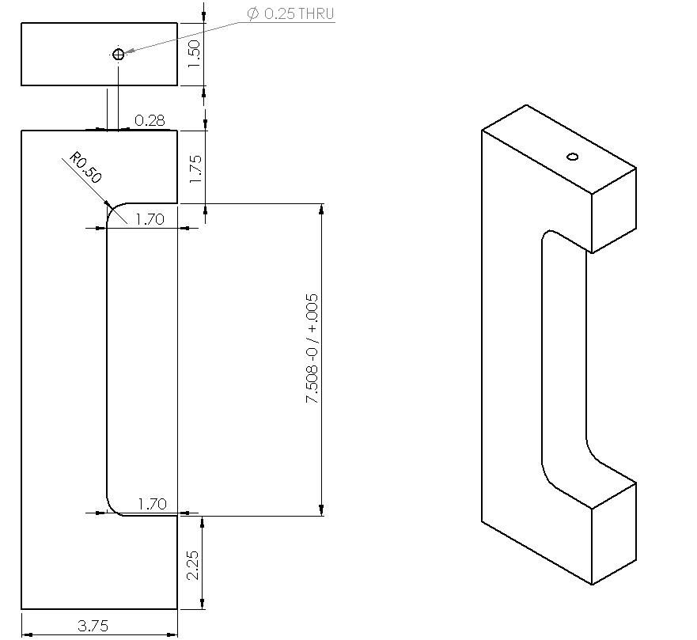
Figure 2 – The drawing above shows the dimensions and tolerances specified for the clips used to secure the pressure housing.

A simple 90 degree cut into bar stock would be the simplest solution in terms of fabrication. However, the sharp corners of the bar caused unacceptably large stress concentrations. FEA results suggested that adding a 0.5 inch fillet to each corner would reduce the stress to an acceptable amount. In order to reduce the amount of material required for each clip, the top and bottom edge of the bellows housing were also filleted. The FEA analysis of this solution is shown in Figure 3 below. Note that the maximum VonMises stress is 26 571psi, which is well below the 40 000psi yield strength of 6061-T6 aluminum. As expected, the bellows housing undergoes some deformation as a result of the high pressure. The surface between the bellows housing and lid however has a difference in vertical displacement of .006 in, which is less than the extrusion limit.

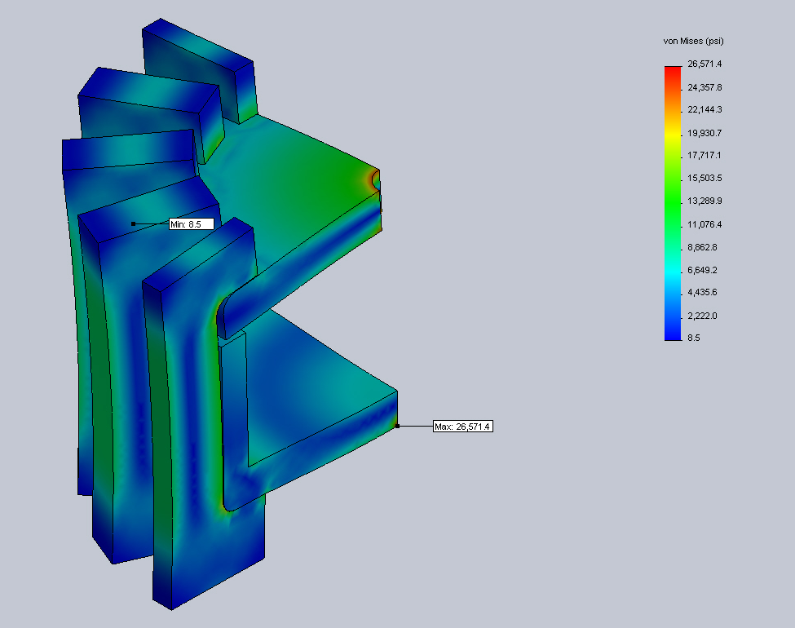

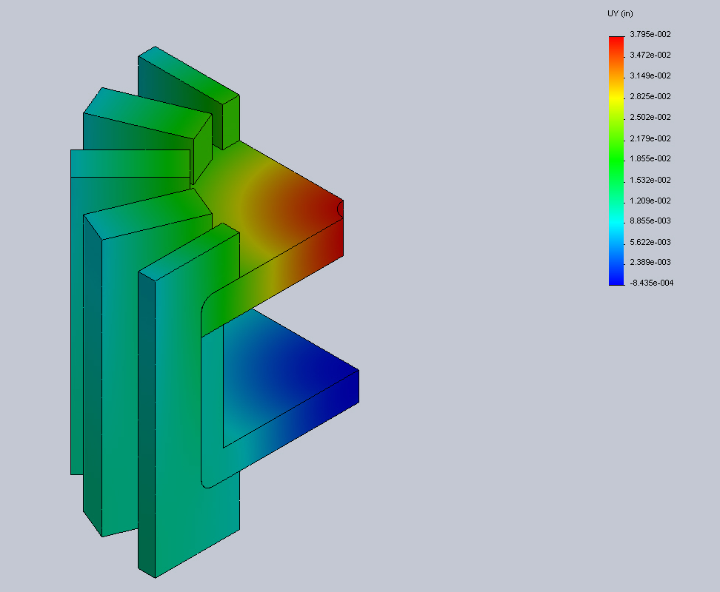

Figure 3 – The above plots indicate the von Mises stress and vertical displacement resulting from Finite Element Analysis. The maximum stress does not exceed the yield strength of Aluminum (40,000 psi). The displacement between the bellows housing an lid does not exceed the gap limit of .006 in.

Such high magnitude pressures should also cause radial expansion of the housing, which could potentially dislodge the clips. A single bolt was run through the top of each clip into the ¼-20 threaded holes originally used to seal the housing. As indicated in Figure 4, the FEA simulation of this configuration verified that the addition of alignment bolts did not significantly change the loading of the pressure vessel.

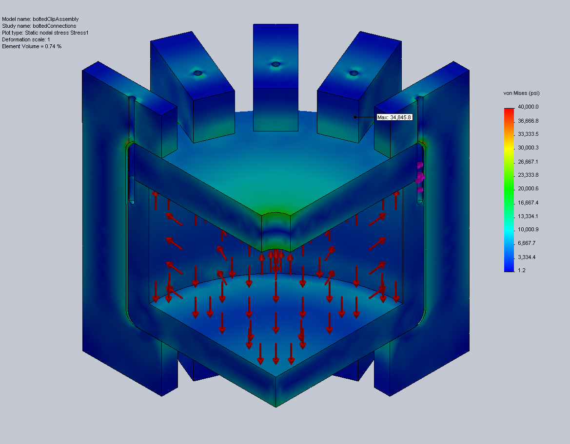
Figure 4 – The addition of bolts through the top each clip into the bellows housing does not significantly affect the stresses acting on the assembly

For the sake of clarity Figure 5 only indicates stresses greater than 20,000 psi. As expected, the point of maximum stress occurs at the junction between the C-clip and housing lid around the bolt clearance hole. Since the maximum stress is well below the yield strength of stainless steel this solution was chosen for the final design.
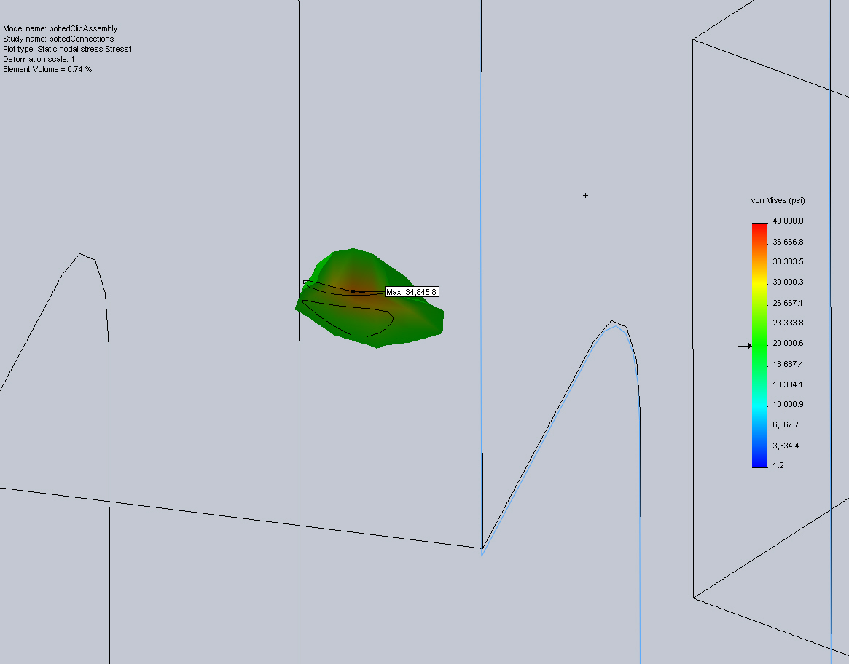
Figure 5 – The drawing above only indicates stressed above 20,000 psi. The maximum stress in the entire assembly is 34.845.8 psi.

HYDRAULIC ASSEMBLY
The design for the bellows engine on the CPF uses an Oildyne 865mL miniature piston pump to transport oil between the internal reservoir and external bellows. The hydraulic schematic in Figure 6 below provides a path for oil to flow in each direction without back-flowing through the filters. Quarter inch Swagelok fittings were used for all pressurized lines. The motor, pump, and pilot valves were mounted to a frame fixed to the bellows housing. ClearFlex ¼ inch inner diameter PVC tubing was used for all low pressure lines.
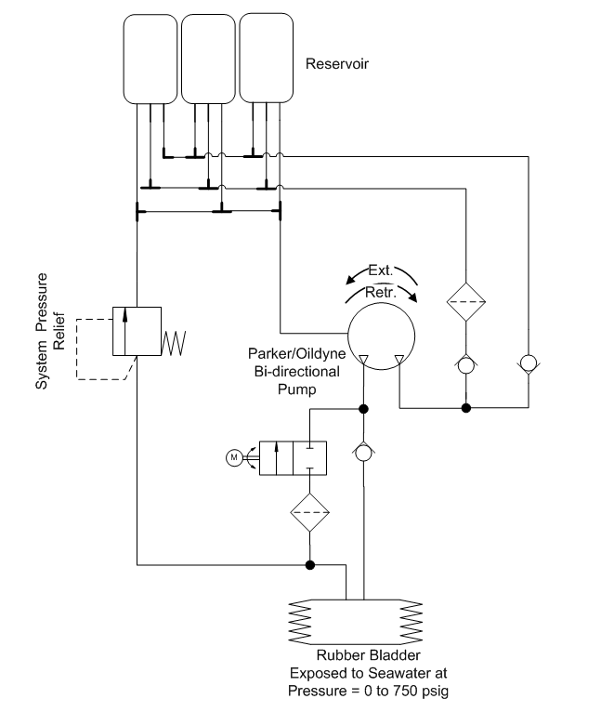
Figure 6 – The schematic above illustrates the hydraulic assembly used to pump oil from the reservoir to the external bladder and vice versa.

SENSOR AND DATA ACQUISITION MODULE INTEGRATION
The pressure simulator employs several commercial-off-the-shelf devices for acquiring engineering data. Two MTS position transducers record the vertical positions of the bellows and spring-loaded cylinder respectively. An OmegaDyne PX329-1KG5V pressure transducer measures the pressure within the piston. Data from these devices are collected using a National Instruments cDAQ 9164. Analog data, including the voltage across a shunt resistor, are passed throuch a NI cRIO-9215 Analog input module. Digital data from the MTS position transducer must be extracted using a NI 9401 Digital input module. The Maxon motor is controlled by an Elmo Harmonica, which receives feedback data from an incremental encoder. The wiring schematic used is shown in Figure 7 below:
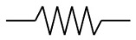

Diagnostic and
Control Sensors

MTS Position
Transducer (x1)
MTS Position
Transducer (x2)
1 Data -
2 Data +
3 Clk -
4 Clk +
5 VCC
6 GND
1 Sig +
2 Sig -
5 VCC
6 GND
Pressure
Transducer
1 Sig
2 VCC
3 GND
Motor Encoder
1 VCC
2 GND
3 A -
4 A +
5 B –
6 B +
7 I –
8 I +
Motor
1 Sig +
2 Sig -
3 GND

Elmo
Motor
Control

Main
Feedback
5
6
7
8
9
10
11
12

Main
Power
1
2
3
4 N/C
5
6
7

Aux.
Power
1
2

Data
Acquisition
cDAQ-9174

cRIO-9215
0
1
2
3
4
5

NI - 9401
19
20
22
22V
RS-232
USB

RS 422 to TTL

CPU

Figure 7 – The wiring diagram above reflects the organization of sensors and controller for the benchtop simulator.

PUMP EFFICIENCY TESTING
Pump efficiency was characterized using three metrics. Pressure varies significantly as the float changes its depth. Since the oil pump must work against the external pressure, determining the pump efficiency at different pressures was critical to designing a realistic model. The efficiency was measured as the bellows volume change per pump cycle and as the change of the product of volume and pressure per Joule of electrical power supplied by the voltage supply. The latter metric was also measured for different bus voltages at a constant pressure.

Volumetric efficiency measurements
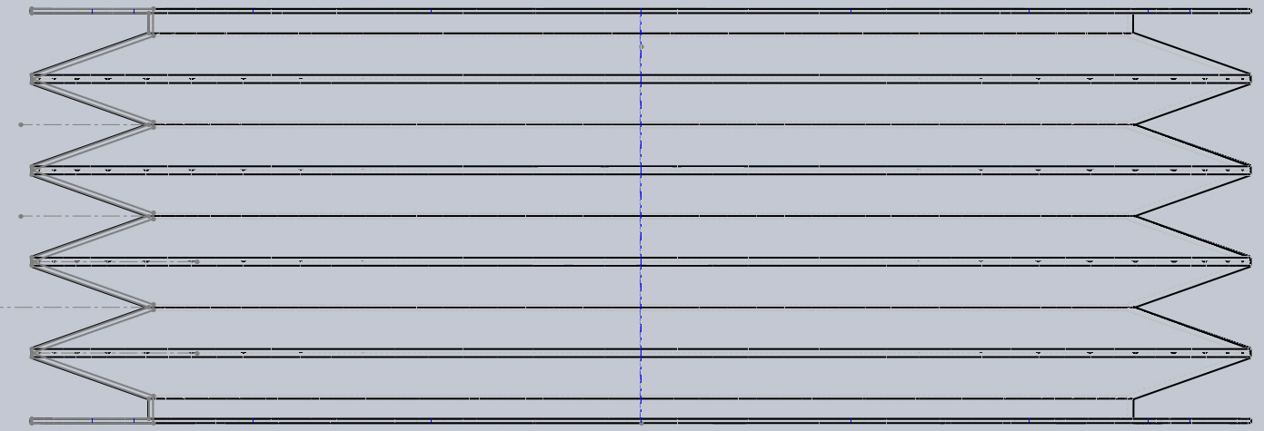
Figure 8 – The above sketch shows the idealized geometry of the bellows.
Flow rate into the bellows was determined by measuring the vertical displacement of the bellows endcap. Qualitative observation of the filling bellows indicated a specific filling order, which was modeled using a piecewise-nonlinear equation. The bellows, shown in Figure 8, can be broken into two cylinders with a radius (r_{i}) of 4.72 and height (c) of 0.2 in, four cylinders with a radius (r_{o}) of 5.91 in and height (d) of 0.08 in, and eight partial cones. The partial cones may be thought of as a series of stacked circular sections, whose radii vary as a function of height according to the equation
$$r\left(h\right)=r_{0}+\frac{r_{i}-r_{o}}{h_{total}} ∙h$$ | (Eq. 1)
The cross-sectional area may also be expressed as a function of height as:
$$SA\left(h\right)={π\left(r_{0}+\frac{r_{i}-r_{o}}{h_{total}} ∙h\right)}^{2}$$ | (Eq. 2)
The volume at any given height for a partial conic section is therefore given by:
$$V\left(h\right)=\int_{0}^{h}{{π\left(r_{0}+\frac{r_{i}-r_{o}}{h_{total}} ∙h\right)}^{2}}dh$$ | (Eq. 3)

Qualitative observations of the bellows filling suggested that the large cylindrical sections fill first, followed by the conic sections, and finally by the small cylindrical sections. The final piece-wise equation used to relate the bellows height to the volume is given below:
$$V\left(h\right)= π{r_{0}}^{2}h*U\left(h\right)+8\left[\frac{πm^{2}{h_{1}}^{3}}{3}+\frac{2πmb{h_{1}}^{2}}{2}+πb^{2}h_{1}\right]*U\left(h-4d\right)$$  $$+π{r_{i}}^{2}h_{2}*U\left(h-4d-8x_{max}\right)$$ | (Eq. 4)
Where U(h) is the step function, x_{max} is the height of a single conic section, and h₁ and h₂ are defined as:
$$h_{1}=\frac{h-4d}{8}$$ | (Eq. 5)
$$h_{2}=h-4d-8x_{max}$$ | (Eq. 6)
The volumetric efficiency was measured by dividing the calculated volume change by the theoretical input flow rate. The input flow per pump cycle was assumed to be a constant 0.692 mL per revolution. The input flow could then be determined by multiplying this constant by the motor speed.

EFFICIENCY MEASUREMENTS
Pump efficiency was also characterized in terms of work. The input work was measured from the current through a shunt resistor (0.05 Ω), using the equation P = I²R. The output work was calculated by multiplying the bellows pressure by the volumetric change.

Experimental Design
Due to unforeseeable circumstances it was not possible to test the pressure system at high pressures before the writing of this report. However, the experimental methods developed below were tested with low pressures and preliminary results suggest that these metrics are useful for characterizing the engine efficiency.

Efficiency v. Pressure
Prior to the experiment all oil was evacuated from the bellows and the pressure inside the bellows housing was measured. The pump was then driven at a rate of 100 rpm until the vessel reached a pressure of 250 psi. The resulting pump efficiency was plotted as a function of pressure using both energy and volumetric methods. This process was repeated twice over a range of pump speeds from 100 rpm to 5000 rpm. Figure 9 and Figure 10 show two sample trials using a motor speed of 500 rpm. These results indicate good repeatability between trials. Note that Figure 9 indicates a steep drop in efficiency as the pressure drops to 0, whereas Figure 10 shows a more gradual decrease. The sharp drop in the volumetric efficiency does not seem accurate, and there are several factors that could influence these results. The first is that when the bellows is nearly empty the bellows velocity is a poor indication of the volume change. Furthermore, qualitative observations indicate that the system has a small amount of air in spring loaded cylinder, which creates some compressibility. Both of these factors would be relevant only for small pressures, and can therefore be safely ignored.

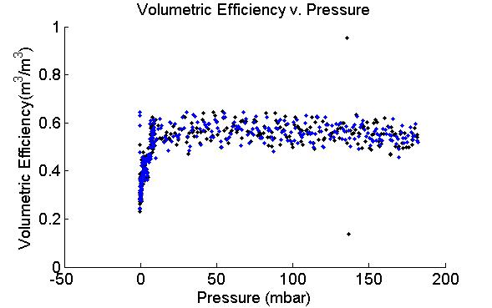
Figure 9 - The above plot shows two trials measuring volumetric efficiency at a motor speed of 500 rpm. The first trial is plotted in black, and the second trial is plotted in blue.
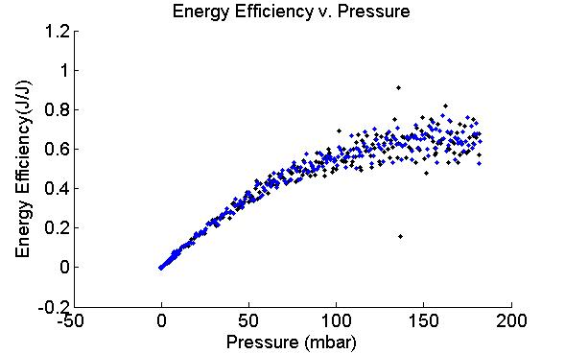
Figure 10 - The above plot shows two trials measuring energy efficiency at a motor speed of 500 rpm. The first trial is plotted in black; the second trial is plotted in blue.
Energy Efficiency v. Bus Voltage
Prior to the experiment all oil was evacuated from the bellows and the pressure inside the bellows housing was measured. The pump was then driven at a rate of 500 rpm until the vessel reached a pressure of 250 psi. This process was repeated twice over a range of bus voltages from 22V to 24V in 0.5V increments. These results are shown in Figure 11 and Figure 12 below. Perhaps due to the small change in bus voltage, neither metric of efficiency shows strong sensitivity to the voltage change.

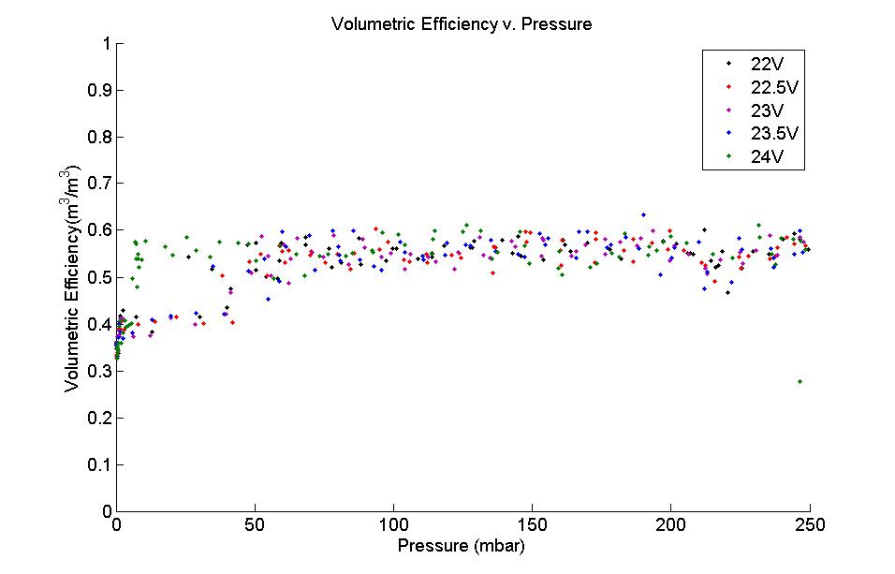
Figure 11 – The above plot shows volumetric efficiency as a function of pressure for different bus voltages
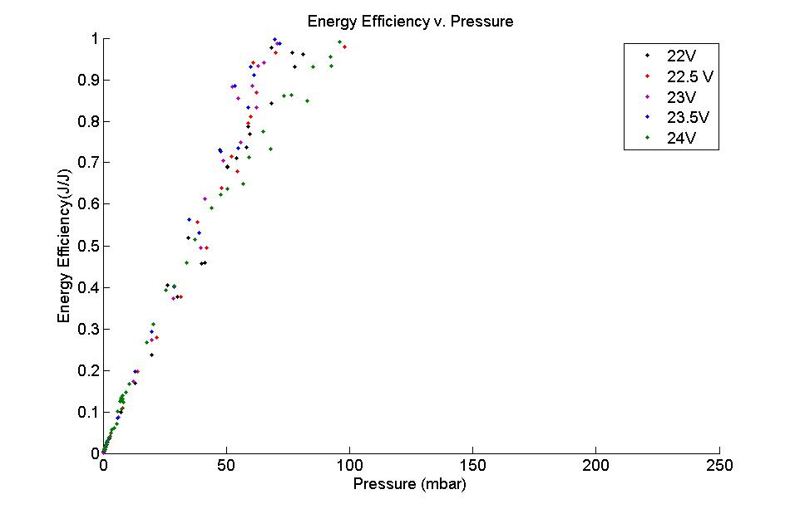
Figure 12 - The above plot shows energy efficiency as a function of pressure for different bus voltages

SYSTEM CHARACTERIZATION OF TEST TANK FLOAT
The drag force is commonly approximated using the empirical equation
$$F_{drag}=\frac{C_{d}v^{2}A}{2}$$ | (Eq. 7)
where C_{d} is an empirical constant known as the drag coefficient. The drag coefficient varies with the object’s shape, direction of flow, and the Reynolds number. At the velocities that a profiling float would typically experience the Reynolds number is relatively constant, therefore the drag coefficient is relatively insensitive to velocity changes. Under ideal conditions the drag coefficient could be calculated from Eq. 7 by weighting the float with a known force and measuring its terminal velocity. Without writing a control loop to control bellows position however, the bellows will compress as the pressure increases beneath the surface, which decreases the buoyant force acting on the float. Since terminal velocity could not be achieved, a steady state measurement could not be used and acceleration also needed to be considered. The drag coefficient and added mass therefore needed to be determined simultaneously. The following procedure was only applied to measure the drag coefficient in descent, but could easily be modified to measure the drag coefficient during ascent.
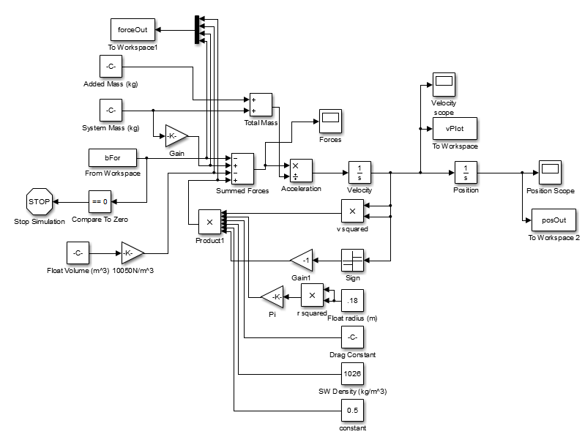
Figure 13 - The above Simulink model was created to simulate the physics of the added mass tests.

A test tank prototype of the CPF was pre-ballasted to a known weight and released from the surface. The pressure data and bellows position were recorded over time. These results were compared to a numerical simulation where the coefficient of drag and added mass could be varied independently. The Simulink model shown in Figure 9 was run iteratively varying each of these variables at each step. The sum of the error squared was assigned to each combination of drag coefficient and added mass, which results in a 2D error map. Error maps were combined by multiplying corresponding error values from each test, and raising the product to one over the number of elements combined. This resulting error map is shown in Figure 13. The drag coefficient and added mass estimates that gave the lowest error were inputted into each simulation, resulting in the float trajectories plotted in Figure 14. Note that the results for the float pre-ballasted to 7.5g shows poor agreement between the predicted and actual trajectory. This is most likely due to an error in the initial measurement of the system mass. Figure 15 indicates that note of the predicted trajectories matched that actual trajectory very well. However, the close agreement between the other two trajectories suggests that with more precise measurements of the system this procedure could be a viable means of determining the drag coefficient and added mass simultaneously.

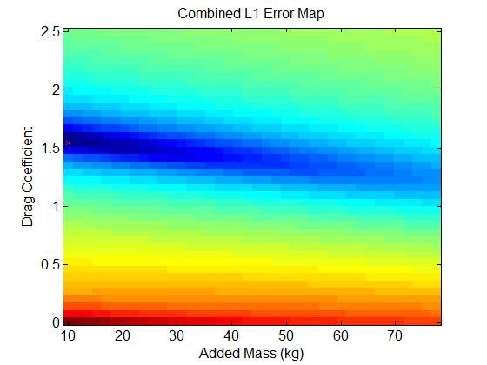
Figure 14 – The plot above shows the Combined Error Map resulting from 2D Least Square Regressions applied to each trial.
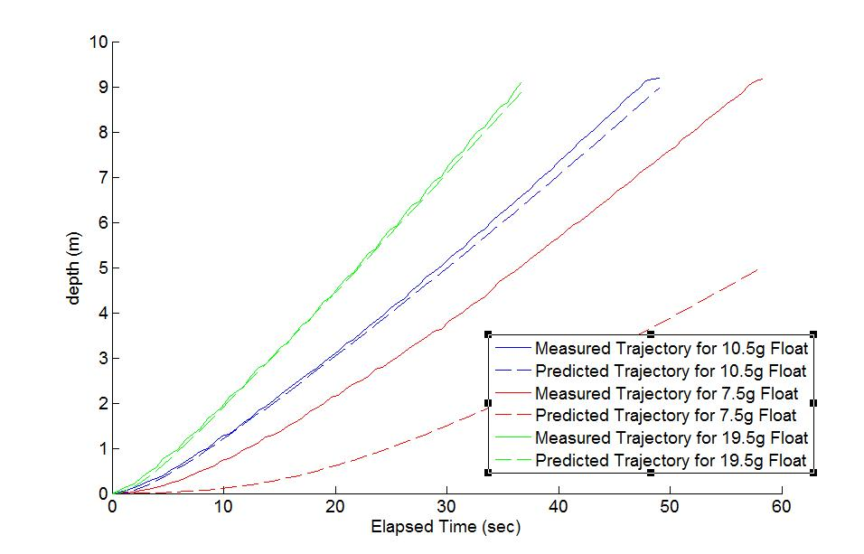
Figure 15 – The above plot compares predicted and measured trajectories for float ballasted to different set weights, as indicated by the line of the color. Predicted trajectories are dotted, measured trajectories are continuous lines.

CONCLUSION
This completion of this project resulted in several advancements for the Coastal Profiling Float project. The largest accomplishment of the project was the completion of a fully operation pressure simulator for the buoyancy engine. The pressure simulator was complemented by the development of software tools and a procedure for characterizing the engine performance at high pressures. This characterization is critical to developing a better depth controller. This project also addressed other aspects of the float dynamics, which could further inform the theoretical model. The procedure for simultaneous measurement of added mass and drag coefficients enables simple measurements without introducing errors that may result from a bellows-position based controller. While these tests were performed on the test tank prototype, the methods for parameter estimation can easily be applied to a sea-going prototype. While there will undoubtedly be other complications with the sea-going model, this project provides a strong starting point for optimizing a depth controller.

ACKNOWLEDGMENTS
This research would not have been possible without the support of the Monterey Bay Aquarium Research Institute and The David and Lucile Packard Foundation. Gene Massion provided invaluable insight and guidance and helped shape this project. Mike Parker fabricated many of the components in the test apparatus. The contributions of Ken Johnson, Carole Sakamoto, Ginger Elrod, Patrick Gibson, Jose Rosal and Frank Flores are also noted.

REFERENCES
Parker Hannifin Corporation. Parker O-Ring Handbook. Cleveland: Parker Hannifin
Corp., 2007
Roberson J.A. and C.T. Crowe. Engineering Fluid Mechanics. New York: John Wiley &
Sons, Inc., 1993

Parker Hannifin Corp., 2007
Roberson and Crowe, 1993

