Testing Buoyancy Engine Motors for the Coastal Profiling Float

Rudra Gaikwad
University of Washington
Seattle, USA
rudrag21@uw.edu
Gene Massion
Monterey Bay Aquarium Research Institute
Monterey, USA
magene@mbari.org

Abstract – The Monterey Bay Aquarium Research Institute (MBARI) has developed a Coastal Profiling Float (CPF) to study waters in both coastal environments and the open ocean at depths up to 350m. Existing autonomous platforms, including Argo, biogeochemical (BGC), and SOCCOM floats, as well as Seagliders, have enabled large-scale ocean observation, but fall short when working in the dynamic conditions found in coastal regions. These environments are characterized by strong stratification, and rapidly evolving biogeochemical conditions, which complicate both vehicle control and sustained observations. The CPF is designed to address these limitations while maintaining the ability to operate in key open ocean environments, making it a flexible platform for a wide range of applications. This work presents the capabilities of the CPF, specifically regarding the buoyancy engine and characterizing performance of the motors and assessing risk when working at depth.

The CPF uses a closed-loop buoyancy control system, allowing it to accurately follow user-defined depth and velocity profile. This closed-loop approach allows the float to dynamically adjust buoyancy in response to local density gradients, improving depth accuracy compared to traditional open-loop systems. The CPF incorporates a buoyancy engine capable of 3.5 liters of displacement change. This corresponds to a buoyancy engine volume change of approximately 9% of the total float volume, several times that of existing profiling floats. This expanded buoyancy range enables operation across a wider range of density profiles, from fresh water to very salty water, and decreases deployment complexity by reducing the need for precise pre-deployment ballasting. To minimize on-shore and off-shore drift, the CPF has the ability to anchor on, and more importantly de-anchor from the seafloor. The larger buoyancy range also enables higher vertical velocities (up to 50 cm/s), further reducing drift. The

buoyancy engine is crucial to ensure the success of the CPF’s dives

The CPF can support a large variety of instruments, including the standard BGC-Argo suite of biogeochemical sensors, including conductivity-temperature-depth (CTD), dissolved oxygen, pH, nitrate, and fluorescence and optical backscatter sensors and an optical radiometer. Due to its expanded frame and robust design, the CPF is also able to accommodate additional payloads depending on mission requirements.
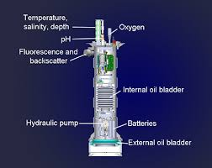

These capabilities make the CPF well suited for a wide range of applications in both coastal and upper ocean environments. For example, the CPF can connect BGC measurements from the coastal zone out to the open-ocean, helping to bridge the gap between nearshore and open-ocean systems. For instance, the CPF can repeatedly profile across coastal upwelling zones, capturing rapid changes in temperature, oxygen, and nutrient concentrations associated with upwelling events. A particularly interesting application for the CPF is as the observation platform for local fishing organizations developing science-based fishery management policies. The CPF is also effective for understanding and monitoring processes such as hypoxic (“dead zone”) formation, marine heatwaves, and harmful algal blooms (HABs). A particularly important and timely challenge is ocean acidification. The CPF is particularly well suited to provide the observations required for the monitoring, reporting and validation (MRV) systems required for emerging, potentially multi-billion-dollar marine carbon dioxide removal industry. Together, these capabilities position the CPF as a versatile platform for advancing coastal ocean observation and addressing emerging challenges in ocean science and management.

The buoyancy engine in the coastal profiling float is critical in achieving the desired platform velocity and stabilizing the float at a target depth. The performance of the buoyancy engine can be characterized by its motor, motor controller, and pump. Ensuring this system performs reliably is critical to the overall performance and operation of the float. The following paper discusses a testbench developed to test the performance of different motor controllers and motors that can be used to controller the buoyancy engine.

Introduction
The Coastal Profiling Float (CPF) is an autonomous underwater vehicle that is intended to operate in coastal regions up to 350 meters deep. A typical profile for the CPF is pictured below.
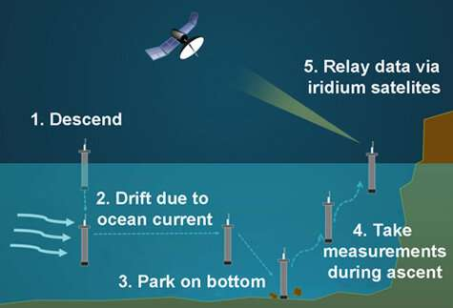
The float will descend and park on the seafloor to anchor. This is done to minimize horizontal drift due to ocean currents. On ascent, the float will take measurements. Once the float surfaces, it will transmit scientific data collected, as well as an engineering log, via iridium.

The buoyancy engine is instrumental helping navigate the float up and down the water column. Following Archimedes principle, Increasing the volume of the float increases its buoyancy, causing it to ascend. Deflating the bladder decreases its buoyancy, causing it to descend. The CPF uses a 3.5-liter capacity bladder. This buoyancy range allows the float to be deployed in various locations without the need for ballasting. The buoyancy engine uses an H156 Oildyne hydraulic pump, along with a Maxon EC90 motor, to move oil from the internal reservoir out to the bladder. The motor is controlled using the ELMO Gold Twitter motor controller.

At greater depths, pumping oil out into the bladder can start to pose a challenge in two key aspects. The first being simple risk mitigation. When anchored on the sea floor, the oil in the CPF’s reservoir becomes colder and thus more viscous. More viscous oil requires more torque and energy from the motor to pump. The second challenge is the problem of battery efficiency. The buoyancy engine takes up a significant portion of the float’s energy consumption over the course of its deployment (~200 profiles). Thus, characterizing this energy usage for a given motor is important to assess the profiling capacity of the float. A more efficient float will collect more profiles per deployment, reducing the cost per profile.

Benchtop simulators are crucial for testing these subsystems at a low cost and risk compared to a deployment in the ocean. A test setup was developed to assess these problems. Various motor and motor combinations were compared against one another to gather data on their peak current draw and overall energy consumption. The following sections will discuss the capabilities of this testbench, and the methods used to simulate ocean environments on the bench.

Motor Testbench
The motor testbench used for this analysis supports multiple motor and motor controller combinations. Motors are pre-mounted to machined plates, and motor controllers powered through WAGO blocks. Power into the motor controller is fed through the INA229 energy monitor to measure power supplied to the motors.

LabVIEW was the primary program used to communicate with the motor controllers via RS232. The program contained a set of 3 adjustable commands. The user could modify the motor speed, and the acceleration and deceleration limits. Additional functionalities also existed within the program, such as a terminal to log data when commands were sent, and a data acquisition mode sampling motor speed, voltage, and IQ (quadrature axis) current at a sample rate of 100Hz (33Hz per measurement) All these files were made easy to parse through to gather data across various tests.
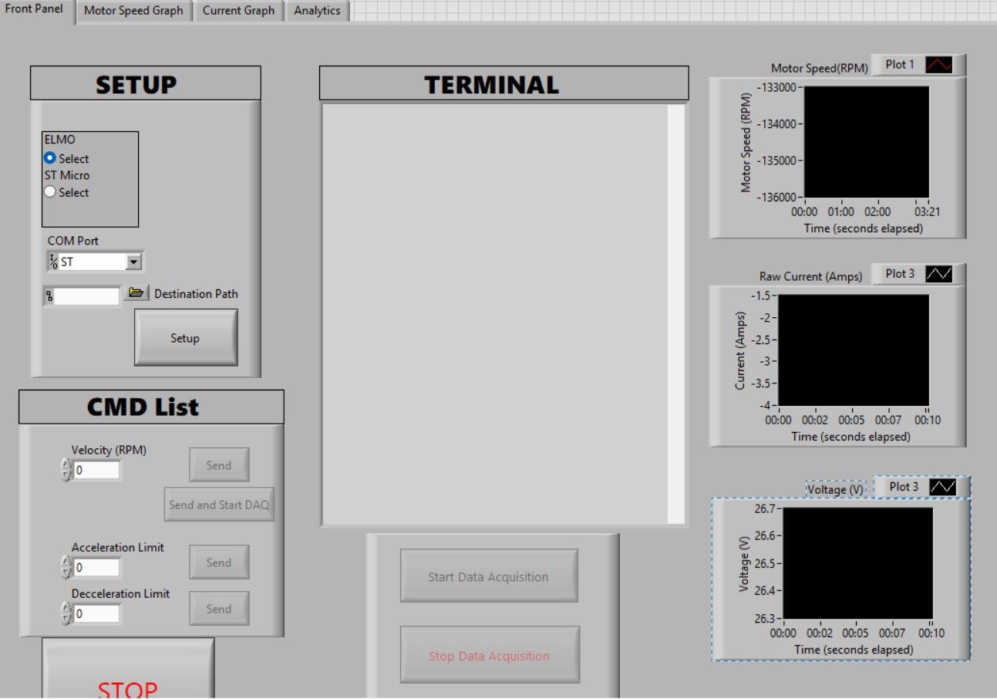

Many steps were taken to ensure the setup simulated an ocean environment as best as possible. Oil was placed in a 1-liter reservoir and was pumped through back into itself. The system was plumbed through a pressure relief valve, allowing the user to induce a pressure load upon the motors. Pressure was read in PSI using a pressure monitor plumbed into the setup.

Methods
The ELMO Gold Twitter and the STMicro EVLSERVO1 were two motor controllers being tested in this experiment. The Maxon EC90 Flat and the Maxon EC60 Flat were the two motors being tested. Three combinations of motor controllers and motors were tested. The STMicro and EC90 combination was the only one not tested due to a lack of support for the STMicro motor controller using the LabVIEW at the time of testing. Data already existed for the STMicro controlling the EC60 in the same testbench, and that data was used for some of the tests.

Two ocean situations were tested with the use of this setup. The first situation being addressed was the current draw to operate continuously at a certain pressure range. When using the buoyancy system, floats are primarily suspended in the water column. Thus, it is crucial to know the current (and consequently the energy which can be easily extrapolated) needed to use the buoyancy engine at a given depth. To test this, motors were spun at 1000 RPM pumping oil continuously. When pressure was added to the system via the pressure relief valve, the system was allowed to stabilize, then measurements were taken using the INA229 current monitor using a 4kHz sampling frequency over a 5 second window (20,000 samples). Measurements were collected for 10 load pressures ranging from 0-650PSI (translated to 450 dBar). This process was repeated for 3 different motor and motor controller combinations. The ELMO Gold Twitter with the two Maxon motors, and the STMicro motor controller with the Maxon EC60.

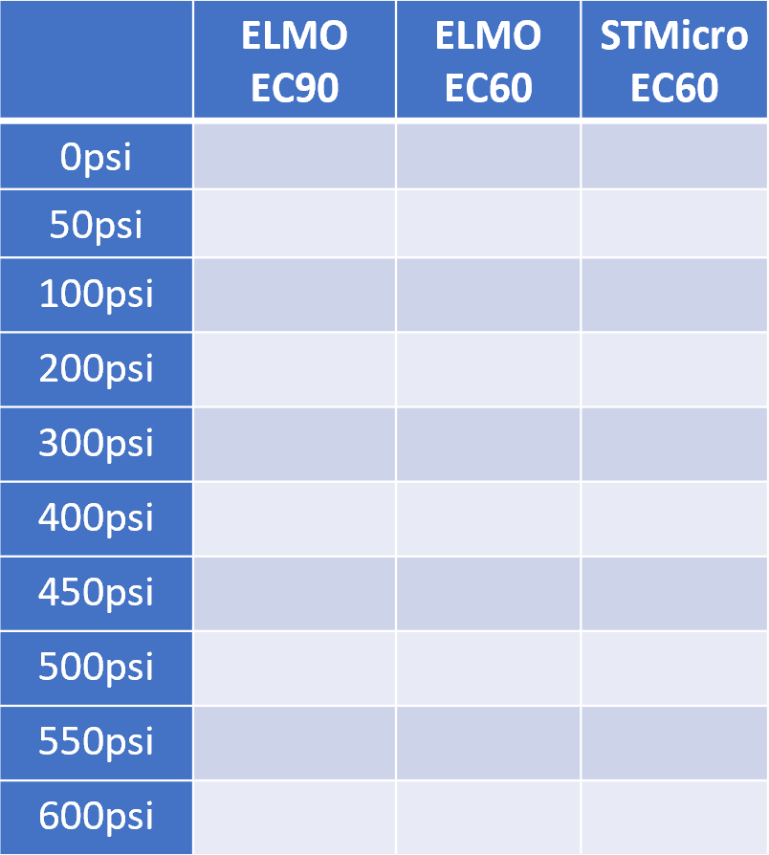

The second situation being addressed was the peak current draw used to de-anchor the CPF. When the CPF is parked on the seafloor, there is pressure acting on the bladder working against it inflating. For longer parking periods, the oil inside the reservoir can also become colder and thus more viscous. These two factors require the motor to provide a larger torque to pump oil. The startup test was conducted at 350 dBar of pressure using the same current measurement setup of 4kHz sampling over a 5 second window. The data acquisition mode was not used in this test due to being too slow of a sample rate for startup data. Consequently, the data acquisition mode was not used for the continuous depth test for continuity purposes.

The startup test used the ELMO Gold Twitter and the EC90 motor to first verify the peak current was within 10Amps. Two different acceleration values were tested. The first accelerated the motor to 1000 RPM over 0.1 second (1000 RPM/s). The second accelerated the motor to 1000 RPM over 1 second (1000 RPM/s).

If the peak current was within the limits, the test would be repeated for the Maxon EC60 at the two different acceleration values. This data was used to characterize performance of different motors accelerating to 1000 RPM at different rates and compare the energy they consumed to pump oil at a fixed rate with no motion. The load upon startup for this system was 500psi, or 350dBar, simulating a CPF attempting to deanchor from the seafloor.

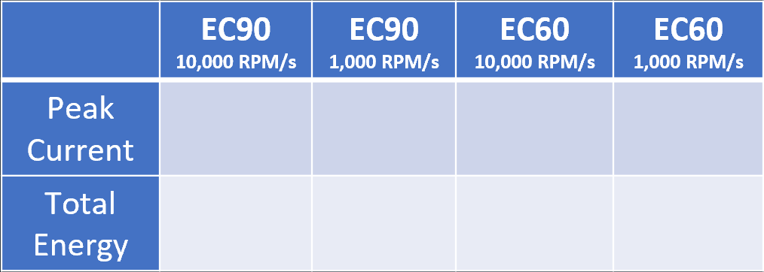

Results
For the continuous pressure test, there appears to be a clear trend favoring the EC90 motor in terms of current required to operate at 1000 RPM, however, there does not appear to be a noticeable performance difference between the two different motor controllers.
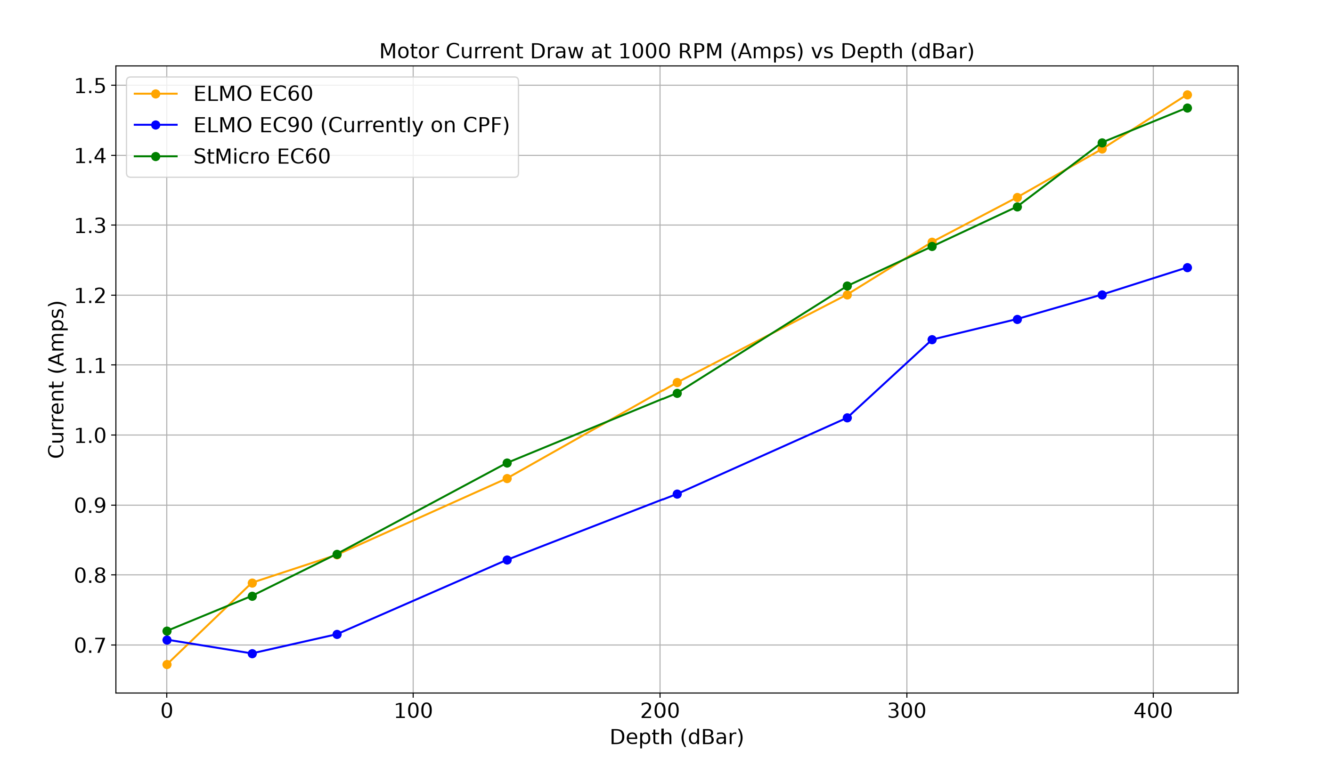

Pressure was converted to dbar to maintain consistency with the CPF's pressure sensor measurements. As pressure increases, the current required by the motor also increases approximately linearly. This trend is consistent with the relationship between motor torque and current for Maxon motors, where torque is proportional to the supplied current after accounting for the no-load current. The equation below describes this relationship using the motor's torque constant.
$$T = K_{T }(I-I_{0})$$
Motor torque is proportional to the supplied current after accounting for the no-load current. Across both motor controller configurations, the EC90 consistently draws approximately 15% less current than the EC60. This difference in current draw can be used to estimate the resulting difference in energy consumption and, consequently, the number of profiles achievable by each of the three motor-controller combinations. Assuming the buoyancy engine accounts for 60% of the CPF's total battery consumption over its deployment life, a 15% reduction in motor energy usage could result in approximately a 9% increase in the number of profiles.

Next looking at the peak current required for startup using the ELMO Gold Twitter and Maxon EC90 Motor using different acceleration values to get up to 1000RPM, there is a clear difference in the peak current draw on startup.
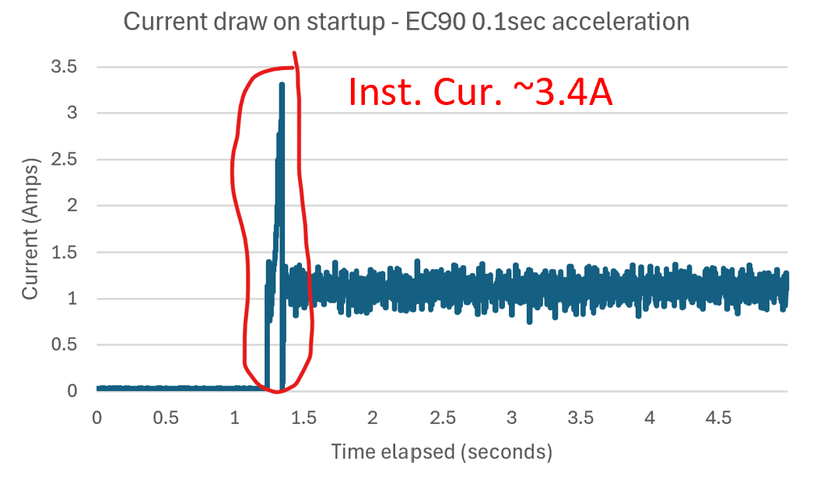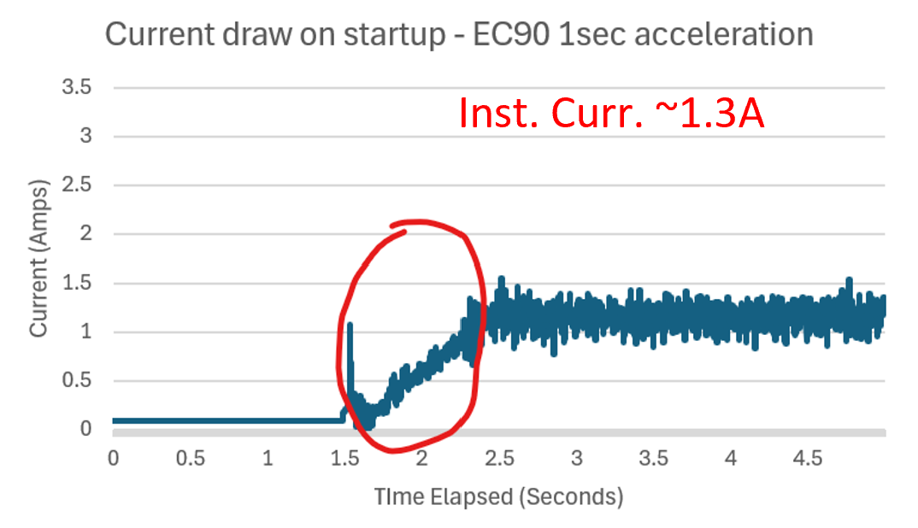
There is a clear peak for the 10,000 RPM/s acceleration, compared to the slower 1,000 RPM/s, which seems to have a more gradual ramp up into its desired current. For the purposes of the CPF’s buoyancy engine, the acceptable peak current was 10A, so both variations passed this test.

The next part of this test looked at the total energy used upon startup. The Maxon EC60 was also tested with the two different acceleration values for a total of four tests. The following equation was used to assess energy consumption in this test.
$$W = V\int{I(t)dt}$$
The tests using the higher acceleration value were integrated over a 0.1sec interval, and for the lower acceleration an interval of 1sec was used. Voltage was a constant 26.5V for all four tests.

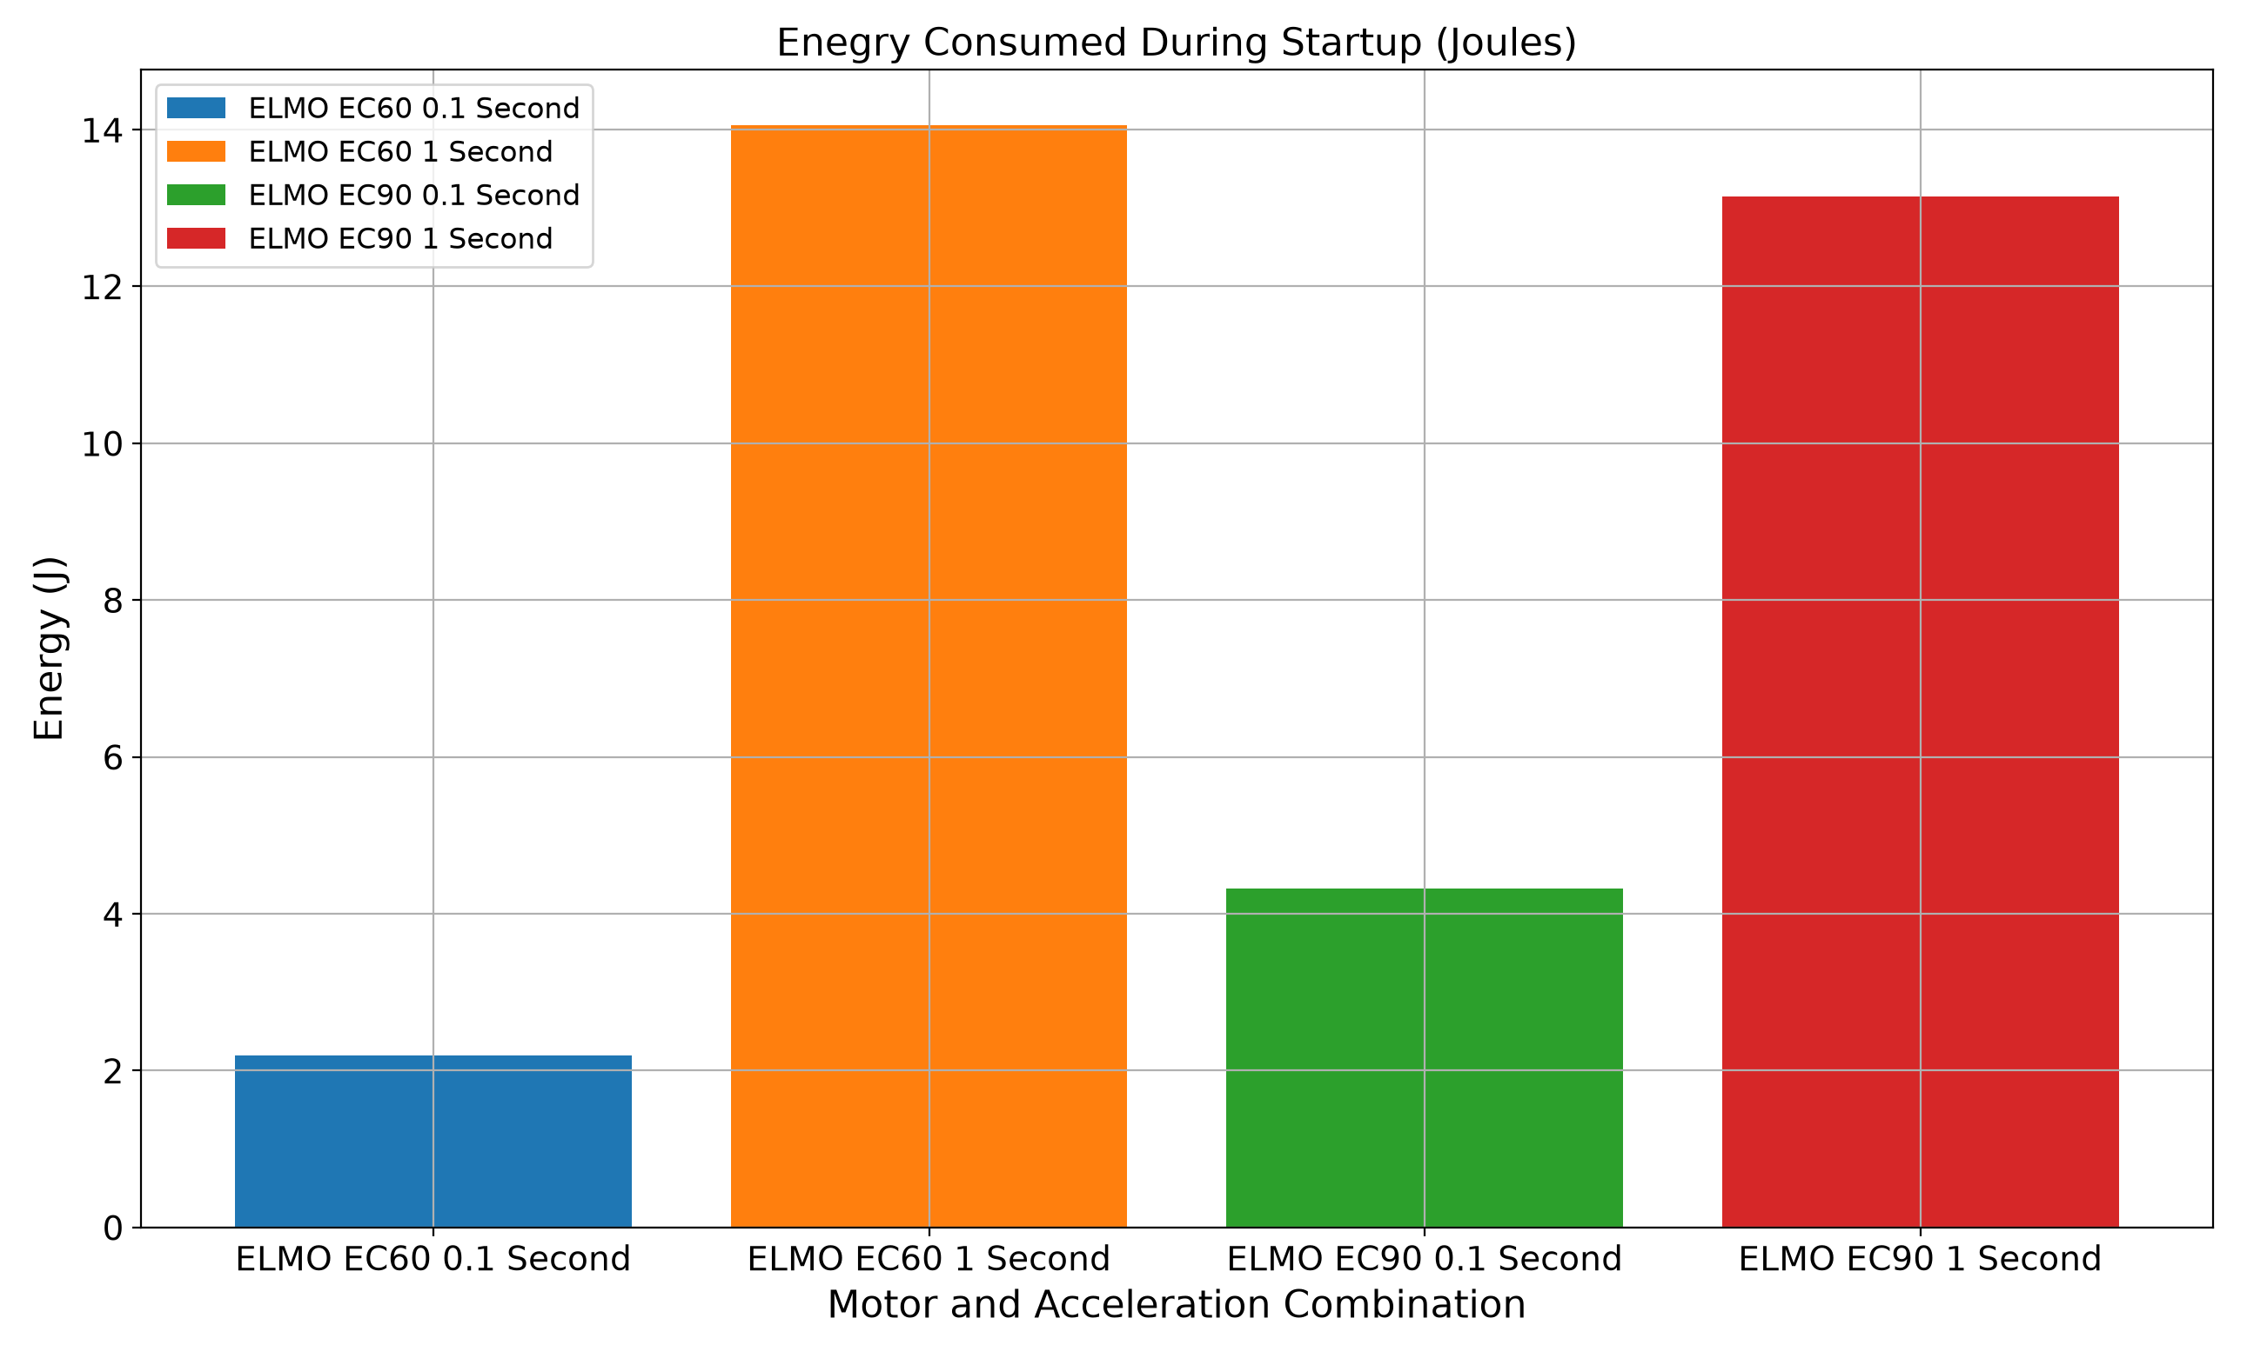

There were a few key findings from the energy consumed on startup data. First – The acceleration value used seemed to be the greatest determinant of efficiency. The higher acceleration tests both had lower energy consumption than the lower acceleration, regardless of the motor. The difference was fairly significant; the higher acceleration tests were about 3-7x more efficient compared to the lower acceleration tests. Second – looking at a set acceleration value and different motors, there was not a motor more efficient across both acceleration values.

The third point has more context behind it. Energy consumed on startup was analyzed to see if changes to the motor or acceleration value would provide any meaningful difference. The bar chart above is plotted against the % of float battery used over 200 profiles using the following equation, where 1.85x10^6 is the float’s battery capacity.

$$\% Battery=\frac{Energy for Startup (Joules) 200 }{1.85x{10}^{6} Joules}$$

Over 200 profiles, it was determined that the energy consumed on startup fell in the range of 2-14 Joules. This translated to a difference in % of the CPF’s battery used over 200 profiles of 0.13% between the highest energy consumer – the EC60 at 1 second of acceleration, and the lowest energy consumer – the ELMO EC60 at 0.1sec of acceleration. 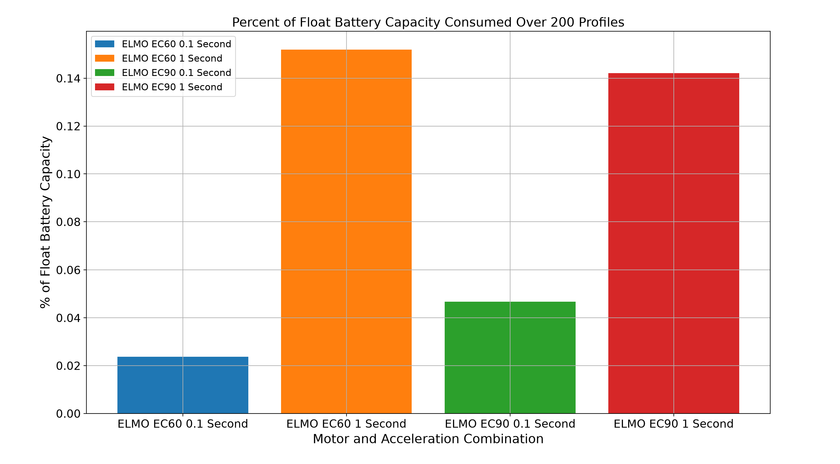This is an insignificant difference, and thus it was determined the energy consumed on startup should not be a factor in selecting a motor for the CPF’s buoyancy engine.

Conclusion

The CPF’s buoyancy system was designed with a lot of these energy considerations in mind, but characterizing its performance through a testbench was something that had not been done yet. It is now clearer how the current buoyancy engine setup on the CPF performs compared to alternative methods.

Benchtop testing is critical in verifying the performance and mitigating risk of subsystems in oceanographic instruments. While this paper only talks about tests comparing two different motors and two different motor controllers, a solid foundation has been set for this testbench keeping modifiability in mind. Integrating new motors and motor controllers is simple to do in the future.
A large portion of time was spent on creating the benchtop simulator and the LabVIEW software to communicate with the motor controllers. It would be nice to have a setup that encompasses everything. Currently, logging data through the energy monitor is a separate process from the LabVIEW program that communicates with the motor controller. One future development would be to integrate the INA229 into the LabVIEW software.

