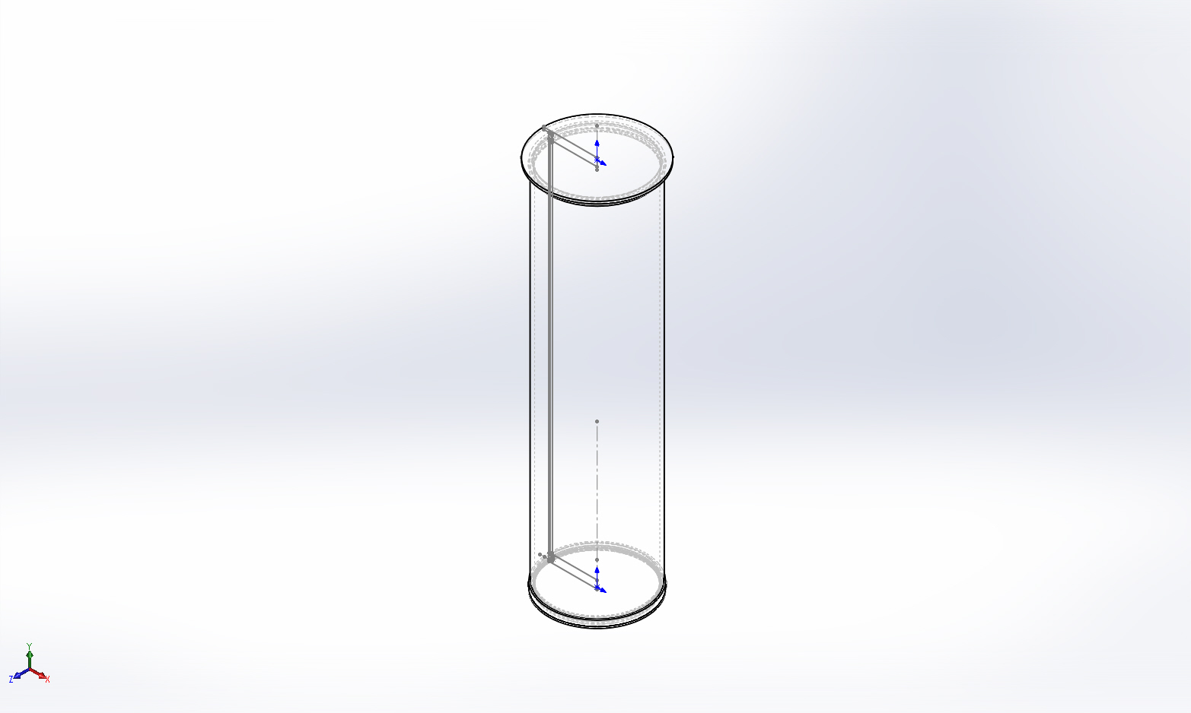
  Simulation of FFS CPF
  Date: Friday, March 27, 2015
  Designer: Analysis was performed by Farley F. Shane
  Study name: 260315 CPF Buckling 1
  Analysis type: Buckling
  Table of Contents
  Description 1
  Model information 2
  Study Properties 4
  Units 4
  Material Properties 5
  Loads and Fixtures 6
  Connector Definitions 6
  Contact Information 7
  Mesh Information 9
  Sensor Details 11
  Study Results 12
  Conclusion 13

Description
Buckling Analysis for the Coastal Profiling Float
26March2015

Model information

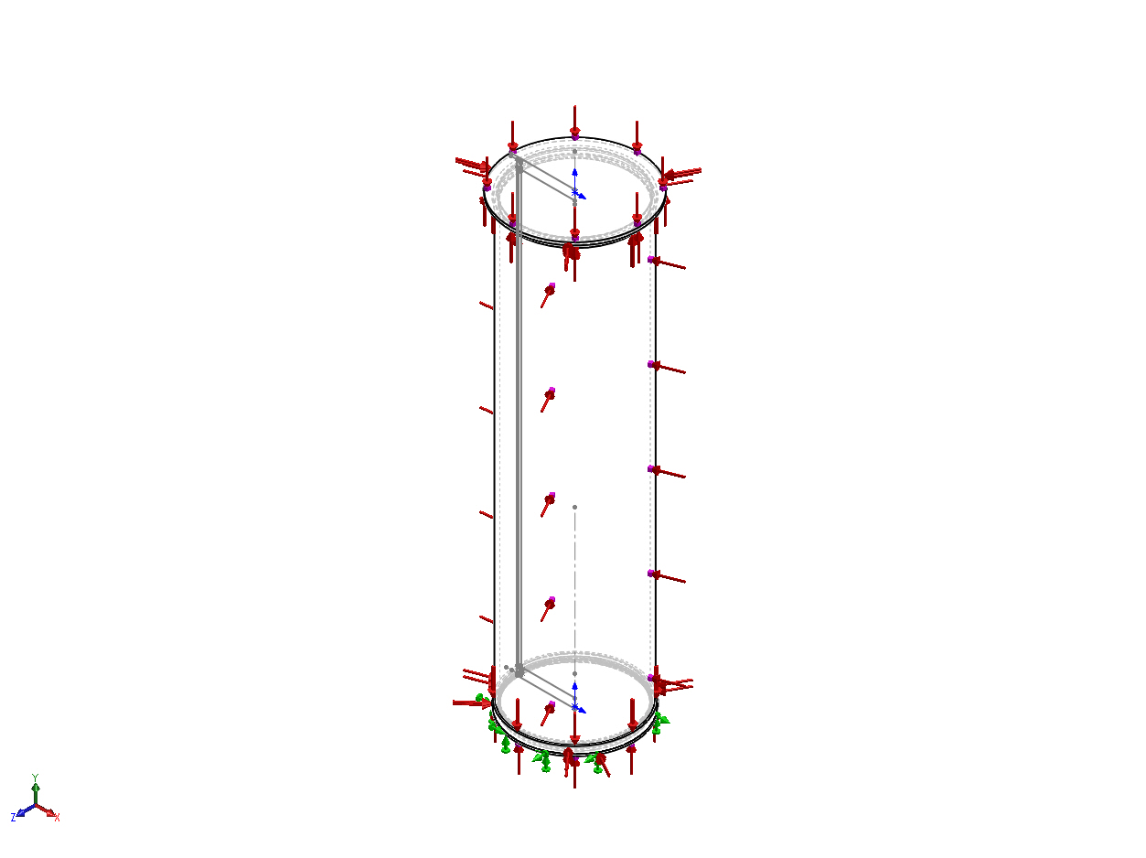
Model name: FFS CPF
Current Configuration: Default
Solid Bodies
Document Name and Reference | Treated As | Volumetric Properties | Document Path/Date Modified
Cut-Revolve2  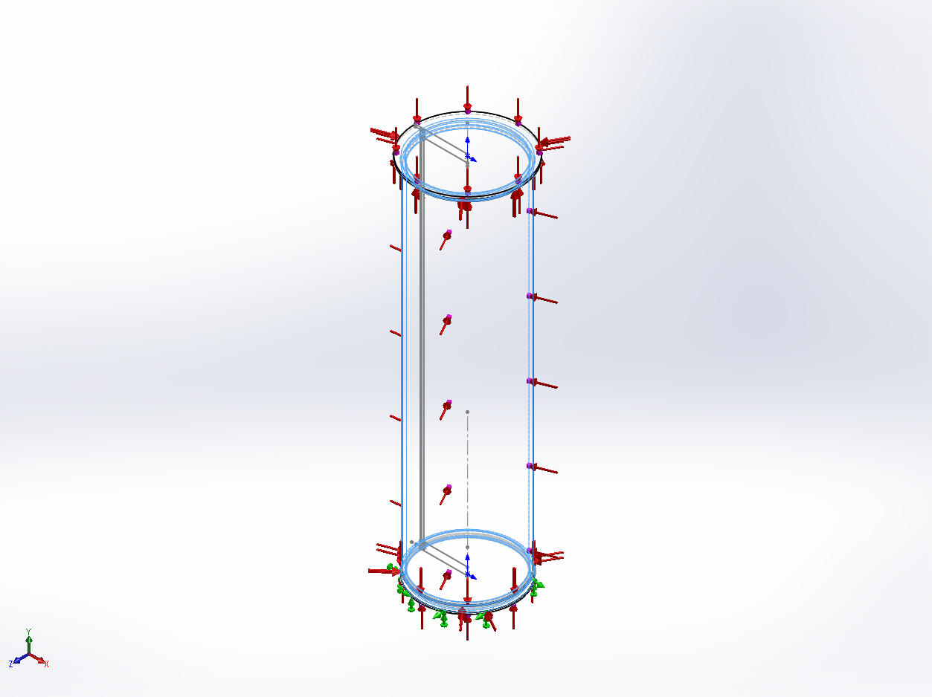 | Solid Body | Mass:16.7098 lb  Volume:171.306 in^3  Density:0.0975437 lb/in^3  Weight:16.6985 lbf | X:\CPF\Mechanical Engr\Farley\CPF2015Feb03\FFS PipeSch40x8.0-cpfV2.SLDPRT  Mar 26 16:01:21 2015
Revolve1  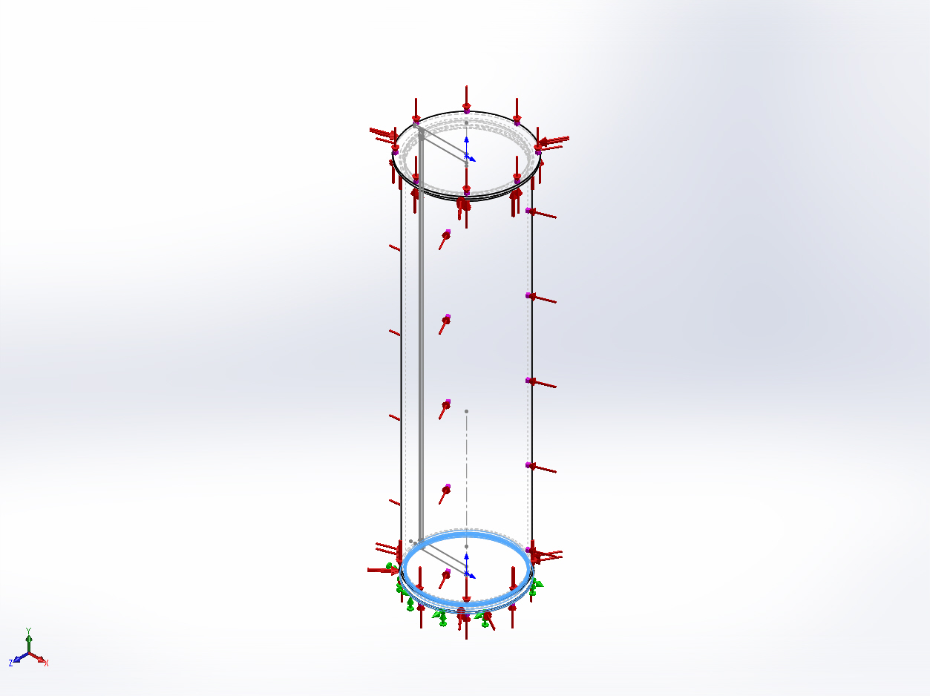 | Solid Body | Mass:3.55334 lb  Volume:36.4282 in^3  Density:0.0975437 lb/in^3  Weight:3.55093 lbf | X:\CPF\Mechanical Engr\Farley\CPF2015Feb03\FFS housingBase-cpfV2.SLDPRT  Mar 16 15:23:24 2015
Split Line5  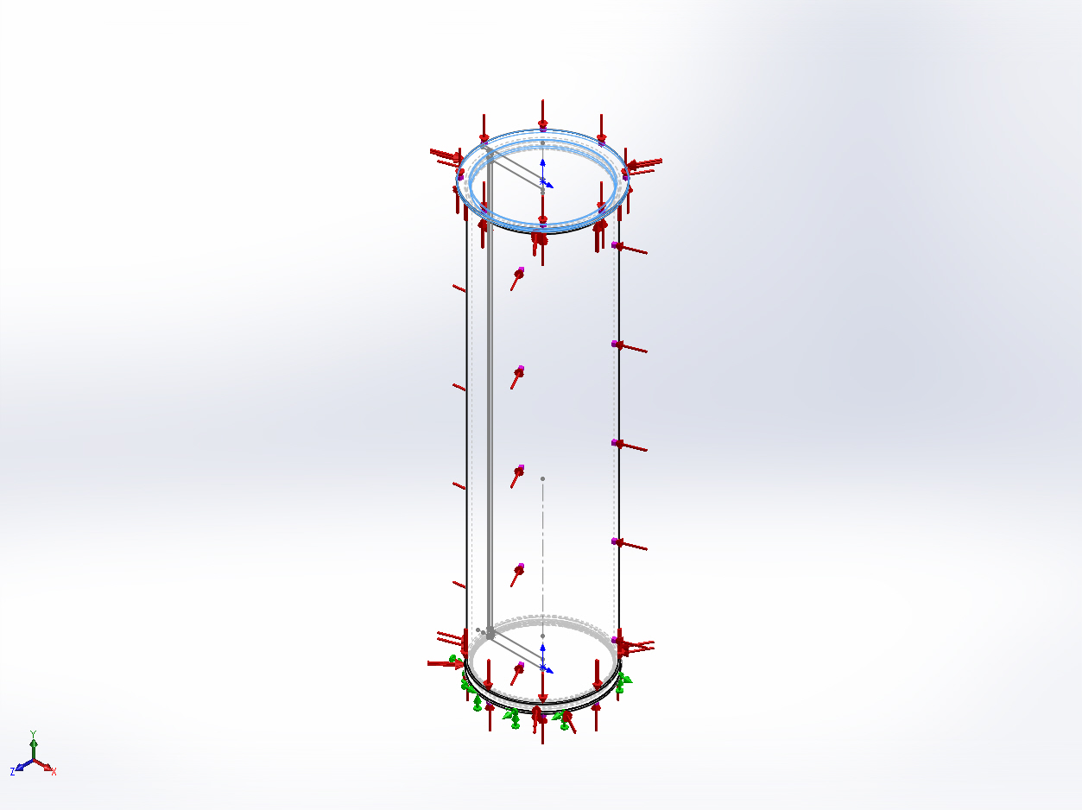 | Solid Body | Mass:3.8916 lb  Volume:39.896 in^3  Density:0.0975437 lb/in^3  Weight:3.88897 lbf | X:\CPF\Mechanical Engr\Farley\CPF2015Feb03\FFS topFlange-cpfV2.SLDPRT  Mar 18 14:21:51 2015

Comments:
This analysis was done on simplified End Caps
and the housing

Study Properties
Study name | 260315 CPF Buckling 1
Analysis type | Buckling
Mesh type | Solid Mesh
Number of modes | 1
Solver type | Direct sparse solver
Incompatible bonding options | Automatic
Thermal Effect: | On
Thermal option | Include temperature loads
Zero strain temperature | 77 Fahrenheit
Include fluid pressure effects from SolidWorks Flow Simulation | Off
Soft Spring: | Off
Result folder | SolidWorks document (X:\CPF\Mechanical Engr\Farley\CPF2015Feb03)

Units
Unit system: | English (IPS)
Length/Displacement | in
Temperature | Fahrenheit
Angular velocity | Hertz
Pressure/Stress | psi

Material Properties
Model Reference | Properties | Components
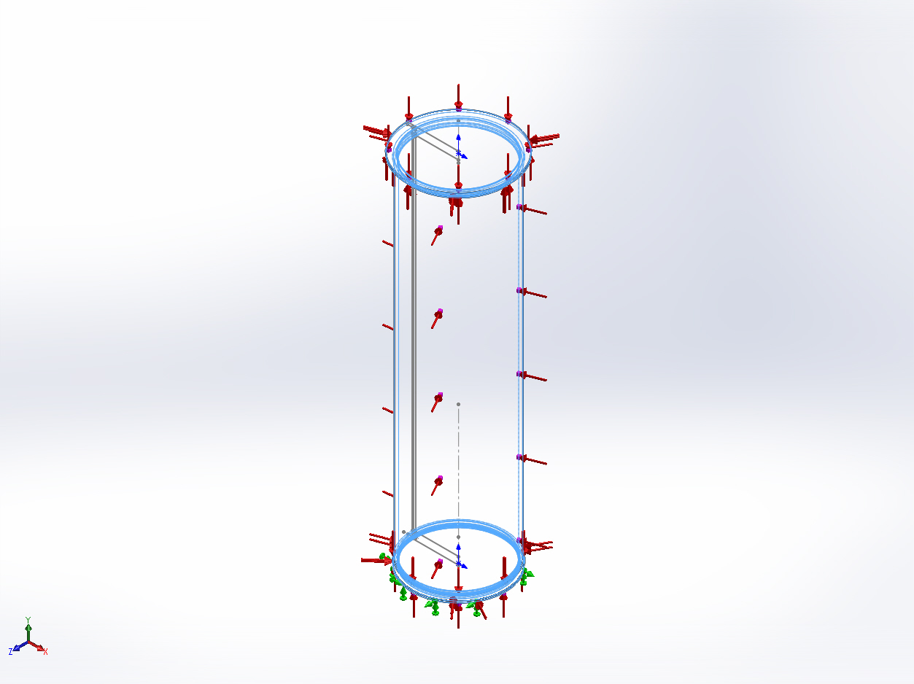 |  | SolidBody 1(Cut-Revolve2)(FFS PipeSch40x8.0-cpfV2-1),  SolidBody 1(Revolve1)(FFS housingBase-cpfV2-1),  SolidBody 1(Split Line5)(FFS topFlange-cpfV2-1)
  Name: | 6061-T6 (SS)
  Model type: | Linear Elastic Isotropic
  Default failure criterion: | Unknown
  Yield strength: | 39885.4 psi
  Tensile strength: | 44961.7 psi
  Mass density: | 0.0975437 lb/in^3
  Elastic modulus: | 1.00076e+007 psi
  Poisson's ratio: | 0.33
  Thermal expansion coefficient: | 1.33333e-005 /Fahrenheit
Curve Data:N/A

Loads and Fixtures
Fixture name | Fixture Image | Fixture Details
Fixed-1 | 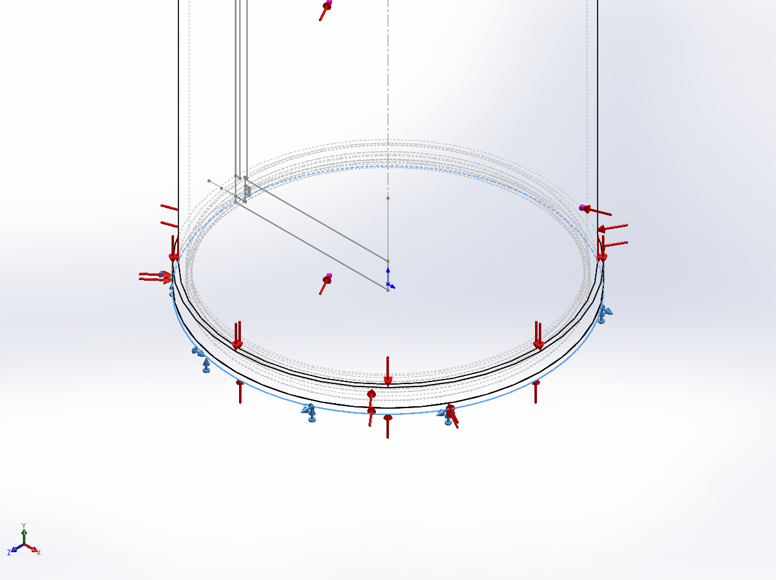
  Entities: | 1 edge(s)
  Type: | Fixed Geometry

Load name | Load Image | Load Details
Pressure-1 | 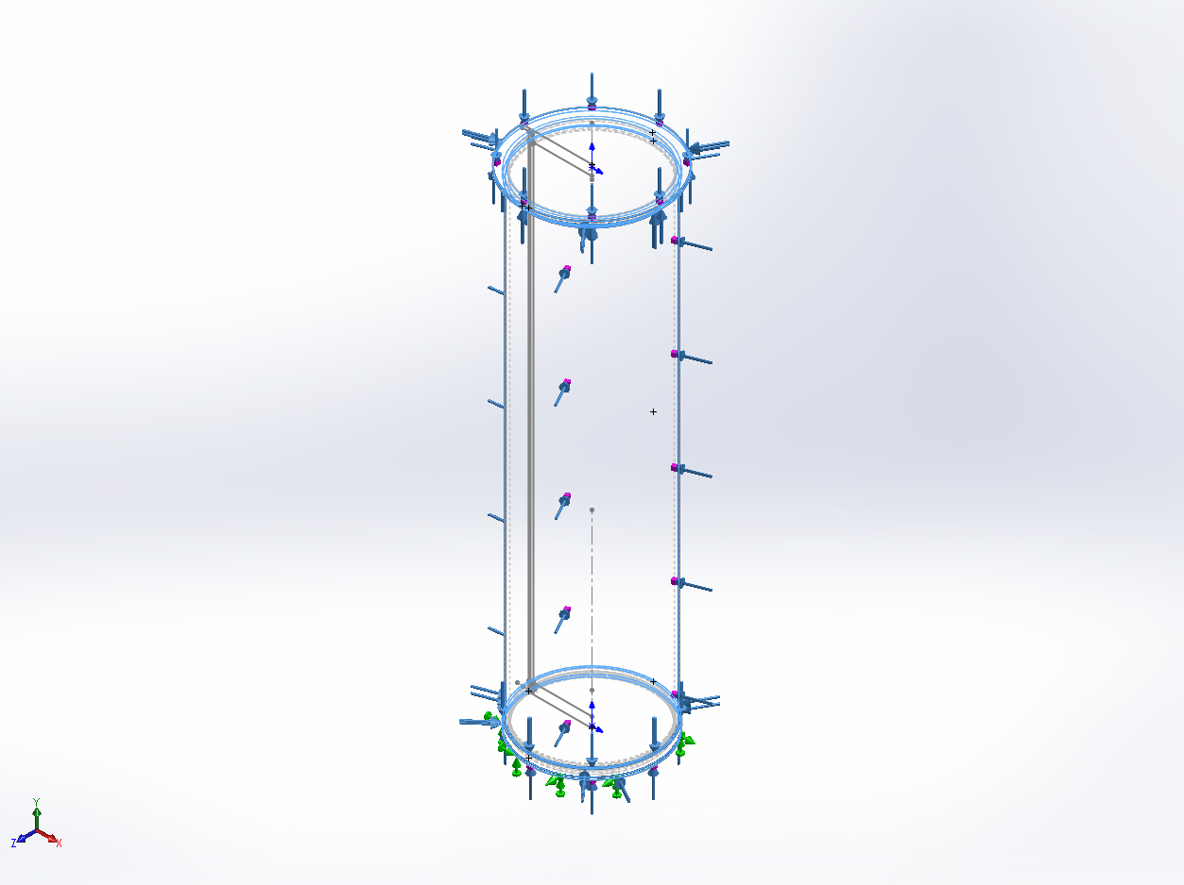
  Entities: | 10 face(s)
  Type: | Normal to selected face
  Value: | 750
  Units: | psi
  Phase Angle: | 0
  Units: | deg

Connector Definitions
No Data

Contact Information

Contact | Contact Image | Contact Properties
Contact Set-1 | 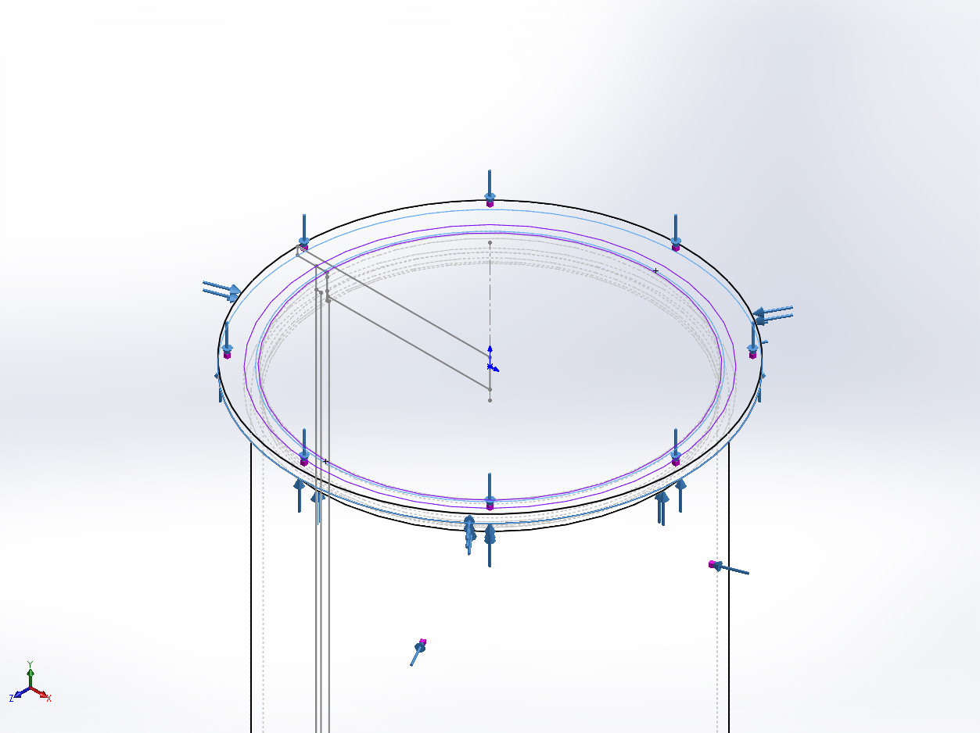
  Type: | Bonded contact pair
  Entites: | 2 face(s)
Contact Set-2 | 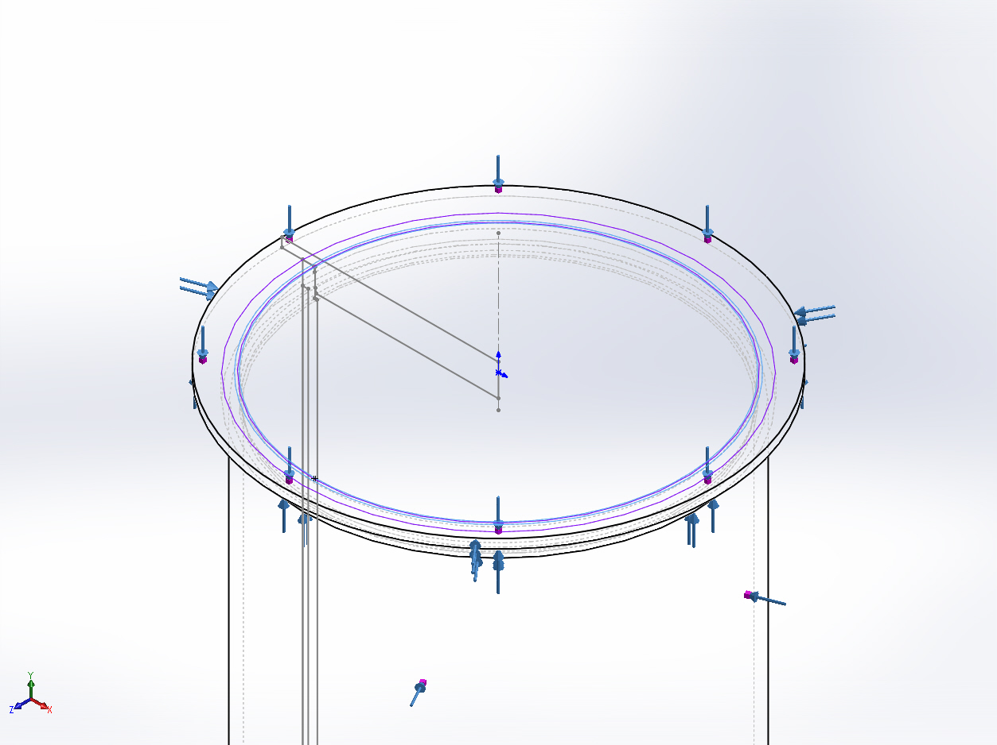
  Type: | Bonded contact pair
  Entites: | 2 face(s)
Contact Set-3 | 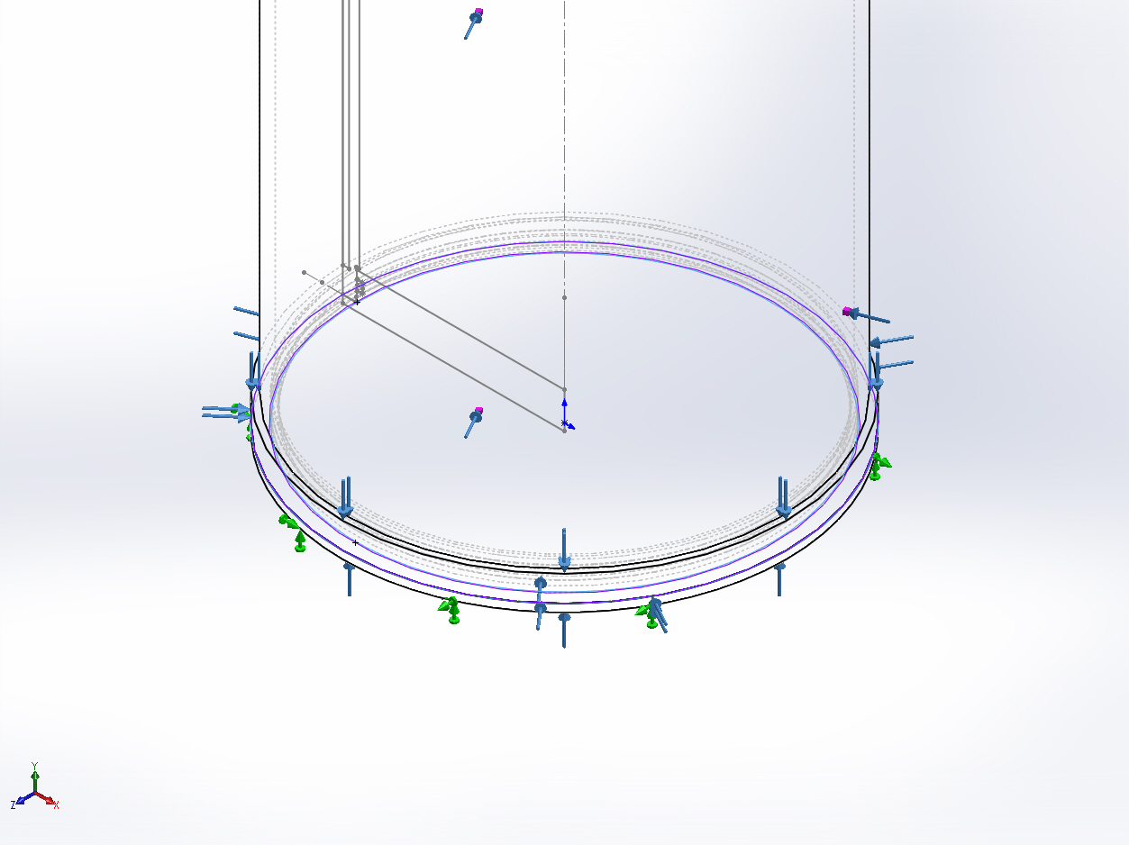
  Type: | Bonded contact pair
  Entites: | 2 face(s)
Global Contact | 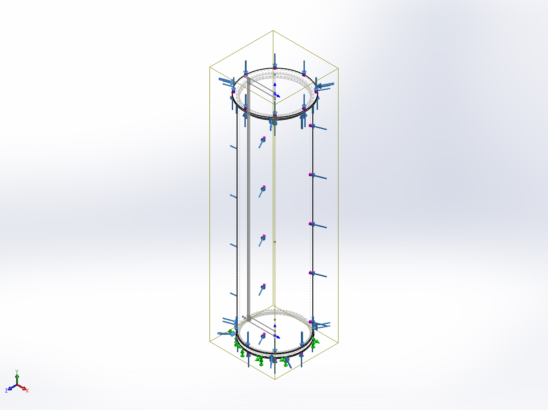
  Type: | Bonded
  Components: | 1 component(s)
  Options: | Compatible mesh

Mesh Information
Mesh type | Solid Mesh
Mesher Used: | Curvature based mesh
Jacobian points | 4 Points
Maximum element size | 0.25 in
Minimum element size | 0.05 in
Mesh Quality | High
Remesh failed parts with incompatible mesh | On

Mesh Information - Details
Total Nodes | 361253
Total Elements | 205204
Maximum Aspect Ratio | 258.09
% of elements with Aspect Ratio < 3 | 90.5
% of elements with Aspect Ratio > 10 | 2.29
% of distorted elements(Jacobian) | 0
Time to complete mesh(hh;mm;ss): | 00:00:34
Computer name: | ENIGMA
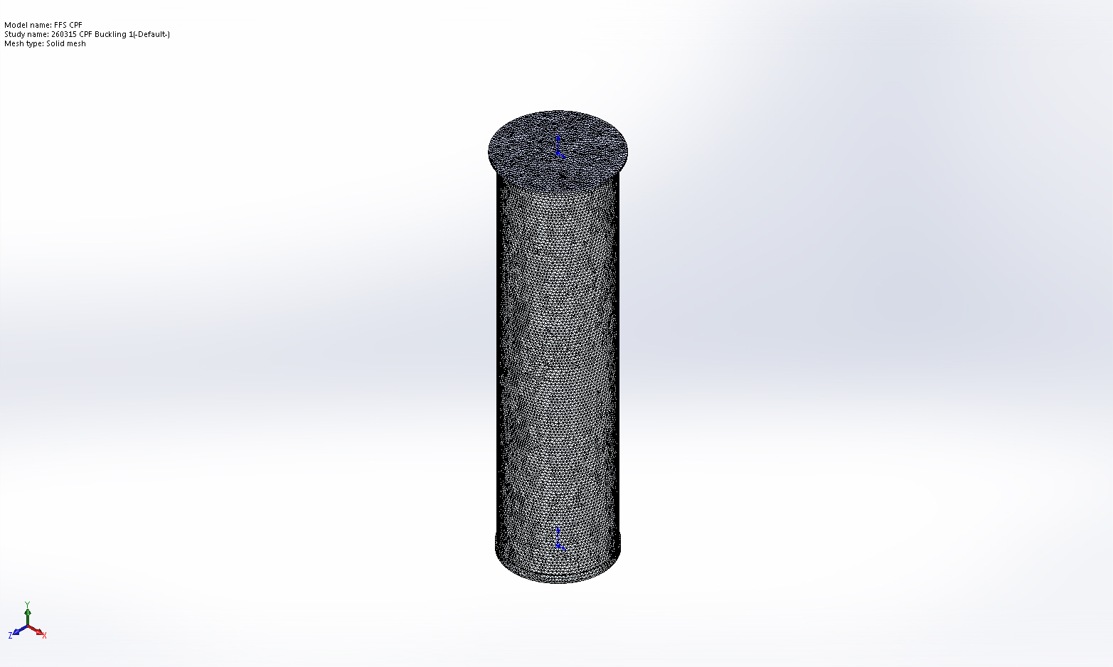

Mesh Control Information:
Mesh Control Name | Mesh Control Image | Mesh Control Details
Control-1 | 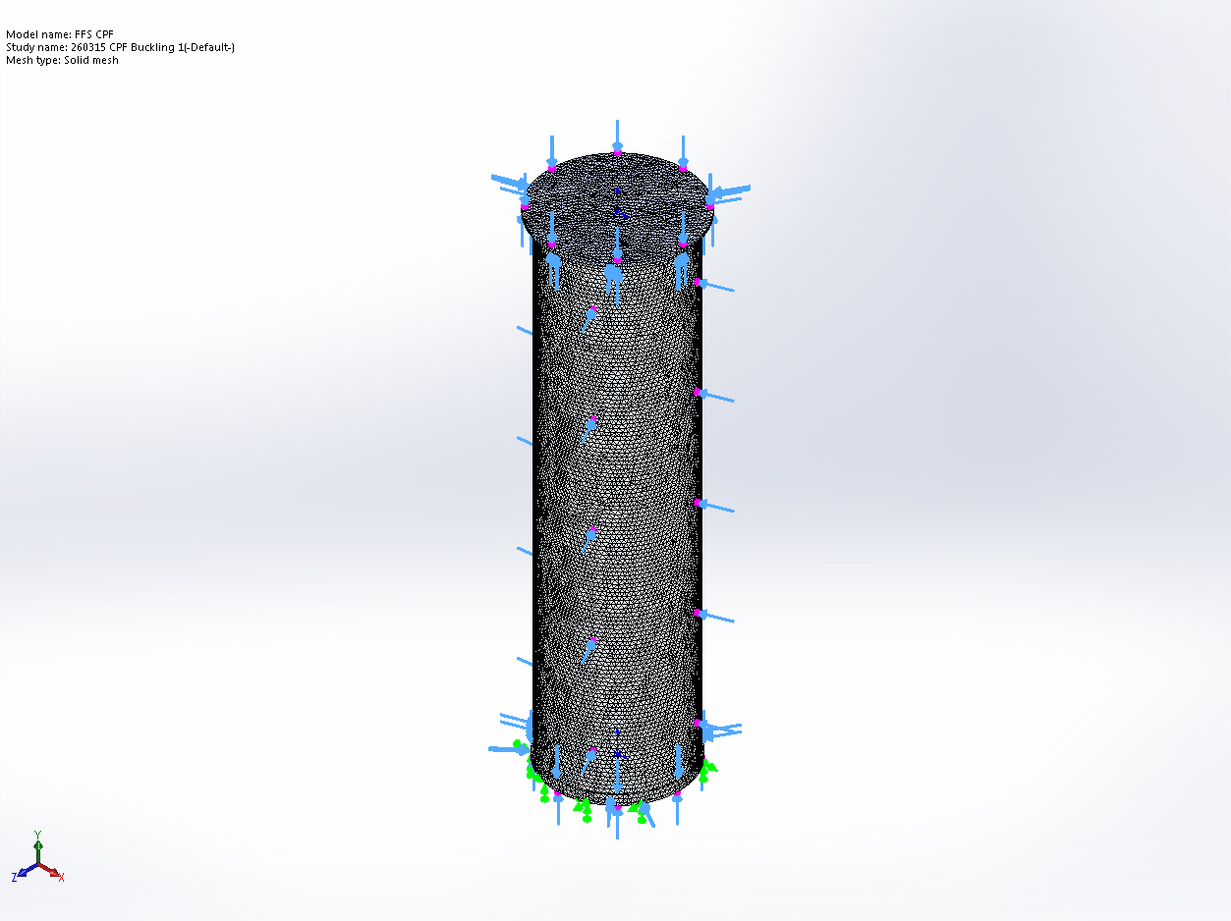
  Entities: | 3 face(s)
  Units: | in
  Size: | 0.25
  Ratio: | 1.5

Sensor Details
No Data

Study Results

Name | Type | Min | Max
Amplitude1 | AMPRES: Resultant Amplitude Plot for Mode Shape: 1(Load Factor = 1.29431) | 0  Node: 185560 | 0.000252207  Node: 163138
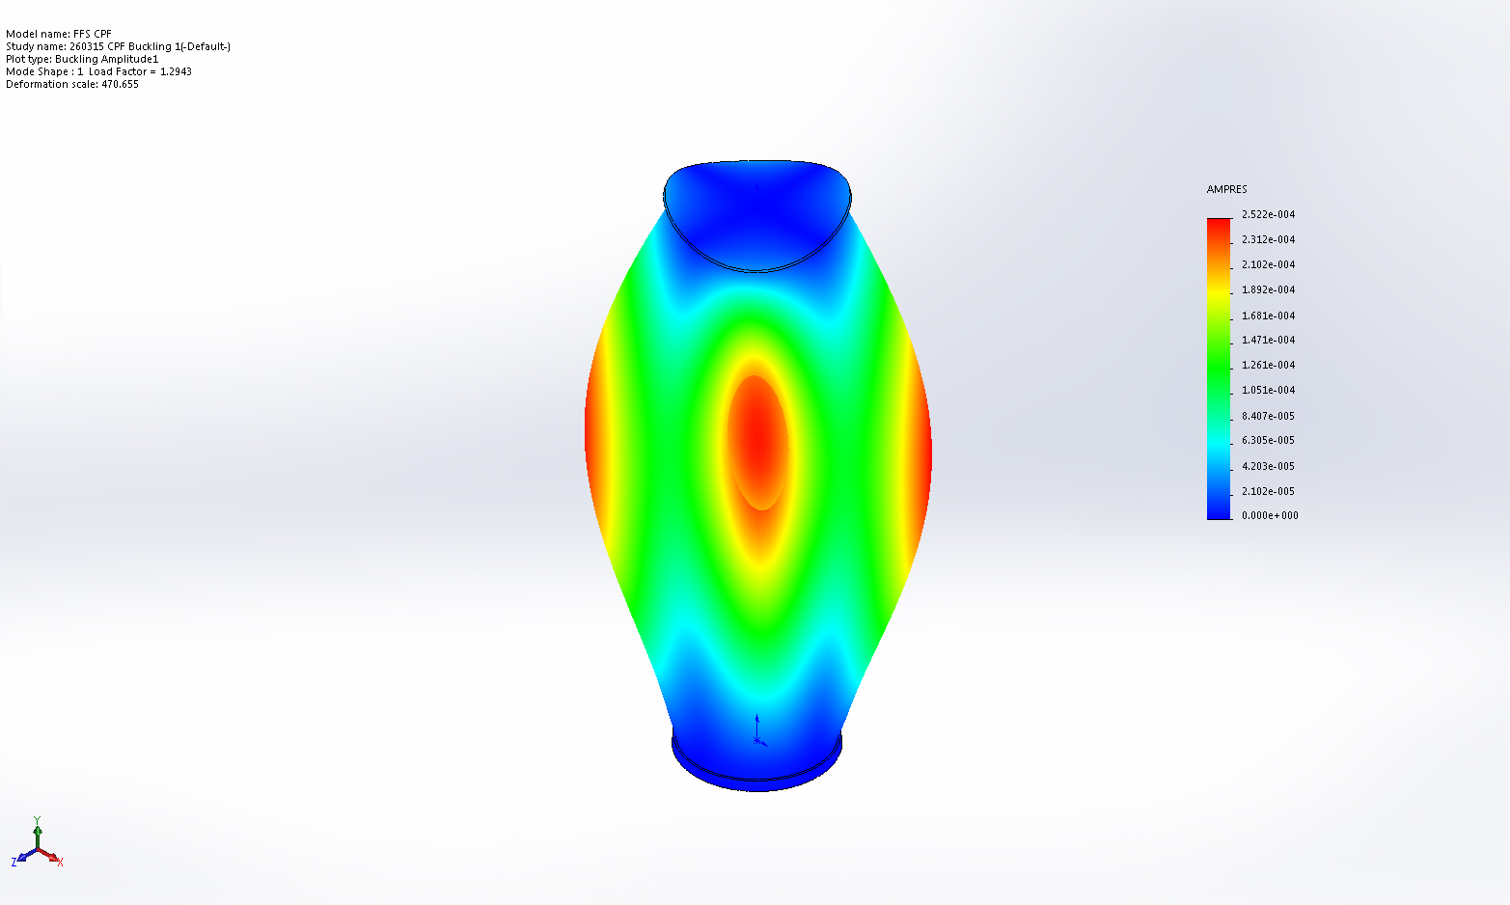
FFS CPF-260315 CPF Buckling 1-Amplitude-Amplitude1

Name | Type
Displacement1 | AMPRES: Resultant Amplitude
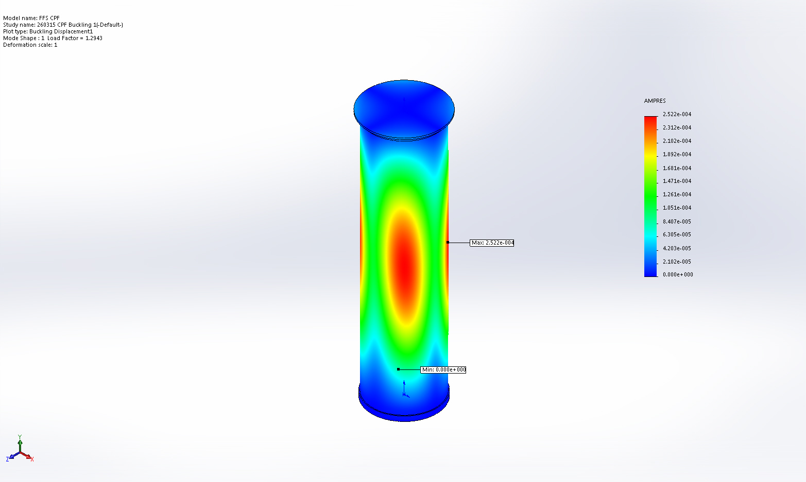
FFS CPF-260315 CPF Buckling 1-Displacement-Displacement1

Mode List
Mode Number | Load Factor
1 | 1.2943

Conclusion

