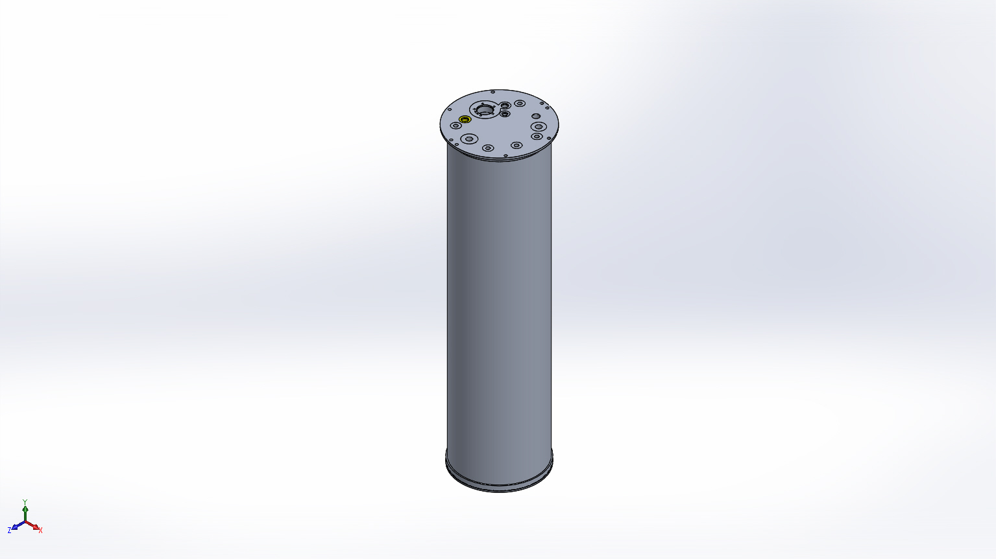
  Simulation of FFS CPF
  Date: Tuesday, March 31, 2015
  Designer: FEA performed by Farley F. Shane
  Study name: 31Mar2015 CPF Assy Buckling 2
  Analysis type: Buckling
  Table of Contents
  Description 1
  Assumptions 2
  Model Information 2
  Study Properties 3
  Units 4
  Material Properties 4
  Loads and Fixtures 5
  Connector Definitions 5
  Contact Information 6
  Mesh Information 7
  Sensor Details 9
  Study Results 10
  Conclusion 12

Description
Coastal Profiling Float Housing Assembly
Coarse Mesh

Assumptions

Model Information

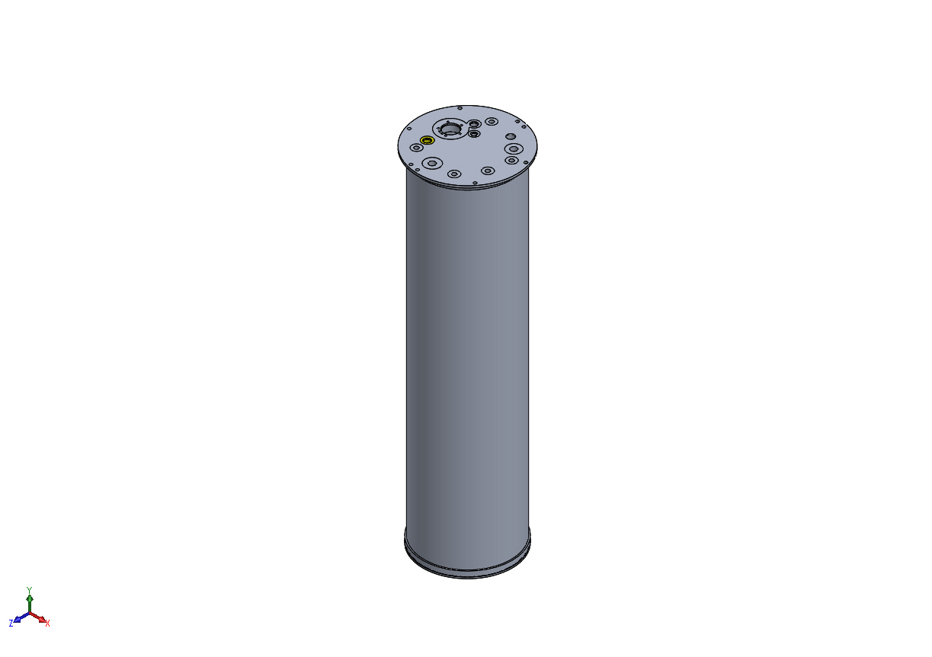
Model name: FFS CPF
Current Configuration: Default
Solid Bodies
Document Name and Reference | Treated As | Volumetric Properties | Document Path/Date Modified
Mirror1  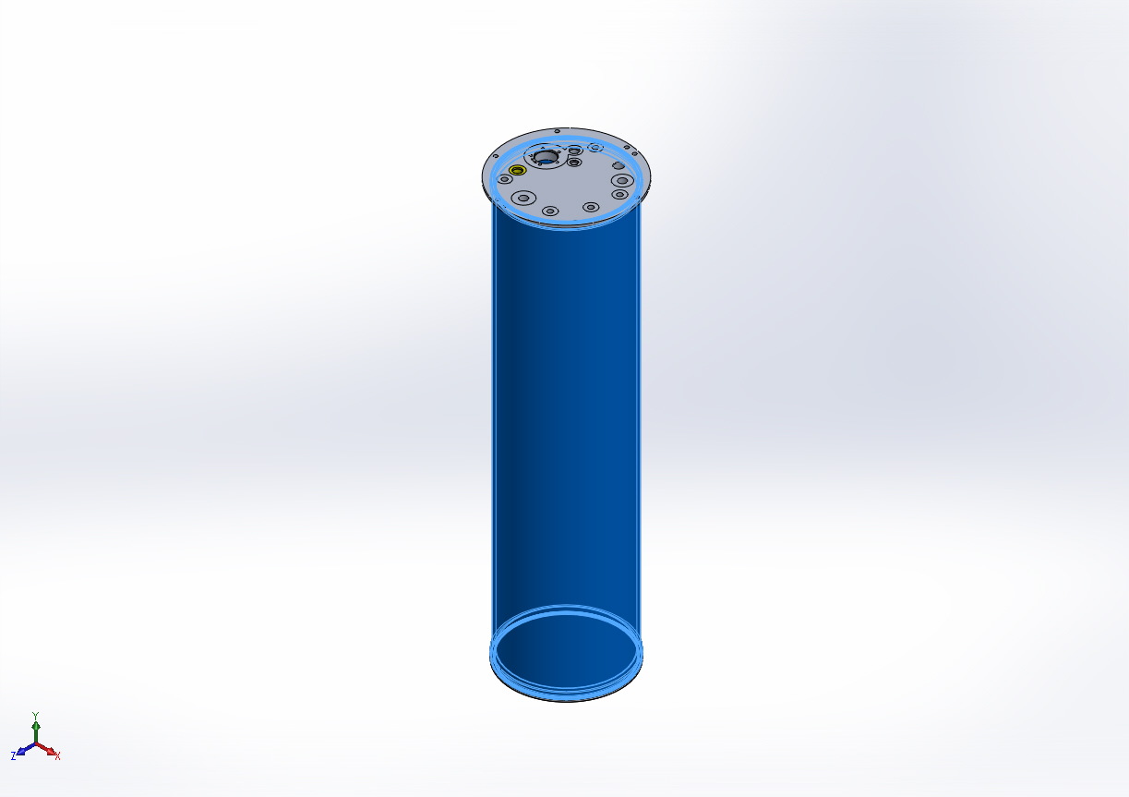 | Solid Body | Mass:16.655 lb  Volume:170.744 in^3  Density:0.0975437 lb/in^3  Weight:16.6437 lbf | X:\CPF\Mechanical Engr\Farley\CPF2015Feb03\FFS PipeSch40x8.0-cpfV2.SLDPRT  Mar 27 14:40:27 2015
17/64 (0.26563) Diameter Hole1 | Solid Body | Mass:3.457 lb  Volume:35.4405 in^3  Density:0.0975437 lb/in^3  Weight:3.45466 lbf | X:\CPF\Mechanical Engr\Farley\CPF2015Feb03\FFS housingBase-cpfV2.SLDPRT  Mar 27 14:40:27 2015
CBORE for 7/16 Hex Head Bolt1 | Solid Body | Mass:3.53825 lb  Volume:36.2735 in^3  Density:0.0975437 lb/in^3  Weight:3.53585 lbf | X:\CPF\Mechanical Engr\Farley\CPF2015Feb03\FFS topFlange-cpfV2.SLDPRT  Mar 30 17:30:45 2015

Study Properties
Study name | 31Mar2015 CPF Assy Buckling 2
Analysis type | Buckling
Mesh type | Solid Mesh
Number of modes | 1
Solver type | Direct sparse solver
Incompatible bonding options | Automatic
Thermal Effect: | On
Thermal option | Include temperature loads
Zero strain temperature | 77 Fahrenheit
Include fluid pressure effects from SolidWorks Flow Simulation | Off
Soft Spring: | Off
Result folder | SolidWorks document (X:\CPF\Mechanical Engr\Farley\CPF2015Feb03)

Units
Unit system: | English (IPS)
Length/Displacement | in
Temperature | Fahrenheit
Angular velocity | Hertz
Pressure/Stress | psi

Material Properties
Model Reference | Properties | Components
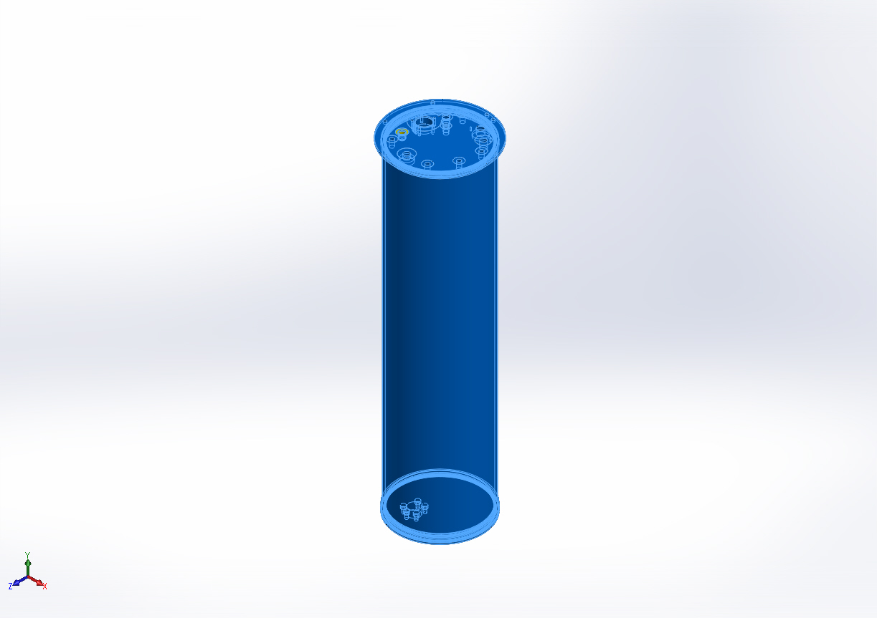 |  | SolidBody 1(Mirror1)(FFS PipeSch40x8.0-cpfV2-1),  SolidBody 1(17/64 (0.26563) Diameter Hole1)(FFS housingBase-cpfV2-1),  SolidBody 1(CBORE for 7/16 Hex Head Bolt1)(FFS topFlange-cpfV2-1)
  Name: | 6061-T6 (SS)
  Model type: | Linear Elastic Isotropic
  Default failure criterion: | Unknown
  Yield strength: | 39885.4 psi
  Tensile strength: | 44961.7 psi
  Mass density: | 0.0975437 lb/in^3
  Elastic modulus: | 1.00076e+007 psi
  Poisson's ratio: | 0.33
  Thermal expansion coefficient: | 1.33333e-005 /Fahrenheit
Curve Data:N/A

Loads and Fixtures
Fixture name | Fixture Image | Fixture Details
Reference Geometry-1 | 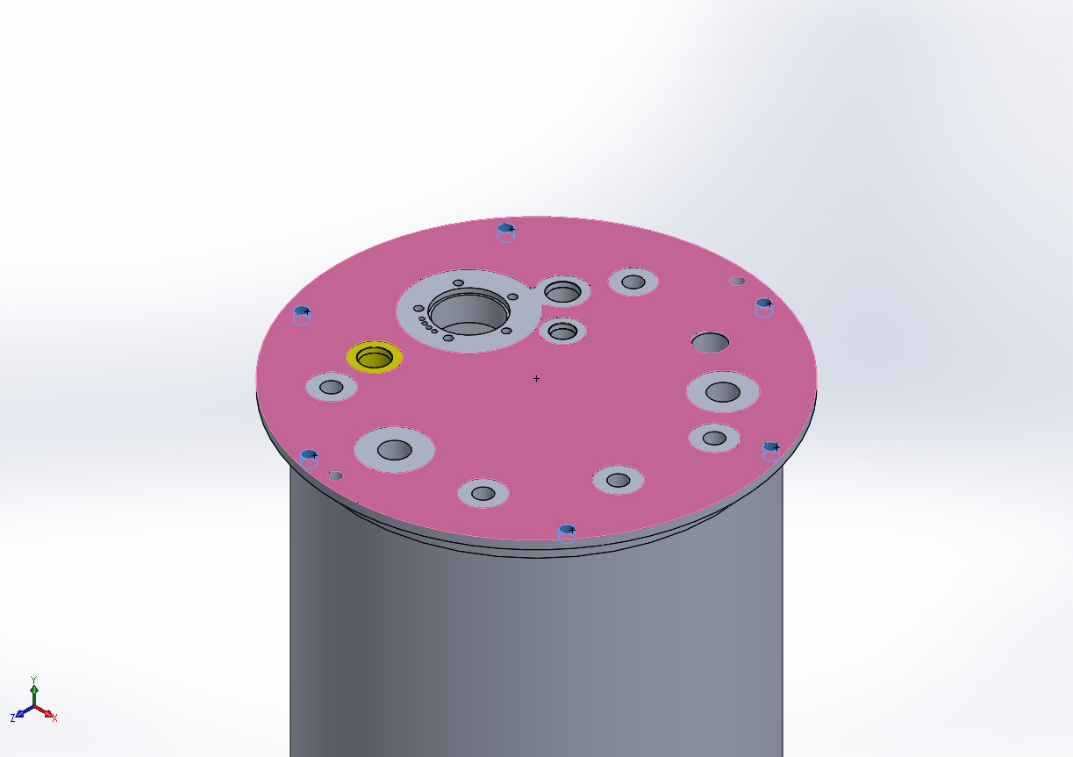
  Entities: | 6 face(s)
  Reference: | Face< 1 >
  Type: | Use reference geometry
  Translation: | ---, ---, 0
  Units: | in

Load name | Load Image | Load Details
Pressure-1 | 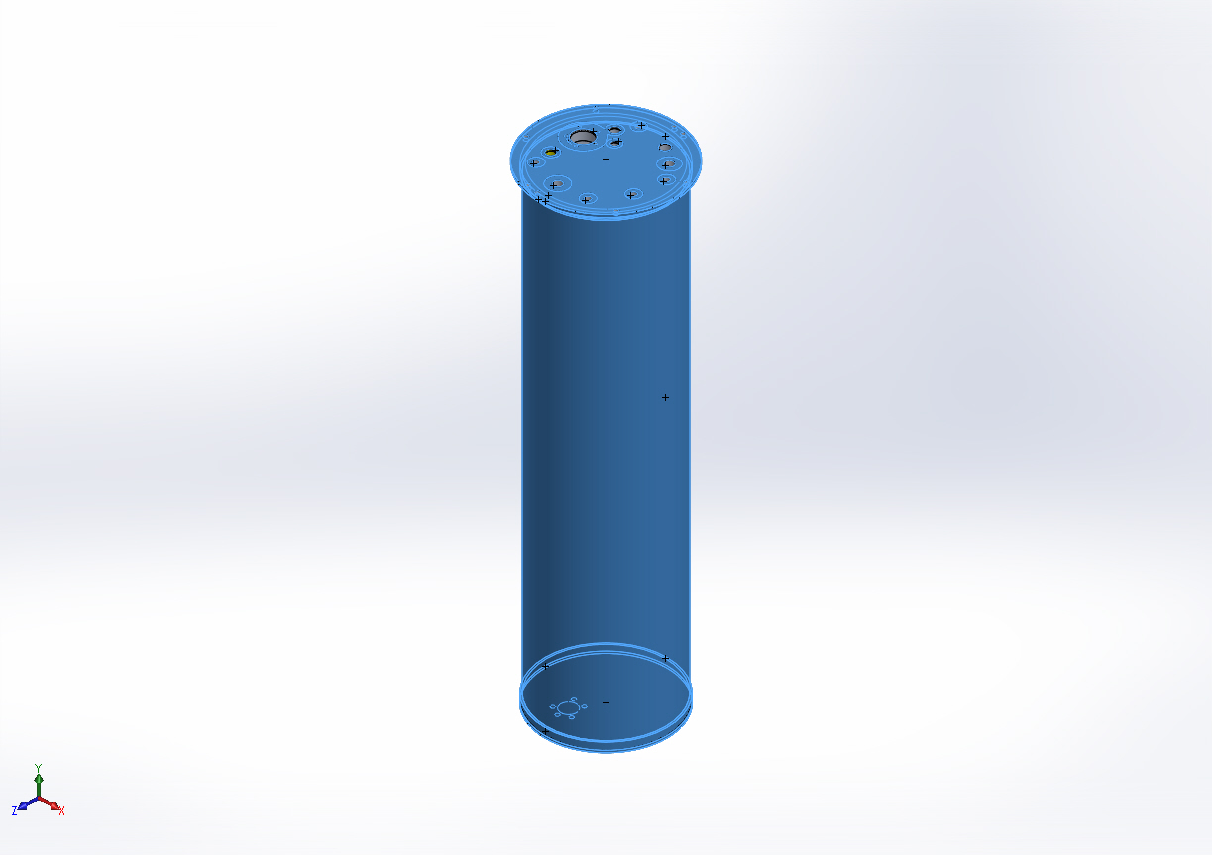
  Entities: | 20 face(s)
  Type: | Normal to selected face
  Value: | 750
  Units: | psi
  Phase Angle: | 0
  Units: | deg

Connector Definitions
No Data

Contact Information

Contact | Contact Image | Contact Properties
Contact Set-1 | 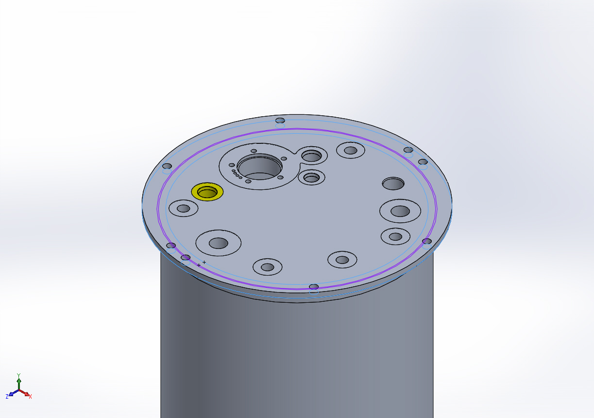
  Type: | Bonded contact pair
  Entites: | 2 face(s)
Contact Set-2 | 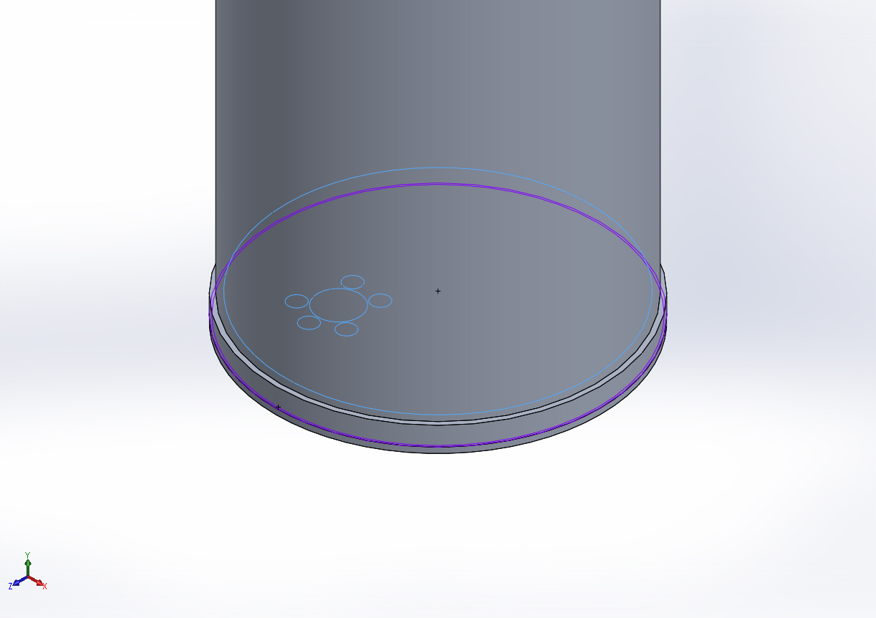
  Type: | Bonded contact pair
  Entites: | 2 face(s)
Global Contact | 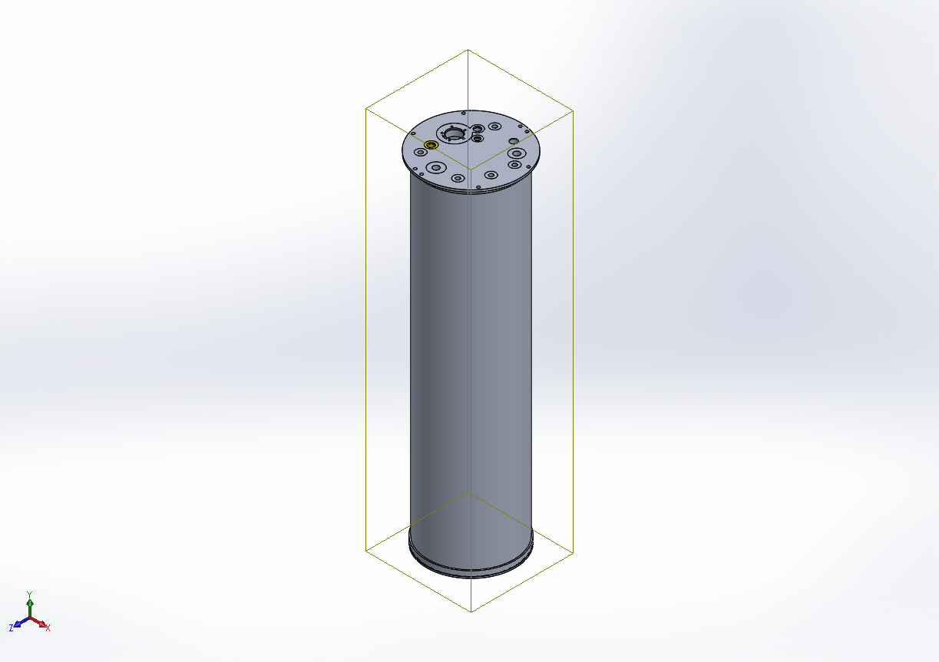
  Type: | Bonded
  Components: | 1 component(s)
  Options: | Compatible mesh

Mesh Information
Mesh type | Solid Mesh
Mesher Used: | Curvature based mesh
Jacobian points | 4 Points
Maximum element size | 1.81054 in
Minimum element size | 0.362108 in
Mesh Quality | High
Remesh failed parts with incompatible mesh | On

Mesh Information - Details
Total Nodes | 190954
Total Elements | 112720
Maximum Aspect Ratio | 499.81
% of elements with Aspect Ratio < 3 | 77
% of elements with Aspect Ratio > 10 | 4.59
% of distorted elements(Jacobian) | 0
Time to complete mesh(hh;mm;ss): | 00:00:18
Computer name: | ENIGMA
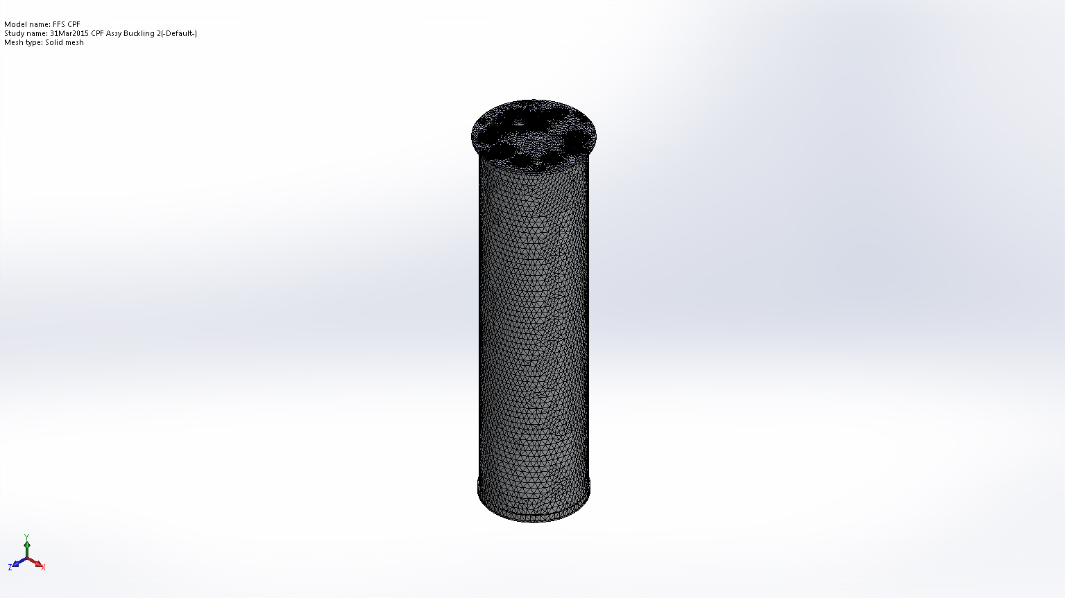

Mesh Control Information:
Mesh Control Name | Mesh Control Image | Mesh Control Details
Control-1 | 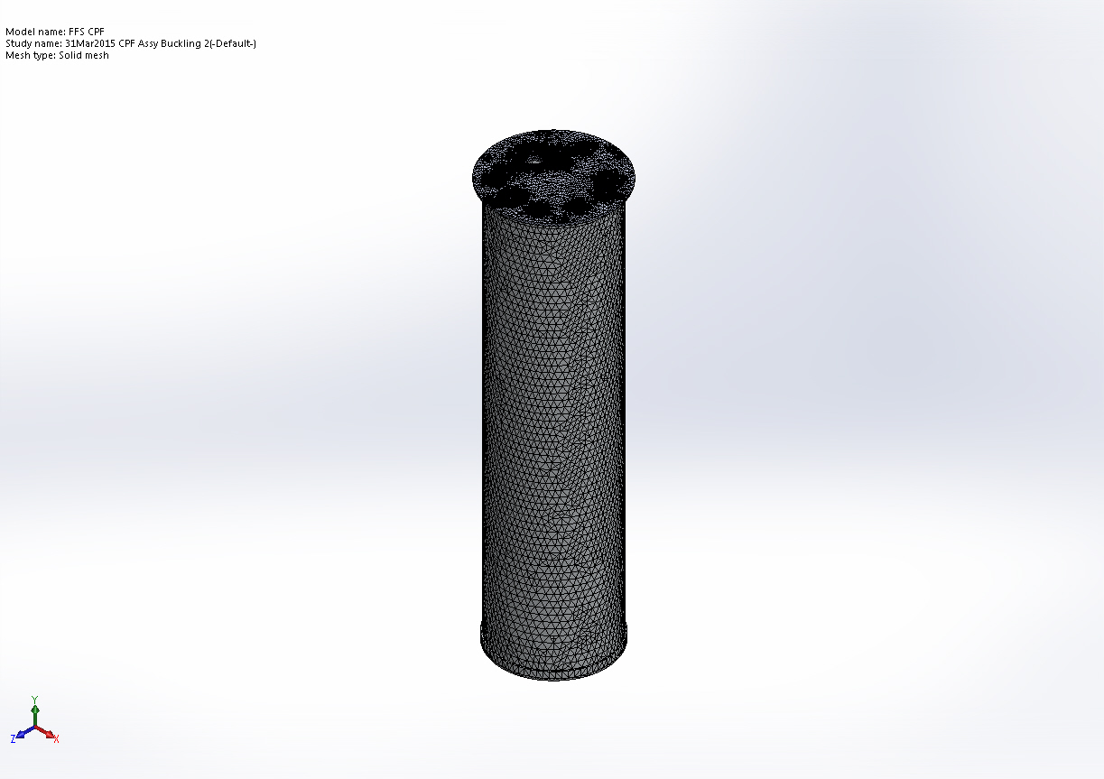
  Entities: | 2 face(s)
  Units: | in
  Size: | 0.452635
  Ratio: | 1.5
Control-2 | 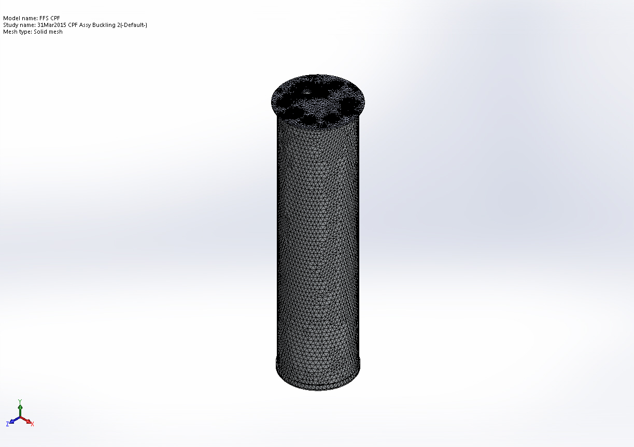
  Entities: | 1 face(s)
  Units: | in
  Size: | 0.25
  Ratio: | 1.5
Control-3 | 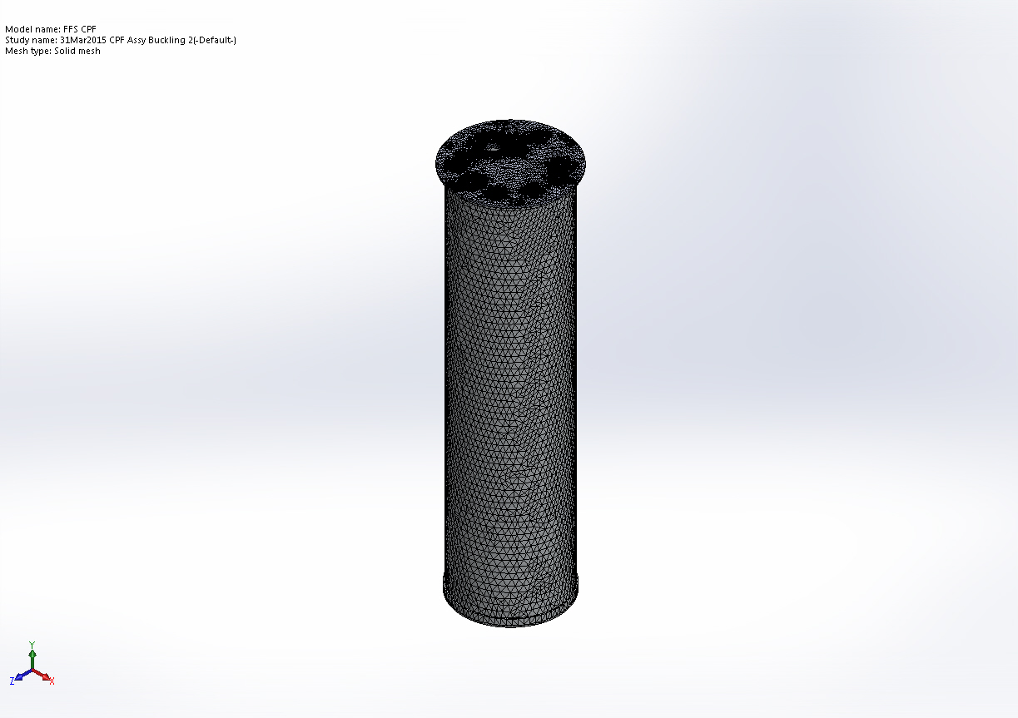
  Entities: | 10 face(s)
  Units: | in
  Size: | 0.05
  Ratio: | 1.5

Sensor Details
No Data

Study Results

Name | Type | Min | Max
Amplitude1 | AMPRES: Resultant Amplitude Plot for Mode Shape: 1(Load Factor = 1.87451e-010) | 1.3987e-006  Node: 44887 | 0.000237284  Node: 86769
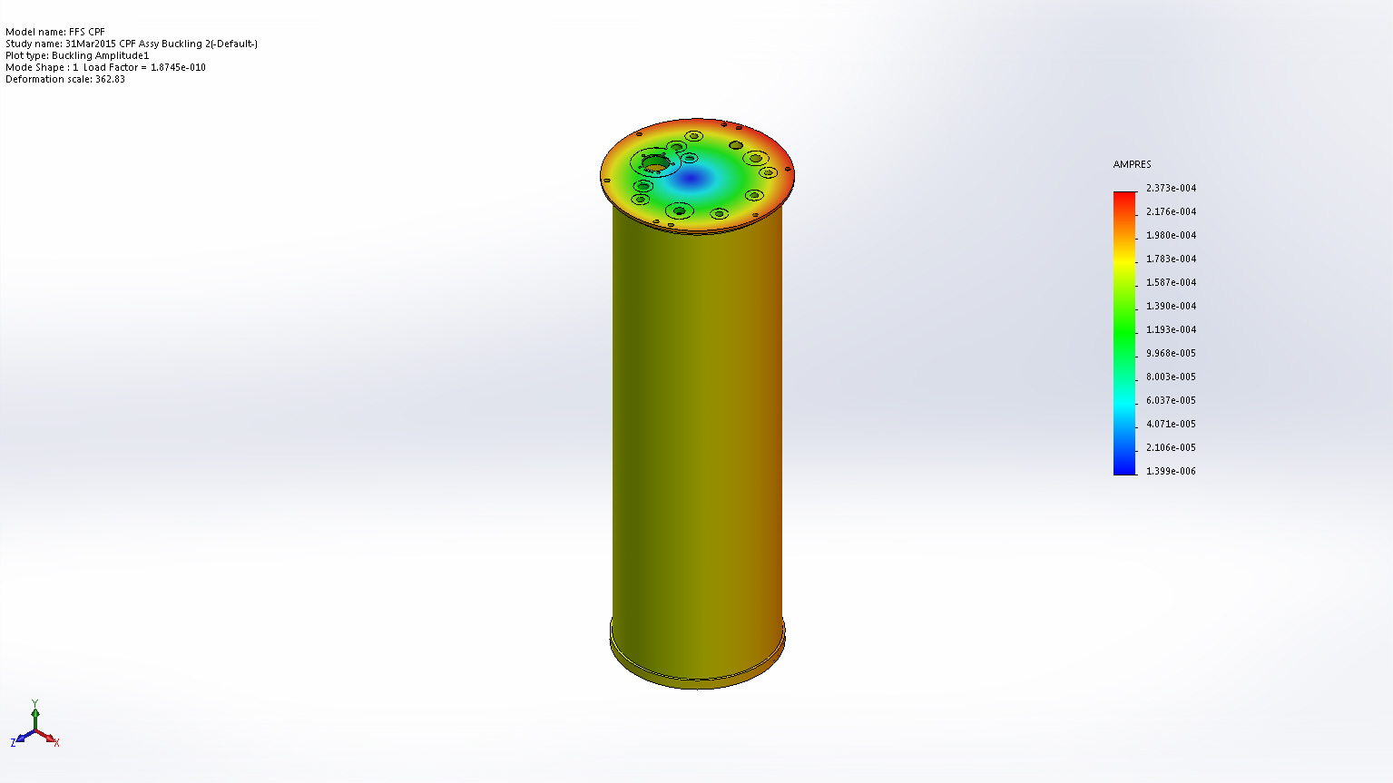
FFS CPF-31Mar2015 CPF Assy Buckling 2-Amplitude-Amplitude1

Name | Type
Displacement1 | Deformed Shape
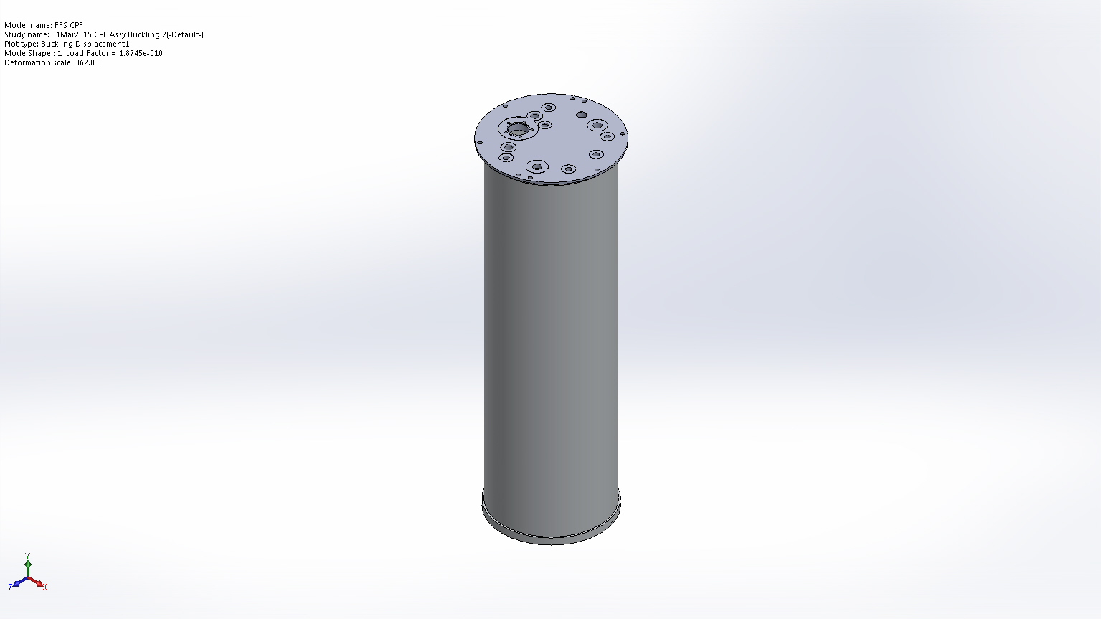
FFS CPF-31Mar2015 CPF Assy Buckling 2-Displacement-Displacement1

Mode List
Mode Number | Load Factor
1 | 1.8745e-010

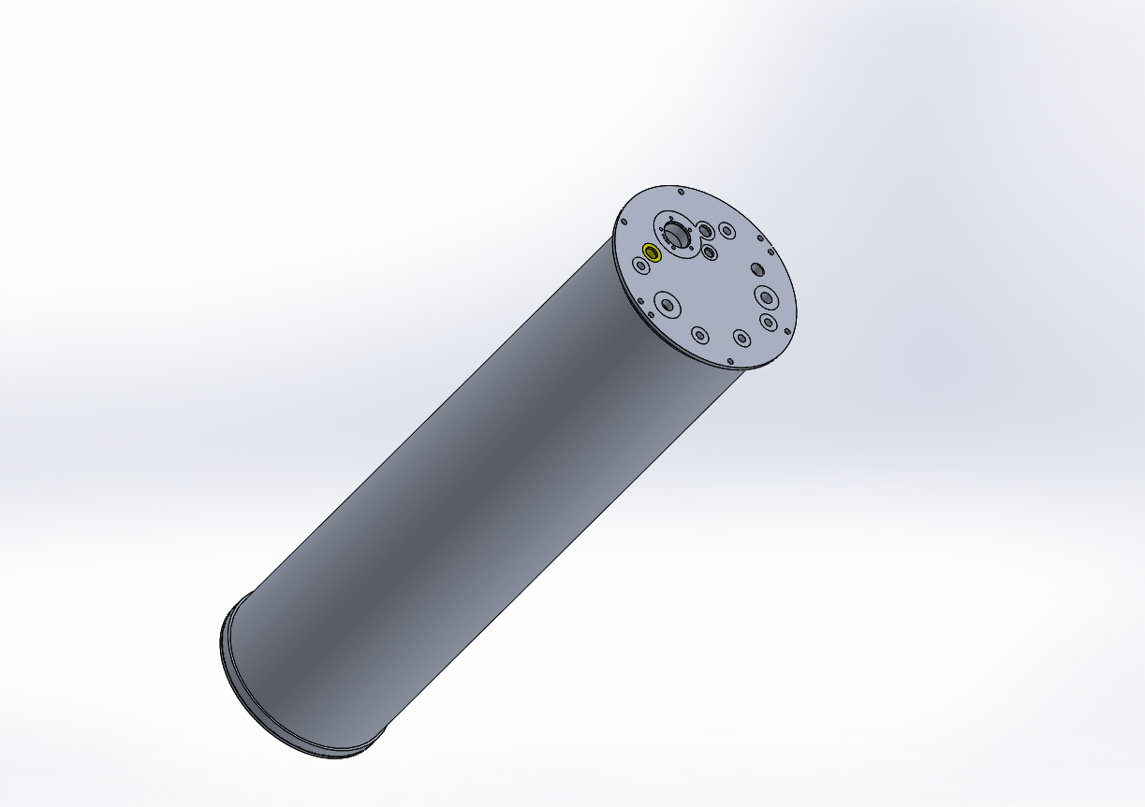
Coastal Profiling Float Housing Assembly

Conclusion

