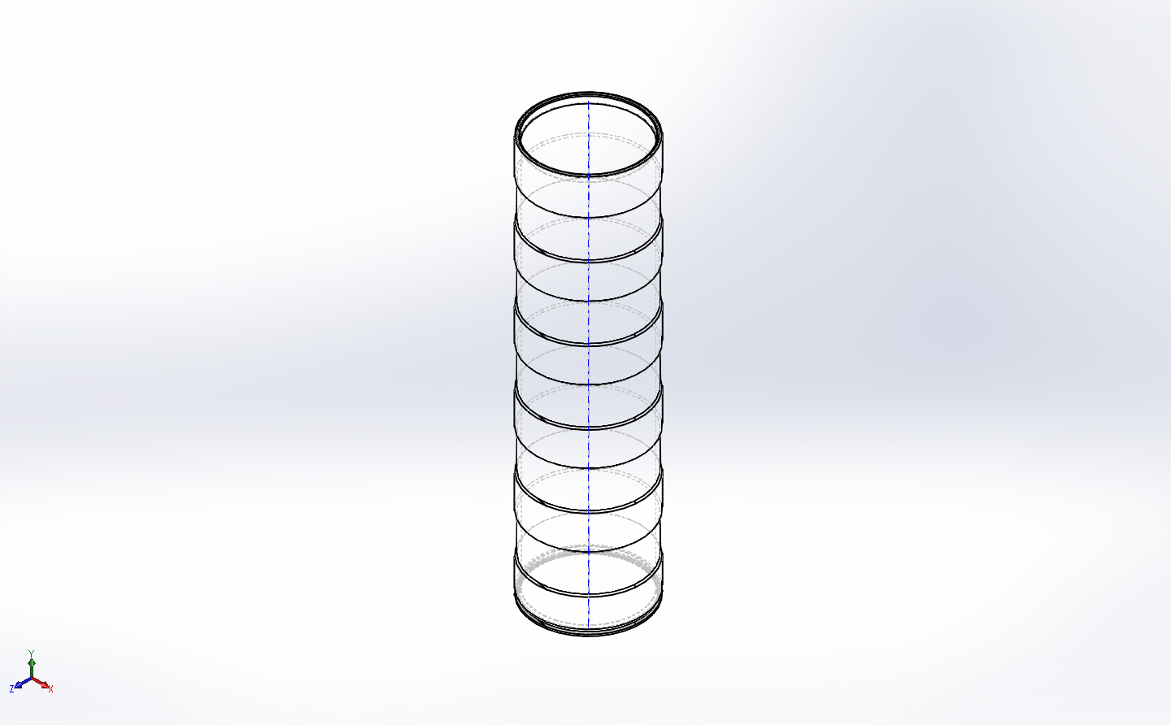
  Simulation of FFS PipeSch40x8.0-cpfV2
  Date: Wednesday, May 13, 2015
  Designer: FEA Run by Farley F. Shane
  Study name: 12May2015 4Ring - 3in Buckling
  Analysis type: Buckling
  Table of Contents
  Description 1
  Assumptions 2
  Model Information 2
  Study Properties 3
  Units 3
  Material Properties 4
  Loads and Fixtures 5
  Connector Definitions 6
  Contact Information 6
  Mesh information 7
  Sensor Details 8
  Study Results 9
  Conclusion 10

Description
Buckling, 3 inch wide cut, 5 inch width, 4 rings

Assumptions

Model Information

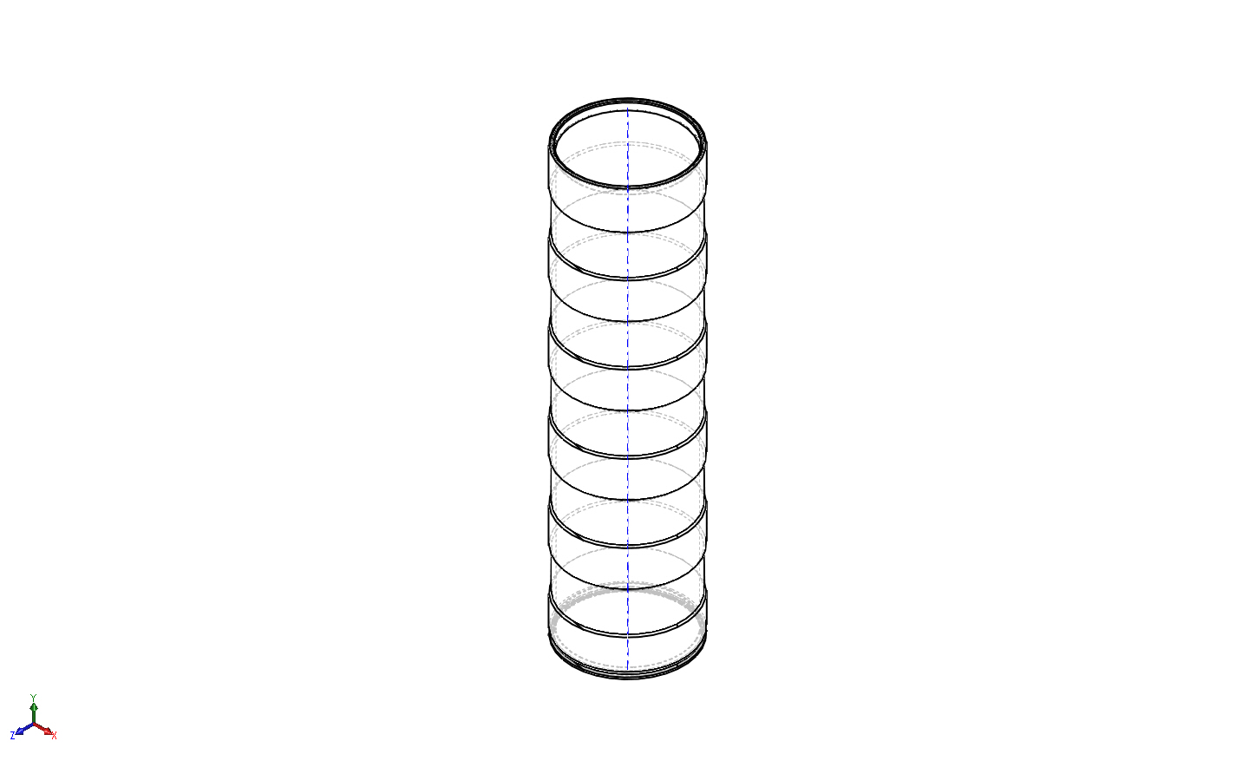
Model name: FFS PipeSch40x8.0-cpfV2
Current Configuration: 3 in wide cut 5in width 4 ring
Solid Bodies
Document Name and Reference | Treated As | Volumetric Properties | Document Path/Date Modified
LPattern3  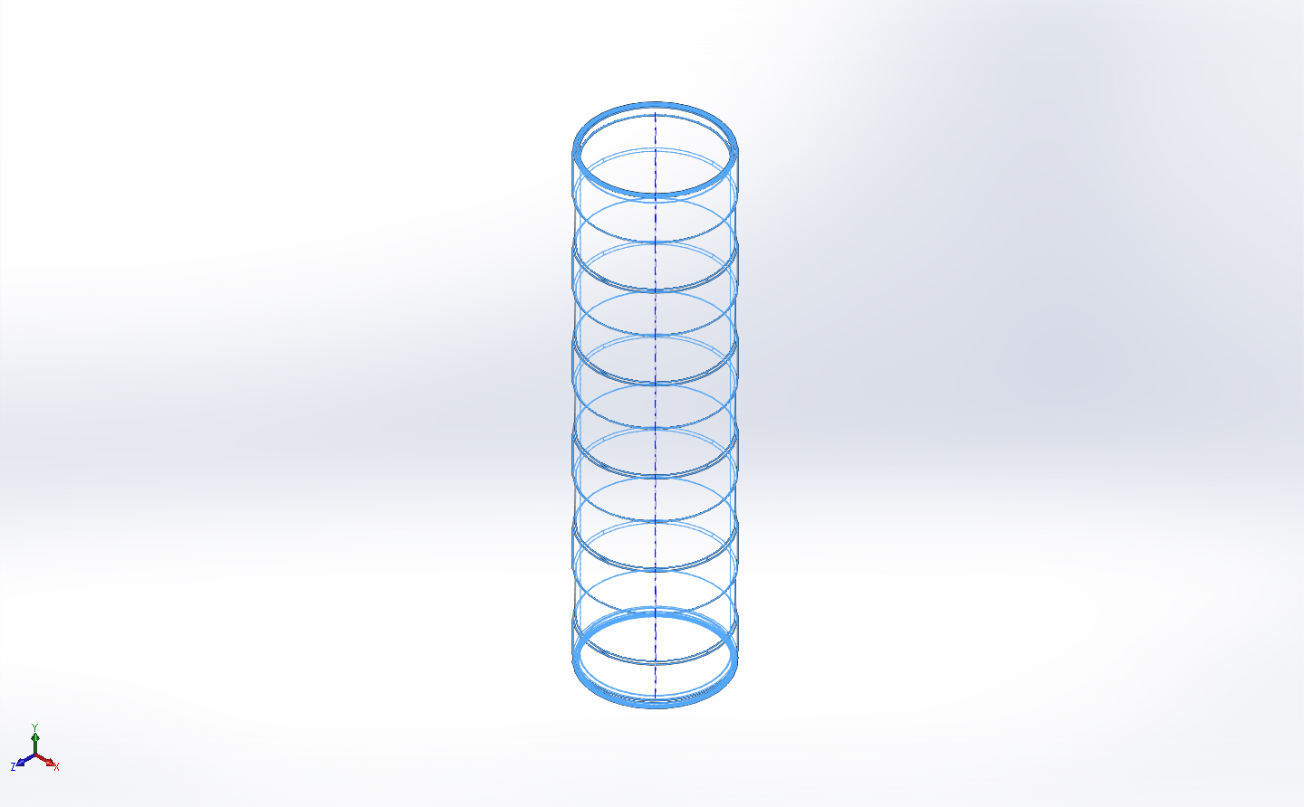 | Solid Body | Mass:9.81628 kg  Volume:0.00363566 m^3  Density:2700 kg/m^3  Weight:96.1996 N | X:\CPF\Mechanical Engr\Farley\CPF2015Feb03\FFS PipeSch40x8.0-cpfV2.SLDPRT  May 12 13:58:25 2015

Study Properties
Study name | 12May2015 4Ring - 3in Buckling
Analysis type | Buckling
Mesh type | Solid Mesh
Number of modes | 1
Solver type | Direct sparse solver
Incompatible bonding options | Automatic
Thermal Effect: | On
Thermal option | Include temperature loads
Zero strain temperature | 298 Kelvin
Include fluid pressure effects from SOLIDWORKS Flow Simulation | Off
Soft Spring: | On
Result folder | SOLIDWORKS document (X:\CPF\Mechanical Engr\Farley\CPF2015Feb03)

Units
Unit system: | SI (MKS)
Length/Displacement | mm
Temperature | Kelvin
Angular velocity | Rad/sec
Pressure/Stress | N/m^2

Material Properties
Model Reference | Properties | Components
 |  | SolidBody 1(LPattern3)(FFS PipeSch40x8.0-cpfV2)
  Name: | 6061-T6 (SS)
  Model type: | Linear Elastic Isotropic
  Default failure criterion: | Unknown
  Yield strength: | 2.75e+008 N/m^2
  Tensile strength: | 3.1e+008 N/m^2
  Mass density: | 2700 kg/m^3
  Elastic modulus: | 6.9e+010 N/m^2
  Poisson's ratio: | 0.33
  Thermal expansion coefficient: | 2.4e-005 /Kelvin
Curve Data:N/A

Loads and Fixtures
Fixture name | Fixture Image | Fixture Details
On Cylindrical Faces-1 | 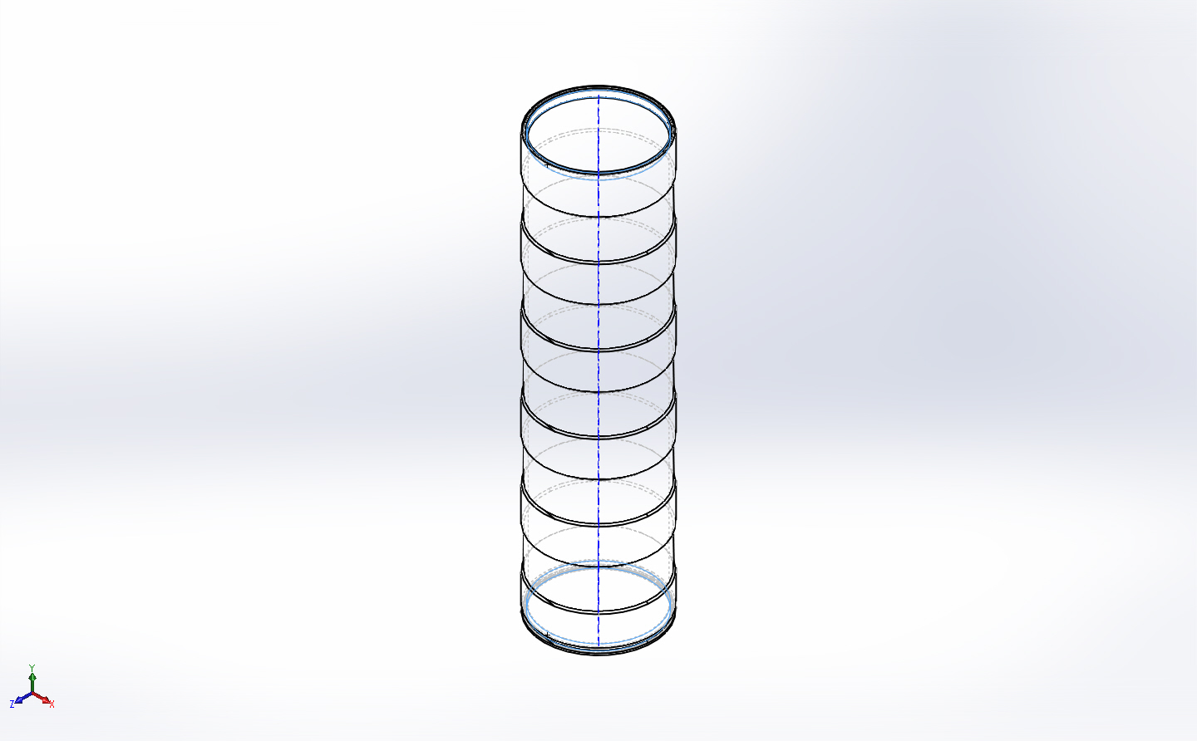
  Entities: | 2 face(s)
  Type: | On Cylindrical Faces
  Translation: | -0.002, ---, ---
  Units: | in
Fixed-1 | 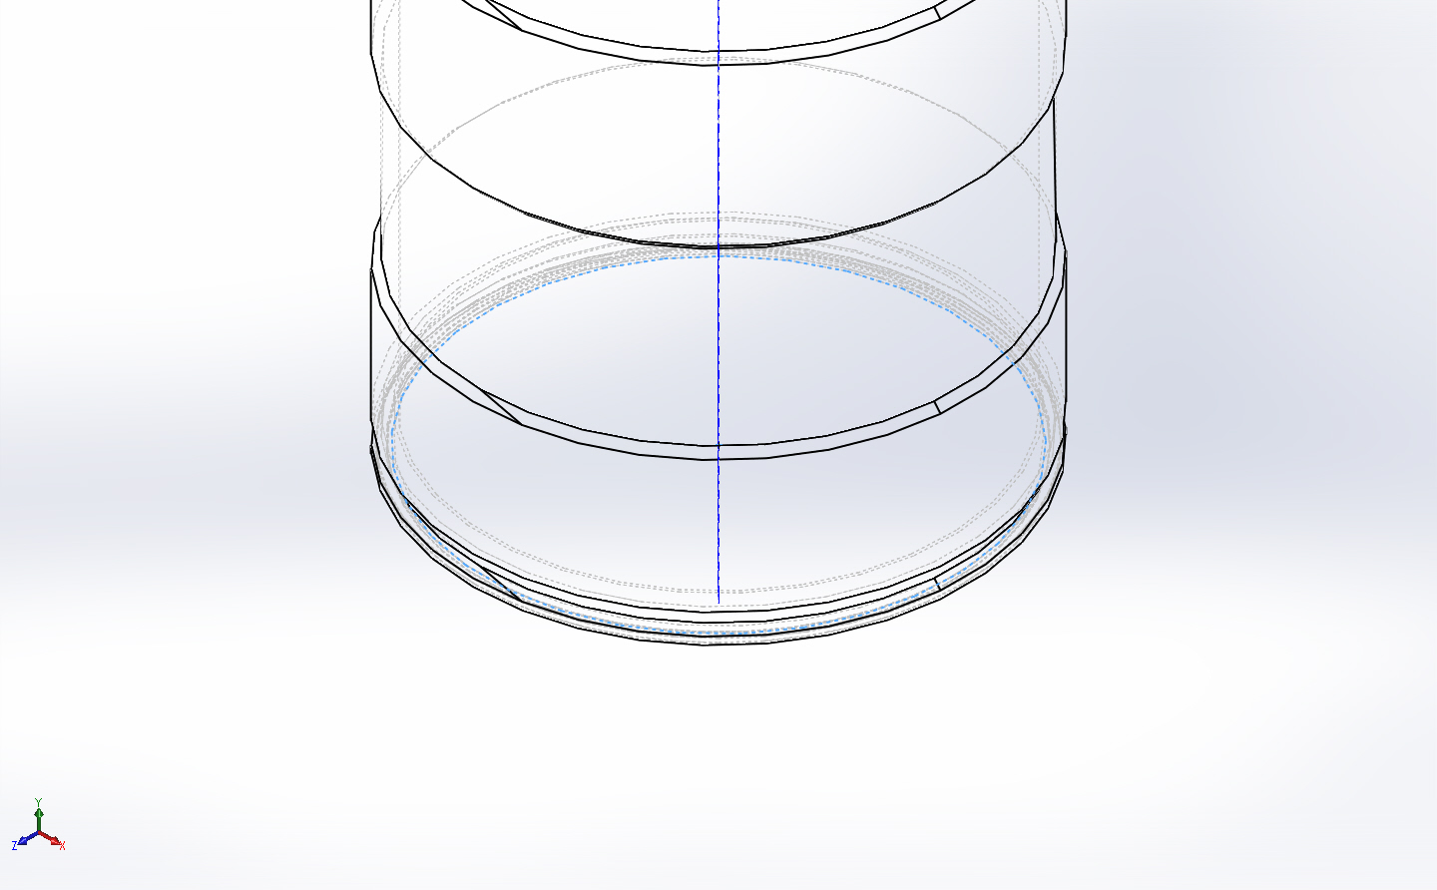
  Entities: | 1 edge(s)
  Type: | Fixed Geometry

Load name | Load Image | Load Details
Force-1 | 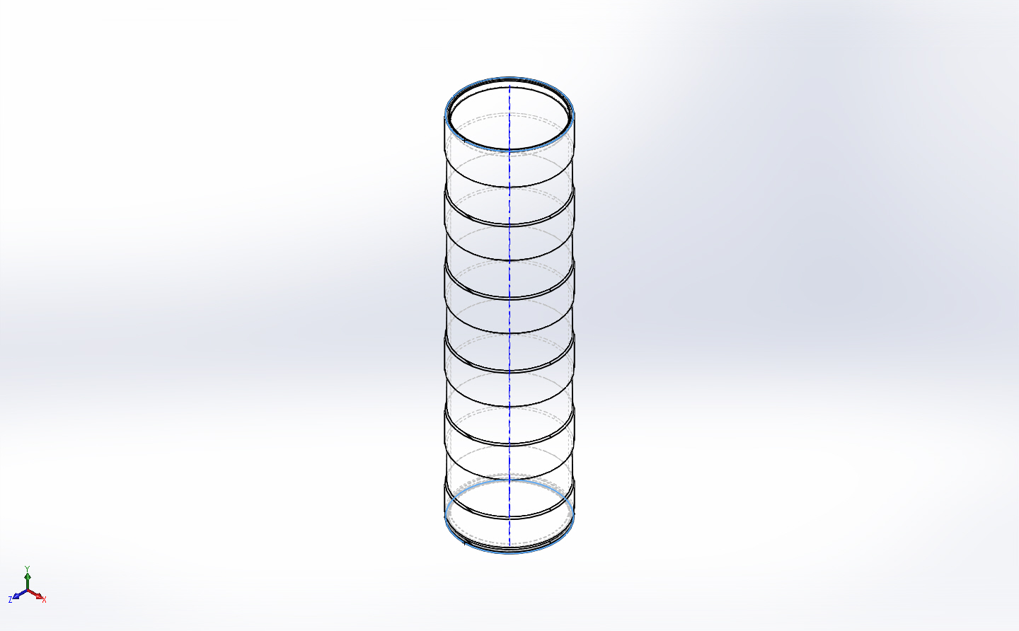
  Entities: | 2 face(s)
  Type: | Apply normal force
  Value: | 23289 lbf
Force-2 | 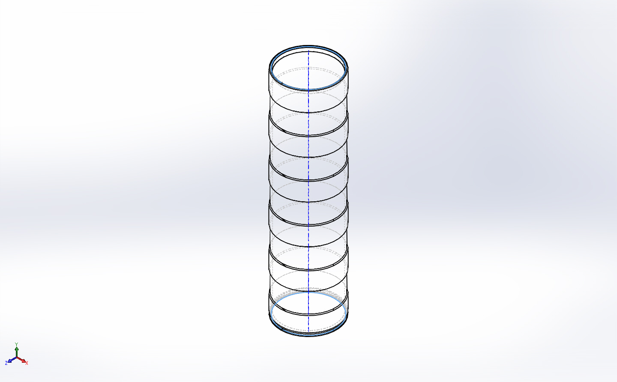
  Entities: | 2 face(s)
  Type: | Apply normal force
  Value: | 20531 lbf
Pressure-1 | 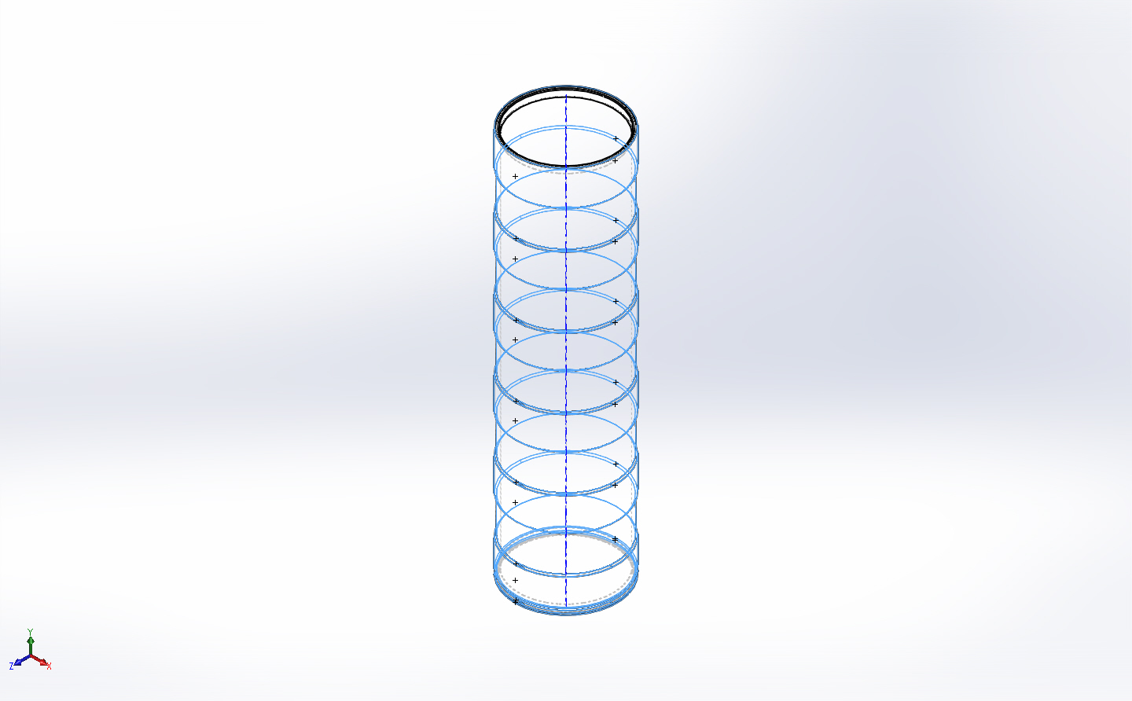
  Entities: | 25 face(s)
  Type: | Normal to selected face
  Value: | 750
  Units: | psi
  Phase Angle: | 0
  Units: | deg

Connector Definitions
No Data

Contact Information
No Data

Mesh information
Mesh type | Solid Mesh
Mesher Used: | Curvature based mesh
Jacobian points | 4 Points
Maximum element size | 0.5 in
Minimum element size | 0.1 in
Mesh Quality | High

Mesh information - Details
Total Nodes | 115900
Total Elements | 59074
Maximum Aspect Ratio | 379.26
% of elements with Aspect Ratio < 3 | 66.1
% of elements with Aspect Ratio > 10 | 18.9
% of distorted elements(Jacobian) | 0
Time to complete mesh(hh;mm;ss): | 00:00:17
Computer name: | ENIGMA
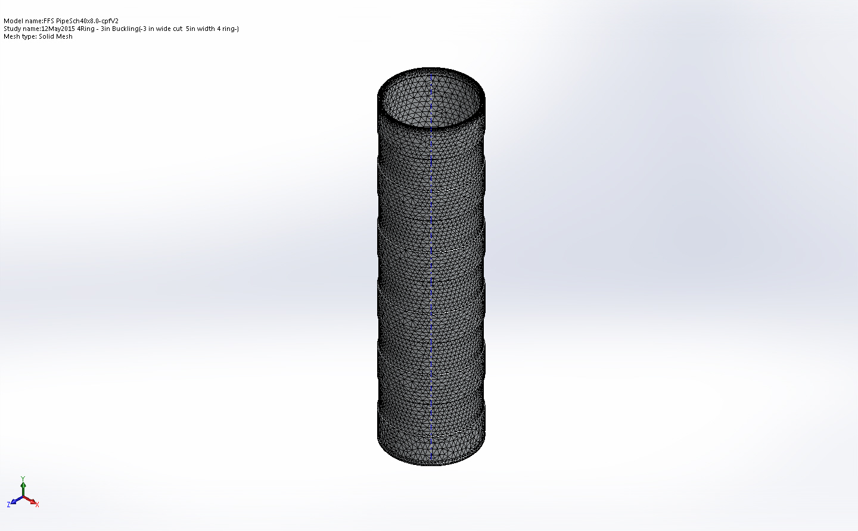

Sensor Details
No Data

Study Results

Name | Type | Min | Max
Amplitude1 | AMPRES: Resultant Amplitude Plot for Mode Shape: 1(Load Factor = 2.09514) | 0  Node: 80 | 0.000257106  Node: 49062
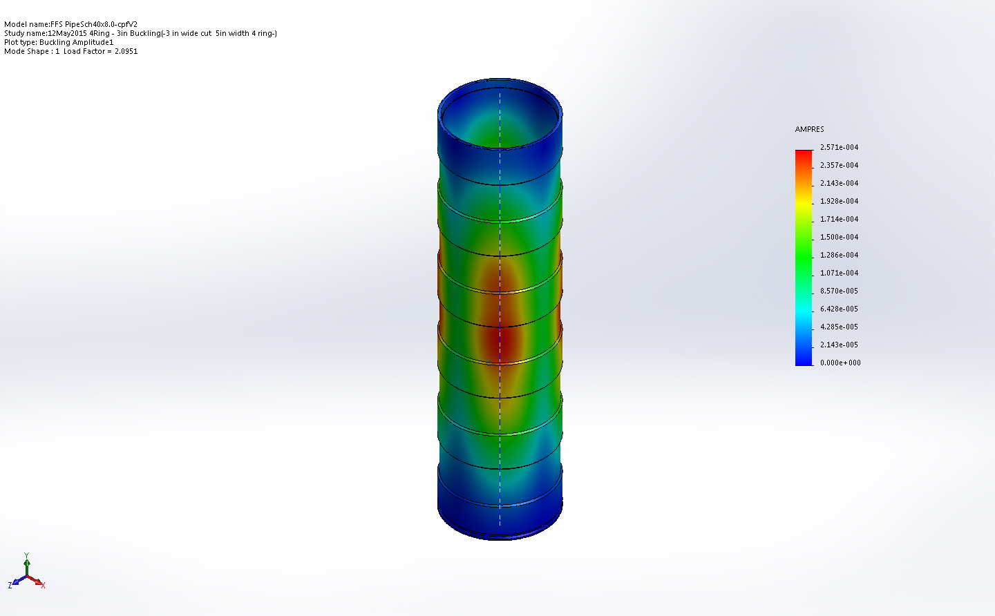
FFS PipeSch40x8.0-cpfV2-12May2015 4Ring - 3in Buckling-Amplitude-Amplitude1

Mode List
Mode Number | Load Factor
1 | 2.0951

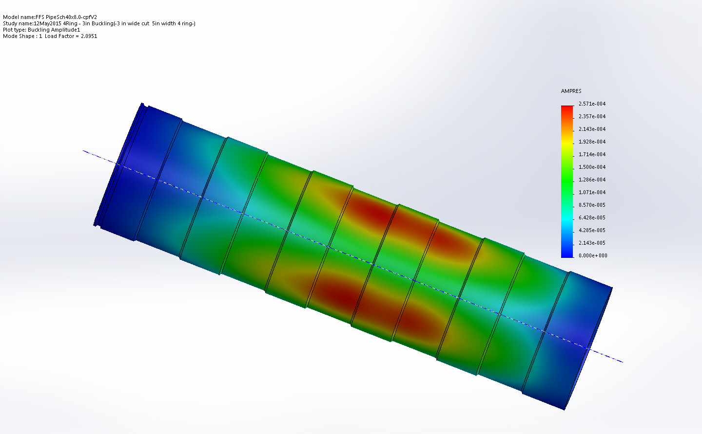
Image-1

Conclusion

