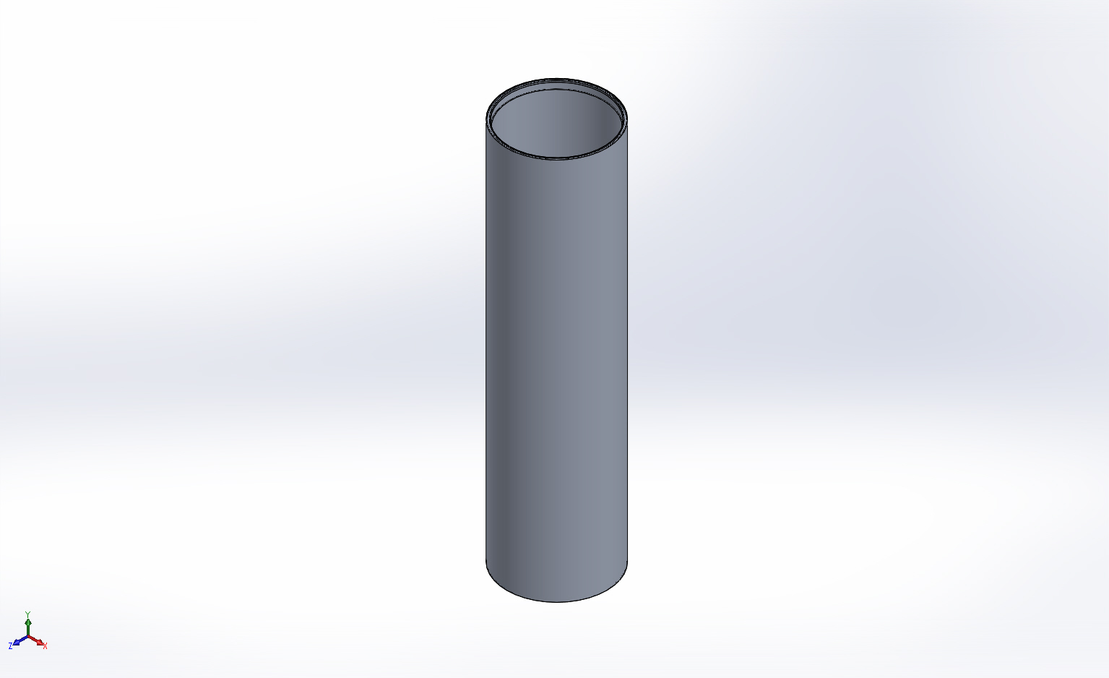
  Simulation of FFS PipeSch40x8.0-cpfV2
  Date: Tuesday, April 14, 2015
  Designer: FEA Run by Farley F. Shane
  Study name: 14Apr2015 Static CPF Hsg 1
  Analysis type: Static
  Table of Contents
  Description 1
  Assumptions 2
  Model Information 2
  Study Properties 3
  Units 4
  Material Properties 4
  Loads and Fixtures 5
  Connector Definitions 7
  Contact Information 7
  Mesh Information 8
  Sensor Details 9
  Resultant Forces 10
  Beams 10
  Study Results 11
  Conclusion 15

Description
14Apr2015 CPF Static Analysis for Stock Dia. Housing

Assumptions

Model Information

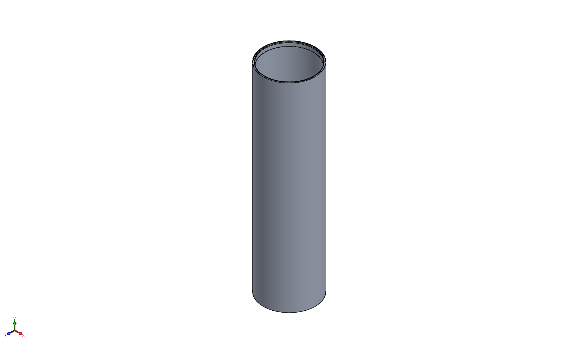
Model name: FFS PipeSch40x8.0-cpfV2
Current Configuration: Stock Housing w-O-Rings
Solid Bodies
Document Name and Reference | Treated As | Volumetric Properties | Document Path/Date Modified
Mirror1  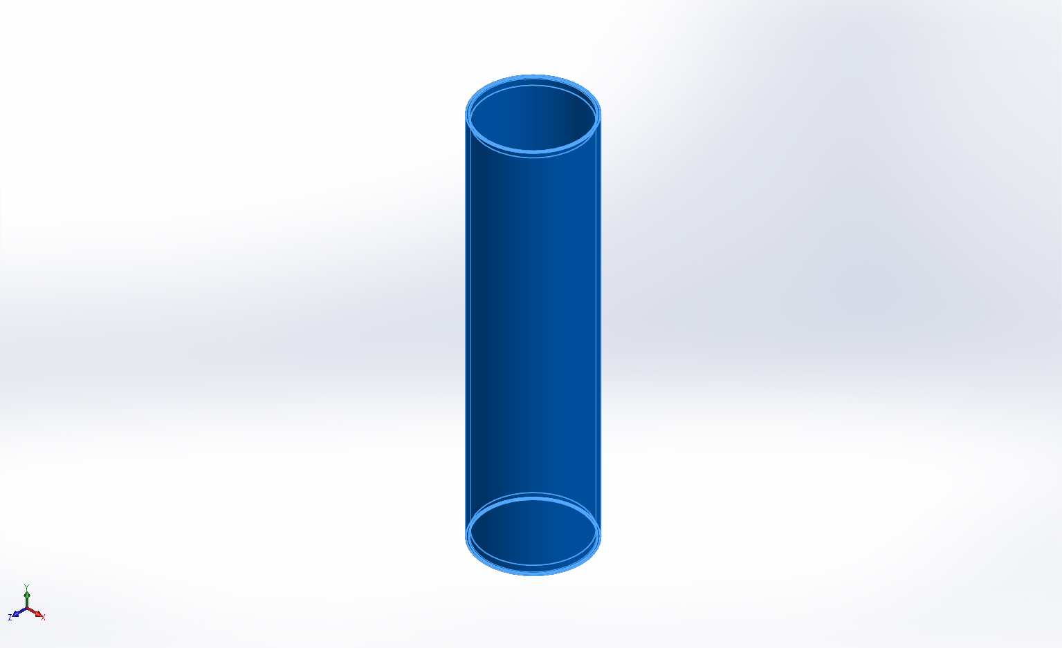 | Solid Body | Mass:26.8276 lb  Volume:275.032 in^3  Density:0.0975437 lb/in^3  Weight:26.8094 lbf | X:\CPF\Mechanical Engr\Farley\CPF2015Feb03\FFS PipeSch40x8.0-cpfV2.SLDPRT  Apr 10 14:15:51 2015

Study Properties
Study name | 14Apr2015 Static CPF Hsg 1
Analysis type | Static
Mesh type | Solid Mesh
Thermal Effect: | On
Thermal option | Include temperature loads
Zero strain temperature | 77 Fahrenheit
Include fluid pressure effects from SolidWorks Flow Simulation | Off
Solver type | FFEPlus
Inplane Effect: | Off
Soft Spring: | Off
Inertial Relief: | Off
Incompatible bonding options | Automatic
Large displacement | Off
Compute free body forces | On
Friction | Off
Use Adaptive Method: | Off
Result folder | SolidWorks document (X:\CPF\Mechanical Engr\Farley\CPF2015Feb03)

Units
Unit system: | English (IPS)
Length/Displacement | in
Temperature | Fahrenheit
Angular velocity | Hertz
Pressure/Stress | psi

Material Properties
Model Reference | Properties | Components
 |  | SolidBody 1(Mirror1)(FFS PipeSch40x8.0-cpfV2)
  Name: | 6061-T6 (SS)
  Model type: | Linear Elastic Isotropic
  Default failure criterion: | Unknown
  Yield strength: | 39885.4 psi
  Tensile strength: | 44961.7 psi
  Elastic modulus: | 1.00076e+007 psi
  Poisson's ratio: | 0.33
  Mass density: | 0.0975437 lb/in^3
  Shear modulus: | 3.77098e+006 psi
  Thermal expansion coefficient: | 1.33333e-005 /Fahrenheit
Curve Data:N/A

Loads and Fixtures
Fixture name | Fixture Image | Fixture Details
Reference Geometry-1 | 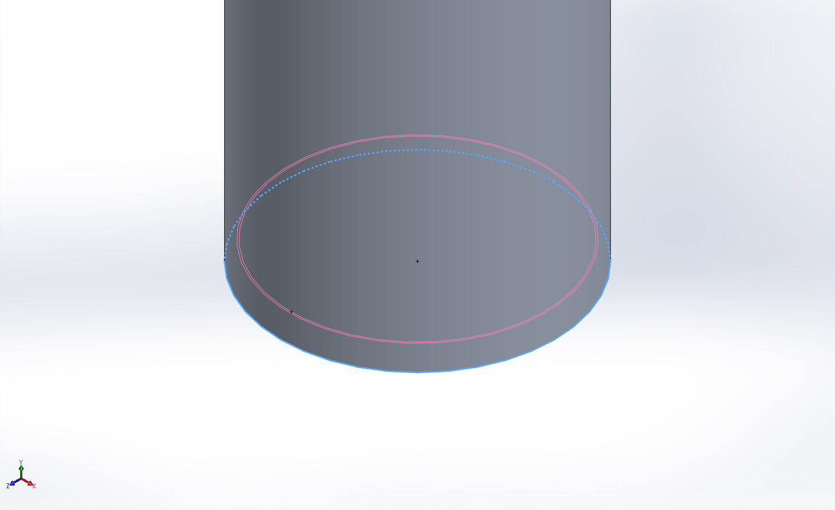
  Entities: | 1 edge(s)
  Reference: | Face< 1 >
  Type: | Use reference geometry
  Translation: | ---, ---, 0
  Units: | in
Resultant Forces
Components | X | Y | Z | Resultant
Reaction force(lbf) | -11.8361 | 2.46741 | -8.95915 | 15.0482
Reaction Moment(lbf.in) | 0 | 0 | 0 | 0

On Cylindrical Faces-1 | 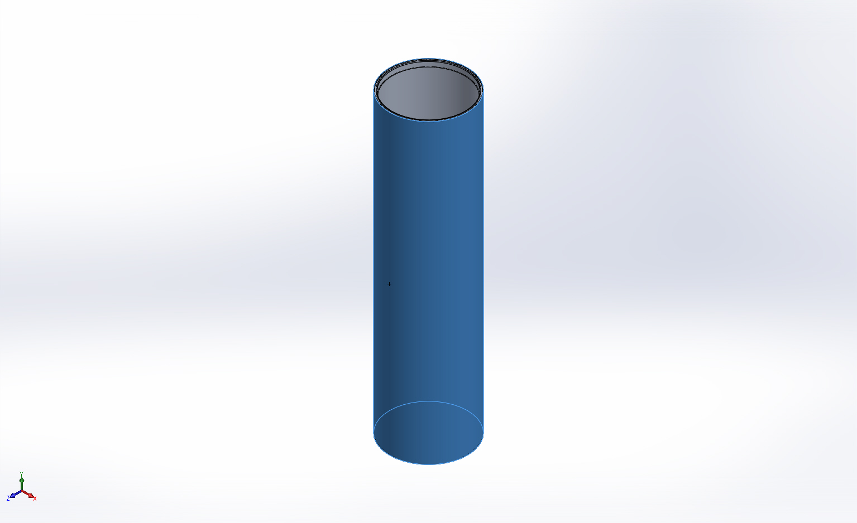
  Entities: | 1 face(s)
  Type: | On Cylindrical Faces
  Translation: | 0, ---, ---
  Units: | in
Resultant Forces
Components | X | Y | Z | Resultant
Reaction force(lbf) | -20.0179 | -17.9923 | 12.7369 | 29.7769
Reaction Moment(lbf.in) | 0 | 0 | 0 | 0

Load name | Load Image | Load Details
Force-1 | 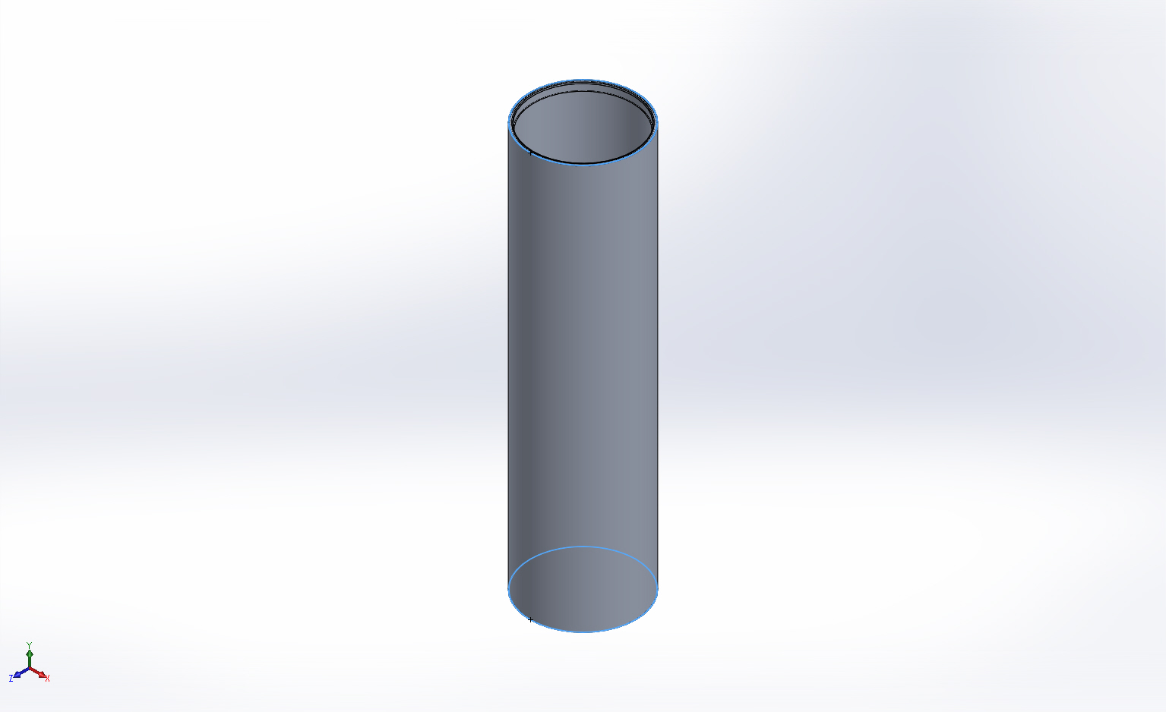
  Entities: | 2 face(s)
  Type: | Apply normal force
  Value: | 23278 lbf
Force-2 | 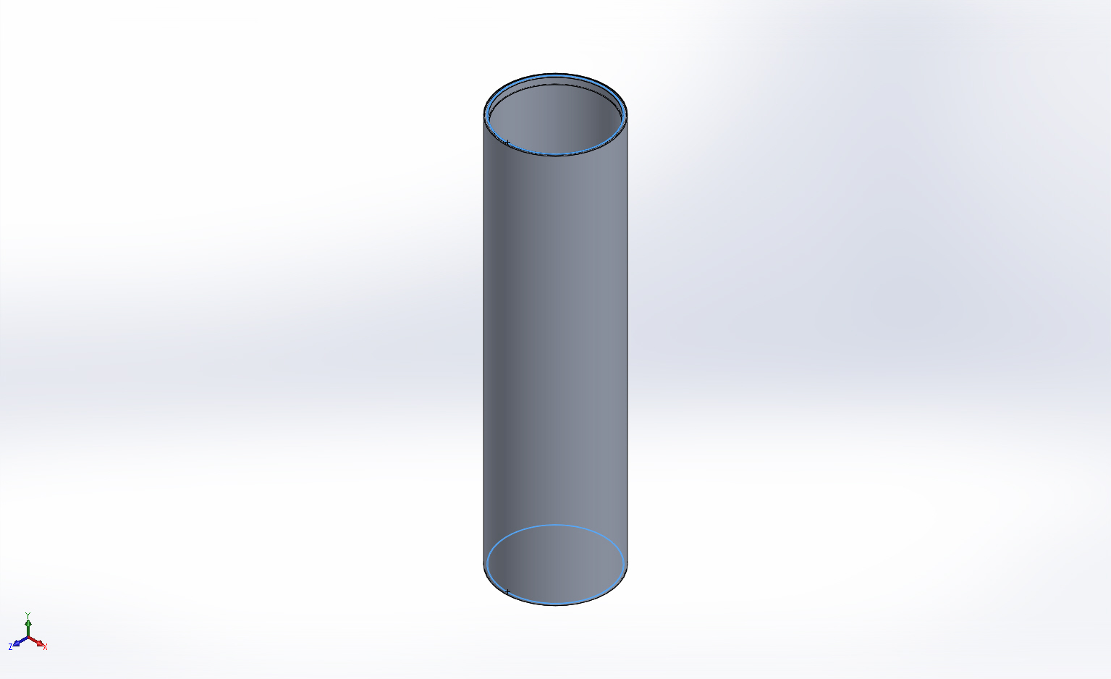
  Entities: | 2 face(s)
  Type: | Apply normal force
  Value: | 20522 lbf

Connector Definitions
No Data

Contact Information
No Data

Mesh Information
Mesh type | Solid Mesh
Mesher Used: | Curvature based mesh
Jacobian points | 4 Points
Maximum element size | 0.5 in
Minimum element size | 0.1 in
Mesh Quality | High

Mesh Information - Details
Total Nodes | 103713
Total Elements | 53593
Maximum Aspect Ratio | 376.31
% of elements with Aspect Ratio < 3 | 66.2
% of elements with Aspect Ratio > 10 | 20.6
% of distorted elements(Jacobian) | 0
Time to complete mesh(hh;mm;ss): | 00:00:16
Computer name: | ENIGMA
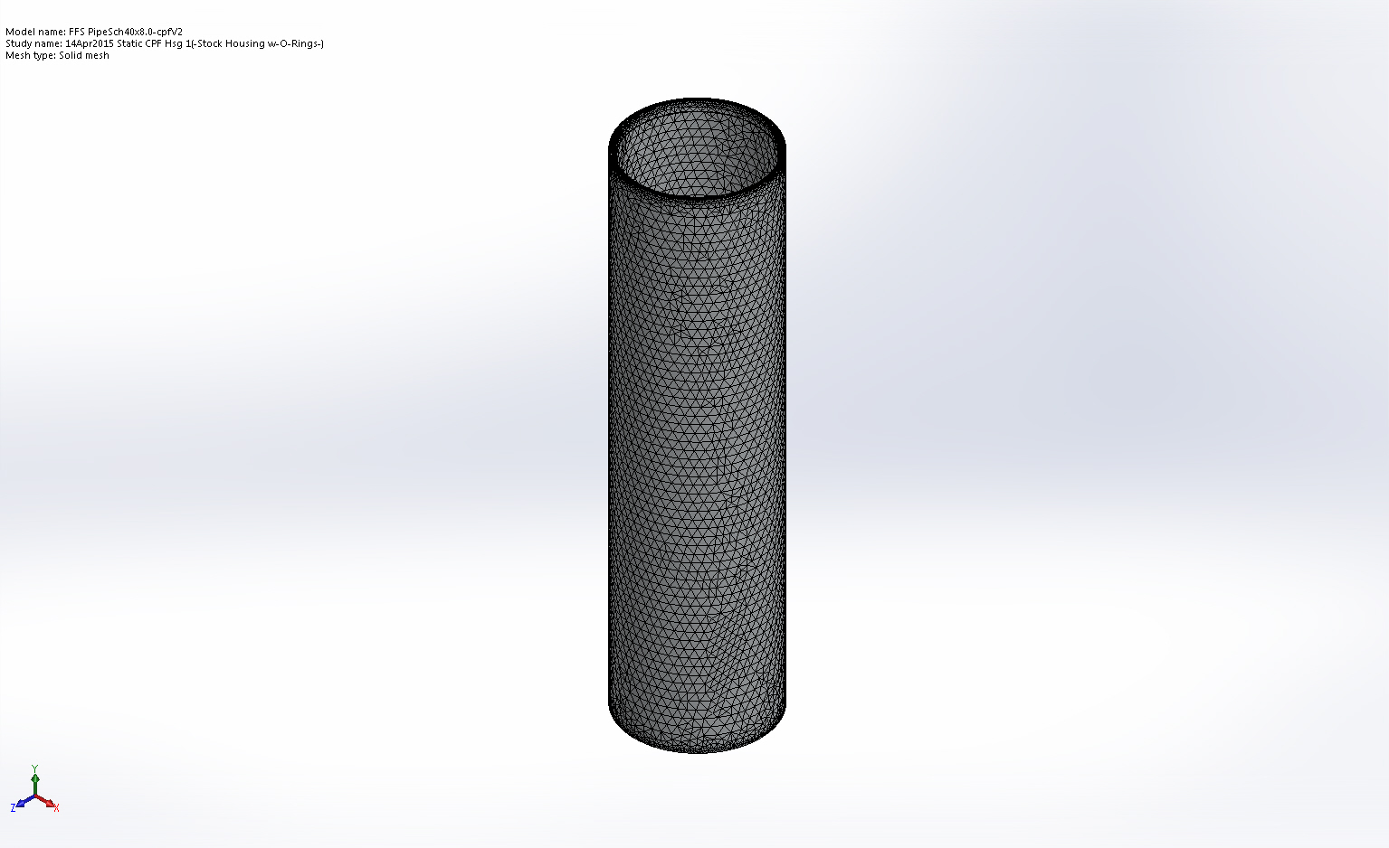

Sensor Details
No Data

Resultant Forces

Reaction Forces
Selection set | Units | Sum X | Sum Y | Sum Z | Resultant
Entire Model | lbf | -20.0179 | -17.9923 | 12.7369 | 29.7769

Reaction Moments
Selection set | Units | Sum X | Sum Y | Sum Z | Resultant
Entire Model | lbf.in | 0 | 0 | 0 | 0

Beams
No Data

Study Results

Name | Type | Min | Max
Stress1 | VON: von Mises Stress | 516.358 psi  Node: 15102 | 39991.1 psi  Node: 19364
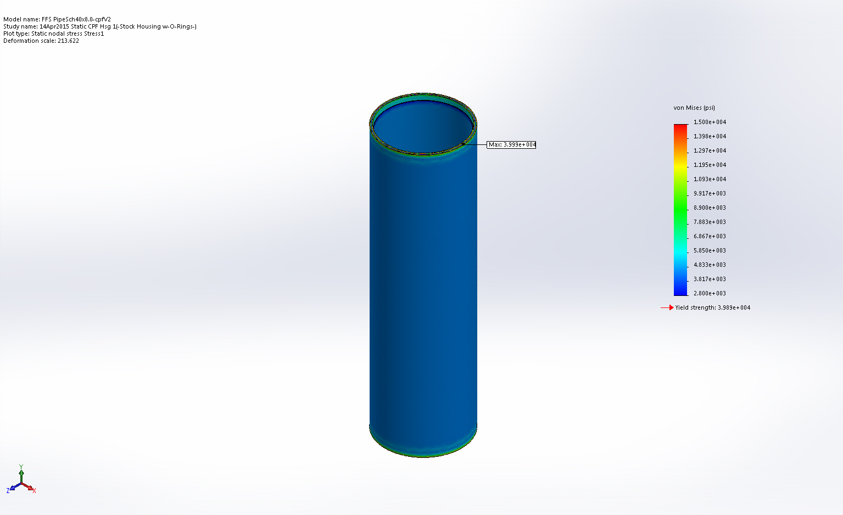
FFS PipeSch40x8.0-cpfV2-14Apr2015 Static CPF Hsg 1-Stress-Stress1

Name | Type | Min | Max
Displacement1 | URES: Resultant Displacement | 0.00027744 in  Node: 59177 | 0.0154506 in  Node: 614
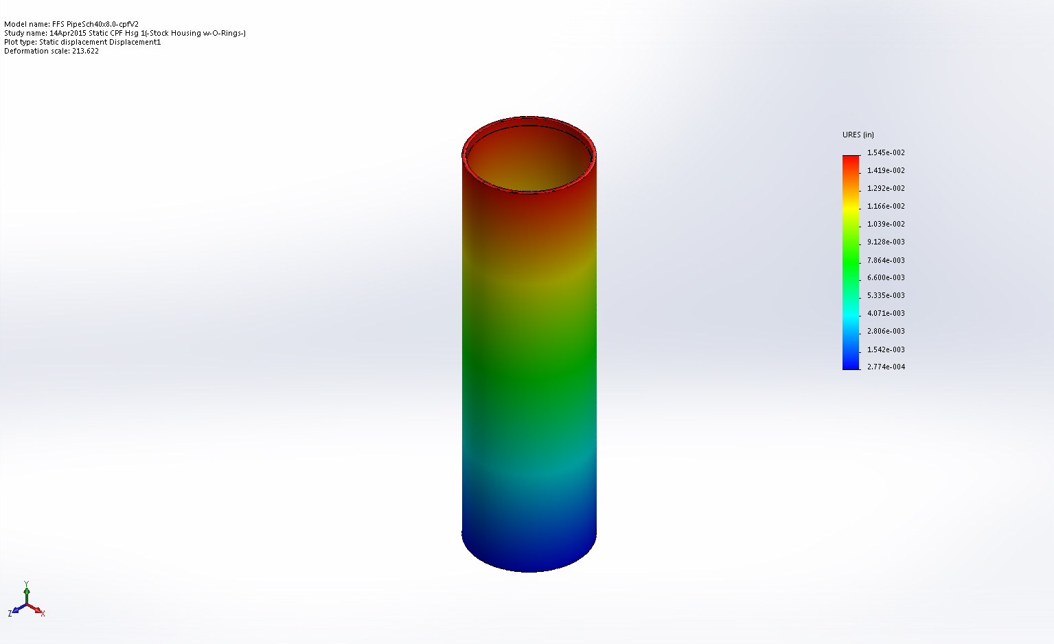
FFS PipeSch40x8.0-cpfV2-14Apr2015 Static CPF Hsg 1-Displacement-Displacement1

Name | Type | Min | Max
Strain1 | ESTRN: Equivalent Strain | 3.57503e-005  Element: 49718 | 0.00199588  Element: 50107
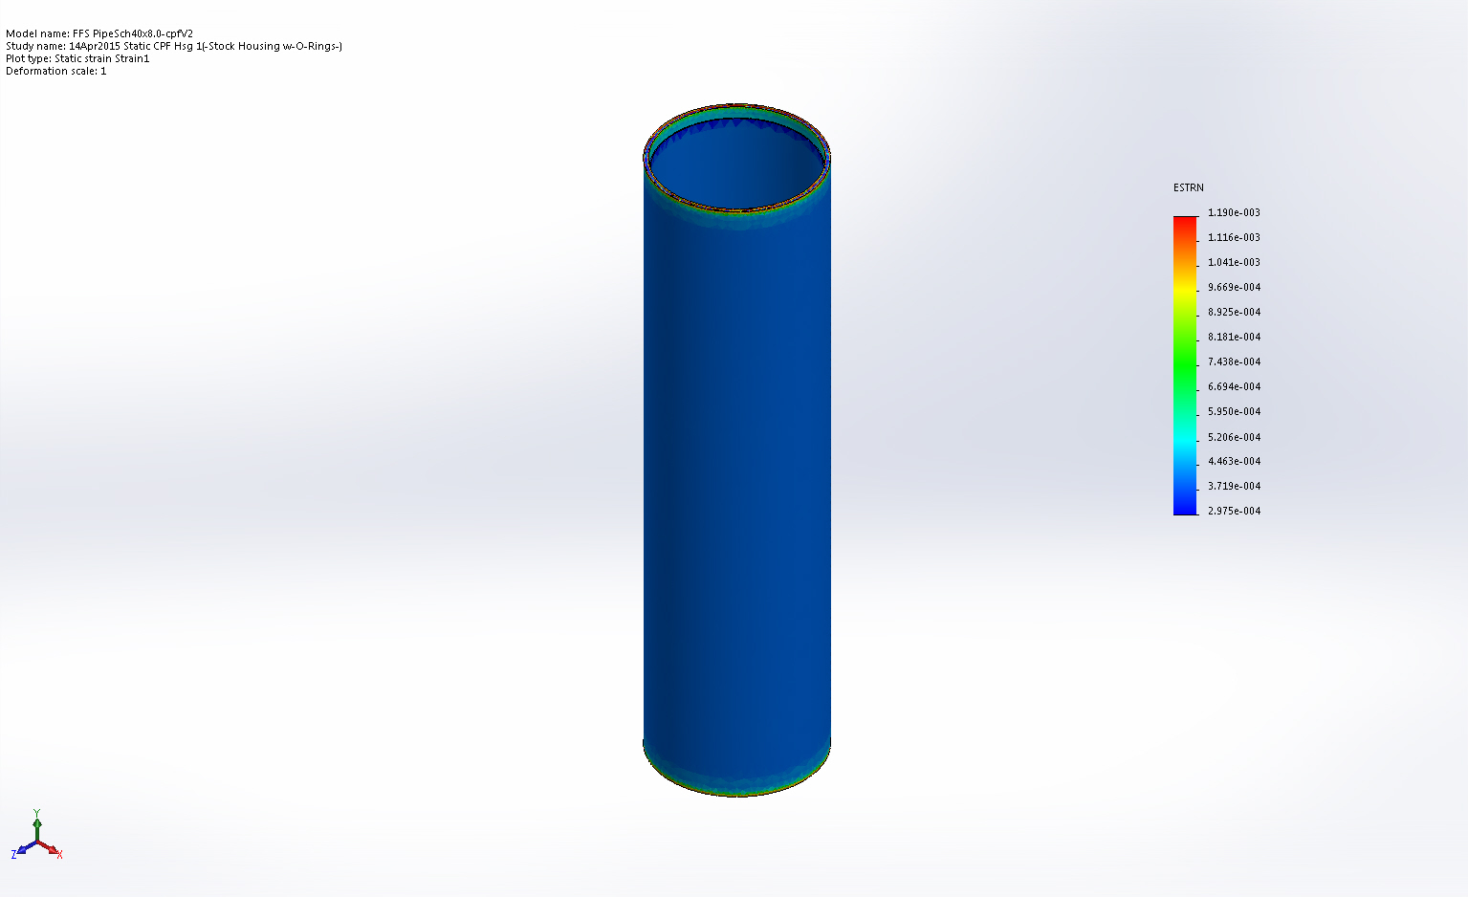
FFS PipeSch40x8.0-cpfV2-14Apr2015 Static CPF Hsg 1-Strain-Strain1

Name | Type | Min | Max
Factor of Safety1 | Automatic | 0.997357  Node: 19364 | 10  Node: 1060
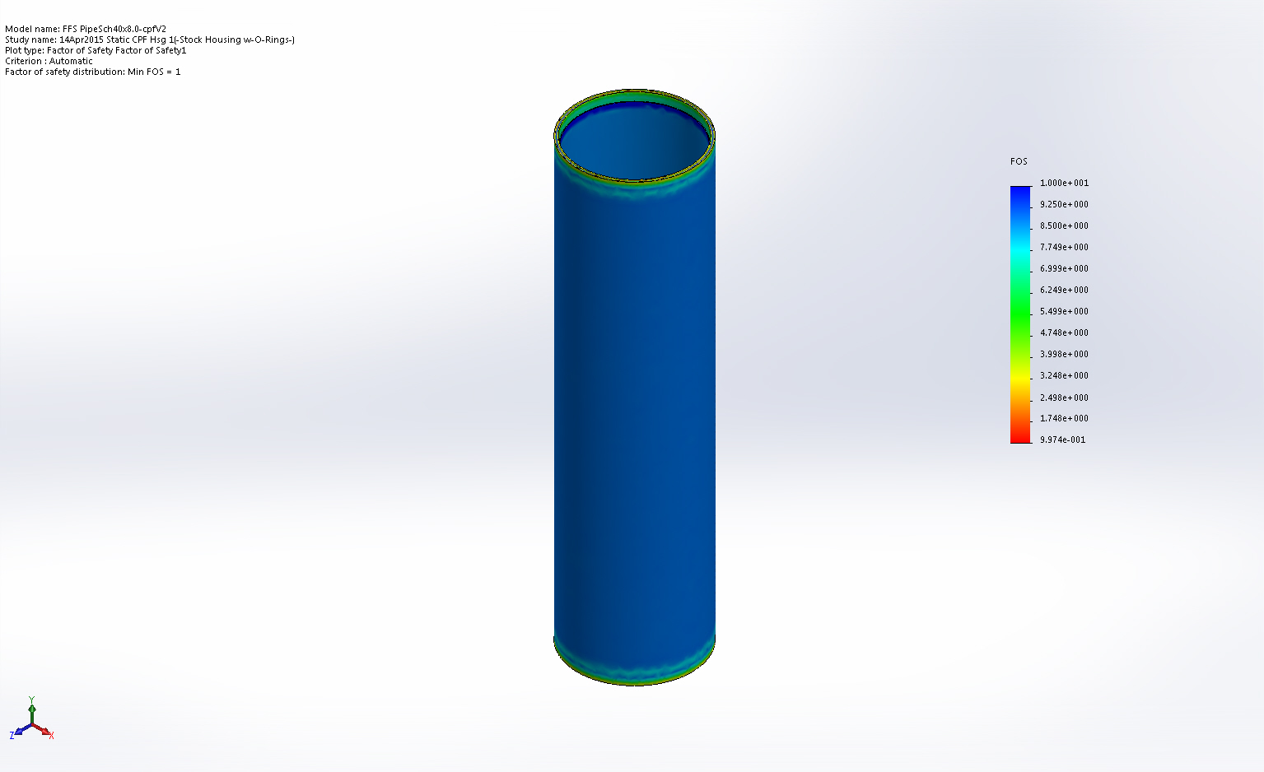
FFS PipeSch40x8.0-cpfV2-14Apr2015 Static CPF Hsg 1-Factor of Safety-Factor of Safety1

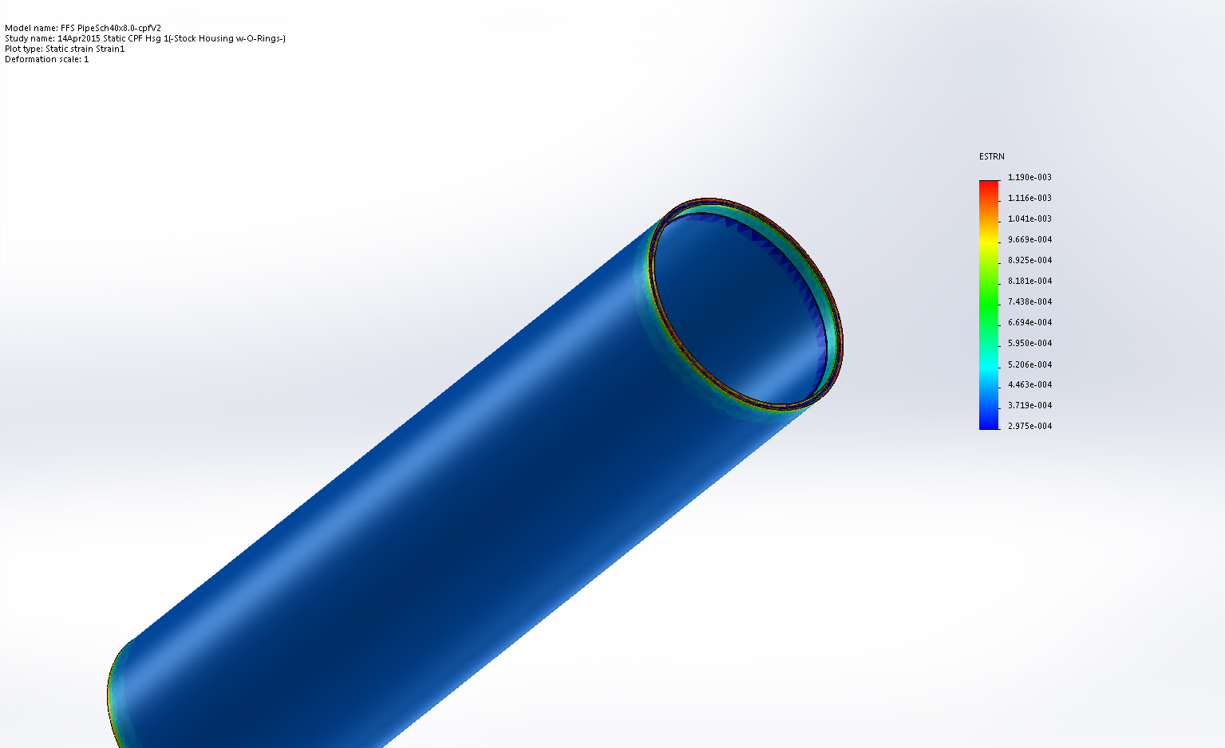
Strain

Conclusion

