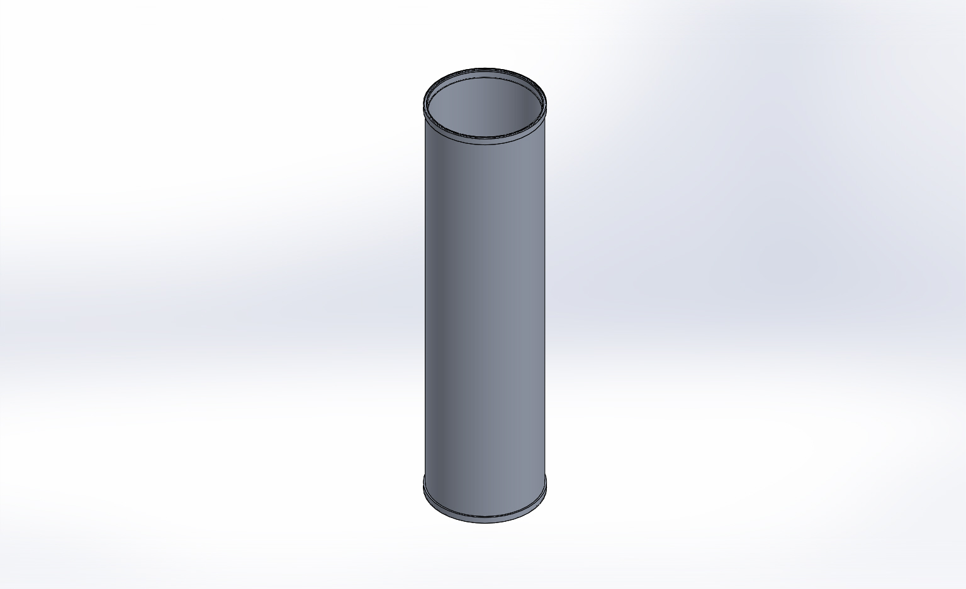
  Simulation of FFS PipeSch40x8.0-cpfV2
  Date: Thursday, April 16, 2015
  Designer: FEA Run By Farley F. Shane
  Study name: 16Apr15 CPF Actual Hsg Buckling
  Analysis type: Buckling
  Table of Contents
  Description 1
  Assumptions 2
  Model Information 2
  Study Properties 3
  Units 3
  Material Properties 4
  Loads and Fixtures 5
  Connector Definitions 7
  Contact Information 7
  Mesh Information 8
  Sensor Details 9
  Study Results 10
  Conclusion 20

Description
16Apr2015 CPF Actual Housing Buckling FEA

Assumptions

Model Information

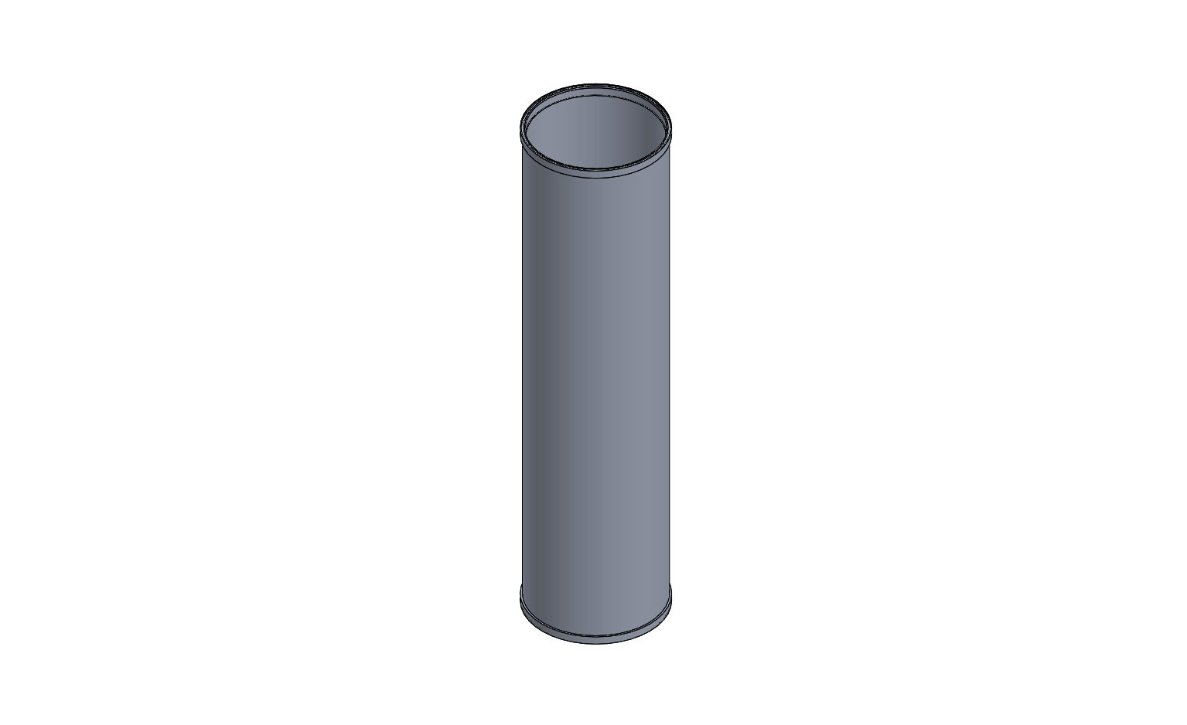
Model name: FFS PipeSch40x8.0-cpfV2
Current Configuration: Default
Solid Bodies
Document Name and Reference | Treated As | Volumetric Properties | Document Path/Date Modified
Mirror1  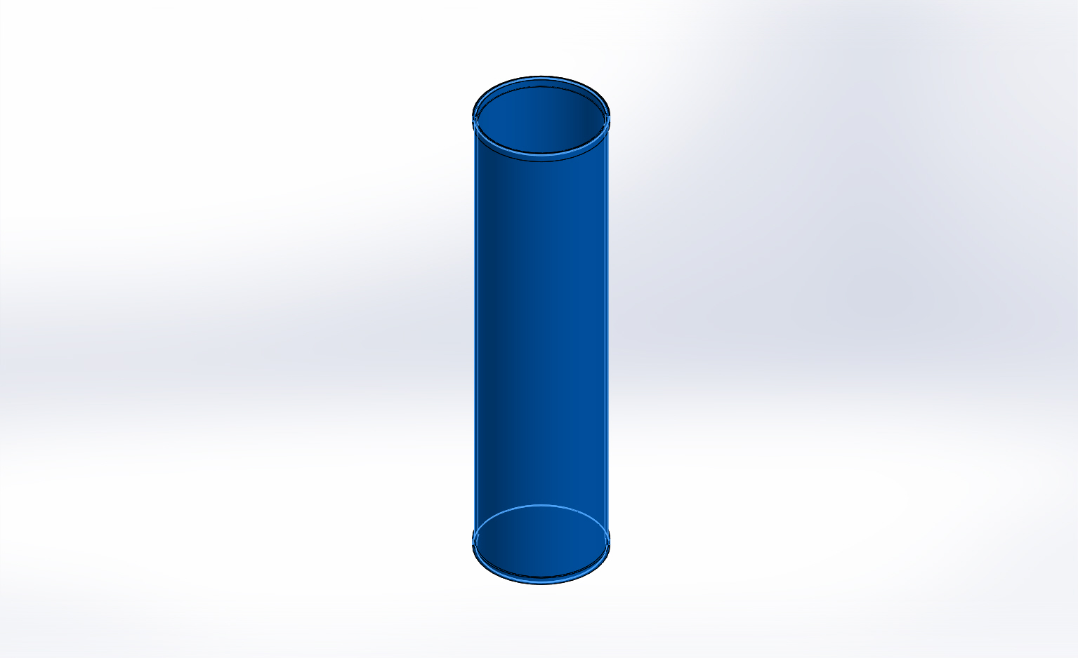 | Solid Body | Mass:16.655 lb  Volume:170.744 in^3  Density:0.0975437 lb/in^3  Weight:16.6437 lbf | X:\CPF\Mechanical Engr\Farley\CPF2015Feb03\FFS PipeSch40x8.0-cpfV2.SLDPRT  Apr 16 12:01:30 2015

Study Properties
Study name | 16Apr15 CPF Actual Hsg Buckling
Analysis type | Buckling
Mesh type | Solid Mesh
Number of modes | 5
Solver type | Direct sparse solver
Incompatible bonding options | More accurate (slower)
Thermal Effect: | On
Thermal option | Include temperature loads
Zero strain temperature | 77 Fahrenheit
Include fluid pressure effects from SolidWorks Flow Simulation | Off
Soft Spring: | On
Result folder | SolidWorks document (X:\CPF\Mechanical Engr\Farley\CPF2015Feb03)

Units
Unit system: | English (IPS)
Length/Displacement | in
Temperature | Fahrenheit
Angular velocity | Hertz
Pressure/Stress | psi

Material Properties
Model Reference | Properties | Components
 |  | SolidBody 1(Mirror1)(FFS PipeSch40x8.0-cpfV2)
  Name: | 6061-T6 (SS)
  Model type: | Linear Elastic Isotropic
  Default failure criterion: | Unknown
  Yield strength: | 39885.4 psi
  Tensile strength: | 44961.7 psi
  Mass density: | 0.0975437 lb/in^3
  Elastic modulus: | 1.00076e+007 psi
  Poisson's ratio: | 0.33
  Thermal expansion coefficient: | 1.33333e-005 /Fahrenheit
Curve Data:N/A

Loads and Fixtures
Fixture name | Fixture Image | Fixture Details
On Cylindrical Faces-1 | 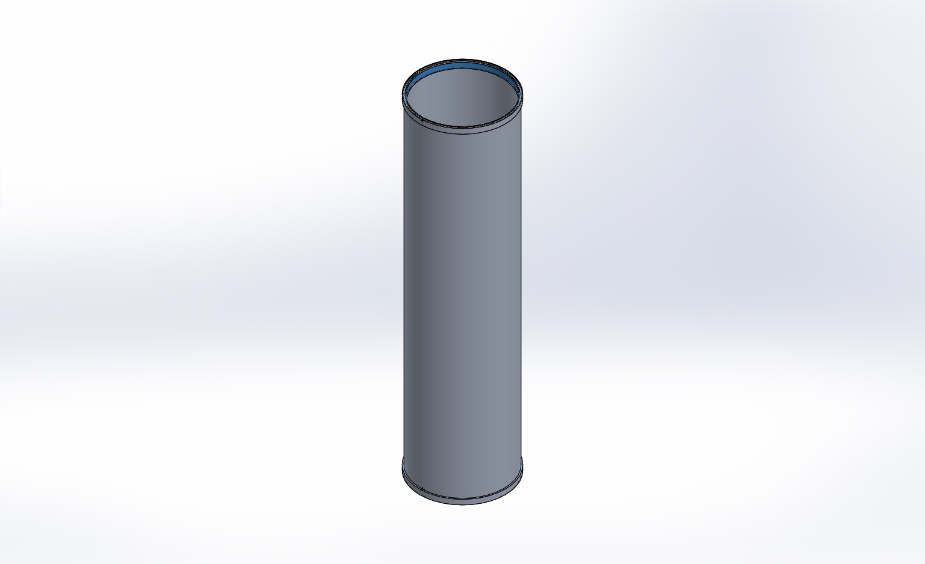
  Entities: | 2 face(s)
  Type: | On Cylindrical Faces
  Translation: | -0.002, ---, ---
  Units: | in
Fixed-1 | 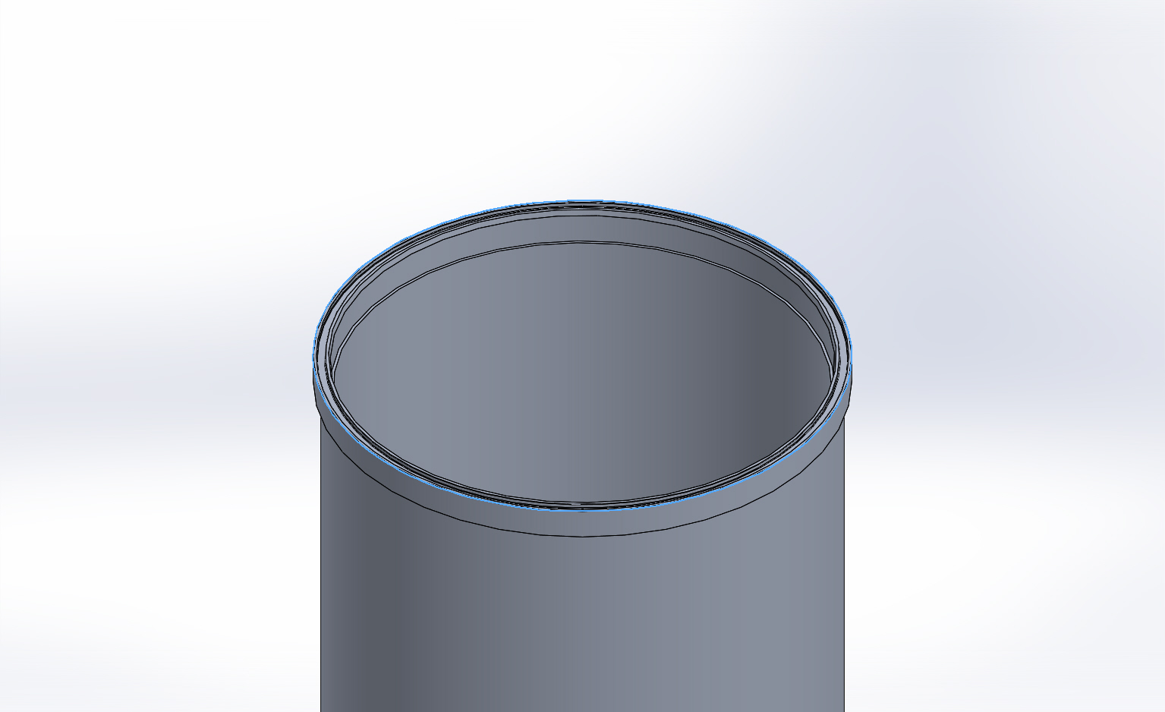
  Entities: | 1 edge(s)
  Type: | Fixed Geometry

Load name | Load Image | Load Details
Force-1 | 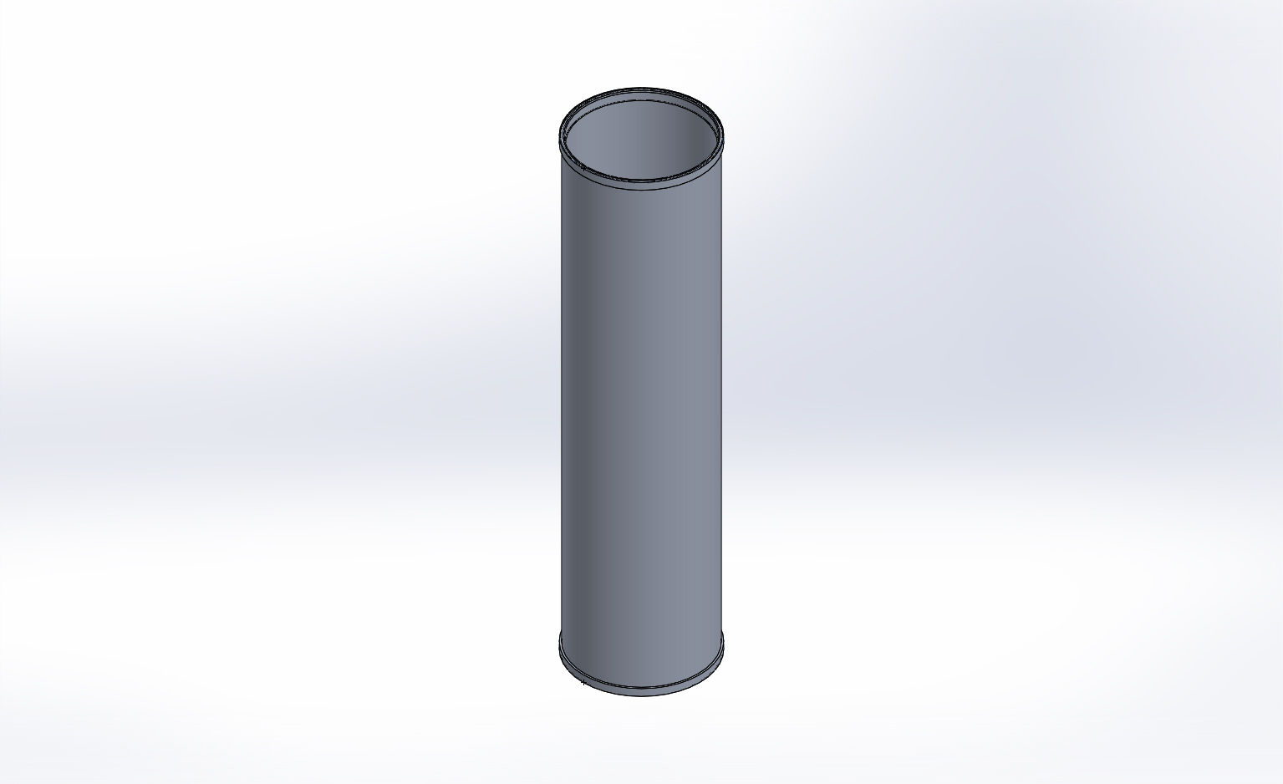
  Entities: | 2 face(s)
  Type: | Apply normal force
  Value: | 23289 lbf
Force-2 | 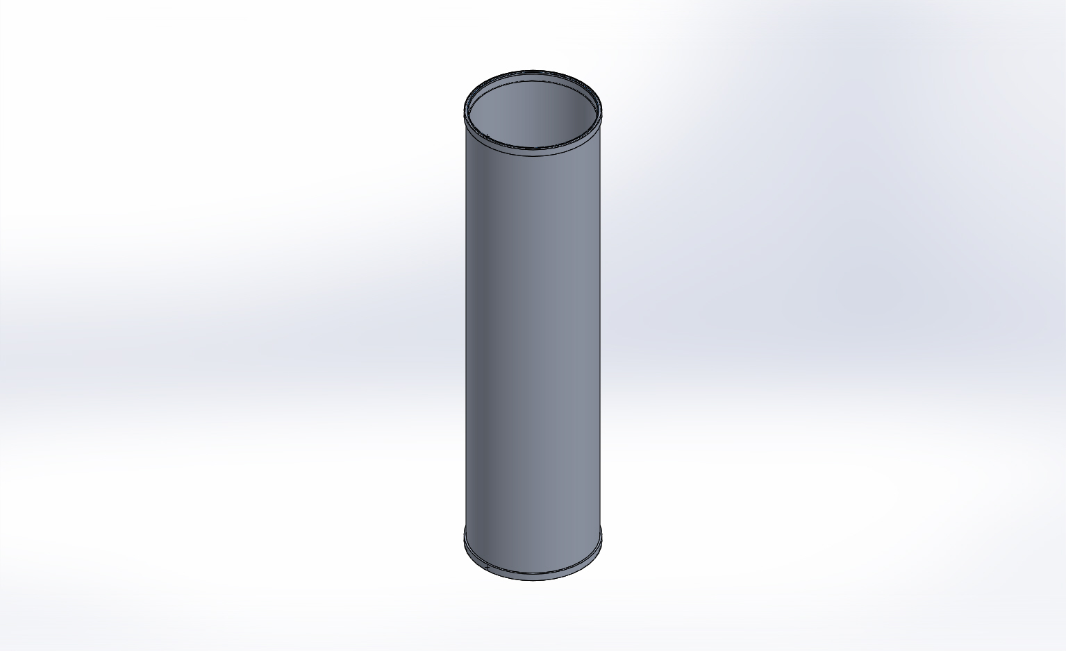
  Entities: | 2 face(s)
  Type: | Apply normal force
  Value: | 20531 lbf
Pressure-1 | 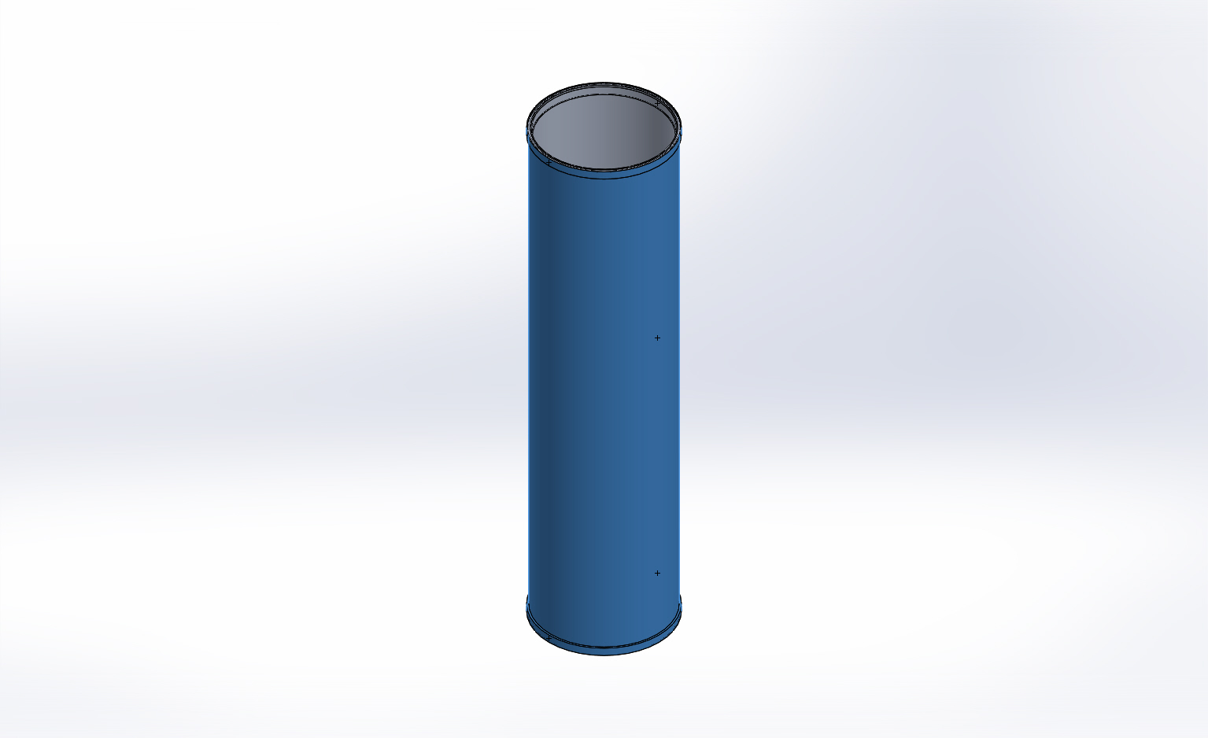
  Entities: | 5 face(s)
  Type: | Normal to selected face
  Value: | 750
  Units: | psi
  Phase Angle: | 0
  Units: | deg

Connector Definitions
No Data

Contact Information
No Data

Mesh Information
Mesh type | Solid Mesh
Mesher Used: | Curvature based mesh
Jacobian points | 4 Points
Maximum element size | 0.4 in
Minimum element size | 0.08 in
Mesh Quality | High

Mesh Information - Details
Total Nodes | 146189
Total Elements | 75283
Maximum Aspect Ratio | 487.75
% of elements with Aspect Ratio < 3 | 70.4
% of elements with Aspect Ratio > 10 | 16.5
% of distorted elements(Jacobian) | 0
Time to complete mesh(hh;mm;ss): | 00:00:26
Computer name: | ENIGMA
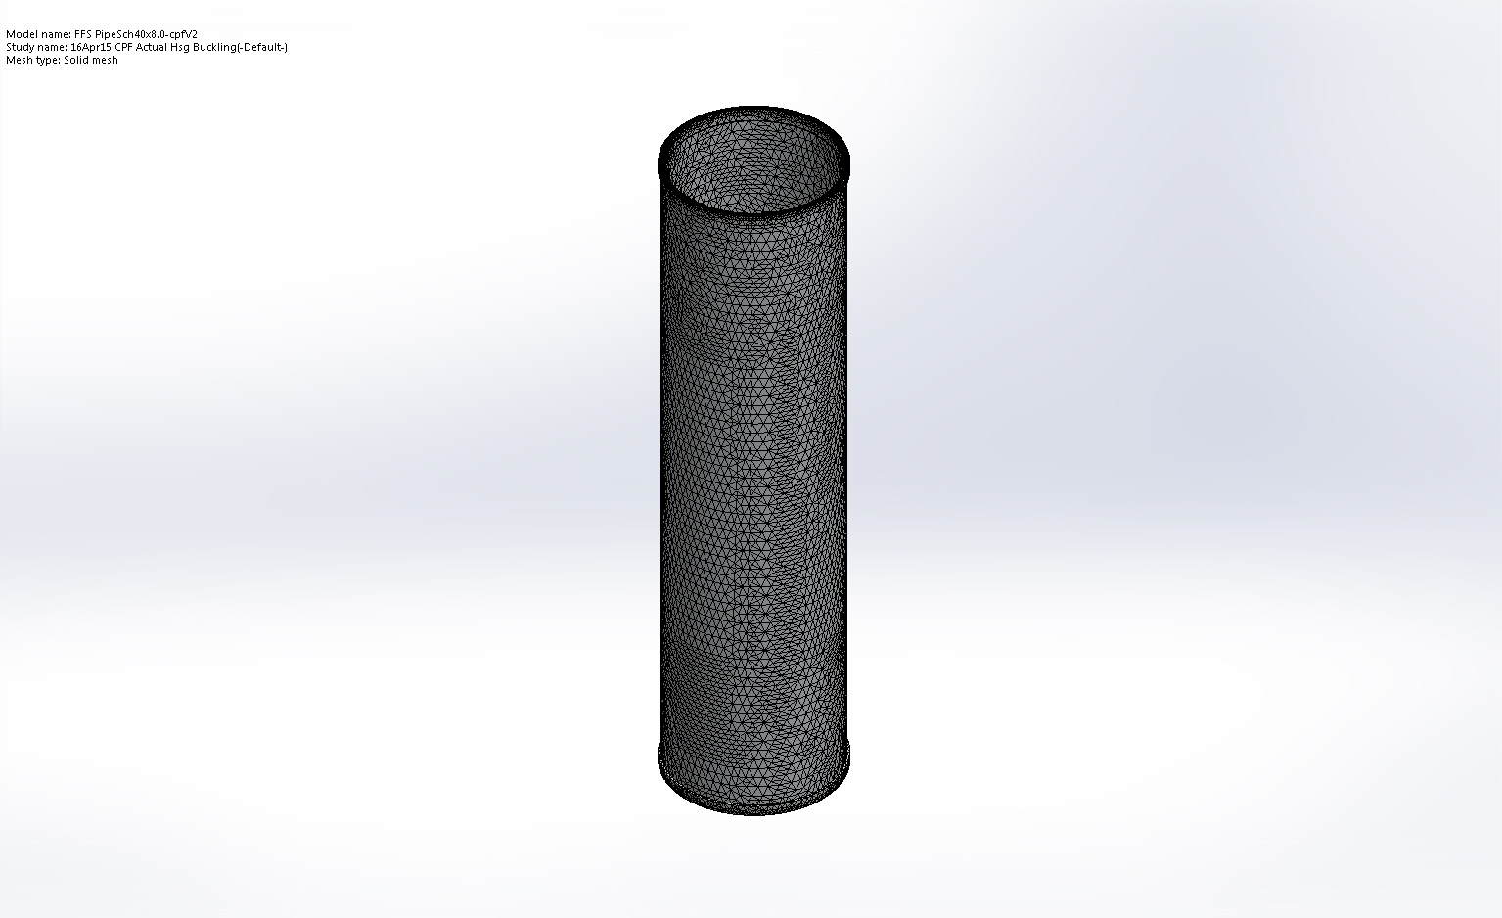

Sensor Details
No Data

Study Results

Name | Type | Min | Max
Amplitude1 | AMPRES: Resultant Amplitude Plot for Mode Shape: 1(Load Factor = 1.31486) | 0  Node: 511 | 0.000256323  Node: 141598
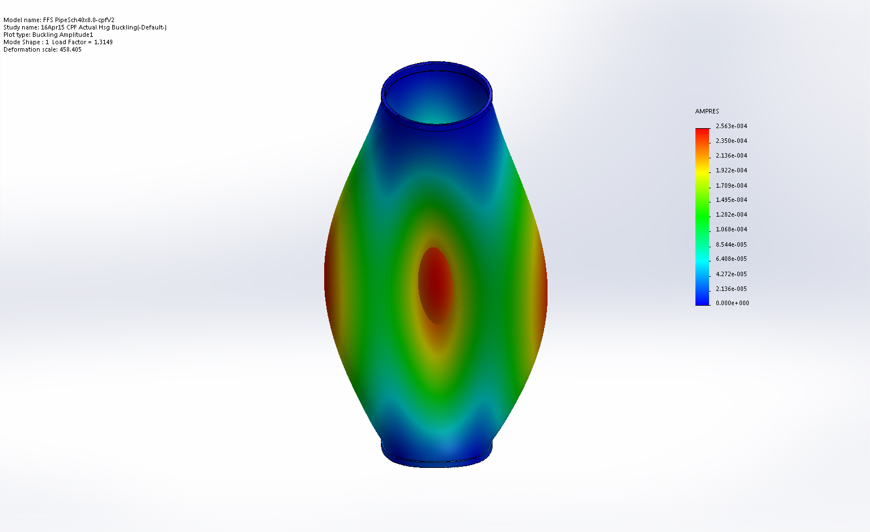
FFS PipeSch40x8.0-cpfV2-16Apr15 CPF Actual Hsg Buckling-Amplitude-Amplitude1

Name | Type | Min | Max
Amplitude2 | AMPRES: Resultant Amplitude Plot for Mode Shape: 2(Load Factor = 1.33583) | 0  Node: 511 | 0.000163927  Node: 124491
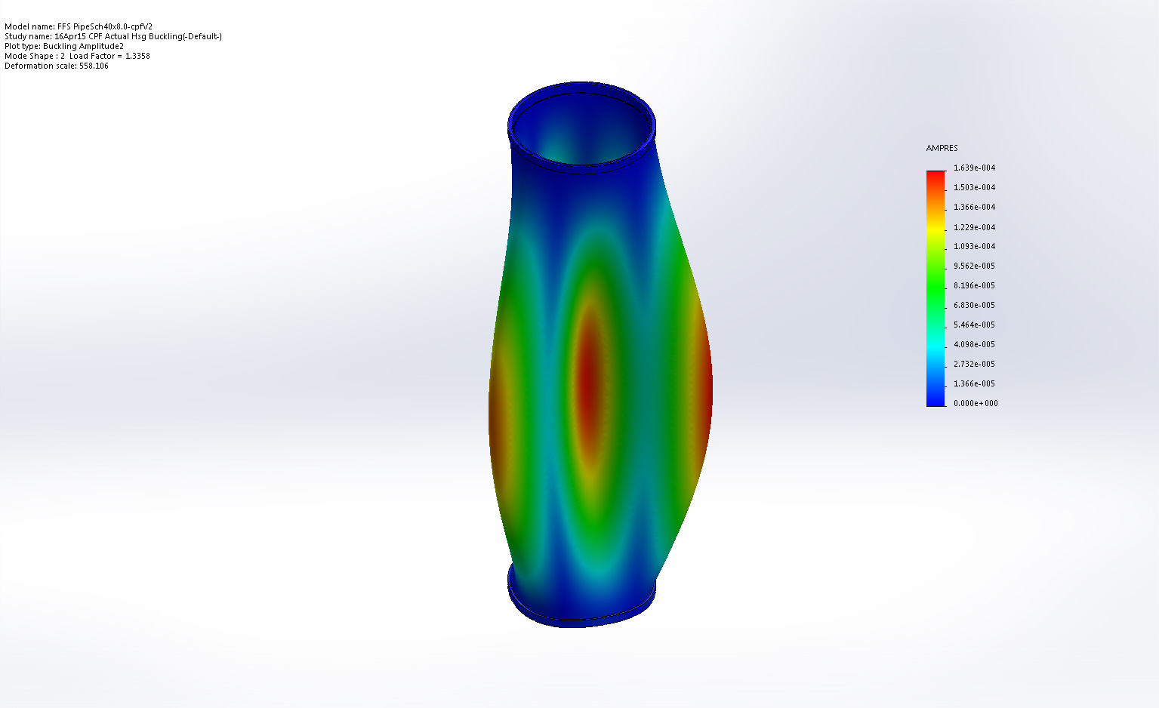
FFS PipeSch40x8.0-cpfV2-16Apr15 CPF Actual Hsg Buckling-Amplitude-Amplitude2

Name | Type | Min | Max
Amplitude3 | AMPRES: Resultant Amplitude Plot for Mode Shape: 3(Load Factor = 1.33646) | 0  Node: 511 | 0.000163344  Node: 112292
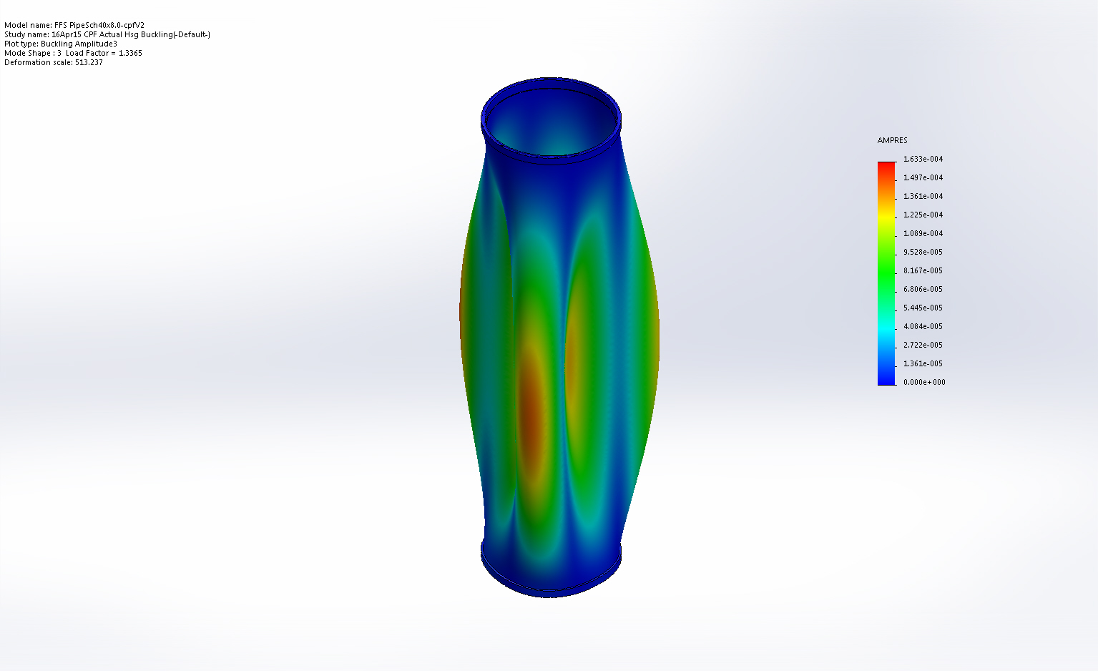
FFS PipeSch40x8.0-cpfV2-16Apr15 CPF Actual Hsg Buckling-Amplitude-Amplitude3

Name | Type | Min | Max
Amplitude4 | AMPRES: Resultant Amplitude Plot for Mode Shape: 4(Load Factor = 1.3563) | 0  Node: 511 | 0.000264196  Node: 115102
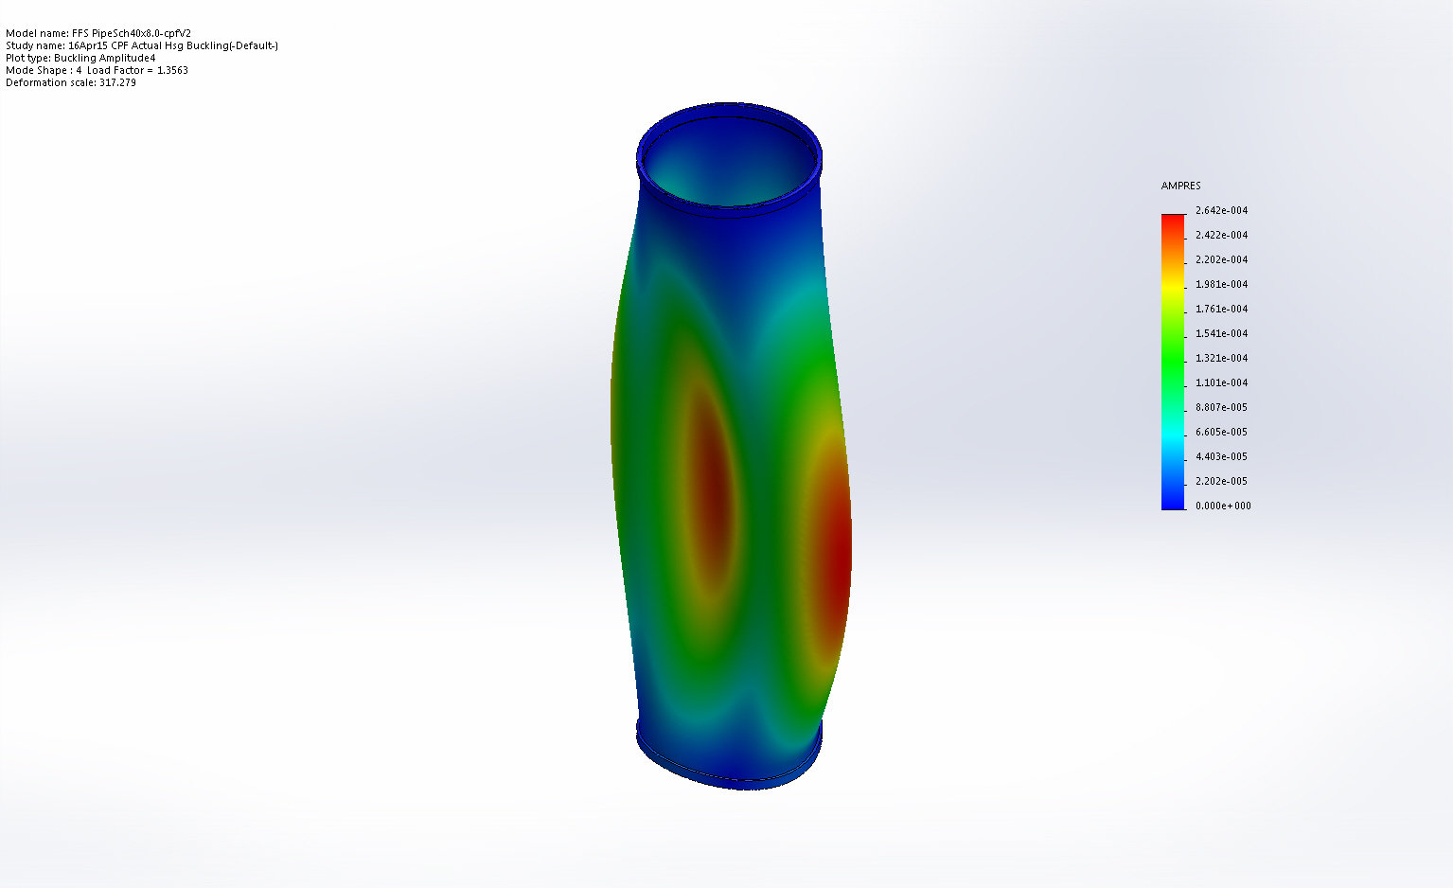
FFS PipeSch40x8.0-cpfV2-16Apr15 CPF Actual Hsg Buckling-Amplitude-Amplitude4

Name | Type | Min | Max
Amplitude5 | AMPRES: Resultant Amplitude Plot for Mode Shape: 5(Load Factor = 1.85698) | 0  Node: 511 | 0.000169162  Node: 137035
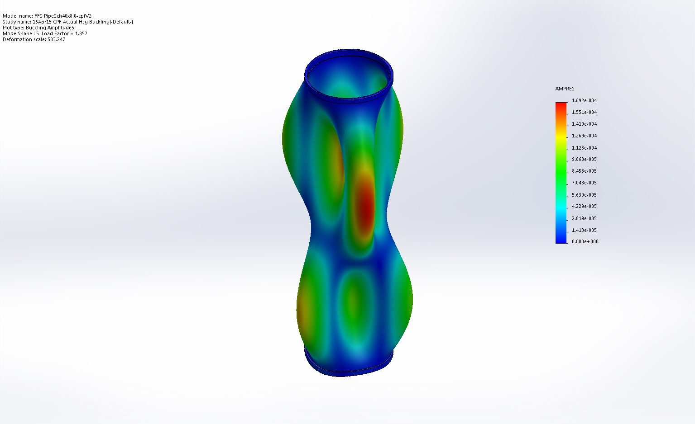
FFS PipeSch40x8.0-cpfV2-16Apr15 CPF Actual Hsg Buckling-Amplitude-Amplitude5

Name | Type | Min | Max
Amplitude6 | AMPRES: Resultant Amplitude Plot for Mode Shape: 3(Load Factor = 1.33646) | 0  Node: 511 | 0.000163344  Node: 112292
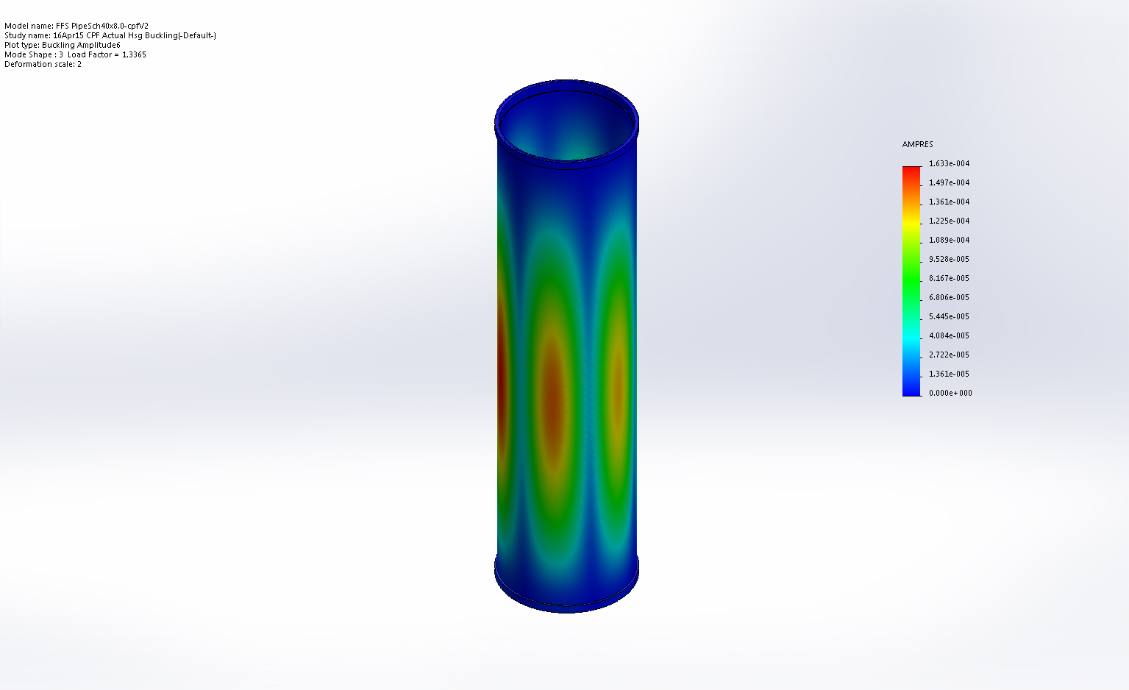
FFS PipeSch40x8.0-cpfV2-16Apr15 CPF Actual Hsg Buckling-Amplitude-Amplitude6

Name | Type | Min | Max
Amplitude7 | AMPRES: Resultant Amplitude Plot for Mode Shape: 1(Load Factor = 1.31486) | 0  Node: 511 | 0.000256323  Node: 141598
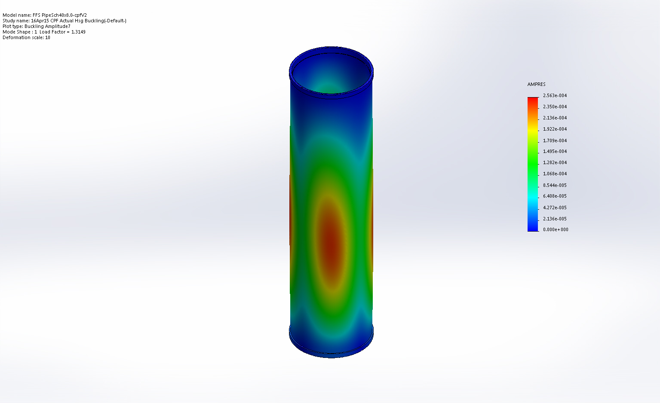
FFS PipeSch40x8.0-cpfV2-16Apr15 CPF Actual Hsg Buckling-Amplitude-Amplitude7

Name | Type | Min | Max
Amplitude8 | AMPRES: Resultant Amplitude Plot for Mode Shape: 1(Load Factor = 1.31486) | 0  Node: 511 | 0.000256323  Node: 141598
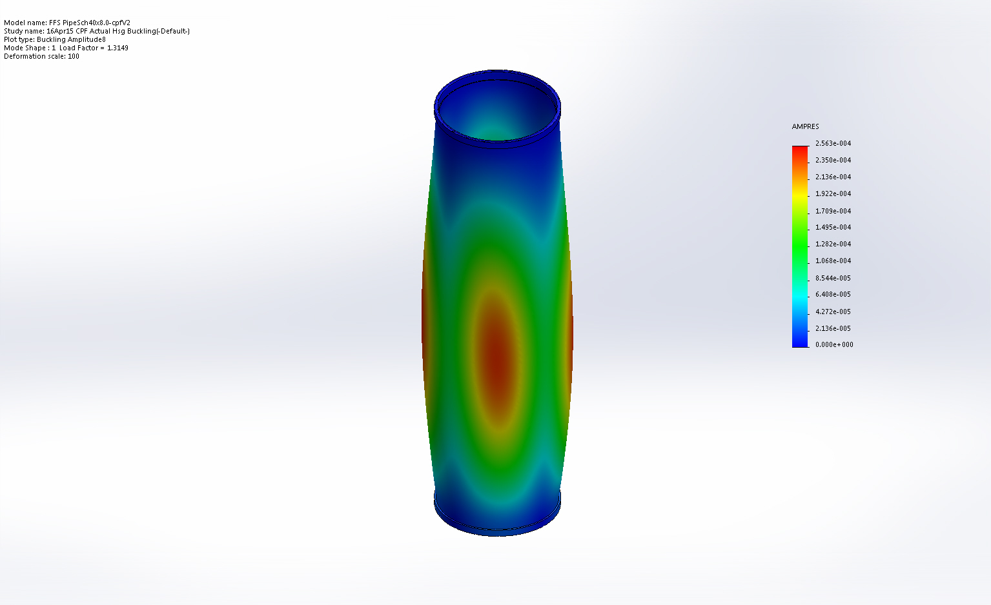
FFS PipeSch40x8.0-cpfV2-16Apr15 CPF Actual Hsg Buckling-Amplitude-Amplitude8

Name | Type | Min | Max
Amplitude9 | AMPRES: Resultant Amplitude Plot for Mode Shape: 1(Load Factor = 1.31486) | 0  Node: 511 | 0.000256323  Node: 141598
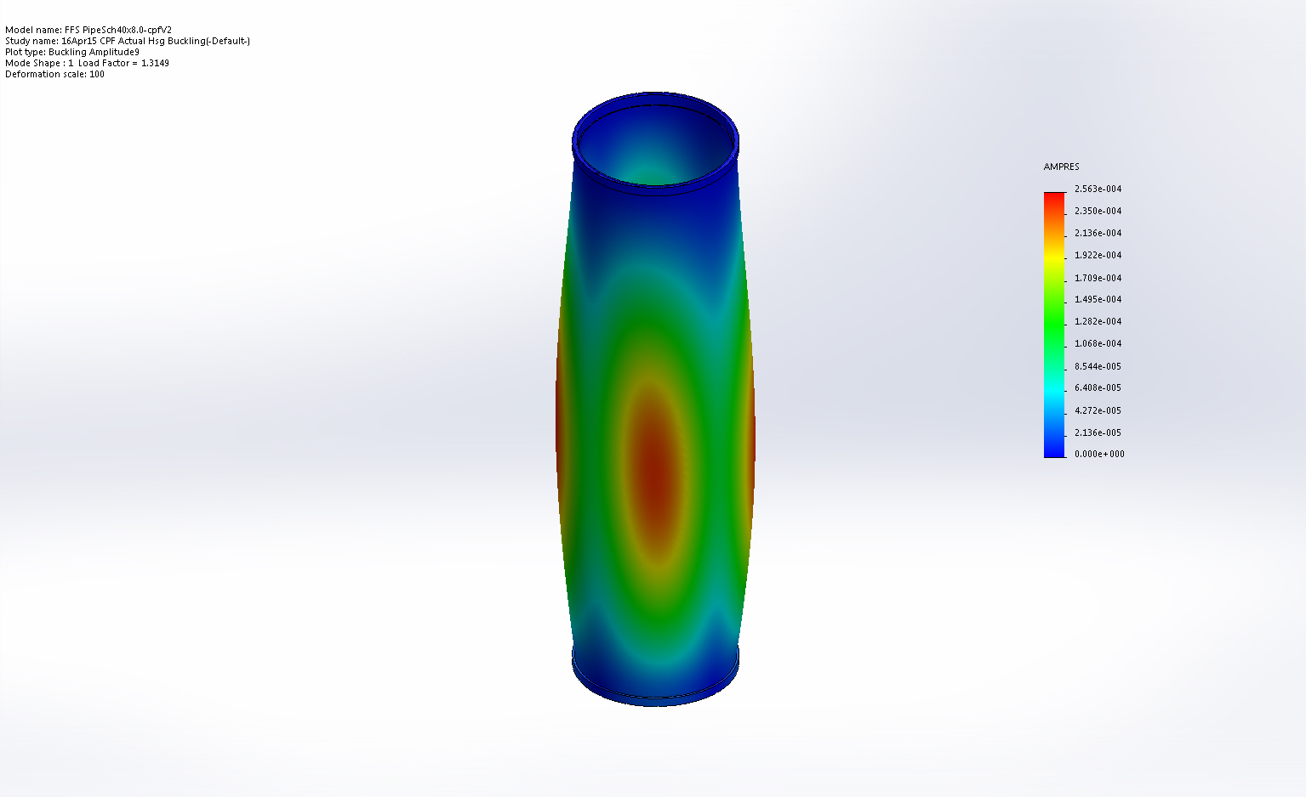
FFS PipeSch40x8.0-cpfV2-16Apr15 CPF Actual Hsg Buckling-Amplitude-Amplitude9

Mode List
Mode Number | Load Factor
1 | 1.3149
2 | 1.3358
3 | 1.3365
4 | 1.3563
5 | 1.857

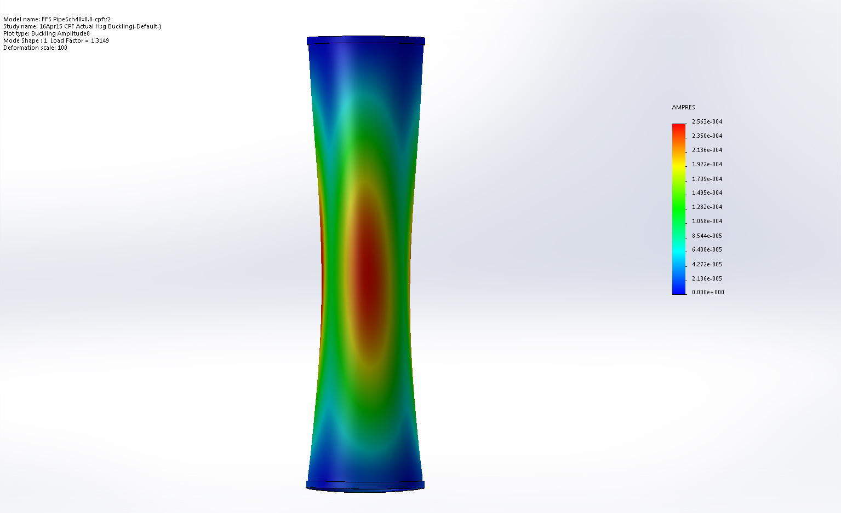
Nodal Concave displacement

Image Comments:
View is 100X deformation

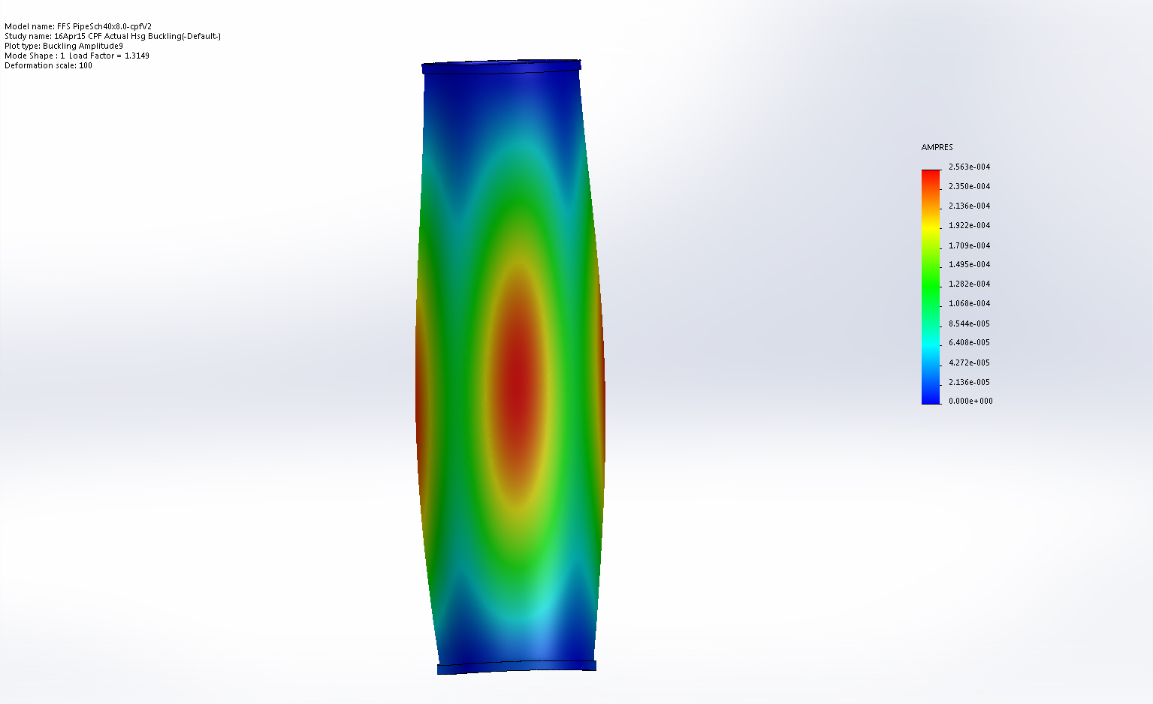
Nodal Convex Displacement

Image Comments:
Deformation is 100X Actual

Conclusion

